SUBJECT* | LAACC Security Cameras

GENERAL INFORMATION
CONTRACTING OFFICE’S ZIP CODE* | 90815
SOLICITATION NUMBER* | 36C26226Q0725
RESPONSE DATE/TIME/ZONE | 05-05-2026 10:00 AM PACIFIC TIME, LOS ANGELES, USA
ARCHIVE | 60 DAYS AFTER THE RESPONSE DATE
RECOVERY ACT FUNDS | N
SET-ASIDE
PRODUCT SERVICE CODE* | 6710
NAICS CODE* | 561621
CONTRACTING OFFICE ADDRESS | Department of Veterans Affairs  Network Contracting Office 22  4811 Airport Plaza Drive  Suite 600  Long Beach CA 90815
POINT OF CONTACT* | Contract Specialist  Choo, Sam  sam.choo@va.gov  sam.choo@va.gov

PLACE OF PERFORMANCE
ADDRESS | Department of Veterans Affairs
 | Greater Los Angeles VA Healthcare System
 | Los Angeles CA
POSTAL CODE | 90073
COUNTRY | USA

ADDITIONAL INFORMATION
AGENCY’S URL
URL DESCRIPTION
AGENCY CONTACT’S EMAIL ADDRESS
EMAIL DESCRIPTION

DESCRIPTION
THIS REQUEST FOR INFORMATION (RFI) / SOURCES SOUGHT NOTICE ISSUED SOLELY FOR INFORMATION AND PLANNING PURPOSES. THIS IS NOT A SOLICITATION.
SUBMISSION OF INFORMATION ABOUT PRICING, DELIVERY, THE MARKET, AND CAPABILITIES IS HIGHLY ENCOURAGED AND ALLOWED UNDER THIS RFI FOR PLANNING PURPOSES IN ACCORDANCE WITH (IAW) FAR 15.201(e).

DISCLAIMER
This RFI is issued solely for information and planning purposes and does not constitute a solicitation. All information received in response to this RFI that is marked as proprietary will be handled accordingly. IAW FAR 15.201(e), responses to this notice are not offers and cannot be accepted by the Government to form a binding contract. Responders are solely responsible for all expenses associated with responding to this RFI.

SOURCES SOUGHT/RFI DESCRIPTION

This is NOT a solicitation announcement. This is a Sources Sought Notice / RFI only. The purpose of this Sources Sought Notice / RFI is to gain information about potential qualified sources and their size classification relative to NAICS 561621 – Security Systems Services (Size standard of $25.0 MM). Responses to this Sources Sought Notice / RFI will be used by the Government to make appropriate acquisition decisions. After review of the responses to this Sources Sought Notice / RFI, further RFIs and/or a solicitation or other announcements may be published.

The purpose of this contract is to have a vendor to provide all labor, materials, tools, equipment, qualified personnel, and transportation to replace security cameras at VA Greater Los Angeles Healthcare System, Los Angeles Downtown Clinic. The vendor shall provide following or Equal:

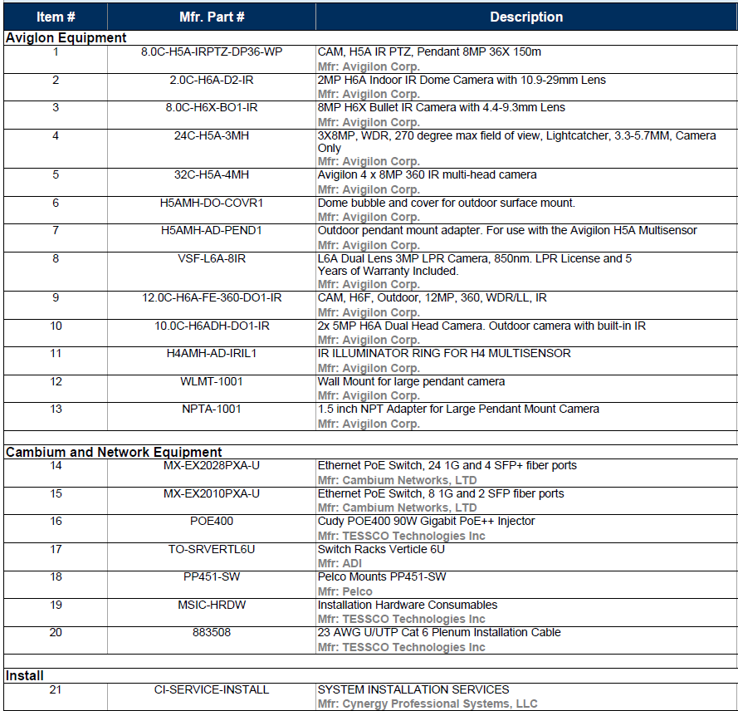

- General Requirements

  - Basic Requirements: GLA VA Healthcare System requires expansion and upgrade of the existing video security surveillance (VSS) system.

  - Qualifications: Vendor must have the following certifications/qualifications:
    - Avigilon Certified Technician
    - Cambium Networks Certified
    - R-56 Certified
    - Motorola Solutions Premier Service Partner (PSP)

- Specific Tasks

  - Cameras for Los Angeles Ambulatory Care Center
    - Install 137x cameras, all Brand Name or Equal to those listed below:
      - 7 - CAM, H5A IR PTZ, Pendant 8MP 36X 150m, Avigilon
      - 23 -2MP H6A Indoor IR Dome Camera with 10.9-29mm Lens, Avigilon
      - 9- 8MP H6X Bullet IR Camera with 4.4-9.3mm Lens, Avigilon
      - 6 - 3X8MP, WDR, 270-degree max field of view, Lightcatcher, 3.3-5.7MM, Avigilon
      - 6 - Avigilon 4 x 8MP 360 IR multi-head camera
      - 12 - Dome bubble and cover for outdoor surface mount.
      - 12 - Outdoor pendant mount adapter. For use with the Avigilon H5A Multi-sensor, Avigilon
      - 2- L6A Dual Lens 3MP LPR Camera, 850nm. LPR License and 5 Years of Warranty Included. Avigilon
      - 14 - CAM, H6F, Outdoor, 12MP, 360, WDR/LL, IR, Avigilon
      - 18 -2x 5MP H6A Dual Head Camera. Outdoor camera with built-in IR
      - 12 - IR ILLUMINATOR RING FOR H4 MULTISENSOR
      - 8 - Wall Mount for large pendant camera, Avigilon
      - 6 - 1.5 inch NPT Adapter for Large Pendant Mount Camera, Avigilon

    - Install Brand Name or Equal Ethernet PoE Switch and Transceiver:
      - 10 -Ethernet PoE Switch, 24 1G and 4 SFP+ fiber ports, Cambium Networks
      - 2 - Ethernet PoE Switch, 8 1G and 2 SFP fiber ports, Cambium Networks
      - 20 - Cudy POE400 90W Gigabit PoE++ Injector, TESSCO Technologies Inc
      - 12 -Switch Racks Verticle 6U, ADI
      - 6 -Pelco Mounts PP451-SW, Pelco
      - 1 - Installation Hardware Consumables, TESSCO Technologies Inc
      - 25 -23 AWG U/UTP Cat 6 Plenum Installation Cable, TESSCO Technologies Inc
      - 1120 -SYSTEM INSTALLATION SERVICES, Cynergy
      - Licenses for each camera

If your company is interested and capable of providing the required supplies/services, you MUST provide the information indicated below OR your intent, interest to participation, and information provided will not be considered as valid for research purposes. Response to this notice should include company name, address, point of contact, size of business pursuant to the following questions:
(1) Submit your capabilities statement illustrating how your organization can/cannot meet the list of DRAFT/SALIENT CHARACTERISTICS/SOW requirements. For instances where your company cannot meet the DRAFT/SALIENT CHARACTERISTICS/SOW requirement(s), please explain. For instances where your company can meet the DRAFT/SALIENT CHARACTERISTICS/SOW requirement(s), please show how your company meets/exceeds each requirement.
(2) Please review the list of DRAFT/SALIENT CHARACTERISTICS/SOW requirements and provide any additional feedback or suggestions. If none, please reply as N/A.
(3) Please indicate the size status and representations of your business, such as but not limited to: Service-Disabled Veteran-Owned Small Business (SDVOSB), Veteran-Owned Small Business (VOSB), HUBZone, Woman Owned Small Business (WOSB), Large Business, etc.
(4) Is your company considered small under the NAICS code identified in this RFI?
(5) Are you the manufacturer, authorized distributor, and/or can your company provide a solution to the required supplies/services described in the list of DRAFT/SALIENT CHARACTERISTICS/SOW?
(6) If you are a large business, do you have any designated/authorized distributors? If so, please provide their company name, telephone, point of contact and size status (if available).
(7) If you’re a small business and you are an authorized distributor/reseller for the items identified above, do you alter; assemble; modify; the items requested in any way? If you do, state how and what is altered; assembled; modified.
(8) Limitations on Subcontracting: How does your business ensure compliance with the limitations on subcontracting as outlined in 13 CFR § 125.6?
(9) Are the items you are identifying/providing considered Commercial of the Shelf (COTS) items as defined in FAR Part 2.101 under commercial items?
(10) Non-Manufacturer Rule: If applicable, can you confirm your business complies with the Non-Manufacturer rule? Specifically, does your company: Provide a product from a small business manufacturer or processor? Not exceed 500 employees? Primarily engage in the retail or wholesale trade and normally sell the type of item being supplied? Take ownership or possession of the item(s) with its personnel, equipment or facilities in a manner consistent with industry practice?
(11) Please indicate whether your product conforms to the requirements of the Buy American Act? Please indicate if manufacturer is/will be US domestic Small Business / US Domestic Large Business / Foreign.
(12) What is your lead time to deliver a single unit with all components? Is there scale in lead time with greater quantities? Please elaborate.
(13) What is estimated life span of your solution? What support/services does that entail?
(14) Does your organization offer a leasing solution? Please elaborate.
(15) Does your company have a Federal Supply Schedule (FSS) GSA/NAC/SAC/BPA/NASA SEWP or any other Federal Government contract? If so, please provide the contract number(s).
(16) If you are an FSS GSA/NAC/SAC/BPA/NASA SEWP or any other Federal Government contract holder, are all the items/solutions you are providing information about available on your schedule/contract? Please state if all or some items are available on the contract.
(17) General pricing of your products/solution is encouraged. Pricing will be used for the purpose of market research only. It will not be used to evaluate for any type of award.
(18) Please provide your SAM.gov Unique Entity ID/Cage Code number.
Responses to this notice shall be submitted via email to sam.choo@va.gov. Telephone responses will not be accepted. Responses must be received no later than Tuesday, May 5, 2026 by 10:00 AM PST.
All responses to this Sources Sought/RFI will be used for planning purposes only. Responses to this Sources Sought Notice / RFI are not considered a request to be added to a prospective bidders list or to receive a copy of the solicitation. If further RFIs and/or a solicitation or other announcement is issued as a result of the information provided from this RFI, all interested parties must respond to the specific posting separately IAW the specifications of that announcement.

See attached document: 36C26226Q0725.

