

Statement of Work

1.0 - Background
The Bureau of Reclamation (Reclamation), Upper Colorado Basin Region, Albuquerque Area Office (AAO), is one of the largest area offices in Reclamation, reaching from the Alamosa area of southern Colorado through most of New Mexico and into west Texas. The AAO is responsible for planning, design, and construction of projects in the Brackish Groundwater National Desalination Research Facility (BGNDRF) located in Alamogordo, NM.
BGNDRF was authorized by FY 2004 Energy & Water Appropriations (Sec 210 of PL 108-137) pursuant to the Water Desalination Act (PL 104-298) and explicitly permits up to 100% federal cost-share of facility design, construction, operation, maintenance, repair, and rehabilitation.
The Brackish Groundwater National Desalination Research Facility (BGNDRF) is a federal facility that operates under the United States Department of Interior, Bureau of Reclamation (Reclamation). Established by an Act of Congress, the facility mission is to promote sustainable advanced water treatment research and technology development for inland brackish groundwater sources and, specifically, to conduct research for the development of cost-effective, robust desalination and alternative energy technologies that produce sustainable new supplies of water and power for municipal, industrial, agricultural, and environmental purposes.
The BGNDRF has an urgent need to repair a leak on two piping systems near its largest outdoor pad. The facility is at reduced capacity and is unable to support ongoing research. Additionally, there is a potential for unauthorized discharges to the ground or sanitary sewer without repair; discharges at the facility are covered by a New Mexico Environment Department discharge permit. This project is needed to fix known leaks on two valves, but the proximity and method of original installation may require replacement of all valves and associated fittings in the area. The potable water does not appear to be leaking at this time. The leaks and scope are based on the excavation done by Reclamation staff. The contractor will need to fully excavate the work area to confirm whether any changes are necessary.

2.0 - Scope

2.1 – Location and Hours of Operations
Reclamation’s facility is located at 500 La Velle Road, Alamogordo, NM 88310.
Reclamation’s standard business hours are Monday through Friday from 7:30 AM to 4:30 PM MST except federal holidays.

2.2 – Period of Performance
The Government needs the work to be completed within 30 days of contract award. Adjustments to the schedule will be considered if parts availability are an issue or weather will impact quality and safety during the project activities/tasks.

3.0 - Objectives
The purpose is to facilitate and promote advanced water treatment research and technology development at the BGNDRF. There is a total of 10 research areas located inside and outside the building. The work area for this project is the large concrete pad southwest of the main building.
The facility has four wells that can supply one of three tanks. Two of the three tanks are not in use now due to the leaks at Pad 10. The storage tanks are isolated, so the only water remaining in the pipelines is residual that hasn’t drained. During original construction 20 years ago, all fittings were buried and covered by concrete. The two tanks’ pipelines that are leaking are located underneath the same concrete.
The location of the valves and piping is shown in Figures 1-2. The gray shaded box shows the approximate area excavated by Reclamation personnel. The primary leak was determined to be the connecting line between the 6” valves that supply Pad 10 and Pad 7 (supplied by ST2B). During excavation, the pipeline was moved. The leak was visible prior to that. Additionally, after excavation, a leak was present on ST1C. The exact location of the ST1C leak is unknown; however, it is suspected to be in the pipeline or fittings underneath the concrete covering the other pipelines. The leak stopped after isolating the storage tanks (ST2B first, then ST1C). The third storage tank (ST3A) is presently not leaking.
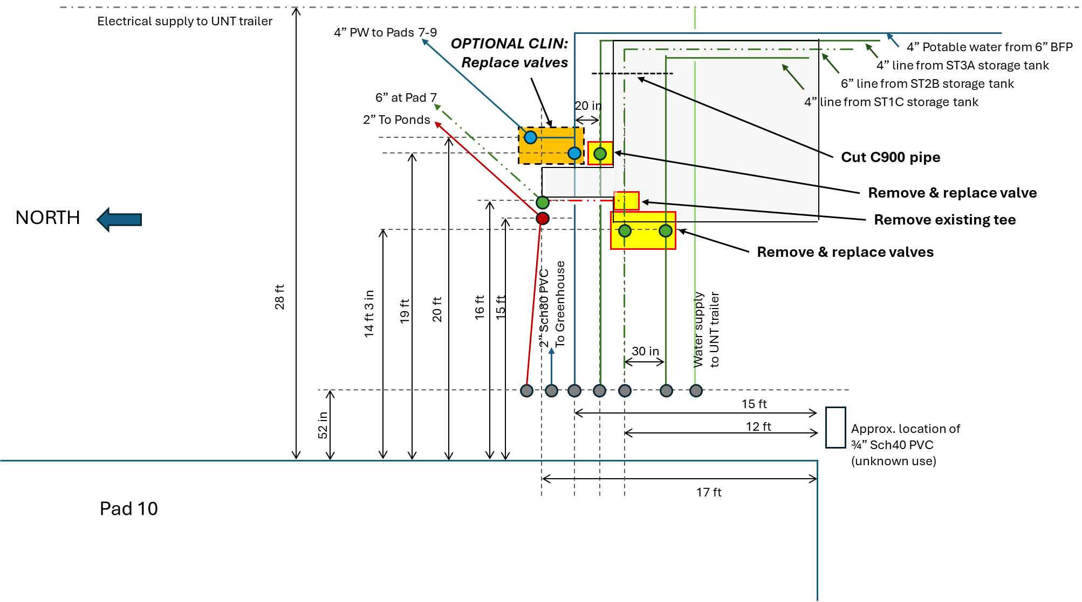
Figure 1. Pad 10 piping diagram showing approximate trench location (shaded) and needed work
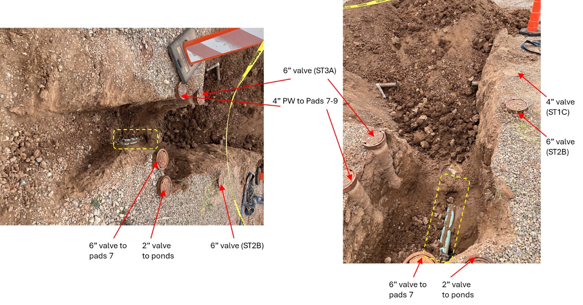
Figure 2. Exposed Piping showing locations of valves (red arrows) and the known leak area (yellow dashed box)

4.0 - Tasks
PRINCIPAL COMPONENTS OF WORK
      - Excavation of pipelines and associated fittings to verify scope

  - An excavation work plan must be completed prior to excavation work starting.
  - There are several buried utilities in the area: electrical, controls, brackish and potable supply pipelines, sanitary sewer, and waste pipelines connected to the evaporation ponds.
      - Excavate such that supply pipelines are visible and a safe work area is achieved.
      - Order materials
        - All materials must be suitable for brackish groundwater.
        - There are two (2) 4” valves and one (1) 6” valve that must be replaced (valves associated with the storage tanks). Utilize MEGA couplings for all valves and piping connections. Alternative couplings must be approved by the CO/COR prior to ordering.
        - OPTIONAL CLIN: While there are no leaks present on the potable water line and associated 4” valves, there is a possible need to replace if excavation or other activities lead to or identify a new leak.
        - All 4” and 6” piping is C900. The 2” piping is Schedule 80 PVC.
        - Where necessary, thrust blocks should be installed, however, the fittings and valves shall not be buried if at all possible.
        - Dirt onsite may be used directly or mixed with fresh engineered fill if the bidder feels it will compact sufficiently and prevent movement of the installed materials.
      - Compete installation and re-bury site. See Figure 3 for approximate finished piping and valve locations.
        - Install all new fittings.
          - Water stored in tanks shall not be released to the ground surface or sanitary sewer. When piping is cut, pump water out of pit to BGNDRF evaporation ponds – coordinate this with the COR to ensure a valve is open on the other end of the pipeline prior to cutting the pipeline.
          - If possible, installing the valves in a straight line is preferred (see Figure 3). The valves must be installed with risers and shall not buried in concrete.
          - OPTIONAL CLIN: If needed, remove and replace potable water fittings.
        - There is at least one 6” tee that will need to be removed (associated with ST2B). The loose piping and associated 6” valve can be removed or left in place if found to be stable.
        - Mark up BGNDRF design drawings or prepare new drawings showing the location of all pipelines, valves, and fittings in the excavated area. Distances from the concrete pad, electrical pad, greenhouse, or other static objects shall be shown.
        - Take detailed pictures of the installed piping and fittings.
        - Pressure test overnight to verify no leaks are present.
        - Bury piping and fittings. Utilize a vibrating plate or jumping jack with appropriate lifts for soil compaction. Install magnetic location tape on all excavated and newly installed piping.
        - Pressure test for at least two hours to confirm no leaks are present.
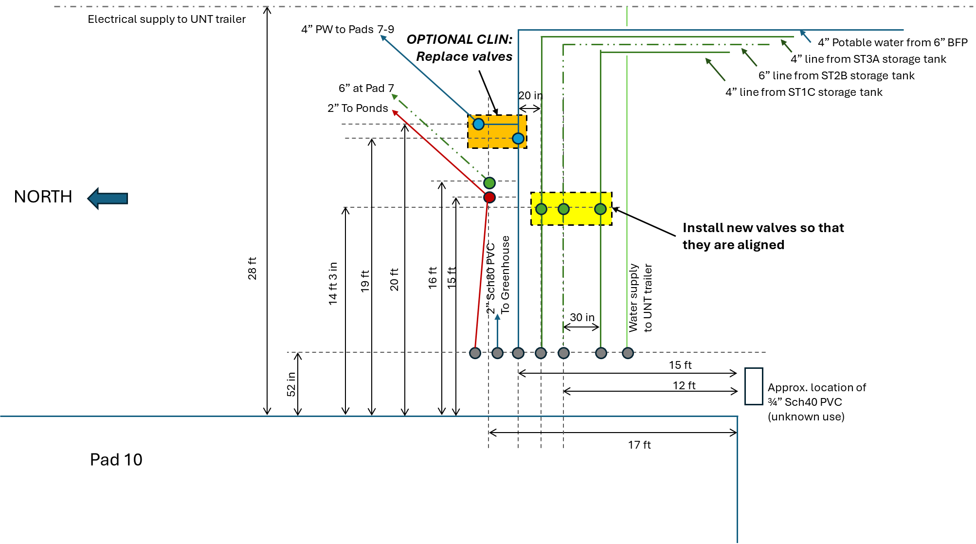
Figure 3. Pad 10 piping after tank valves installed

5.0 - Submittals
Submit the following for Government review or approval:
- Prepare in English.
- Measurement Units: US Customary Units.
- Label and file name must include contract number and title including Required Submittal Number (RSN).
- Provide a unique transmittal tracking number for each submittal.
- Manufacturer’s certifications shall be signed by an authorized representative.
- Review of submittals:
  - Time required: The Government will require a minimum of 5 working days to review each submittal or resubmittal, unless otherwise specified.
  - Excess Time: Should the Government require additional review time, the CO may extend the contract completion date to allow completion of work. Time extension will be to the extent that the excess review time caused delay to contract completion.
- Submit the following for Government approval or review.
  - Submittal Types: A – Action requiring Government approval and I – Informational requires Government written receipt.
  - Submit to COR one electronic (eMail) copy for review.
RSN | Required Submittal and Description | Due Date or Delivery Time | Type
S1 | Project Schedule shall include the following key milestones:  - Proposed date to mobilize.  - Proposed date for initial inspection and scope verification  - Proposed schedule of remaining activities | Within 2 days after contract award | A
S2 | Excavation Work Plan | Within 7 days of contract award | A
S3 | Proposed materials (valves, fittings, piping) | Within 7 days of excavation | A
S4 | Summary report of installation including drawings, pictures, and description of installation. | Within 14 days of installation completion | I

6.0 – Provided to Offeror

6.1 – Point of Contact
The following key Government personnel are
Contracting Officer: Kristen Ruiz Jimenez
Kristen_ruizjimenez@ios.doi.gov

Contracting Officer’s Representative: Malynda Cappelle
500 La Velle Rd
Alamogordo, NM 88310
(575) 443-6553
mcappelle@usbr.gov

6.2 – Government provided Utilities
The Government will make electricity available for activities. If an electrical outage is needed at any point, the contractor will need to provide power for outside if needed. The facility restrooms can be made available for use by the Contractor if requested.
If project work requires disconnection of any utilities such as electrical, water, HVAC equipment, etc., provide a minimum of 48-hour notice to the Government.

7.0 –Safety
This section describes the security and safety requirements for this Reclamation facility. The following sub-sections provide additional details for various considerations on this effort.
The selected contractor will be monitored at all times by a government employee or designated construction inspector.
Contractor and its subcontractors shall comply and incorporate into their safety and health programs/plans the following safety requirements:
- Occupational Safety and Health Administration (OSHA) Part 1926 Construction.
- Reclamation Safety and Health Standards (RSHS) which can be found at the following website: https://www.usbr.gov/ssle/safety/RSHS/rshs.html.
The contractor and its subcontractors (if applicable) shall promptly report all facts regarding accidents, near miss(es), emergencies, and/or mishaps involving Government property damage or injury to Government personnel and to cooperate in any resulting safety investigation.
The contractor shall notify the Contracting Officer’s Representative and Contracting Officer by one of the following methods: in person, by telephone, and/or by email within four hours of all incidents. Reclamation personnel will notify Reclamation’s Safety and Health office. The contractor shall immediately secure the incident area and any damaged property. If requested by Reclamation Safety and Health office, the Contractor shall submit all pertinent maintenance and training records for equipment or personnel involved in the safety incident(s). If the Government investigates the safety incident, the contractor and the subcontractors shall cooperate fully and assist the Government personnel with the investigation.

8.0 –Reference Standards
      - Industrial and Governmental Documents:
        - When a reference has a joint designation (e.g., ANSI/IEEE) these specifications generally cite the proponent organization (e.g., IEEE).
        - Addresses for obtaining industrial and governmental (other than Federal and Reclamation specifications and standards) specifications, standards, and codes are listed in Table 01 42 10A - Addresses for Specifications, Standards, and Codes.

Table 01 42 10A - Addresses for Specifications, Standards, and Codes
Acronym | Name and Address | Phone
AARST | American Association of Radon Scientists and Technologists  Administrative Office  527 N Justice Street  Hendersonville, NC 28739  www.aarst.org | (828) 348-0185
AASHTO | American Association of State Highway and Transportation Officials  444 North Capitol St. NW, Suite 249  Washington, DC 20001  www.aashto.org | (202) 624-5800  (800) 231-3475
ACI | American Concrete Institute  38800 Country Club Dr.  Farmington Hills, MI 48331-3439  www.concrete.org | (248) 848-3700
AGC | Associated General Contractors of America  333 John Carlyle Street, Suite 200  Alexandria VA 22314  www.agc.org | (703) 548-3118
ANSI | American National Standards Institute  1819 L Street NW  Washington, DC 20036  www.ansi.org | (202) 293-8020
ASCE | American Society of Civil Engineers  1801 Alexander Bell Drive  Reston, VA 20191  www.asce.org | (800) 548-2723
ASHRAE | American Society of Heating, Refrigerating and Air-Conditioning Engineers  1791 Tullie Circle, N.E. Atlanta, GA 30329  www.ashrae.org | (800) 527-4723
ASME | American Society of Mechanical Engineers  3 Park Avenue  New York, NY 10016-5990  www.asme.org | (800) 843-2763
ASSE | American Society of Sanitary Engineering  18927 Hickory Creek Drive, Suite 220  Mokena, IL 60448  www.asse-plumbing.org | (708) 995-3019
ASTM | ASTM International  PO Box C700  100 Barr Harbor Drive  West Conshohocken, PA 19428-2959  www.astm.org | (610) 832-9585
ICC | International Code Council  500 New Jersey Avenue NW, 6th Floor  Washington, DC 20001  www.iccsafe.org | (888) 422-7233
IEEE | Institute of Electrical and Electronics Engineers  3 Park Ave.,17th Floor  New York, NY 10016-5997  www.ieee.org | (212) 419-7900
IES | Illuminating Engineering Society  120 Wall St. Fl 17  New York, NY 10005-4026  www.ies.org | (212) 248-5000
NEMA | National Electrical Manufacturers Association  1300 N 17th Street, Suite 1847  Rosslyn, VA 22209  www.nema.org | (703) 841-3200
NFPA | National Fire Protection Association  One Batterymarch Park  P.O. Box 9101  Quincy, MA 02269-9101  www.nfpa.org | (800) 344-3555  (617) 770-3000
NSF | NSF International  P.O. Box 130140  789 North Dixboro Road  Ann Arbor, MI 48113  www.nsf.org | (800) 673-8010
OSHA | U.S. Department of Labor  Occupational Safety & Health Administration  200 Constitution Avenue NW  Washington, DC 20210  www.osha.gov | (800) 321-OSHA  (800) 321-6742
SMACNA | Sheet Metal and Air Conditioning Contractors’ National Association  4201 Lafayette Center Drive  Chantilly, VA 20151-1219  www.smacna.org | (703) 803-2980
UL | Underwriters Laboratories Inc.  333 Pfingsten Road  Northbrook, IL 60062-2096  www.ul.com | (847) 272-8800

