Statement of Work

Subsistence Prime Vendor
Indefinite Delivery / Indefinite Quantity

1. Background 2
2. General Requirements 2
2.2 Communications Between Prime Vendor and Government 2
2.3 Subcontract Management 3
2.3 Subcontract Management. 3
2.4 Delivery Fee 3
2.5 Termination of IDIQ 3
3. Security Training and Safety Awareness 3
3.1 Level 1 Antiterrorism Awareness Training 3
3.2 iWATCH 3
3.3 Access and General Protection 3
3.4 Facility Access 4
4. Safety 4
5. Delivery Orders 4
5.1 General 4
5.3 Emergency Orders 5
5.4 Delivery Order Cancellation 5
5.5 Returns and Rejections 5
6. Delivery 6
7. Inspection and Acceptance 6
8. Invoicing 7
9. Products 7
10. Catalog Price Updates 8
11. Labeling 9
12. Packaging and Specific Product Requirements 9
13. Sanitation, Warehousing, Pest Management 10
14. Quality Control Plan 10
14. Quality Control Plan (QCP) 10
15. Reports 11
16. References 11
17. Definitions 12
TECHNICAL EXHIBIT 1: Deliverables 13
TECHNICAL EXHIBIT 2: Delivery Address 15

1. Background

The Ohio Army National Guard (OHARNG) requires a Prime Vendor, Subsistence, Indefinite Delivery / Indefinite Quantity (IDIQ) contract. This single award IDIQ concept has been in place since 1994. The OHARNG is comprised of approximately one hundred units and ten thousand Soldiers stationed throughout Ohio.

The Prime Vendor shall acquire, store, assemble, and deliver weekly orders of subsistence items requested by the OHARNG to units throughout Ohio. The period of performance shall be a base ordering period of twelve months and four additional twelve-month ordering periods. Once the guaranteed minimum is met, the Government is under no obligation to place additional orders.

Guaranteed Minimum: $500.00

Contract Maximum: $8,000,000.00

2. General Requirements

2.1 Contract Administration

2.1.1 Contract Authority. An OHARNG Contracting Officer is the only person authorized to approve changes or modify any requirement of this IDIQ or resulting delivery order.

2.1.2 Unauthorized Commitment. If the Prime Vendor or other Government personnel make any change at the direction of any person other than a Contracting Officer, the change will be considered to have been made without authority and will not be binding on the Government. The Contracting Officer shall authorize, in writing, any modification to this IDIQ or a resulting delivery order.

2.1.3 Incidental Non-Personal Services. This is a product / supply acquisition for subsistence items. Delivery of these products is an incidental non-personal service.

2.2 Communications Between Prime Vendor and Government

2.2.1 Prime Vendor Point of Contact. The Prime Vendor shall designate a single point of contact for communication between the Prime Vendor and the Government. All communication with the Government shall be conducted through the Contracting Officer's Representative (COR), the OHARNG Food Program Manager, the contract specialist, or the Contracting Officer.

2.2.2 Prime Vendor Availability. The Prime Vendor will be available and responsive to Government communication at a minimum of Monday through Friday, except US Federal Holidays, between the hours of 9:00am to 4:00pm Eastern Standard Time.

2.2.3 Communication Monitoring. All communications with DoD organizations are subject to communication security (COMSEC) review and monitoring. All telephone communication networks are continually subject to intercept by unfriendly intelligence organizations. The Department of Defense (DoD) has authorized the military departments to conduct COMSEC monitoring and recording of telephone calls originating from, or terminating at, DoD organizations. Any time the Prime Vendor places or receives a call from the Government, they are subject to COMSEC procedures.

2.3 Subcontract Management. If subcontractors are utilized, the Prime Vendor will be responsible and accountable for all subcontract management and performance. Anytime this document references the “Prime Vendor” or “Prime Vendor personnel” these terms shall include all subcontractor personnel.

2.4 Delivery Fee. The price for all aspects of performance detailed in the Statement of Work (SOW) shall be included in the item price for each subsistence product. Without exception, individual product prices shall encompass all costs related to acquiring, storing, assembling and delivering the product to the customer. No additional charges are permitted beyond individual product price. Fixed price type contracts place the maximum risk and responsibility for costs, and resulting profit or loss, on the Prime Vendor.

2.5 Termination of IDIQ. Completion of the ID/IQ. This IDIQ will terminate once the maximum contract amount is reached or at the end of the last effective ordering period, whichever occurs first.

3. Security Training and Safety Awareness

3.1 Level 1 Antiterrorism Awareness Training. All personnel requiring access to Army installations and facilities shall complete Level 1 Antiterrorism Awareness Training within 45 calendar days after the contract start-date. The Prime Vendor shall submit certificates of completion for each employee and subcontractor employee requiring access to the COR within 45 calendar days after contact award. AT Level I awareness training is available online at https://jko.jten.mil/courses/AT-level1/launch.html.

3.2 iWATCH. The Prime Vendor will brief personnel on the iWATCH/iSALUTE program. This locally developed training will be used to inform personnel of the types of behavior to watch for and instruct personnel to report suspicious activity to the COR. This training will be completed within 45 calendar days after the contract is awarded and within 30 calendar days after new personnel commence contract performance.

3.3 Access and General Protection. During delivery, Prime Vendor personnel shall provide all information required for background checks as is required by the installation provost marshal office, director of emergency services, or security office. Prime Vendor personnel must comply with all personal identification verification requirements as directed by the Department of Defense, (DoD), Headquarters Department of the Army (HQDA), and / or local policy. Should the Force Protection Condition (FPCON) at any individual facility or installation change, the Government may require changes in Prime Vendor security matters or processes.

3.4 Facility Access. For personnel that require access to a DoD facility or installation, the personnel shall comply with adjudication standards and procedures using the National Crime Information Center Interstate Identification Index (NCIC-III) and Terrorist Screening Database (TSDB) (Army Directive 2014-05 / AR 190-13), applicable installation, facility, and area commander installation / facility access, and local security policies and procedures, provided by government representative, in accordance with status of forces agreements and other regulations.

4. Safety

4.1. The Prime Vendor shall comply with Public Law 91-596 (Occupational Safety and Health Act (OSHA)) and the Environmental, Safety, and Occupational Health (ESOH) (DODD 4715.1E).

4.2. The Prime Vendor shall promptly report mishaps involving damage to Government property or injury to Government personnel and will cooperate in any resulting safety investigation. The Prime Vendor shall notify the contracting officer within two hours of all incidents.

4.3. All subsistence items, storage / warehousing, and delivery vehicles / processes, shall meet health and sanitation standards set by United States Department of Agriculture (USDA), the Food and Drug Administration (FDA), the Department of Health, and any applicable Army Regulation. A requirement / regulation / statute that is more stringent than another is superseding.

5. Delivery Orders

5.1 General.

5.1.1 The Prime Vendor must be able to receive and process delivery orders on any day of the week. Delivery orders shall be sent to the Prime Vendor no later than 4:00pm (Eastern Standard Time) seven calendar days prior to the date of delivery.

5.1.2 Generally, delivery orders will be placed once per week for one week’s worth of deliveries. That delivery order may contain several different delivery dates and delivery locations throughout Ohio. Delivery days may be every day of the week. More than one week of orders may be contained in a single delivery order when orders for multiple weeks are known.

5.1.3 The Prime Vendor shall split subsistence cases as required by the delivery order. Items ordered shall be rounded up to the nearest measure (pound, package, ounce, etc), at the convenience of the Prime Vendor.

5.1.4 Delivery Locations. See Technical Exhibit 2. This list is subject to change without notice.

  - Ordering Process

5.2.1 Planned Order. OHARNG G4 Supply personnel will input subsistence requirements into the Automated Food Management Information System (AFMIS). For an upcoming delivery order, the Food Service Management Team will send a copy of the AFMIS order to the vendor for awareness of the subsistence orders to be delivered. Only personnel from the Food Service Management Team are authorized to approve AFMIS estimates to send to the Prime Vendor. All quantities in AFMIS are estimates. The estimates do not obligate the Government and are for planning purposes only.

5.2.2 Reservation of Funds. The Food Service Management Team will input a purchase request in the Army’s financial management system, General Fund Enterprise Business System (GFEBS), committing funds to cover the planned order. Once funding is certified by the funds manager, the purchase request is transmitted to the Purchasing and Contracting office for action.
5.2.3 Issuance of Contract – SF 1449 Delivery Order. Once a funded purchase request is received in the Army Contract Writing System via GFEBS interface, a Contract Specialist shall draft a delivery order for the Contracting Officer to verify, review, and approve. Only the Contracting Officer is authorized to issue a SF 1449 delivery order, negotiate changes to the delivery order, or otherwise modify, substitute, adjust, terminate or cancel the delivery order. Once a SF 1449 delivery order is signed by the Contracting Officer, a copy of the executed unilateral order shall be sent to the Prime Vendor for fulfillment. The Prime Vendor shall action orders after receipt of a delivery order, or other authorizing action, issued by the Contracting Officer.

5.3 Emergency Orders. The Prime Vendor shall be capable of responding to OHARNG emergency situations for short notice requirements. Emergency orders are those that are required for delivery sooner than the seven-day lead time. Expeditious fulfillment of emergency requirements is imperative. The Prime Vendor will make every effort to fulfill the order or give the Government a notice of non-availability of an item as soon as that information is known.

5.4 Delivery Order Cancellation. The Government may cancel, in part or in total, a delivery order up until 12:00pm EST four calendar days prior to the scheduled delivery date without penalty. No restocking / disposal charges apply when orders are cancelled before 12:00pm EST four calendar days prior to the required delivery date. All other cancellations will be reviewed by the Contracting Officer on a case-by-case basis.

5.5 Returns and Rejections. The Prime Vendor shall accept returns for products that are shipped in error; damaged in shipment, found to have latent damage, delivered in unsanitary delivery vehicles; do not meet the minimum quality requirements; fail to meet the minimum/maximum specified temperature; or other similar reasons. The Prime Vendor shall make every attempt to redeliver conforming products if requested by the Government. Any items that were returned or rejected will not be accepted when invoiced through Wide Area Workflow (WAWF)

6. Delivery

6.1. Delivery shall follow a standard delivery schedule: Monday – consumption for Tuesday and Wednesday, Wednesday - consumption for Thursday and Friday, Friday- consumption for Saturday, Sunday, and Monday. Occasional Saturday deliveries may be required. The date for delivery will be noted on the week’s rollup of orders. Delivery time is between 8:00 a.m. and 4:00 p.m.

6.2. Deliveries will not be made on federal holidays: New Year's Day, Dr. Martin Luther King Day, President's Day, Memorial Day, Juneteenth, Independence Day, Labor Day, Columbus Day, Veterans Day, Thanksgiving Day, and Christmas Day, unless specifically requested by the Contracting Officer.

6.3. Each subsistence order at the unit level/location must be delivered in one delivery. Partial and or multiple deliveries to fulfill one unit-level order is not acceptable.

6.4. When transporting subsistence items, vehicles shall be equipped to maintain the appropriate temperatures and proper product segregation. Vehicles shall be maintained in good sanitary condition to prevent contamination. Delivery Vehicles shall be subject to inspection. Delivery vehicles shall be clean and closed and covered under an insurance plan. Subsistence items transported in vehicles that are not sanitary or that are not equipped to maintain prescribed temperatures will be rejected without further inspection.

6.5 Unscheduled gate closures by the Security Police may occur at any time causing all personnel entering or exiting an installation to experience a delay. This cannot be predicted or prevented. The Prime Vendor will not be compensated for unexpected closures or delays.

6.6 Vehicles operated by Prime Vendor personnel are subject to search pursuant to applicable regulations. All personnel shall carry proper identification with them at all times and shall be subject to such checks as may be deemed necessary. Prime Vendor personnel shall become familiar with and obey the regulations of the installation, including fire, traffic, safety and security regulations.

6.7 The Government reserves the right to direct the removal of personnel from Government property for misconduct, moving/traffic violations, security concerns, or any overt evidence of communicable disease. Removal of Prime Vendor personnel for these reasons does not relieve the Prime Vendor from performance.

7. Inspection and Acceptance

7.1 Inspection and acceptance of products will be performed at destination (delivery location). The receiving official at each delivery point is responsible for inspecting and accepting products as they are delivered. The inspection is generally limited to identify, count and condition; however, this may be expanded if deemed necessary by the receiving official, military Veterinary Inspector, Food Service Officer, or the Contracting Officer.

7.2 A delivery ticket shall be provided by the Prime Vendor listing date of order, delivery order number (W91364-xx-F-Axxx), itemized list of products delivered to the unit/delivery location, quantity ordered, quantity delivered, and total price of the order. The receiving official will sign the delivery ticket acknowledging acceptance of those items. A delivery ticket shall not be signed prior to the inspection of each product. The receiving official and the delivery driver will each keep a signed copy.

7.3 Overages, shortages, and rejections shall be noted on the delivery ticket. Any product delivered in error or rejected by the receiving official must be taken back to the vendor by the delivery driver. Items not meeting the standards shall be replaced within 24 hours.

8. Invoicing. After complete delivery of all items contained on a Delivery Order, the Prime Vendor shall invoice through WAWF at https://wawf.eb.mil. After acceptance of the invoice, payment will be made via electronic funds transfer (EFT) directly into the Prime Vendor’s bank account identified in the System for Award Management (SAM). It is the Prime Vendor’s responsibility to ensure their registration and account information is current.

9. Products

9.1 Master Product Catalog. The Prime Vendor shall maintain an electronic catalog with a comprehensive list of all products required and available under the IDIQ. Each item in the catalog shall contain item description, unit of issue and unit price. Meal Kits will be itemized, listing each item contained in the kit, and quantities for each kit item with a total price per kit listed.

9.2 Individual meal kits / shelf-stable meals shall be nutritionally complete in accordance with the Joint Culinary Center of Excellence, Meal Kit Standards. The Prime Vendor shall provide brand name / high recognition items in shelf-stable individual meal kits, for example, Cheerios cereal, Kellogg Pop-Tarts, JIF peanut butter packet, StarKist tuna packets. Review the Joint Culinary Center of Excellence, Meal Kit Standards, at http://www.quartermaster.army.mil/jccoe/Operations_Directorate/QUAD/Meal_Kits_Policy.pdf and Army Regulation 30-22, and the Army Food Program requirements at https://armypubs.army.mil/ProductMaps/PubForm/Details.aspx?PUB_ID=1004219.

9.3 The Government Food Program Manager will conduct sporadic product quality audits assessing whether an item or meal kit meet the quality and characteristics required at the contractual and regulatory specified minimum criteria.

9.4 The Prime Vendor shall coordinate with the COR and The Government Food Program Manager on alternate menu items that will enhance Food Service Operations. Annually, The Government Food Program Manager, the COR and the Prime Vendor shall meet to discuss evaluation of food items and changes to the OHARNG menus to ensure high quality standards are met and to discuss any potential improvements to the master product catalog.

9.5 See Consolidated Price List, Individual and Standard Meal Book, Frozen Meal Kit Meal Book, Rapid Preparation Meal Book, and Shelf Stable Meal Book.

10. Catalog Price Updates.

10.1 Fair and Reasonable price. Product prices will be subject to ongoing review to ensure a fair product price is being offered. The OHARNG will utilize Product Price Index (PPI) through the Bureau of Labor Statistics, index comparison, market research and analysis, vendor price comparison, or any other means the government deems appropriate to ensure a fair and reasonable product price. The Prime Vendor should expect to be queried on pricing and be expected to solicit alternative sources of products when prices are deemed to be not fair and reasonable.

10.2 The OHARNG reserves the right to request documentation for any purchase of product to ensure adequate product price competition. The Contracting Officer may require the submission of supporting data to substantiate any requested price change or the requested continuation of the pre-existing price for any item, including prices applicable to prior ordering months. Upon notice from the Contracting Officer that supporting data is required, the Prime Vendor shall promptly furnish, within five business days, all supporting data, including but not limited to, invoices, quotes, price lists, supplier documentation regarding rebates/allowances, and any other substantiating information as requested by the Contracting Officer.

10.3 Updates to Individual Products, Prices, or both:

10.3.1 Requests to add new items and / or requests for changes to individual product prices shall be submitted no more than once monthly. No changes to individual product prices shall be made during the first ordering period absent an extraordinary change in prices per corresponding PPI index.

10.3.2 The Prime Vendor shall notify the Food Program Manager in the form of an email which includes an updated Schedule of Items spreadsheet. The request shall include the Prime Vendor’s adjustment in the product price. The Prime Vendor will substantiate through narratives and supporting evidence of the requested change in product price.

10.3.3 The Food Program Manager will conduct a preliminary review of the changes and ensure all supporting narratives and substantiating documentation is complete, accurate, and based on market, supply or PPI changes. The Food Program Manager will forward the reviewed request to the Contracting Officer for review and approval / disapproval.

10.3.4 Upon the Contracting Officer’s acceptance and approval of updated product price, the Food Program Manager will update the AFMIS catalog and will notify the Prime Vendor of the acceptance. The updated price shall be used once it is updated in AFMIS. The posting of updated prices in AFMIS constitutes a modification to the product catalog. No further contract modification is required to necessitate this change.

10.3.5 In the event of a price change not posting or an ordering catalog contract unit price not computed in accordance with this section, resulting in an incorrectly increased or decreased Contract unit price, the prime vendor shall immediately notify the Contracting Officer in writing and promptly thereafter correct its ordering catalog and submit a refund for any amounts paid to the Prime Vendor resulting from the erroneous price.

10.3.6 Price change requests that the Contracting Officer questions or finds to be inconsistent or not fair and reasonable will be disapproved. The Contracting Officer will notify the Prime Vendor of such disapproval. If the Contracting Officer cannot determine a price fair and reasonable, and the Contracting Officer and the Prime Vendor cannot negotiate a fair and reasonable price, the Contracting Officer may reject any price change and direct in writing that the item in question be removed from the Prime Vendor’s ordering catalog, without Government liability. The Government has the right to procure such removed items from any alternate source of supply, and the failure of the Prime Vendor to supply such item will be considered a negative instance of performance.

11. Labeling: Labeling shall be in accordance with normal business practice. Labeling requirements shall comply with the Federal Food, Drug and Cosmetic Act and regulations promulgated thereunder. All products must include readable dates, (e.g. use by date, date of production, date of processing/pasteurization, etc.) according to industry standards, State and Federal statutes, and Army Regulation. To assure that the receiving unit may properly handle and store items, standard commercial precautionary markings, (e.g. “KEEP FROZEN”, “KEEP REFRIGERATED”, etc.) shall be used on the shipping box when appropriate.

12. Packaging and Specific Product Requirements

12.1 Packaging shall be in accordance with normal business practice. Non-perishable items requiring protection from heat shall be shipped and stored in temperatures below 70 degrees Fahrenheit. Items requiring chilled conditions shall be shipped and stored under refrigeration of 34-40 degrees Fahrenheit. Meat and poultry products shall be packaged in a vacuum process or individually wrapped in plastic food wrapping.

12.2 Dairy products, including cheese, shall have at least 50% shelf life remaining, and be delivered within 72 hours after pasteurization. Sour cream shall be delivered within 7 days after pasteurization. Butter shall be delivered within 30 days after pasteurization.

12.3. Fresh Fruits and Vegetables: Fresh fruit and vegetables shall be free from decay, well colored, and possess characteristics normally associated with U.S. No. 1 quality or better.

12.4. Meat and Poultry: All meat and poultry items shall meet the minimum requirements of Table I-1, DA Pam 30-22; Operating Procedures for the Army Food Program. Ground beef shall be no less than 85% lean, 15% fat.

13. Sanitation, Warehousing, Pest Management.

13.1 Sanitary Program. The Prime Vendor shall maintain a sanitary program which complies with, at a minimum, the Code of Federal Regulations (CFR, ref. Appendix A.), Title 21, part 110, to ensure sanitation and warehousing practices for food are monitored and evaluated in accordance with current industry standards. This Sanitary Program shall be incorporated into the vendors Quality Control Plan (see para. 14 below).

13.2 Prime Vendor will provide the Contracting Officer a copy of their food sanitation inspection reports that have been conducted by the supporting local, state, or government supporting activity within fifteen days of award. The most recent inspection report shall be due to the COR within fifteen days after request anytime thereafter.

13.3 Without prior notice, Prime Vendor shall allow Government inspectors on site to inspect delivery trucks and food storage and warehousing locations.

13.4. Stored Products Pest Management Program. The Prime Vendor shall maintain a Stored Products Pest Management Program that assures pest management practices for food and other co-located non-food items are monitored and evaluated in accordance with current industry standards. These standards shall include, but are not limited to, 21 CFR part 110, ref., Good Manufacturing Practices; the Federal Insecticide, Fungicide and Rodenticide Act (as amended), and pertinent State and local laws and regulations. This Stored Products Pest Management Program shall be incorporated into the Quality Control Plan (see para. 14 below)

14. Quality Control Plan (QCP):

14.1 The Prime Vendor shall develop and maintain a QCP to ensure acquiring, storing, delivery, and individual subsistence products meet the applicable statutes, regulations, and standards set forth in this SOW and relevant laws and regulations. The Prime Vendor shall develop and implement procedures to identify, prevent, and ensure non-recurrence of defective products. At a minimum, the Prime Vendor shall develop quality control procedures that address the areas identified in Attachment 1 of the Quality Assurance Surveillance Plan (QASP). The QCP will identify process and procedures referencing its Sanitary Program (para. 13.1) and Stored Products Pest Management Program (para. 13.4) above.

14.2 A draft QCP is required at the time of quote submission. The QCP shall be subject to the Government's review and approval. The Government may find the QCP "unacceptable" whenever the Prime Vendor's procedures do not accomplish quality control objectives. A final QCP shall be submitted to the COR NLT 10 days after contract award. After acceptance of the QCP, the Prime Vendor shall obtain the Contracting Officer’s acceptance in writing of any proposed changes to its QCP.

14.3 Quality Assurance (QA): The Government will evaluate the Prime Vendor’s performance under this contract in accordance with the Quality Assurance Surveillance Plan (QASP). This plan is primarily focused on what the Government will do to ensure that the Prime Vendor has performed in accordance with the performance standards. It defines how the standards will be applied, the frequency of surveillance, and acceptable quality level(s) or defect rate(s).

15. Reports
15.1 The Prime Vendor will submit the following reports to the COR according to the set schedule.
15.2 Weekly Dashboard Summary (WDS) Report; frequency weekly. Vendor generated report after receiving an estimate of weekly orders via .doc / .pdf / etc. from the ordering office. The WDS report details reflect a summary of all delivery orders for the reportable week, to include but not limited to; delivery order number, customer ID, type customer account name (IDT/AT), Ship to DoDAAC, Ship to Address, delivery order dollar amount, and a report total dollar sum. WDS report is electronically submitted to the Food Service Management Team no later than close of business on the last day of the reportable week.
15.3 Weekly Invoice Summary (WIS) Report; frequency weekly. The WIS report and the accompanying invoices make up the WIS packet. The report will include a roll up of all items ordered by invoice, as well as the total dollar sum for those listed delivery orders. The WIS report is electronically submitted to the Food Service Management Team no later than close of business on the last day of the reportable week.
15.4 Monthly Invoice Summary (MIS) Report; frequency monthly. The MIS reports will reflect a summary of delivery orders for the reportable month. The MIS Report details should include, but not limited to, Customer Number, Customer Name, Contract generated Document Number, Document Date, Sales Amount, and unique Government generated customer delivery order "W91364-F" numbers. The MIS report is electronically submitted to the Food Service Management Team no later than the 15th following the reportable month.
15.5 Meal Usage Summary (MUS) Report; frequency monthly. The MUS report details by individual Unit/customer, consolidated total number of same individual listed delivery ordered meals during the specified date range and the proper menu description names for the individual meals, as stated on the OHARNG approved meal menu document for the reportable period requested. The MUS report is electronically submitted to the Food Service Management Team no later than the 15th following the reportable month.
15.6 Menu Item Usage (MIU) Report; frequency monthly. The MIU report will reflect a total year-to-date usage of OHARNG food menu delivery orders, sorted by least number of food menus order to most popular food menus ordered. The MIU report is electronically submitted to the Food Service Management Team no later than the 15th following the reportable month.

16. References

16.1 Armed Forces Recipe Card: https://quartermaster.army.mil/jccoe/publications/recipes/cover.pdf

16.2 Army Regulation 40-25, Nutrition Standards and Education: https://armypubs.army.mil/ProductMaps/PubForm/Details.aspx?PUB_ID=1002833

16.3 Code of Federal Regulation Title 21, Food and Drugs: http://uscode.house.gov/browse/prelim@title21&edition=prelim

16.4 Worldwide Directory of Sanitary Approved Food Establishments for Armed Forces Procurement: https://sph.health.mil/approved.nsf/PHC_Main.xsp

16.5 Federal Food, Drug and Cosmetic Act:
https://www.fda.gov/regulatoryinformation/lawsenforcedbyfda/federalfooddrugandcosmeticactfdcact/default.htm

16.6 Joint Culinary Center of Excellence, Meal Kit Standards:
https://quartermaster.army.mil/jccoe/Operations_Directorate/QUAD/nutrition/Army%20Meal%20Kit%20Standards%202022.pdf

16.7 Tri-Service Food Code: https://armypubs.army.mil/epubs/DR_pubs/DR_a/pdf/web/ARN15052_TB_MED_530_FINAL.pdf

16.8 United States Department of Agriculture:
https://www.usda.gov

16.9 Public Law 91-596 (Occupational Safety and Health Act (OSHA)) and the Environmental, Safety, and Occupational Health (ESOH) (DODD 4715.1E): https://safety.army.mil/ON-DUTY/Workplace/Policy

17. Definitions

Contracting Officer - an individual with the authority to enter into, administer, and/or terminate contracts and make related determinations and findings.

Contracting Officer’s Representative (COR) - an individual designated and authorized in writing by the contracting officer to perform specific technical or administrative functions on a contract.

Indefinite Delivery, Indefinite Quantity (IDIQ) - contract vehicle that provides for an indefinite quantity of services or supplies during a fixed period, typically used when exact needs are unknown. It facilitates on-demand ordering, requiring a minimum guarantee of purchases and establishing maximum limits within a set timeframe.

Mishap – unplanned event or series of events that result in injury to government personnel or damage to government property.

Prime Vendor - The single vendor (the prime vendor) buys inventory from a variety of suppliers and to store the inventory in a commercial warehouses. The customer orders supplies from the prime vendor, largely through electronic ordering systems. The supplier then ships directly to the customer, as needed, within a specific geographic area.

TECHNICAL EXHIBIT 1

Deliverables Schedule

Reference | Frequency | Number of Copies | Medium/Format | Submit To
2.2.1 Prime Vendor Point of Contact | At time of award. | 1 | Electronic Submission | Contracting Officer & COR
3.1 Level 1 Antiterrorism Awareness Training | 3.1 Prime Vendor Shall submit within 45 calendar days after time of award and 15 calendar days after new employees are onboarded. | 1 | Electronic Submission | COR
3.2 iWATCH Training | This training will be completed within 45 calendar days after the contract is awarded and within 30 calendar days after new personnel commence contract performance. | 1 | Electronic Submission | COR
13.2 Food Sanitation Inspection Report | Within fifteen days of award and within fifteen days after request thereafter. | 1 | Electronic Submission | COR
14 Quality Control Plan | Draft QCP is required at the time of quote submission. Note: See para. 13.1 Sanitary Program, and 13.4, Stored Products Pest Management Program which must be incorporated into the QCP.  A final QCP shall be submitted to the COR NLT 10 days after contract award. | 1 | Electronic Submission | COR
15.2 Weekly Dashboard Summary (WDS) Report | Weekly | 1 | Electronic Submission | COR
15.3 Weekly Invoice Summary (WIS) Report | Weekly | 1 | Electronic Submission | COR
15.4 Monthly Invoice Summary (MIS) Report | Monthly | 1 | Electronic Submission | COR
15.5 Meal Usage Summary (MUS) Report | Monthly | 1 | Electronic Submission | COR
15.6 Menu Item Usage (MIU) Report | Monthly | 1 | Electronic Submission | COR

TECHNICAL EXHIBIT 2

Delivery Locations

ADDRESS | CITY | ZIP
414 N. HAWKINS AVE. | AKRON | 44313-6161
1175 VINE ST. | ALLIANCE | 44601-1180
11495 CHILLICOTHE LANCASTER RD. | AMANDA | 43102-8310
1241 W. NEWTON RD. | BOWLING GREEN | 43402-2921
6225 ENGLE RD | BROOK PARK | 44142-2107
7600 E. WASHINGTON ST. | CHAGRIN FALLS | 44023-4404
2154 NARROWS RD | CHILLICOTHE | 45601-9688
4303 GREEN ROAD | CLEVELAND | 44128-8400
2825 W. DUBLIN-GRANVILLE ROAD | COLUMBUS | 43235-2789
3990 E. BROAD ST. BLDG 1 | COLUMBUS | 43213-1152
7710 TUSKEGEE AIRMEN RD, BLDG 922 | COLUMBUS | 43217-5922
8174 S. ACCESS RD., BLDG 920 | COLUMBUS | 43217-5920
8202 S. ACCESS RD., BLDG 946 | COLUMBUS | 43217-5946
8208 S. PERIMETER RD, BLDG 930 | COLUMBUS | 43217-5918
8210 S. ACCESS RD, BLDG 945 | COLUMBUS | 43217-5945
8226 S. PERIMETER RD., BLDG 933 | COLUMBUS | 43217-5933
8227 S. ACCESS RD. BLDG 943 | COLUMBUS | 43217-5931
8302 S. PERIMETER RD, BLDG 931 | COLUMBUS | 43217-5931
85 N. YEARLING RD. | COLUMBUS | 43213-5000
24680 AIRPORT RD. | COSHOCTON | 43812-2547
1121 S. HAUK RD. | DELAWARE | 43015
1434 WAGNER AVE. | GREENVILLE | 45331-2076
3000 SYMMES RD | HAMILTON | 45015-1331
2555 COUNTY LINE RD | KETTERING | 45430-1506
113 E. TAYLOR ST. | LEBANON | 45036-1923
855 S. COLLETT ST. | LIMA | 45804-1099
3520 GROVE AVE. | LORAIN | 44055-2048
2400 AIRPORT ROAD NORTH | MANSFIELD | 44903
200 COLEMANS CROSSING BLVD | MARYSVILLE | 43040
4497 HAWK DR. | McCONNELSVILLE | 43756-0238
920 W. LAFAYETTE RD. | MEDINA | 44256-2415
2002 S. MAIN ST. | MIDDLETOWN | 45044-7343
1257 HOLLAR LANE | NEWARK | 43055-1926
1440 STATE ROUTE 534 SW | NEWTON FALLS | 44444-9519
5990 WEST AIRPORT DR. | NORTH CANTON | 44720-1438
400 W. MAIN ST. | NORWALK | 44857-9547
623 E. ASH ST. | PIQUA | 45346-2409
1000 LAWRENCE ROAD, BLDG 1 | PORT CLINTON | 43452-9578
1620 COLES BLVD. | PORTSMOUTH | 45662-3298
8451 SR 5, BLDG 1037 | RAVENNA | 44266
117 WOODLAWN AVE. | SANDUSKY | 44870-5567
1120 W. BLEE ROAD | SPRINGFIELD | 45502
1240 W BLEE ROAD BLDG 101 | SPRINGFIELD | 45502
109/113 E. SOUTH | ST. MARYS | 45885-2535
4630 ALLEN RD. | STOW | 44224-1038
500 RIVERSIDE DR. | TIFFIN | 44883-1613
925 RESEARCH DR. | TOLEDO | 43614-2788
28846 TRACY RD. | WALBRIDGE | 43465-9768
1050 WOODLAWN BLVD. | WOODLAWN | 45215-1394
1400 W. LINCOLN WAY | WOOSTER | 44691-3326
39 WEAVER ST. | XENIA | 45385-2229
475 VICTORIA RD. | YOUNGSTOWN | 44515-2029

TECHNICAL EXHIBIT 3
Weekly Dashboard Summary (WDS) Report
IAW SOW at 15.2: Vendor generated report after receiving an estimate of weekly orders via .doc / .pdf / etc. from the ordering office. The WDS report details reflect a summary of all delivery orders for the reportable week, to include but not limited to; delivery order number, customer ID, type customer account name (IDT/AT), Ship to DoDAAC, Ship to Address, delivery order dollar amount, and a report total dollar sum. WDS report is electronically submitted to the Food Service Management Team no later than close of business on the last day of the reportable week.

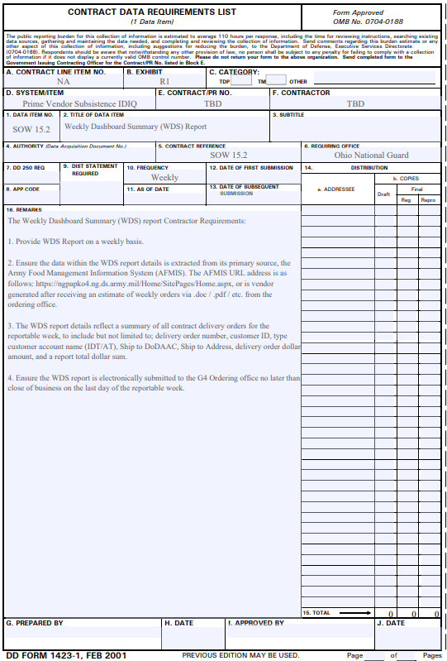

TECHNICAL EXHIBIT 4
Weekly Invoice Summary (WIS) Report

IAW SOW at 15.2: 15.3 Weekly Invoice Summary (WIS) Report; frequency weekly. The WIS report and the accompanying invoices make up the WIS packet. The report will include a roll up of all items ordered by invoice, as well as the total dollar sum for those listed delivery orders. The WIS report is electronically submitted to the Food Service Management Team no later than close of business on the last day of the reportable week.
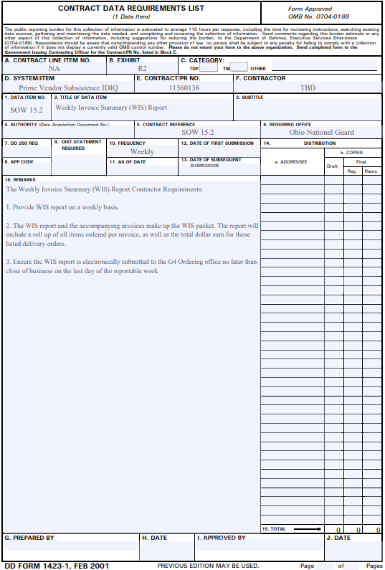

TECHNICAL EXHIBIT 5
Monthly Invoice Summary (MIS) Report

IAW SOW at 15.2: 15.4 Monthly Invoice Summary (MIS) Report; frequency monthly. The MIS reports will reflect a summary of delivery orders for the reportable month. The MIS Report details should include, but not limited to, Customer Number, Customer Name, Contract generated Document Number, Document Date, Sales Amount, and unique Government generated customer delivery order "W91364-F" numbers. The MIS report is electronically submitted to the Food Service Management Team no later than the 15th following the reportable month.
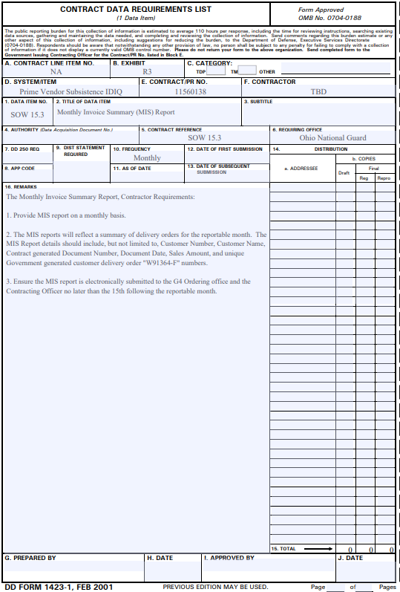

TECHNICAL EXHIBIT 6
Meal Usage Summary (MUS) Report

IAW SOW at 15.2: 15.5 Meal Usage Summary (MUS) Report; frequency monthly. The MUS report details by individual Unit/customer, consolidated total number of same individual listed delivery ordered meals during the specified date range and the proper menu description names for the individual meals, as stated on the OHARNG approved meal menu document for the reportable period requested. The MUS report is electronically submitted to the Food Service Management Team no later than the 15th following the reportable month.
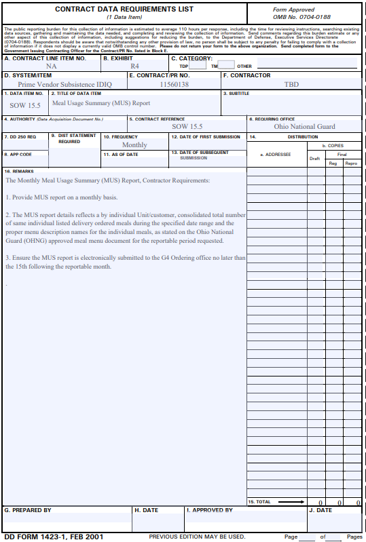
TECHNICAL EXHIBIT 7
Menu Item Usage (MIU) Report
IAW SOW at 15.2: 15.6 Menu Item Usage (MIU) Report; frequency monthly. The MIU report will reflect a total year-to-date usage of OHARNG food menu delivery orders, sorted by least number of food menus order to most popular food menus ordered. The MIU report is electronically submitted to the Food Service Management Team no later than the 15th following the reportable month.
