NSSC Unescorted Visitor Request
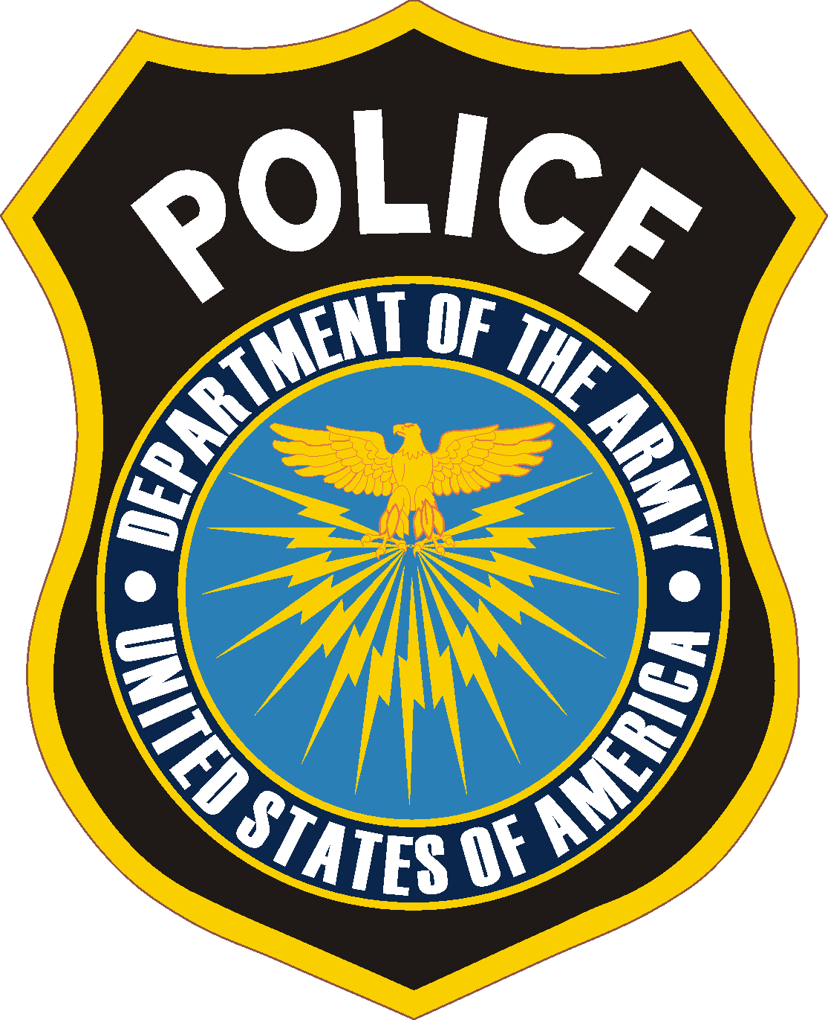

Date of Request: TBD Installation Point of Contact: Adin Morales/Michelle Poirier
Date and Time of Visit: 6 May 2026 13:00 Installation POC Phone#: (520)713-8019/(520) 714-3198

IS THIS VISITOR A CONTRACTOR: (YES OR NO) Yes

Last Name | First Name | Date of  Birth | Driver’s License (DL) # | DL  State | Current Address | States Resided In  During Past 5 Years

- Per U.S. Army Directive-Type Memorandum (DTM) 09-012, all of the above information is required for unescorted access. The POC will only be notified if the visitor is not authorized entry onto the installation.

- All U.S. visitors 18 years of age and older must be vetted prior to entry to NSSC. Foreign visitors (both official and unofficial) must be vetted through the appropriate Foreign Disclosure Officer based on the organization he/she is coming to see. Please contact the appropriate office for instructions.

- To protect PII, there are two methods of submitting this form. This form can be emailed encrypted to “USARMY USAG Natick IMCOM List NATI-PoliceVistorAccess-SSC” at email address usarmy.natick.imcom.list.nati-policevistoraccess-ssc@army.mil Alternatively, this form can be faxed to (508) 206-4009.

- Requests must be received by USAG Natick Police at least 24 hours prior to the visitor’s arrival. Upon successful vetting, the visitor will be added to the Daily Access Roster for the date of the visit. The Daily Access Roster is maintained at the Main Gate.

- If a visitor has been vetted within the last 90 days, their information will be on the appropriate Visitor Access Roster. For those personnel not on the Visitor Access Roster or who have recently expired, then send an email request to the above address at least 24 hours prior to the visitor’s arrival. Include the visitor’s full name, date of visit, time of visit and POC.

- If a visitor has derogatory information found when vetted, a call will go to the POC only and not allowed on Installation.

- Contact the USAG Natick Police Desk at 508-206-4007, to verify whether or not a visitor has been vetted within the last 90 days.

- Please direct any questions regarding this process to the USAG Natick Police Desk at 508-206-4007.

- Note: If individual has been denied access a Waiver Request and instructions can be obtained from USAG Natick Police Desk.

