Industry Questions and Government Answers

Question 1: The first page of the SF33 states the following: "6 The Government has not designated key personnel for the labor category positions associated with this Solicitation / Task Order.” However, in section 3.1.3 Element C – Personnel Approach (It requests one resume for each position) and the requirements for each Key Personnel. Can the gov't clarify if Key personnel are required or not?

Answer 1: Refer to Personal Qualifications, Attachment 02, the Government did not identify key personnel. Additionally, see Solicitation, Section A, item #6 (page 2 of 52).

Question 2: Can you clarify on the 2.5 if the File Naming Convetion is to be used or the 3.0 Proposal Organization and Content naming convention? See illustration below:
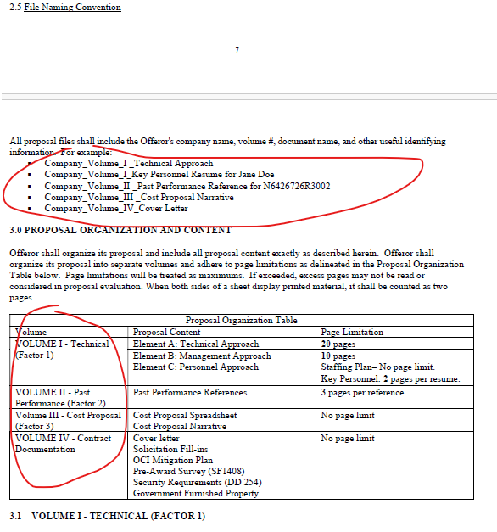

Answer 2: See Section L, Attachment 23, paragraph 2.5 File Naming Convention. Paragraph 3.0 does not conflict with paragraph 2.5, it provides additional proposal organization context, as applicable.

----------------------------------------------As of 19 March 2026--------------------------------------------------------------------

