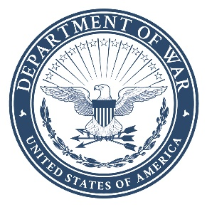
DEPARTMENT OF THE AIR FORCE
502D AIR BASE WING
JOINT BASE SAN ANTONIO

19 Mar 26

TO: 502D Contracting Squadron
1655 Selfridge Ave.
JBSA – Lackland AFB, TX 78236

FROM: Company Name_________________________________
Address_______________________________________
Address _______________________________________
Phone No. _____________________________________
Email Address__________________________________
Cage Code ____________________________________

SUBJECT: Exhaust Hood & Duct Cleaning
NAICS: 561790
PSC: J041

- The Government is only conducting market research and attaining information to identify contractors that are able to provide all items listed below and the cost associated to acquire these specific items/services. All information provided is STRICTLY VOLUNTARY.
- Is your company a small business? ______________(Yes/ No)
- If Small Business, please identify company’s socio-economic concern(s):______________________ (HUBZone, service-disable veteran-owned small bus., women-owned small bus., etc…)
- Have you previously supplied the item to military customers? ________(Yes/No)
- Is the NAICS listed above, the most appropriate NAICS?_____ (Yes/No). If not, please suggest a better NAICS that fits this type of work __________.
- If you do not manufacture/produce the items, do you obtain them from a small business in the USA? ______________(Yes/ No)
- This request for information (RFI) is strictly voluntary and is not to be interpreted as a quote in anticipation of a future contract award.
- Please respond via e-mail by 26 March 2026, 12:00pm CST. Email:francisco.ferrier.2@us.af.mil and laura.herring.2@us.af.mil. If you have any questions, please contact Francisco Ferrier or Laura Herring via e-mail.

