SUBJECT* | Tray Assembly System for Station 663

GENERAL INFORMATION
CONTRACTING OFFICE’S ZIP CODE* | 98661
SOLICITATION NUMBER* | 36C26026Q0600
RESPONSE DATE/TIME/ZONE | 05-05-2026 10:00 PACIFIC TIME, LOS ANGELES, USA
ARCHIVE | 14 DAYS AFTER THE RESPONSE DATE
RECOVERY ACT FUNDS | N
SET-ASIDE
PRODUCT SERVICE CODE* | 7310
NAICS CODE* | 333310
CONTRACTING OFFICE ADDRESS | Network Contracting Office 20  ATTN: V4CONT  1601 E. Fourth Plain Blvd  Bldg.17, Suite B428  Vancouver WA 98661
POINT OF CONTACT* | Contract Specialist  Nick Heintz  Nicholas.Heintz@va.gov

PLACE OF PERFORMANCE
ADDRESS | American Lake VA Medical Center
 | 9600 Veterans Dr SW
 | Tacoma, WA 98493
POSTAL CODE
COUNTRY

ADDITIONAL INFORMATION
AGENCY’S URL
URL DESCRIPTION
AGENCY CONTACT’S EMAIL ADDRESS
EMAIL DESCRIPTION

DESCRIPTION
This is a SOURCES SOUGHT ANNOUNCEMENT ONLY. It is neither a solicitation announcement nor a request for proposals or quotes and does not obligate the Government to award a contract. Responses to this Sources Sought Announcement must be in writing. The purpose of this Sources Sought Announcement is for market research to make appropriate acquisition decisions and to gain knowledge of potential businesses interested and capable of providing the services described below.

Background:

The American Lake VA Medical Center Nutrition & Food Services, located in Tacoma, WA is seeking a contractor for the procurement, delivery, installation and initial staff training of a meal tray assembly system. This must be a modular system designed for health care food service that allows for seamless flow of a meal tray from hot food service through cold food assembly. Requiring minimal bending, twisting or lifting of employees working. The system must work with no more than 3 employees. The entire system must fit in a workspace approximately 200” long x 150” wide. Please see Salient Characteristics below:
Salient Characteristics
  - Mobile Gravity Shelf Carts (7320-438479 FOOD TRAY PREPARE ASSY):
    - Adjustable (slanted & flat) shelving units each with four shelves that are ergonomically positioned to fit above the tray assembly tables for easy access of food items.
    - Swivel casters with 2 side brakes to move & secure units around the operation
    - Divider bars to allow for easy organization of shelving units
    - Anti-falling devices to prevent bins & objects from falling from shelves when in slanted position
    - Large kanban bins with removable dividers for storage of food & supplies
    - Small kanban bins with removable dividers for storage of food & supplies
  - Air Curtain Glass Door Pass-Thru Refrigerators (4110-439178 REFRIGERATOR FOOD (COMM)):
    - Pass-Thru Air Curtain Type
    - Refrigerated cabinet is at the exact height as the tray assembly slider tables for ease & ergonomics.
    - Built-in thermometers with temperature controls & a digital display
    - Glass door with aluminum frame on back side so tray line loader can see stock levels, swings fully open & can be secured on the side of the machine.
    - Stainless steel insulated door on front for temperature retention
    - Door opens 90 degrees with slide back option to keep open & unobstructed during tray line service.
    - 5 pairs of adjustable stainless steel pan slides with pans. Slides are angled to allow for gravity-feed of products to reduce reach during operation.
    - Capable of maintaining temperatures at or below 41F for up to 90 minutes with door open.
    - Removable panels for easy access for cleaning & maintenance.
    - Swivel casters with 2 side brakes to move & secure units around the operation.
    - Electrical: 120 V / 20 Amp / 1 Ph. NEMA 5-20R receptacle.
  - Mobile Tray & Rack Dispensers (7320-445867 DISPENSER SERVTRAY & TBLW):
    - Spring-loaded lowerator mechanism to store trays so that the top tray is the exact height of the tray assembly slide tables.
    - Capacity: At least 100 trays
    - Dispenses trays or chinaware in racks or baskets
    - Swivel casters with 2 side brakes to move & secure units around the operation
  - Mobile Slider Tables (7320-890167 SLIDE TRAY SERVICE):
    - Sliding rails that fit standard meal trays
    - Opening between rails to allow for storage of supplies & food items with spring-loaded risers
    - Two shelves below rails for storage of supplies
    - Connector Piece for the tables to ensure smooth sliding of trays across units
    - Swivel casters with 2 side brakes to move & secure units around the operation
  - Hot Food Server (7310-938450 STEAM TABLE):
    - 6 standard pan size wells for hot food
    - Open shelf under heating units to store supplies
    - Individual drain in each well & spigot
    - Individual thermostat for each steam well
    - Individual circuit braker per well
    - Push handle on one side of unit for mobility.
    - Swivel casters with 2 side brakes to move & secure unit around the operation
    - Must have 2 menu holders
    - Electrical: 208 V / 30 Amp / 1 Ph. NEMA L6-30 receptacle.

  - Interior & exterior surfaces of all equipment must be made from stainless steal to allow for easy cleaning.
  - All equipment must meet National Sanitation Foundation (NSF) requirements & only be constructed from Food & Drug Administration (FDA)-approved materials.

Photos and Diagrams for Reference
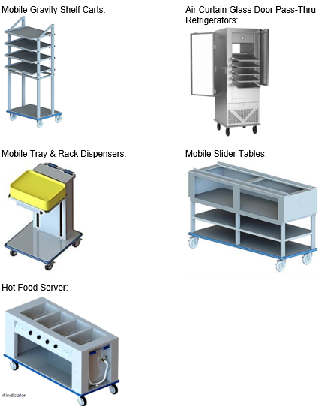

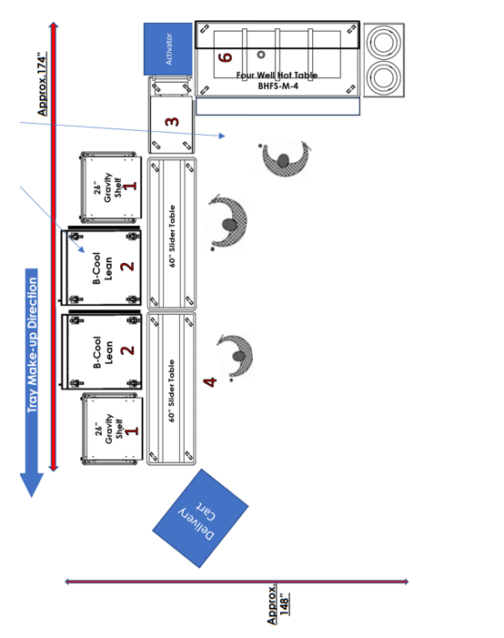
If you are interested and capable of providing the required or comparable product(s) please provide the following information:

Company:
Contact Name:
Phone No:
Email:
UEI:

Business size information
Select all that applies:
☐ Small Business
☐ Emerging Small Business
☐ Small Disadvantaged Business
☐ Certified under Section 8(a) of the Small Business Act
☐ HubZone
☐ Woman Owned
☐ Certified Service-Disabled Veteran Owned Small in Vetbiz.gov
☐ Certified Veteran Owned Small Business in Vetbiz.gov
☐ Large Business
☐ Other:____________

Is your company considered small under the NAICS code: 333310 | Yes ☐ No ☐
Is your company an FSS/ GSA Contract Holder with referenced items/solutions on your contract? | Yes ☐ No ☐
FSS/ GSA Contract Number that would be used for this contract.
Brand Name and Model Number you would provide to meet the requirement.
General pricing for your products/solutions for market research purposes.
Manufactured Country of Origin

The Government is not obligated to nor will it pay for or reimburse any costs associated with responding to this Sources Sought Announcement. This notice shall not be construed as a commitment by the Government to issue a solicitation or ultimately award a contract, nor does it restrict the Government to a particular acquisition approach. The Government will in no way be bound to this information if any solicitation is issued. The VA is mandated by Public Law 109-461 to consider a total set-aside for Service Disabled Veteran Owned Small Businesses. However, if there are insufficient Service Disabled Veteran Owned Small Business responses, an alternate set-aside or full and open competition may be determined. No sub-contracting opportunity is anticipated. The North American Classification System (NAICS) code for this acquisition is 333310

After review of the responses to this Sources Sought Announcement, a solicitation may be published on the sam.gov or GSA eBuy websites. Responses to this Sources Sought Announcement will not be considered adequate responses to the solicitation. All interested offerors must respond to the solicitation in addition to responding to this Sources Sought Announcement. Prospective bidders must be authorized re-sellers in order to participate in the solicitation process.

Notice to potential offerors: All offerors who provide goods or services to the United States Federal Government must be registered in the System for Award Management (SAM) at www.sam.gov. Additionally, all Service Disabled Veteran Owned Small Businesses or Veteran Owned Small Businesses must be listed as SDVOSB under NAICS code 333310 in the Small Business administration (SBA) (Dynamic Small Business Search)

Responses to this notice shall be submitted via email to Nicholas.Heintz@VA.gov Subject Line: Meal Tray Assembly System Telephone responses will not be accepted. Responses must be received no later than 05/05/2026 10:00 a.m. PST.

