

State Of The Art

3rd year Project 2012-2013

|  |
| --- |
| Project Name: |
| Development of a Card Game Management Application within a Real & Virtual Environment |

|  |
| --- |
| Authors: |
| * Andréi BROUSSILLON * Bastien CARRE * Boris LENG * Lyvia LOUISIUS |

|  |
| --- |
| Supervising Professors: |
| * Catherine MARECHAL * Elizabeth COLIN * Lamine BOUGUEROUA |

|  |
| --- |
| Versions: |
| Latest Version: 08/12/2012 |

Table of Content

INTRODUCTION 2

I- Technology forecasting 3

1- Definition of RFID Technology 3

2- History 3

3- Functioning principles 4

II- Competitive Intelligence 5

1- Existing Solutions 5

a- Poker high-tech 5

b- RFID Scores High at Mind Sports' Scrabble Tournament 5

c- Tablet computer and Android applications 6

2- Originality of Blue Weasel 6

III- Bibliography and References 7

# INTRODUCTION

This paper is The State Of The Art for the 3rd year project “Development of a Card Game Management Application within a Real & Virtual Environment”. This project is held by two pairs of students working on the two main parts of the project; an electronic part which includes the RFID detection of cards and a development part which includes the game interface and architecture. The main goal of this project is to mix a real and a virtual environment within a card game context.

The State Of The Art describes the research axis about the technologies involved in this project. Radio Frequency IDentification is commonly used today in many industries for wireless systems and data transfer. The following sections provide first an understanding of RFID and its related Applications, and subsequently a review of existing solutions with regard to our Blue Weasel project.

# Technology forecasting

This part of the paper defines RFID and its applications, the common use of this technology today, and its development for the nearest future.

## Definition of RFID Technology

RFID, Radio-frequency identification technology is a data transfer technology using electromagnetic waves in order to perform automatic identification or tracking.

Basically, the main components are:

* + RFID tags \ transponder  
    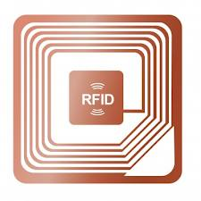

The reader sends out the RF signal carrying commands to the tag.

Consequently, the tag responds with its stored data to be authorized, detected, or counted.

Antenna

RF Circuitry

Figure 1 Example of an RFID card

* + RFID readers

Figure Some RFID readers

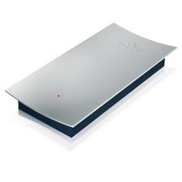 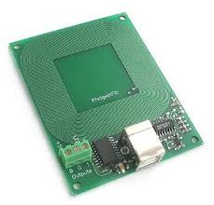 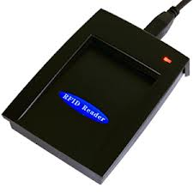

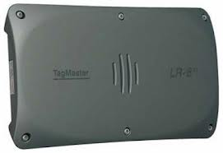 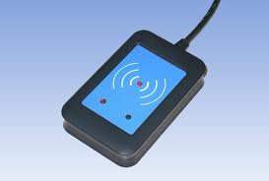

## History

## Functioning principles

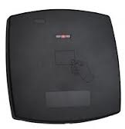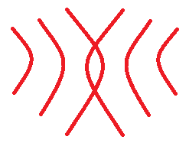

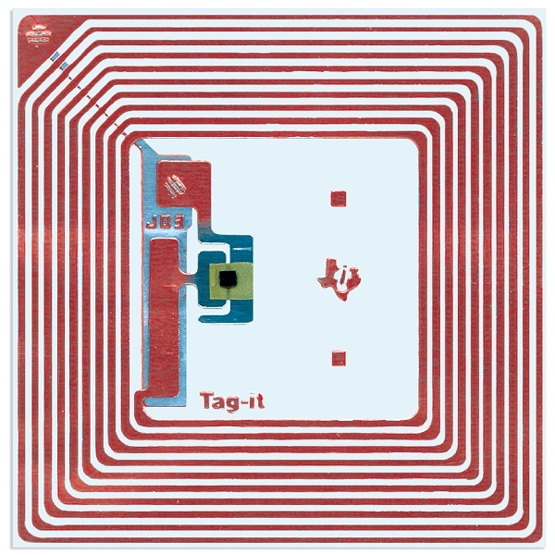

Workstation

ERP, Software…

RFID reader

Transponder

The Identification process is based on the fact that each transponder has an UID, generally in 32bits. Transponder stands for **trans**mitter/res**ponder**.The electromagnetic signals are exchanged between both the reader and the transponder.

# Competitive Intelligence

Doing the State-Of-The-Art of Blue Weasel is useful insofar as the gathered information about existing solutions using RFID and Game Applications

## Existing Solutions

### Poker high-tech

RFID is commonly used in poker tournament in order to broadcast on-the-fly the cards either Online or on TV. This is card tracking. However, most of solutions don’t include local geolocalisation of cards or rfid triangularisation, in order distinguish pile of cards according to where they are located on the game table. As a matter of fact, most of poker tables have several readers corresponding to a unique player position.

### RFID Scores High at Mind Sports' Scrabble Tournament

An article from rfidjournal.com shows the use of RFID technology for a Scrabble tournament:

Dec. 6, 2012—Mind Sports International's mission is to provide events that bring together the players of "the world's most popular mind sports." Last weekend, the company held its inaugural event, Prague Mind Sports Festival 2012, which included not only tournaments for bridge, backgammon, poker and Risk, but also RFID-powered Scrabble matches

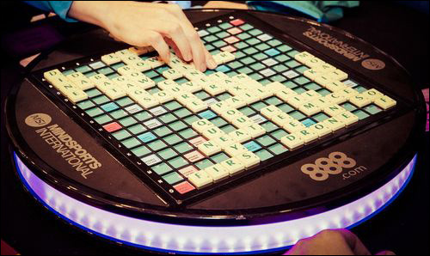

Every tile has a passive 13.56 MHz RFID tag

225 squares, under each of which there is a single antenna

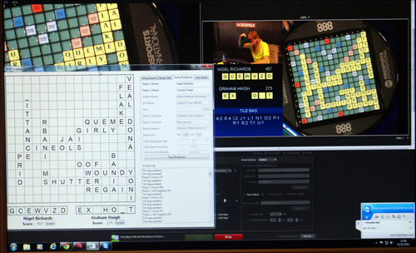

For antenna holders, each antenna could read the tag of a tile placed within approximately 4 millimeters of that antenna.

### Tablet computer and Android applications

There are already several apps available on the Google Play Store which enable users to play card games with artificial intelligences or online with other users. However none of them enables tablet users to play with real users who play with real cards. That is why Blue Weasel is original.

## Originality of Blue Weasel

Blue Weasel does use RFID technology as do other Card Games. The way RFID is used is similar to the Scrabble example presented in the previous section. However there are some differences and some limits which Blue Weasel manages to go through.

* BW doesn’t need many RFID readers
* BW enables real and virtual players (online players) to play together

## NFC, Another technology

NFC stands for Near Field Communication. It is a set of standards for devices aimed to use radio communication between each other within a close proximity. NFC is not properly a new technology but can be considered as an extension of RFID technology.

# References

* <http://www.rfidjournal.com>
* <http://www.rfidjournal.com/article/view/10192>
* <http://www.rfidfr.org/>
* <http://en.wikipedia.org/wiki/Near_field_communication>
* <http://www.differencebetween.net/technology/difference-between-rfid-and-nfc/>