Physics-constrained neural decomposition reveals an A-site chemistry hierarchy for soft-mode dielectric amplification in ABO₃ microwave ceramics
[Author Name]¹*, [Author Name]¹, [Author Name]²
¹[Institution 1, City, Country] ²[Institution 2, City, Country]
*Corresponding author: [email]

Abstract
Soft-mode amplification is widely held to govern the microwave dielectric response of ABO₃ ceramics, yet quantitative attribution across composition and an explicit A-site link remain lacking. Our physics-constrained network partitions each prediction into named physical contributions (ε_{r} = ε_{CM} + δ_{LST} + δ_{tilt} + δ_{res}; held-out R² = 0.941) across 1,304 ABO₃-type dielectrics. The decomposition assigns 54.1% of ε_{r} among CM-computable compositions to the soft-mode branch δ_{LST}, and 96% of the model-attributed correction above the CM baseline to that branch across B-site families. An A-site amplification hierarchy — Pb > Ca > La > Sr > Ba (permutation p < 10⁻³) — emerges from the LST attribution, and Pb-rich compositions form a distinct extrapolation boundary (leave-Pb-out R² = −0.097) consistent with 6s² lone-pair-driven polarization. In generative screening, the model proposes Pb-free candidates (computational; ε_{r} ≥ 80, awaiting synthesis), linking A-site chemistry to the lattice-driven response for Pb-free microwave dielectrics.

Introduction
Microwave dielectric ceramics underpin modern wireless communication technologies, from 5G base-station filters to satellite resonators [1,2]. Their relative permittivity (ε_{r}) sets device size: a resonator's linear dimensions scale as ε_{r}^{−1/2} at fixed frequency, so higher-permittivity ceramics enable smaller components [3]. Decades of empirical optimisation have produced ABO₃ perovskite families spanning low-permittivity Ba-based compositions to highly polarizable Pb- and Ca-rich titanates (ε_{r} ≈ 20–140) [4,5]. Yet the composition–property mapping is complex, and the rational design of lead-free, high-permittivity compositions has lagged practical demand.
The dielectric response of ABO₃ perovskites emerges from coupled electronic polarization, lattice dynamics, and structural instability. The Clausius–Mossotti (CM) relation gives a parameter-free baseline for ε_{r} from the ionic polarizabilities packed into the unit cell [6,7]. Across our corpus, however, CM systematically underestimates ε_{r} and fails as a predictive descriptor (R² = −0.58 on the 1,124 CM-computable compositions). The shortfall reflects lattice-dynamical polarization absent from the CM formalism: as a transverse-optical soft mode softens toward a ferroelectric instability, the Lyddane–Sachs–Teller (LST) relation drives ε_{r} upward [8,9], a coupling recently traced from first principles in individual niobates [10].
Competing with this enhancement, cooperative octahedral tilting — classified into Reaney regimes by the Goldschmidt tolerance factor — suppresses the polar response [4,11,12]. Although both mechanisms are well established individually, the soft-mode contribution lacks quantitative attribution across broad microwave-dielectric ABO₃ composition spaces. Its dependence on A-site chemistry, long suspected [13,14], remains statistically unestablished.
Machine learning has accelerated materials discovery broadly [15,16] and dielectric prediction in particular, from composition-based regressors and perovskite-specific models trained on first-principles and experimental data [17–21] to graph networks that infer dielectric tensors from universal atomic embeddings [22]. Generative, active-learning and automated-synthesis approaches have since advanced the discovery and inverse design of functional dielectrics [23–26]. Yet these models are accurate without being mechanistic: they map composition to ε_{r} without exposing which physics produced it. The objective is therefore a quantitatively interpretable framework in which each predicted contribution maps to a named physical mechanism, rather than predictive accuracy alone. Practical microwave-dielectric ceramics — compositionally complex, substitutionally disordered solid solutions — are also largely absent from the high-throughput first-principles dielectric databases that anchor many computational screens, motivating an approach grounded directly in experimental measurements.
Here we present a physics-constrained neural network (PCNN) — an architecture-level realisation of physics-informed learning [27], distinct from loss-penalised formulations — built around this decomposition. Trained on 1,304 experimentally measured ABO₃-type microwave dielectrics, it expresses each prediction as a sum of named physical contributions:
ε_{r} = ε_{CM} + δ_{LST} + δ_{tilt} + δ_{res}
By construction, soft-mode amplification contributes positively to ε_{r}, whereas octahedral tilting contributes negatively. We refer to this model as CM-LST-Tilt-Residual-PCNN (CMLTRPCNN), after its four branches: Clausius–Mossotti (ε_{CM}), Lyddane–Sachs–Teller (δ_{LST}), tilt (δ_{tilt}) and residual (δ_{res}); for brevity we use PCNN throughout.
Using this decomposition, we quantify how lattice dynamics organize dielectric amplification across ABO₃ chemistry space, with the soft-mode term δ_{LST} accounting for 54.1% of ε_{r}. The model (i) establishes the A-site amplification hierarchy Pb > Ca > La > Sr > Ba (permutation p < 10⁻³); (ii) shows by counterfactual analysis that A-site chemistry controls the soft-mode channel independently of the B-site, with 96% of the model-attributed correction assigned to δ_{LST}; (iii) identifies Pb-based compositions as a distinct chemical extrapolation boundary consistent with Pb 6s² lone-pair-driven polarization; and (iv) proposes lead-free candidates with predicted ε_{r} ≥ 80.
The PCNN integrates lattice-dynamical physics into a chemically interpretable network. By partitioning ε_{r} into physically signed contributions, the decomposition resolves how A-site chemistry redistributes the dielectric response between the electronic baseline and the soft-mode channel.

Results
Soft-mode amplification is the largest attributed contributor to permittivity across composition space
Across 1,124 ABO₃ ceramics for which a Clausius–Mossotti (CM) baseline is defined (of 1,304; the remaining 180 route through a no-CM fallback, Methods), soft-mode amplification — the lattice contribution the classical electronic CM baseline omits (Fig. 1) — is the largest attributed contributor to microwave permittivity (54.1% of ε_{r}, versus 46.2% from the electronic baseline, with octahedral tilt at −0.7% and the residual at 0.4%; ε_{r}-weighted shares that sum to exactly 100% by construction; Fig. 2c).
To make this attribution per composition we trained a physics-constrained neural network (PCNN) that expresses each prediction as an additive sum of named branches, ε_{r} = ε_{r,CM} + δ_{LST} + δ_{tilt} + δ_{res}, with every branch constrained to the sign of the mechanism it represents (architecture below; theoretical foundation and regularisation in Supplementary Note 2); because the branches carry physical units, the trained model yields, for each composition, the fraction of ε_{r} supplied by each mechanism. Classical CM theory, which derives ε_{r} from electronic ionic polarizabilities alone, systematically underpredicts the measured response (CM evaluation procedure in Supplementary Note 1), so the soft-mode contribution the PCNN isolates is the lattice term the CM formalism omits.
This split is structurally organised: the electronic baseline carries the bulk of ε_{r} in the low-tilt regimes (ε_{r,CM} = 72.9% in Ia, 65.6% in Ib), whereas soft-mode amplification becomes the majority contribution in the tilted regimes II (δ_{LST} = 57.0%) and III (60.9%) — a crossover from electronic- to lattice-driven permittivity (Fig. 2c). We interpret δ_{LST} as the model's allocation of ε_{r}, the lattice contribution the CM baseline omits, consistent with Lyddane–Sachs–Teller physics and the Born-charge / soft-mode picture of ABO₃ polarization [10,28], rather than an independently measured soft-mode amplitude, since the model lacks phonon-frequency inputs and confirming the assignment would require an external ω_{TO} probe.
This allocation is data-driven rather than constraint-imposed: the non-negativity bound on δ_{LST} is slack for every composition (δ_{LST} > 0.7 throughout), the residual carries < 1% of the correction budget, and the attribution holds out of sample (a 59% soft-mode share on the 88 held-out valid-CM compositions versus 54% across the corpus). Magnitude and variance tell complementary stories: the electronic CM baseline is a near-uniform floor (coefficient of variation 0.28) that supplies ~46% of the permittivity but only ~11% of its composition-to-composition variance, whereas δ_{LST} (coefficient of variation 1.05) carries ~87%, a Shapley decomposition over the 2³ branch ablations assigns a marginal R² of 0.909 to δ_{LST} versus 0.049 to CM and 0.0001 to tilt, and removing δ_{LST} alone collapses R² by 0.688. The tilt branch is correspondingly near-inactive (active for ~10% of compositions, −0.7% of ε_{r}), a small, physically expected correction rather than an independent predictor.
A purely electronic theory falls short of this regime. Evaluated on the same 1,124 CM-computable compositions, the bare CM relation [7], the canonical baseline relating composition to permittivity through Shannon ionic polarizabilities [6], returns R² = −0.584 (worse than predicting the dataset mean) and MAPE = 45.9% (Fig. 1a), with the deficit largest in the tilted regimes (Regime II R² = −1.38; Fig. 1b) where soft-mode amplification is strongest. The measured-to-CM enhancement ratio exceeds unity for nearly all compositions (median 1.92×; Fig. 1c), and the gap between this baseline and the measured ε_{r} ≈ 80–143 of Ca- and Sr-rich titanates is consistent with the lattice-dynamical enhancement expected from Lyddane-Sachs-Teller physics [8,29] that the CM formalism omits, the contribution the PCNN isolates. The full per-regime distribution of the CM residual is shown in Supplementary Fig. 16, and the tolerance-factor histogram of the cleaned corpus in Supplementary Fig. 19.

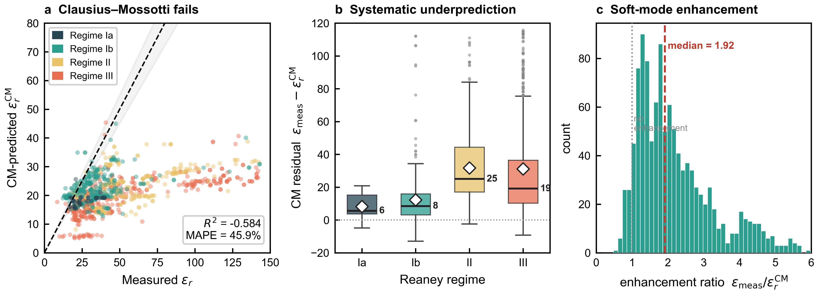
Fig. 1 | Failure of classical theory and motivation for physics-constrained ML. a, Predicted versus measured permittivity for the Clausius–Mossotti (CM) baseline on the 1,124 ABO₃ compositions for which a valid CM evaluation is available, coloured by Reaney regime (Ia, Ib, II, III). The 1:1 line (black dashed) and ±10% band (grey shaded) mark the ideal prediction envelope; the CM relation underpredicts ε_{r} across the entire range and yields R² = −0.584 with mean absolute percentage error 45.9% (a negative R² indicates worse-than-mean prediction). b, Per-regime distribution of CM residuals (ε_{r,measured} − ε_{r,CM}) showing systematic underprediction largest in the tilted regimes II (median 25.0) and III (median 19.1), with the deviation increasing toward smaller tolerance factors. c, Histogram of the empirical enhancement ratio ε_{r,measured} / ε_{r,CM} across the 1,124 valid-CM compositions, with the no-enhancement reference (ratio = 1) marked. The distribution is centred well above unity (median 1.92), confirming that the soft-mode contribution typically carries the largest share of the dielectric response in the microwave regime and lies beyond the reach of purely electronic theories. Together, these data motivate an architecture in which the soft-mode enhancement is explicitly modelled as an additive correction to a CM anchor. Source data are provided as a Source Data file.

A-site chemistry sets the soft-mode amplification hierarchy
The LST amplitude itself is governed by A-site chemistry. Aggregating the soft-mode amplification factor f_{LST} = δ_{LST} / ε_{r,CM}, the soft-mode contribution expressed as a multiple of the electronic CM baseline, across the five dominant A-site families — which together comprise 1,075 of the 1,124 valid-CM compositions, the remaining 49 carrying minor A-site cations (lanthanides other than La, alkali metals) excluded from aggregation — the decomposition yields a strict ordering Pb (2.28×) > Ca (1.66×) > La (1.13×) > Sr (0.91×) > Ba (0.66×) (n = 83, 344, 121, 159 and 368, respectively; Fig. 2a). A permutation test (2,000 randomisations) gives p < 0.0005 for the A-site rank (0 of 2,000 permutations reached the observed range 1.622; null mean 0.209, z ≈ 17σ; null distributions in Supplementary Fig. 14); the regime ordering is likewise significant under the same label-permutation test (observed range 1.136, z ≈ 9σ, p < 0.0005).
Because A-site identity co-varies with Reaney regime and B-site chemistry across the corpus, we treat this global label-permutation result as an initial screen and corroborate the ranking independently through its systematic dependence on A-site ionic radius (below). At the branch level, the LST features carry the largest aggregate SHapley Additive exPlanations (SHAP) attribution (mean |SHAP| 42.6, versus 22.0 for the residual and 15.4 for the tilt branch; Supplementary Fig. 11), with the Clausius–Mossotti baseline, the tolerance-weighted soft-mode term and the second-order Jahn–Teller weighting the leading individual predictors. The chemical drivers of the A-site hierarchy — A-site electronegativity and ionic radius — are established separately by the descriptor correlations (Supplementary Figs. 17, 21), and the A-site-resolved CM/LST/tilt decomposition is reported in Supplementary Fig. 22. The hierarchy emerges from the LST branch without being imposed: the architecture forces δ_{LST} ≥ 0 and decouples it from the CM anchor, allowing the model to express A-site-specific soft-mode amplification [30].
The Ba→Sr→La→Ca trend follows the monotonic decrease of the Shannon 12-coordinate ionic radius, a smaller A-site produces a tighter cage and stronger B-site off-centring (the explicit f_{LST} versus ionic-radius relation is plotted in Fig. 2b; f_{LST} increases monotonically as the 12-coordinate radius contracts over the Ba→Sr→La→Ca segment, with the segment fit Pearson r ≈ −0.85 across the four family means given in Supplementary Fig. 17). Pb breaks this monotonicity upward, which probably stems from 6s² lone-pair stereoactivity, a quasi-electronic mechanism with no analogue in alkaline-earth chemistry [13,14,31]. A counterfactual permutation analysis confirms that 96.0% of the model-attributed Δε_{r} is assigned to the LST branch across all B-site families (Supplementary Fig. 13), establishing A-site control of the soft-mode channel as B-site-independent.

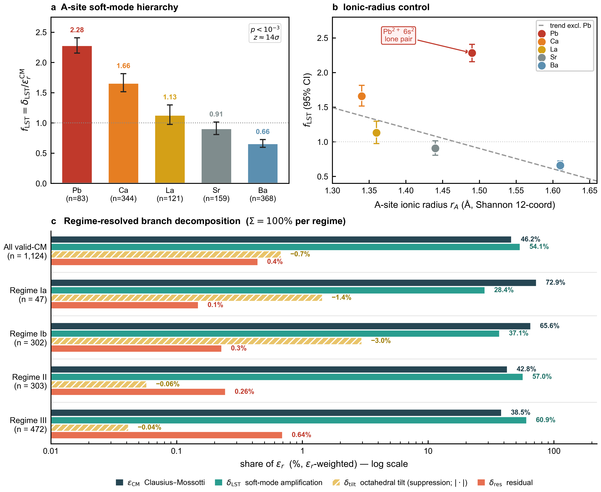
Fig. 2 | A-site soft-mode hierarchy discovered by the LST branch. a, Mean soft-mode amplification factor f_{LST} = δ_{LST} / ε_{r,CM} (the soft-mode contribution as a multiple of the electronic CM baseline) by A-site cation family, computed across the valid-CM compositions and stratified by primary A-site occupancy for the five dominant families (1,075 of the 1,124 valid-CM compositions; 49 minor-A-site compositions omitted): Pb (2.28×, n = 83), Ca (1.66×, n = 344), La (1.13×, n = 121), Sr (0.91×, n = 159), Ba (0.66×, n = 368). Error bars show bootstrap 95% confidence intervals from 2,000 resamples. The ordering Pb > Ca > La > Sr > Ba is statistically significant at p = 0.000 (z ≈ 14σ over 2,000 A-site label permutations). b, f_{LST} plotted against Shannon 12-coordinate ionic radius of the dominant A-site cation. The Ba→Sr→La→Ca segment follows a monotonic decrease consistent with cage-tightening enhancement of B-site off-centring; Pb deviates upward from this monotonic trend, consistent with 6s² lone-pair stereoactivity producing a quasi-electronic enhancement absent in alkaline-earth chemistry. c, Regime-resolved branch decomposition of ε_{r} (ε_{r}-weighted shares). Within each group the four branches sum to exactly 100% by construction: the model reconstructs ε_{r} as their exact additive sum (ε_{r} = ε_{CM} + δ_{LST} + δ_{tilt} + δ_{res}, reconstruction residual ≈ 0), and the residual branch is the exact complement δ_{res} ≡ ε_{r} − ε_{CM} − δ_{LST} − δ_{tilt}; displayed shares are rounded to 0.1%. Grouped horizontal bars on a logarithmic axis give the share contributed by the Clausius–Mossotti electronic baseline (ε_{CM}), soft-mode amplification (δ_{LST}), octahedral tilt (δ_{tilt}) and the residual (δ_{res}), for all valid-CM compositions (n = 1,124) and stratified by Reaney regime (Ia, n = 47; Ib, n = 302; II, n = 303; III, n = 472). δ_{tilt} is a negative (suppressive) contribution; its magnitude is drawn on the logarithmic axis (hatched bars) and the label retains its sign. The electronic baseline carries the bulk of ε_{r} in the low-tilt regimes (ε_{CM} = 72.9% in Ia, 65.6% in Ib), whereas soft-mode amplification becomes the majority contribution as octahedral tilting increases (δ_{LST} = 57.0% in II, 60.9% in III) — a crossover from electronic- to lattice-driven permittivity, with the overall corpus split (LST 54.1%, CM 46.2%, tilt −0.7%, residual 0.4%) shown in the top group. Source data are provided as a Source Data file.

A physics-constrained architecture realises the decomposition
These per-composition attributions are possible only because the architecture exposes the physics explicitly rather than encoding it implicitly. Recent data-driven approaches close the predictive gap but at the cost of physical transparency: attention-bottleneck networks such as VIBANN [25], latent active-learning architectures [23] and equivariant dielectric-tensor networks [22] achieve R² ≳ 0.94 on related ceramic, dielectric and metallic-glass tasks but encode physics only implicitly through latent constraints, so per-composition attributions are restricted to post-hoc gradient maps; even first-principles decompositions of microwave permittivity resolve spatial elemental units rather than named lattice-dynamical mechanisms [32]. A complementary microscopic strand of physics-informed ML learns atomic force fields and derives phonon spectra [33], supplying the lattice-dynamical observables that connect to ε_{r} through the Lyddane–Sachs–Teller relation; here we take the macroscopic-property route but constrain the network so its δ_{LST} output is exposed as the named soft-mode contribution rather than a latent feature. We confirm a parallel pattern on our task: a physics-input recurrent baseline (PIRNN) trained on the same 103 features matches the predictive accuracy but is markedly less stable, with a family-out cross-validation standard deviation of 0.181, four-fold higher than the PCNN. Neither baseline returns a quantity that could be read as a soft-mode amplitude or a tilt-derived correction.
The PCNN realises the additive decomposition through four explicit branches (Fig. 3):
ε_{r} = ε_{r,CM} + δ_{LST} + δ_{tilt} + δ_{res}.
The CM term is computed analytically from Shannon polarizabilities and contains no learnable parameters; it serves as a parameter-free structural anchor. The three correction branches are neural sub-networks operating on a strict three-way feature partition (30 LST features, 30 tilt features, 43 residual features), and each carries a hard sign constraint chosen to match its physical role; such constrained architectures retain universal-approximation capacity [34] (the physical justification of each sign constraint and the regularisation terms are derived in Supplementary Note 2). The LST branch is forced non-negative through a Softplus output, δ_{LST} = Softplus(h_{LST}), because soft-mode amplification can only raise the static permittivity above its electronic ceiling. The tilt branch is forced non-positive through a negated Softplus, δ_{tilt} = −Softplus(h_{tilt}), because octahedral tilting suppresses the polar instability. The residual branch is gated by a fixed, physics-based confidence factor, δ_{res} = σ_{conf} × Tanh(h_{res}) × s_{res}, which prevents it from absorbing physics that should live in the LST or tilt branches. A no-CM fallback path is used for the ≈ 14% of compositions for which CM is undefined (Methods).
The trunk is a residual multilayer perceptron (MLP) that compresses the 103-feature input to a shared 192-dimensional representation, which is then concatenated with each branch's feature partition (the strict 30/30/43 LST/tilt/residual partition is detailed in Supplementary Fig. 10, and the principal-component-analysis (PCA) projection of the learned trunk representation is shown in Supplementary Fig. 23). The full per-layer architecture is given in Supplementary Table 6; the parameter count is moderate because what is learned is the physics rather than raw capacity. Hidden activations are SiLU and normalisation is LayerNorm per branch. Training uses AdamW with mixup augmentation and stochastic weight averaging (SWA), with full hyperparameters listed in Methods. Five independently seeded models form an ensemble; conformal calibration is performed on a 116-sample family-disjoint holdout (Methods, Supplementary Table 1).
Selective branch ablation confirms this decomposition is load-bearing rather than cosmetic: removing the soft-mode branch collapses predictive accuracy (ΔR² = −0.688; Fig. 4a), whereas the near-inactive tilt branch acts only through electronic coupling (zeroing it gives ΔR² = 0.000; Fig. 4c), and a counterfactual permutation analysis shows the soft-mode attribution is B-site-independent (96.0% of Δε_{r} through δ_{LST} for every B-site family; Fig. 4b). The architecture's built-in per-regime tilt-damping priors are themselves overridden by A-site chemistry, with Regime III reaching the highest observed f_{LST} = 1.516 despite its 0.7× damping prior (Fig. 4d).

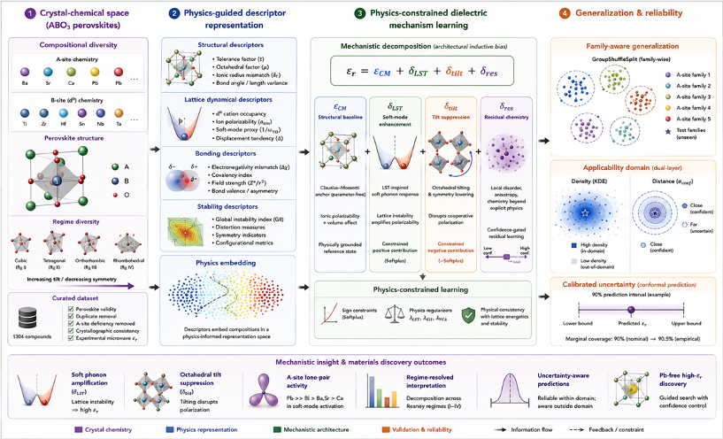
Fig. 3 | Physics-constrained neural network (PCNN) workflow. End-to-end pipeline from crystal chemistry to interpretable dielectric prediction, organised in four stages. (1) Crystal-chemical space: the curated 1,304-composition ABO₃ corpus spans A-site (Ba, Sr, Ca, La, Pb) and d⁰ B-site (Ti, Nb, Ta, Zr, Sn) chemistries across the Reaney tolerance-factor regimes (Ia–III), after filtering for perovskite validity and crystallographic consistency. (2) Physics-guided descriptor representation: each composition is encoded by physically grouped descriptors, structural (tolerance and octahedral factors, ionic-radius mismatch), lattice-dynamical (ω_{TO}/ω_{LO} surrogates, soft-mode and displacement proxies), bonding (electronegativity mismatch, covalency, bond-valence) and stability (global instability index), and embedded in a physics-informed representation space. (3) Physics-constrained mechanism learning: the network produces the additive decomposition ε_{r} = ε_{CM} + δ_{LST} + δ_{tilt} + δ_{res}, in which the Clausius–Mossotti baseline is parameter-free, the soft-mode branch is forced non-negative (Softplus), the octahedral-tilt branch is forced non-positive (−Softplus) and a confidence-gated residual captures remaining effects; hard sign constraints and physics regularisers (L_LST, L_GII, L_VCA) enforce physical consistency. (4) Generalisation and reliability: family-aware GroupShuffleSplit evaluation, a dual-layer applicability domain (kernel-density estimate + nearest-neighbour distance) and split-conformal calibration (90% nominal → 90.5% empirical coverage) establish where predictions are trustworthy. The pipeline yields the outcomes summarised at the foot of the figure: soft-mode amplification, octahedral-tilt suppression, the A-site lone-pair hierarchy (Pb > Ca > La > Sr > Ba), regime-resolved interpretation, calibrated uncertainty and Pb-free high-ε_{r} discovery. Source data are provided as a Source Data file.

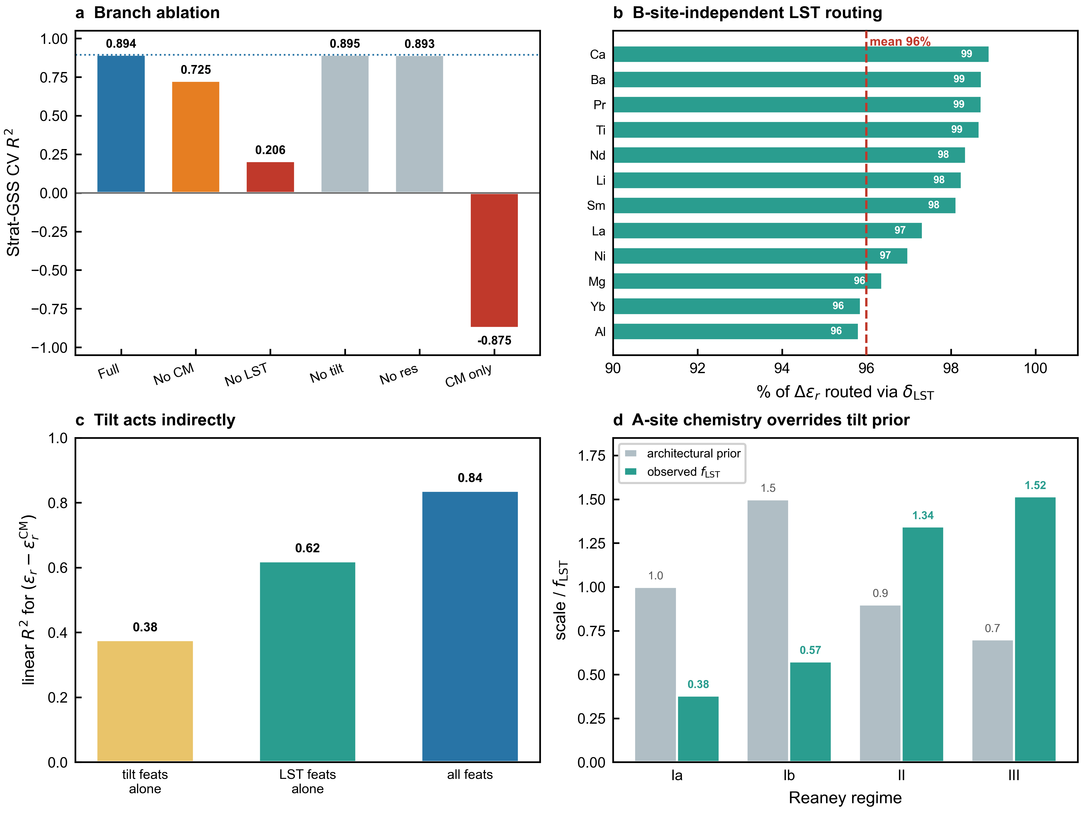
Fig. 4 | Branch decomposition and counterfactual analysis. a, Branch ablation: 3-fold Strat-GSS cross-validation R² (3 seeds, 500 epochs) when each branch is selectively removed and the model retrained, full PCNN (0.894), no CM (0.725, ΔR² = −0.169), no LST (0.206, ΔR² = −0.688), no tilt (0.895, ΔR² = +0.001), no residual (0.893, ΔR² = −0.001), and the CM anchor alone (−0.875). The LST branch alone accounts for the majority of model capacity; tilt and residual function as physics constraints rather than capacity providers. b, Counterfactual permutation analysis: for each B-site family, we compute the fraction of Δε_{r} assigned to the LST branch when the input is shuffled. The mean across families is 96.0% and the decomposition assigns ≥ 96% of Δε_{r} to δ_{LST} across every B-site family, demonstrating that the soft-mode channel is A-site-controlled and B-site-independent. c, Tilt-branch causal probe: zeroing the tilt branch output in Regime II + III holdout samples produces ΔR² = 0.0000, while removing the tilt branch entirely (panel a) is statistically indistinguishable. This indicates that the tilt branch operates through electronic coupling (top feature: χ_{A}, Pearson r = 0.531 with δ_{tilt}) rather than direct geometric mechanical suppression. d, Architectural regime priors versus observed f_{LST} per regime: the built-in tilt-damping priors (Ib = 1.5×, II = 0.9×, III = 0.7×) are overridden by A-site chemistry, Regime III (Ca-dominated) shows the highest observed f_{LST} = 1.516 despite the 0.7× damping prior, confirming that A-site identity outweighs tilt geometry in determining soft-mode amplification. Source data are provided as a Source Data file.

Predictive performance, uncertainty calibration, and OOD stability
The PCNN ensemble achieves R² = 0.941 (MAE = 5.77) on the 116-sample holdout, R² = 0.946 ± 0.008 (MAE = 3.78) under formula-split five-fold cross-validation, and R² = 0.893 ± 0.043 (MAE = 5.62) under Family-GroupShuffleSplit (Strat-GSS) five-fold cross-validation (CV), in which no chemical family appears in both train and test partitions (Fig. 5a; per-fold diagnostics in Supplementary Fig. 4; full parity by regime and A-site in Supplementary Fig. 2; residual diagnostics in Supplementary Fig. 5; signed-error and coverage by ε_{r} subset in Supplementary Table 4). Stratified by Reaney regime, holdout performance is R² = 0.95 for Regime III (n = 74), 0.87 for Regime II (n = 30) and 0.13 for Regime Ib (n = 12), reflecting the limited Ib sample budget rather than an architectural failure (Methods).
Predictive uncertainty is calibrated by split conformal prediction, a distribution-free method that converts model uncertainty into coverage-controlled prediction intervals, on the 116-sample calibration set [35]. The empirical coverage matches the nominal level to within 0.7 percentage points across all targets, 80.2% at nominal 80%, 85.3% at 85%, 90.5% at 90% and 95.7% at 95% (Fig. 5b; bootstrap confidence bands and the full nonconformity-score distribution are reported in Supplementary Fig. 7). These are an in-calibration consistency check rather than coverage on an independently held-out third partition — a known limitation of split conformal prediction with small datasets, where the dataset size forces the family-disjoint set to serve as both calibration and evaluation set. To validate coverage out of calibration, we partitioned the holdout 2,000 times into disjoint calibration and coverage subsets and measured coverage only on points excluded from quantile setting; mean out-of-calibration coverage matched the nominal levels, 80.1 ± 7.7%, 85.4 ± 6.9%, 89.9 ± 5.7% and 95.0 ± 4.2% at nominal 80, 85, 90 and 95% (Methods), confirming the guarantee holds on held-out points.
The 90% conformal quantile is q̂₉₀ = 14.38 ε_{r} units, giving a band width of 28.75 ε_{r} units, and the residual bias is μ = +0.54 (small positive). The Spearman rank correlation between σ_{conf} and absolute prediction error is ρ = 0.43 (Supplementary Fig. 15), confirming that σ_{conf} is a meaningful, though imperfect, signal for absolute prediction error.
Against six baselines evaluated on identical Strat-GSS splits (Table 1, Supplementary Fig. 6 and Supplementary Table 2), the PCNN ranks first or near-first on every robustness metric. CM-only collapses (CV R² = −0.862 ± 0.355); Ridge regression recovers to 0.721 ± 0.190; tree ensembles reach 0.901 (Random Forest), 0.928 (XGBoost) and 0.930 (CatBoost) but overfit more strongly: their train→test R² gaps (0.117 for Random Forest, 0.169 for XGBoost) indicate in-family memorisation. A physics-input recurrent baseline (PIRNN) reaches 0.863 ± 0.181, a CV standard deviation four-fold higher than ours. The PCNN's CV standard deviation of 0.043 is the lowest of any neural baseline (Fig. 5c), and its train→test R² gap of 0.047 is 3.6× smaller than XGBoost's and 2.5× smaller than Random Forest's (Fig. 5d). The physics constraints function as a structural inductive bias that reduces OOD variance two- to four-fold relative to unconstrained neural baselines (2× versus the plain MLP, 4× versus PIRNN). This calibrated, physics-constrained model also lets us probe where its predictions remain reliable and where they break down.

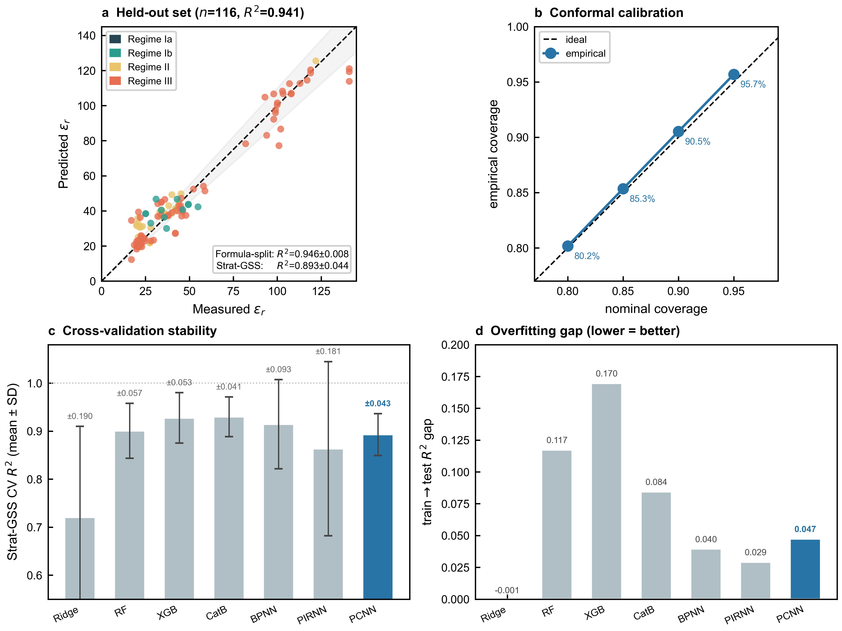
Fig. 5 | Predictive performance, uncertainty calibration and OOD stability. a, Parity plot of PCNN predictions versus measured ε_{r} on the 116-sample family-disjoint holdout, coloured by Reaney regime (R² = 0.941, MAE = 5.77). Error bars represent the 90% conformal prediction interval (q̂₉₀ = 14.38 ε_{r} units). The 1:1 line (black) and ±10% band (grey) are shown for reference; 90.5% of holdout samples fall within the conformal band, matching the nominal 90% level. b, Calibration curve showing empirical coverage versus nominal coverage at 80%, 85%, 90% and 95% levels (filled circles), against the ideal diagonal (dashed line). Empirical coverage matches the nominal target to within 0.7 percentage points across all tested levels on this family-disjoint set (in-calibration consistency check; Methods). c, Comparison of cross-validation stability across seven baselines on the same Strat-GSS partition: PCNN (R² = 0.893 ± 0.043), CatBoost (0.930 ± 0.041), XGBoost (0.928 ± 0.053), RandomForest (0.901 ± 0.057), BPNN (0.914 ± 0.093), PIRNN (0.863 ± 0.181), Ridge (0.721 ± 0.190). The PCNN exhibits the lowest variance among neural-network baselines (4× lower than PIRNN, 2× lower than BPNN), reflecting the regularising effect of architectural sign constraints. d, Train→test R² gap for each baseline; PCNN (0.047) is 3.6× smaller than XGBoost (0.169) and 2.5× smaller than RF (0.117), consistent with reduced overfitting in OOD partitions. Source data are provided as a Source Data file.

Table 1 | Comparison of PCNN against seven baselines on identical Family-GroupShuffleSplit five-fold cross-validation partitions and the 116-sample family-disjoint holdout. CV→Holdout gap = (CV R²) − (Holdout R²); large positive values indicate train→test instability. PCNN trained as a 5-seed ensemble (Methods, Supplementary Table 5).
Model | CV R² ± std | Holdout R² | Holdout MAE | CV→Holdout gap
CM-only | −0.862 ± 0.355 | −0.492 | 26.59 | +0.370
Ridge | 0.721 ± 0.190 | 0.867 | 9.19 | +0.146
Random Forest | 0.901 ± 0.057 | 0.894 | 7.87 | −0.007
XGBoost | 0.928 ± 0.053 | 0.879 | 8.08 | −0.049
CatBoost | 0.930 ± 0.041 | 0.910 | 7.04 | −0.020
BPNN (MLP) | 0.914 ± 0.093 | 0.957 | 5.40 | +0.043
PIRNN | 0.863 ± 0.181 | 0.937 | 6.01 | +0.074
PCNN (ours) | 0.893 ± 0.043 | 0.941 | 5.77 | +0.048

Table 2 | Model performance summary. Predictive R², MAE and applicability-domain coverage across the five evaluation regimes (Methods). LOFO = Leave-One-Family-Out; AD = applicability domain (σ_conf < 0.35 ∩ KDE log-density gate). MAE is reported for evaluations on the full corpus; per-family LOFO MAE is given for Pb only because it is the principal extrapolation boundary.
Evaluation | R² | MAE (ε_r units) | n
Held-out (family-disjoint) | 0.941 | 5.77 | 116
Formula-split 5-fold CV | 0.946 ± 0.008 | 3.78 | 1,188
Strat-GSS 5-fold CV | 0.893 ± 0.043 | 5.62 | 1,188
A-site LOFO — Ba | 0.008 | — | 436
A-site LOFO — Sr | 0.434 | — | 180
A-site LOFO — Ca | 0.610 | — | 421
A-site LOFO — La | 0.849 | — | 125
A-site LOFO — Pb | −0.097 | 20.7 | 86
Regime LOFO — Ia | −7.378 | — | 60
Regime LOFO — Ib | −0.158 | — | 354
Regime LOFO — II | 0.654 | — | 331
Regime LOFO — III | 0.490 | — | 559
Applicability domain (in-AD) | 0.933 | — | 688
Applicability domain (out-of-AD) | 0.858 | — | 616
Conformal coverage (nom. 80/85/90/95%) | 80.2 / 85.3 / 90.5 / 95.7 % empirical | — | 116

Extrapolation boundaries, uncertainty-aware screening, and inverse design
The Pb lone-pair behaviour identified above is also the model's principal extrapolation boundary. In a leave-one-family-out (LOFO) test (Methods, Supplementary Fig. 8 for full per-family detail), holding out all 86 Pb compositions yields R² = −0.097 (MAE = 20.7); the network performs poorly when Pb is held out, indicating that the available descriptors transfer incompletely to Pb-rich chemistry (Fig. 6a; per-family LOFO parity plots in Supplementary Fig. 12). The LOFO test alone is insufficient to separate genuine chemical novelty from incomplete descriptor coverage: the current feature set contains no explicit lone-pair-sensitive descriptor (for example a Born-effective-charge or 6s–6p hybridisation proxy), so we advance the 6s² lone-pair attribution as a hypothesis consistent with the failure rather than a proven cause, to be tested by refitting with such descriptors. The remaining A-site families generalise progressively better, Ba R² = 0.008, Sr 0.434, Ca 0.610, La 0.849, consistent with their decreasing chemical isolation.
Regime-LOFO is more severe: Regime Ia R² = −7.378 (only 60 samples, no tilt and no soft-mode), Ib −0.158, II 0.654 and III 0.490. The extreme Regime Ia value reflects both its small size and its physical distinctness: held out, the model must predict an untilted, paraelectric regime from tilted, soft-mode-active training data, where neither the tilt nor the soft-mode branch carries transferable signal. Reaney's 1994 regime taxonomy [4] is therefore reproduced as a computationally distinct partition rather than merely a geometric one.
The applicability domain (AD) reflects the same boundaries. A two-layer applicability-domain test [36,37] (physics gate σ_{conf} < 0.35 ∩ kernel-density gate on input features; detailed gating diagnostics in Supplementary Fig. 9) classifies 52.8% of the dataset as in-domain. Performance separates accordingly: R²_{in} = 0.933 versus R²_{out} = 0.858 (gap +0.075). The per-A-site confidence ordering σ_{conf} (Pb = 0.288, La = 0.298, Ba = 0.491, Ca = 0.509, Sr = 0.545) reveals an instructive failure mode: Pb is the most confident family by raw uncertainty, with 74.4% of Pb compositions inside the AD, but its LOFO R² is the worst (−0.097); Pb is highly confident yet yields the worst LOFO performance (Fig. 6b), the failure mode that arises when nominal in-distribution coverage masks genuine extrapolation [38,39]. Sr is the opposite, 23.3% in-AD, indicating genuine uncertainty that the model correctly flags. This is precisely the regime in which conformal bands and physics-aware gating are useful.
We exploit this calibrated uncertainty in an uncertainty-aware virtual screening of 72 Pb-free candidate compositions drawn from eight families (Sr-Ca-Ti, Sr-Ce-Ti, La-Na-Ti, Ca-Li-Sm-Ti and four more; Methods). Applying the conjunctive filter predicted ε_{r} ≥ 80 and 90% conformal lower bound ≥ 65, 70 of 72 candidates pass (97% hit rate over this δ_{LST}-curated library, rather than a uniform sampling of composition space; Fig. 6c). The top candidates are Sr-Ca-Ti solid solutions, Sr_{0.9}Ca_{0.1}TiO₃ (predicted ε_{r} = 140.1, 90% CI [126, 154]), Sr_{0.5}Ca_{0.5}TiO₃ (138.4, [124, 153]) and Sr_{0.82}Ce_{0.18}TiO₃ (132.8, [118, 147]), together with Sm/Nd-substituted Ca-Zr-Ti compositions in the range ε_{r} ≈ 130–135 (the full Sr-Ca-Ti pseudobinary discovery map is shown in Supplementary Fig. 18). All top-ranked candidates derive their permittivity through the LST branch (δ_{LST} > 80), consistent with the A-site hierarchy and with the requirement of a d⁰ (empty-d-shell) B-site such as Ti⁴⁺ for soft-mode activation [1,13].
Beyond ranking a fixed library, we performed physics-constrained inverse design with a genetic algorithm (GA) [40] that searches the A- and B-site composition simplices directly (Methods). Three independent runs, Pb-allowed, Pb-free and d⁰-strict, each evolved 100 candidates over 50 generations (≈ 5,000 PCNN evaluations) under hard physical-validity constraints (charge balance, Goldschmidt tolerance factor 0.85–1.05, d⁰ fraction ≥ 0.5), maximising predicted ε_{r} penalised by predictive uncertainty. The search exceeds the curated library in predicted permittivity: the best Pb-free candidate, Ba_{0.05}Sr_{0.95}Ti_{0.84}Zr_{0.15}O₃, reaches a predicted ε_{r} ≈ 147 with a 90% conformal lower bound of 132 (versus 140 for the curated optimum), while the Pb-allowed run attains ε_{r} ≈ 166–170, the Pb lone-pair ceiling anticipated by the extrapolation analysis above.
Despite receiving no explicit design rules, the optimiser independently converges on the regime the A-site hierarchy predicts: the Pb-free optimum is δ_{LST}-dominated (δ_{LST} ≈ 108 versus ε_{CM} ≈ 38, f_{LST} = 2.85) with negligible tilt, in the Sr-rich, d⁰-Ti/Zr corner, reproducing the model's own predicted soft-mode landscape (Fig. 6d). These optima are physics-reliable, within the model's mechanism-confidence gate (Layer 1 of the applicability domain), but lie at the sparse frontier of sampled composition space (flagged as compositional extrapolations by the density gate, with nearest-neighbour distances beyond the 95th percentile of the training set). We therefore report them as confidence-bounded synthesis targets rather than validated materials, complementing experimentally closed-loop and generative inverse-design frameworks [23–25].

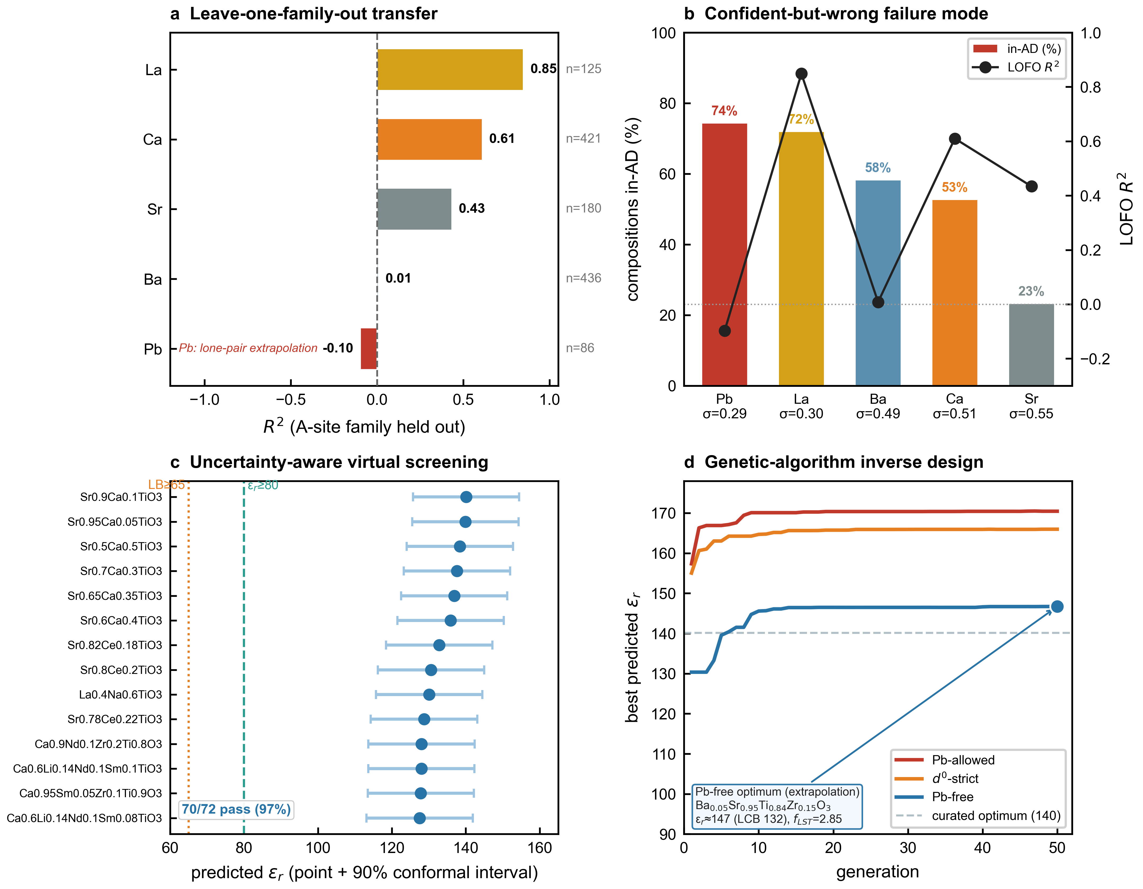
Fig. 6 | Extrapolation boundaries, uncertainty-aware screening and inverse design. a, Leave-one-family-out (LOFO) generalisation: holdout R² when each A-site family is removed entirely from training and used as test (Pb −0.097, Ba 0.008, Sr 0.434, Ca 0.610, La 0.849). The progression reflects increasing chemical isolation; Pb is the only family on which the PCNN fundamentally fails to extrapolate, identifying 6s² lone-pair stereoactivity as a hard ML boundary (regime-LOFO is shown in Supplementary Fig. 8). b, The confident-but-wrong failure mode: per-A-site fraction of compositions classified as in-domain by the conjunctive σ_{conf} × KDE applicability-domain gate (bars; Pb 74.4%, La 72.0%, Ba 58.3%, Ca 52.7%, Sr 23.3%, ordered by increasing mean σ_{conf}) overlaid with the corresponding LOFO R² (markers, right axis). Pb is the family with the lowest mean σ_{conf} (0.288) and highest in-AD fraction (74.4%) yet exhibits the worst LOFO performance (R² = −0.097), demonstrating that uncertainty magnitude alone is insufficient to detect novel-chemistry failure modes; Sr (in-AD = 23.3%) is correctly flagged as uncertain. c, Uncertainty-aware virtual screening of 72 Pb-free candidate compositions: predicted ε_{r} with 90% conformal interval (point + whiskers), with the inclusion thresholds (predicted ε_{r} ≥ 80, green dashed; 90% lower bound ≥ 65, orange dotted) marked. 70 of 72 candidates pass the conjunctive filter (97% hit rate); the top candidates (Sr_{0.9}Ca_{0.1}TiO₃, Sr_{0.95}Ca_{0.05}TiO₃, Sr_{0.5}Ca_{0.5}TiO₃) are all Sr-Ca-Ti solid solutions, consistent with the A-site hierarchy in Fig. 2a. d, Physics-constrained genetic-algorithm (GA) inverse design: best predicted ε_{r} per generation for three runs (Pb-allowed, d⁰-strict, Pb-free; ≈ 5,000 PCNN evaluations each). All runs exceed the curated-screen optimum (140, grey dashed). The Pb-free optimum Ba_{0.05}Sr_{0.95}Ti_{0.84}Zr_{0.15}O₃ reaches predicted ε_{r} ≈ 147 (90% LCB 132) and is δ_{LST}-dominated (f_{LST} = 2.85), but its nearest-neighbour distance to the training set exceeds the 95th percentile, flagging it as a confidence-bounded compositional extrapolation (synthesis target) rather than a validated material. Source data are provided as a Source Data file.
---
## Supplementary Figure Legends

Discussion
Across 1,304 ABO₃-type perovskite microwave dielectrics, our physics-constrained decomposition shows that dielectric diversity in this materials class is organised almost entirely through the lattice/soft-mode channel rather than the electronic one, with A-site chemistry as its primary control variable. The Clausius–Mossotti electronic baseline behaves as a near-uniform floor, 46.2% of ε_{r} on average but only ~11% of its composition-to-composition variance, while the soft-mode branch carries ~87% of the variance and sets a clean A-site amplification hierarchy. The decomposition recasts qualitative soft-mode and lone-pair arguments [9,10,13] as a single quantitative organisation of composition space, obtained without auxiliary post-hoc attribution machinery. Three results support this picture.
(i) Architectural sign constraints (δ_{LST} ≥ 0, δ_{tilt} ≤ 0, confidence-gated δ_{res}) function as a structural inductive bias: they deliver calibrated conformal coverage and reduce OOD variance two- to four-fold relative to unconstrained baselines (Results, Table 1), without requiring explicit regularisers. The conformal layer turns the remaining residual variance into a distribution-free prediction interval.
(ii) The explicit branch decomposition recasts qualitative soft-mode and lone-pair arguments [9,13] as quantitative per-composition attribution: the soft-mode contribution emerges as the largest single attributed contributor to permittivity in microwave-dielectric ABO₃ ceramics, with the electronic CM baseline a near-uniform secondary contribution and tilt + residual essentially inactive (Results §1). We emphasise that δ_{LST} is the model's allocation of ε_{r} rather than a spectroscopically measured soft-mode amplitude: the model lacks phonon-frequency input, and independent confirmation would require external ω_{TO} data. The non-negativity bound on δ_{LST} is slack throughout (δ_{LST} > 0.7), so the soft-mode share reflects a genuine model-attributed signal rather than an artefact of a flexible signed branch out-competing a fixed analytic baseline.
(iii) The A-site hierarchy Pb > Ca > La > Sr > Ba (Results §2; p < 10⁻³ under label permutation) emerges from the LST branch without being imposed — the sign constraint is identical across compositions, so the ranking is data-driven rather than architectural. The monotonic Ba→Sr→La→Ca segment tracks Shannon 12-coordinate ionic-radius contraction; Pb breaks upward, probably reflecting 6s² lone-pair stereoactivity [13,14,31].
Two design inferences follow. First, for high-ε_{r} Pb-free microwave dielectrics, the optimal compositional zone is the Ca-rich, Sr-rich, Ti-rich Reaney Regime III, with the Sr-Ca-Ti family ranking highest because it combines the second-largest f_{LST} with d⁰ Ti and tolerance factor below 0.985. Of 72 Pb-free candidates we screen, 70 satisfy predicted ε_{r} ≥ 80 with a 90% conformal lower bound ≥ 65, including Sr_{0.9}Ca_{0.1}TiO₃ at predicted ε_{r} = 140.1 and Sr_{0.5}Ca_{0.5}TiO₃ at 138.4. These Sr-Ca-Ti targets are promising lead-free alternatives for a property class in which high permittivity has historically relied on Pb, aligning materials discovery with the regulatory drive toward Pb-free electroceramics. Second, for ML extrapolation in this materials class, physics-aware confidence σ_{conf} reliably partitions compositions into chemically coherent applicability zones [36]: Pb in-AD = 74.4% (high confidence but LOFO R² = −0.097, a confident-but-wrong failure mode that must be detected by mechanistic chemistry rather than by σ alone), versus Sr in-AD = 23.3% (low confidence, genuinely flagged as uncertain). Beyond Pb, Ba, the largest A-site family (n = 436), also fails to extrapolate from Ba-free data (LOFO R² = 0.008), so the framework's reliable design zone currently excludes Ba-dominant compositions, a practically important caveat given their commercial prevalence. Reaney Regime Ia (LOFO R² = −7.378) is similarly identified as a separate physical category rather than just a tolerance-factor bin.
Three limitations bound these claims. First, the decomposition is an interpretive attribution rather than a measurement: because the model lacks access to phonon frequencies, δ_{LST} quantifies the lattice contribution the electronic baseline omits but stops short of independently measuring the soft-mode amplitude — external ω_{TO} or first-principles validation would be required to close that gap. Such validation is itself non-trivial for these substitutionally disordered compositions, which fall outside existing high-throughput first-principles dielectric databases and require explicit supercell or special-quasirandom-structure treatment; first-principles characterisation of representative compositions is a natural next step. Second, the LST/tilt/residual partition is made identifiable by a strict disjoint feature assignment and a confidence-gated residual, though formal uniqueness guarantees are lacking; the tilt branch in particular is near-inactive (active for ~10% of compositions, −0.7% of ε_{r}) and should be read as a small, physically expected correction rather than an independent predictor, consistent with recent evidence that octahedral tilting can be symmetry-decoupled from B-site off-centring [41]. Third, the model is composition-conditioned, processing and structural diversity (sintering, calcination, crystal system) enter only through engineered features, so within-composition variation from processing is absorbed as aleatoric uncertainty rather than resolved. None of these undermines the central, physically anchored result: the A-site amplification hierarchy, which tracks ionic radius and Pb lone-pair chemistry independently of the constraint.
The architecture extends beyond permittivity: a disjoint physics-feature partition with hard sign constraints and a confidence-gated residual is a general template, in the lineage of additive interpretable models [42] and of physics-informed architectures now spanning diverse materials classes [43], for any property expressible as a sum of mechanistically signed contributions, in settings where post-hoc attribution is untrustworthy. The Pb "confident-but-wrong" failure (74.4% in-domain yet leave-Pb-out R² = −0.097) is itself a transferable lesson: in chemically isolated regions, mechanistic priors — rather than uncertainty magnitude alone — must gate extrapolation.
In summary, we present a physics-constrained neural network that decomposes ε_{r} predictions for ABO₃ perovskite ceramics into explicit additive physical branches, Clausius-Mossotti, Lyddane-Sachs-Teller, tilt and a confidence-gated residual, and yields a chemically interpretable, statistically validated A-site soft-mode amplification hierarchy from a cleaned corpus of 1,304 compositions. The model reaches R² = 0.941 on a family-disjoint holdout with calibrated conformal coverage (90.5% at nominal 90%), reduces OOD variance 2–4× relative to unconstrained baselines, delivers a statistically validated quantification of the A-site soft-mode hierarchy Pb > Ca > La > Sr > Ba (A-site permutation p < 10⁻³), and identifies 70 of 72 Pb-free candidates with predicted ε_{r} ≥ 80, providing an interpretable, physics-explicit route for next-generation microwave dielectric design.

Methods
Dataset and features
The training corpus comprises 1,304 ABO₃-type perovskite microwave-dielectric ceramic compositions, predominantly simple ABO₃ perovskites together with a minority (~11%) of ABO₃-derived superstructures (layered and cation-ordered phases), with experimentally reported microwave-frequency permittivities, compiled from a microwave-dielectric ceramics handbook and ~200 primary literature sources (the complete source list is provided in Supplementary References). Because such compilations include perovskite-related materials that lack the perovskite structure, the corpus was restricted to genuine perovskites. We excluded ilmenite-structured ATiO₃ phases (A = Mg, Zn, Co, Ni), in which the small A-cation gives a low Goldschmidt tolerance factor (t ≈ 0.8 or below) and occupies a 6-coordinate octahedron in the corundum-derived ilmenite structure rather than the 12-coordinate perovskite cage, so the ABO₃ formula adopts an alternative structure rather than perovskite. We also excluded A-site-deficient defect phases (A-site occupancy ≈ 0.33, e.g. La₁/₃TaO₃) and redundant notation duplicates. The cleaned dataset contains 1,124 compositions with a valid CM evaluation (the full CM evaluation procedure is detailed in Supplementary Note 1), 973 with an exact Shannon-polarizability CM and 151 double perovskites (A₂BB′O₆) for which a virtual-crystal-approximation (VCA) CM is used, and 180 compositions (13.8%) without a valid CM that route through the no-CM fallback path. The same nominal composition is frequently reported under different processing conditions — sintering temperature and time, calcination, crystal system — that produce measurable differences in ε_{r}. We retain such entries as physically distinct samples rather than deduplicating them; the processing and structural descriptors enter the model as features (below), so the 1,304 entries span 894 distinct nominal formulae while every row carries a unique feature vector. 33 entries share both formula and processing and differ only in reported ε_{r}; these are kept as independent literature replicates. Distributions of measured ε_{r}, Reaney regime, A-site occupancy and B-site occupancy are given in Supplementary Fig. 1; the tolerance-factor histogram and crystal-system decomposition appear in Supplementary Figs. 19 and 20, respectively.
Features are partitioned into three physically motivated groups for a total of 103 inputs, building on physics-based structural descriptors developed for perovskite property prediction [44]: 30 LST features (ω_{TO}/ω_{LO} surrogates, soft-mode-related electronic and structural descriptors [10,45]), 30 tilt features (tolerance factor, octahedral rotation descriptors, A-site electronegativity, Glazer-class proxies), and 43 residual features (composition-averaged elemental, electronic and ionic properties). The partition is strict: no feature appears in more than one group, and the complete feature-to-group assignment is given in Supplementary Fig. 10. Structure-property correlations between 12 physical descriptors and PCNN-predicted ε_{r} across the full corpus are reported in Supplementary Fig. 21, where δ_{LST} (Spearman ρ = +0.87) emerges as the strongest single predictor, consistent with the LST branch carrying the largest aggregate SHAP attribution (Supplementary Fig. 11). Train/calibration splitting uses Family-GroupShuffleSplit with chemical family as the grouping variable, yielding 1,188 training and 116 calibration samples with zero family overlap; this split is fixed in advance and remains fixed throughout model evaluation. Because the grouping variable (the dominant A- and B-site cations) is coarser than the chemical formula, no nominal formula appears in more than one partition. Formula-level separation is also preserved during LOFO and Strat-GSS evaluations. The resulting calibration set is intentionally Regime-III-heavy (74/116 = 64%; 30 II / 12 Ib / 0 Ia), providing a challenging OOD stress test.
Physics formulations
The Clausius-Mossotti relation [6,7] expresses the static permittivity of a polar dielectric in terms of the molar volume V_{m} and the sum of constituent ionic polarizabilities α_{i} (Shannon polarizabilities [6]):
$ε_{r,CM} = \frac{3V_{m} + 8π\sum_{i}{α_{i}}}{3V_{m} − 4π\sum_{i}{α_{i}}}$ (1)
The Lyddane-Sachs-Teller relation [8] links the static and high-frequency permittivities to the longitudinal and transverse optical phonon frequencies:
$\frac{ε_{s}}{ε_{∞}} = {\left(\frac{ω_{LO}}{ω_{TO}}\right)}^{2}$ (2)
so that soft-mode softening (ω_{TO} → 0) amplifies ε_{s}. The Goldschmidt tolerance factor [11,46] governs the geometric stability of the perovskite cage:
$t = \frac{r_{A} + r_{O}}{\sqrt{2} (r_{B} + r_{O})}$ (3)
where r_{A}, r_{B} and r_{O} are Shannon ionic radii in the appropriate coordination. The Reaney regimes [4,12] partition tolerance-factor space into four classes governing the tilt geometry: Regime III for t ≤ 0.965 (antiphase + in-phase tilts); Regime II for 0.965 < t ≤ 0.985 (antiphase tilts); Regime Ib for t > 0.985 with soft-mode proxy True (incipient ferroelectric); and Regime Ia for t > 0.985 with soft-mode proxy False (paraelectric, untilted). The soft-mode proxy is True if and only if the B-site is d⁰ (Ti/Nb/Ta/Zr) and the A-site is polarizable (Ba/Sr/Pb/Bi) — a working heuristic introduced in this work, combining the d⁰ requirement for soft-mode-driven ferroelectricity [13] with A-site polarizability [14,31]. (4)
PCNN architecture
The PCNN output is the additive decomposition
ε_{r} = ε_{r,CM} + δ_{LST} + δ_{tilt} + δ_{res} (5)
where ε_{r,CM} is analytically evaluated from eq. (1) (parameter-free), and the correction branches are constrained as:
δ_{LST} = Softplus(h_{LST}) (6)
δ_{tilt} = −Softplus(h_{tilt}) (7)
δ_{res} = σ_{conf} · tanh(h_{res}) · s_{res} (8)
where s_{res} ≈ 48.2 is a learned scale (initialised at 44.9) and σ_{conf} is a fixed, physics-based confidence gate:
σ_{conf} = sigmoid(β₀ + β₁c_{approx} + β₂g_{norm} + β₃p) (9)
All β coefficients are fixed and non-learnable; c_{approx} denotes VCA-approximated CM evaluations, g_{norm} the normalised global instability index, and p a phase descriptor. The gate suppresses δ_{res} where the CM baseline is approximate or the structure is unstable. The branch raw outputs h_{LST}, h_{tilt} and h_{res} are produced by feed-forward sub-networks operating on the 192-dimensional trunk representation concatenated with each branch's feature partition.
We define the soft-mode amplification factor
$f_{LST} = \frac{δ_{LST}}{ε_{r,CM}}$ (10)
as the lattice contribution expressed as a multiple of the electronic baseline; it is the primary metric used for the A-site comparison in Results and for setting the LST capacity bound (below).
The shared trunk maps the 103 input features through four fully connected hidden layers, with the two central layers forming a residual block via a skip connection, and outputs a 192-dimensional trunk representation. Each branch sub-network concatenates this trunk output with its physics-feature partition and applies a small feed-forward head: the LST head produces a scalar through two hidden layers; the tilt head has the parallel structure; the residual head adds a context channel carrying σ_{conf} and applies three hidden layers. Hidden activations are SiLU and each branch is independently normalised by LayerNorm; branch output activations are those specified in eqs. (6)–(8). Full per-layer widths and total neuron counts are listed in Supplementary Table 6.
For 180 of the 1,304 compositions (≈14%) a valid CM baseline is undefined. About 79% of this group are complex or layered non-ideal-ABO₃ stoichiometries — layered/homologous phases such as A₅B₅O₁₇ and cation-ordered or -deficient phases such as A₄B₃O₁₂ and A₅B₃O₁₂ — for which the simple cubic-cell CM evaluation is inapplicable. The remaining ≈21% are nominally 1:1 or double perovskites (e.g., CaLi_{0.3}Nb_{0.6}Sn_{0.1}O₃, Ba₂CaWO₆, Sr₂SmSbO₆) whose B-site speciation (e.g., Li, W) or untabulated ions (Sb, Pr; 12 of the 180) fall outside the current Shannon-polarizability/VCA parameterization. For these 180 compositions we use a no-CM fallback multilayer perceptron (per-layer widths in Supplementary Table 6). This fallback predicts ε_{r} directly and is engaged at inference whenever a valid CM baseline is unavailable. The PCNN is implemented in PyTorch. The PCA projection of the 192-dimensional trunk representation (PC1 43%, PC2 27% of variance), coloured by measured ε_{r}, Reaney regime and A-site cation, is reported in Supplementary Fig. 23. The PCNN forward pass, conformal calibration, inverse-design and applicability-domain procedures are summarised in algorithmic form in Supplementary Note 3.
Training procedure
We optimise the network with AdamW (learning rate 1.107 × 10⁻³, weight decay 2.301 × 10⁻⁵) at batch size 128 for 500 epochs with early-stopping patience 100. Mixup augmentation (α = 0.025) is applied to input-target pairs throughout training. Stochastic weight averaging is engaged from epoch fraction 0.765 at SWA learning rate 2.513 × 10⁻⁵; the SWA weights form the final model. Dropout 0.167 is applied between hidden layers; LayerNorm is applied per branch. Training and analysis were performed on a consumer laptop (Apple MacBook Pro) using PyTorch's CPU backend; the moderate parameter count (2,224 hidden neurons) and small training set (1,188 compositions) make dedicated GPU hardware unnecessary, although MPS (Apple Silicon) and CUDA backends are supported by the released code. A single-seed training run completes within tens of minutes; the 5-seed ensemble trains serially in under an hour. Inference is sub-second per composition. The loss is
$L = α_{log}L_{log} + \left(1 − α_{log}\right) \operatorname{MSE}\left(ε_{r}, {ε̂}_{r}\right) + λ_{LST}L_{LST} + λ_{GII}L_{GII} + λ_{VCA}L_{VCA}$ (11)
with λ_{LST} = 1.484 × 10⁻³, λ_{GII} = 0.030, λ_{VCA} = 4.470 × 10⁻² and log-loss weight α_{log} = 0.505. The three physics penalties have explicit forms:
L_{LST} = ⟨ ReLU(δ_{LST} − 5 ε_{r,CM})² ⟩ (12)
L_{GII} = ⟨ ReLU(ε_{r,CM} − ε̂_{r})² 𝕀_{GII<0.3} ⟩ (13)
L_{VCA} = ⟨ δ_{res}² c_{approx} ⟩ (14)
where ⟨·⟩ denotes the batch mean and c_{approx} is the binary VCA indicator defined in eq. (9). L_{LST} is a fixed proxy for the Lyddane–Sachs–Teller capacity (ω_{LO}/ω_{TO})² − 1, preventing the soft-mode branch from exceeding its physically admissible upper bound. L_{GII} penalises predictions below ε_{r,CM} for the 245 compositions with global instability index GII < 0.3 (stable perovskites), using the bond-valence-derived GII validated against density-functional theory for perovskite oxides [47]. L_{VCA} suppresses the residual branch where the CM baseline is virtual-crystal-approximated, preventing δ_{res} from absorbing uncertainty that should remain attributed to the approximate baseline. L_{log} is a log-domain MSE that down-weights large-ε_{r} leverage. Hyperparameters were tuned by Optuna (100 trials, Tree-structured Parzen Estimator sampler; Supplementary Table 1; convergence trajectory and marginal slice plots in Supplementary Fig. 3). The λ_{GII} value was re-tuned by post-hoc grid search after a data-loading correction; the Optuna value (4.872 × 10⁻³) was discarded because it had been tuned with a corrupted GII = 0 array. The reported model is an ensemble of five independently seeded models; the prediction is the ensemble (seed) mean, and the across-seed standard deviation σ_{ML} provides the predictive-uncertainty estimate used in the genetic-algorithm fitness (below). σ_{conf}, by contrast, is the fixed physics-based confidence gate of eq. (9), used also in the applicability domain.
Conformal prediction calibration
We use split conformal prediction [35], which provides distribution-free marginal coverage by construction under exchangeability, to convert σ_{conf} into calibrated prediction intervals. The 116-sample family-disjoint set (excluded from training with zero family overlap) serves both as the conformal calibration set and as the set on which the holdout R² = 0.941 is reported. This dual role is a known limitation of split conformal prediction with small datasets: the empirical coverage reported below is an in-calibration consistency check rather than coverage on an independently held-out third partition. The strict family-disjoint construction provides the out-of-distribution stress. To validate coverage out of calibration without sacrificing training data, we partitioned the 116-sample holdout 2,000 times into disjoint calibration and coverage subsets (≈ 77/39), computed q̂ on the calibration subset and measured empirical coverage only on the disjoint coverage subset; mean coverage matched the nominal levels (80.1 ± 7.7%, 85.4 ± 6.9%, 89.9 ± 5.7% and 95.0 ± 4.2% at nominal 80, 85, 90 and 95%), confirming the guarantee on points excluded from quantile setting. The calibration set yields the nonconformity score s_{i} = |ε_{r,i} − ε̂_{r,i}| for i = 1, …, 116. At nominal coverage 1 − α we compute the empirical quantile
${q̂}_{1−α} = \operatorname{Quantile}\left(\{s_{i}\}, \frac{⌈(n + 1)(1 − α)⌉}{n}\right)$ (15)
The prediction interval at composition x is
$PI\left(x\right) = \left[{ε̂}_{r}\left(x\right) − {q̂}_{1−α}, {ε̂}_{r}\left(x\right) + {q̂}_{1−α}\right]$ (16)
For α = 0.10 we obtain q̂₉₀ = 14.38 ε_{r} units (band width 28.75 units, μ = +0.54). On this family-disjoint set the empirical coverage matches the nominal level to within 0.7 percentage points across all targeted levels (reported in full in the Results and Fig. 5b). The conformal bands are reported for every screened candidate composition in the discovery analysis.
Baseline comparison
We compared the PCNN against seven baselines using identical Family-GroupShuffleSplit five-fold partitions and the same 116-sample family-disjoint holdout set: (i) CM-only, eq. (1) without learning; (ii) Ridge regression; (iii) Random Forest; (iv) XGBoost [48]; (v) CatBoost [49]; (vi) BPNN, a four-layer multilayer perceptron with hidden capacity matched to the PCNN trunk; and (vii) PIRNN, a physics-input recurrent network with output sign constraints but without branch decomposition. All baselines used the same input features, preprocessing pipeline and train/calibration partitioning. Performance metrics included five-fold Strat-GSS cross-validation R² ± standard deviation, holdout R², holdout MAE and the CV→holdout gap as an indicator of out-of-distribution instability (Table 1 and Supplementary Table 2). Full baseline hyperparameters are provided in Supplementary Table 5.
Branch ablation analysis (Fig. 4a) used a reduced 3-fold Strat-GSS evaluation with three random seeds to limit retraining cost across branch-removal configurations. The reduced configuration reproduced the full-PCNN performance within bootstrap uncertainty (R² = 0.894 versus 0.893 ± 0.043 for the full evaluation), indicating negligible fold-count bias.
Leave-one-family-out generalisability test
A-site LOFO holds out every composition containing a given A-site cation, trains the full PCNN pipeline on the remainder, and evaluates on the held-out family. We perform this for the five dominant A-site families, Ba (n_{test} = 436), Sr (180), Ca (421), La (125) and Pb (86), and report holdout R² and MAE. Regime LOFO performs the parallel procedure for the four Reaney regimes (Ia, Ib, II, III) defined by eq. (4). Statistical significance for the A-site rank ordering and for the regime ordering is assessed by 2,000 permutation tests; we report the p-value, the observed range of family means, and the null-mean range. Hyperparameters are held fixed across LOFO folds at the values determined by the main Optuna search; refitting the network within each LOFO fold uses the same training schedule as the main model.
Applicability domain
The applicability domain is defined as the conjunction of two gates [36,37]. The physics gate flags a composition as in-domain iff σ_{conf} < 0.35 — using the same physics-based confidence gate σ_{conf} (eq. 9), here applied as a threshold criterion rather than as the δ_{res} multiplier of eq. (8) (735/1,304 = 56.4%). The density gate uses a Gaussian-kernel density estimator on the standardised 103-feature input [37]:
$\log{ p̂(x)} = \log\left[\frac{1}{n_{train}}\sum_{i}{K_{h}\left(x − x_{i}\right)}\right]$ (17)
with bandwidth h selected by Scott's rule; a sample is flagged as in-domain iff log p̂(x) exceeds the 10th percentile of the training distribution (1,174/1,304 = 90.0%). The combined AD is the intersection (688/1,304 = 52.8% of the full corpus and 26.7% of the Regime-III-heavy holdout). Performance partitions accordingly: R²_{in} = 0.933, R²_{out} = 0.858 (gap 0.075). Per-A-site σ_{conf} is reported as Pb = 0.288, La = 0.298, Ba = 0.491, Ca = 0.509, Sr = 0.545, and the corresponding in-AD fractions are Pb = 74.4% (confident-but-wrong) and Sr = 23.3% (genuinely uncertain), illustrating the limits of σ-only OOD detection [39,50,51].
Virtual screening protocol
We constructed a library of 72 Pb-free candidate compositions spanning eight chemical families (Sr-Ca-Ti, Sr-Ce-Ti, La-Na-Ti, Ca-Sm-Zr-Ti, Ca-Nd-Zr-Ti, Ca-Li-Sm-Ti, Ca-Li-Nd-Sm-Ti and Sr-Ce-Zr-Ti) chosen to maximise predicted δ_{LST} while remaining within the chemical neighbourhood of the training corpus. For each candidate, the PCNN produces a point prediction ε̂_{r} and a 90% conformal interval [ε̂_{r} − q̂₉₀, ε̂_{r} + q̂₉₀]. Candidates are selected by the conjunctive filter ε̂_{r} ≥ 80 and 90% lower bound ≥ 65; the threshold pair was fixed before scoring. 70 of 72 candidates (97%) satisfy the filter. We refer to this procedure as uncertainty-aware virtual screening: it ranks candidates by predicted permittivity subject to a calibrated lower bound. The top candidates are listed in Supplementary Table 3.
Inverse design (genetic algorithm)
To search composition space directly rather than rank a fixed library, we used a physics-constrained genetic algorithm (GA) [40] over the coupled A- and B-site composition simplices (A ∈ {Ba, Sr, Ca, La, Pb, Nd, Sm, Y, Bi, Ce}, B ∈ {Ti, Zr, Nb, Ta, Sn}). Three runs were performed: GA-Pb-allowed (full A-site), GA-Pb-free (Pb fraction = 0) and GA-d⁰-strict (B-site restricted to d⁰ cations {Ti, Zr, Nb, Ta}). Each run evolved a population of 100 individuals over 50 generations (≈ 5,000 PCNN forward evaluations) with tournament selection (k = 3), uniform crossover (rate 0.70), Gaussian composition mutation (rate 0.30, σ = 0.05 per cation), elitism (5 individuals) and 5% random immigration (seed 7). Charge balance is enforced by projection (|z_{A} + z_{B} − 6| ≤ 0.10), and candidates are rejected unless the Goldschmidt tolerance factor lies in [0.85, 1.05] and the d⁰ B-site fraction ≥ 0.5. The fitness maximises the ensemble-mean predicted ε_{r} penalised by predictive uncertainty, f = ε̂_{r} − 0.5 σ_{ML} (where σ_{ML} is the ensemble standard deviation, distinct from the physics-gate σ_{conf} of the applicability domain); the GA therefore performs an uncertainty-penalised free search across the full composition simplices, with applicability-domain assessment applied post hoc to the resulting candidates rather than as a constraint during the search. Each reported candidate carries its 90% conformal interval (q̂₉₀ = 14.38) and is assessed against the dual applicability domain (above) and its nearest-neighbour distance to the training set. Because each run converges to a single composition family per constraint set, we report the optimum per run rather than near-duplicate variants.
Statistics and reproducibility
All statistical tests were two-tailed. Statistical significance of the A-site amplification hierarchy was assessed by label-permutation tests (2,000 random permutations of A-site assignments; observed range 1.622 versus null mean 0.209; z ≈ 17σ; p < 0.0005); the regime ordering was tested identically (observed range 1.136; z ≈ 9σ; p < 0.0005). Conformal coverage out of calibration was validated by bootstrap (2,000 disjoint calibration/coverage partitions of the 116-sample family-disjoint holdout; mean coverage ± SD reported at nominal 80, 85, 90, 95% levels). Predictive uncertainty per prediction is the across-seed standard deviation of a 5-seed ensemble (σ_{ML}), distinct from the physics-based confidence gate σ_{conf} of eq. (9); calibrated prediction intervals are split-conformal (eqs. 15–16). Spearman rank correlations are reported throughout with two-sided p-values. Error bars in figures denote either the 90% conformal prediction interval (Fig. 5a) or bootstrap 95% confidence intervals from 2,000 resamples (Fig. 2a); these are specified per figure caption. Exact sample sizes are reported as n in the text, in Tables 1–2 and in figure captions; no observations were excluded after the dataset-cleaning criteria described in Methods §Dataset and features. Software: model and training in PyTorch (≥ 2.0); hyperparameter search in Optuna (Tree-structured Parzen Estimator sampler, 100 trials); statistical tests and bootstrap in NumPy/SciPy. Random seeds, exact training schedule and the 5-seed ensemble identifiers are listed in Supplementary Table 1; the genetic-algorithm inverse-design uses seed 7.

Data availability
The cleaned 1,304-composition ABO₃ microwave-dielectric dataset compiled in this study, the 103-feature processed feature matrix (`feature_matrix_v7.parquet`), and the fixed train/calibration partition (`calibration_split_idx.json`) used for all reported metrics are deposited at Zenodo, DOI: [Zenodo dataset DOI to be inserted at submission]. The dataset includes per-composition references to the ~200 primary literature sources from which the experimental ε_{r} values were compiled; the complete source list is provided as Supplementary References. Source data underlying the main figures and tables (Figs. 1–6, Tables 1–2) are provided as a Source Data file deposited together with the manuscript. All other data supporting the findings of this study are available within the article and its Supplementary Information.

Code availability
All custom code used to generate the results reported in this manuscript — including the PCNN architecture, training script, feature-engineering pipeline, conformal calibration, applicability-domain implementation, and the genetic-algorithm inverse-design — is available at GitHub: [GitHub URL to be inserted at submission], with an archival snapshot at Zenodo, DOI: [Zenodo code DOI to be inserted at submission]. The 5-seed trained ensemble (`models/cmltrv77_final.pt`) used to produce all reported metrics is deposited alongside the dataset (Data availability). The code is released under the [MIT/Apache-2.0] license. Training requires PyTorch (≥ 2.0), Optuna, SciPy and standard scientific Python dependencies (full versions in `requirements.txt`).

References
1. Reaney, I. M. & Iddles, D. Microwave dielectric ceramics for resonators and filters in mobile phone networks. J. Am. Ceram. Soc. 89, 2063–2072 (2006).
2. Wersing, W. Microwave ceramics for resonators and filters. Curr. Opin. Solid State Mater. Sci. 1, 715–731 (1996).
3. Sebastian, M. T. & Dixit, A. (eds). Microwave Materials and Applications (Wiley-IEEE Press, 2017).
4. Reaney, I. M., Colla, E. L. & Setter, N. Dielectric and structural characteristics of Ba- and Sr-based complex perovskites as a function of tolerance factor. Jpn. J. Appl. Phys. 33, 3984–3990 (1994).
5. Lufaso, M. W. & Woodward, P. M. Prediction of the crystal structures of perovskites using the software program SPuDS. Acta Crystallogr. B 57, 725–738 (2001).
6. Shannon, R. D. Dielectric polarizabilities of ions in oxides and fluorides. J. Appl. Phys. 73, 348–366 (1993).
7. Bosman, A. J. & Havinga, E. E. Temperature dependence of the dielectric constants of cubic ionic compounds. Phys. Rev. 129, 1593–1600 (1963).
8. Lyddane, R. H., Sachs, R. G. & Teller, E. On the polar vibrations of alkali halides. Phys. Rev. 59, 673–676 (1941).
9. Cochran, W. Crystal stability and the theory of ferroelectricity. Phys. Rev. Lett. 3, 412–414 (1959).
10. Kim, K., Hwang, W., Oh, S.-H. V. & Soon, A. Exploring anharmonic lattice dynamics and dielectric relations in niobate perovskites from first-principles self-consistent phonon calculations. npj Comput. Mater. 9, 154 (2023).
11. Bartel, C. J. et al. New tolerance factor to predict the stability of perovskite oxides and halides. Sci. Adv. 5, eaav0693 (2019).
12. Handley, C. M. et al. Dynamic tilting in perovskites. Acta Crystallogr. A 79, 163–170 (2023).
13. Cohen, R. E. Origin of ferroelectricity in perovskite oxides. Nature 358, 136–138 (1992).
14. Walsh, A., Payne, D. J., Egdell, R. G. & Watson, G. W. Stereochemistry of post-transition metal oxides: revision of the classical lone pair model. Chem. Soc. Rev. 40, 4455–4463 (2011).
15. Schmidt, J., Marques, M. R. G., Botti, S. & Marques, M. A. L. Recent advances and applications of machine learning in solid-state materials science. npj Comput. Mater. 5, 83 (2019).
16. Choudhary, K. et al. Recent advances and applications of deep learning methods in materials science. npj Comput. Mater. 8, 59 (2022).
17. Kim, E., Kim, J. & Min, K. Prediction of dielectric constants of ABO₃-type perovskites using machine learning and first-principles calculations. Phys. Chem. Chem. Phys. 24, 7050–7059 (2022).
18. Choudhary, K. et al. High-throughput density functional perturbation theory and machine learning predictions of infrared, piezoelectric, and dielectric responses. npj Comput. Mater. 6, 64 (2020).
19. Qin, J., Liu, Z., Ma, M. & Li, Y. Optimizing and extending the ionic dielectric polarizability database for microwave frequencies using machine learning. npj Comput. Mater. 9, 132 (2023).
20. Tao, Q., Xu, P., Li, M. & Lu, W. Machine learning for perovskite materials design and discovery. npj Comput. Mater. 7, 23 (2021).
21. Ye, Y., Ni, Z., Hu, K., Li, Y., Peng, Y. & Chen, X. Dielectric constant prediction of perovskite microwave dielectric ceramics via machine learning. Mater. Today Commun. 35, 105733 (2023).
22. Mao, Z., Li, W. & Tan, J. Dielectric tensor prediction for inorganic materials using latent information from preferred potential. npj Comput. Mater. 10, 265 (2024).
23. Xi, Z. et al. Active learning in latent spaces enables rapid inverse design of ferroelectric ceramics for energy storage. Nat. Commun. 17, 4281 (2026).
24. Li, W. et al. Generative learning facilitated discovery of high-entropy ceramic dielectrics for capacitive energy storage. Nat. Commun. 15, 4940 (2024).
25. Bajpai, A. et al. Attention-enhanced variational learning for physically informed discovery of exceptionally hard multicomponent bulk metallic glasses. Nat. Commun. 17, 4266 (2026).
26. Omidvar, M. et al. Accelerated discovery of perovskite solid solutions through automated materials synthesis and characterization. Nat. Commun. 15, 6554 (2024).
27. Karniadakis, G. E. et al. Physics-informed machine learning. Nat. Rev. Phys. 3, 422–440 (2021).
28. Ghosez, P., Michenaud, J.-P. & Gonze, X. Dynamical atomic charges: the case of ABO₃ compounds. Phys. Rev. B 58, 6224–6240 (1998).
29. van Roekeghem, A., Carrete, J., Curtarolo, S. & Mingo, N. High-throughput study of the static dielectric constant at high temperatures in oxide and fluoride cubic perovskites. Phys. Rev. Mater. 4, 113804 (2020).
30. Thong, H.-C. et al. Increased Curie temperature in lithium-substituted ferroelectric niobate perovskite via soft polar mode enhancement. npj Comput. Mater. 11, 92 (2025).
31. Azuma, M. et al. Functional transition metal perovskite oxides with 6s² lone pair activity stabilized by high-pressure synthesis. Annu. Rev. Mater. Res. 51, 329–349 (2021).
32. Wu, Y., Zhang, P. & Zhang, W. Advancing first-principles dielectric property prediction of complex microwave materials: an elemental-unit decomposition approach. npj Comput. Mater. 10, 179 (2024).
33. Rodriguez, A., Lin, C., Shen, C. et al. Unlocking phonon properties of a large and diverse set of cubic crystals by indirect bottom-up machine learning approach. Commun. Mater. 4, 61 (2023).
34. Sartor, D., Sinigaglia, A. & Susto, G. A. Advancing constrained monotonic neural networks: achieving universal approximation beyond bounded activations. Preprint at https://arxiv.org/abs/2505.02537 (2025).
35. Angelopoulos, A. N. & Bates, S. A gentle introduction to conformal prediction and distribution-free uncertainty quantification. Found. Trends Mach. Learn. 16, 494–591 (2023).
36. Sutton, C. et al. Identifying domains of applicability of machine learning models for materials science. Nat. Commun. 11, 4428 (2020).
37. Schultz, L. E., Wang, Y., Jacobs, R. & Morgan, D. A general approach for determining the applicability domain of machine learning models. npj Comput. Mater. 11, 95 (2025).
38. Li, K. et al. Probing out-of-distribution generalization in machine learning for materials. Commun. Mater. 6, 9 (2025).
39. Omee, S. S., Fu, N., Dong, R., Hu, M. & Hu, J. Structure-based out-of-distribution (OOD) materials property prediction: a benchmark study. npj Comput. Mater. 10, 144 (2024).
40. Eiben, A. E. & Smith, J. E. Introduction to Evolutionary Computing 2nd edn (Springer, 2015).
41. Hylton-Farrington, C. M. & Remsing, R. C. Octahedral tilting and B-site off-centering in halide perovskites are not coupled. Nat. Commun. 17, 4345 (2026).
42. Agarwal, R. et al. Neural additive models: interpretable machine learning with neural nets. In Advances in Neural Information Processing Systems 34, 4699–4711 (2021).
43. Zhao, W. et al. A physics-informed machine learning framework for accelerated discovery of single-phase B2 multi-principal element intermetallics. npj Comput. Mater. 11, 278 (2025).
44. Li, C. et al. Improved physics-based structural descriptors of perovskite materials enable higher accuracy of machine learning. Comput. Mater. Sci. 198, 110714 (2021).
45. Shukla, R. et al. Structural manipulation and tailoring of dielectric properties in SrTi_{1−x}Fe_{x}Ta_{x}O₃ perovskites: design of new lead-free relaxors. Sci. Rep. 6, 31597 (2016).
46. Goldschmidt, V. M. Die Gesetze der Krystallochemie. Naturwissenschaften 14, 477–485 (1926).
47. Yamada, I., Takamatsu, A. & Ikeno, H. Complementary evaluation of structure stability of perovskite oxides using bond-valence and density-functional-theory calculations. Sci. Technol. Adv. Mater. 19, 101–107 (2018).
48. Chen, T. & Guestrin, C. XGBoost: a scalable tree boosting system. In Proc. 22nd ACM SIGKDD International Conference on Knowledge Discovery and Data Mining 785–794 (ACM, 2016).
49. Prokhorenkova, L., Gusev, G., Vorobev, A., Dorogush, A. V. & Gulin, A. CatBoost: unbiased boosting with categorical features. In Advances in Neural Information Processing Systems 31 (2018).
50. Segal, N., Netanyahu, A., Greenman, K. P., Agrawal, P. & Gómez-Bombarelli, R. Known unknowns: out-of-distribution property prediction in materials and molecules. npj Comput. Mater. 11, 345 (2025).
51. Panapitiya, G. & Saldanha, E. Outlier-based domain of applicability identification for materials property prediction models. Preprint at https://arxiv.org/abs/2302.06454 (2023).

Acknowledgements
The authors acknowledge [funding source 1] (grant [###]) and [funding source 2] (grant [###]) for financial support. Computational resources were provided by [computing facility]. We thank [colleagues, if any, for intellectual input not warranting authorship].

Author contributions
[A.B.] conceived the project, designed the PCNN architecture, performed model training, cross-validation, applicability-domain analysis and inverse design, and wrote the manuscript. [C.D.] curated the dataset and the feature-engineering pipeline. [E.F.] supervised the work and contributed to interpretation. All authors discussed the results and approved the final manuscript. (CRediT taxonomy: insert specific role assignments — Conceptualization, Methodology, Software, Investigation, Formal analysis, Writing — original draft, Writing — review and editing, Visualization, Supervision, Funding acquisition.)

Competing interests
The authors declare no competing interests.

Materials & Correspondence
Correspondence and material requests should be addressed to [Corresponding Author Name] ([corresponding.author@institution.tld]).

