Supplementary Information
Physics-constrained neural decomposition reveals an A-site chemistry hierarchy for soft-mode dielectric amplification in ABO₃ microwave ceramics
[Author Name]¹*, [Author Name]¹, [Author Name]²

Contents
Supplementary Note 1: CM evaluation procedure (1,124 CM-computable compositions)
Supplementary Note 2: Theoretical foundations and regularisation of the physics-constrained decomposition
Supplementary Note 3: Model algorithms (PCNN training, conformal calibration, inverse design, applicability domain)
Supplementary Table 1: Hyperparameter search results (Optuna 100 trials)
Supplementary Table 2: Extended baseline comparison metrics
Supplementary Table 3: Top Pb-free virtual screening candidates
Supplementary Table 4: Signed-error and coverage by ε_r subset
Supplementary Table 5: Baseline model hyperparameters
Supplementary Table 6: PCNN per-layer architecture
Supplementary Figs. 1–23: Detailed diagnostics, ablations, and validation
Supplementary References: dataset source list (deposited with the dataset)

Supplementary Note 1 | Clausius–Mossotti evaluation procedure
The Clausius–Mossotti (CM) relation was evaluated on each ABO₃ composition by summing the Shannon-tabulated ionic polarizabilities of the constituent A-, B-, and oxygen ions, scaled by stoichiometric occupancy. The molar volume V_m was computed from the experimental unit-cell volume reported in each source where available, or from a Vegard-rule estimate using Shannon ionic radii where unavailable. Compositions for which one or more ionic species lacked a tabulated Shannon polarizability (e.g., uncommon oxidation states, transition metals in unusual coordination) were routed through the no-CM fallback network. Of the 1,304 compositions in the cleaned corpus, 1,124 admit a valid CM evaluation: 973 with an exact Shannon-polarizability CM and 151 double perovskites (A₂BB′O₆) evaluated under a virtual-crystal approximation. The remaining 180 compositions route through the no-CM fallback network. The CM baseline benchmark (Fig. 1, main text) is evaluated on all 1,124 CM-computable compositions, on which the parameter-free CM relation yields R² = −0.584 (MAPE 45.9%).

Supplementary Note 2 | Theoretical foundations and regularisation of the physics-constrained decomposition
The PCNN expresses the static relative permittivity as an additive sum of four physically interpretable contributions, each mapped to a distinct polarisation mechanism in ABO₃ perovskites:
ε_{r} = ε_{CM} + δ_{LST} + δ_{tilt} + δ_{res} (S1)
where ε_{CM} (eq. 1, main text) captures the electronic and static-ionic polarisability packed into the unit cell, is computed analytically from Shannon polarizabilities with no learnable parameters, and serves as a fixed, parameter-free physical anchor. The three neural correction branches account for the lattice-dynamical contributions the CM formalism omits.
Each correction branch carries a hard sign constraint matched to the direction of its physical effect, enforced architecturally through the output activation rather than through a soft loss penalty. The Lyddane–Sachs–Teller branch is non-negative,
δ_{LST} = Softplus(h_{LST}) ≥ 0 (S2)
because the soft-mode contribution to the static permittivity is an amplification above the high-frequency electronic ceiling — the LST relation ε_{s}/ε∞ = (ω_{LO}/ω_{TO})² ≥ 1 (eq. 2, main text) implies that the lattice term can only raise ε_{r}. The octahedral-tilt branch is non-positive,
δ_{tilt} = −Softplus(h_{tilt}) ≤ 0 (S3)
because cooperative tilting stiffens the polar soft mode and suppresses the dielectric response. The residual branch is bounded and gated,
δ_{res} = σ_{conf} · tanh(h_{res}) · s_{res} (S4)
where σ_{conf} is a fixed physics-based confidence gate (eq. 9, main text) that suppresses the residual where the CM baseline is approximate or the structure is unstable, confining δ_{res} to a small safety valve and preventing it from absorbing physics that should be attributed to the named LST or tilt branches.
This places the PCNN in the architecture-constrained family of physics-informed models, in which the physical sign of each mechanism is guaranteed by construction, rather than the loss-penalised family, in which it is only encouraged and can be violated. Imposing hard sign constraints preserves expressivity: sign-restricted (monotone) neural networks retain universal-approximation capacity, so each branch can represent any continuous mapping consistent with its physical sign.
The data fidelity term convexly blends a log-domain and a standard mean-squared error (weight α_{log} = 0.505 on the log term, which down-weights the leverage of the few very-high-permittivity compositions; eq. 11, main text), and three physics-motivated penalties regularise the attribution. The LST capacity penalty
L_{LST} = ⟨ ReLU(δ_{LST} − 5 ε_{CM})² ⟩ (S5)
is a fixed proxy for the Lyddane–Sachs–Teller capacity (ω_{LO}/ω_{TO})² − 1, preventing the soft-mode branch from exceeding its physically admissible upper bound. The GII stability penalty
L_{GII} = ⟨ ReLU(ε_{CM} − ε̂_{r})² 𝕀_{GII<0.3} ⟩ (S6)
penalises predictions below the electronic CM floor for compositions with a low global instability index (GII < 0.3, structurally stable perovskites), encoding the expectation that stable, weakly anharmonic compositions retain at least their CM permittivity. The VCA consistency penalty
L_{VCA} = ⟨ δ_{res}² c_{approx} ⟩ (S7)
suppresses the residual branch where the CM baseline is virtual-crystal-approximated, preventing δ_{res} from absorbing uncertainty that should remain attributed to the approximate baseline (c_{approx} is the binary VCA flag of eq. 9, main text). Together these penalties make the four-way attribution identifiable while keeping every contribution within physically admissible bounds.

Supplementary Note 3 | Model algorithms
The four core procedures of the framework are summarised below; full parameter values are given in Methods.
Algorithm S1 | PCNN forward pass and ensemble training
Inputs: LST/tilt/residual feature partition (30/30/43); analytic CM baseline ε_{CM} and CM-validity flag; regime indicators; measured ε_{r}.
Procedure:
1. Shared trunk: 103 features → residual MLP → 192-dimensional representation t.
2. δ_{LST} = regime_scale · Softplus(h_{LST}(t, LST features)) (≥ 0).
3. δ_{tilt} = −Softplus(h_{tilt}(t, tilt features)) (≤ 0).
4. σ_{conf} = sigmoid(β · [CM-approx, GII, phase]) (fixed gate); δ_{res} = σ_{conf} · Tanh(h_{res}(t, residual features, context)) · s_{res}.
5. ε_{r} = ε_{CM} + δ_{LST} + δ_{tilt} + δ_{res} for CM-computable compositions; no-CM fallback MLP otherwise.
6. Optimise the eq. (9) loss with AdamW + cosine schedule, mixup and stochastic weight averaging; repeat for 5 independently seeded models.
Outputs: 5-seed ensemble (prediction = seed mean); per-composition decomposition (ε_{CM}, δ_{LST}, δ_{tilt}, δ_{res}); ensemble standard deviation σ_{ML}.
Algorithm S2 | Split conformal calibration
Inputs: family-disjoint calibration set (n = 116) with ensemble predictions; nominal level 1 − α.
Procedure:
1. Nonconformity scores s_{i} = |ε_{r,i} − ε̂_{r,i}|.
2. q̂(1−α) = the ⌈(n+1)(1−α)⌉/n empirical quantile of {s_{i}}.
3. Prediction interval = [ε̂_{r} − q̂, ε̂_{r} + q̂].
Outputs: calibrated intervals (q̂₉₀ = 14.38 ε_{r} units); coverage validated out of calibration over repeated disjoint calibration/coverage splits of the holdout (Methods).
Algorithm S3 | Physics-constrained genetic-algorithm inverse design
Inputs: trained ensemble; A- and B-site composition simplices; hard validity constraints (charge balance |z_{A} + z_{B} − 6| ≤ 0.1, Goldschmidt tolerance factor in [0.85, 1.05], d⁰ B-site fraction ≥ 0.5); fitness f = ε̂_{r} − 0.5 σ_{ML}.
Procedure:
1. Initialise a population of 100 physically valid compositions.
2. For 50 generations: tournament selection (k = 3), uniform crossover (rate 0.70), Gaussian composition mutation (rate 0.30, σ = 0.05), elitism (5), 5% random immigration.
3. Project each candidate to enforce charge balance; reject candidates that violate the validity constraints.
4. Evaluate fitness with the ensemble (≈ 5,000 forward evaluations per run).
Outputs: per-run optimum with its 90% conformal interval; post-hoc applicability-domain and nearest-neighbour assessment of each candidate.
Algorithm S4 | Two-layer applicability domain
Inputs: trained ensemble; standardised 103-feature inputs.
Procedure:
1. Physics gate: in-domain iff σ_{conf} < 0.35.
2. Density gate: Gaussian-kernel log-density on the standardised features exceeds the 10th percentile of the training distribution.
3. Applicability domain = intersection of the physics and density gates.
Outputs: in-domain / out-of-domain label per composition; partitioned performance R²_{in} versus R²_{out}.

Supplementary Table 1 | Hyperparameter search results
Optuna 100-trial search (TPE sampler) hyperparameters. Final reported values correspond to trial 97 of the search.
Parameter | Value | Type
Trunk hidden units | 384 | Tuned
Trunk residual blocks | 1 | Tuned
LST branch hidden | 96 | Tuned
Tilt branch hidden | 64 | Tuned
Residual branch hidden | 256 | Tuned
Residual scale | 44.9 | Tuned
Dropout | 0.167 | Tuned
Hidden activation | SiLU | Fixed
Normalisation | LayerNorm per branch | Fixed
Optimiser | AdamW | Fixed
Learning rate | 1.107 × 10⁻³ | Tuned
Weight decay | 2.301 × 10⁻⁵ | Tuned
Batch size | 128 | Tuned
Training epochs | 500 | Fixed
Early stopping patience | 100 | Fixed
Mixup α | 0.025 | Tuned
SWA start fraction | 0.765 | Tuned
SWA learning rate | 2.513 × 10⁻⁵ | Tuned
λ_LST | 1.484 × 10⁻³ | Tuned
λ_GII | 0.030 | Tuned (grid)
λ_VCA | 4.470 × 10⁻² | Tuned
Log-loss α | 0.505 | Tuned

Supplementary Table 2 | Baseline comparison: extended metrics
Stratified Family-GroupShuffleSplit cross-validation (n_train = 1,188, 5 folds) and held-out evaluation (n_holdout = 116) for seven baselines plus the PCNN. CV→Holdout gap indicates train-to-test stability; positive values mean the model improves on holdout (over-cautious CV); negative values indicate in-family memorisation.
Model | CV R² ± std | Holdout R² | Holdout MAE | CV→Holdout gap
CM-only | −0.862 ± 0.355 | −0.492 | 26.59 | +0.370
Ridge | 0.721 ± 0.190 | 0.867 | 9.19 | +0.146
Random Forest | 0.901 ± 0.057 | 0.894 | 7.87 | −0.007
XGBoost | 0.928 ± 0.053 | 0.879 | 8.08 | −0.049
CatBoost | 0.930 ± 0.041 | 0.910 | 7.04 | −0.020
BPNN (MLP) | 0.914 ± 0.093 | 0.957 | 5.40 | +0.043
PIRNN | 0.863 ± 0.181 | 0.937 | 6.01 | +0.074
PCNN (ours) | 0.893 ± 0.043 | 0.941 | 5.77 | +0.048

Supplementary Table 3 | Top-20 Pb-free virtual screening candidates
Top candidates from uncertainty-aware virtual screening. Filter: predicted ε_r ≥ 80 AND 90% conformal lower bound ≥ 65. Conformal width: 28.75 ε_r units (q̂₉₀ = 14.38).
Rank | Composition | Predicted ε_r | 90% CI | δ_LST | Family
1 | Sr₀.₈₅Ca₀.₁₅TiO₃ | 140.1 | [126, 154] | 98.7 | Sr-Ca-Ti
2 | Sr₀.₉Ca₀.₁TiO₃ | 140.1 | [126, 154] | 97.8 | Sr-Ca-Ti
3 | Sr₀.₉₅Ca₀.₀₅TiO₃ | 139.9 | [126, 154] | 96.7 | Sr-Ca-Ti
4 | Sr₀.₅Ca₀.₅TiO₃ | 138.4 | [124, 153] | 102.4 | Sr-Ca-Ti
5 | Ca₀.₉₅Sm₀.₀₅Zr₀.₂Ti₀.₈O₃ | 135.4 | [121, 150] | 104.9 | Ca-Sm-Zr-Ti
6 | Ca₀.₉₅Nd₀.₀₅Zr₀.₂Ti₀.₈O₃ | 135.4 | [121, 150] | 105.0 | Ca-Nd-Zr-Ti
7 | Sr₀.₈₂Ce₀.₁₈TiO₃ | 132.8 | [118, 147] | 82.7 | Sr-Ce-Ti
8 | La₀.₄Na₀.₆TiO₃ | 130.1 | [116, 144] | 111.0 | La-Na-Ti
9 | Ca₀.₆Li₀.₁₄Nd₀.₁₈Sm₀.₀₈TiO₃ | 129.7 | [115, 144] | 98.9 | Ca-Li-Nd-Sm-Ti
10 | Ca₀.₇₅Li₀.₀₆₂Sm₀.₁₈₈TiO₃ | 129.6 | [115, 144] | 97.7 | Ca-Li-Sm-Ti

Supplementary Table 4 | Signed-error and coverage by ε_r subset
Bias diagnostics on the 116-sample family-disjoint holdout, stratified by measured ε_r. Signed error = mean(predicted − measured): a small positive value indicates near-unbiased prediction; negative values indicate under-prediction. The model is near-unbiased overall and mildly under-predicts the highest-ε_r compositions, where the conformal-band coverage also softens.
Subset | n | Signed error | MAE | Within 90% band
Full holdout | 116 | +0.54 | 5.77 | 0.91
Top-20% ε_r | 24 | −4.05 | 7.50 | 0.79
Top-10% ε_r | 12 | −5.06 | 7.35 | 0.75

Supplementary Table 5 | Baseline model hyperparameters
Fixed hyperparameters of the seven comparison baselines (Supplementary Table 2). These are standard, robust settings held constant across all folds; every baseline uses the identical 103-feature inputs, scalers, and train/calibration split as the PCNN.
Model | Fixed hyperparameters
CM-only | Analytic Clausius–Mossotti; no learnable parameters
Ridge | α = 10
Random Forest | 500 trees; max-features 0.33; min-samples-leaf 2
XGBoost | 800 trees; max-depth 6; learning rate 0.05; subsample 0.8; colsample 0.8; λ = 2
CatBoost | 1,000 iterations; depth 7; learning rate 0.05; l2-leaf-reg 3; subsample 0.8
BPNN / MLP | 3 hidden layers (256, 256, 128); SiLU; dropout 0.15; AdamW
PIRNN | Shared encoder (256) → sign-constrained heads; no feature partition
PCNN (ours) | See Supplementary Table 1 and Supplementary Note 3

Supplementary Table 6 | PCNN per-layer architecture
Layer-by-layer widths for the four-branch CMLTRPCNN. Total: 11 hidden layers and 2,224 hidden neurons (384 + 384 + 384 + 192 + 96 + 48 + 64 + 32 + 256 + 256 + 128) summed over parallel trunk + branch paths. The deepest single computational path (trunk + residual branch) is 7 hidden layers. Hidden activations: SiLU. Normalisation: LayerNorm per branch.
Module | Inputs | Hidden widths | Output | Notes / sign constraint
Shared trunk | 103 | 384 → 384 → 384 → 192 | 192 | Two central 384-width layers form a residual block (skip connection)
LST branch | 192 + 30 = 222 | 96 → 48 | 1 (scalar) | Softplus → δ_LST ≥ 0 (eq. 6)
Tilt branch | 192 + 30 = 222 | 64 → 32 | 1 (scalar) | −Softplus → δ_tilt ≤ 0 (eq. 7)
Residual branch | 192 + 43 + 1 = 236 | 256 → 256 → 128 | 1 (scalar) | σ_conf × Tanh × s_res (eq. 8); σ_conf is fixed (no learnable parameters)
No-CM fallback MLP | 103 | 256 → 64 | 1 (scalar) | Engaged when CM is undefined (≈14% of compositions)

Supplementary Figures

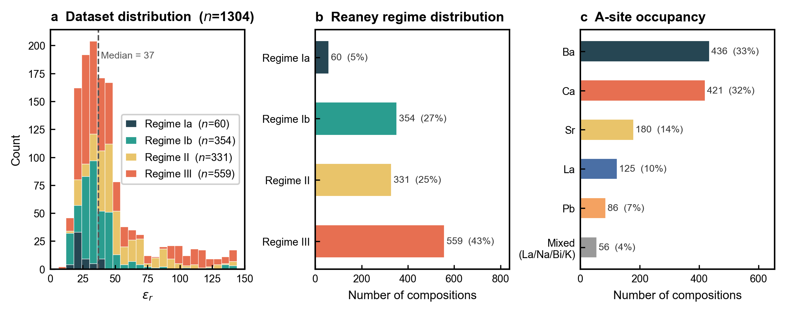
Supplementary Fig. 1 | Dataset statistics. Distribution of measured ε_r (panel a, n = 1,304 with median 37.0 and interquartile range [27.5, 49.4]), Reaney regime composition (b, Ia 60, Ib 354, II 331, III 559), and primary A-site occupancy (c, Ba 436, Ca 421, Sr 180, La 125, Pb 86, and 56 mixed La/Na/Bi/K-co-occupied compositions).

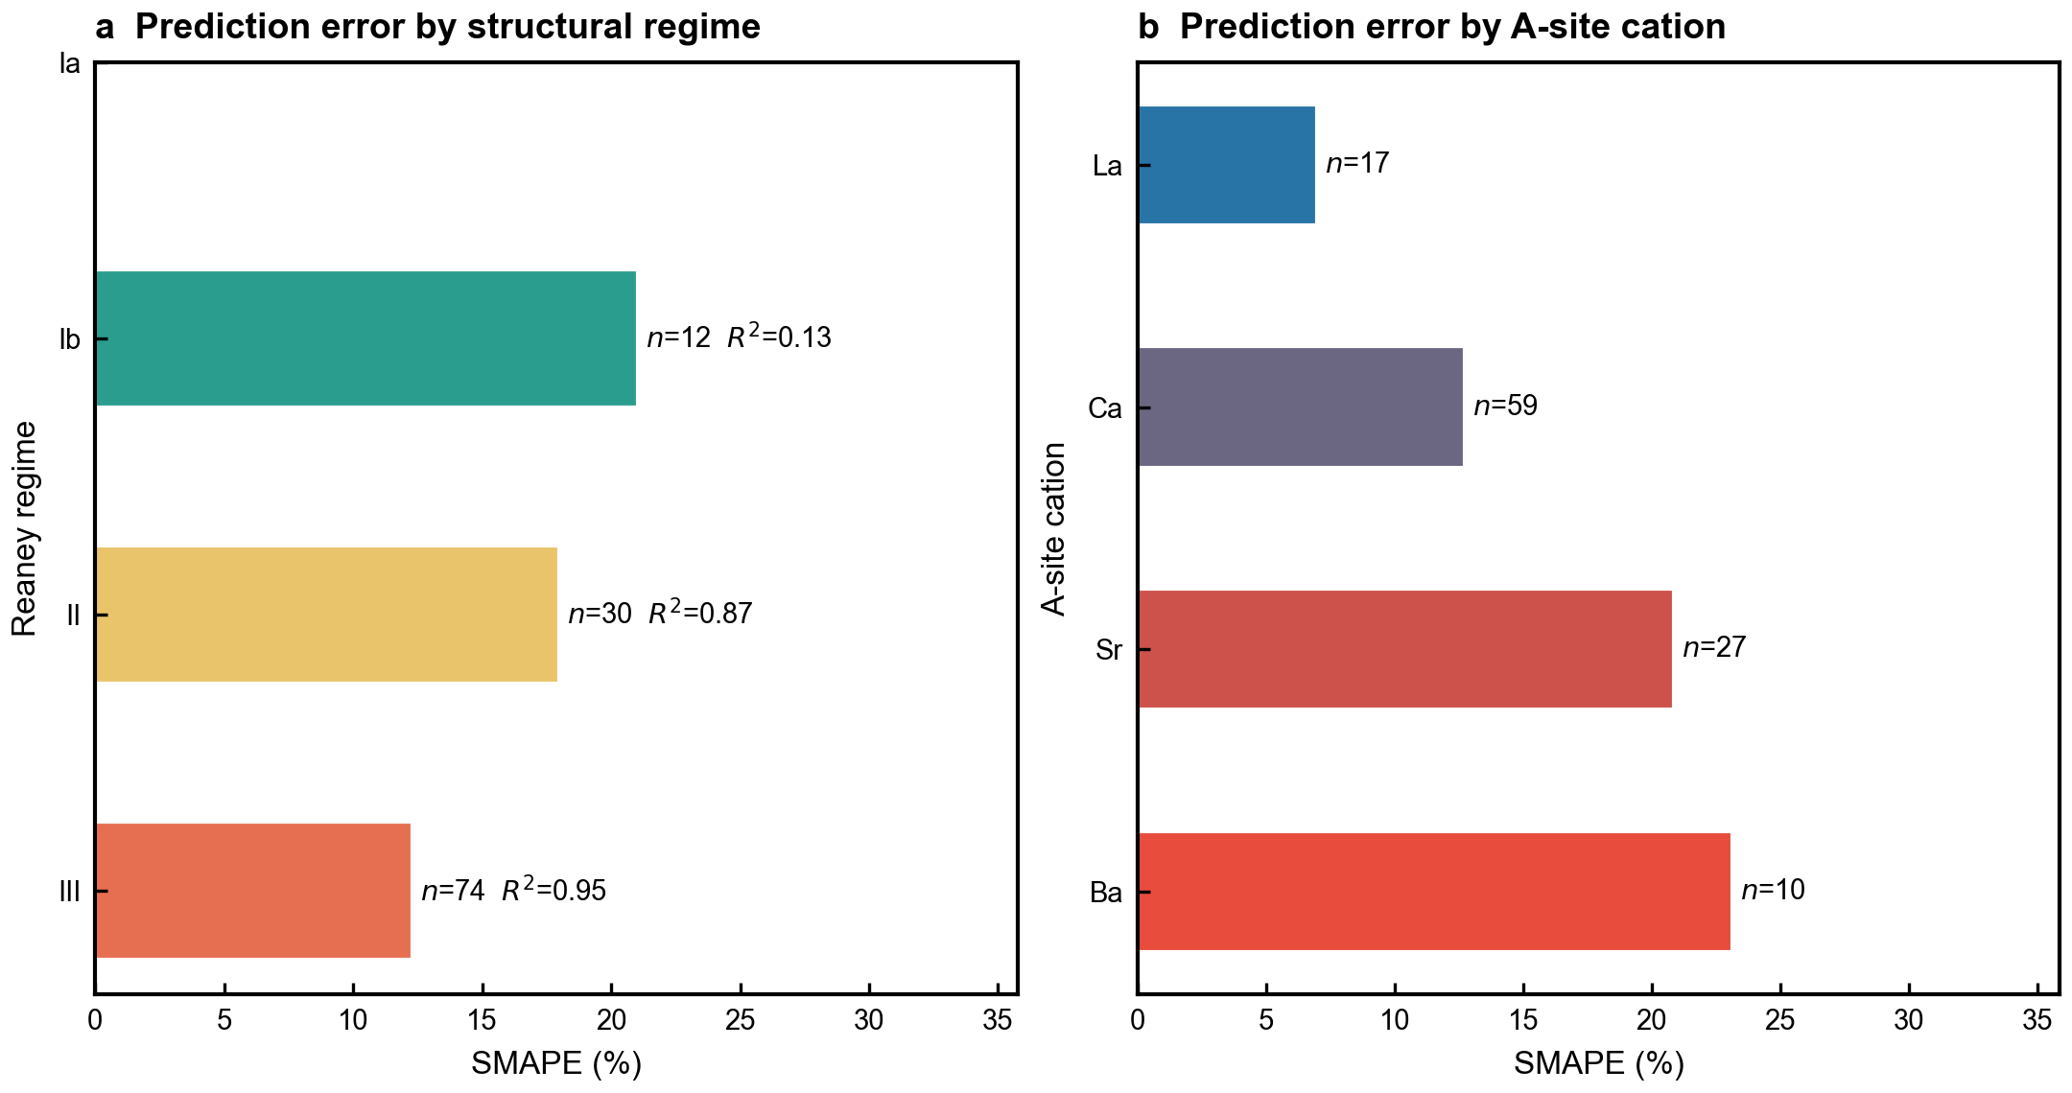
Supplementary Fig. 2 | Error stratification by regime and A-site. Holdout (n = 116) predicted-vs-measured ε_r, with PCNN predictions coloured separately by Reaney regime (a) and A-site cation (b). Regime III dominates the holdout (74/116 = 64%) and shows the tightest agreement (R² = 0.95); Regime Ib (12/116) is sample-limited (R² = 0.13). Per-A-site holdout R² ranges from 0.78 (Ca) to 0.96 (Sr).

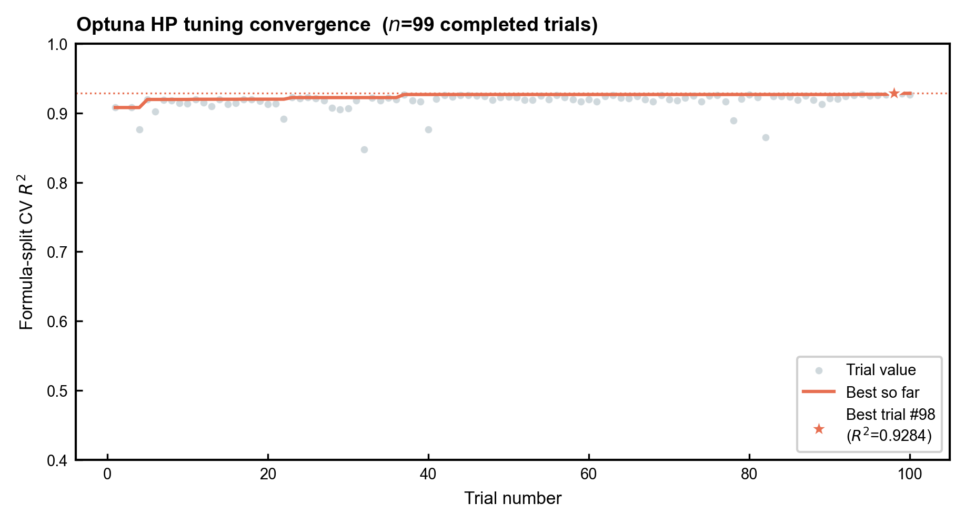
Supplementary Fig. 3 | Optuna hyperparameter convergence. Hyperparameter search history across the 99 completed Optuna trials (of 100 sampled; TPE sampler). Best-trial formula-split R² as a function of trial number, converging by trial ~60 to the best configuration (trial 98, R² = 0.928).

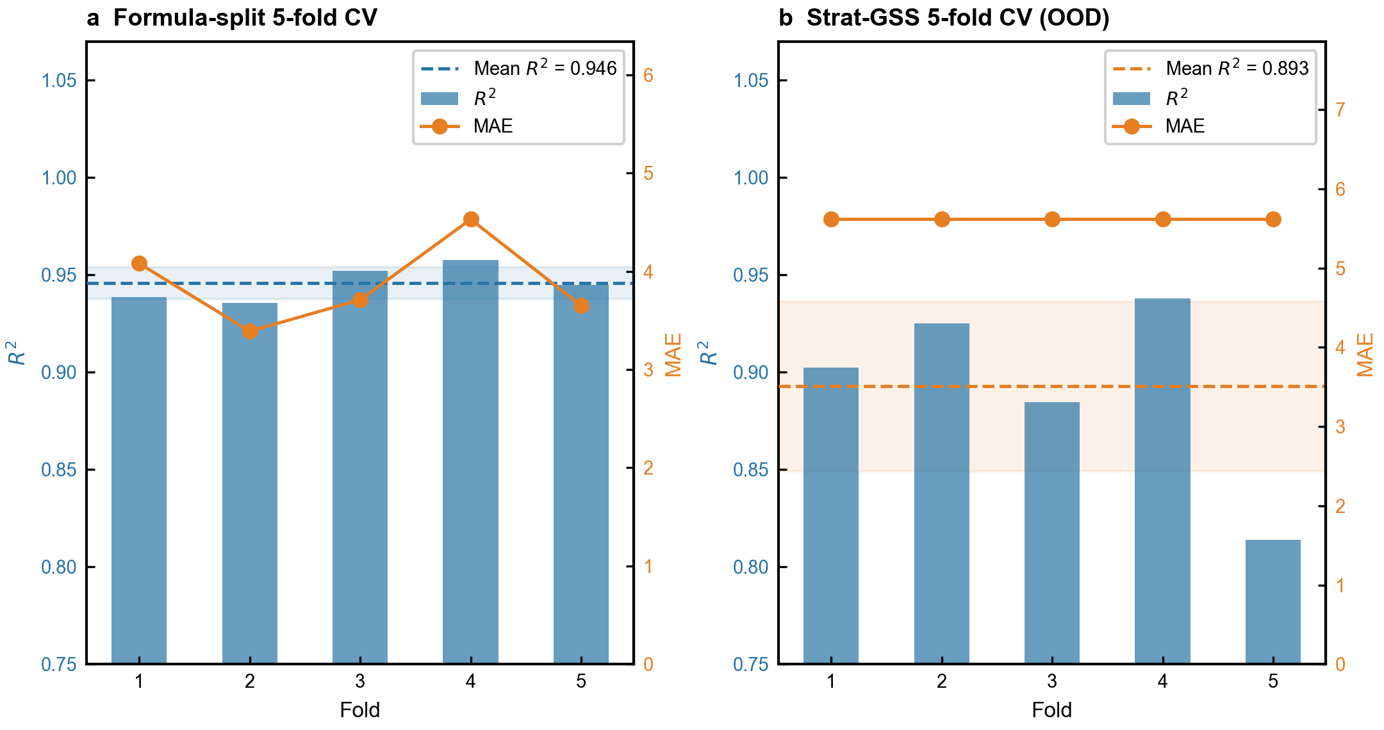
Supplementary Fig. 4 | Cross-validation diagnostics across folds. a, Per-fold formula-split CV R² (mean 0.946, SD 0.008) and Strat-GSS CV R² (mean 0.893, SD 0.043) for the PCNN. b, Per-fold Strat-GSS (grouped-shuffle) cross-validation R² under the out-of-distribution split, showing fold-to-fold stability about the 0.893 mean.

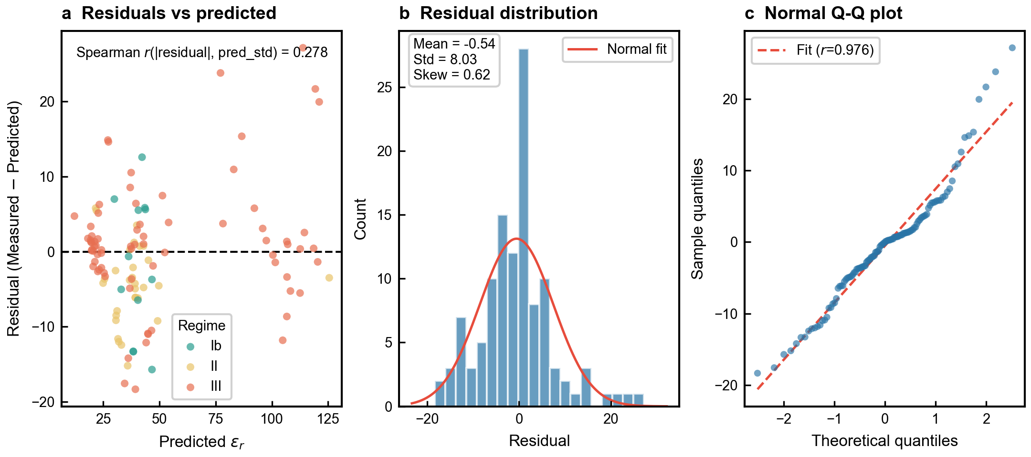
Supplementary Fig. 5 | Residual diagnostics. a, PCNN holdout residuals (measured − predicted ε_r) versus predicted ε_r, coloured by Reaney regime, with no strong heteroscedastic structure (Spearman r between |residual| and predicted σ = 0.28). b, Residual distribution (mean −0.54, SD 8.03, skew 0.62) with a Gaussian fit, indicating a slight negative bias. c, Normal quantile–quantile plot of the residuals (linear-fit r = 0.976), near-Gaussian in the central region with mildly heavier tails consistent with the Regime III-heavy holdout composition.

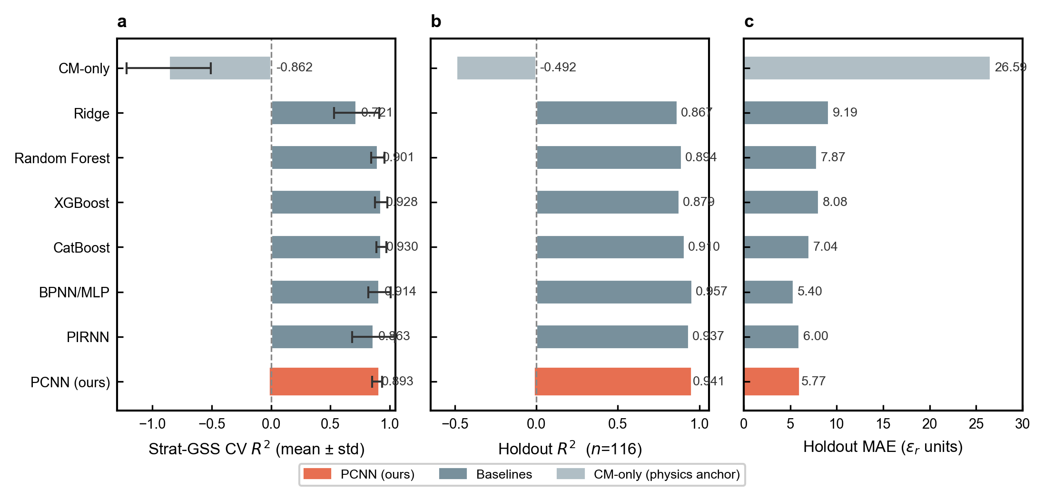
Supplementary Fig. 6 | Baseline comparison, full Strat-GSS + holdout. Per-baseline (CM-only, Ridge, Random Forest, XGBoost, CatBoost, BPNN/MLP, PIRNN, PCNN) Strat-GSS five-fold cross-validation R² (mean ± SD as error bars, a), holdout R² (b) and holdout MAE (c). Several flexible baselines match or slightly exceed the PCNN on raw holdout accuracy (e.g. BPNN/MLP R² = 0.957 vs PCNN 0.941), but the PCNN attains the lowest out-of-distribution cross-validation variance (SD 0.043 vs 0.181 for PIRNN) — the physics constraints buy generalisation stability at no cost to point accuracy.

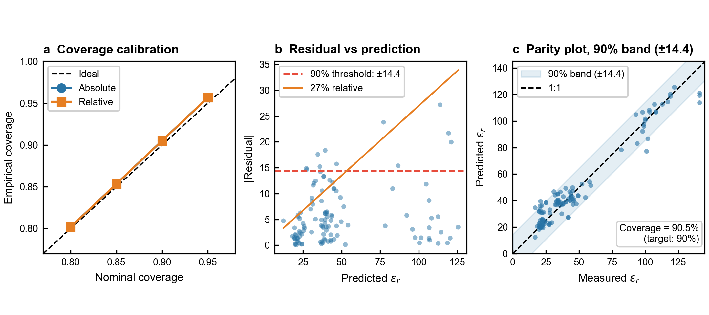
Supplementary Fig. 7 | Conformal calibration details. a, Empirical versus nominal coverage at α = 0.20, 0.15, 0.10, 0.05 (80.2 / 85.3 / 90.5 / 95.7%) for both absolute and relative conformal variants, tracking the ideal diagonal. b, Absolute residual |ε_r,pred − ε_r,measured| versus predicted ε_r, with the 90% conformal threshold (±14.4 ε_r units) and the 27%-relative band marked. c, Conformal parity: predicted ε_r with its 90% band (±14.4) versus measured ε_r, illustrating interval width across the prediction range.

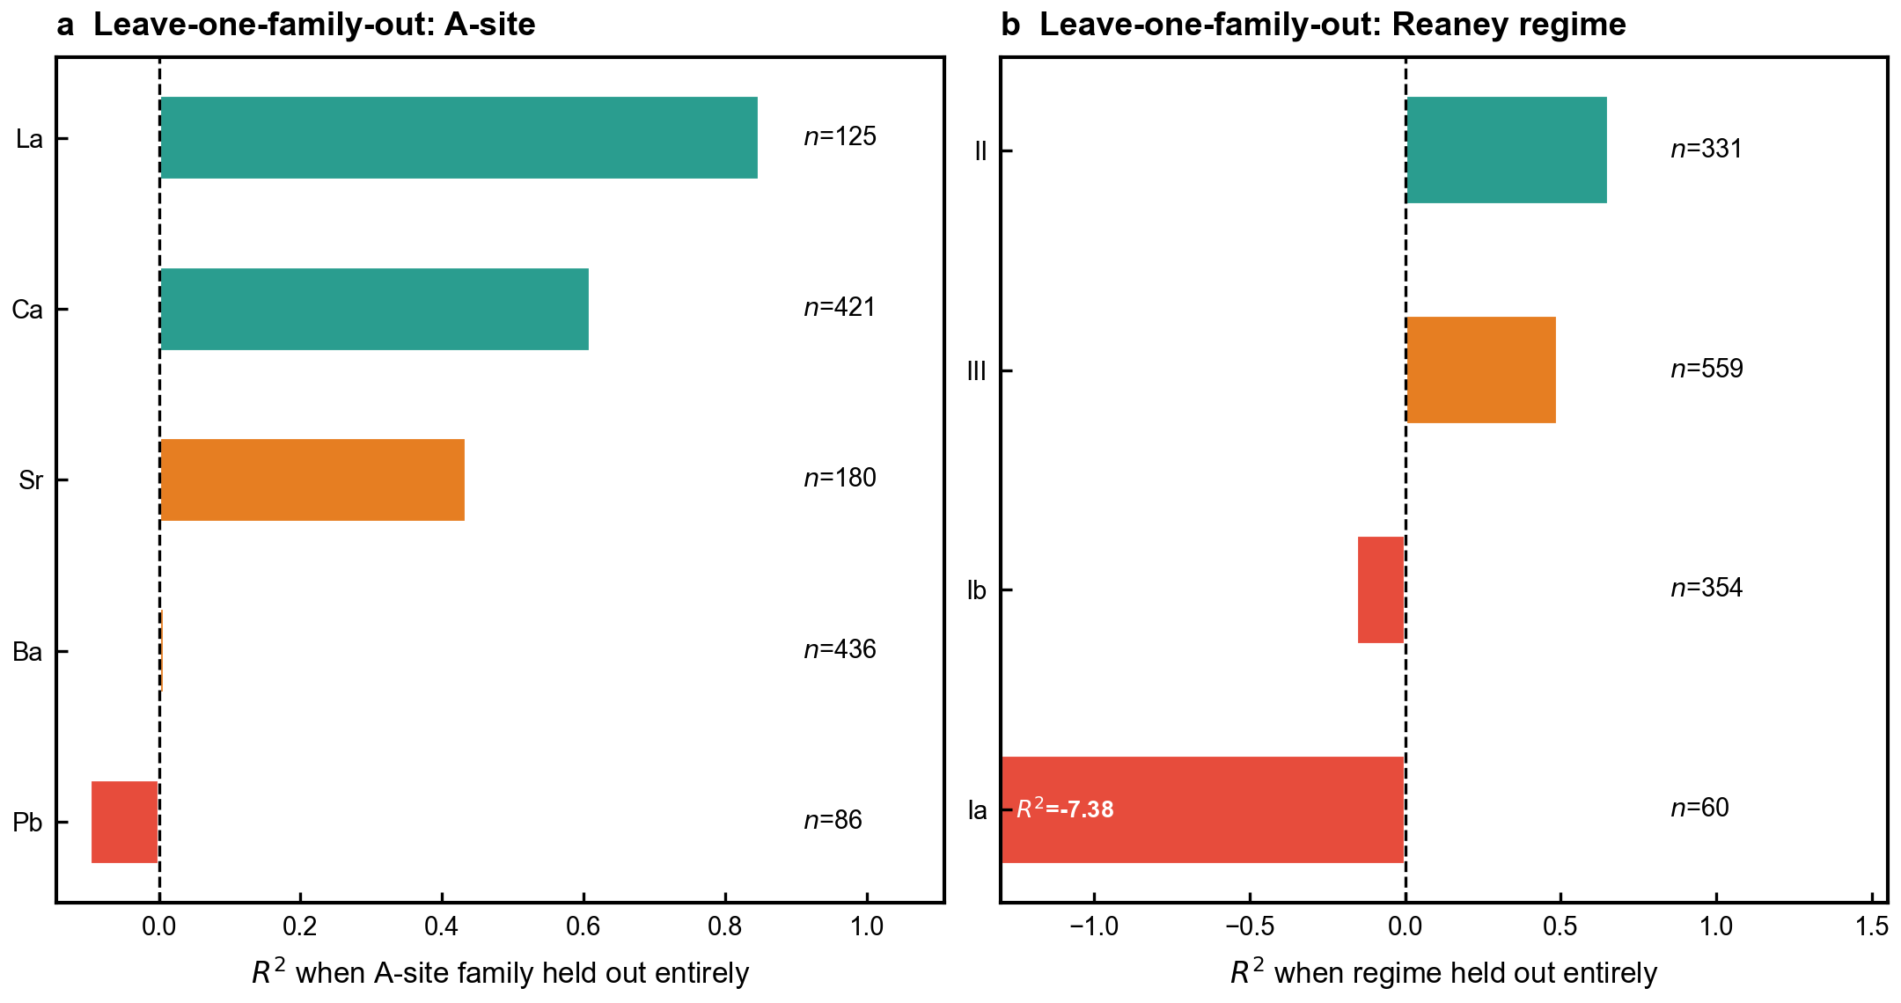
Supplementary Fig. 8 | Leave-one-family-out (LOFO) generalisability, detailed. a, A-site leave-one-family-out (LOFO) holdout R²: La 0.849 (n = 125), Ca 0.610 (n = 421), Sr 0.434 (n = 180), Ba 0.008 (n = 436), Pb −0.097 (n = 86). b, Regime LOFO holdout R²: II 0.654 (n = 331), III 0.490 (n = 559), Ib −0.158 (n = 354), Ia −7.378 (n = 60). Transfer collapses for the extrapolative Pb family and the tilt-free Regime Ia, consistent with their data sparsity and out-of-distribution character.

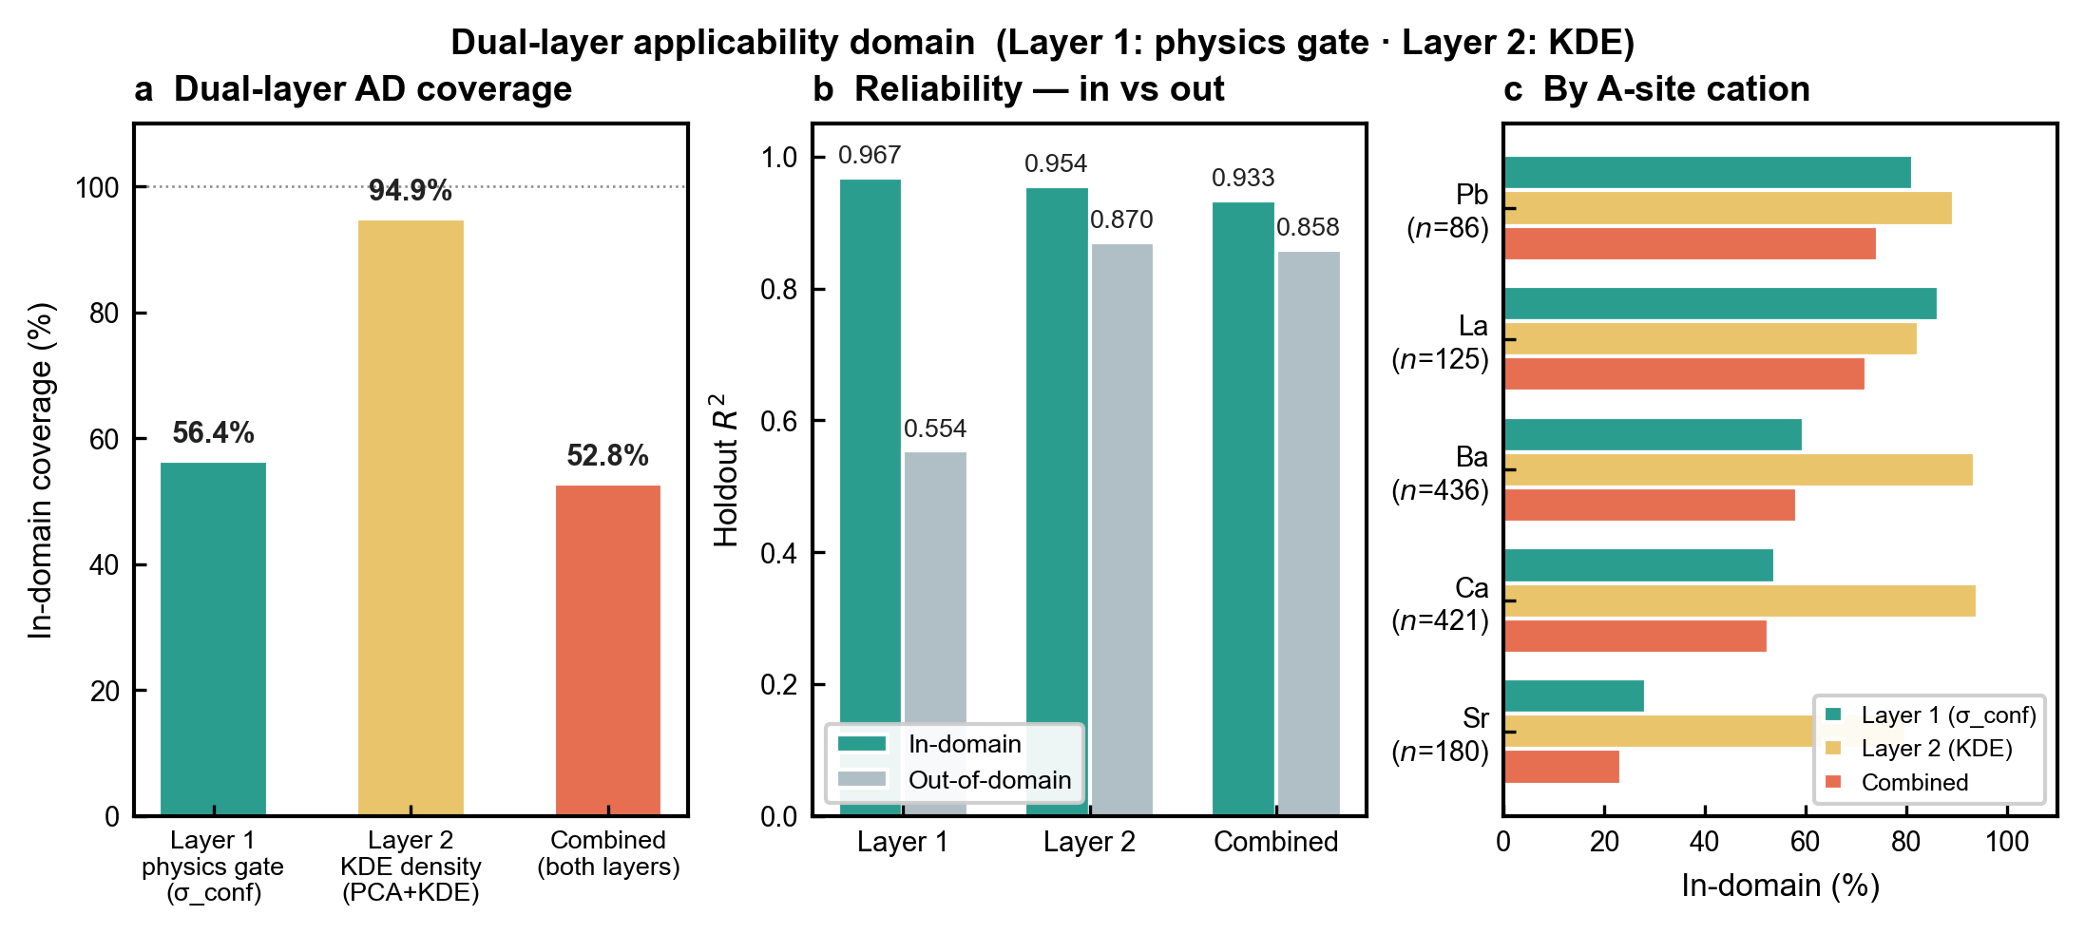
Supplementary Fig. 9 | Applicability domain, physics and density gates. Dual-layer applicability domain (Layer 1: physics-mechanism gate σ_conf; Layer 2: PCA + KDE density). a, In-domain coverage of each layer — physics gate 56.4%, KDE density 94.9% and the combined domain 52.8% of the corpus. b, Holdout reliability inside versus outside each domain (Layer 1 R²_in 0.967 / R²_out 0.554; Layer 2 0.954 / 0.870; combined 0.933 / 0.858), confirming that in-domain predictions are markedly more reliable. c, Combined in-domain fraction resolved by A-site cation (Pb 74%, La 72%, Ba 58%, Ca 53%, Sr 23%); Sr-rich compositions fall outside the domain most often.

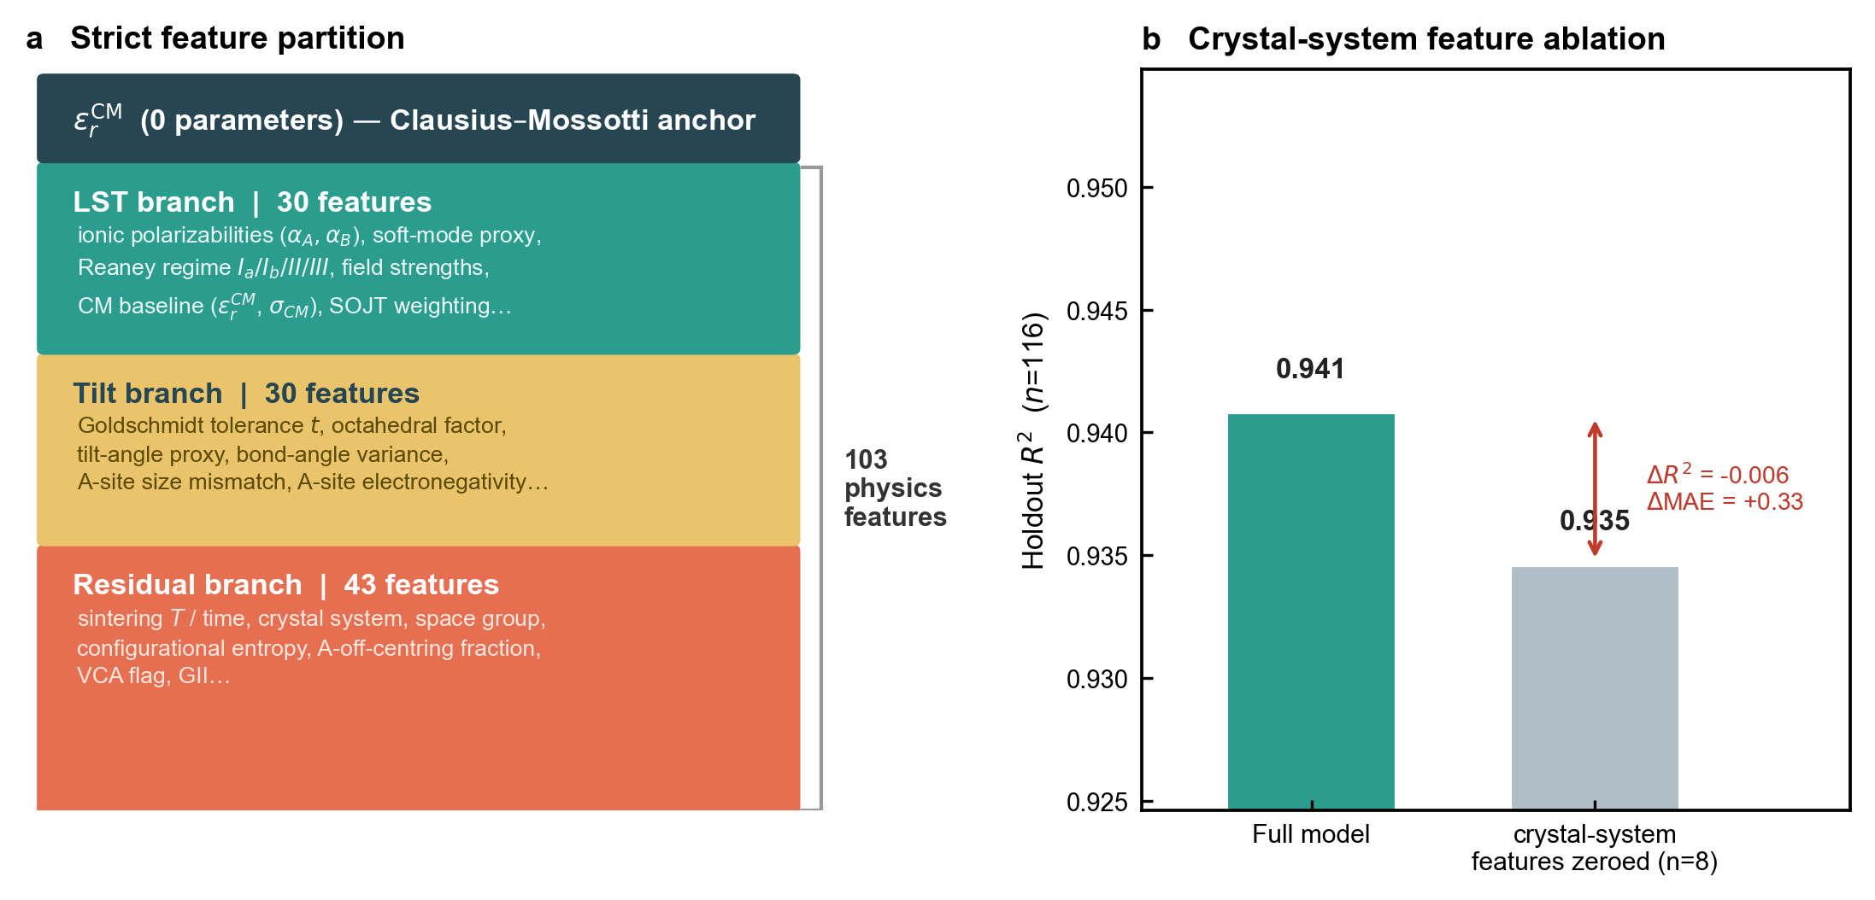
Supplementary Fig. 10 | Feature partition and crystal-system ablation. a, The strict 30/30/43 LST/tilt/residual partition of the 103 physics features feeding the zero-parameter Clausius–Mossotti anchor; no feature appears in more than one branch. b, Crystal-system feature ablation: holdout R² (n = 116) with the 8 crystal-system features zeroed (0.941 → 0.935, ΔR² = −0.006, ΔMAE = +0.33), showing the crystal-system features have a minor, non-zero impact — the model is crystal-system-agnostic.

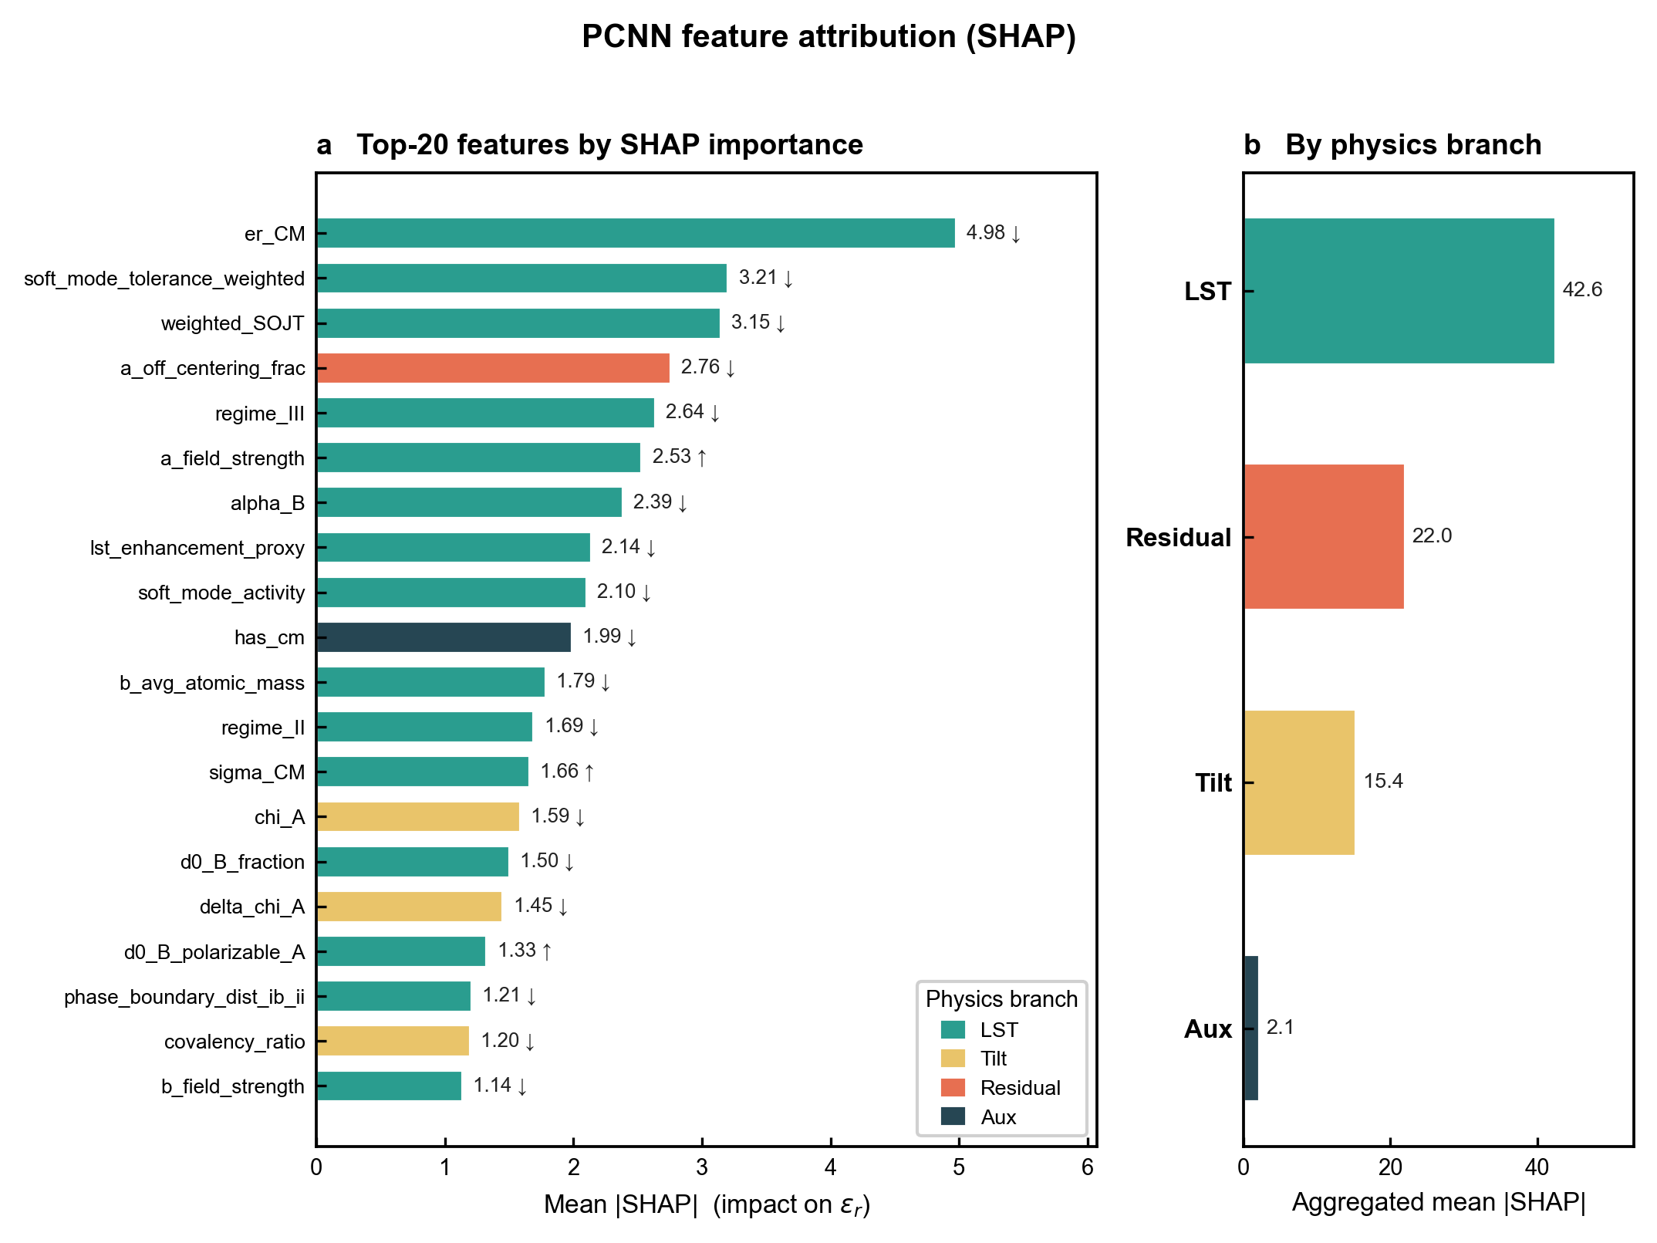
Supplementary Fig. 11 | SHAP feature attribution. GradientExplainer SHAP values over 400 test compositions (108 input features). a, Top-20 features by mean |SHAP|, colour-coded by physics branch, with arrows giving the sign of the mean effect on ε_r; the leading individual predictors are the Clausius–Mossotti baseline (er_CM, 4.98), the tolerance-weighted soft-mode term (3.21) and the second-order Jahn–Teller weighting (weighted_SOJT, 3.15). b, Aggregated mean |SHAP| by branch (LST 42.6 > residual 22.0 > tilt 15.4 > auxiliary 2.1), confirming that the soft-mode (LST) features carry the largest share of the model's feature attribution, consistent with the LST-branch dominance reported in Fig. 2.

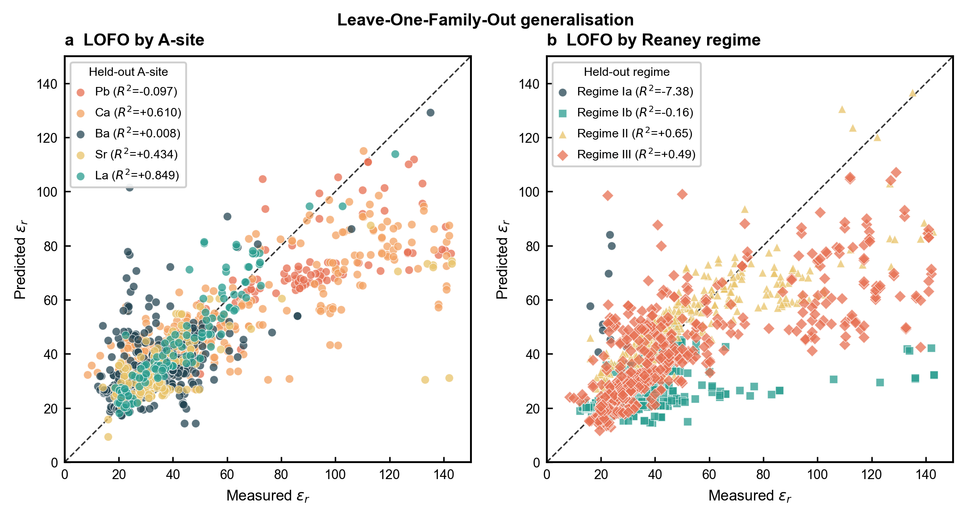
Supplementary Fig. 12 | LOFO parity diagnostics. Leave-one-family-out predicted-vs-measured ε_r parity, with the 1:1 line, resolved by A-site cation (a; per-family holdout R² in the legend: La 0.849, Ca 0.610, Sr 0.434, Ba 0.008, Pb −0.097) and by Reaney regime (b; Ia −7.38, Ib −0.16, II 0.65, III 0.49). The held-out Pb series (panel a) is systematically underpredicted across the Pb-containing composition range.

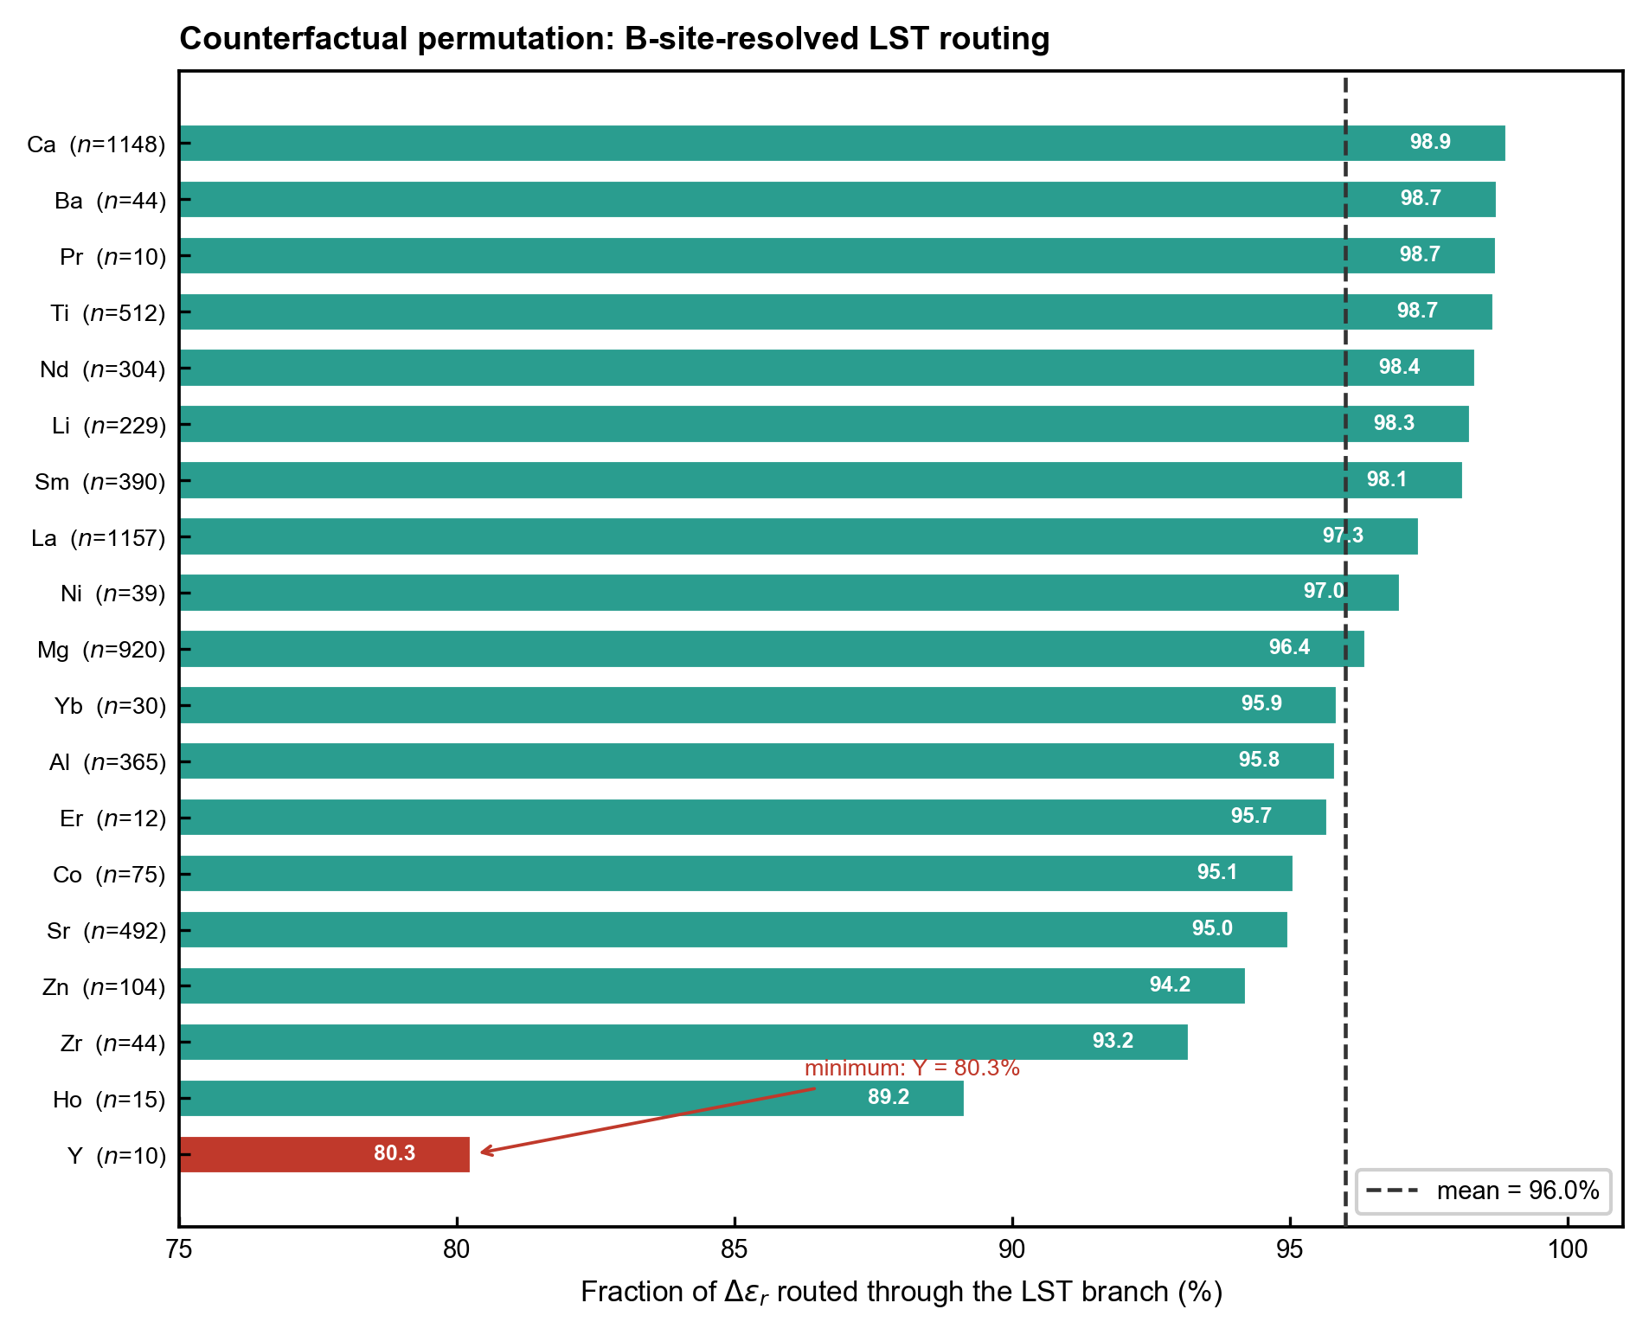
Supplementary Fig. 13 | Counterfactual permutation analysis. For each B-site family, the fraction of Δε_r assigned to the LST branch under permuted input. Mean across families = 96.0%; minimum = 80.3% (Y), confirming A-site control of the LST channel is B-site-independent.

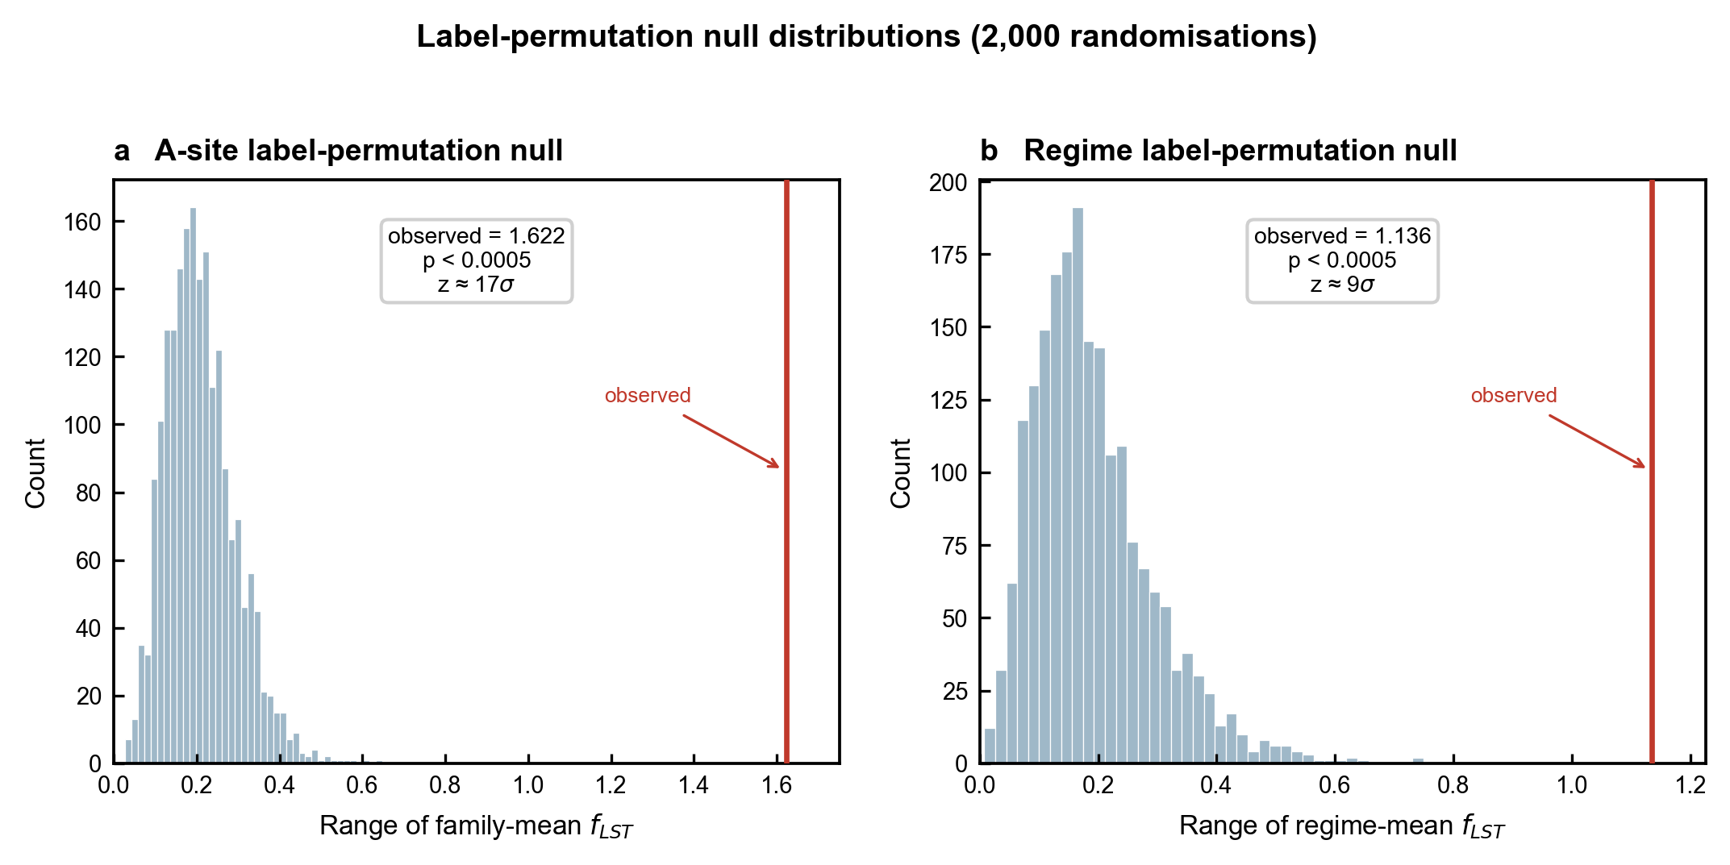
Supplementary Fig. 14 | Permutation null distributions. Null distribution of the family-mean f_LST range under 2,000 random permutations of the grouping labels. a, A-site permutation null: the observed range (1.622; Pb 2.28 → Ba 0.66) lies far in the tail (z ≈ 17σ, p < 0.0005; 0 of 2,000 permutations as extreme). b, Regime permutation null: observed range 1.136 (z ≈ 9σ, p < 0.0005). Because A-site identity co-varies with Reaney regime across the corpus, the regime result corroborates rather than independently confirms the A-site ranking.

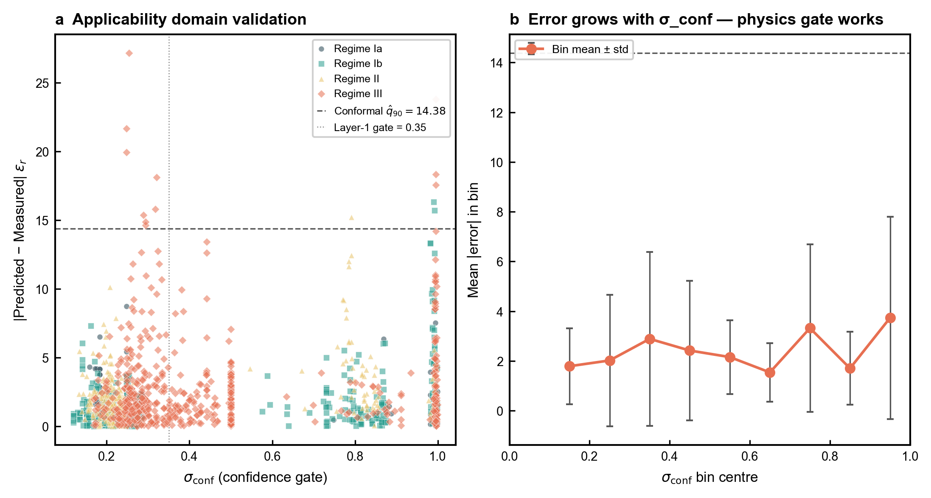
Supplementary Fig. 15 | σ_conf vs absolute prediction error. a, Per-composition predictive confidence σ_conf against |ε_r,pred − ε_r,measured| on the holdout set, coloured by Reaney regime, with the conformal q̂₉₀ = 14.38 and the Layer-1 physics gate (σ_conf = 0.35) marked. b, Binned mean error versus σ_conf, which rises with σ_conf — showing σ_conf is a meaningful (physics-aware, epistemic) uncertainty signal rather than a perfect error predictor.

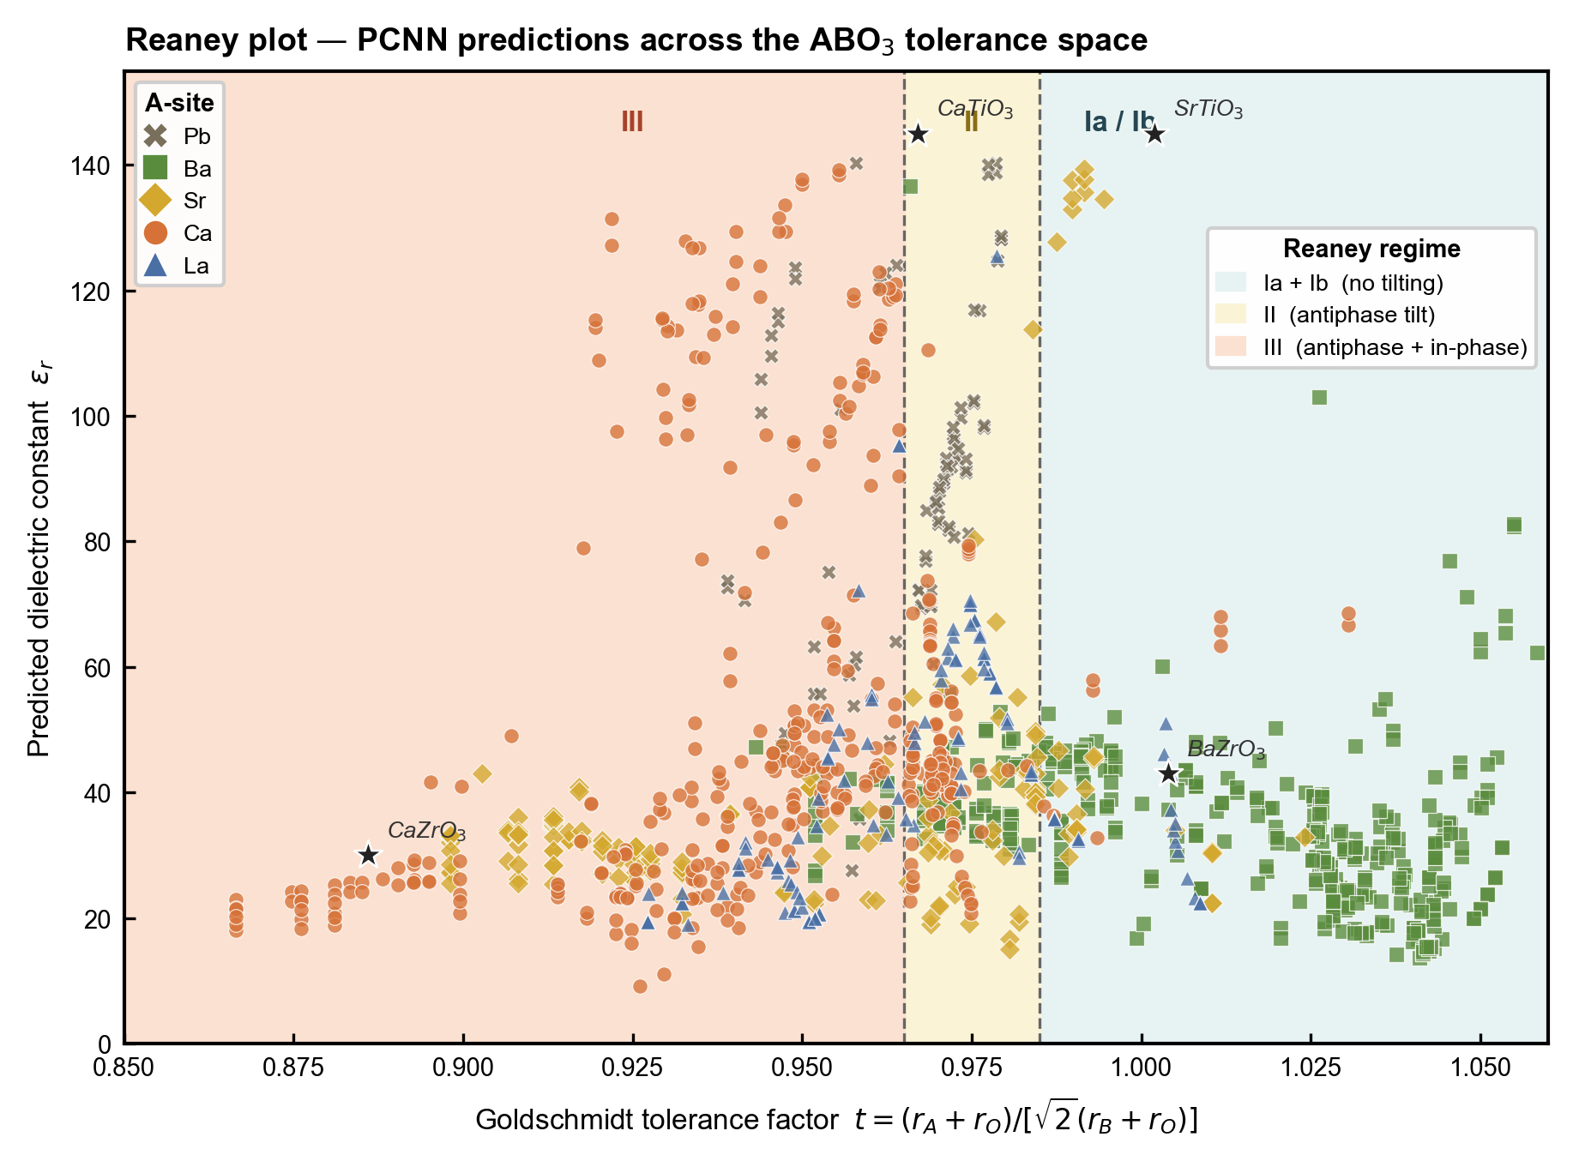
Supplementary Fig. 16 | Reaney-regime plot. Predicted ε_r as a function of Goldschmidt tolerance factor t, with regime boundaries (t = 0.965, 0.985) from Reaney et al.[4] marked. Compositions are coloured by A-site cation. Soft-mode-active regimes (Ib, II, III) show ε_r values 1.5–2.5× larger than untilted Regime Ia, consistent with the dominance of the LST contribution.

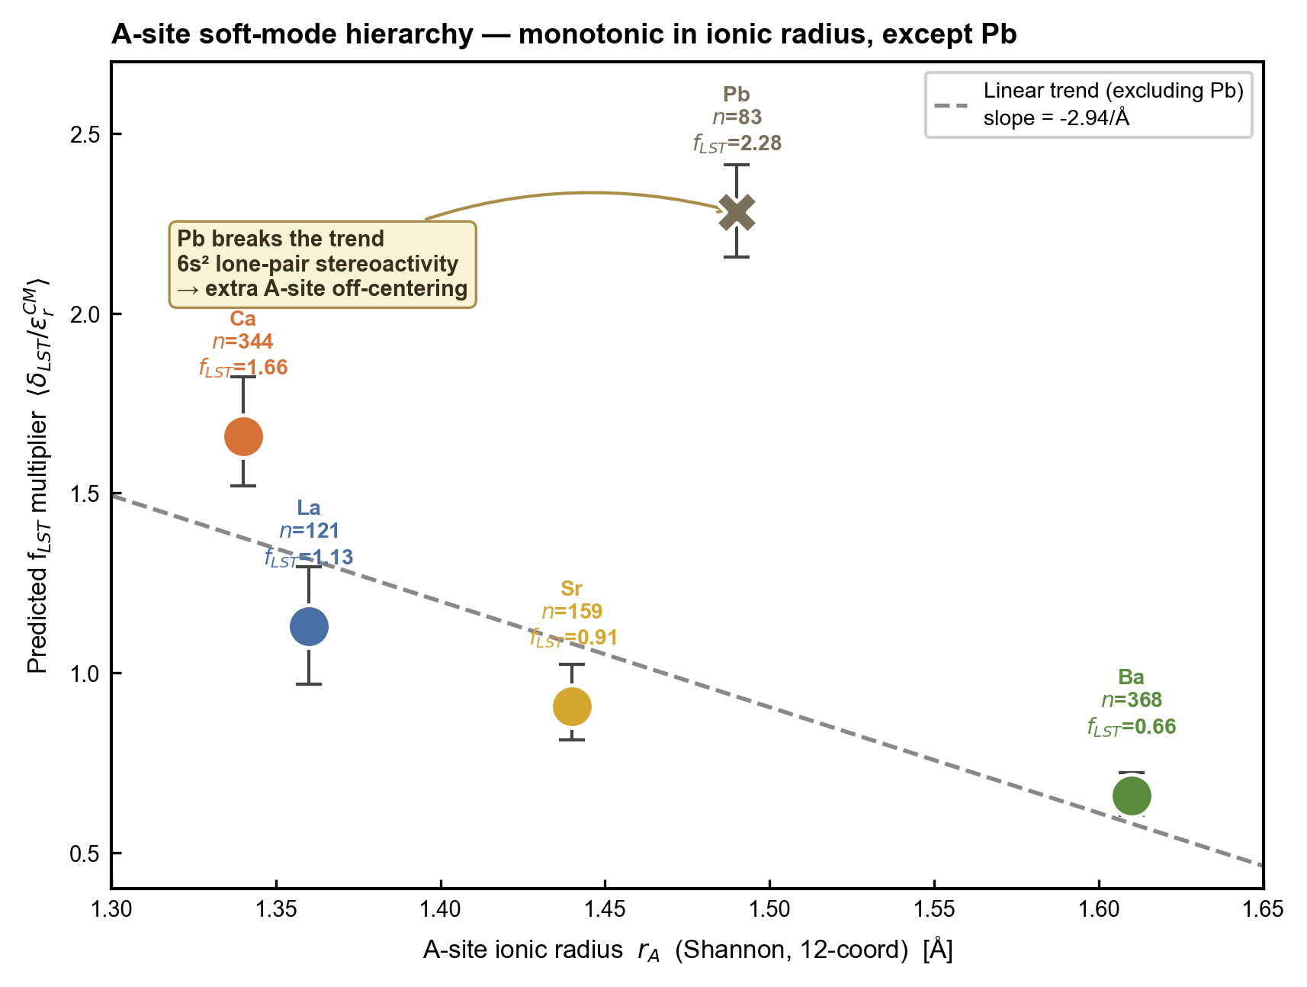
Supplementary Fig. 17 | A-site ionic radius trend. Per-A-site f_LST versus 12-coordinate Shannon ionic radius, with Pb shown as an off-trend outlier. Across the Ba→Sr→La→Ca segment, f_LST increases monotonically as the radius contracts (Pearson r ≈ −0.85 across the four family means).

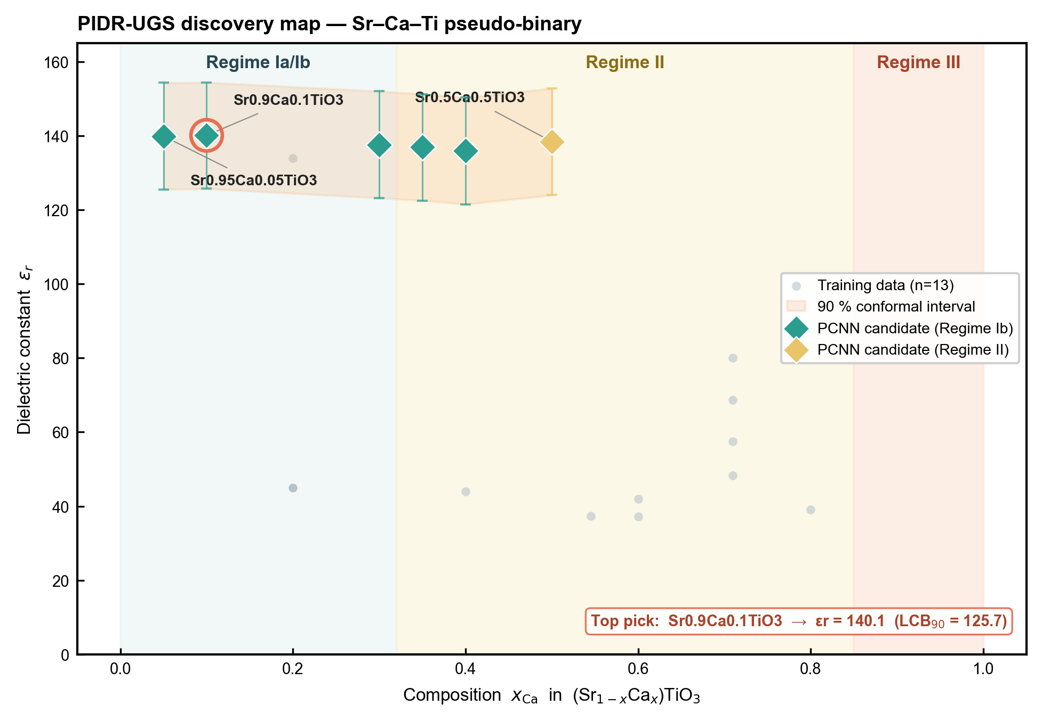
Supplementary Fig. 18 | Sr-Ca-Ti discovery map. Predicted ε_r over the Sr_(1−x)Ca_xTiO₃ pseudobinary, with 90% conformal intervals. The maximum ε_r ≈ 140.1 occurs at x = 0.10 (Sr_0.9Ca_0.1TiO₃), with a 90% lower confidence bound LCB₉₀ = 125.7.

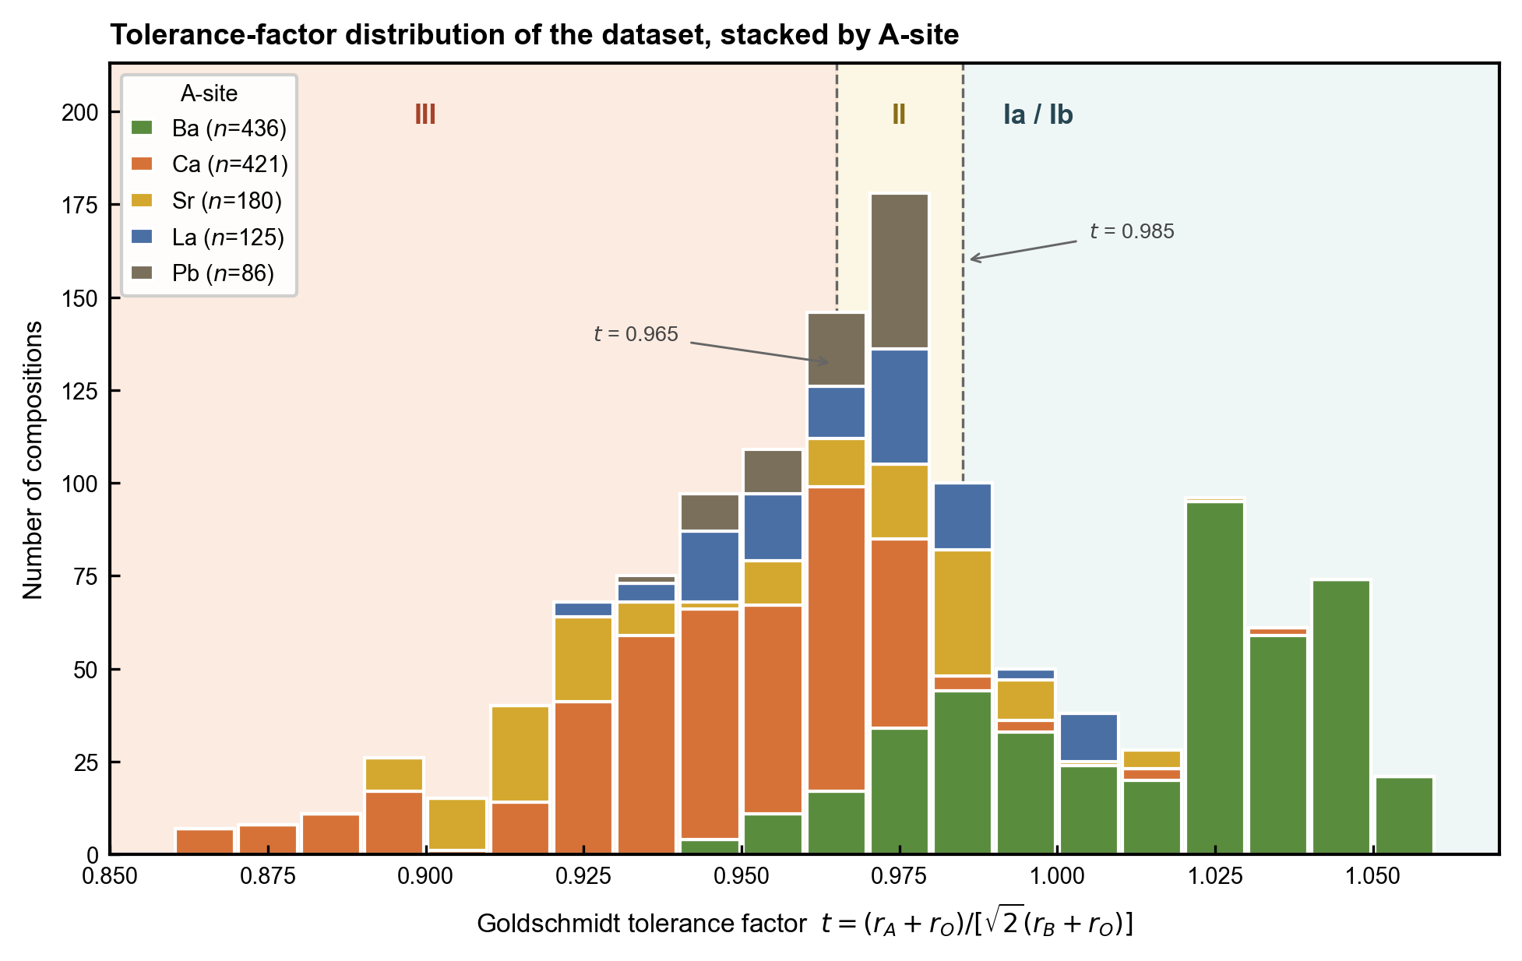
Supplementary Fig. 19 | Tolerance-factor histogram. Distribution of t across the corpus, stacked by primary A-site cation (Ba 436, Ca 421, Sr 180, La 125, Pb 86; the 56 mixed-A-site compositions are omitted), with the Reaney regime boundaries[4] (t = 0.965, 0.985) marked. Regime III (t ≤ 0.965, n = 559) is the largest regime population and Regime Ia (n = 60) the smallest.

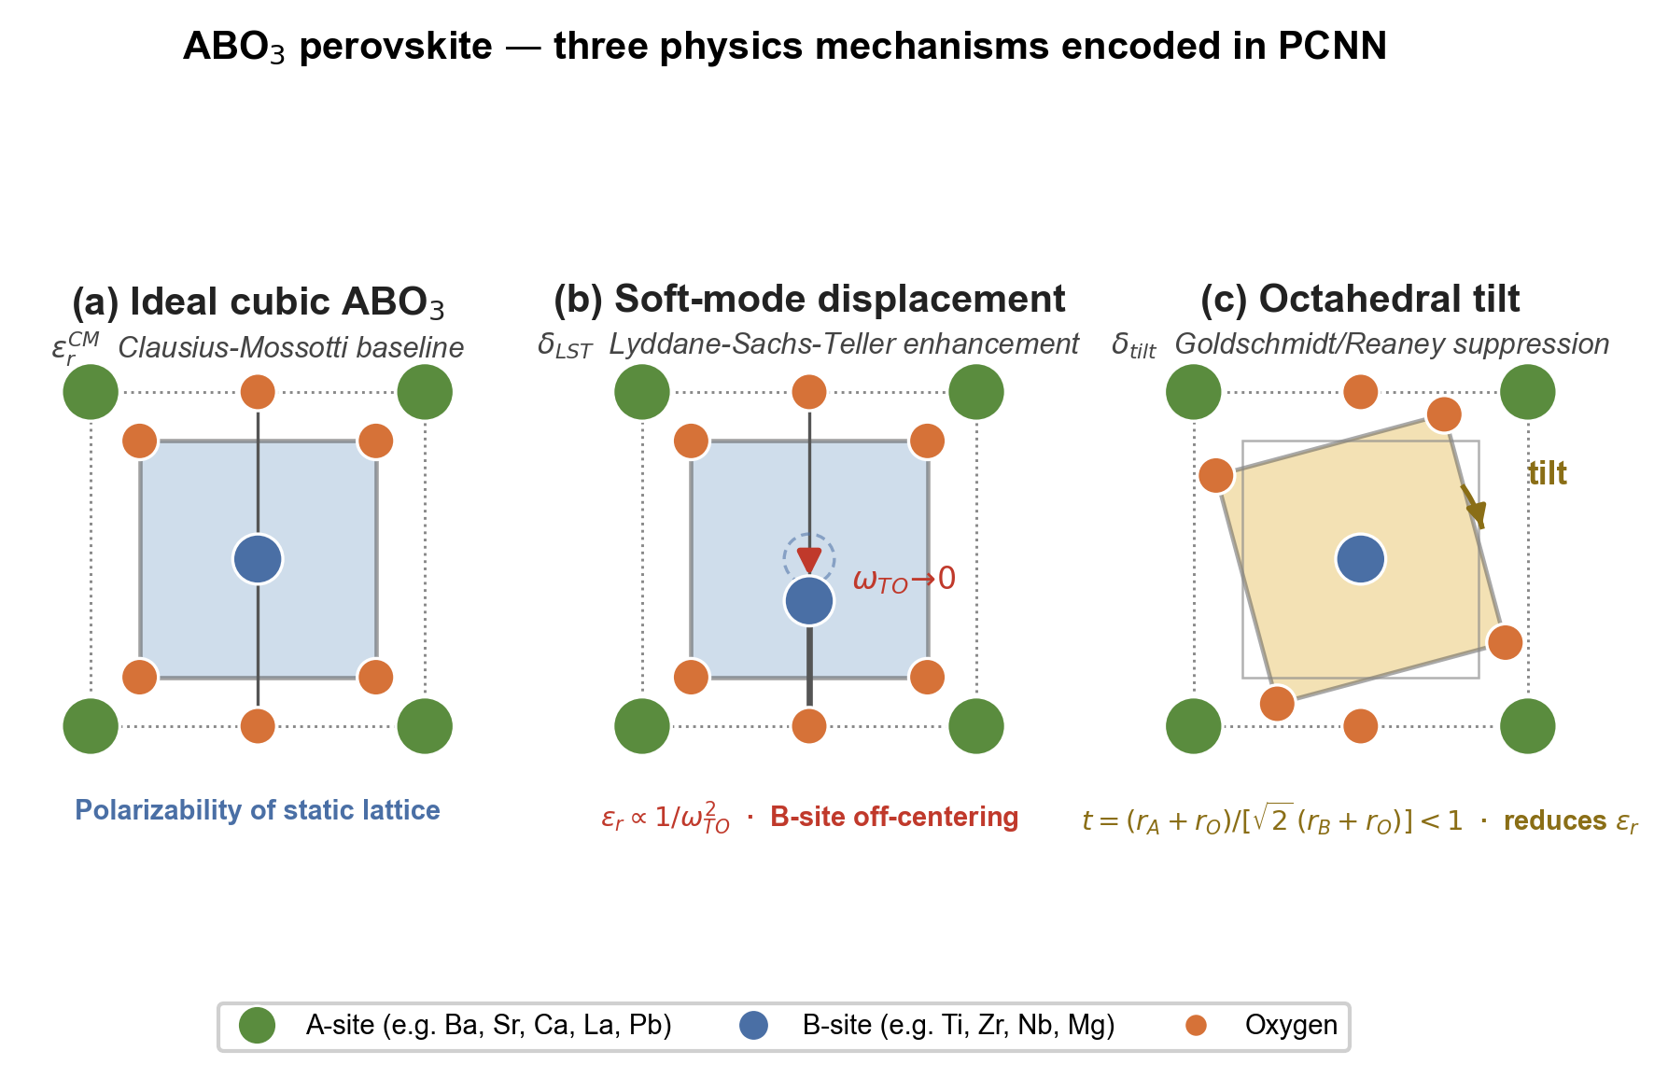
Supplementary Fig. 20 | The three physics mechanisms encoded in the PCNN. Schematic of the ABO₃ perovskite responses the model decomposes: (a) the ideal cubic lattice setting the Clausius–Mossotti baseline ε_r,CM (polarizability of the static lattice); (b) soft-mode (B-site off-centering) displacement giving the Lyddane–Sachs–Teller enhancement δ_LST ∝ 1/ω²_TO; and (c) octahedral tilting (Goldschmidt/Reaney, tolerance factor t < 1) that suppresses ε_r (δ_tilt). A-site, B-site and oxygen sites are indicated in the legend.

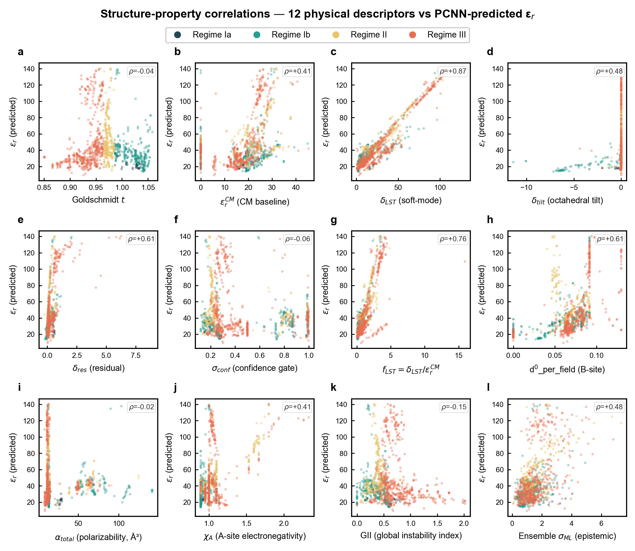
Supplementary Fig. 21 | Structure-property correlations between 12 physical descriptors and PCNN-predicted ε_r. Each panel (a–l) shows the predicted ε_r against one descriptor across all 1,304 ABO₃-type compositions, with points coloured by Reaney regime (Ia, Ib, II, III). The annotated Spearman rank correlation ρ quantifies the monotonic relation between each descriptor and the predicted permittivity. Panels: a, Goldschmidt tolerance factor t (ρ = −0.04). b, Clausius–Mossotti baseline ε_r,CM (ρ = +0.41). c, soft-mode branch δ_LST (ρ = +0.87, the strongest single predictor, consistent with the LST-dominated mechanism reported in the main text). d, octahedral tilt branch δ_tilt (ρ = +0.48). e, residual branch δ_res (ρ = +0.61). f, predictive confidence σ_conf (ρ = −0.06). g, soft-mode enhancement factor f_LST = δ_LST / ε_r,CM (ρ = +0.76). h, B-site d⁰ fraction (ρ = +0.61). i, total ionic polarizability α_total (ρ = −0.02). j, A-site electronegativity χ_A (ρ = +0.41). k, global instability index GII (ρ = −0.15). l, ensemble standard deviation σ_ML (ρ = +0.48). The ranking δ_LST > f_LST > δ_res ≈ d⁰_per_field > χ_A confirms that the soft-mode channel carries the largest single contribution to permittivity, in agreement with the SHAP attribution in Supplementary Fig. 11 and the branch-decomposition statistics in the main text.

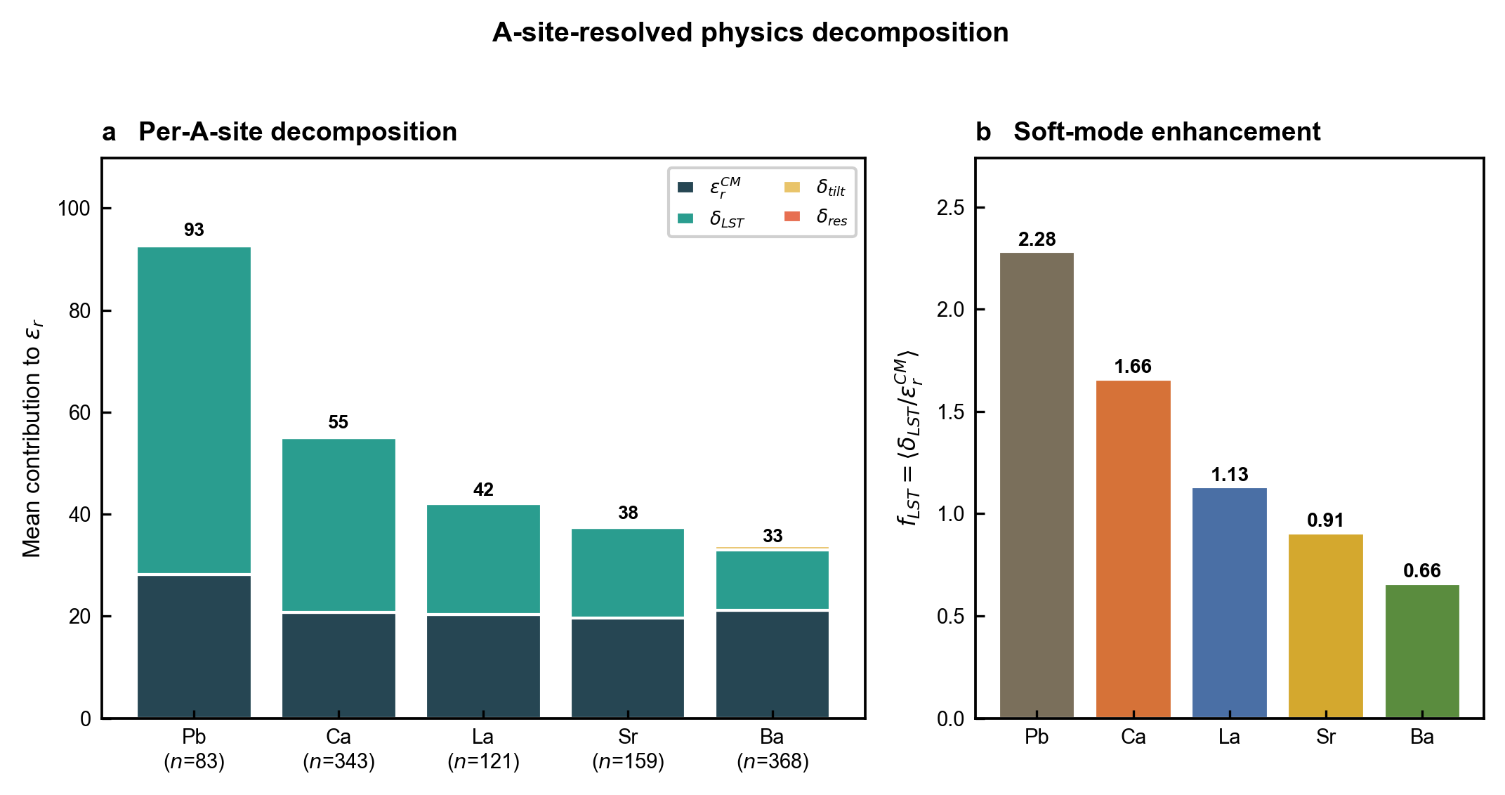
Supplementary Fig. 22 | A-site-resolved physics decomposition. Mean CM, LST, tilt and residual contributions to ε_r resolved by primary A-site cation, computed across all compositions of each family. a, Stacked decomposition (ε_r,CM baseline plus δ_LST, δ_tilt, δ_res) per A-site, ordered by soft-mode enhancement: Pb (total ε_r ≈ 93, n = 83), Ca (55, n = 343), La (42, n = 121), Sr (38, n = 159), Ba (33, n = 368). b, The corresponding soft-mode enhancement factor f_LST = ⟨δ_LST/ε_r,CM⟩ (Pb 2.28 > Ca 1.66 > La 1.13 > Sr 0.91 > Ba 0.66), reproducing the A-site hierarchy of Fig. 2a.

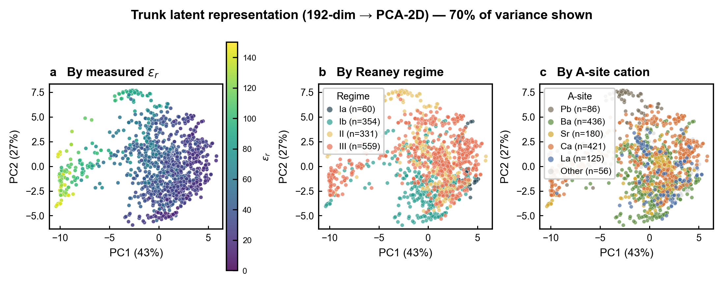
Supplementary Fig. 23 | Latent representation analysis. Two-dimensional PCA projection of the 192-dimensional trunk representation (PC1 43%, PC2 27% of variance; trunk hidden state averaged across 5 seeds), coloured by measured ε_r (a), Reaney regime (b) and A-site cation (c). The trunk learns chemically coherent clusters that align with A-site identity (panel c) more than with regime, consistent with A-site dominance in the soft-mode channel.

Supplementary References
The microwave-dielectric permittivity dataset (n = 1,304 ABO₃-type compositions) was compiled from a microwave-dielectric ceramics handbook and approximately 200 primary experimental literature sources. The complete enumerated list of these data sources is deposited together with the cleaned dataset at Zenodo [DOI placeholder] and will be inserted here in full upon finalisation.

