**Phase 3: Development Part 1**

In this part you will begin building your project by loading and preprocessing the dataset.

Begin the analysis by loading and preprocessing the air quality dataset

Load the dataset using Python and data manipulation libraries (e.g., pandas).

**Air Quality Analysis in Tamil Nadu**

**1. Import the necessary libraries:**

**First, import the libraries you'll need for data manipulation and analysis. You'll primarily use `pandas` for data handling.**



**2. Load the dataset:**

**You'll need to load the air quality dataset into a pandas Data Frame. You can use various methods to load data depending on the file format. For example, if you have a CSV file, you can use `pd.read_csv()`.**



**3. Data Exploration:**

**Once the data is loaded, you can start exploring it. Here are some common operations to get an initial understanding of the dataset:**

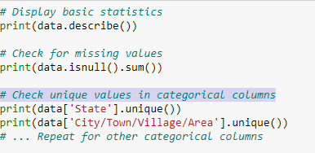

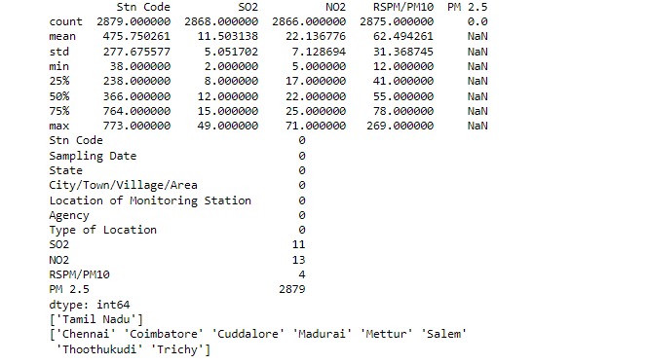

**4. Data Preprocessing:**

**Based on the initial exploration, you might need to perform data preprocessing. This can include handling missing values, renaming columns, converting data types, and more.**

**5. Data Visualization:**

**You can create visualizations to better understand the data. Matplotlib or Seaborn can be used for this purpose. you may need to perform various preprocessing tasks like data cleaning, data transformation, feature engineering, and data normalization.**

**Line Chart                          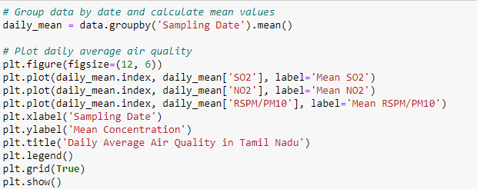**

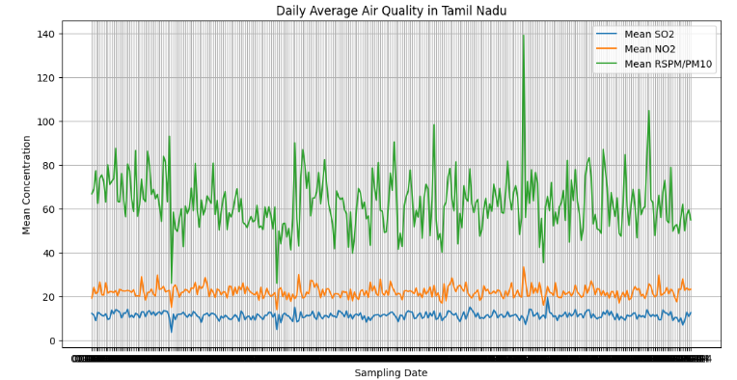

**In the data visualization step, a heatmap was created using Seaborn and Matplotlib to provide a visual representation of air quality levels in different monitoring locations over time. This heatmap helps to reveal patterns and variations in RSPM/PM10 pollutant levels across different locations, enhancing our understanding of air quality trends.**

**Heatmap**

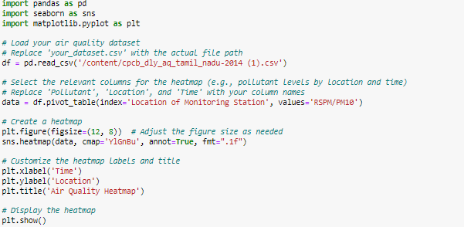

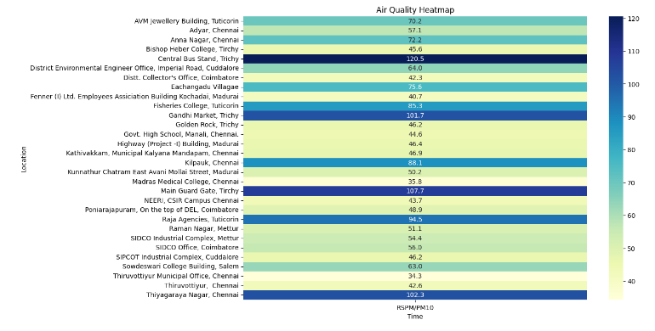

**7. Feature selection:**

**Feature selection is important to choose the most relevant variables for your analysis. You can use techniques like feature importance scores, correlation analysis, or domain knowledge to select features.**

**Popular feature selection methods include Recursive Feature Elimination (RFE), SelectKBest, or using machine learning models that provide feature importance scores.**

**Be sure to document the features you select and the rationale behind the selection process.**

**8. Save the preprocessed dataset:**

**To save your preprocessed dataset, you can use pandas to save it as a CSV, Excel, or any other format that suits your needs. For instance, you can use `df.to_csv()` to save it as a CSV file.**

**It's a good practice to save the preprocessed dataset to a new file or object to ensure that you can work with a clean and consistent dataset in subsequent steps of your analysis.**

**Consider using meaningful names for the saved file to distinguish it from the original dataset.**