Air Qulatity Analysis in Tamilnadu

Phase - 4

**IMPORTING REQUIRED LIBRARIES**

[ ]:

**import**

**pandas**

**as**

**pd**

**import**

**matplotlib**

**.**

**pyplot**

**as**

**plt**

**LOADING THE DATASET**

[ ]: data = pd.read_csv('/content/cpcb_dly_aq_tamil_nadu-2014 (2).csv')

**CALCULATING THE AVERAGE OF SO2,NO2 AND RSPM/PM10 ON THE BASIS**

**OF City/Town/Village/Area**

[ ]:

**import**

**pandas**

**as**

**pd**

*# Load your CSV dataset into a DataFrame*

data

=

pd

.

read_csv(

'

/content/cpcb_dly_aq_tamil_nadu-2014 (2).csv

'

)

*# Group the data by the 'Region' column and calculate the mean for each group*

grouped

=

data

.

groupby(

'

City/Town/Village/Area

'

)[[

'

SO2

'

,

'

NO2

'

,

'

RSPM/PM10

'

]]

.

↪

mean()

*# Display the calculated averages*

print

(

grouped

)

SO2

NO2 RSPM/PM10

City/Town/Village/Area

Chennai 13.014042 22.088442 58.998000 Coimbatore 4.541096 25.325342 49.217241

Cuddalore 8.965986 19.710884 61.881757 Madurai 13.319728 25.768707 45.724490 Mettur 8.429268 23.185366 52.721951

Salem 8.114504 28.664122 62.954198 Thoothukudi 12.989691 18.512027 83.458904

Trichy 15.293956 18.695055 85.054496

**VISUALIZATION OF DAILY AVERAGE OF SO2 AND NO2.**

[ ]: *# Calculate daily average SO2 and NO2 concentrations for all monitoring stations* daily_mean = data.groupby('Sampling Date')[['SO2', 'NO2']].mean()

*# Plot daily average SO2 and NO2 concentrations*

plt

.

figure(figsize

=

(

12

,

6

))

plt

.

plot(daily_mean

.

index, daily_mean[

'

SO2

'

]

, label

=

'

Mean SO2 Concentration

'

)

plt

.

plot(daily_mean

.

index, daily_mean[

'

NO2

'

, label

]

=

'

Mean NO2 Concentration

'

)

plt

.

xlabel(

'

Sampling Date

'

)

plt

.

ylabel(

'

Mean Concentration (µg/m³)

'

)

*# Units may vary based on your data*

plt

.

title(

'

Daily Average SO2 and NO2 Concentrations in Tamil Nadu

'

)

plt

.

legend()

plt

.

grid(

**True**

)

plt

.

show()

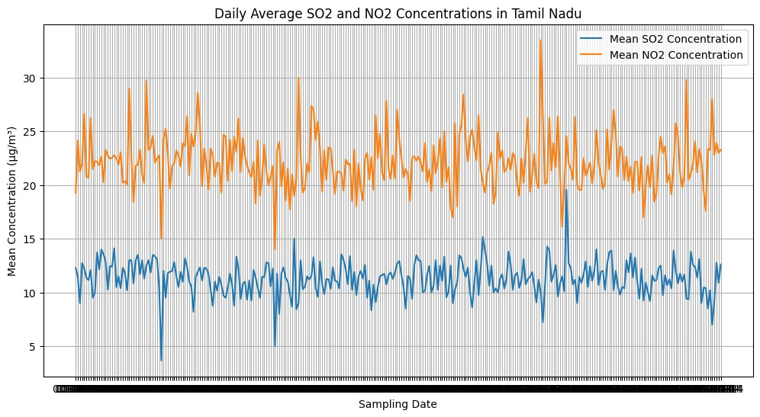

**CALCULATING THE AVERAGE OF SO2, NO2 AND RSPM/PM10 FOR ALL THE**

**Monitoring Stations.**

[ ]:

**import**

**pandas**

**as**

**pd**

*# Load your CSV dataset into a DataFrame*

data

=

pd

.

read_csv(

'

/content/cpcb_dly_aq_tamil_nadu-2014 (2).csv

'

)

*# Group the data by the 'Region' column and calculate the mean for each group*

grouped

=

data

.

groupby(

'

Location of Monitoring Station

'

)[[

'

SO2

'

,

'

NO2

'

,

'

RSPM/

↪

PM10

'

]]

.

mean()

*# Display the calculated averages*

print

(

grouped

)

SO2

NO2 \

Location of Monitoring Station

AVM Jewellery Building, Tuticorin 9.302083 12.697917

Adyar, Chennai 13.252174 18.965217

Anna Nagar, Chennai 13.873874 20.754545

Bishop Heber College, Tirchy 11.800000 14.942857

Central Bus Stand, Trichy 18.013333 21.506667

District Environmental Engineer Office, Imperia… 8.101010 19.151515

Distt. Collector's Office, Coimbatore 4.554348 25.793478

Eachangadu Villagae 11.916667 22.395833

Fenner (I) Ltd. Employees Assiciation Building … 13.643564 27.198020

Fisheries College, Tuticorin 14.526882 20.204301

Gandhi Market, Trichy 17.148649 20.797297

Golden Rock, Trichy 12.014085 15.000000

Govt. High School, Manali, Chennai. 13.043011 15.408602

Highway (Project -I) Building, Madurai 11.947917 24.458333 Kathivakkam, Municipal Kalyana Mandapam, Chennai 12.925532 15.170213

Kilpauk, Chennai 19.232759 27.172414

Kunnathur Chatram East Avani Mollai Street, Mad… 14.340206 25.577320

|  |  |  |
| --- | --- | --- |
| Madras Medical College, Chennai | 7.418605 27.465116 | |
| Main Guard Gate, Tirchy | 17.135135 20.837838 | |
| NEERI, CSIR Campus Chennai | 5.931034 23.758621 | |
| Poniarajapuram, On the top of DEL, Coimbatore | 4.126214 23.019417 | |
| Raja Agencies, Tuticorin | 15.058824 22.441176 | |
| Raman Nagar, Mettur | 7.572816 20.407767 | |
| SIDCO Industrial Complex, Mettur | 9.294118 25.990196 | |
| SIDCO Office, Coimbatore | 4.969072 27.329897 | |
| SIPCOT Industrial Complex, Cuddalore | 6.969697 17.666667 | |
| Sowdeswari College Building, Salem | 8.114504 28.664122 | |
| Thiruvottiyur Municipal Office, Chennai | 8.360465 28.069767 | |
| Thiruvottiyur, Chennai | 13.010417 15.583333 | |
| Thiyagaraya Nagar, Chennai  Location of Monitoring Station | 18.849558 28.250000  RSPM/PM10 | |
| AVM Jewellery Building, Tuticorin | 70.175258 | |
| Adyar, Chennai | 57.068966 | |
| Anna Nagar, Chennai | 72.187500 | |
| Bishop Heber College, Tirchy | 45.633803 | |
| Central Bus Stand, Trichy | 120.546667 | |
| District Environmental Engineer Office, Imperia… | 64.020202 | |
| Distt. Collector's Office, Coimbatore | 42.322222 | |
| Eachangadu Villagae | 75.591837 | |
| Fenner (I) Ltd. Employees Assiciation Building … | 40.732673 | |
| Fisheries College, Tuticorin | 85.255319 | |
| Gandhi Market, Trichy | 101.743243 | |
| Golden Rock, Trichy | 46.222222 | |
| Govt. High School, Manali, Chennai. | 44.612903 | |
| Highway (Project -I) Building, Madurai | 46.427083 | |
| Kathivakkam, Municipal Kalyana Mandapam, Chennai | 46.851064 |
| Kilpauk, Chennai | 88.103448 |
| Kunnathur Chatram East Avani Mollai Street, Mad… | 50.226804 |
| Madras Medical College, Chennai | 35.837209 |
| Main Guard Gate, Tirchy | 107.693333 |
| NEERI, CSIR Campus Chennai | 43.678161 |
| Poniarajapuram, On the top of DEL, Coimbatore | 48.883495 |
| Raja Agencies, Tuticorin | 94.544554 |
| Raman Nagar, Mettur | 51.106796 |
| SIDCO Industrial Complex, Mettur | 54.352941 |
| SIDCO Office, Coimbatore | 55.969072 |
| SIPCOT Industrial Complex, Cuddalore | 46.171717 |
| Sowdeswari College Building, Salem | 62.954198 |
| Thiruvottiyur Municipal Office, Chennai | 34.310345 |
| Thiruvottiyur, Chennai | 42.604167 |
| Thiyagaraya Nagar, Chennai | 102.327434 |

**VISUALIZATION OF DAILY AVERAGE OF RSPM/PM10 CONCENTRATION FOR ALL MONITORING SYSTEMS.**

[ ]: *# Calculate daily average RSPM/PM10 concentrations for all monitoring stations* daily_mean = data.groupby('Sampling Date')[['RSPM/PM10']].mean()

*# Plot daily average RSPM/PM10 concentrations*

plt.figure(figsize=(12, 6)) plt.plot(daily_mean.index, daily_mean['RSPM/PM10'], label='Mean RSPM/PM10␣

↪Concentration') plt.xlabel('Sampling Date') plt.ylabel('Mean Concentration (µg/m³)') *# Units may vary based on your data* plt.title('Daily Average RSPM/PM10 Concentrations in Tamil Nadu') plt.legend() plt.grid(**True**) plt.show()

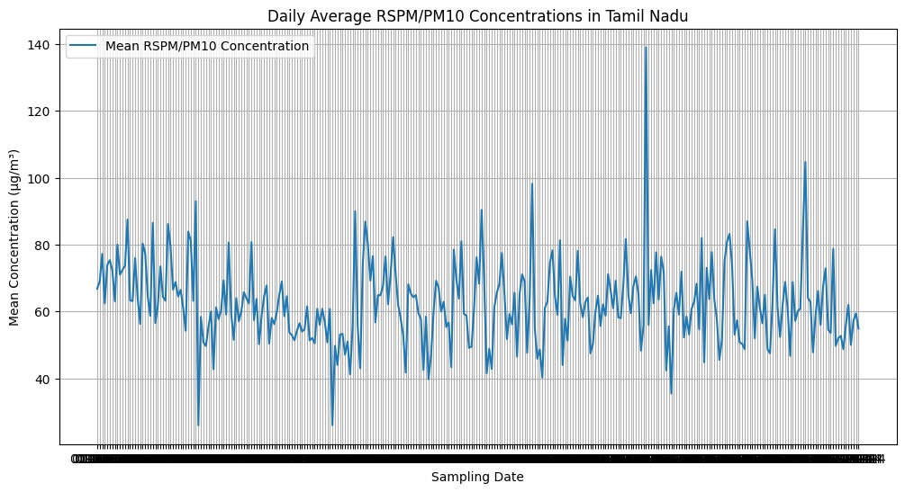

**SORTED AVERAGE POLLUTION OF EACH City/Town/Village/Area**

[1]: **import pandas as pd**

*# Load your CSV dataset into a DataFrame*

data = pd.read_csv('/content/cpcb_dly_aq_tamil_nadu-2014 (1).csv')

*# Calculate the average pollution level for each area*

data['Average_Pollution'] = data[['SO2', 'NO2', 'RSPM/PM10']].mean(axis=1)

*# Sort the areas in increasing order of average pollution levels* sorted_data = data.sort_values(by='Average_Pollution',ascending = **False**)

*# Display the sorted DataFrame* print(sorted_data[['C', 'Average_Pollution']])

City/Town/Village/Area Average_Pollution

|  |  |  |
| --- | --- | --- |
| 354 | Chennai | 113.500000 |
| 2636 | Trichy | 107.000000 |
| 438 | Chennai | 102.000000 |
| 2844 | Trichy | 100.333333 |
| 2846 | Trichy | 100.333333 |
| … | … | … |
| 1556 | Cuddalore | 11.333333 |
| 849 | Chennai | 11.333333 |
| 1563 | Cuddalore | 11.333333 |
| 1557 | Cuddalore | 11.000000 |
| 1562 | Cuddalore | 10.666667 |

[2879 rows x 2 columns]

**VISUALIZATION OF AVERAGE OF SO2 AND NO2 USING MAP.**

[ ]: **import geopandas as gpd import matplotlib.pyplot as plt import pandas as pd**

*# Load geographic boundary data for Tamil Nadu (replace 'tamil_nadu_location.*

↪*shp' with the actual file path)* tamil_nadu_boundary = gpd.read_file('/content/tamil_nadu_location.shp',␣ ↪encoding='utf-8')

*# Merge your data with the Tamil Nadu boundary data based on a common*␣

↪*identifier (e.g., location name)* merged_data = tamil_nadu_boundary.merge(data, left_on='NAME', right_on='City/ ↪Town/Village/Area', how='right')

*# Create a map with the Tamil Nadu boundary data* ax = tamil_nadu_boundary.plot(figsize=(12, 8), color='lightgray',␣ ↪edgecolor='white')

*# Plot the locations and values on the map* merged_data.plot(ax=ax, markersize=merged_data['SO2'], alpha=0.1, legend=**True**,␣

↪cmap='gist_heat', label = "SO2") merged_data.plot(ax=ax, markersize=merged_data['NO2'], alpha=0.2, legend=**True**,␣ ↪cmap='winter', label = "NO2")

*# Add place names as labels to the points on the map* **for** x, y, label **in** zip(merged_data.geometry.x, merged_data.geometry.y,␣ ↪merged_data['City/Town/Village/Area']):

**if not** pd.isna(x) **and not** pd.isna(y):

plt.annotate(label, (x, y), fontsize=10, ha='center', va='bottom')

plt.title('Average of SO2 and NO2 Values in Tamil Nadu') ax.legend() plt.show()

