MSML606 - HW 4

Anbuchelvan K

IMPLEMENTATION DETAILS:

Randomized Quicksort : It is a divide and conquer based solution which works by using a pivot element. We randomly pick the pivot element then we move it to the back of the list then we slowly partition the numbers one by one using the pivot as the point of comparison. We basically keep the smaller elements to the left of the pivot and the bigger elements to the right of the pivot. After this step the pivot is swapped to its sorted position in between those two groups and this process is done recursively.

Heapsort: It is a comparison based sorting solution that uses Max Heap data structure to sort the data. The algorithm first converts the array into a tree structure where the parent node is greater than or equal to the child node. Then we remove the root node since it is the largest number guaranteed by the Max Hep property. Then we call the heapify function again to select a new root node and fix the Max Heap. This is done recursively until the last element is sorted.

TIME AND SPACE COMPLEXITY:

Randomized Quicksort : Best Case - O(N Log N)
Average Case - O(N Log N)
Worst Case - O(N^2)
Best/ Average Space Complexity - O(Log N)
Worst Space Complexity - O(N)

Heapsort : Best Case - O(N Log N)
Average Case - O(N Log N)
Worst Case - O(N log N)
Space Complexity - O(1)

PERFORMANCE COMPARISON :

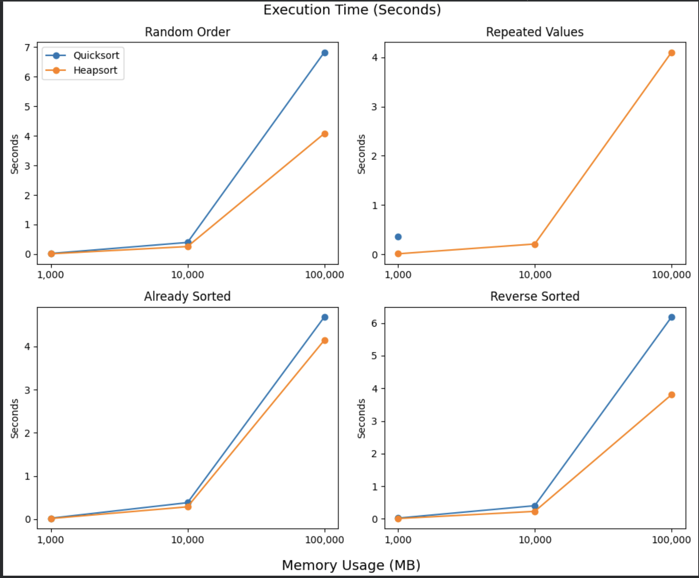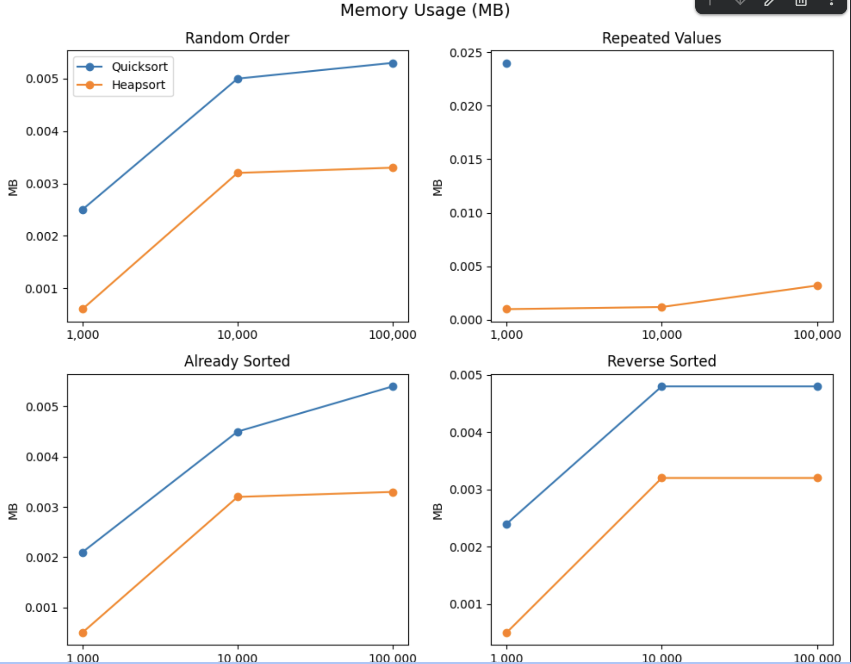

OBSERVATIONS and DISCUSSIONS :

The test cases show that random pivot helps in handling sorted arrays but the algorithm crashes when we use repeating elements. Identical numbers prevented Quicksort from splitting the list evenly, which slows it down and causes Recursion errors. On the other hand heapsort handled all cases well. It also used less memory compared to Quicksort while also taking way less time in all cases. Overall heapsort performed better than Randomized Quicksort

