# UNITY CATALOG

## 1. INTRODUCTION TO UNITY CATALOG

Unity Catalog is Databricks’ centralized data governance solution that provides:  
- Fine-grained access control for data and AI assets  
- Unified security model for all data types (tables, files, ML models)  
- Auditing and lineage tracking  
- Centralized policy enforcement across multiple workspaces  
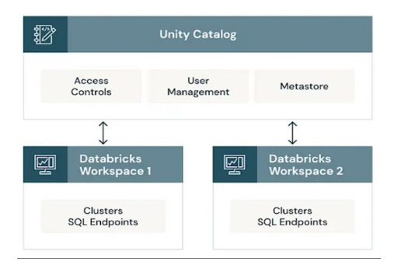  
Unity Catalog standardizes data organization using a three-level namespace: <catalog>. <schema>. <table>.

This provides a clear separation between data governance levels.

## 2. CREATING A UNITY CATALOG METASTORE

**Step 1 – Prerequisites**

- You must be a Databricks account admin.  
- Your Databricks deployment must be on AWS, Azure, or GCP with Unity Catalog support.  
- Your workspace must be on the Premium or Enterprise tier.

**Step 2 – Create the Metastore**

1. Log in to Databricks Account Console (https://accounts.cloud.databricks.com).  
2. In the left navigation, click Data → Metastores.  
3. Click Create Metastore.  
4. Fill in:  
 - Name – descriptive name (e.g., org_metastore)  
 - Region – must match your cloud storage region  
 - Storage Root – cloud storage path for managed tables (Example AWS: s3://my-company-unity-catalog/)  
5. Click Create.

**Step 3 – Assign the Metastore to a Workspace**

1. In the Metastore list, select the one you just created.  
2. Click Assign to Workspace.  
3. Select the workspace(s) to enable.  
4. Click Assign.

## 3. ENABLING UNITY CATALOG IN A DATABRICKS WORKSPACE

After assigning:  
1. Go to your Databricks workspace.  
2. In Admin Settings, ensure Unity Catalog is enabled.  
3. Verify by running in a notebook:  
 SHOW CATALOGS;

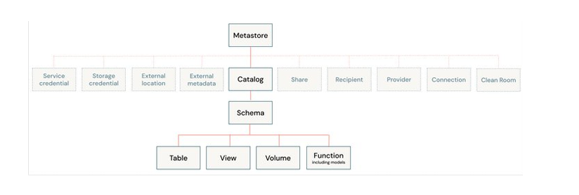

## 4. UNDERSTANDING THE 3-LEVEL NAMESPACE

Unity Catalog organizes data as:  
1. Catalog – Top-level container, typically representing an organization-wide grouping of data assets.  
2. Schema – Logical grouping of tables/views inside a catalog.  
3. Table – The actual data object.  
  
**Example:**  
SELECT * FROM sales_data.europe.customers;  
-- catalog = sales_data  
-- schema = europe  
-- table = customers

## 5. CREATING UNITY CATALOG OBJECTS

* **Create a Catalog:**  
  CREATE CATALOG sales_data COMMENT 'Catalog for sales analytics';
* **Create a Schema:**  
  CREATE SCHEMA sales_data.europe COMMENT 'Schema for European sales data';
* **Create a Managed Table:**  
  CREATE TABLE sales_data.europe.customers (  
   customer_id STRING,  
   name STRING,  
   country STRING  
  )  
  COMMENT 'Customer details for Europe'  
  TBLPROPERTIES ('quality'='gold');
* **Create an External Table:**  
  CREATE TABLE sales_data.europe.orders  
  USING PARQUET  
  LOCATION 's3://external-bucket/orders_data/';

## 6. KEY BENEFITS OF UNITY CATALOG - Fine-grained access control (row/column-level) - Audit & lineage tracking - Multi-cloud compatibility - Consistent namespace across the organization