**MONGODB NOTES**

* MongoDB is a NoSQL, document-oriented database that stores data in flexible JSON-like documents instead of traditional rows and columns.
* MongoDB ≠ RDBMS
* **Advantages:**
* Flexible schema
* High availability
* Horizontal scalability
* Supports fast performance

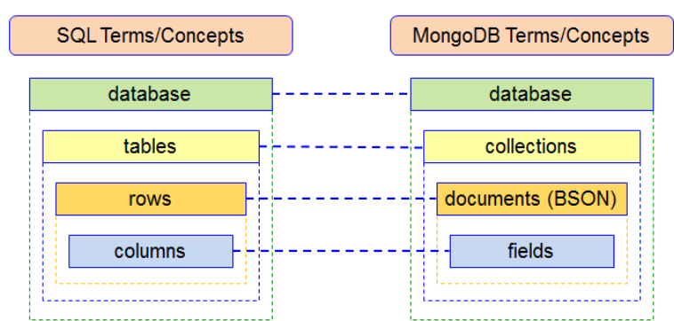

**HORIZONTAL SCALING:**

* + Add more machines/servers to distribute load. There is no limit.
  + It’s key feature is to add capacity by increasing more servers.
  + It is very famous and widely used in real world applications.

**VERTICAL SCALING:**

* + Upgrade the existing machine with more RAM, storage.
  + **Example:** Moving from 8GB RAM to 32GB RAM on the same server.
  + **Used In:** Single-server applications.

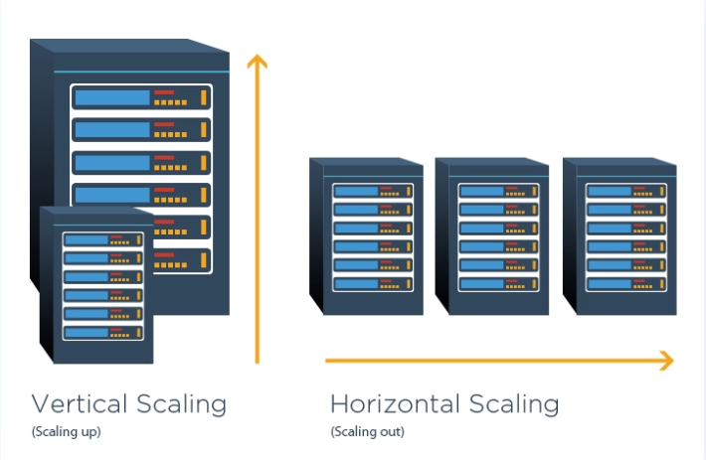

**NOSQL DATABASE:**

Unlike relational databases (which use tables and rows), NoSQL databases store data in different ways such as:

* Document-oriented (MongoDB)
* Key-Value stores
* Column-oriented
* Graph databases

Purpose: Designed to store big data, support real-time applications and provide flexibility without fixed schemas.

**KEY FEATURES OF NOSQL:**

* + Provides a mechanism for storage and retrieval of data other than tabular relations.
  + **Doesn’t use tables** for storing data.
  + Best for **big data** and **real-time applications**.

**HISTORY OF NOSQL:**

* + **Early 1970s:** Data stored in **File Systems**. It has a problem that it has no standard, difficult to store and retrieve data.
  + **Relational Databases (RDBMS)** introduced by **E.F. Codd** to solve structure issues.
  + RDBMS failed to handle massive data and high-speed requirements.
  + **Solution:** NoSQL databases were developed to overcome:
* Schema rigidity
* Horizontal scalability needs
* Performance limitations

**ADVANTAGES OF NOSQL:**

* + Supports Query Language
* Simple and powerful query operations.
  + Fast Performance
* Handles large amounts of read/write data efficiently.
  + Horizontal Scalability
* Can scale out easily by adding more servers (distributed architecture).

**EXAMPLE OF MONGODB JSON DOCUMENT:**

