**File Creation Task**

**Task Description:**

1. Create a directory called ""my_folder"", navigate into it,

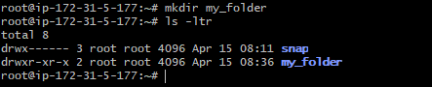

create a file named ""my_file.txt"" with some text. Then, create another file named ""another_file.txt"" with some text.

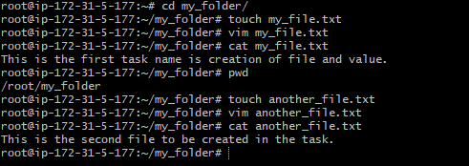

Concatenate the content of ""another_file.txt"" to ""my_file.txt"" and display the updated content.

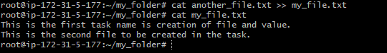

Finally, list all files and directories in the current directory.

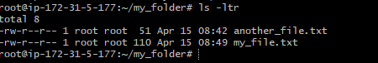

1. Create 20 files with .txt extensions

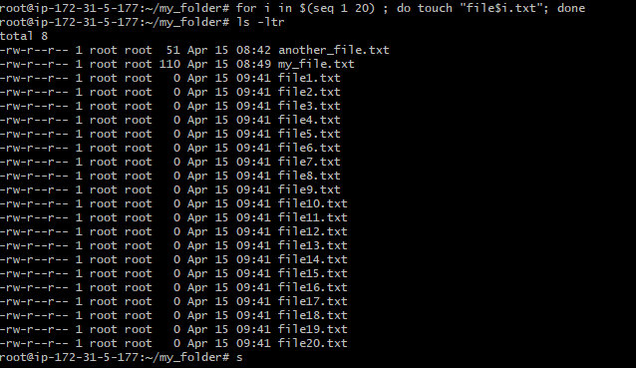

rename the first 5 files to .yml extension

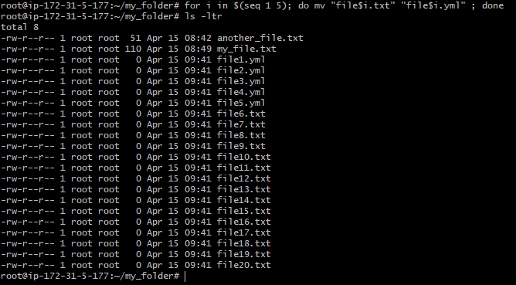

Print the latest created top 5 files among the total no of files".

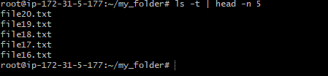

Since the even after the first 5 file name we have modified into .yml extention it is not listing here because modification time stamp of those files are not changed hence it is giving the output of file20.txt to file16.txt.