**Network Task:**

1. **Get the IP address of a particular domain (guvi.in)**

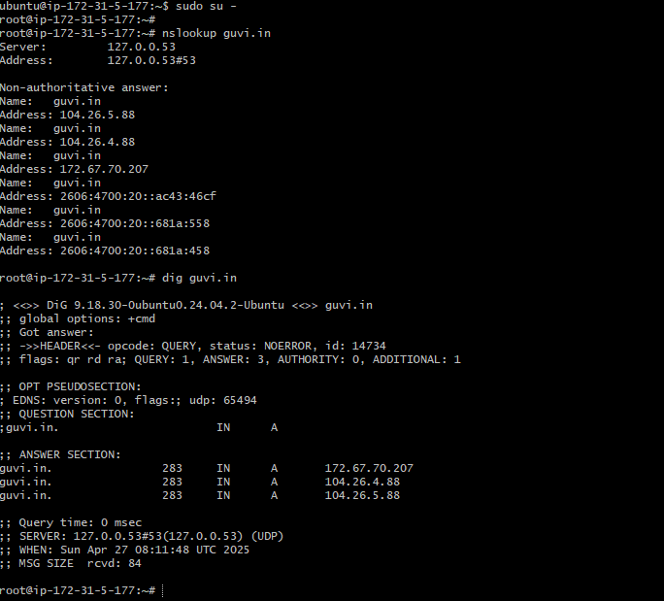

1. **How do I find my CPU/Memory usage of my server?**

By Giving **TOP** command in the server will show the CPU / Memory usage of the server.

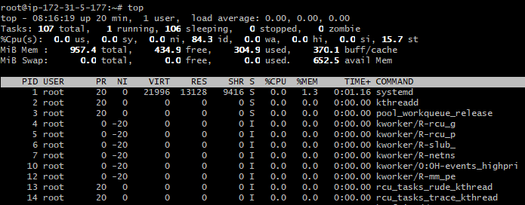

1. **Test the connectivity between 2 nodes?**

In this case, am trying to connect my aws instance from local desktop but it is not able to connect because of the security group is not allowing other user to connect to the AWS instance.

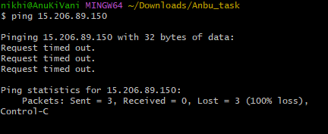

So I have allowed the all the user able to connect from the outside network. For that I have added the security group inbound rule(custom-ICMP-IPV4) & Source as Anywhere IPV4 in the instance which I have created.

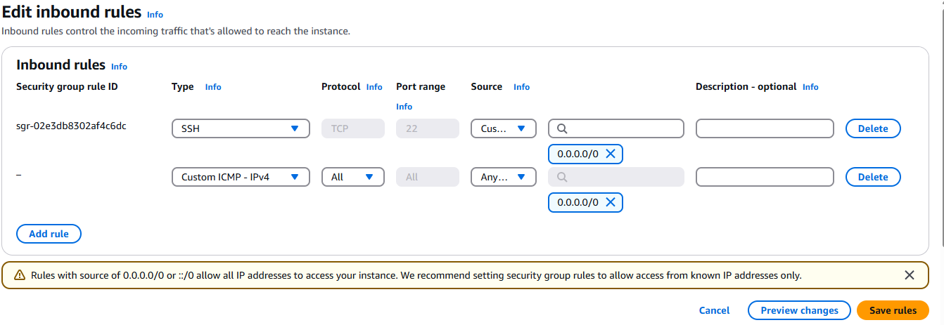

After applying this rule. I can able test the connectivity from the local desktop.

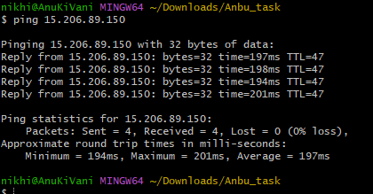

1. **I have deployed an application in guvi.com:9000 and logs show my app is running , but I’m unable to view the page. Check whether my port is open or not?**

Netstat –tupln will show the output of the ports that are listening on the server. If 9000 port is showing listening then the port is open and able to view the page.

