Kubernetes Task-2

Task Description:

Create the K8s EKS,further you have to do the deployment of the Nginx application and access the application outside the cluster.

Solution:
AWSCTL,EKCTL and kubectl has been installed in local desktop
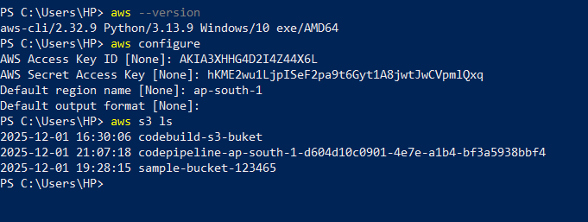
Created demo-cluster using eksctl command
eksctl create cluster –name demo-cluster –region ap-south-1 –version 1.31 –node-type t2.medium –nodes 2
we can check the cluster creation progress in AWS cloudformation tab about the status of the cluster.
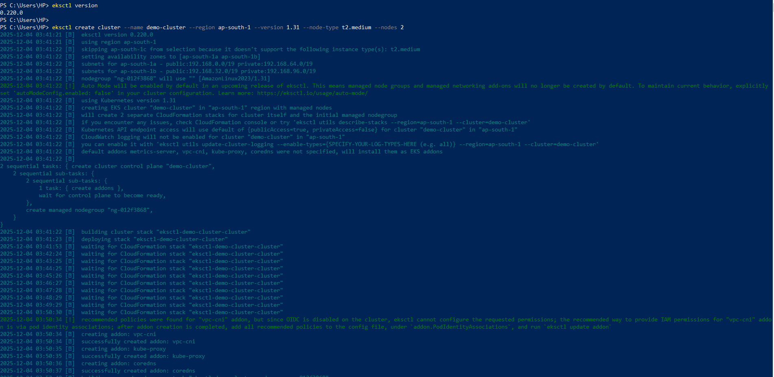
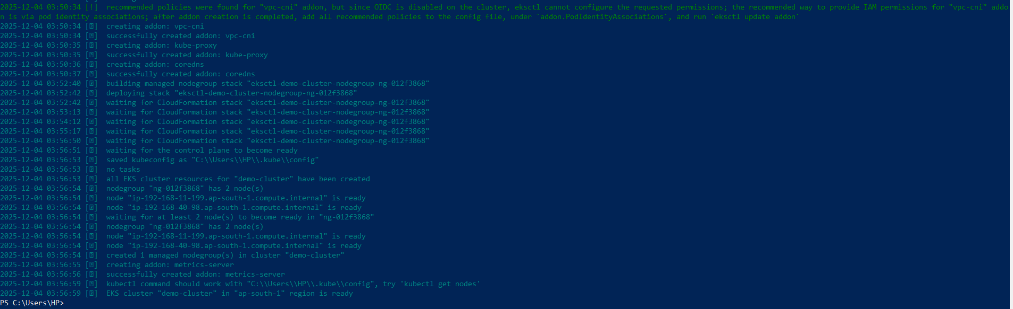
Demo-cluster is created in EKS using eksctl.
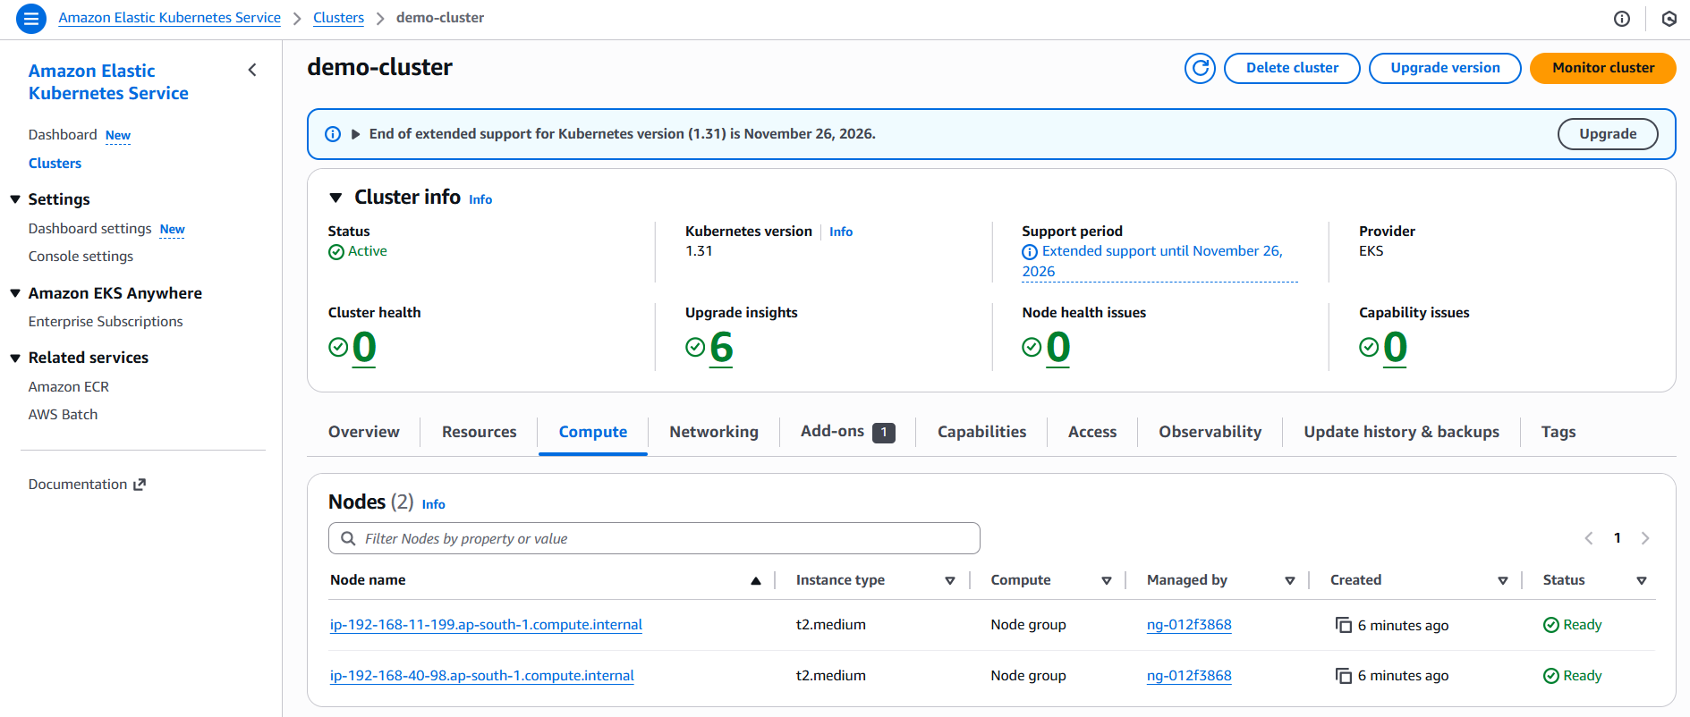
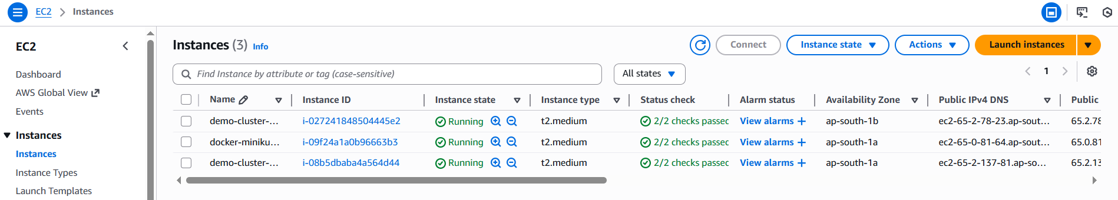

Set the kubeconfig to connect to the created cluster.
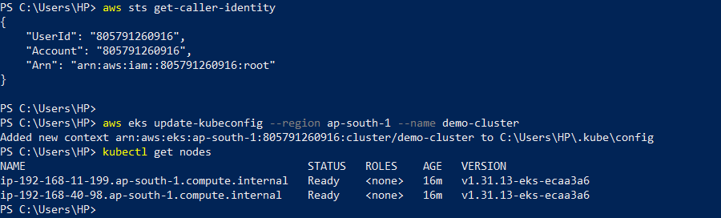

Created deployment of nginx application with nodeport to expose it externally.
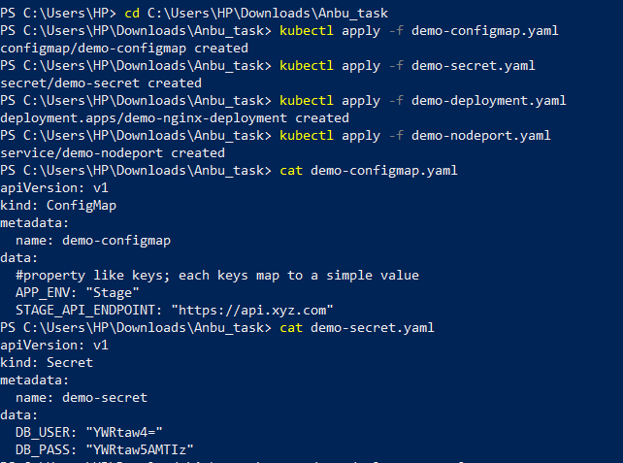
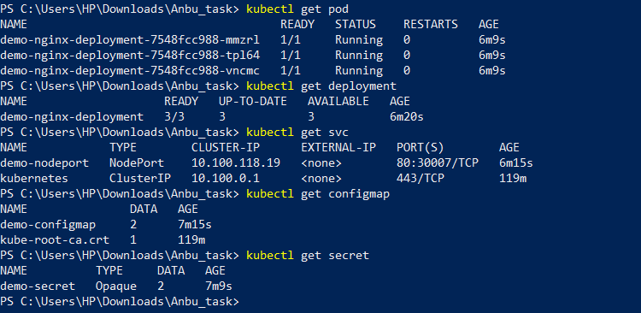
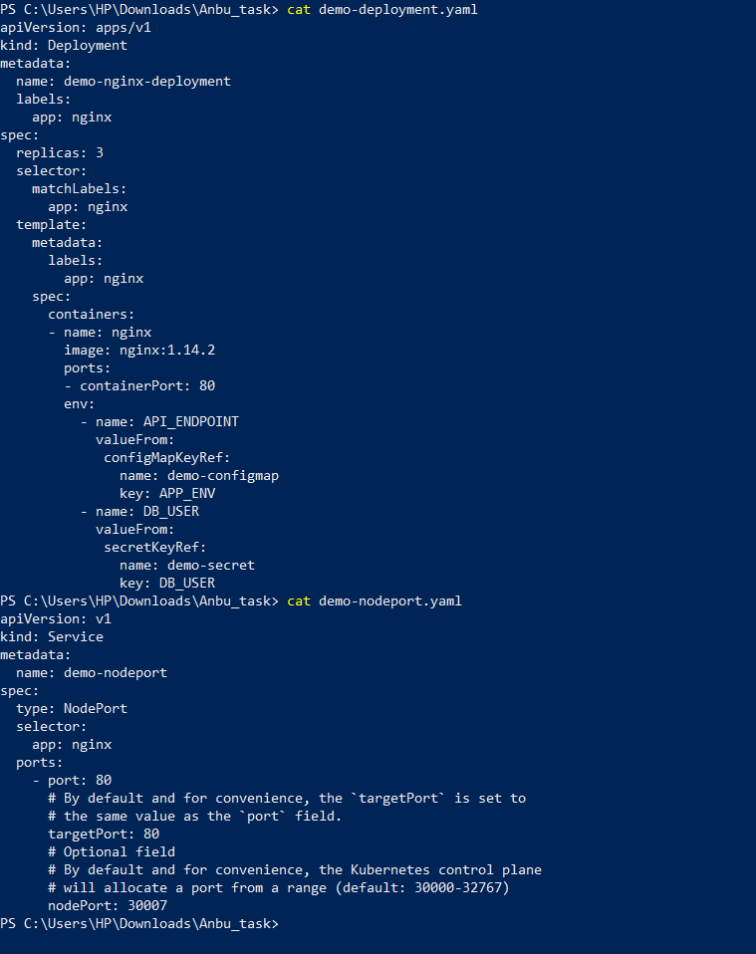
External connection output using EKS cluster worker node public IP
