Terraform Task

Task Description:

Launch Linux EC2 instances in two regions using a single Terraform file.

Solution:
Download terraform for windows and set the environmental path , connect to AWS cluster using AWS configure command
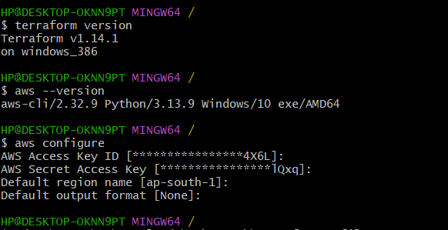
Create main.tf file in local folder and open it in vs code and install Harshicorp plugin writing the simple script to create 2 EC2 instance in two different region
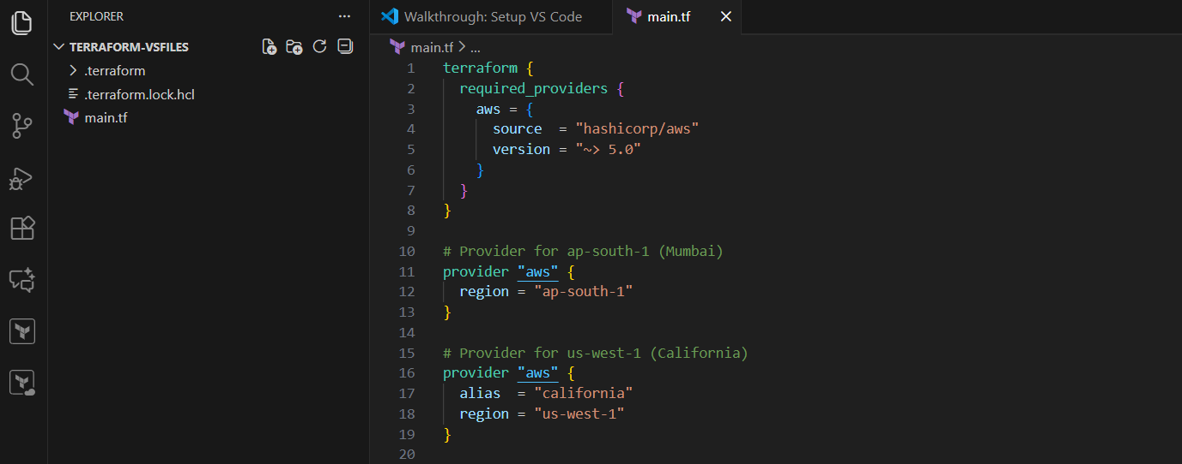

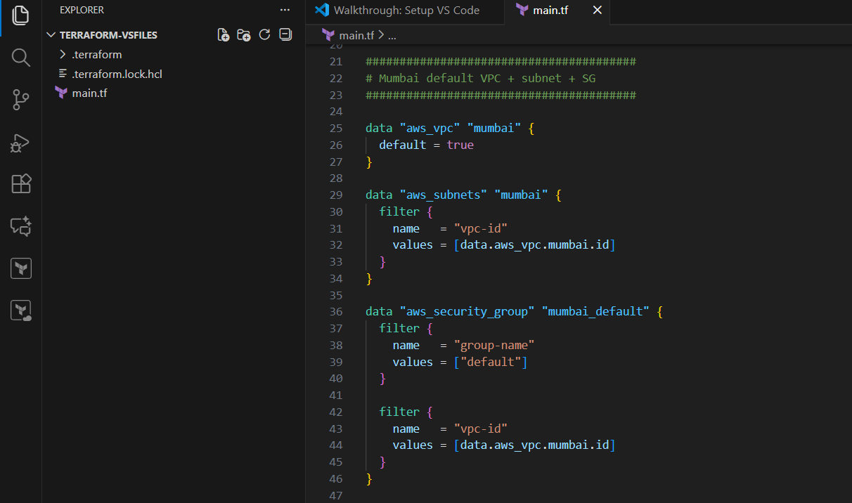
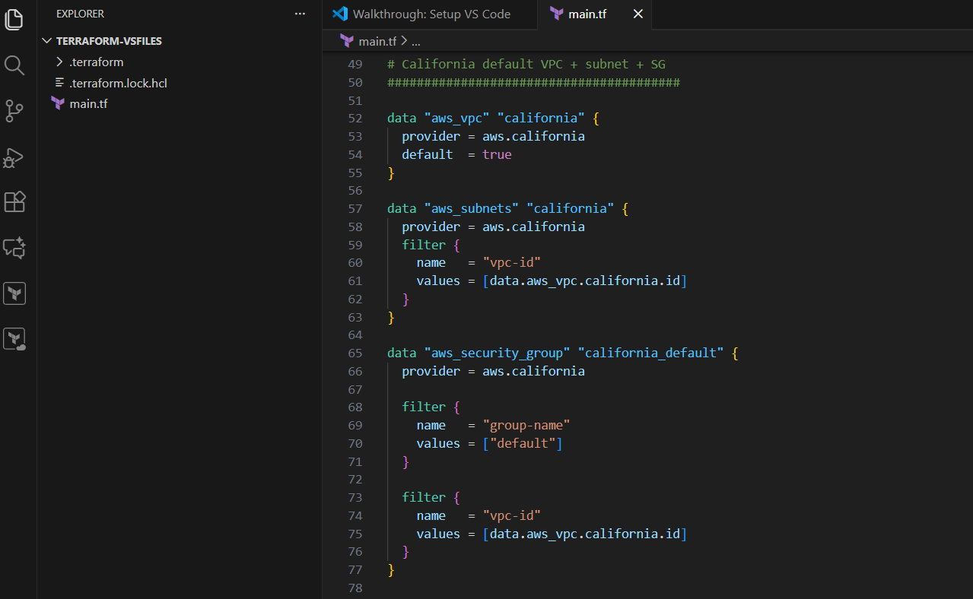
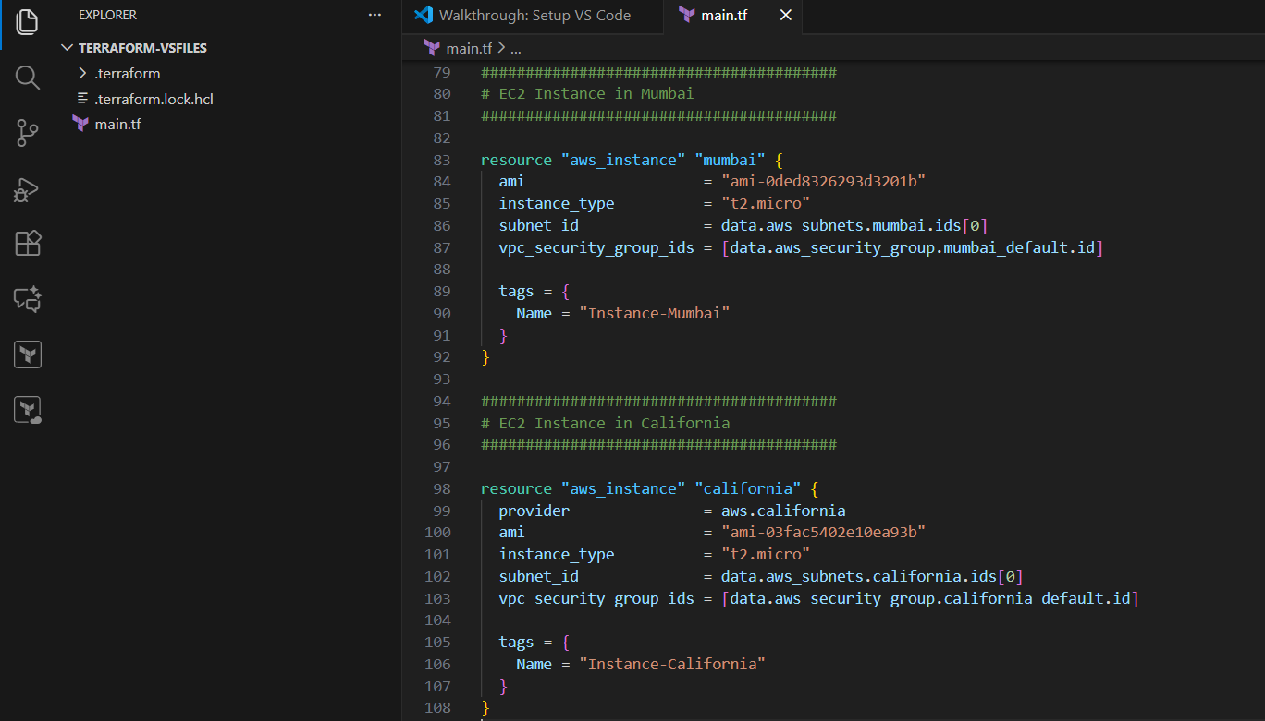

Saved the main.tf file and initiating terraform using terraform init
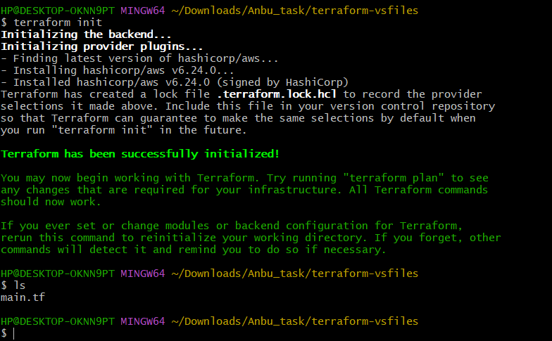
Terraform plan
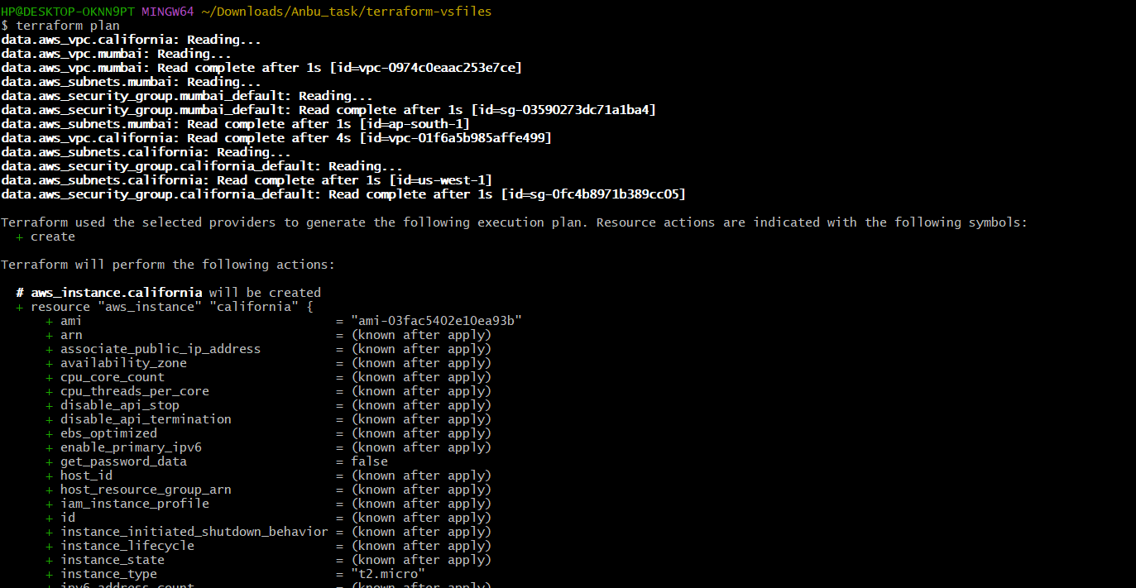
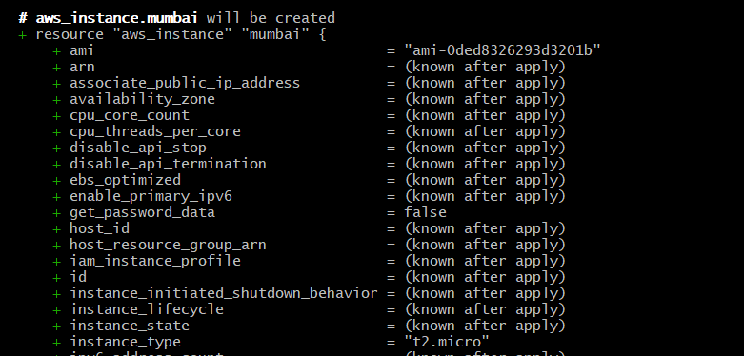
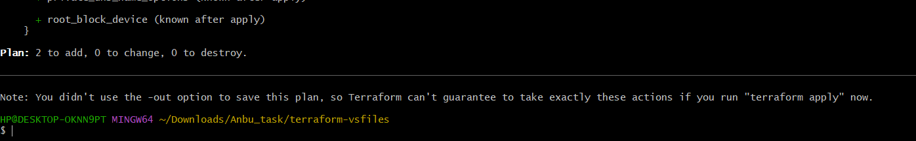

Terraform apply:
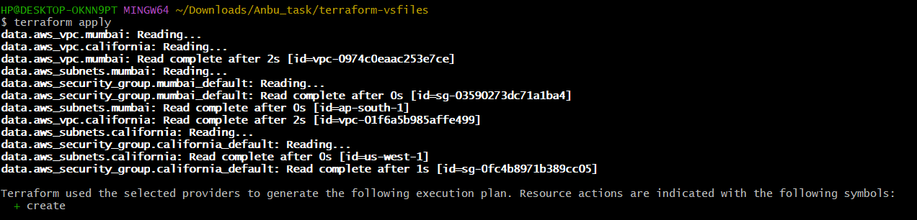
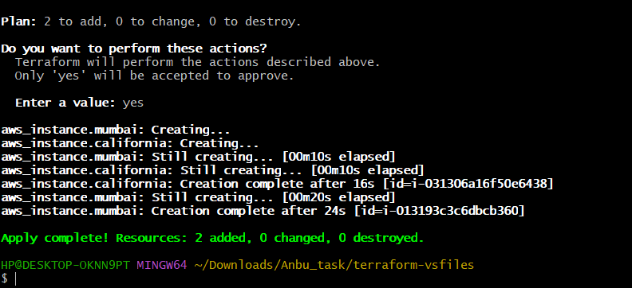
aws-mumbai region
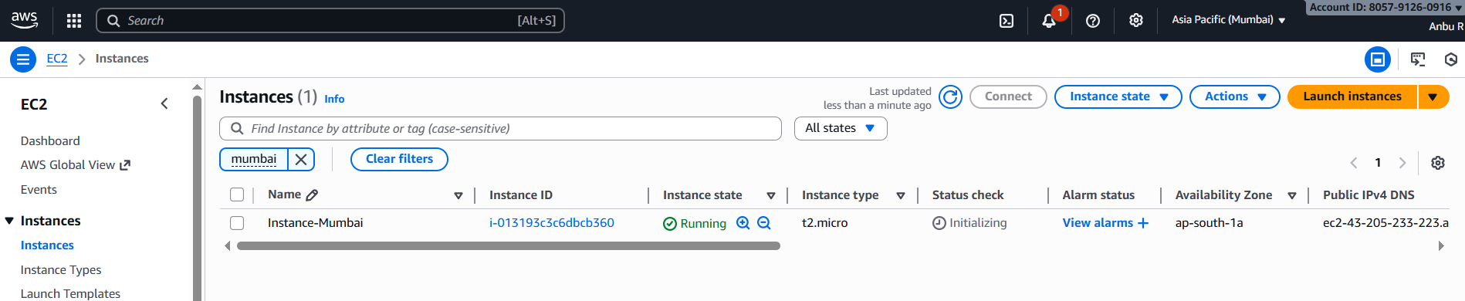
aws-california region
