Terraform Task-2

Task Description:

Create 2 EC2 instances on 2 different regions and install nginx using terraform script.

Solution:
Created main.tf with user data added to install the nginx package while creating the EC2 server.
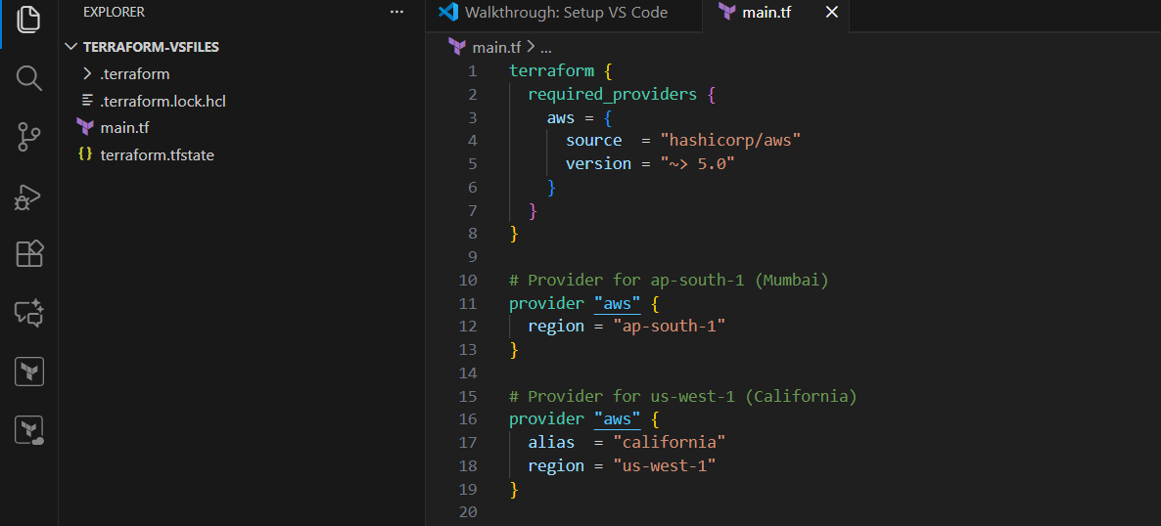
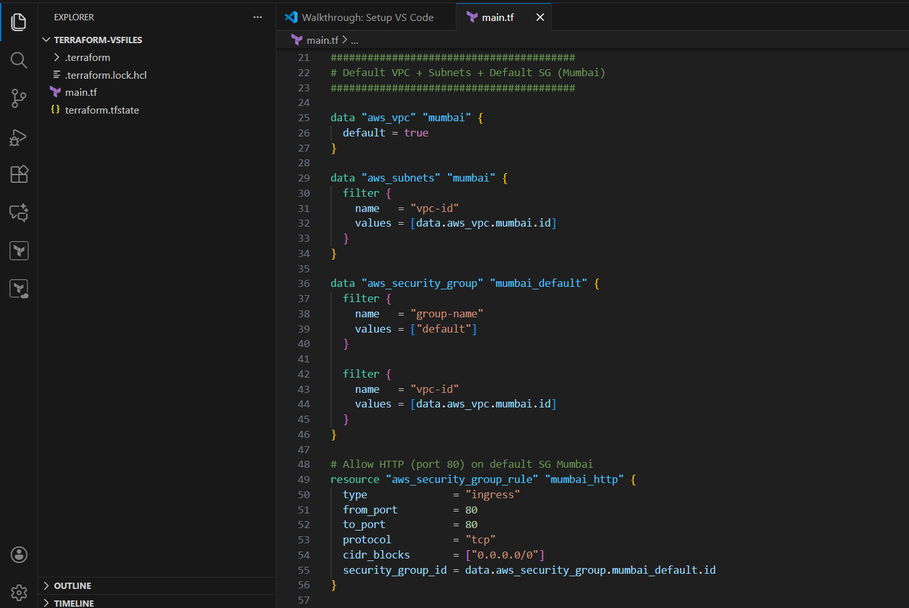
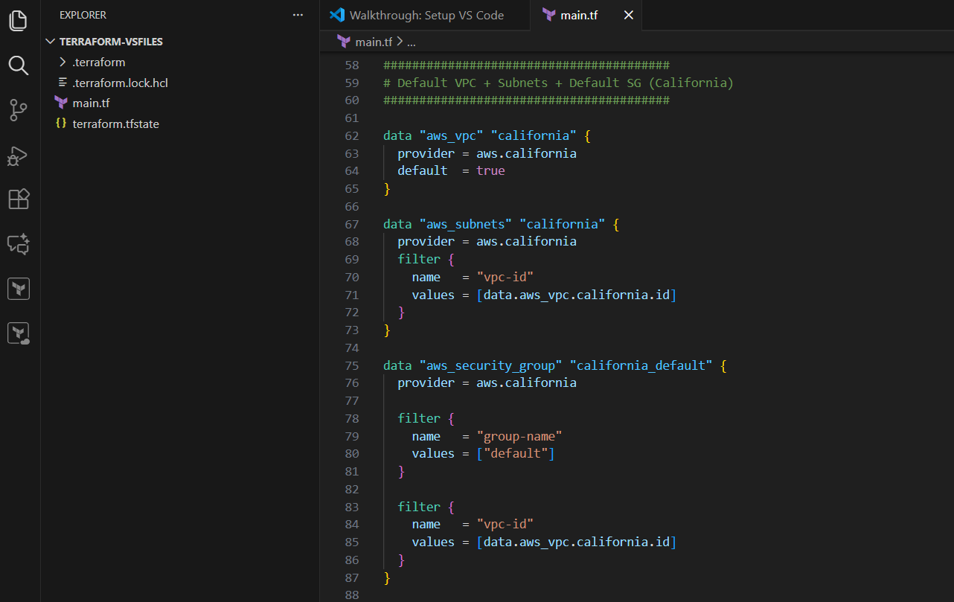
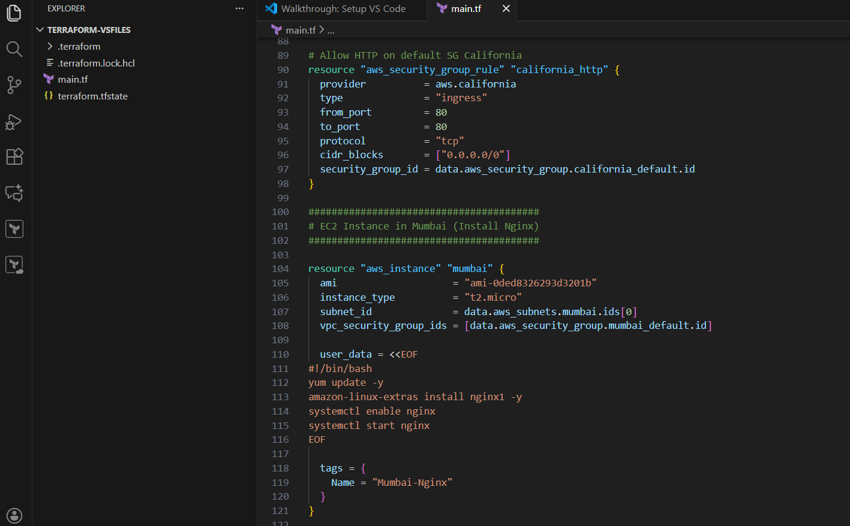
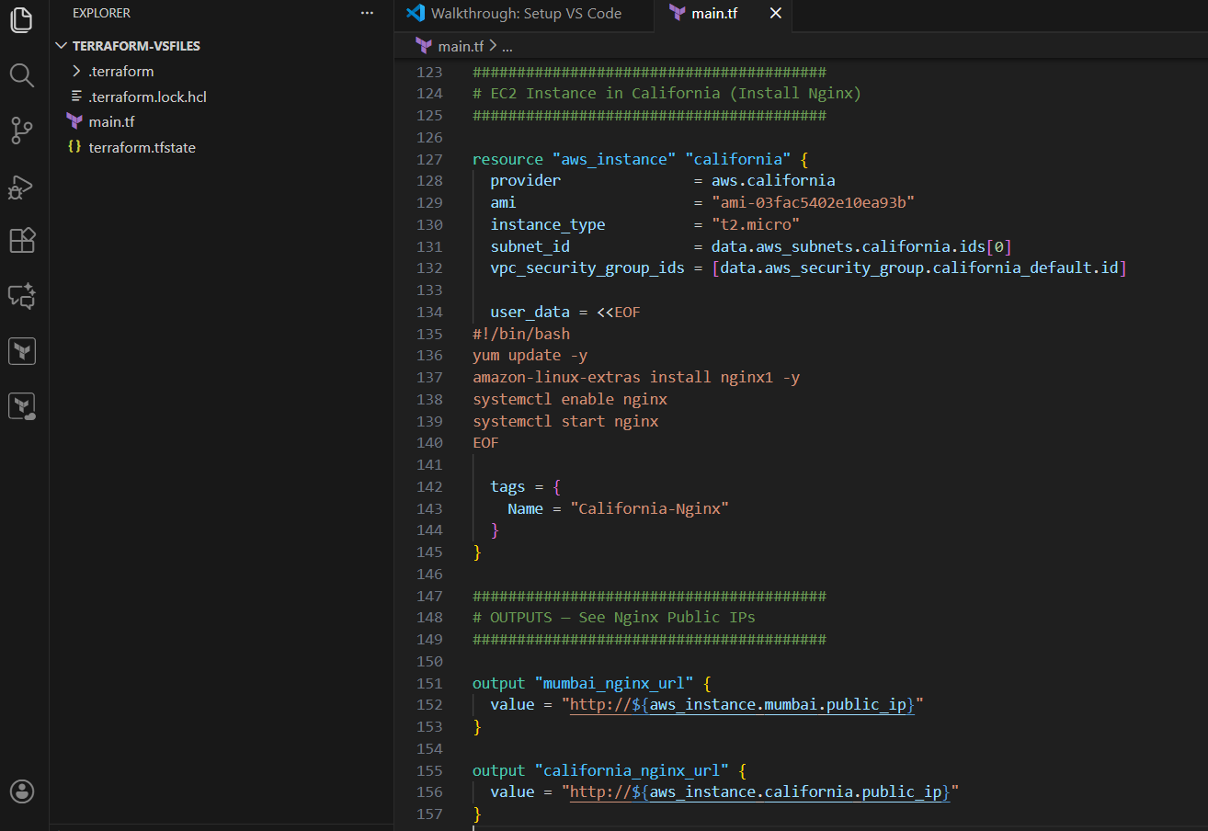

Given terraform plan:
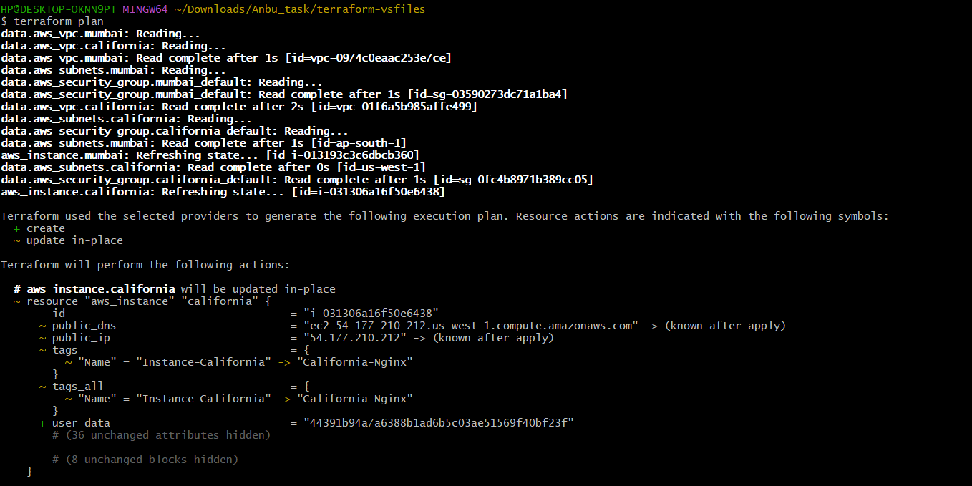

2 changes applied to re-create the instance with installing nginx
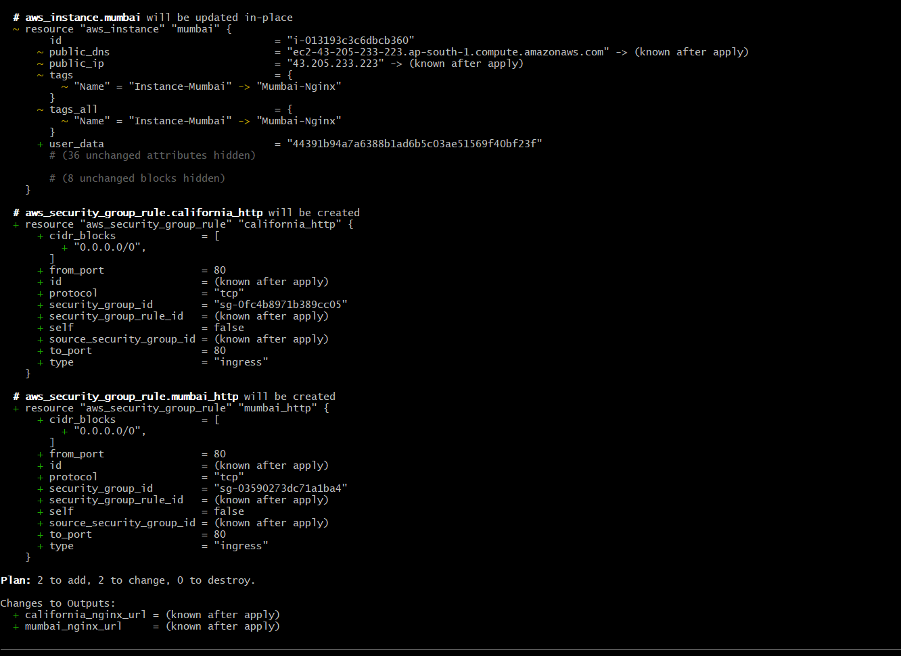
Before applying running taint command to take the user data value in the script
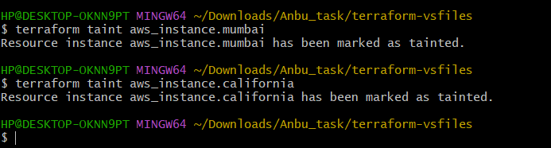

Terraform applied and it is creating the instance with nginx installed in 2 different region
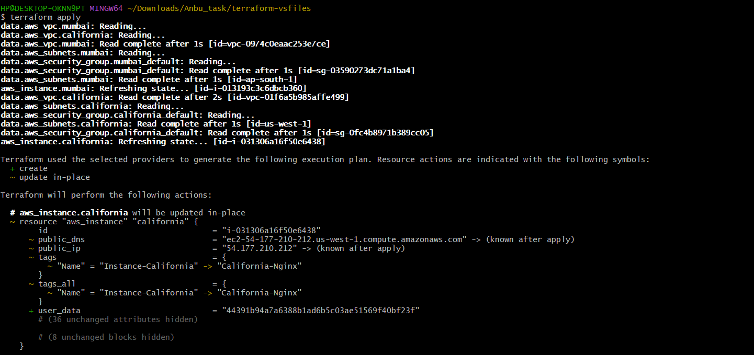
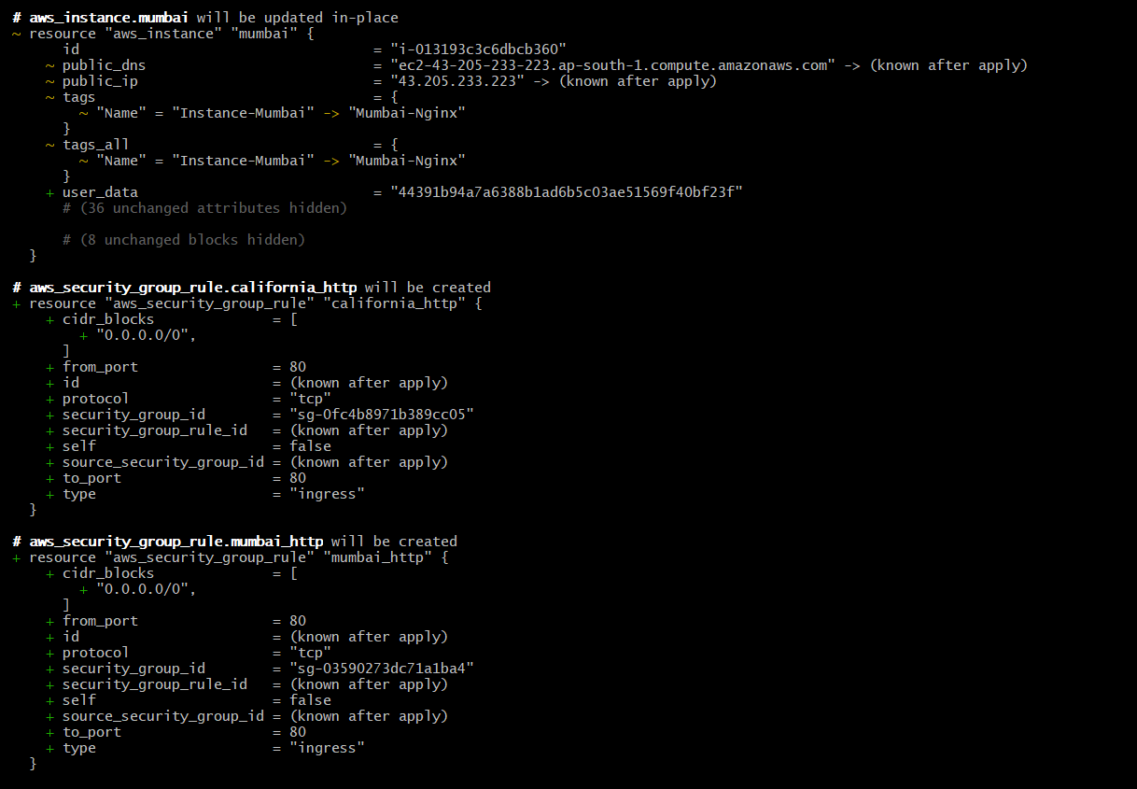

Changes have been mentioned and get the output URL to check the nginx is working
