AWS Task-5

Task Description:

Deploy a simple web application using AWS code commit, code build and deploy & access via browser and automate via codepipeline.

Steps:
Instead of codecommit am using github repo in this pipeline for deploying web application.
https://github.com/anbugit004/codepipeline - This repo has been used for this pipeline
Code build:
Created codebuild project and buildspecyaml file used from gitrepo and in that buildspec file created s3 bucket to get the jar file in it for my application
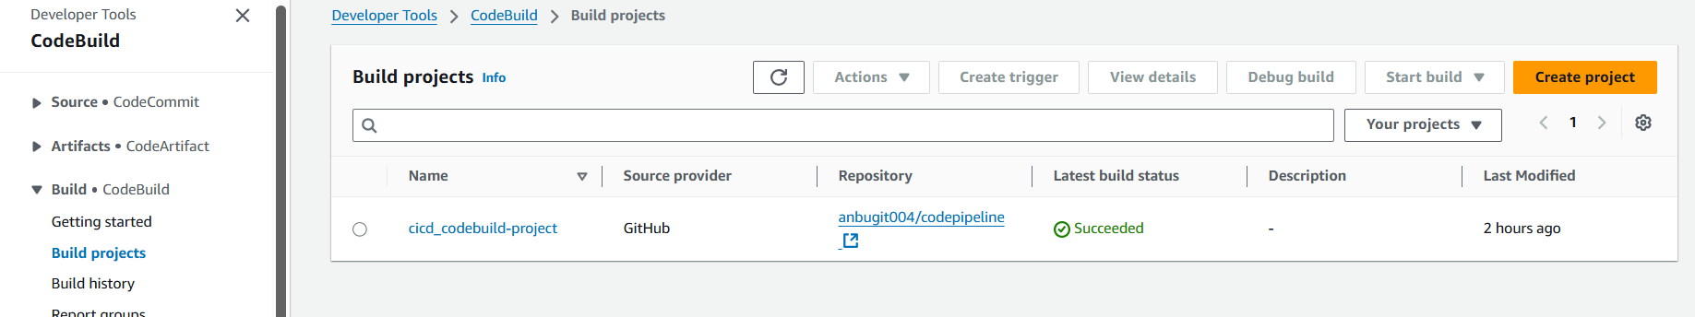
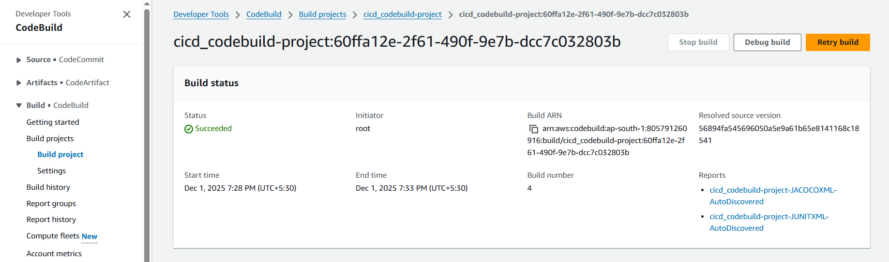
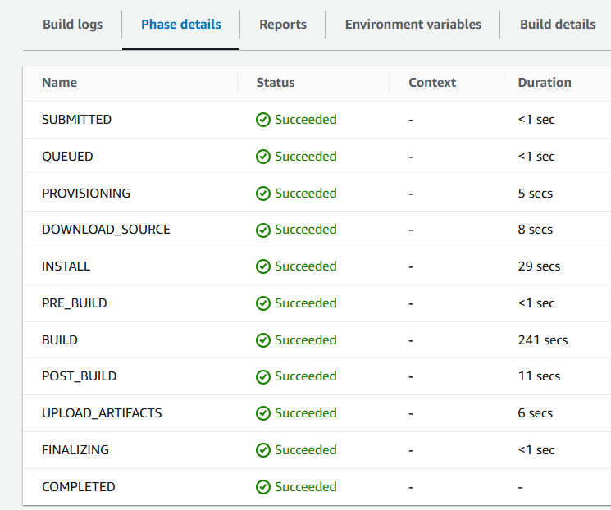
Code deploy:
Created code deploy application and installed code deploy agent in EC2 ubuntu server and created codedeploymentgroup and added IAM role for S3, code deploy and adding script from github and added appspec.yaml file to install dependencies and start the Java application

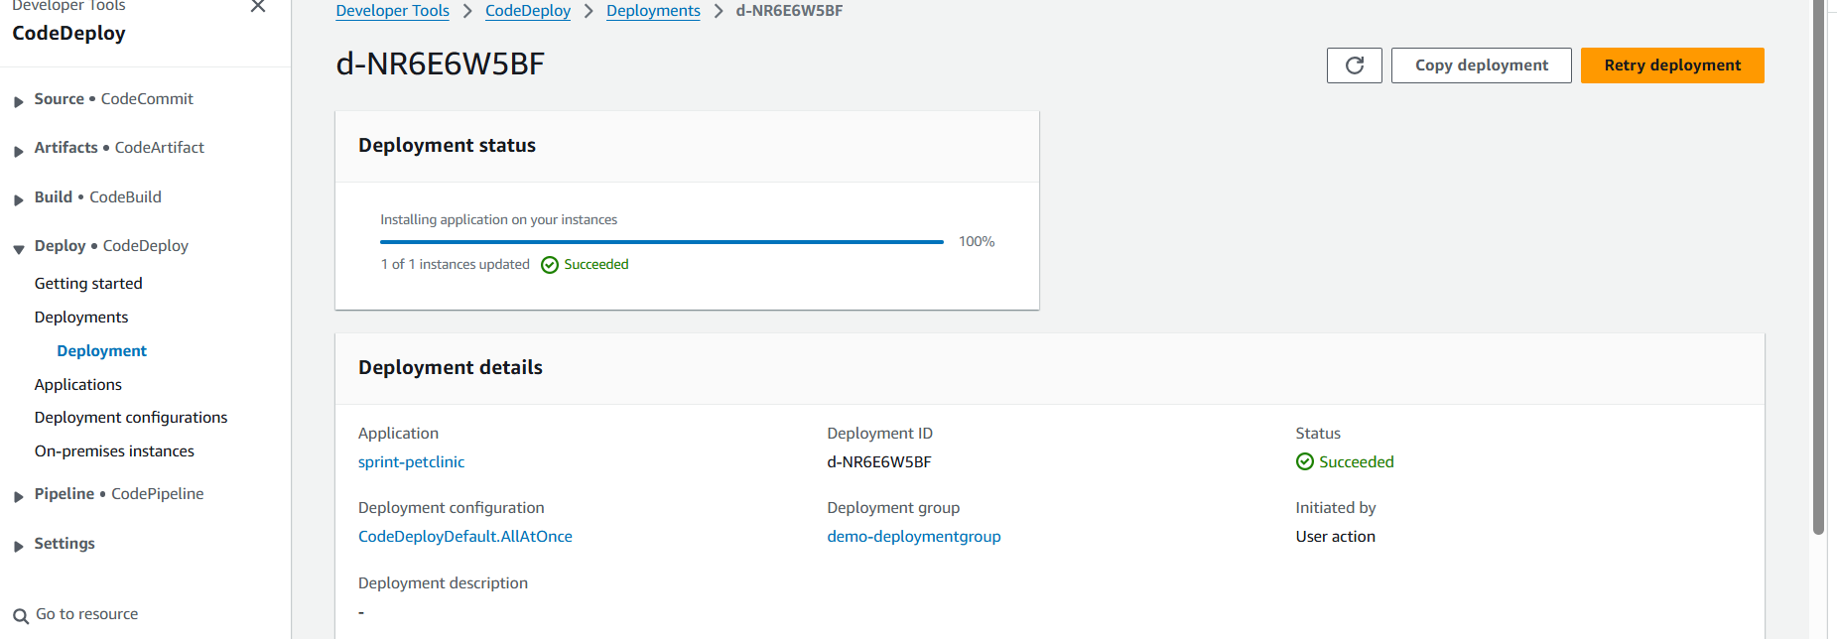
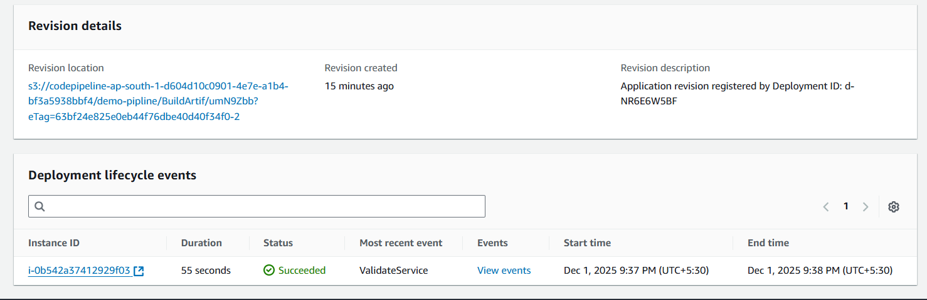
Code pipeline:
Demo pipeline has been created with custom steps added the artifacts and IAM permissions to deploy a pipeline. Once it is completed we need add the inbound rule in SG to get the output from browser.
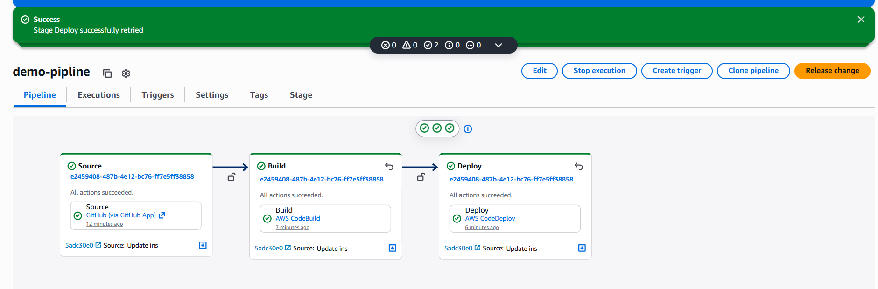

Output from browser:
