Docker Task

Task Description:

Install docker on EC2 and explore the docker commands (docker images, containers, volumes, network)

Solution:
Created EC2 server and installed docker into it.

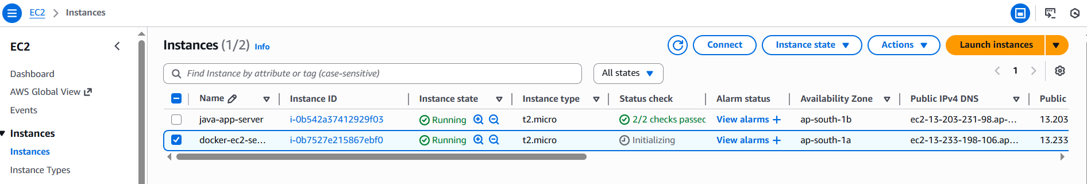

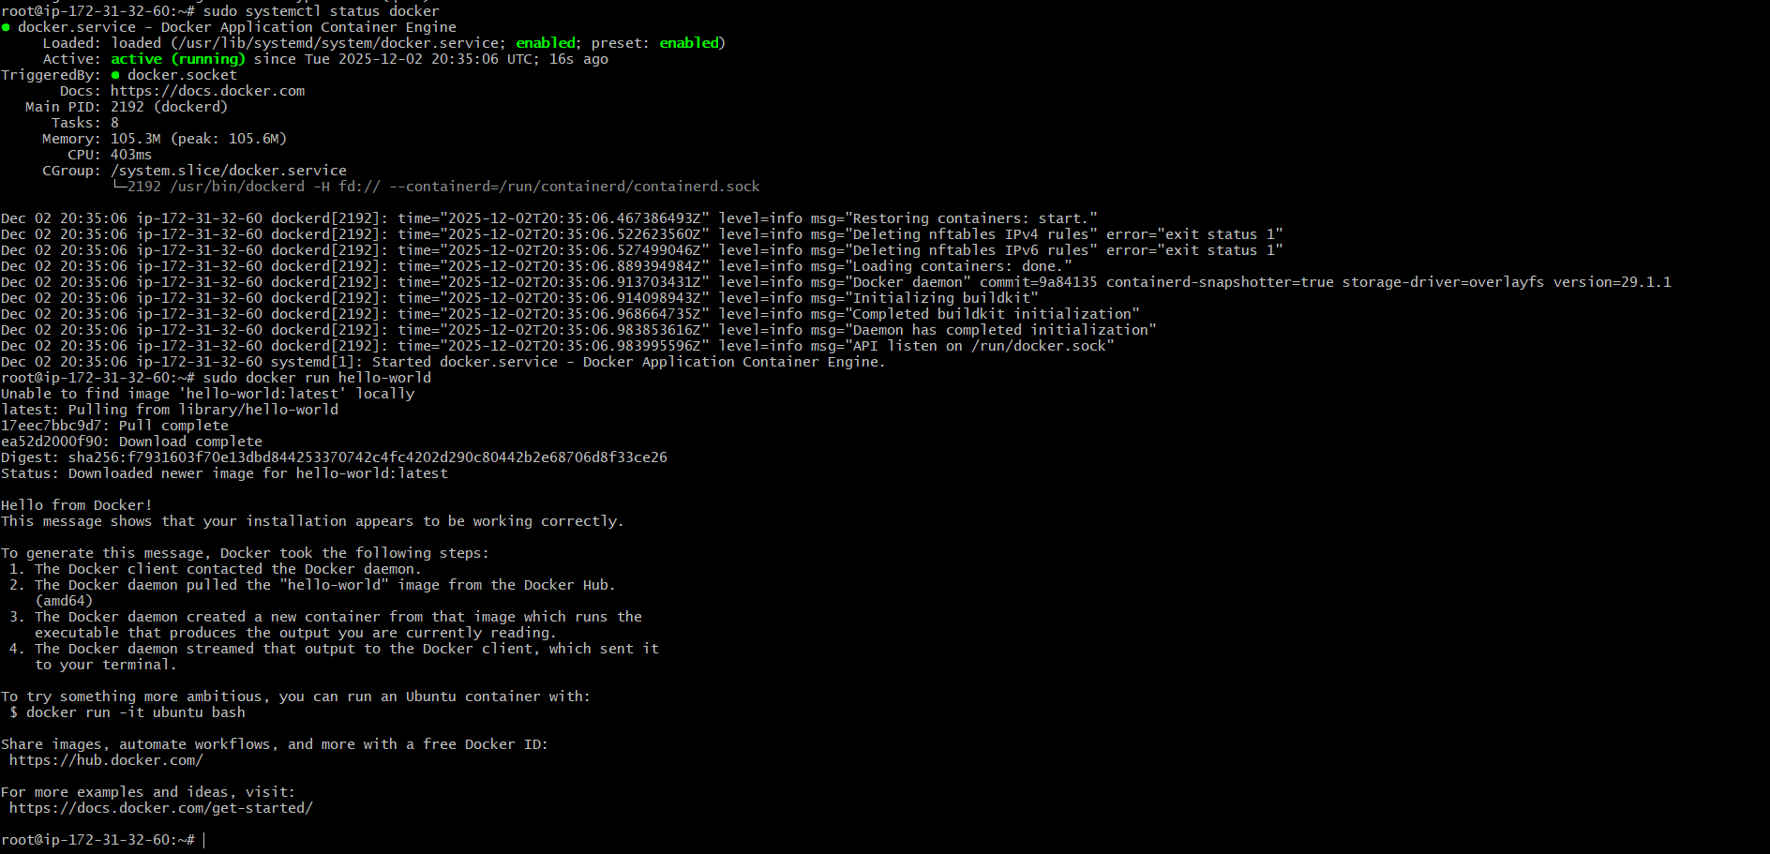
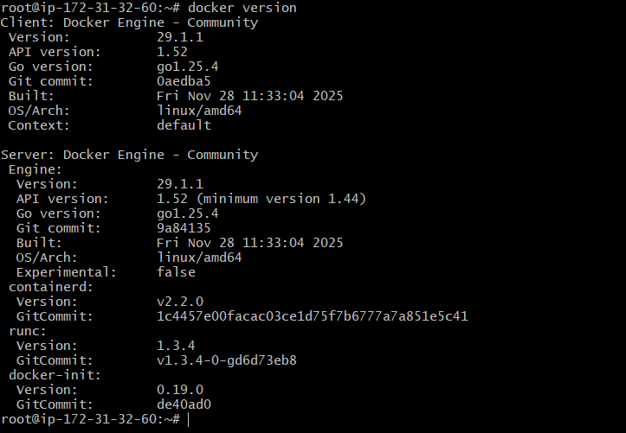
Docker Commands: (Images, container, Volume and Network)
Pulled docker image from docker hub
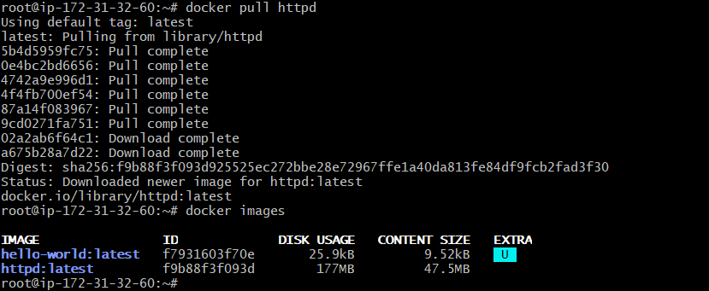
Created container from image
Created docker volume and mounted as below
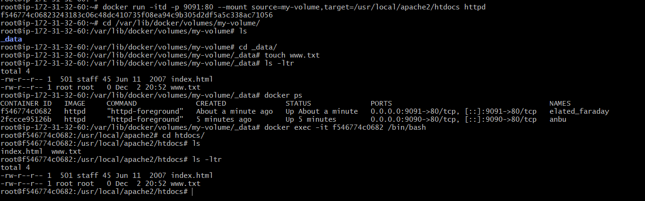
Using Docker Network “host” and created container , able to access with default host port for httpd
