Docker Task -2

Task Description:

Create a dockerfile, docker-compose file which when executed must display your basic details in the website.

Solution:
Application deployment folder structure as below
Docker-task/my-info/
─ app.py
─ templates/ index.html
Docker-task/
Dockerfile
docker-compose.yml
requirements.txt

my-info/app.py
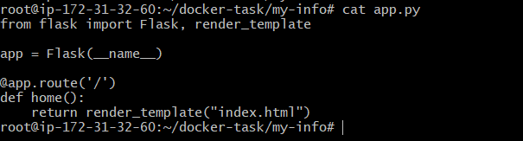
My-info/templates/index.html
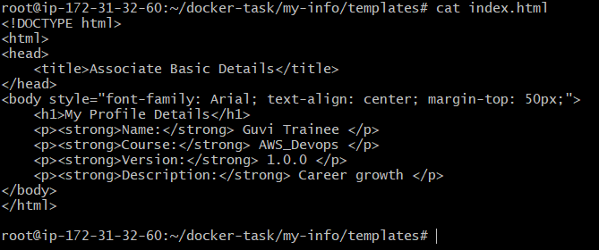

My-info/Dockerfile
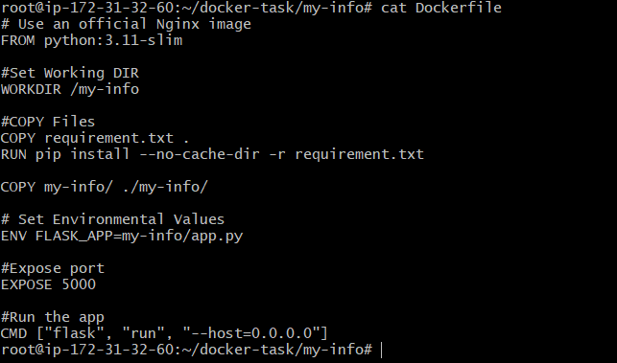
Docker requirement.yaml
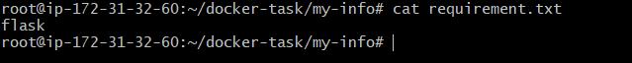
Docker compose.yaml
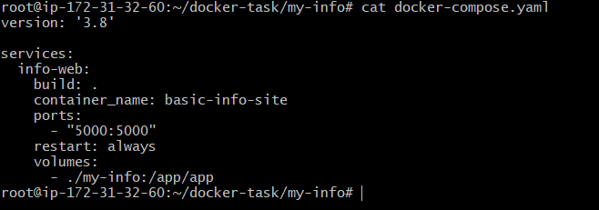
Docker – compose build with detached mode
