Docker Task -3

Task Description:

Create a custom docker image for nginx and deploy it using docker compose, where the volume bind mount should be at /var/opt/nginx location. Push the created custom docker image to your docker-hub.

Solution:
Folder structure for docker_task
Docker-task-3/
- Dockerfile
- Html/index.html
- Docker-compose.yaml

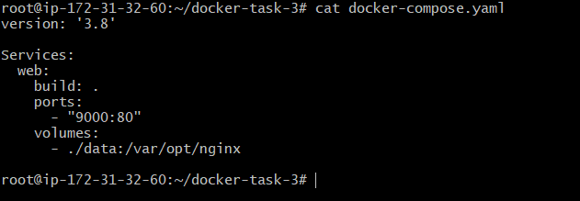
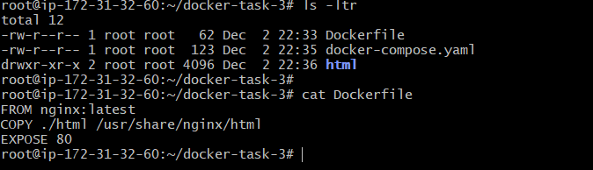
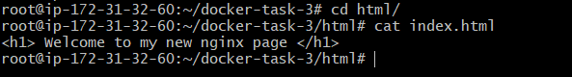

Docker-compose build with detached mode
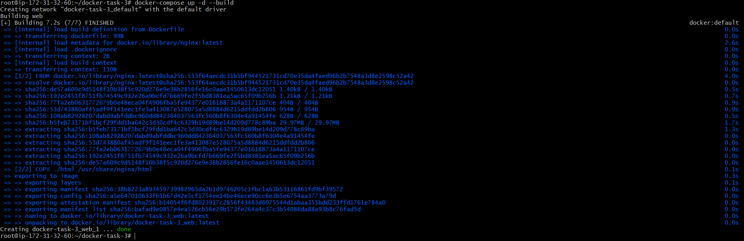
Docker Image
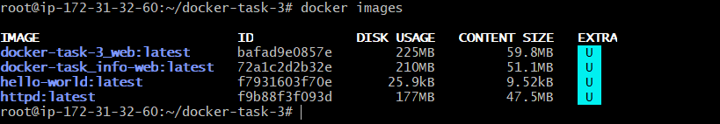

Docker login to push the image
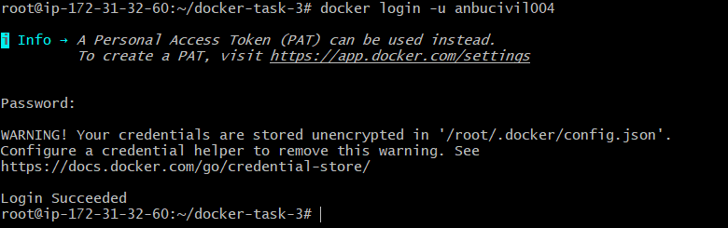

Docker tag the images
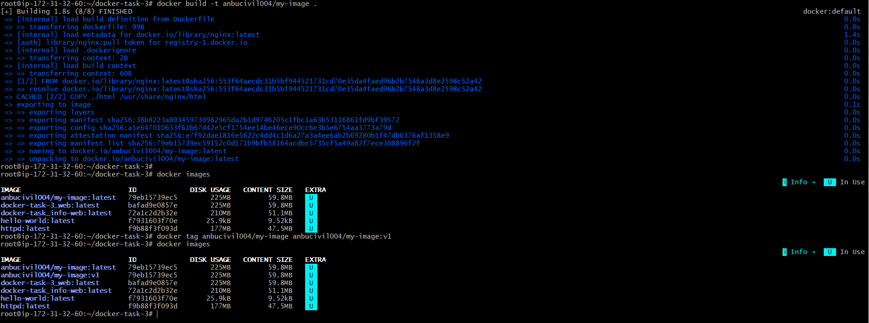
Pushing the image to docker hub
