VCS Task

Task Description:

Establish a new directory, populate it with script files, initiate an empty repository on GitHub, convert the local directory into a Git repository, and link it to GitHub for pushing the code into the repository.Perform merge, rebase, stash commands in following github repo.

Solution:
Created new directory with script files.
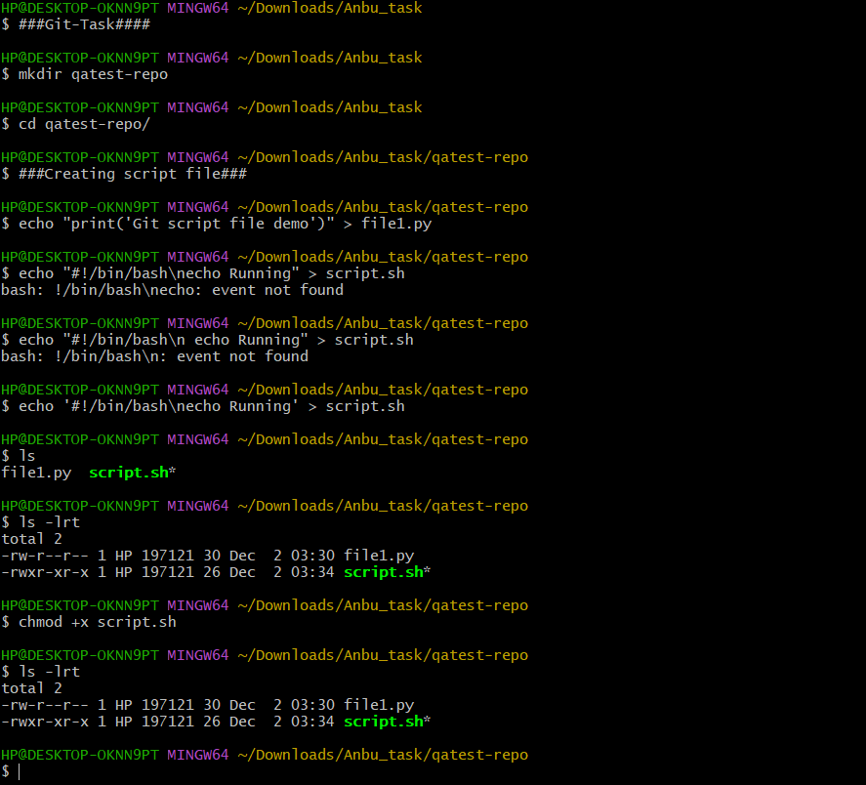
Initiate an empty repository to github:
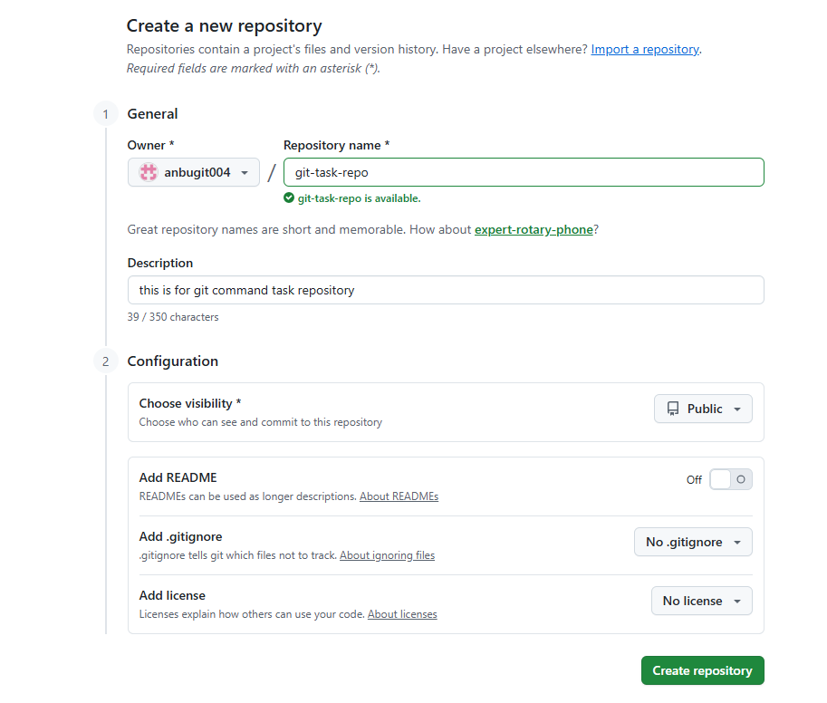
https://github.com/anbugit004/git-task-repo.git
Link a local repo to github remote repository
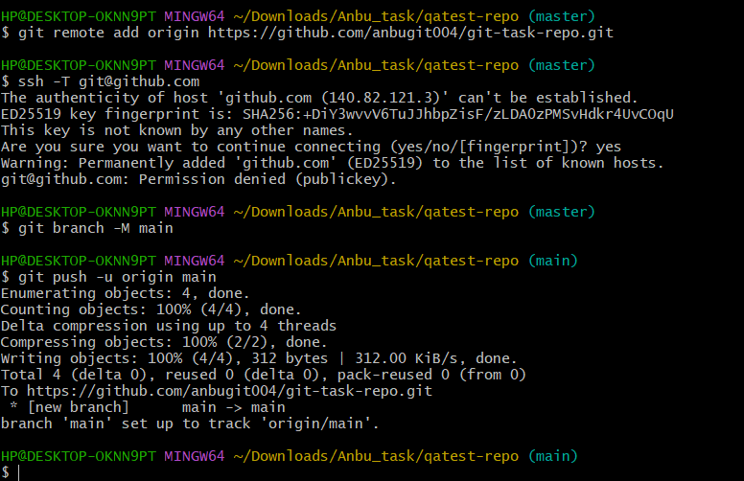
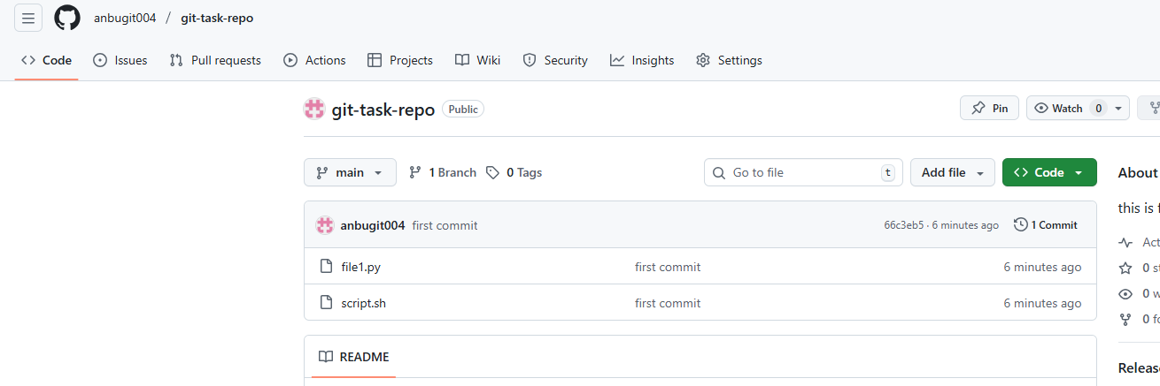

Git operations : Merge, Rebase and stash
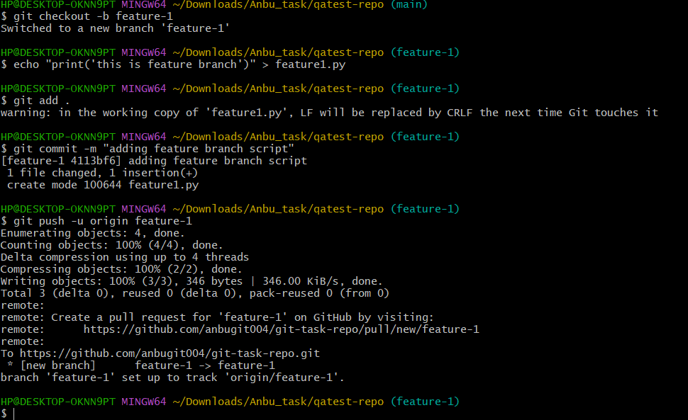

Merging from feature to main branch
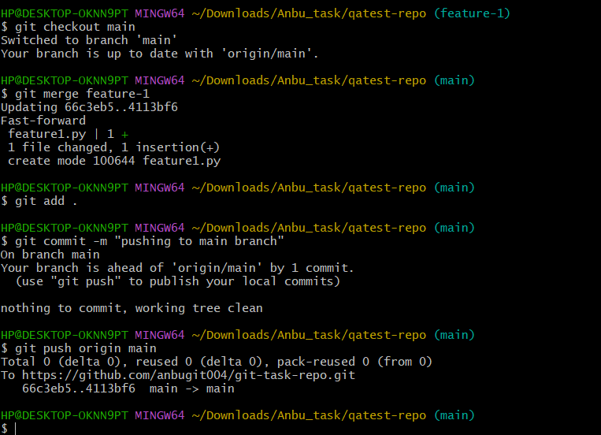
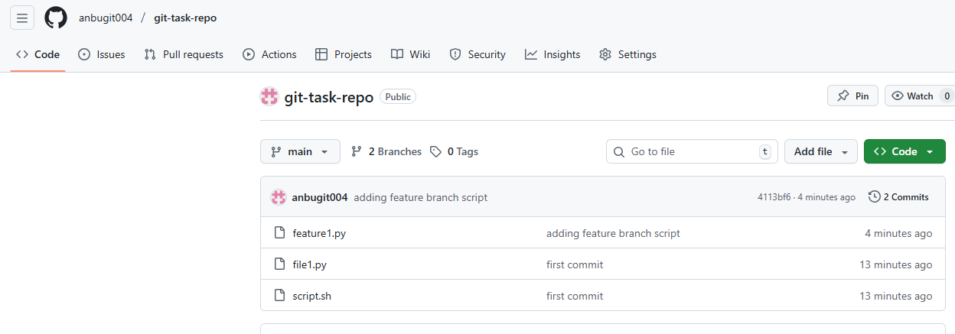

REBASE:
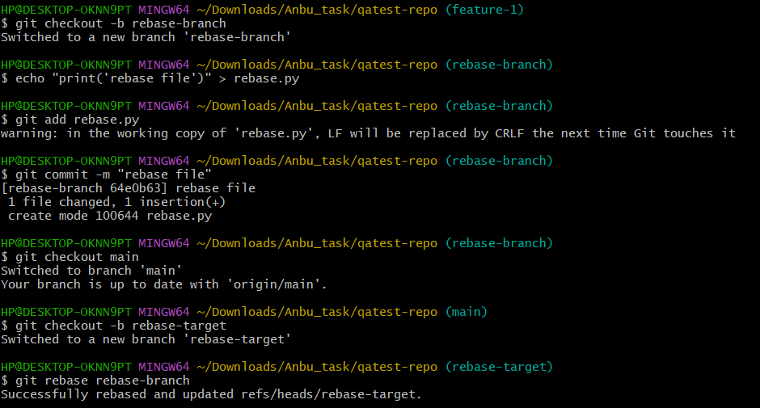

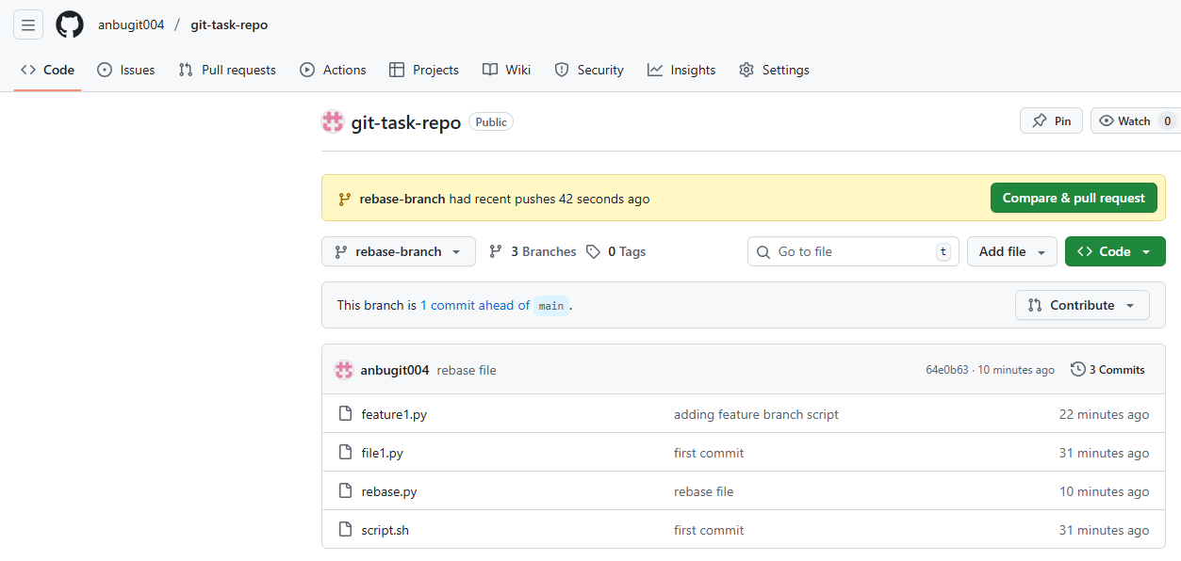

STASH:
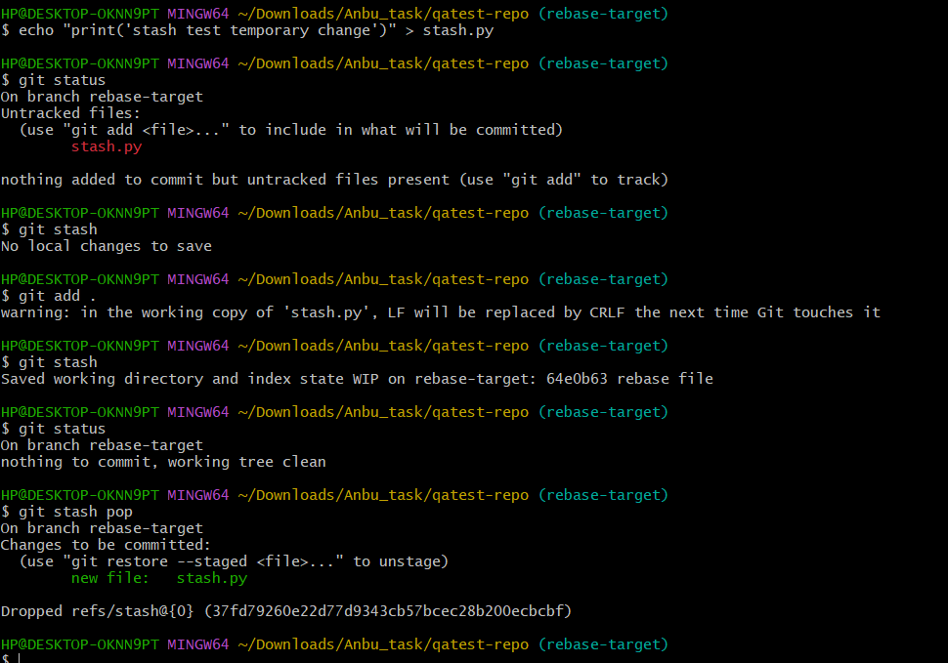
Pushed to remote repository:
