Jenkins Task

Task Description:

Launch jenkins and explore creating projects and users.

Solution:
Created EC2 server and installed java in it
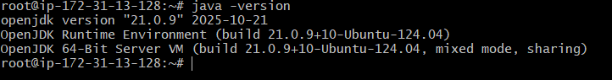
Installed Jenkins:
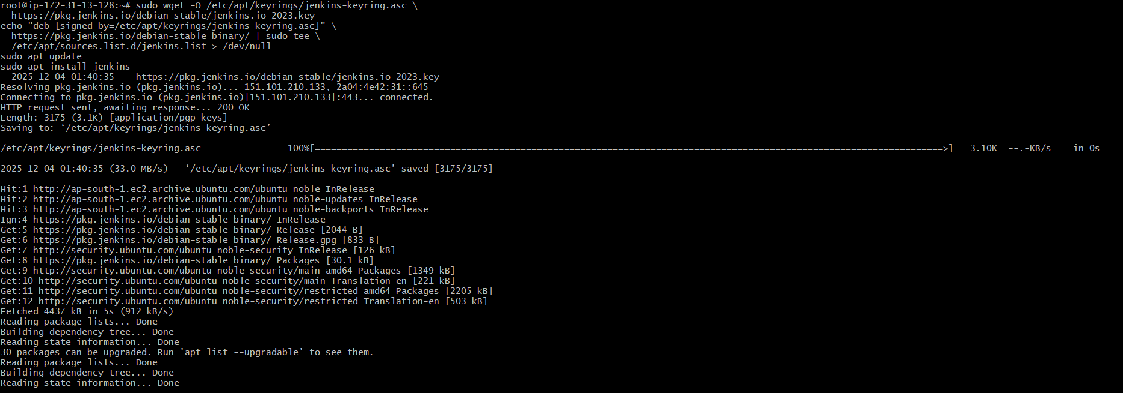
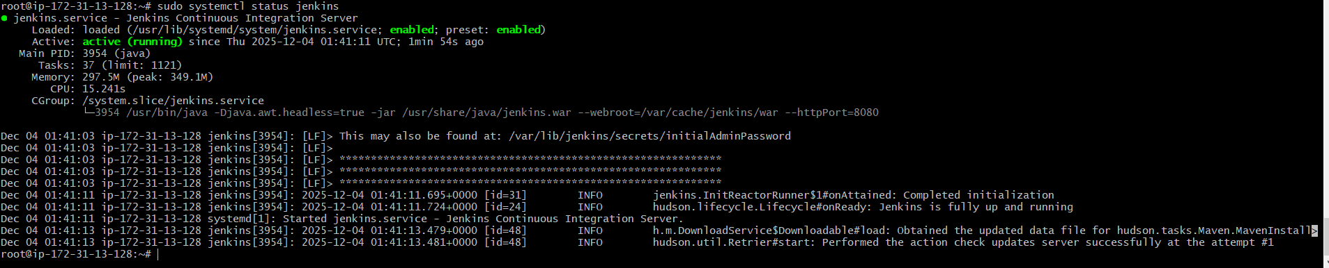

Open inbound rule for port 8080 and login to console
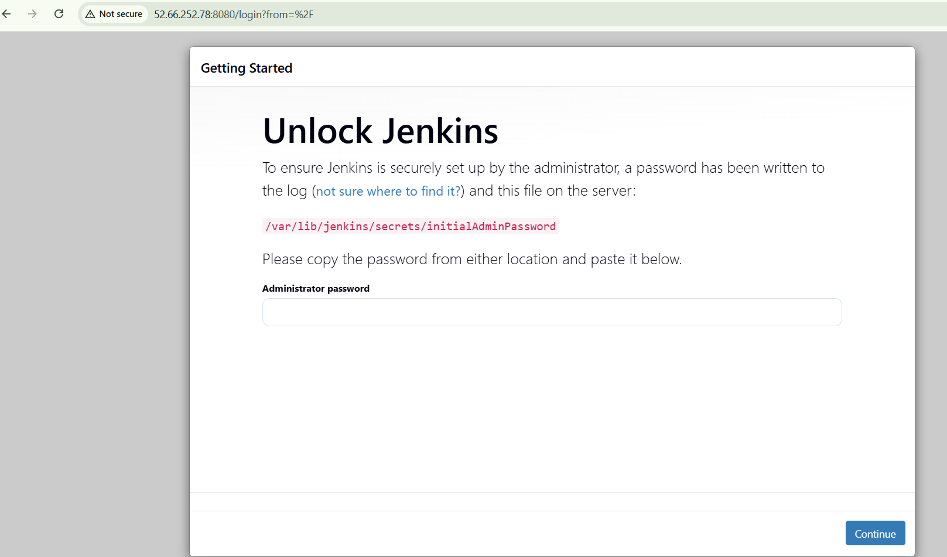
Get the initial pwd from the path
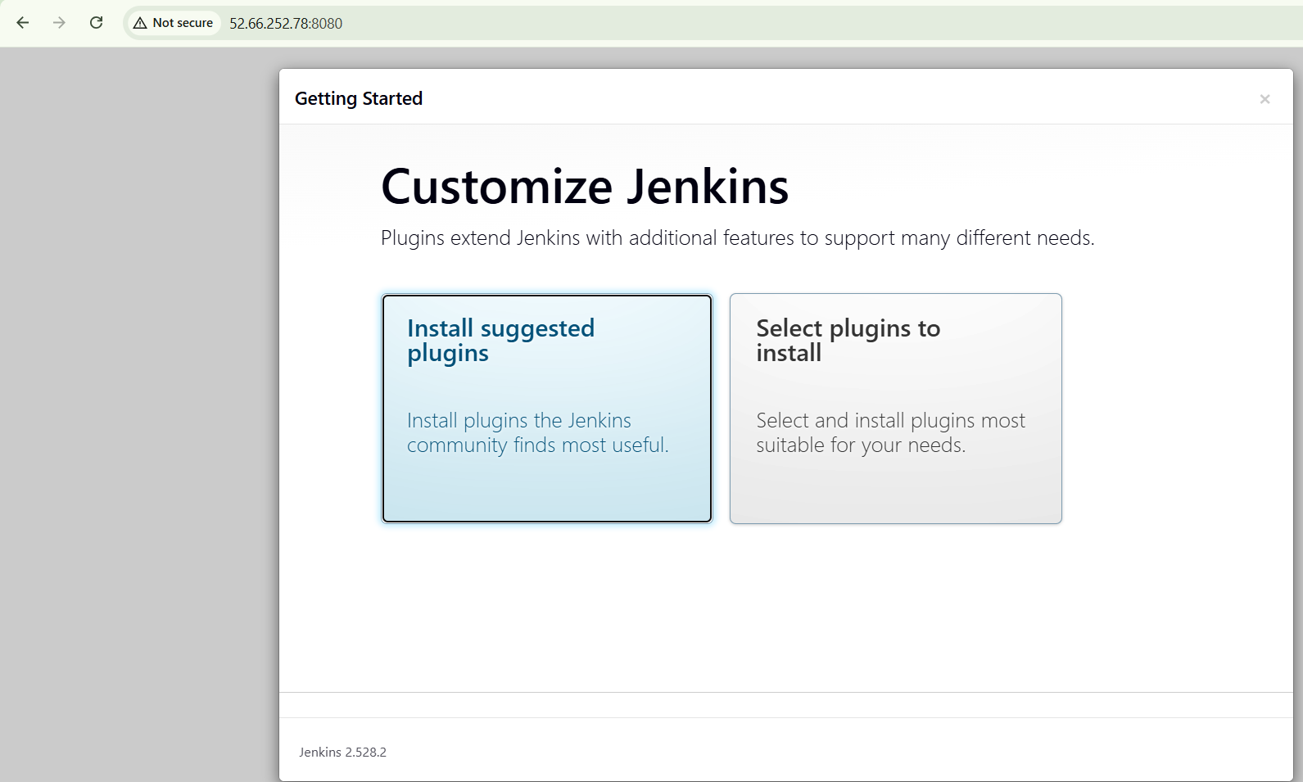
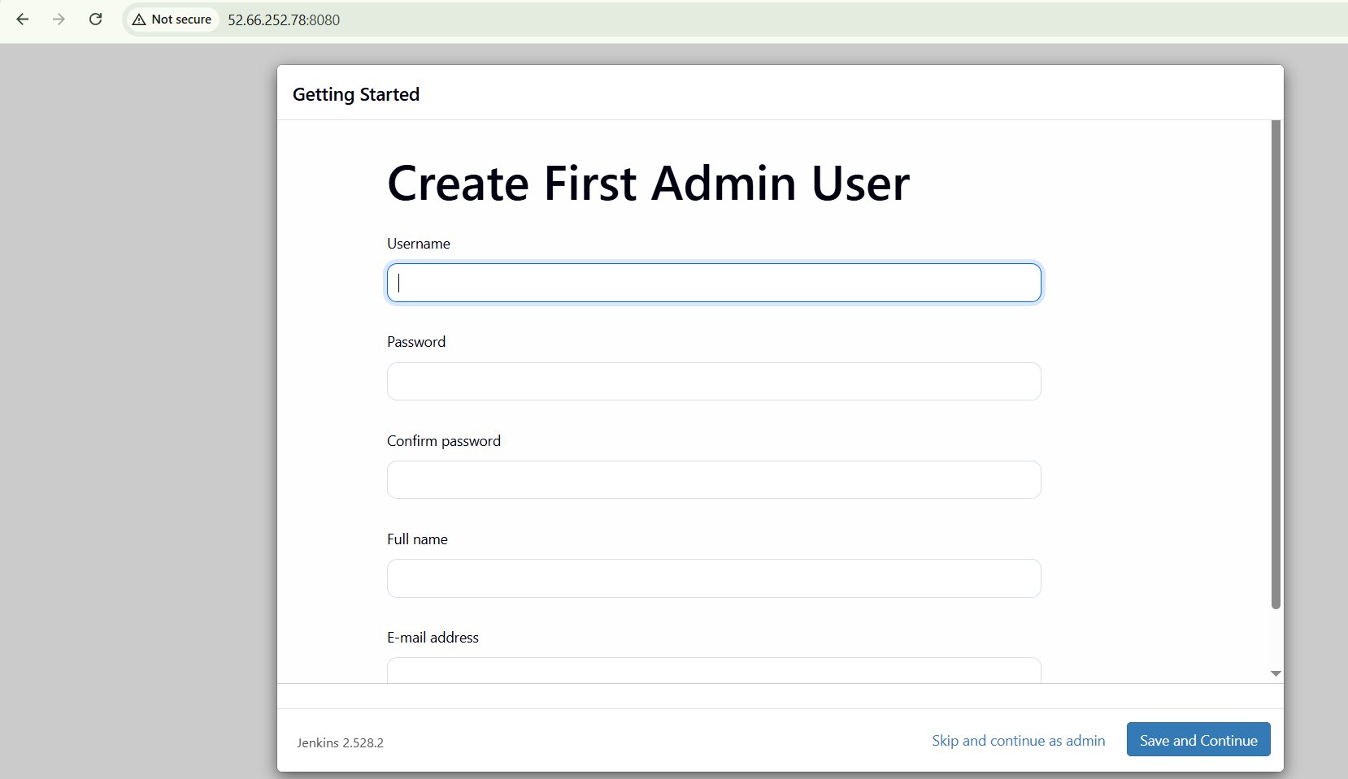
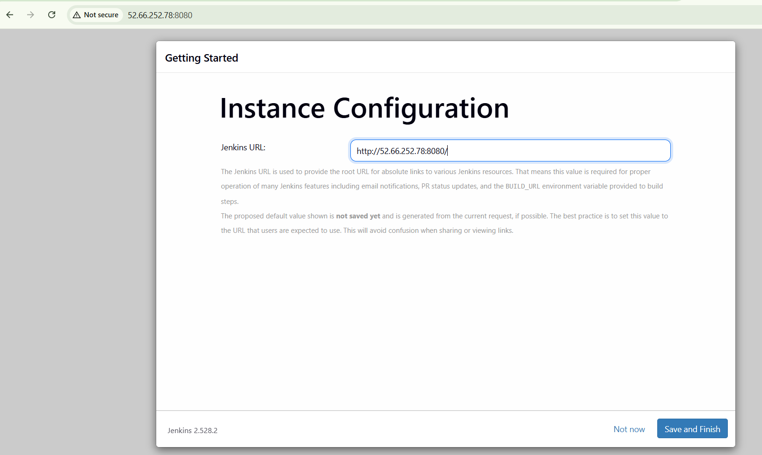
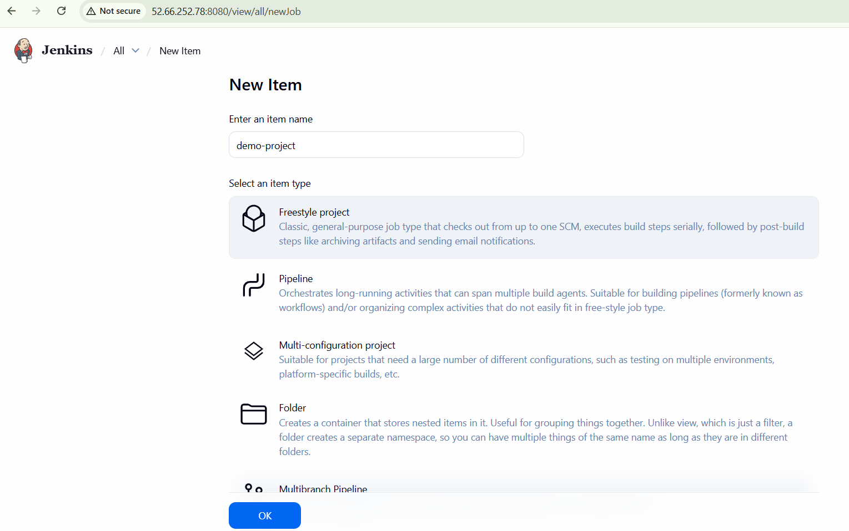
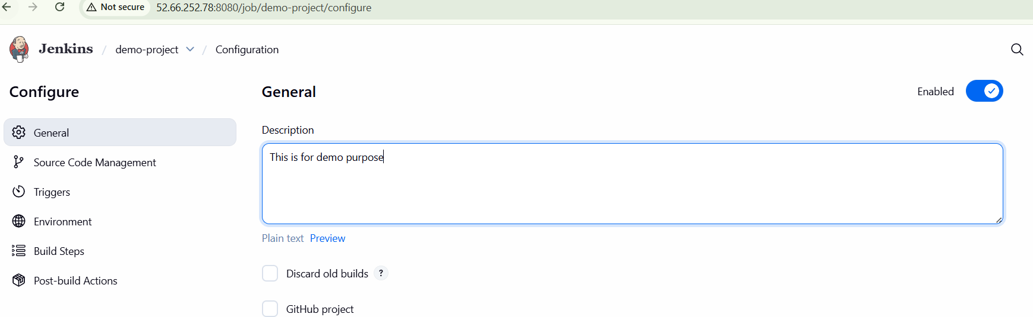
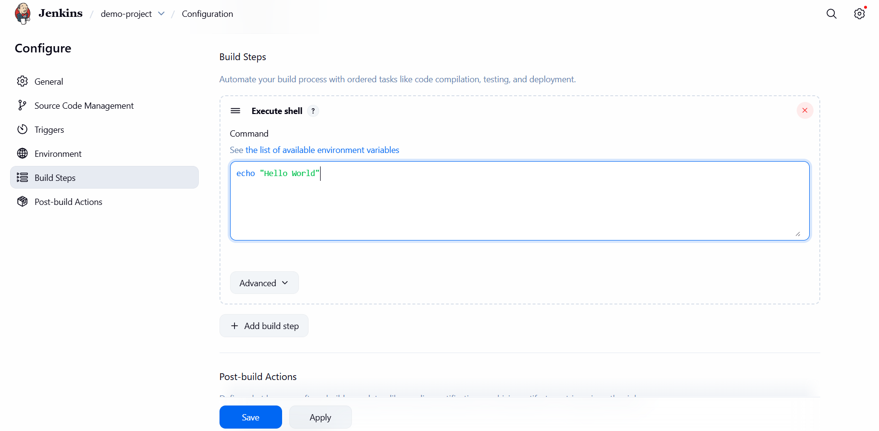

Build a code and click on build now
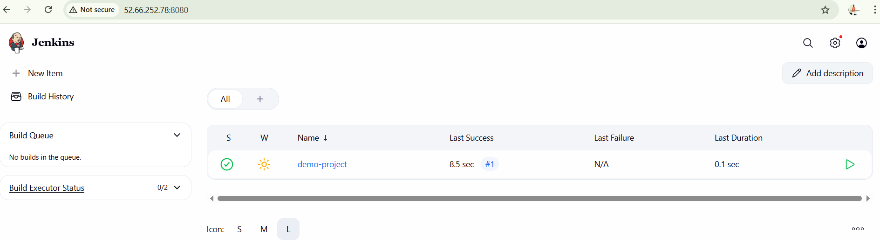
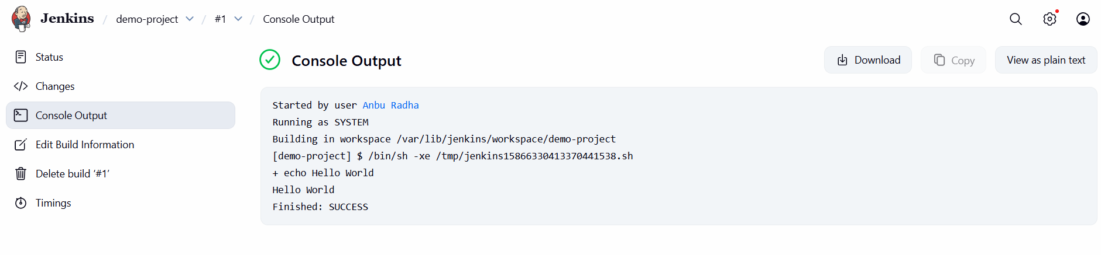

Create user by click on the setting from right corner of profile and create user
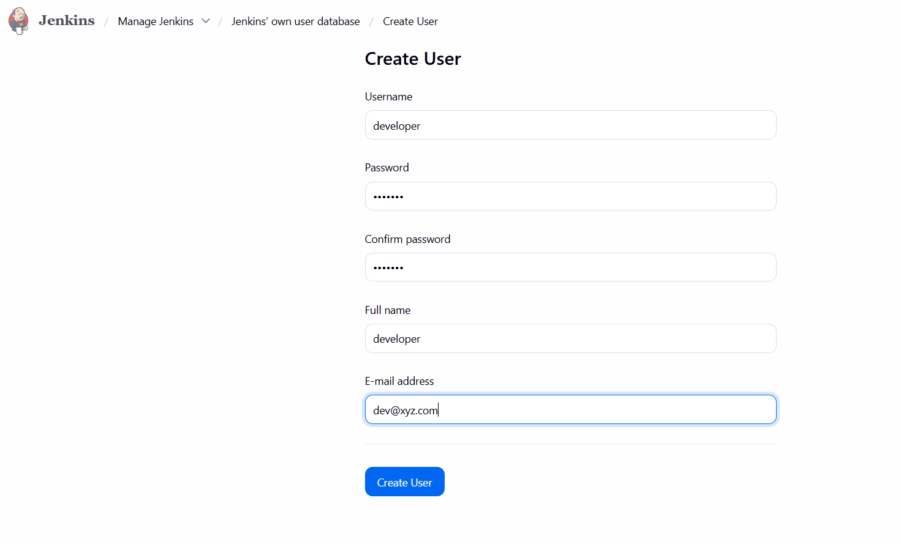

Create devops-admin and developer user:
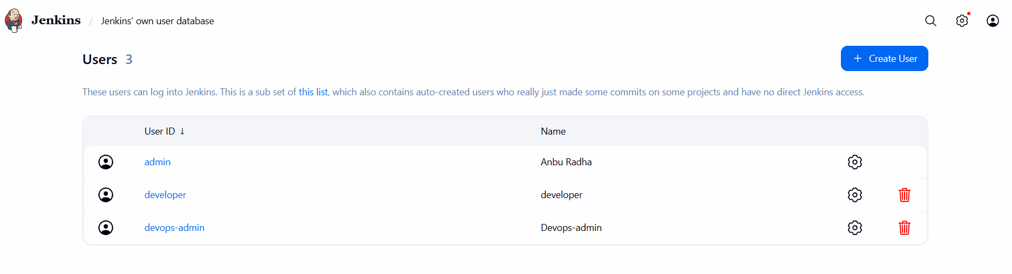
Go to manage Jenkins security
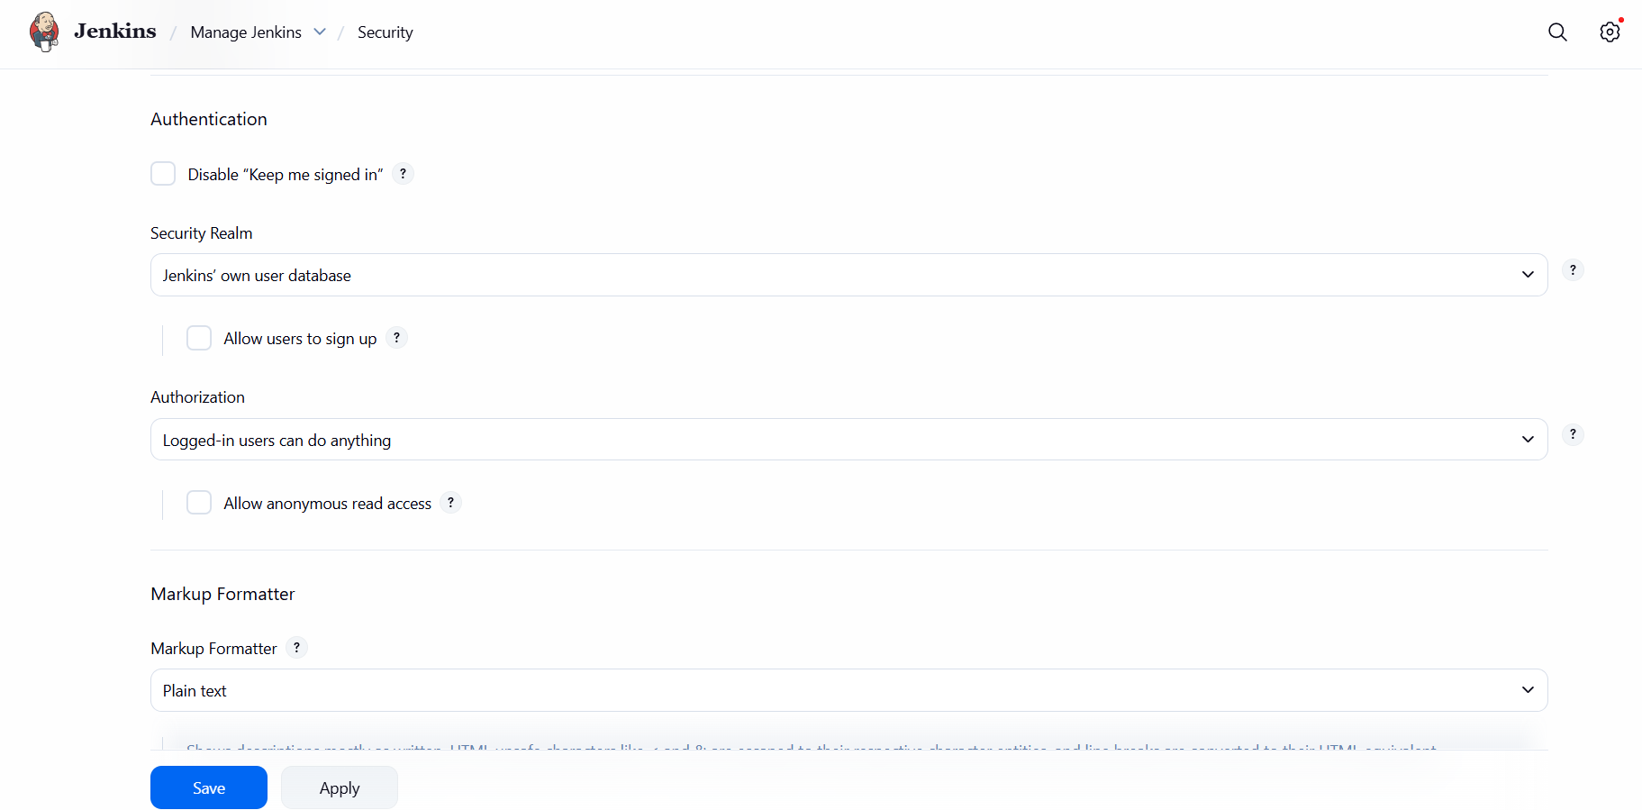
Install role base strategy plugin and restart jenkin and under security Authorization select role base strategy and save it
Now you can able to see the Manage and Assign Role tab
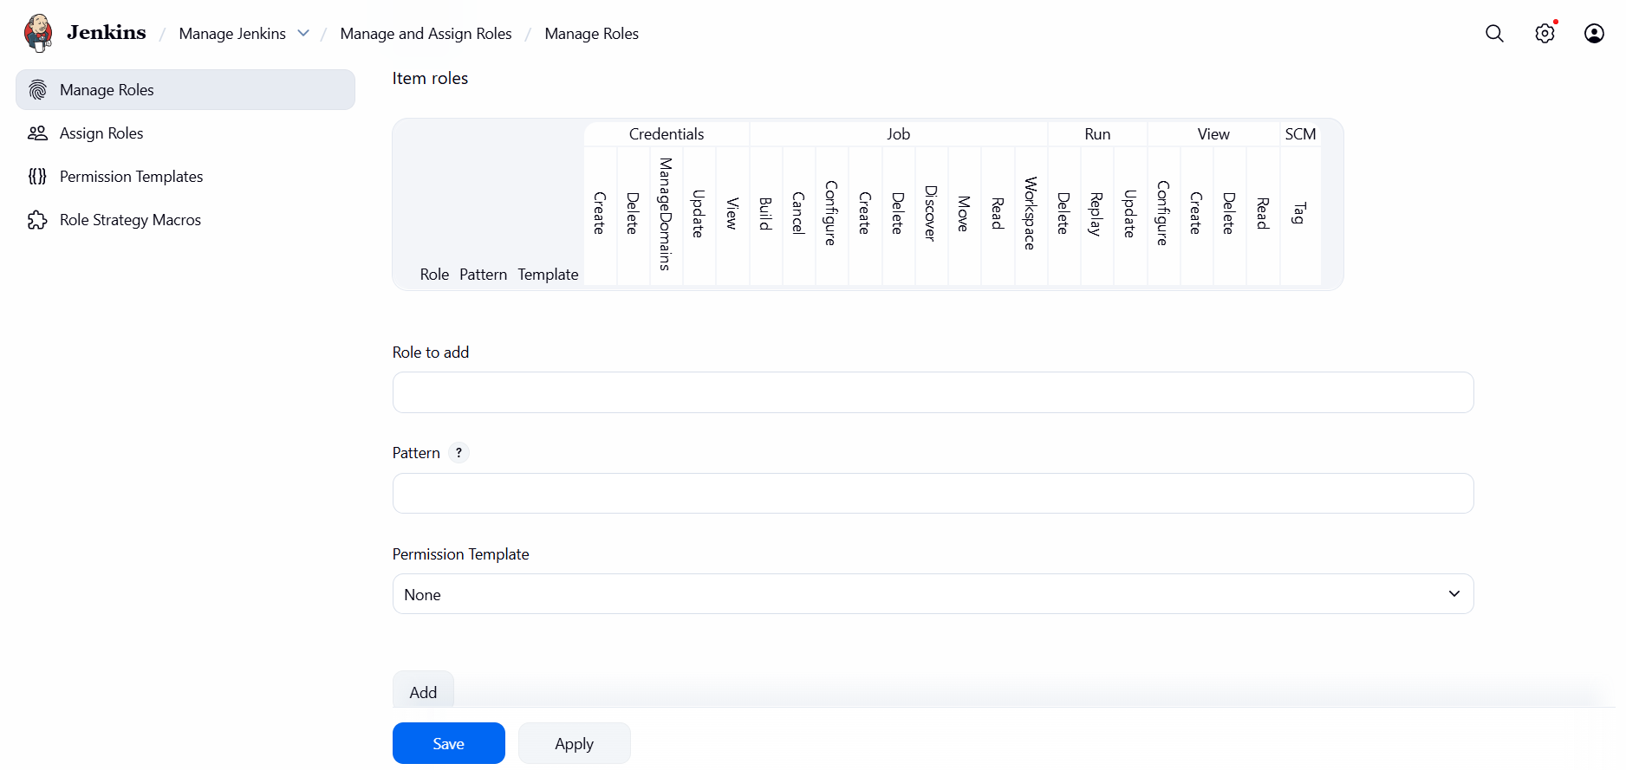
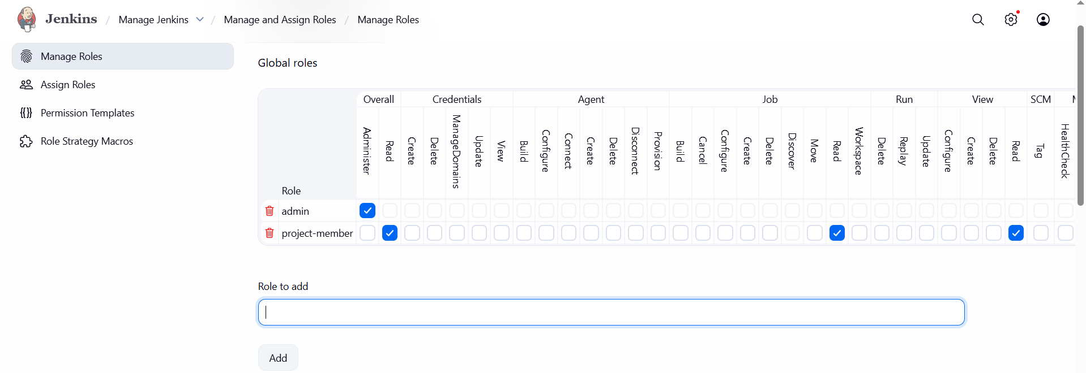
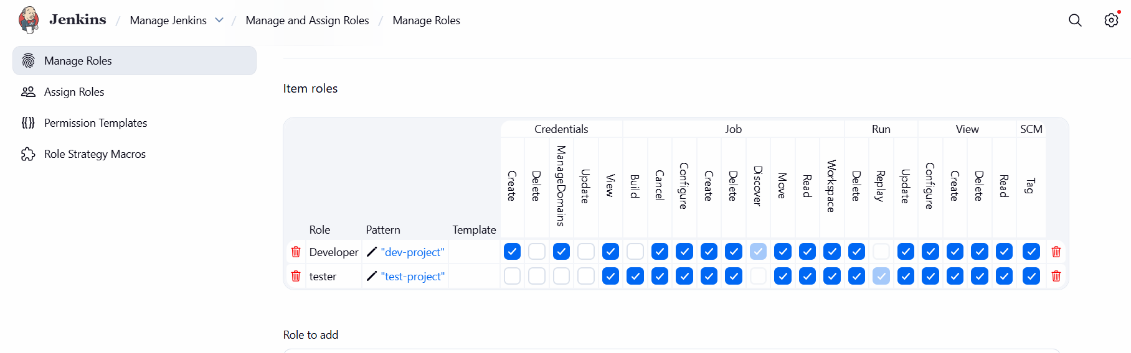
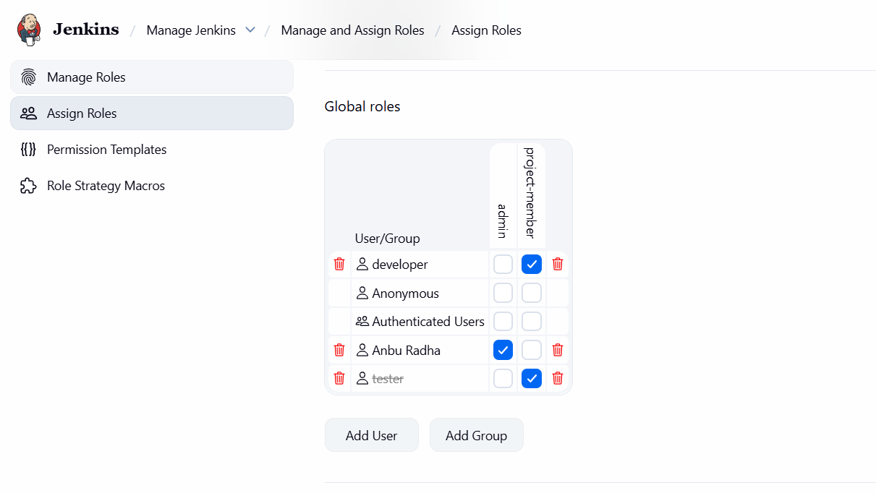
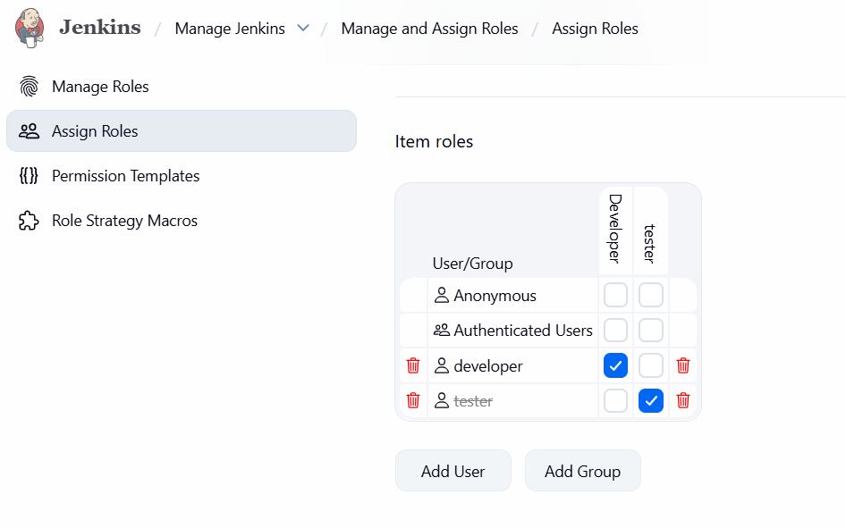
Developer is limited to view dev-project with restricted access also we disabled to create new jobs, and can enable depends on project usecase and types.

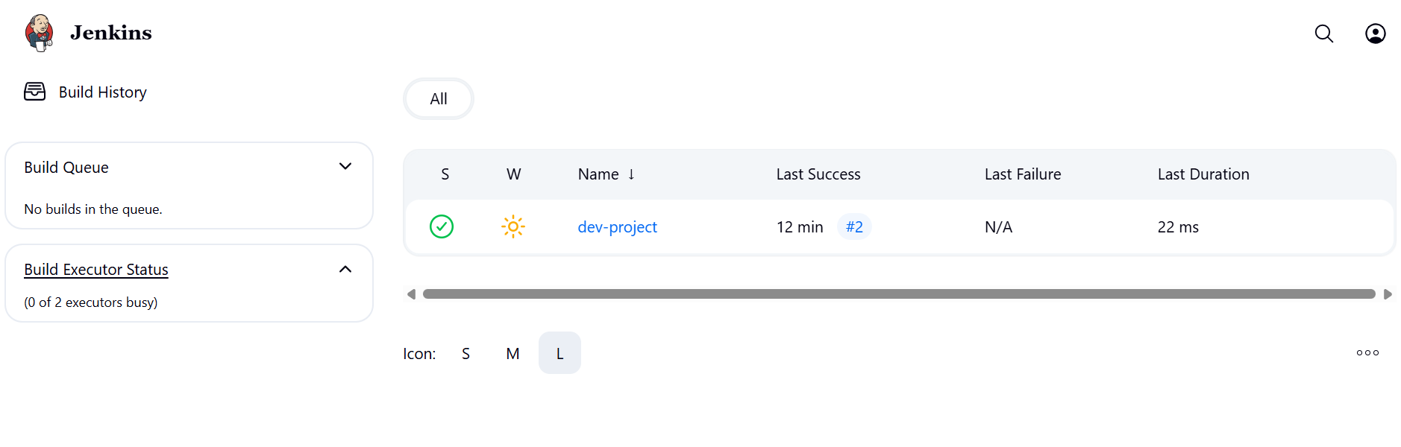
Devops admin can view all pipeline and have more controls
