Kubernetes Task

Task Description:

Setup minikube at your local and explore creating namespaces (Go through official documentation).

Solution:
2 CPUs or more 2GB of free memory 20GB of free disk space Internet connection Container or virtual machine manager, such as: Docker, QEMU, Hyperkit, Hyper-V, KVM, Parallels, Podman, VirtualBox, or VMware Fusion/Workstation

Step 1: We will create AWS EC2 t2.medium server Ubuntu server

Step 2: Docker Instllation on Ubuntu

Run the below command in ec2 server which is logged in locally
# Add Docker's official GPG key:
sudo apt update
sudo apt install ca-certificates curl
sudo install -m 0755 -d /etc/apt/keyrings
sudo curl -fsSL https://download.docker.com/linux/ubuntu/gpg -o /etc/apt/keyrings/docker.asc
sudo chmod a+r /etc/apt/keyrings/docker.asc
# Add the repository to Apt sources:
sudo tee /etc/apt/sources.list.d/docker.sources <<EOF
Types: deb
URIs: https://download.docker.com/linux/ubuntu
Suites: $(. /etc/os-release && echo "${UBUNTU_CODENAME:-$VERSION_CODENAME}")
Components: stable
Signed-By: /etc/apt/keyrings/docker.asc
EOF
sudo apt update

Step3: Add ubuntu user to docker group
sudo usermod -aG docker Ubuntu

Step4: To install the latest minikube stable release on x86-64 Linux using binary download:
curl -LO https://storage.googleapis.com/minikube/releases/latest/minikube-linux-amd64
sudo install minikube-linux-amd64 /usr/local/bin/minikube && rm minikube-linux-amd64

Step 5: Start your cluster
Switch into Ubuntu user and refresh the docker group
Sudo su – Ubuntu
Newgrp docker
Start minikube as Ubuntu user
minikube start --driver=docker
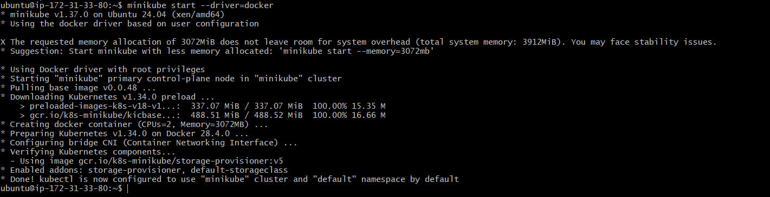

Step 6: Install kubectl

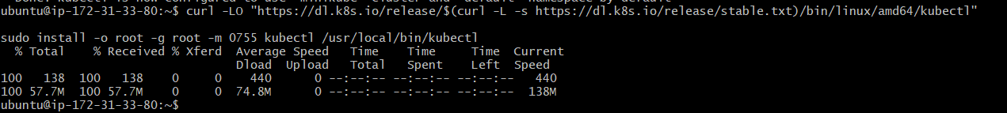
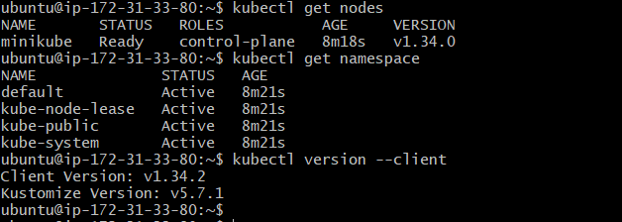

Step 7: Interact with your cluster
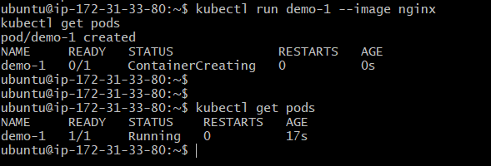

Other method using Docker desktop in local machine:
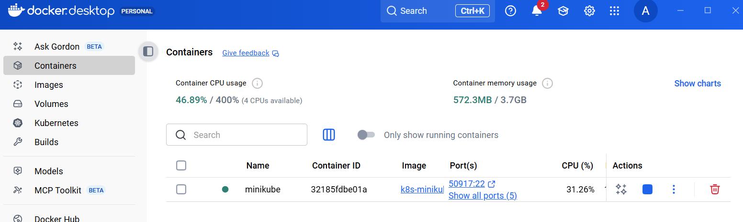
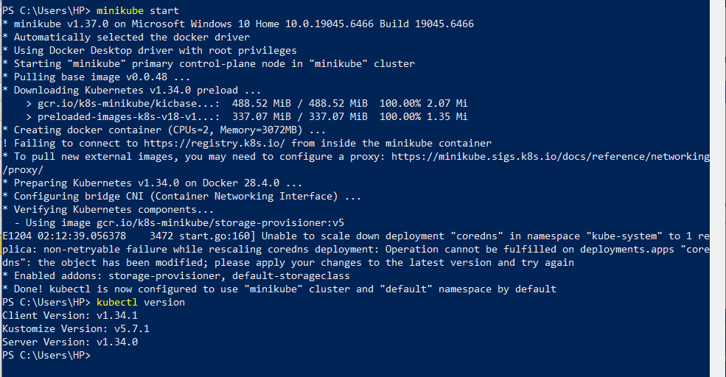
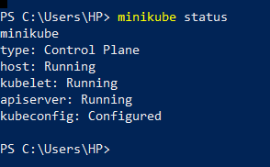
Created namespace
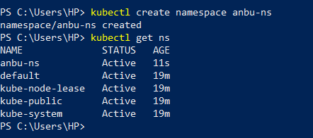
Deployment and pod created for http application:
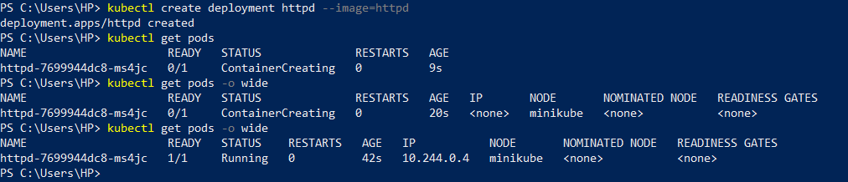
Created service account:
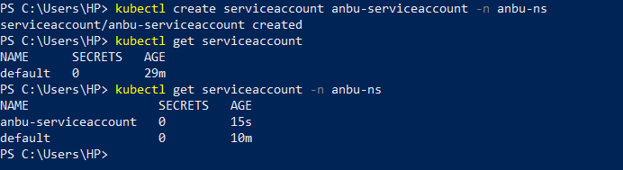
Pod created with service account
