Jenkins Task-2

Task Description:

Create a simple script file and push it to repo. Create a project in Jenkins connected to your GitHub repository. When a commit is made to your repo, automatically build must get triggered from Jenkins and the output must be shared to me via email.

Solution:
Created script in local repository and pushed into remote repository
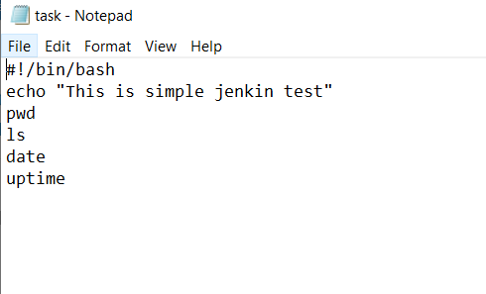
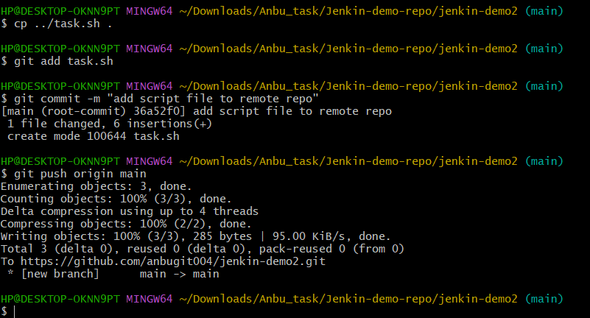
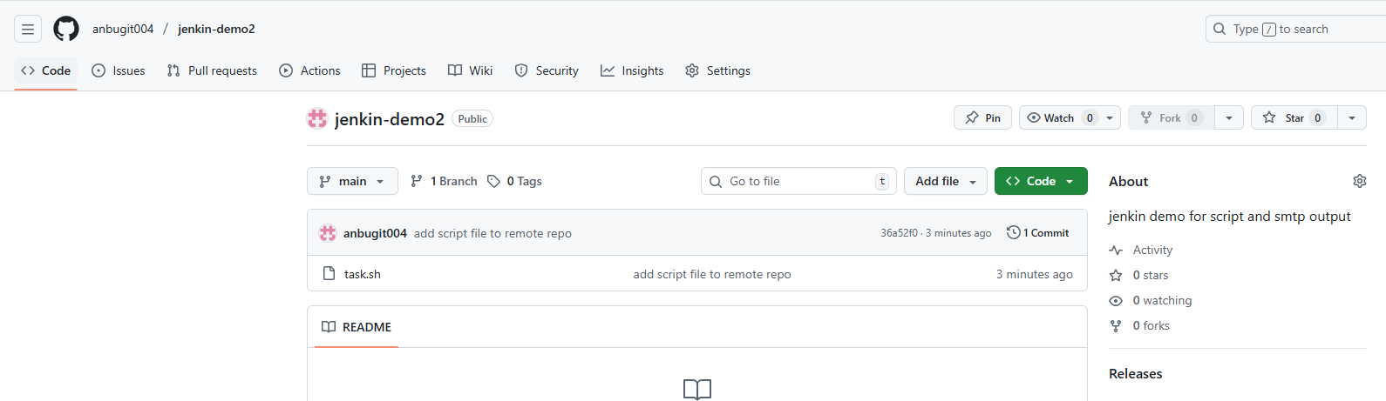

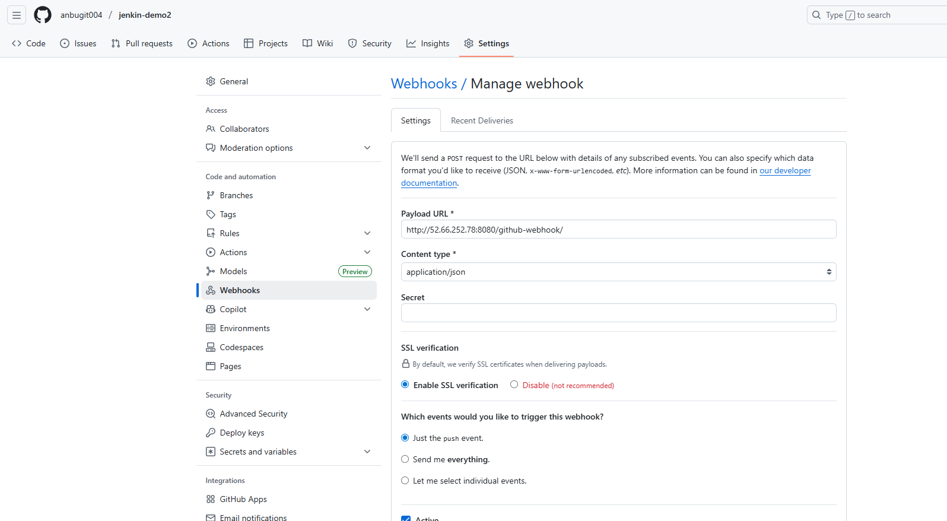

Created a build project
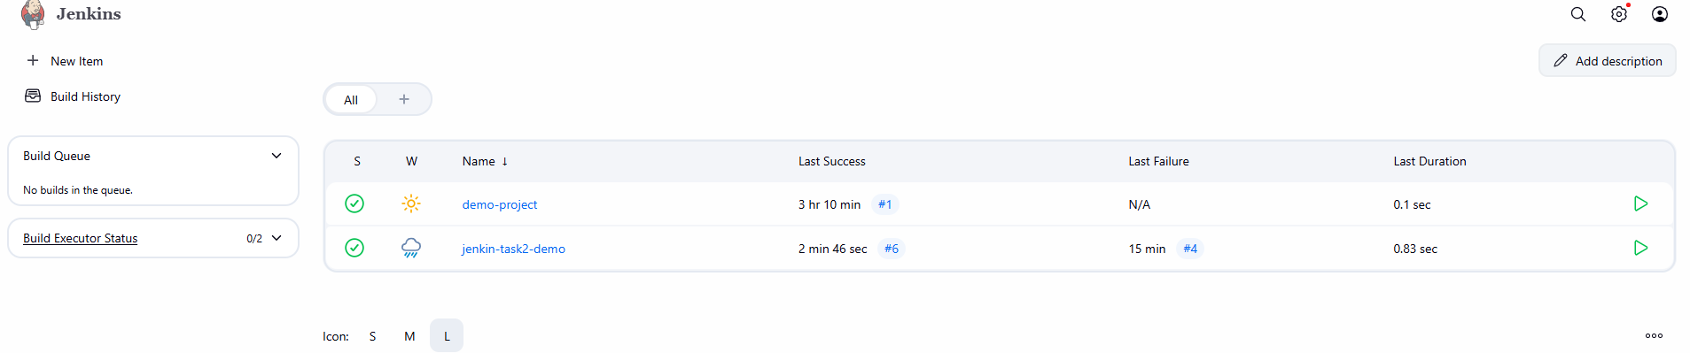

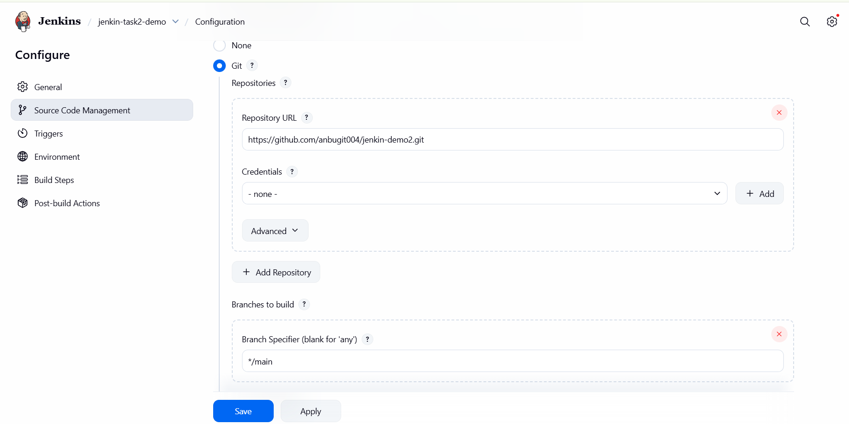

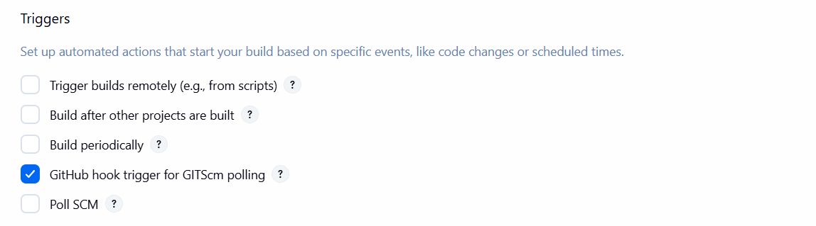
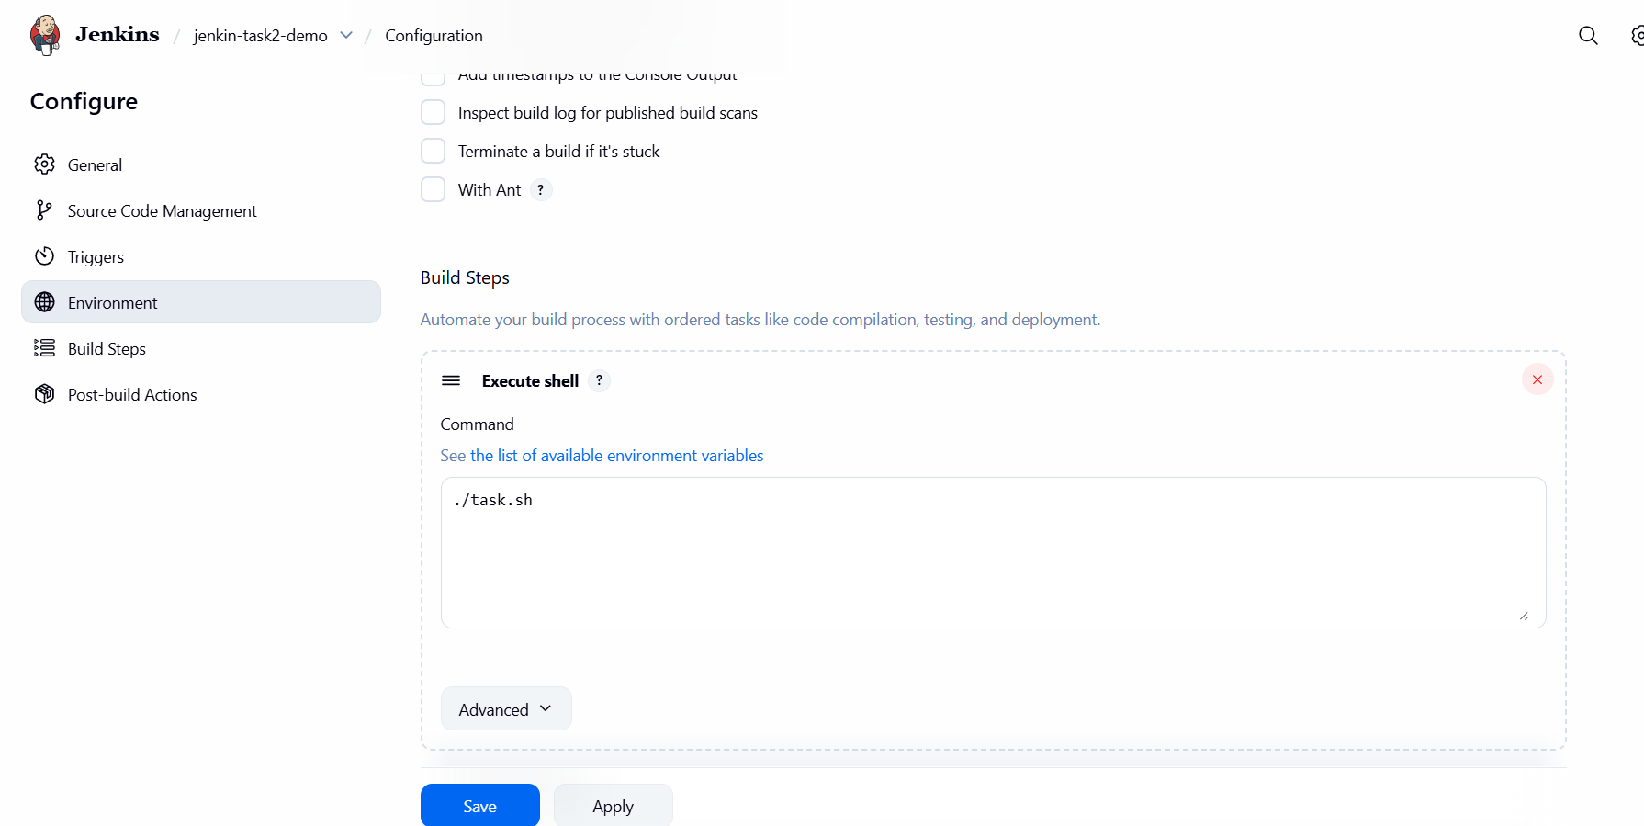

Post build section:
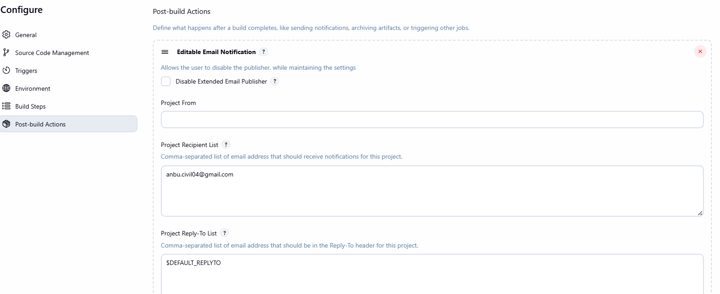
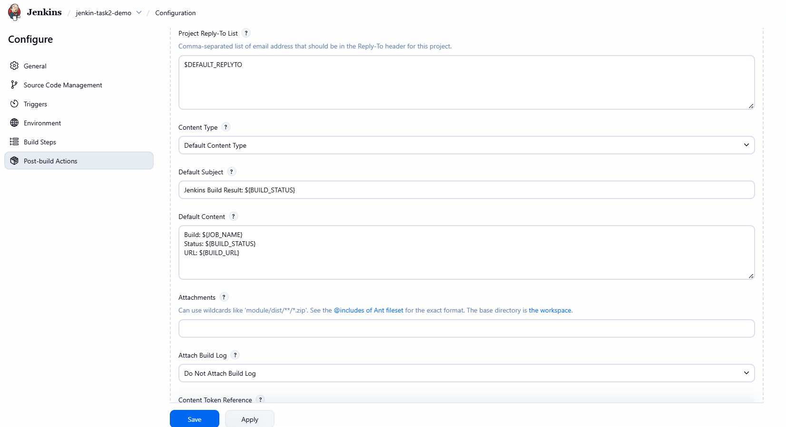
Install email extended plugin and set the SMTP configuration in Manage settings:

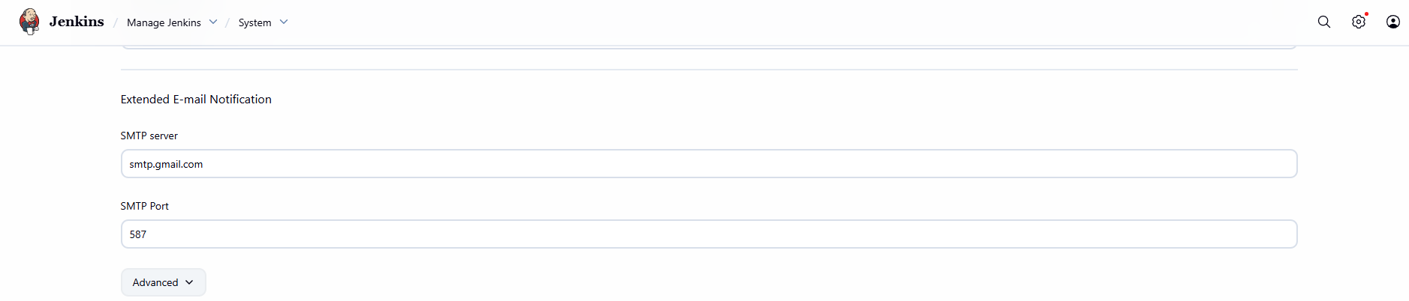

Set the 2FA for jenkin label and added the passkey in pwd column
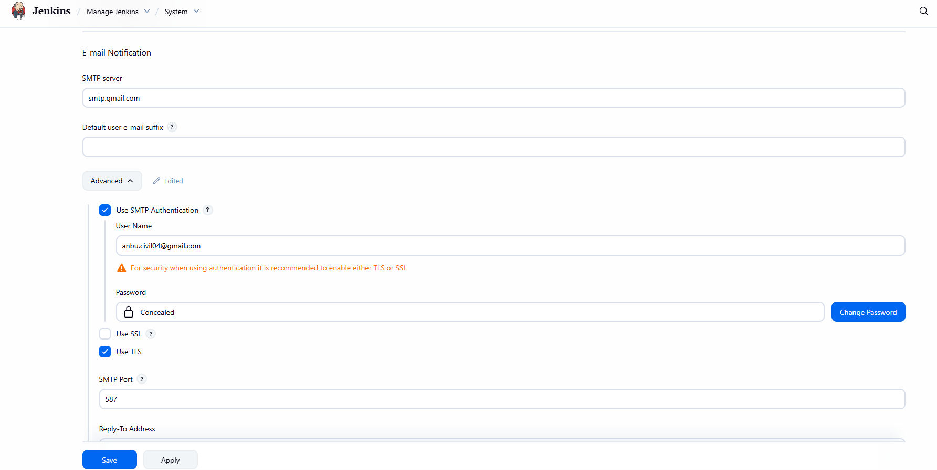

Build console output:
