REMOVED TOP BLANK ROWS

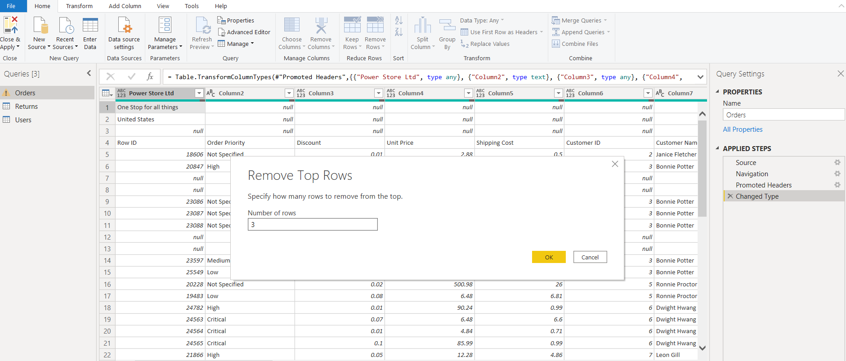

AFTER REMOVAL

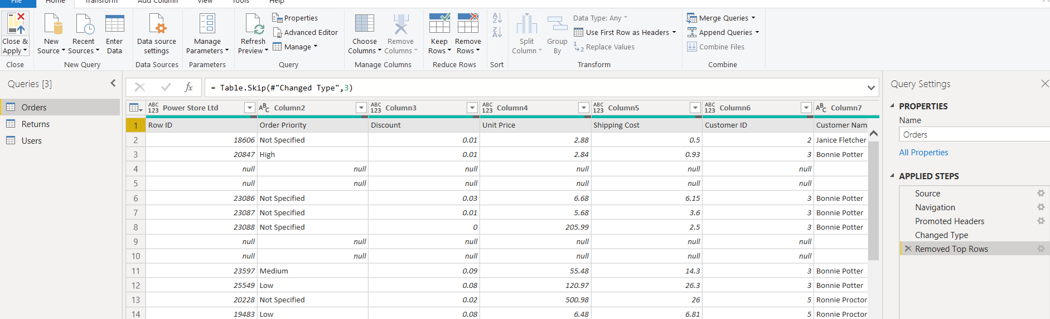

MAKE 1st ROW as HEADER & RENAME COLUMN HEADER

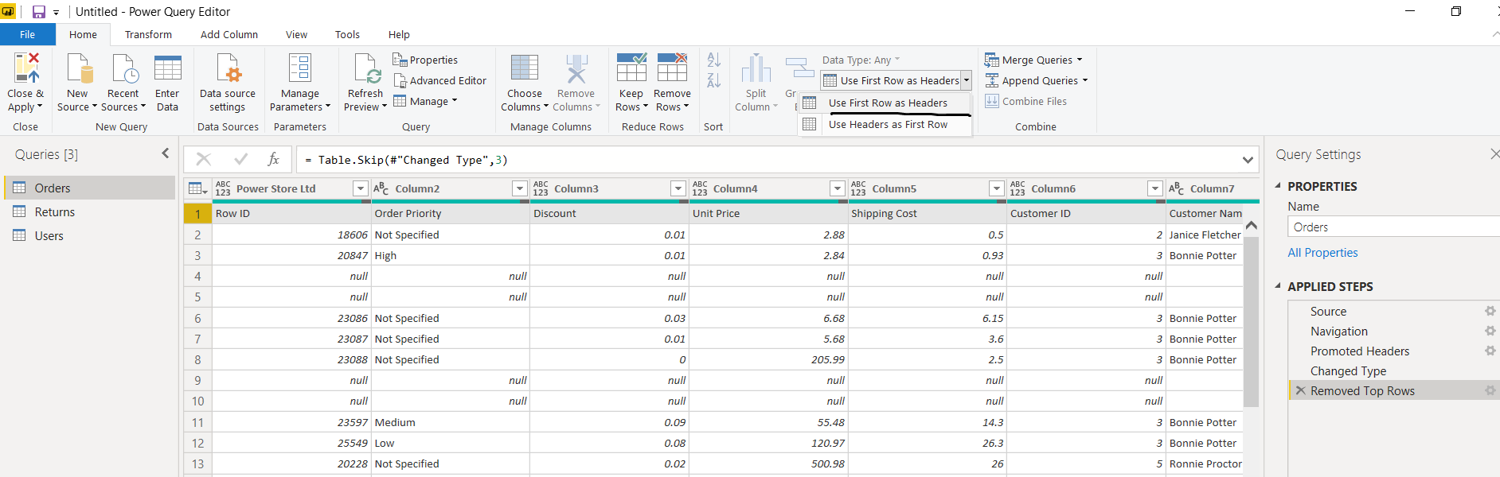

REMOVE BLANK ROWS

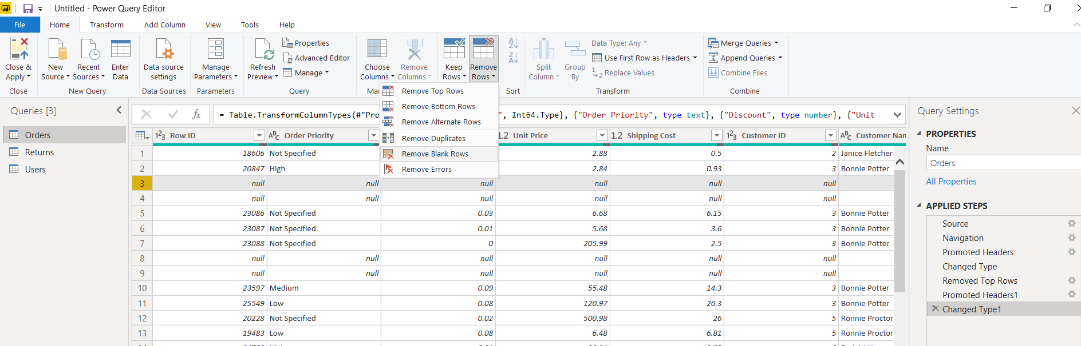

CLOSE & APPLY CHANGES

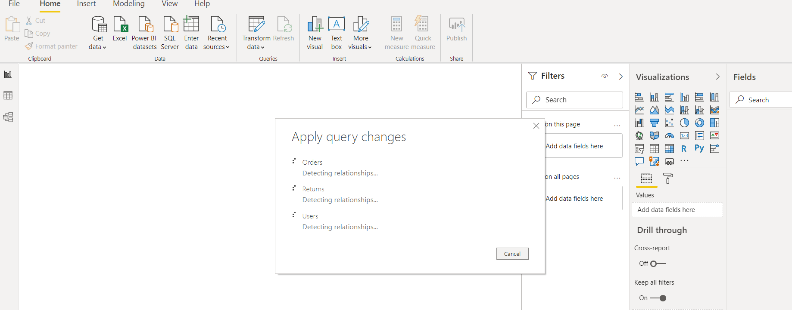

CUSTOMER PRODUCT CATEGORY, REGION BASED TEXT TABLE

