Docker
🧠 1. Hypervisor
If you meant Hypervisor, here's what it is:
- A hypervisor is a software or hardware platform that allows multiple virtual machines (VMs) to run on a single physical machine.
- It manages and allocates hardware resources to each virtual machine.
Day 1: Docker Tutorial for Beginners: What It Solves & How to Install Docker
Docker is a platform used to develop, ship, and run applications in a consistent environment called containers.

🚢 What is Docker?
- Docker is an open-source tool that allows you to package an application along with all its dependencies, libraries, and configurations into a container.
- A container is a lightweight, standalone, executable package of software that includes everything needed to run it.
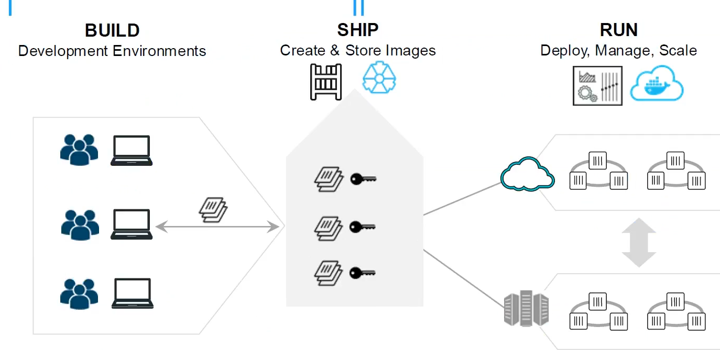
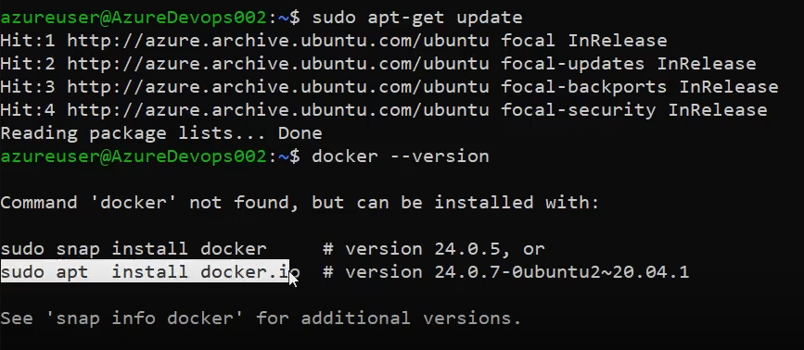
>docker –version
>sudo chmod 777 /var/run/docker.sock
>docker images
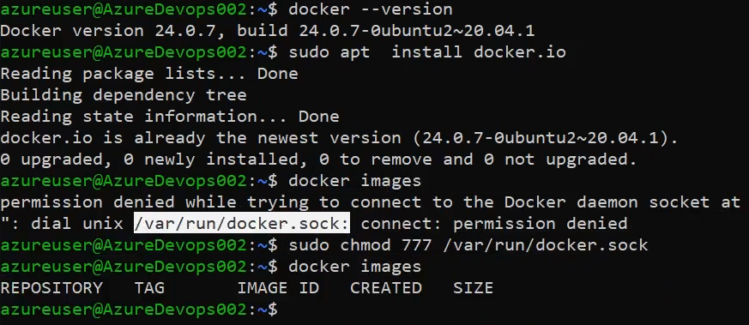
In Docker Hub, already public and private images are available, Just search and pull into that:
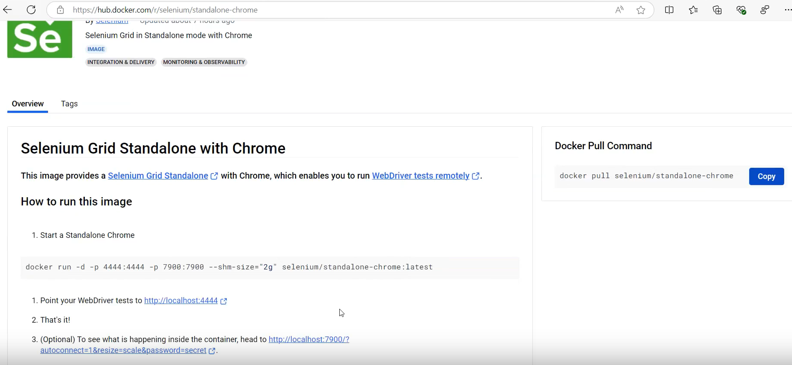

Latest means, It always pull/download latest version.
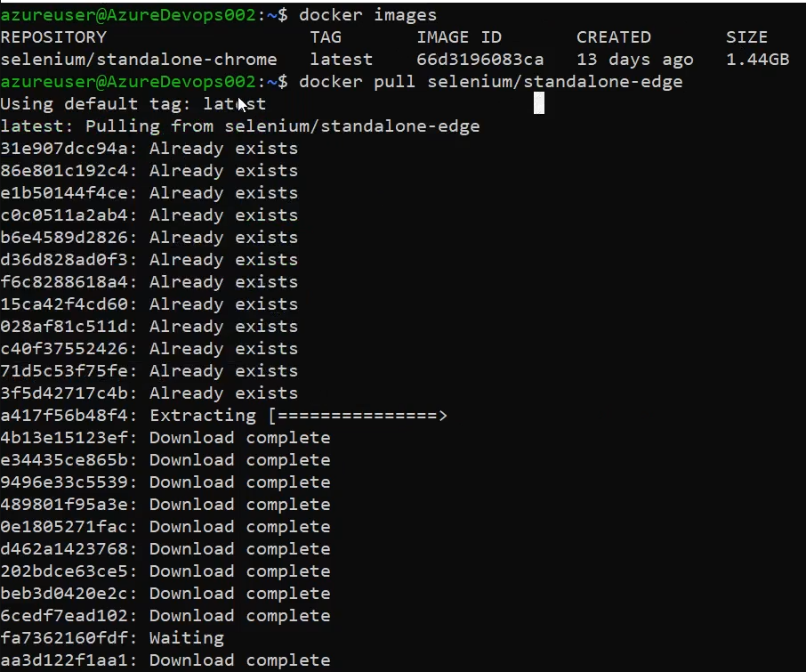
If you want specific version, click on Tag section and select appropriate version:
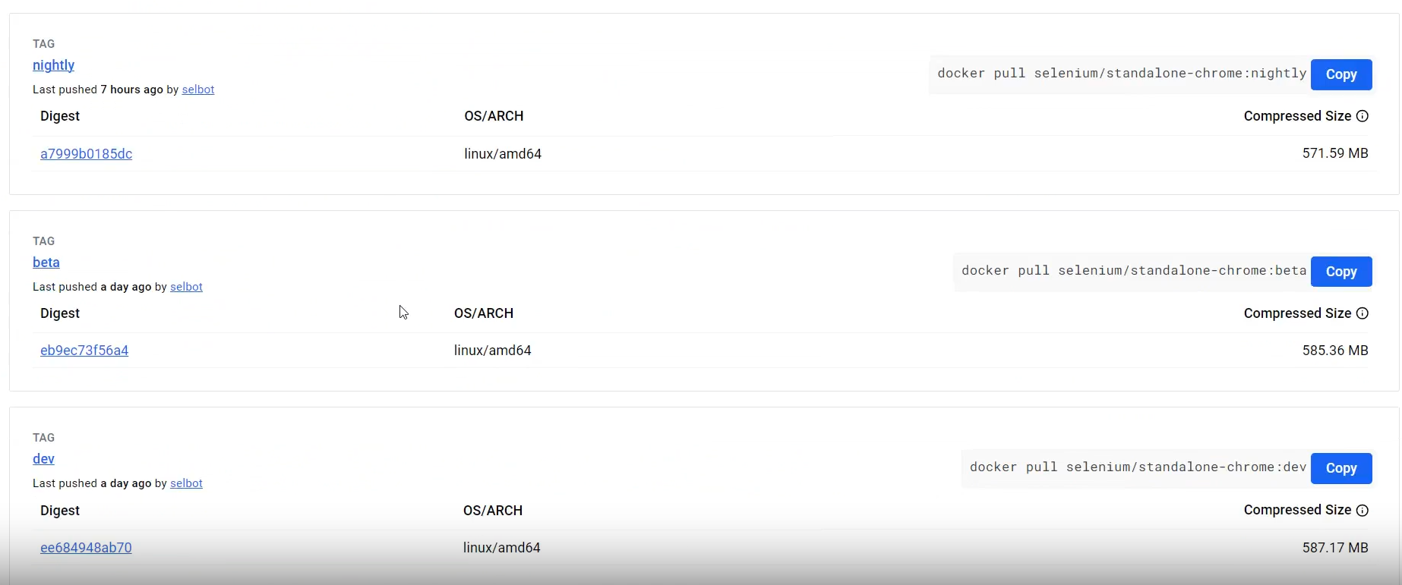
>docker images
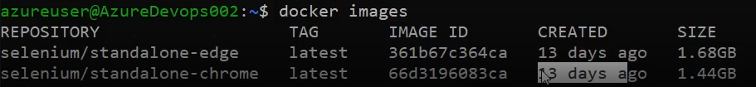
How to run Selenium Grid Standalone with Chrome:
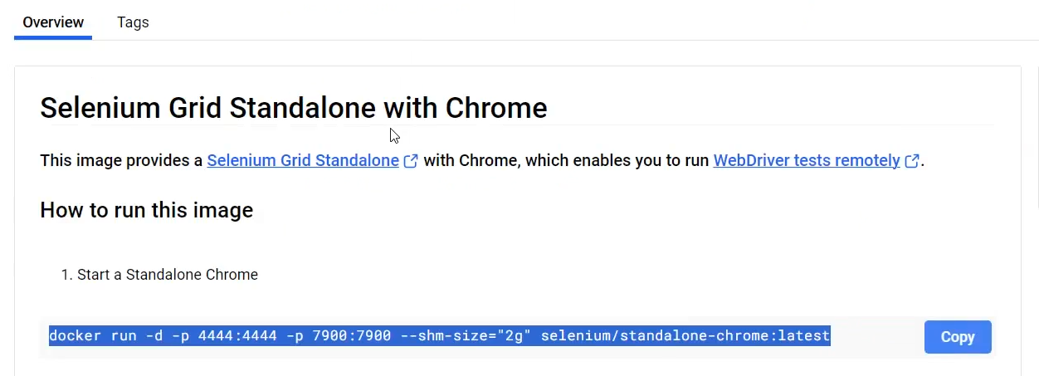
>docker run -d -p 4444:4444 -p 7900:7900 --shm-size="2g" selenium/standalone-chrome:latest
docker - command start with docker
run – create and start a container
-d – deattached mode, run in background
-p – port
4444:4444 – External : Internal
--shm-size
selenium/standalone-chrome:latest – Image Name

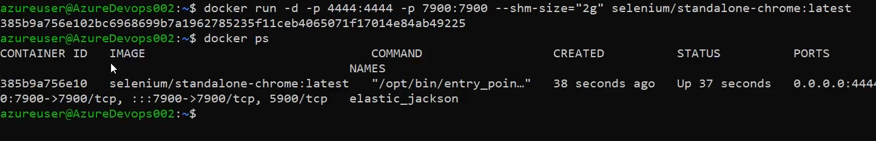
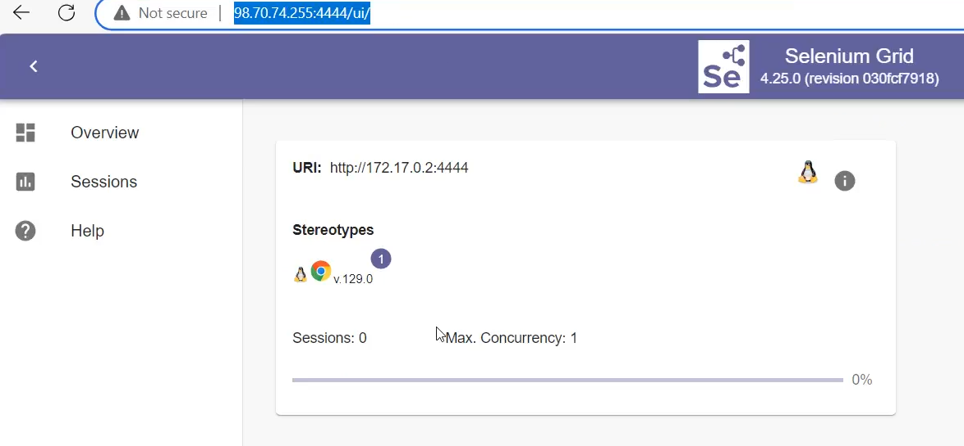
>docker run -d -p 4445:4444 -p 7901:7900 --shm-size="2g" selenium/standalone-edge:latest
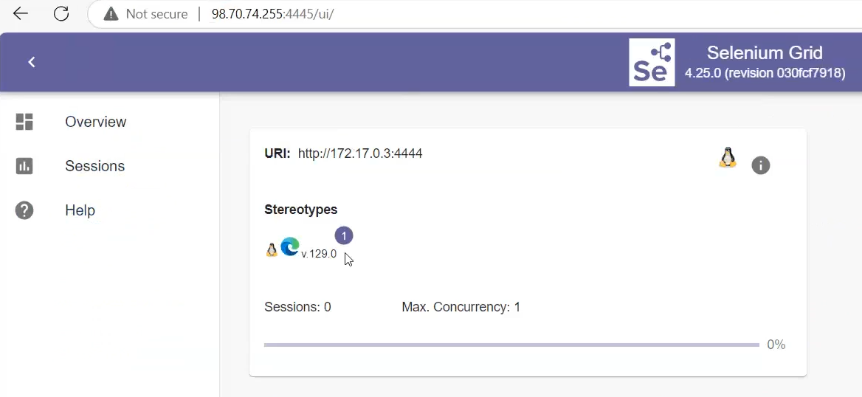

To know the list of port and usage:
https://en.wikipedia.org/wiki/List_of_TCP_and_UDP_port_numbers
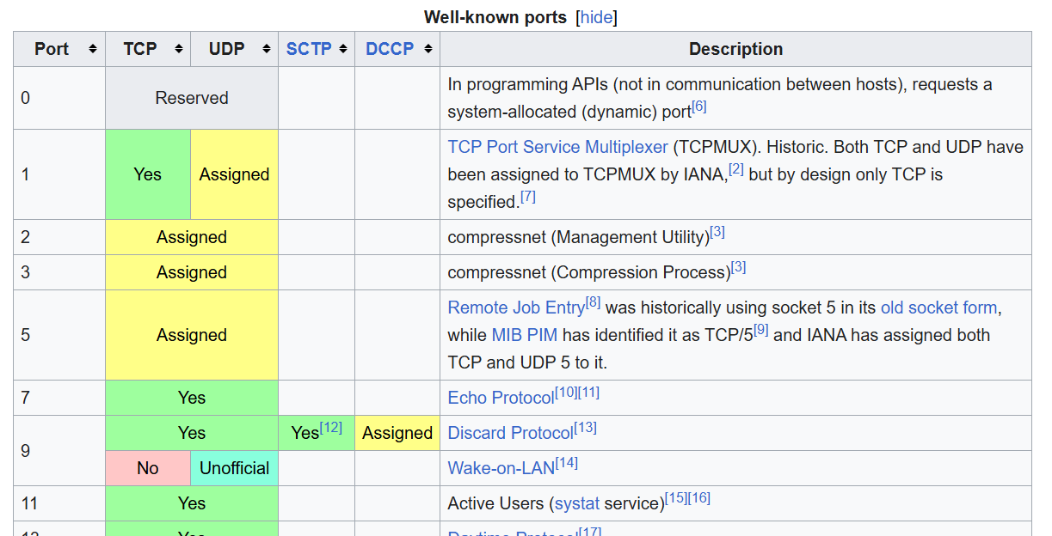
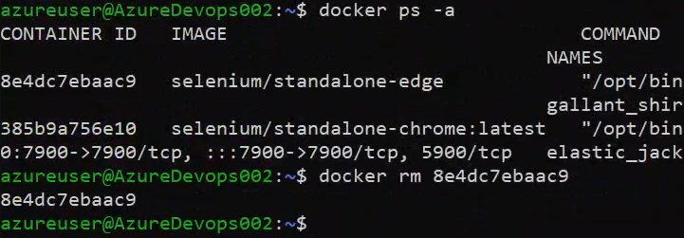
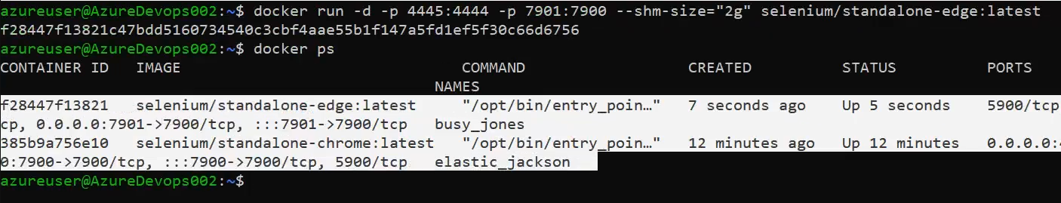

🤔 Why Do We Use Docker?
- Consistency Across Environments
  - "It works on my machine" problem? Gone!
  - Same container runs on dev, test, or production without issues.
- Faster Setup and Deployment
  - You can spin up environments in seconds using Docker images.
- Isolation
  - Each container runs separately, so one app doesn’t affect another.
- Portability
  - Containers can run on any platform that supports Docker (Windows, Linux, macOS, cloud, etc.).
- Efficient Resource Usage
  - Unlike virtual machines, Docker shares the host OS kernel, making containers lightweight and fast.
- Version Control
  - Docker images can be versioned and rolled back if needed.

🚀 Example Use Cases:
- Running web servers like Nginx or Apache
- Deploying microservices
- Automating CI/CD pipelines
- Hosting databases or message queues
- Testing in isolated environments

In Docker, the Docker daemon (also known as dockerd) is a background service that manages all Docker-related operations on your system. It listens for requests from the Docker client (such as the Docker CLI) and handles tasks like building, running, and managing containers.KodeKloudMedium+1Wikipedia+1

🔧 What Is the Docker Daemon?
The Docker daemon is the core component of Docker's client-server architecture. It performs the heavy lifting by:Stack OverflowWhizlabs
- Managing containers: Creating, starting, stopping, and deleting containers.
- Handling images: Building images from Dockerfiles and pulling/pushing images to registries.
- Networking and storage: Setting up networks and managing data volumes for containers.
- Interfacing with the host OS: Utilizing system resources like CPU, memory, and storage to run containers.Wikipedia
The daemon communicates with the Docker client through a REST API over UNIX sockets or TCP ports.

Difference b/w Docket and Ansible:
Docker and Ansible are both powerful DevOps tools, but they serve different purposes. Let’s break it down:

🐳 Docker vs 🛠️ Ansible
Feature | Docker | Ansible
🔧 Type | Containerization platform | Configuration management & automation tool
🎯 Purpose | Package and run apps in isolated containers | Automate provisioning, configuration, and app deployment
📦 What it does | Creates lightweight, portable environments (containers) | Installs software, configures systems, manages infrastructure
🏃‍♂️ Run-time environment | Creates and manages containers | Connects to servers (via SSH) and applies changes
📁 Language | Uses Dockerfile to build images | Uses YAML in Playbooks to define tasks
🔁 State | Docker is imperative (you define step-by-step instructions) | Ansible is declarative (you define the desired state)
👥 Typical use | Run apps consistently across environments | Set up servers, install packages, deploy apps, etc.
🌐 Dependency | Needs Docker Engine installed | Needs Python + SSH access on target machines

📌 In Simple Terms:
- Docker: Think of it as a box 📦 that holds your app and everything it needs to run.
- Ansible: Think of it as a remote assistant 🤖 that sets up and configures your servers.

🔗 Can They Work Together? https://hub.docker.com/
Absolutely! 💥
- You can use Ansible to install Docker and then deploy Docker containers across servers.
- Together, they make a strong DevOps combo.

What is chmod and chown?
Sure! Here's a simple explanation of chmod and chown in Linux, including their purpose:

🔐 – Change File Permissions
Purpose:
Used to change the permissions (who can read, write, or execute) for a file or directory.
Syntax:
chmod [permissions] [file or directory name]
Types of permissions:
- r – read -- 4
- w – write -- 2
- x – execute -- 1
Who:
- u – user (owner)
- g – group
- o – others
- a – all
Examples:
- Add execute permission to the owner:
chmod u+x script.sh
- Make a file readable and writable by everyone:
chmod a+rw file.txt
- Numeric way:
chmod 755 file.sh
  - 7 = read + write + execute (owner)
  - 5 = read + execute (group and others)

👤 chown – Change File Ownership
Purpose:
Used to change the owner and/or group of a file or directory.
Syntax:
chown [new_owner][:new_group] [file or directory]
Examples:
- Change owner of a file:
chown alice file.txt
- Change owner and group:
chown alice:devteam file.txt
- Change ownership recursively for a directory:
chown -R alice:devteam /project-folder

Day 1: Docker Tutorial for Beginners: What It Solves & How to Install Docker – 19th Apr 2025
>sudo su
root>yum install docker
root>docker --version
root>systemctl start docker
root> docker images
root > docker ps
root>docker ps -a
https://hub.docker.com/
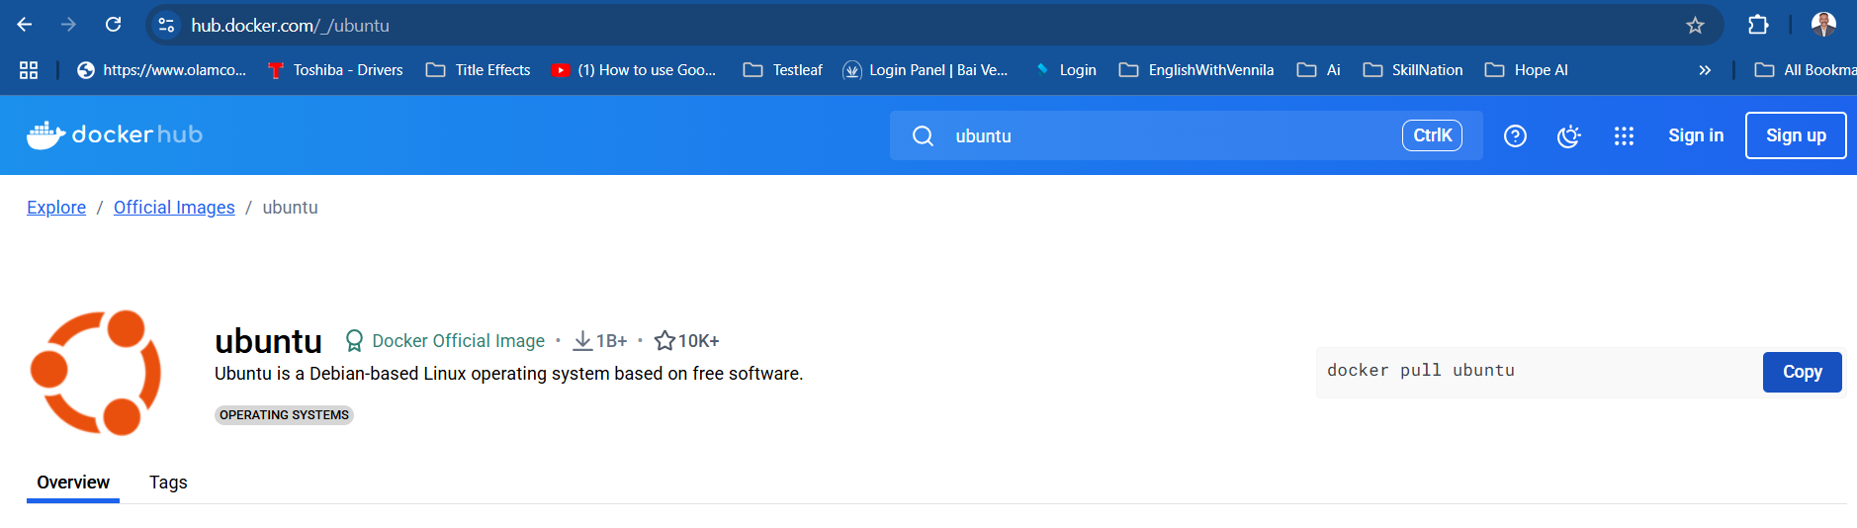
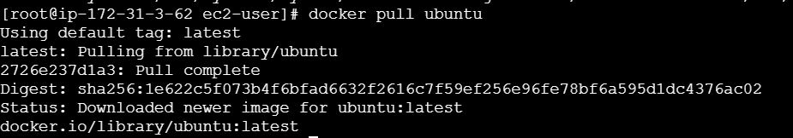
>docker run -it ubuntu // It means Interative Terminal, It will create and run a container with random name. But if you a custom for the container use the below command:
>docker run ---name anbuMachine -it ubuntu // with custom name container
>cat /etc/os-release
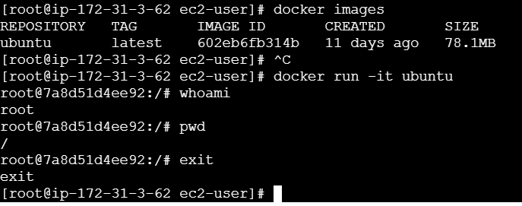

Day 2: Docker Basics for Beginners | Top Docker Commands You MUST Know! – 20th Apr 2025
🐳 What is a Docker Image?
✅ Definition:
A Docker image is like a blueprint or template. It contains everything needed to run a program:
- The code
- Libraries
- Dependencies
- Configuration files
It’s read-only and used to create containers.

🔧 Example:
Think of a cake recipe. That’s your image.
If you have an nginx image, it includes:
- The nginx web server
- All required files to run nginx

📦 What is a Docker Container?
✅ Definition:
A Docker container is a running instance of a Docker image.
It’s like actually baking the cake using the recipe.
You can run, stop, delete, or restart a container.
- Containers are isolated and can run multiple at the same time.
- They are temporary but can be saved if needed.

⚙️ Example:
Using the nginx image (recipe), you start a container (bake a cake). Now you can serve content through it.

📊 Analogy Table
Term | Think of it as... | Key Characteristics
Docker Image | A blueprint or recipe | Read-only, used to create containers
Docker Container | A running machine | A live, working unit based on the image

🔁 Relationship
- You pull or build a Docker image.
- Then you run a container from that image.
# Pulling an image
docker pull nginx
#View all Images
docker images
# Running a container from that image
docker run --name myweb -d nginx
You said:
explain this in detailed :docker run --name myweb -d nginx
ChatGPT said:
Absolutely! Let's break down this Docker command in detail:

🔸 Full Command:
docker run --name myweb -d nginx
This command is used to create and run a Docker container based on the nginx image.

🧱 Word-by-Word Breakdown
Part of Command | Meaning
docker | You're using the Docker command-line tool
run | Tells Docker to create and start a new container
--name myweb | Gives your container a custom name: myweb
-d | Runs the container in detached mode (in the background)
nginx | The image you’re using to create the container (nginx web server)

🧠 What Happens Behind the Scenes:
- Docker checks if the nginx image is already on your machine.
  - If not, it downloads (pulls) it from Docker Hub.
- It creates a new container from the image.
- It starts the container.
- The container runs in the background (thanks to -d).
- The container is named myweb, so you can easily reference it later.

✅ Example Use Case:
You're building a website or testing something. You want to quickly run an nginx server:
docker run --name myweb -d nginx
Now you have a live web server running on nginx inside a Docker container — no manual server setup needed!

🧪 You can now:
- See it running:
  - docker ps
- Access its logs:
  - docker logs myweb
- Stop it:
  - docker stop myweb
- Remove it:
  - docker rm myweb

⚠️ Notes:
- -d (detached mode) is useful when you don’t want your terminal to be blocked.
- You can add ports with -p, like -p 8080:80 to access nginx on your browser.
🔹 docker ps -a
- What it does:
Lists all containers on your system — both running and stopped (exited) ones.
- Breakdown:
  - ps = process status (like ps in Linux).
  - -a = all containers (not just the running ones).
- Useful when:
You want to see containers that have stopped, crashed, or exited.
- Example output:
CONTAINER ID IMAGE COMMAND STATUS NAMES
abc123 nginx "/start.sh" Exited (0) 2 hours ago my_nginx
def456 ubuntu "bash" Up 5 minutes my_ubuntu

🔹 docker images
- What it does:
Lists all Docker images available on your local machine.
- Useful when:
You want to see what base images (like Ubuntu, Nginx, Node, etc.) are available to create containers from.
- Example output:
REPOSITORY TAG IMAGE ID CREATED SIZE
nginx latest abc123 3 days ago 133MB
ubuntu 20.04 def456 2 weeks ago 72.9MB

Summary Table
Command | Shows what? | Includes stopped? | Purpose
docker ps | Only running containers | ❌ No | See what’s running now
docker ps -a | All containers (running + stopped) | ✅ Yes | Full history of containers
docker images | All images on your system | Not about containers | See base images available
To know the list of group:
>cat /etc/group
To know the list of users:
>cat /etc/passwd
To know the user on the specific group:
>lid -g docker // docker is a group name and root user have access to all groups by default.

Add user to the group:
>gpasswd -a ec2-user docker // Once we added an user to the group, we have to restart the system, then only it will reflect.
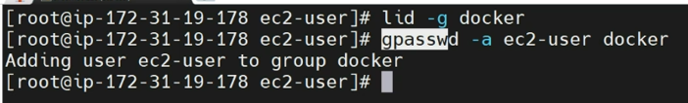
Before restart:
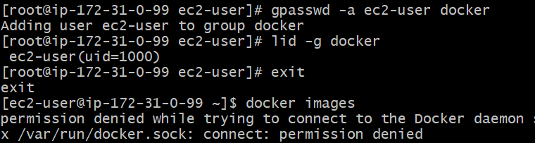
How to restart: >sudo reboot
Using reboot with force > sudo reboot -f
After restart:
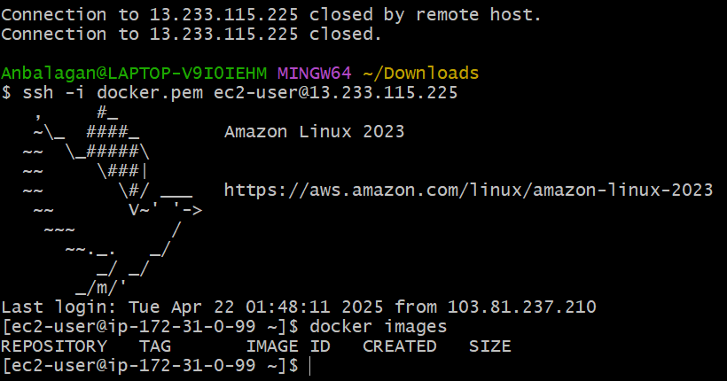
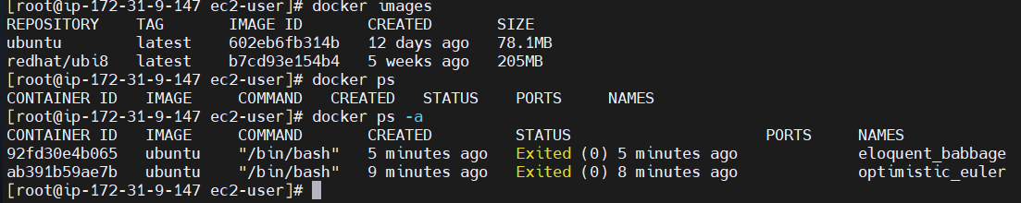
⚠️ Key Differences:
Feature | docker start | docker exec
Container State | Used on stopped containers | Used on running containers
Purpose | To start the container | To run a command inside a container
Creates Process? | Starts the container's main process | Runs additional command inside
Interactive? | Not typically | Can be interactive with -it
🧠 Summary:
Task | Correct Command
Start Docker Engine | sudo systemctl start docker
Start a stopped container | docker start <container-name>

To start the container:
>docker start <container ID> OR <container name>
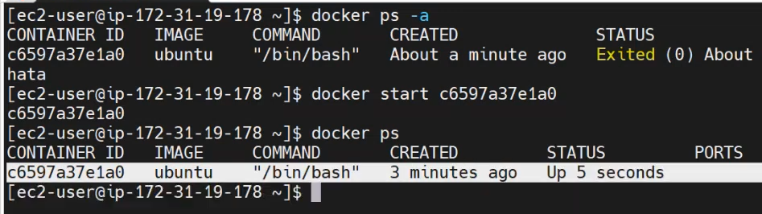
To execute/run the container:
>docker exec -it <containerName or ID> /bin/bash
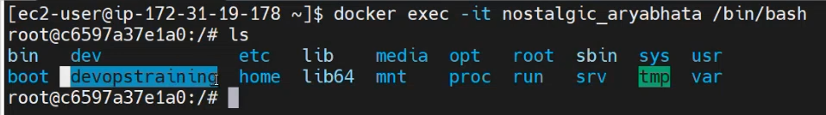
>docker images
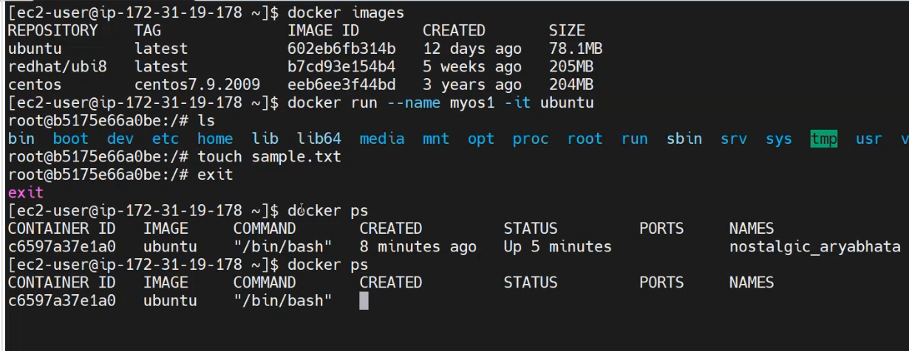
>docker ps
>docker ps -a
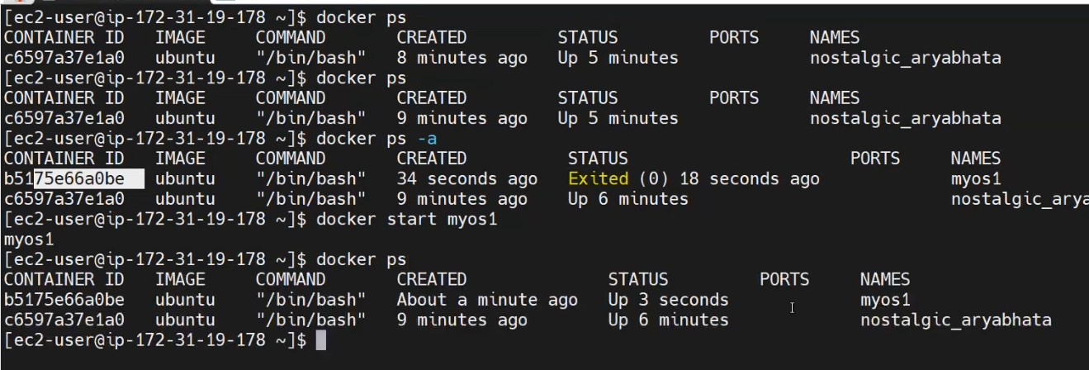

To stop the container:
>docker stop <container id> OR <container name>
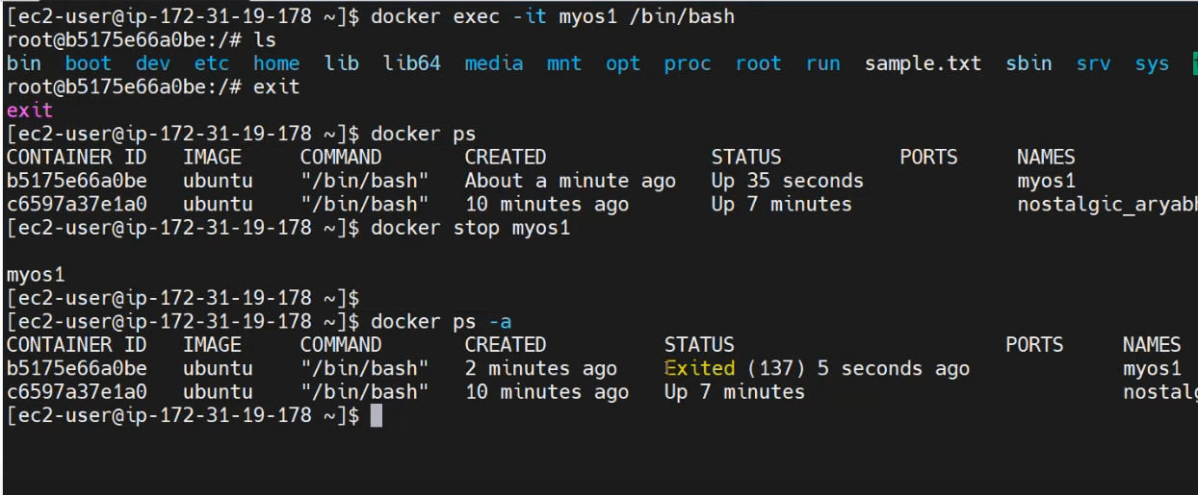
>docker inspect // To know the container details…
To remove docker container, Before removing the container, first we need to STOP the container and then remove.
>docker rm <container Id> OR <containerName>
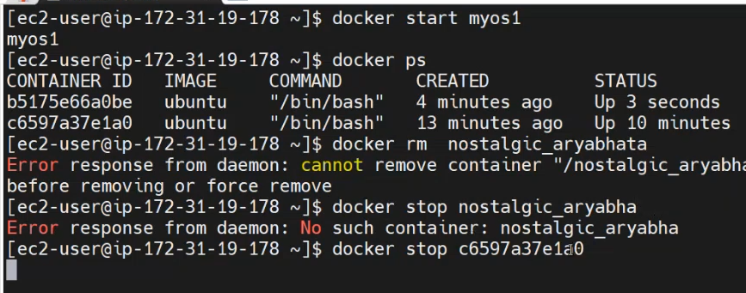

🧹 Remove a Specific Docker Image
To delete an image by its name or ID:​
docker rmi <image_name_or_id>
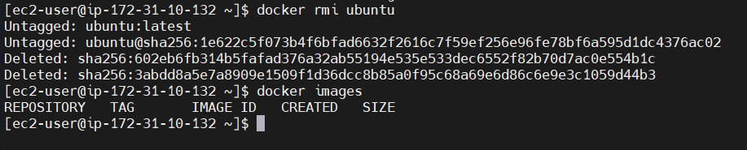

For example:​
docker rmi nginx:latest
If the image is used by any containers (even stopped ones), you'll need to remove those containers first or force the deletion.​
⚠️ Force Delete an Image
To forcefully remove an image, bypassing checks for existing containers:​Stack Overflow+5GeeksforGeeks+5Learn R, Python & Data Science Online+5
docker rmi -f <image_name_or_id>
This is useful when the image is associated with containers that you haven't removed yet.​

🧼 Remove All Docker Images
To delete all images from your system:​
docker rmi $(docker images -q)
This command lists all image IDs and removes them.​

🧹 Remove Dangling (Untagged) Images
Dangling images are layers that are no longer tagged and are not referenced by any container. To remove them:​Warp+5Stack Overflow+5Learn R, Python & Data Science Online+5
docker image prune
To remove all unused images (not just dangling ones):​BlueVPS+7Stack Overflow+7Stack Overflow+7
docker image prune -a
This cleans up images not associated with any container.​

🧩 Remove an Image by Digest
If an image was pulled by digest and has no tag, you can remove it using its digest:​Docker Documentation
docker rmi <image_name>@<digest>
For example:​
docker rmi localhost:5000/test/busybox@sha256:cbbf2f9a99b47fc460d422812b6a5adff7dfee951d8fa2e4a98caa0382cfbdbf
This command un-tags and removes the image associated with the specified digest. ​

Note: Before deleting images, ensure that they are not being used by any running containers to avoid unintended disruptions.

Day 3: Essential Docker Commands for Beginners | Part 2 - Learn Docker Basics
>Mostly recall concept of the previous class…

Day 4: Create a Dockerfile to Deploy a WAR File in Tomcat (Step-by-Step Guide)
A Dockerfile is a text file that contains a set of instructions used to build a Docker image. It tells Docker how to set up the environment and install the necessary software inside a container.

✅ What is a Dockerfile?
It's like a recipe or a blueprint for creating a Docker image. The Dockerfile includes commands to:
- Set a base image (like Ubuntu, Node.js, Python, etc.)
- Install software and dependencies
- Copy files into the image
- Run commands (like installing packages or setting permissions)
- Define a default command to run when the container starts

📦 Why do we use a Dockerfile?
We use a Dockerfile to:
- Automate the image creation process.
- Ensure consistency — same environment every time, everywhere.
- Save time — no need to set up the environment manually again and again.
- Simplify deployment — build once, run anywhere.

🧱 Example Dockerfile (for a Python app)
# Use a base Python image
FROM python:3.9
# Set working directory
WORKDIR /app
# Copy the current folder contents into the container
COPY . .
# Install dependencies
RUN pip install -r requirements.txt
# Run the app
CMD ["python", "app.py"]

When you use a FROM instruction in a Dockerfile (like FROM python:3.9), Docker downloads the base image from the Docker Hub (or another registry like Amazon ECR, GitHub Container Registry, etc.) the first time you build the image.

📂 Where exactly does Docker store the base image?
- On your local machine, Docker stores all images (including base images) in its internal storage.
- The location depends on your operating system:
🪟 On Windows (Docker Desktop with WSL2):
Base images are stored inside a virtual machine (WSL2 backend).
- You don’t access them directly from File Explorer.
- You can view them with:
docker images
🍎 On macOS:
Like Windows, Docker uses a lightweight VM, so the images are inside that VM.
- Also managed internally by Docker Desktop.
🐧 On Linux:
Docker stores images in:
/var/lib/docker/
- Inside that, you'll find folders like overlay2/, image/, and containers/.

📦 To check downloaded images
Run this in your terminal:
docker images
You'll see something like:
REPOSITORY TAG IMAGE ID SIZE
python 3.9 123456abcdef 885MB
This confirms that the base image is downloaded and stored locally.
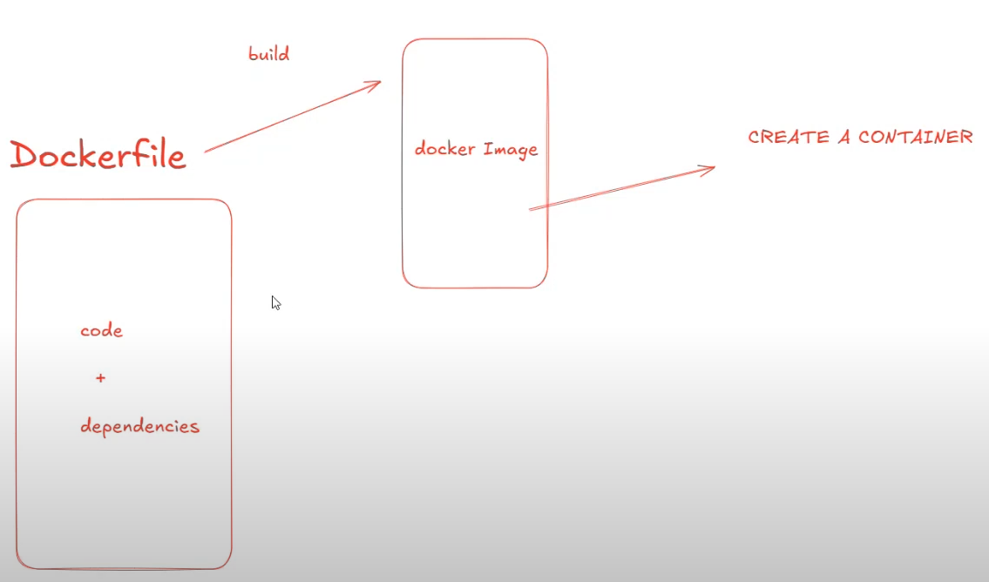
Create a docker file with name of “Dockerfile”
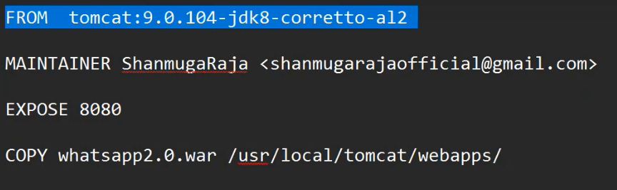
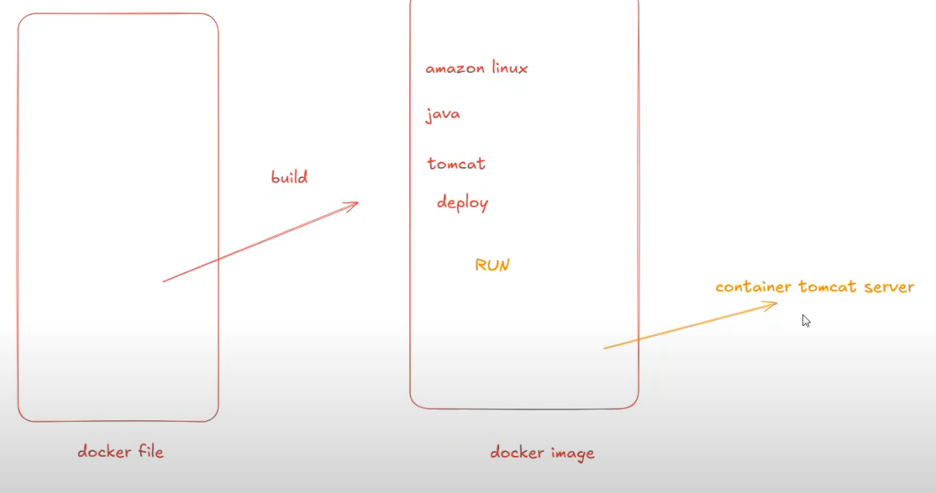
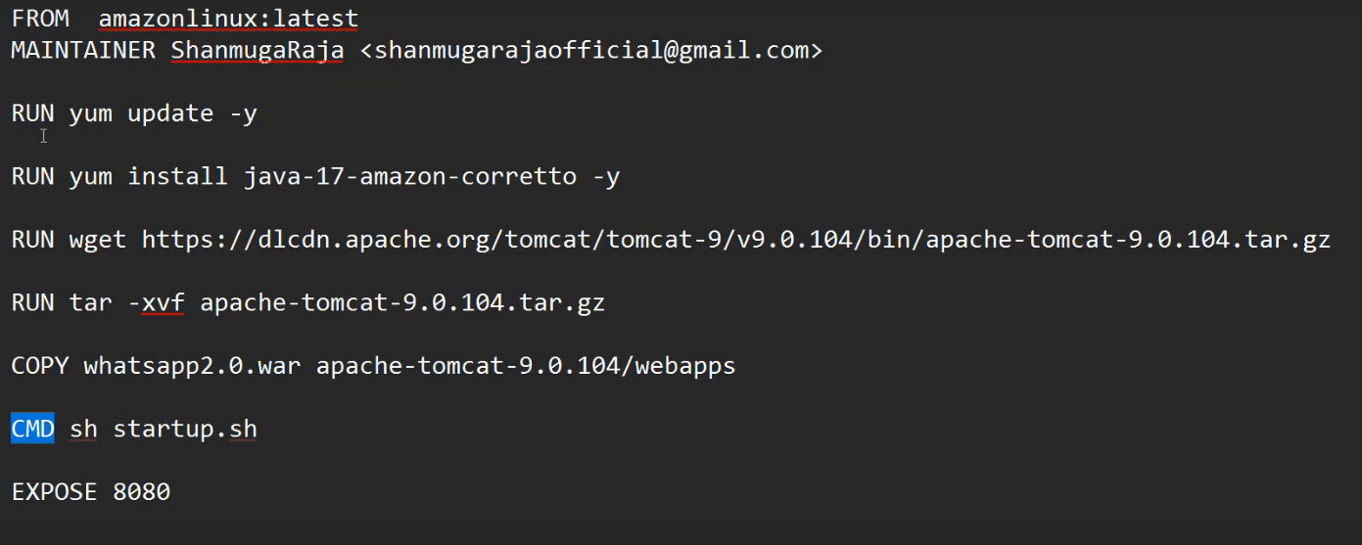
Build a Docker image using Dockerfile:
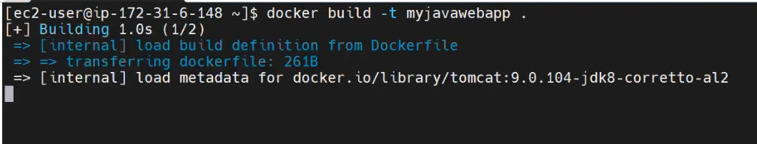

Create a Docker Container using the Docker Image:
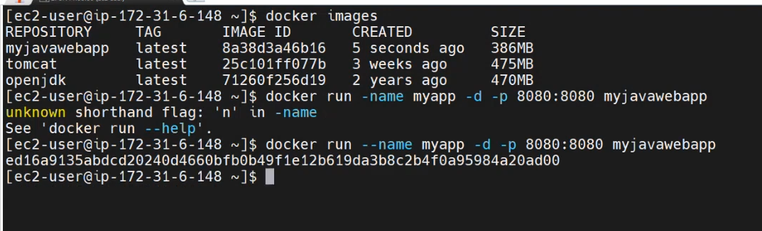
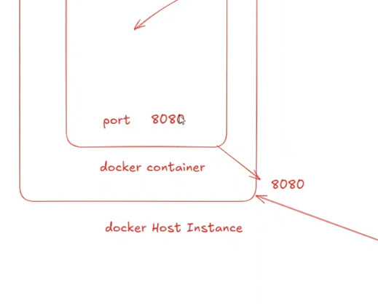
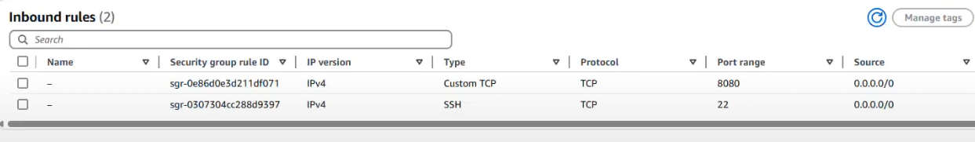
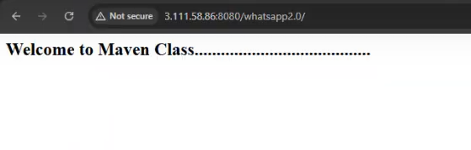
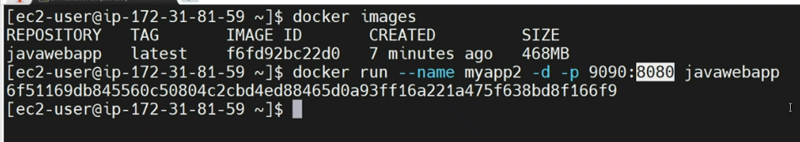
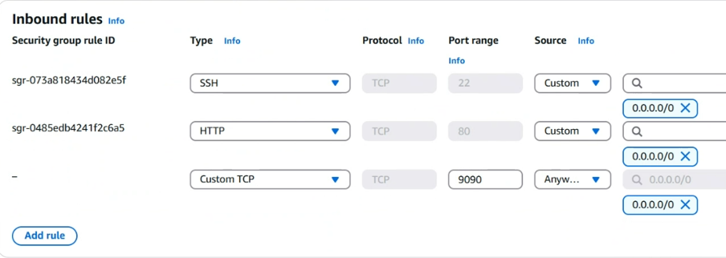

Day 5: Dockerfile for Serving a Static Website with Apache HTTP Server | Docker Tutorial
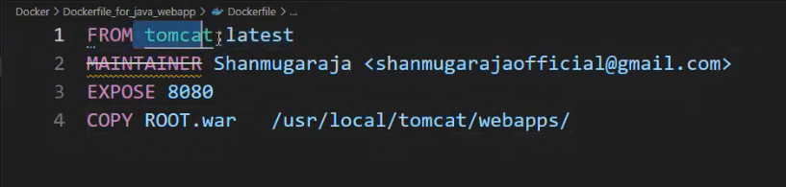
. means, the docker file is available in the current directory.
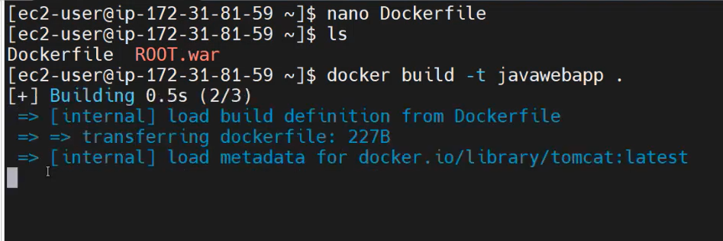

Now created OWN docker image.
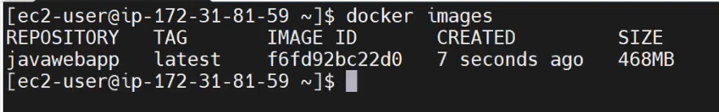
Create a container using the docker image

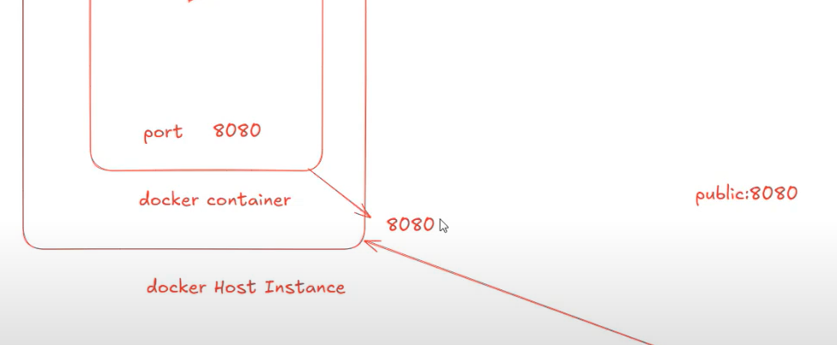
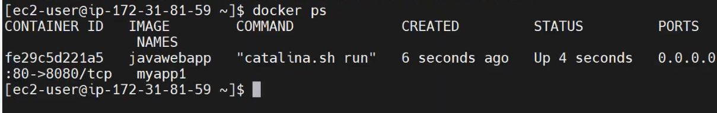
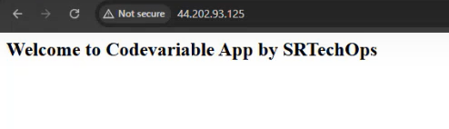
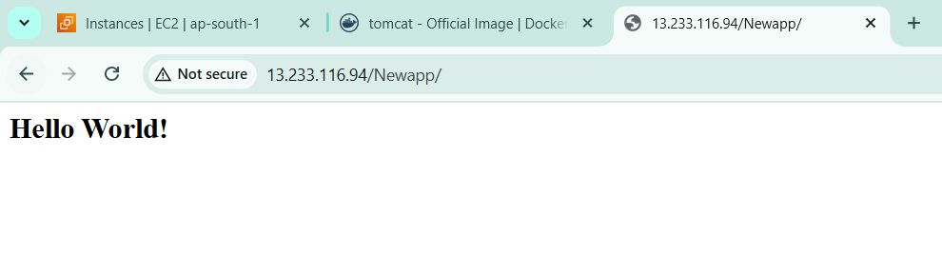
One more docker container using different port:
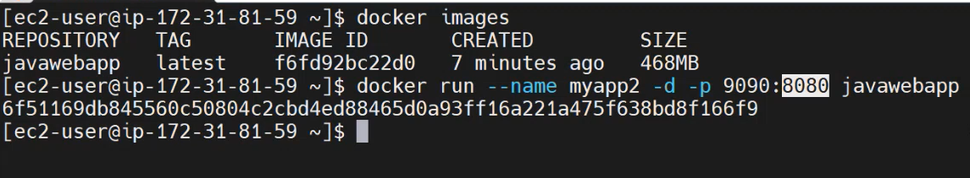
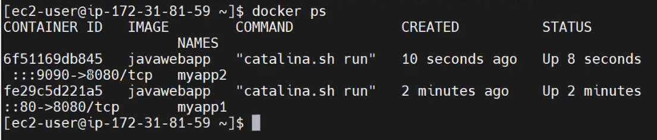
Enable port 9090:
