Maven
Day 1: Introduction to Maven: Why and How
https://www.youtube.com/watch?v=Ied2ruaBT8Q&list=PL7iDpp0KYTgFFlc3DcgdboYWdYp7kNCmy&index=1
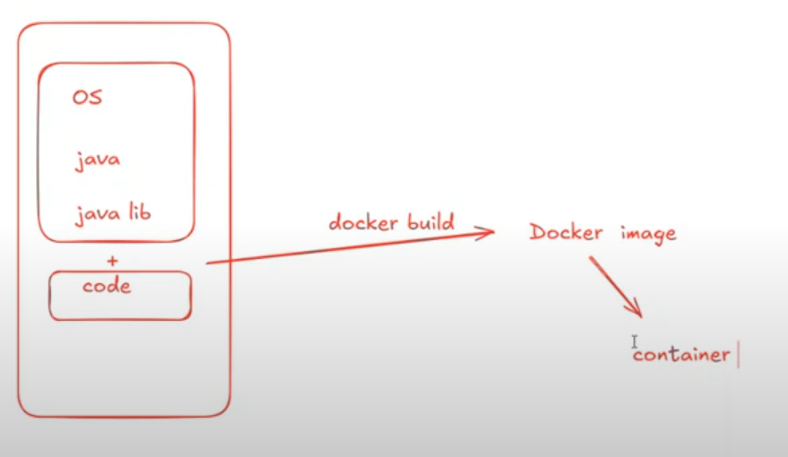
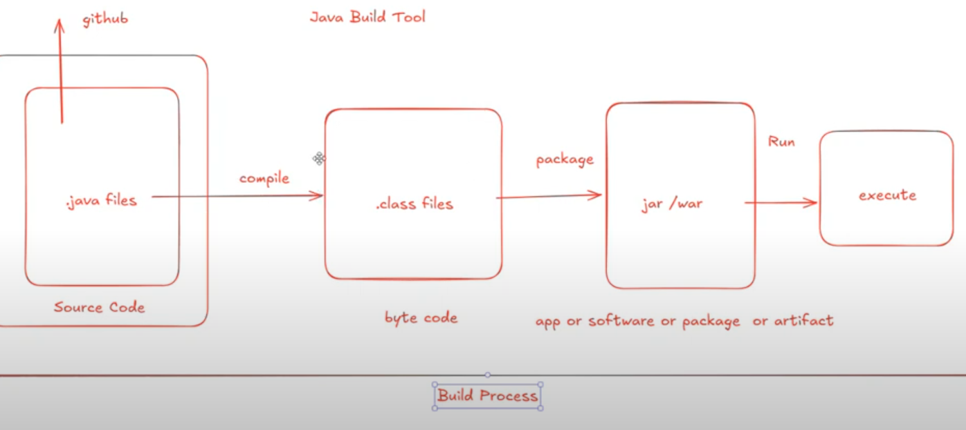
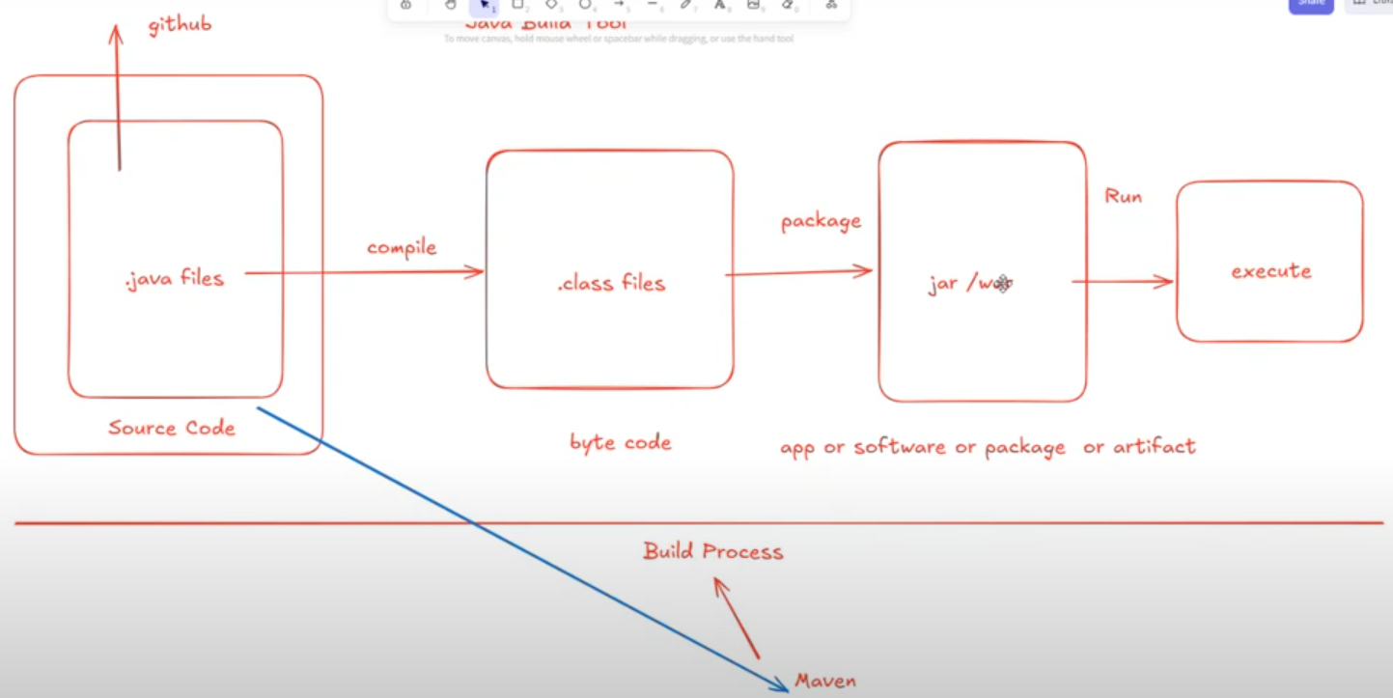
Two types of Application:
- Standlone > download and use it. (Eg. Notepad, VS Code, Browser etc…). They use jar file.
- Web > Create a virtual/physical server and run the code. Access through browser/online. They use war file.
jar > java archive
war > web archive
If we use both standlaone and web application, then we use ear file (Enterprise archive)

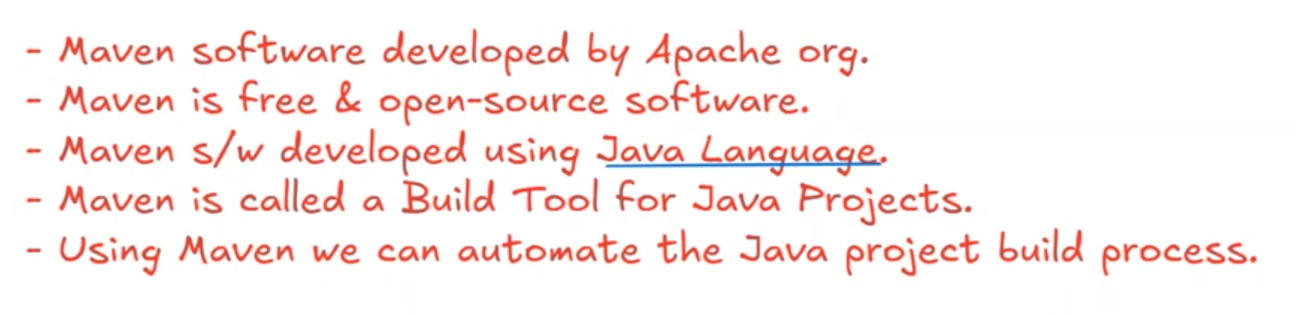
Javascript related project, we use npm (Node Package Manager) to build code. It stores all javascript related library. Using npm, we can install any javascript libraries.
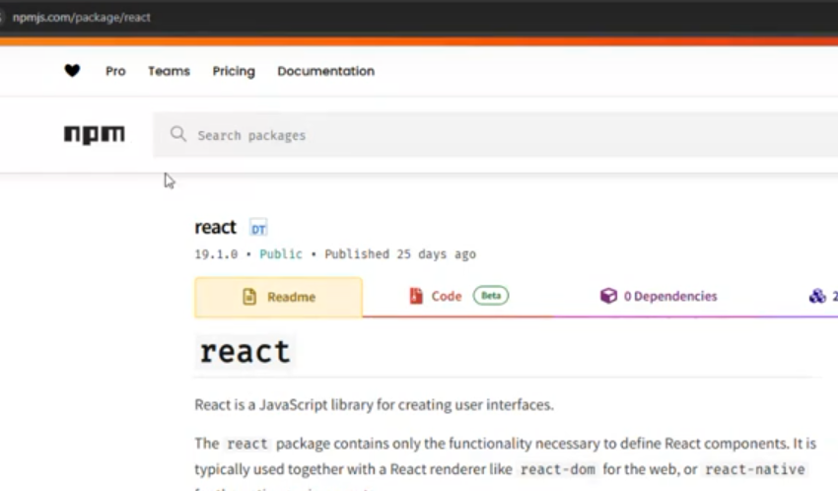
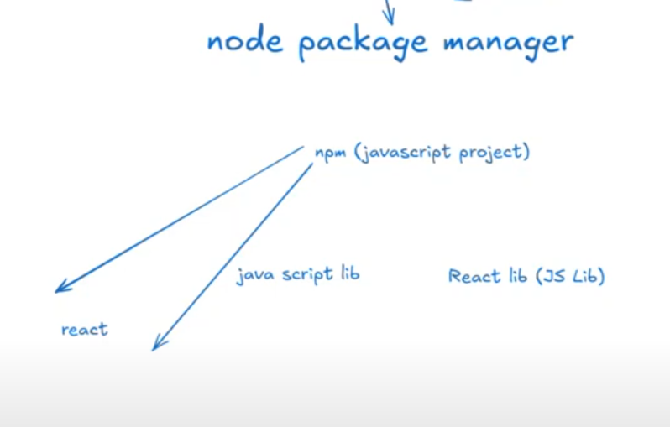
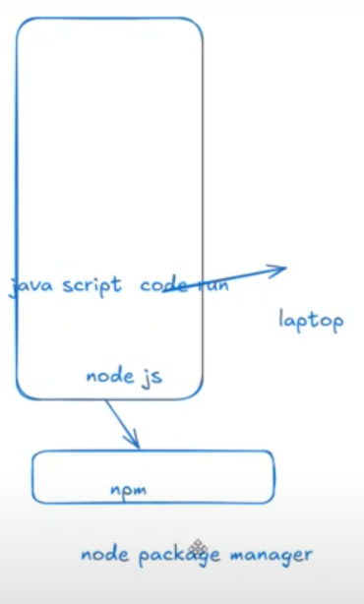
Day 2: How to Install Maven & Master Maven Goals | Complete Beginner Guide | Maven Tutorial
We can download java from oracle or Amazon java
https://aws.amazon.com/corretto/?filtered-posts.sort-by=item.additionalFields.createdDate&filtered-posts.sort-order=desc
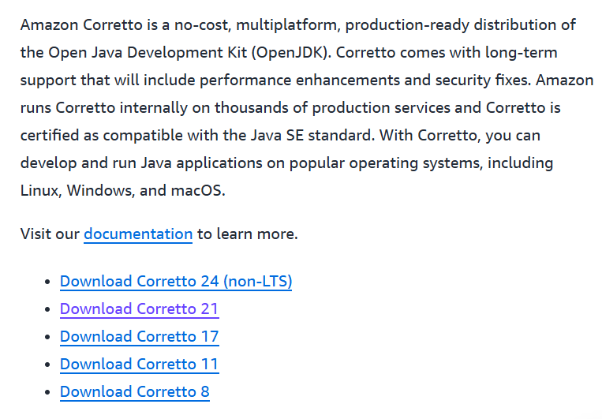
https://www.oracle.com/in/java/technologies/downloads/
IMPORTANT:
1.Install java 17 OR 21 OR any and Maven in C driver under program files.
2.Go to environment variable, then under System Variable, Click New > set a path of JAVA_HOME, MAVEN_HOME
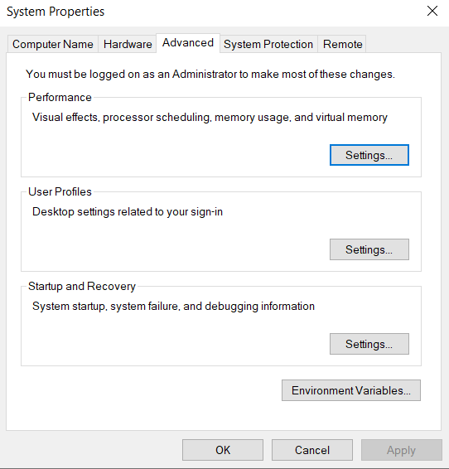
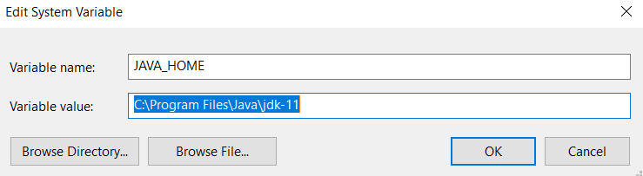
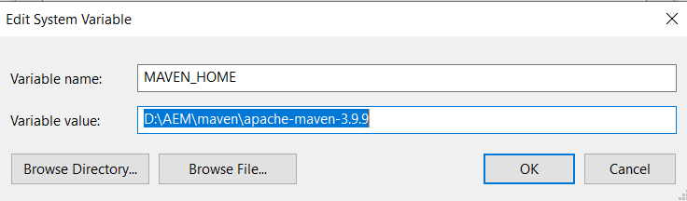

Select & Edit Path:
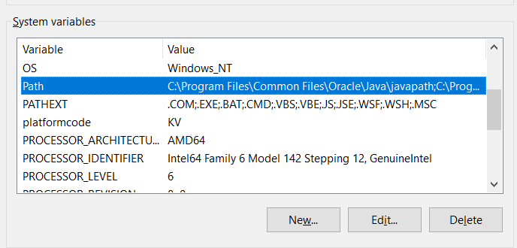
Add below 2:
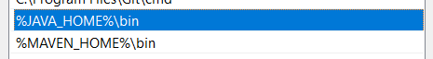
Maven archetype will create a structure of the java project:
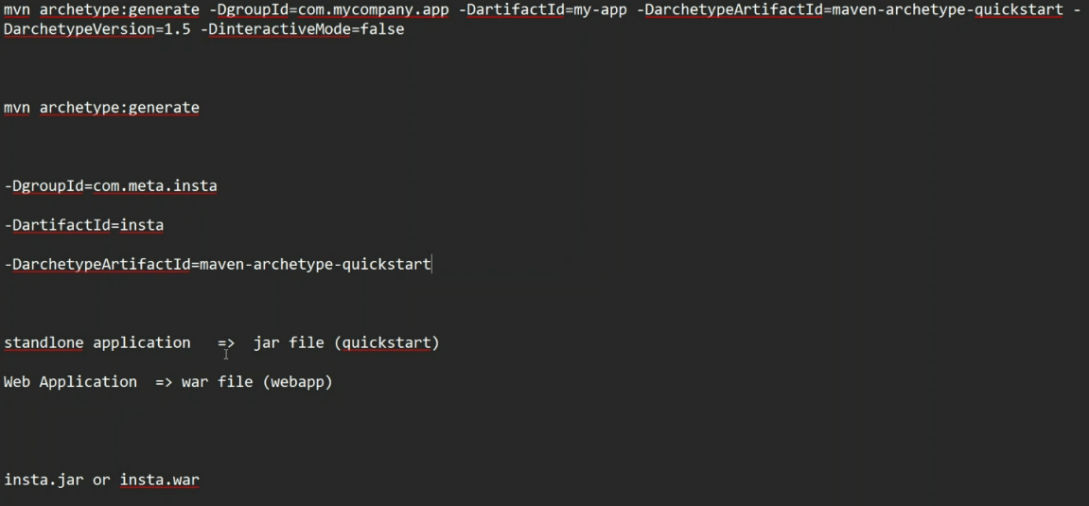
POM: Project Object Model
Maven Goals > User to perform project build process
Go to the specific JAVA folder that should have pom file, then cmd
Command:
>mvn compile // compile all the java files and create a class files.
When we compile, the target folder will be created.
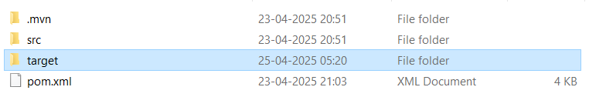
>mvn test // It will compile + test
>mvn package //It will compile+test+package i.e jar or war file
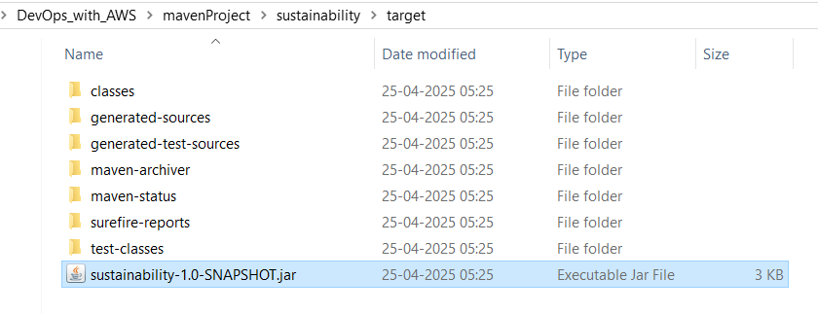
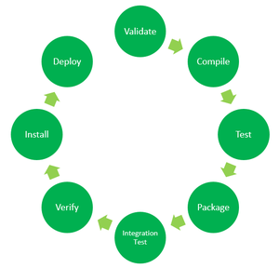
https://www.geeksforgeeks.org/maven-build-phases-and-basic-maven-commands/?utm_source=chatgpt.com
- Validate: This step validates if the project structure is correct. For example – It checks if all the dependencies have been downloaded and are available in the local repository.
- Compile: It compiles the source code, converts the .java files to .class, and stores the classes in the target/classes folder.
- Test: It runs unit tests for the project.
- Package: This step packages the compiled code in a distributable format like JAR or WAR.
- Integration test: It runs the integration tests for the project.
- Verify: This step runs checks to verify that the project is valid and meets the quality standards.
- Install: This step installs the packaged code to the local Maven repository.
- Deploy: It copies the packaged code to the remote repository for sharing it with other developers.
These build phases are executed sequentially by default when you run a Maven build.
In a Maven project, the build process begins with the Validate phase, where Maven validates the project structure. It ensures to Maven standards that the required plugins are available. Next, in the Compile phase, Maven compiles the Java source code into bytecode. Following compilation, the Test phase executes unit tests to validate the code’s functionality. Once tests pass, the Package phase bundles the compiled code, resources, and dependencies into a distributable format, like a JAR or WAR file. Finally, in the Install phase, Maven installs the packaged artifact into the local Maven repository and makes it available for other projects.
Maven Commands
With a simple command-line interface, Maven manages project dependencies, compiles source code, runs tests, and packages applications. Some basic Maven commands includes:
- mvn clean: Cleans the project and removes all files generated by the previous build.
- mvn compile: Compiles source code of the project.
- mvn test-compile: Compiles the test source code.
- mvn test: Runs tests for the project.
- mvn package: Creates JAR or WAR file for the project to convert it into a distributable format.
- mvn install: Deploys the packaged JAR/ WAR file to the local repository.
- mvn site: generate the project documentation.
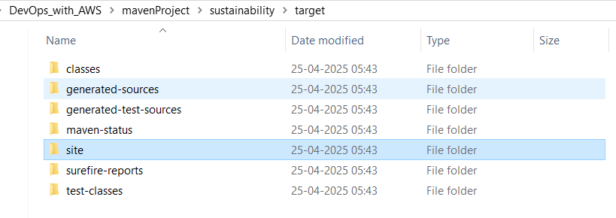
- mvn validate: validate the project’s POM and configuration.
- mvn idea:idea: generate project files for IntelliJ IDEA or Eclipse.
- mvn release:perform: Performs a release build.
- mvn deploy: Copies the packaged JAR/ WAR file to the remote repository after compiling, running tests and building the project.
- mvn archetype:generate: This command is used to generate a new project from an archetype, which is a template for a project. This command is typically used to create new projects based on a specific pattern or structure.
- mvn dependency:tree: This command is used to display the dependencies of the project in a tree format. This command is typically used to understand the dependencies of the project and troubleshoot any issues.
ChatGPT:
1. mvn clean
- Purpose: Removes the target/ directory, which contains all files generated by the previous build.
- Usage: Ensures that the next build starts from a clean state, preventing issues caused by outdated or stale files.
- Example:​Itexus+3GeeksforGeeks+3Automation Panda+3Itexus+1Stack Overflow+1
mvn clean
- Note: It's a good practice to run this command before building your project to avoid potential conflicts from previous builds. ​

2. mvn compile
- Purpose: Compiles the project's main source code located in src/main/java.
- Usage: Processes the source code and outputs the compiled .class files into the target/classes directory.
- Example:​ComputingForGeeks
mvn compile
- Note: This command does not compile test source code. ​DEV Community

3. mvn test
- Purpose: Runs the unit tests for the project.
- Usage: Compiles the test source code located in src/test/java and executes the tests using a testing framework like JUnit or TestNG.
- Example:​GeeksforGeeks+5GeeksforGeeks+5MonoVM+5
mvn test
- Note: This command includes the compile phase before running the tests. ​Automation Panda+1Marco Behler+1

4. mvn package
- Purpose: Packages the compiled code into a distributable format, such as a JAR or WAR file.
- Usage: Executes all necessary phases, including compiling the code, running tests, and packaging the application.
- Example:​GeeksforGeeks+3MonoVM+3GeeksforGeeks+3Soham Kamani+2Stack Overflow+2Marco Behler+2
mvn package
- Note: The output artifact is placed in the target/ directory. ​Automation Panda

Common Combined Usage
Developers often combine these commands to perform multiple actions in sequence. For example:​
mvn clean package
This command cleans the project and then compiles, tests, and packages it. ​GeeksforGeeks
Day 3: Maven Webapp Project Explained | POM File, Local Repo & Remote Repo | Guide for Beginners
what is the command mvn install and mvn package? explain in detail? when we use?
🗒️ Answer
1. mvn package
- This command compiles the source code, runs the tests, and then packages the project into a distributable format like a .jar or .war file [2], [6].
- It stops after creating the package inside the target/ folder.
- Use case:
  - When you just want a packaged file to deploy or share.
  - Example: Creating a JAR to run manually on your machine or send to others.

2. mvn install
- This command does everything mvn package does (compile, test, package), plus it installs the resulting .jar or .war into your local Maven repository (typically at ~/.m2/repository) [1], [2], [5], [6].
- Use case:
  - When your project will be used as a dependency in another local project.
  - Example: After developing a library, installing it so other projects can find it without uploading to a central server.

🔔 Quick Summary:
Command | Does What | When to Use
mvn package | Compile + Test + Create package (JAR/WAR) | Need distributable file
mvn install | package + Install to local repo | Need the project available for other local Maven builds
🌐 Sources
- stackoverflow.com - What does mvn install in maven exactly do
- geeksforgeeks.org - Maven Commands and Options
- maven.apache.org - Maven in 5 Minutes
- marcobehler.com - mvn clean install - a short guide to Maven
- dev.to - Difference between mvn install and mvn package
- geeksforgeeks.org - Maven Build Phases and Basic Maven Commands
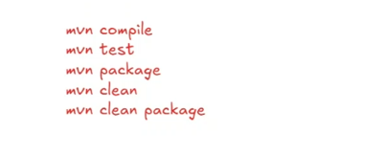
https://maven.apache.org/guides/getting-started/maven-in-five-minutes.html
When we use “webapp”, It will create a web application (war)
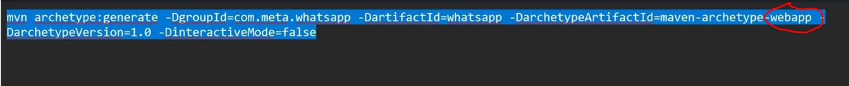
Once the project structure is created, go to folder and then run the mavn command:
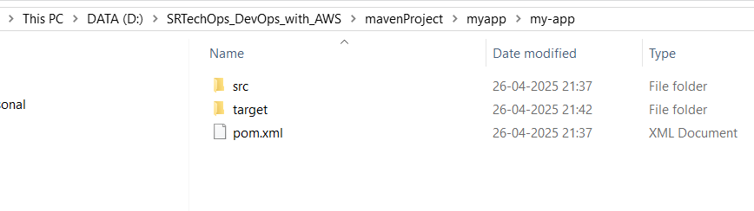
>cd my-app
my-app>mvn package
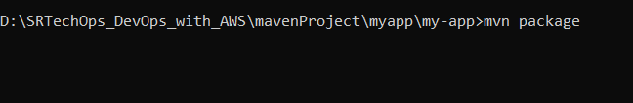

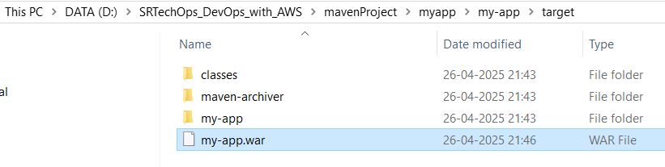
>mvn install
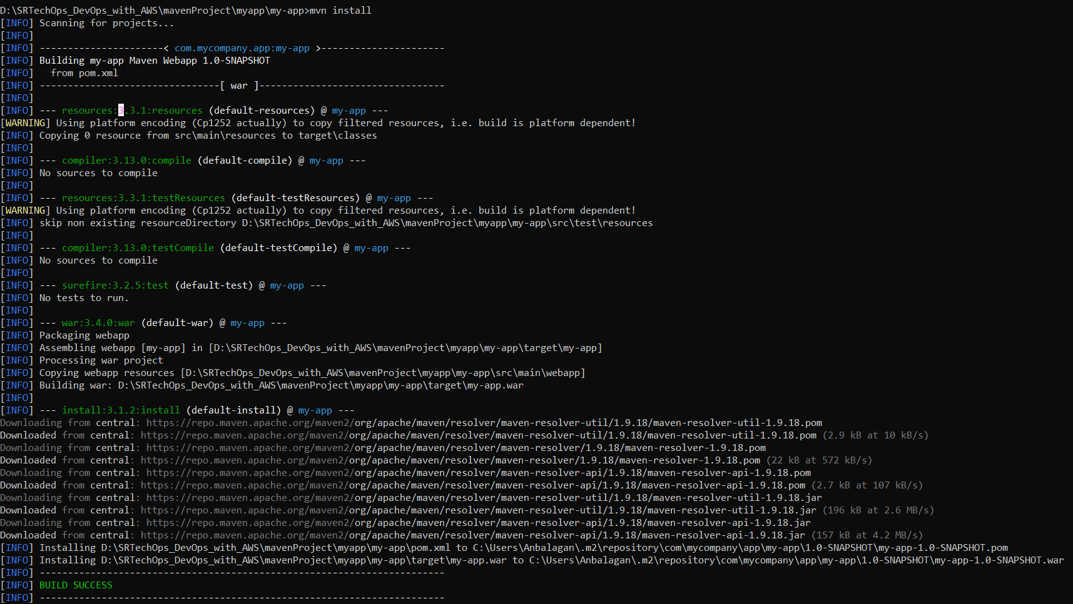
Creating a Project
You need somewhere for your project to reside. Create a directory somewhere and start a shell in that directory. On your command line, execute the following Maven goal:
mvn archetype:generate -DgroupId=com.mycompany.app -DartifactId=my-app -DarchetypeArtifactId=maven-archetype-quickstart -DarchetypeVersion=1.5 -DinteractiveMode=false
If you have just installed Maven, it may take a while on the first run. This is because Maven is downloading the most recent artifacts (plugin jars and other files) into your local repository. You may also need to execute the command a couple of times before it succeeds. This is because the remote server may time out before your downloads are complete. Don't worry, there are ways to fix that.
You will notice that the generate goal created a directory with the same name given as the artifactId. Change into that directory.
cd my-app
Under this directory you will notice the following standard project structure.
my-app
|-- pom.xml
`-- src
|-- main
| `-- java
| `-- com
| `-- mycompany
| `-- app
| `-- App.java
`-- test
`-- java
`-- com
`-- mycompany
`-- app
`-- AppTest.java
The src/main/java directory contains the project source code, the src/test/java directory contains the test source, and the pom.xml file is the project's Project Object Model, or POM.
The POM
The pom.xml file is the core of a project's configuration in Maven. It is a single configuration file that contains the majority of information required to build a project in just the way you want. The POM is huge and can be daunting in its complexity, but it is not necessary to understand all of the intricacies just yet to use it effectively. This project's POM should look like this:
- <project xmlns="http://maven.apache.org/POM/4.0.0" xmlns:xsi="http://www.w3.org/2001/XMLSchema-instance"
- xsi:schemaLocation="http://maven.apache.org/POM/4.0.0 http://maven.apache.org/xsd/maven-4.0.0.xsd">
- <modelVersion>4.0.0</modelVersion>

- <groupId>com.mycompany.app</groupId>
- <artifactId>my-app</artifactId>
- <version>1.0-SNAPSHOT</version>

- <name>my-app</name>
- <!-- FIXME change it to the project's website -->
- <url>http://www.example.com</url>

- <properties>
- <project.build.sourceEncoding>UTF-8</project.build.sourceEncoding>
- <maven.compiler.release>17</maven.compiler.release>
- </properties>

- <dependencyManagement>
- <dependencies>
- <dependency>
- <groupId>org.junit</groupId>
- <artifactId>junit-bom</artifactId>
- <version>5.11.0</version>
- <type>pom</type>
- <scope>import</scope>
- </dependency>
- </dependencies>
- </dependencyManagement>

- <dependencies>
- <dependency>
- <groupId>org.junit.jupiter</groupId>
- <artifactId>junit-jupiter-api</artifactId>
- <scope>test</scope>
- </dependency>
- <!-- Optionally: parameterized tests support -->
- <dependency>
- <groupId>org.junit.jupiter</groupId>
- <artifactId>junit-jupiter-params</artifactId>
- <scope>test</scope>
- </dependency>
- </dependencies>

- <build>
- <pluginManagement><!-- lock down plugins versions to avoid using Maven defaults (may be moved to parent pom) -->
- ... lots of helpful plugins
- </pluginManagement>
- </build>
- </project>

What did I just do?
You executed the Maven goal archetype:generate, and passed in various parameters to that goal. The prefix archetype is the plugin that provides the goal. If you are familiar with Ant, you may conceive of this as similar to a task. This archetype:generate goal created a simple project based upon a maven-archetype-quickstart archetype. Suffice it to say for now that a plugin is a collection of goals with a general common purpose. For example the jboss-maven-plugin, whose purpose is "deal with various jboss items".
Build the Project
mvn package
The command line will print out various actions, and end with the following:
...
[INFO] ------------------------------------------------------------------------
[INFO] BUILD SUCCESS
[INFO] ------------------------------------------------------------------------
[INFO] Total time: 2.953 s
[INFO] Finished at: 2019-11-24T13:05:10+01:00
[INFO] ------------------------------------------------------------------------
Unlike the first command executed (archetype:generate), the second is simply a single word - package. Rather than a goal, this is a phase. A phase is a step in the build lifecycle, which is an ordered sequence of phases. When a phase is given, Maven executes every phase in the sequence up to and including the one defined. For example, if you execute the compile phase, the phases that actually get executed are:
- validate
- generate-sources
- process-sources
- generate-resources
- process-resources
- compile
You may test the newly compiled and packaged JAR with the following command:
java -cp target/my-app-1.0-SNAPSHOT.jar com.mycompany.app.App
Which will print the quintessential:
Hello World!
Java 9 or later
By default your version of Maven might use an old version of the maven-compiler-plugin that is not compatible with Java 9 or later versions. To target Java 9 or later, you should at least use version 3.6.0 of the maven-compiler-plugin and set the maven.compiler.release property to the Java release you are targetting (e.g. 9, 10, 11, 12, etc.).
In the following example, we have configured our Maven project to use version 3.8.1 of maven-compiler-plugin and target Java 11:
- <properties>
- <maven.compiler.release>11</maven.compiler.release>
- </properties>

- <build>
- <pluginManagement>
- <plugins>
- <plugin>
- <groupId>org.apache.maven.plugins</groupId>
- <artifactId>maven-compiler-plugin</artifactId>
- <version>3.8.1</version>
- </plugin>
- </plugins>
- </pluginManagement>
- </build>
To learn more about javac's --release option, see JEP 247.

Running Maven Tools
Maven Phases
Although hardly a comprehensive list, these are the most common default lifecycle phases executed.
- validate: validate the project is correct and all necessary information is available
- compile: compile the source code of the project
- test: test the compiled source code using a suitable unit testing framework. These tests should not require the code be packaged or deployed
- package: take the compiled code and package it in its distributable format, such as a JAR.
- integration-test: process and deploy the package if necessary into an environment where integration tests can be run
- verify: run any checks to verify the package is valid and meets quality criteria
- install: install the package into the local repository, for use as a dependency in other projects locally
- deploy: done in an integration or release environment, copies the final package to the remote repository for sharing with other developers and projects.
There are two other Maven lifecycles of note beyond the default list above. They are
- clean: cleans up artifacts created by prior builds
- site: generates site documentation for this project
Phases are actually mapped to underlying goals. The specific goals executed per phase is dependant upon the packaging type of the project. For example, package executes jar:jar if the project type is a JAR, and war:war if the project type is - you guessed it - a WAR.

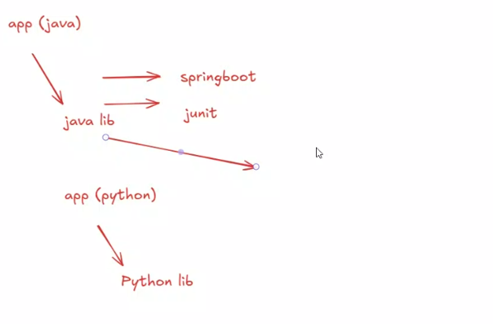
In POM file:
https://mvnrepository.com/
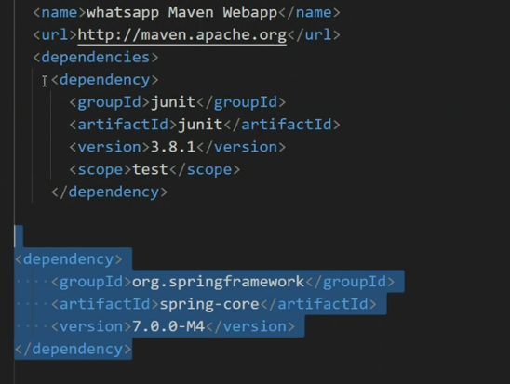
>mvn package
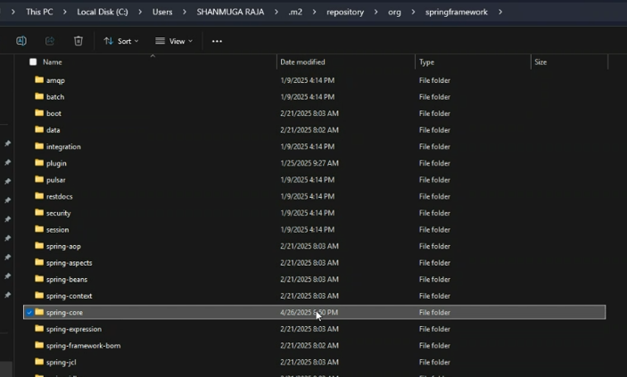

Day 4: Maven Installation in Linux
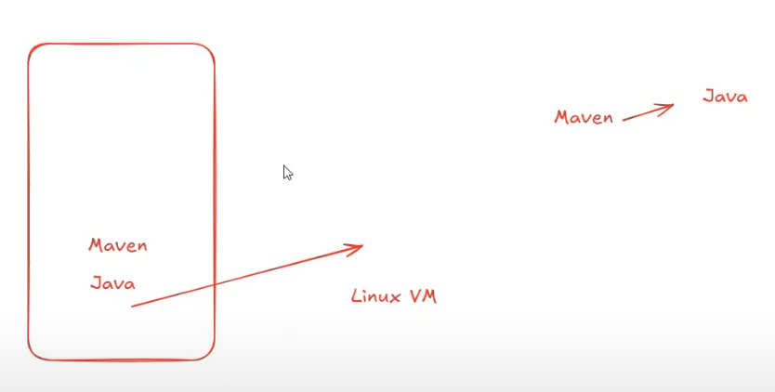
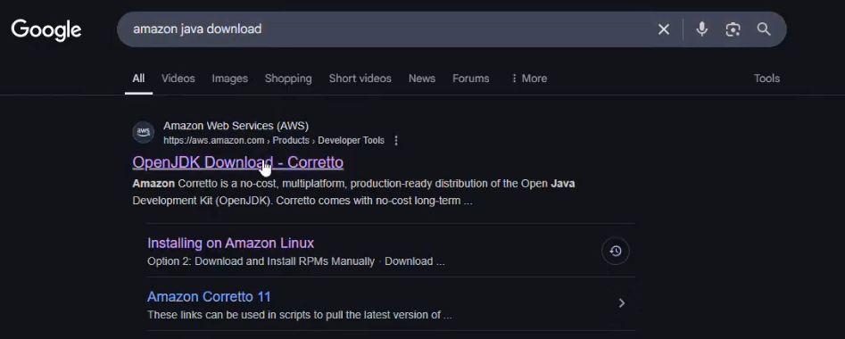
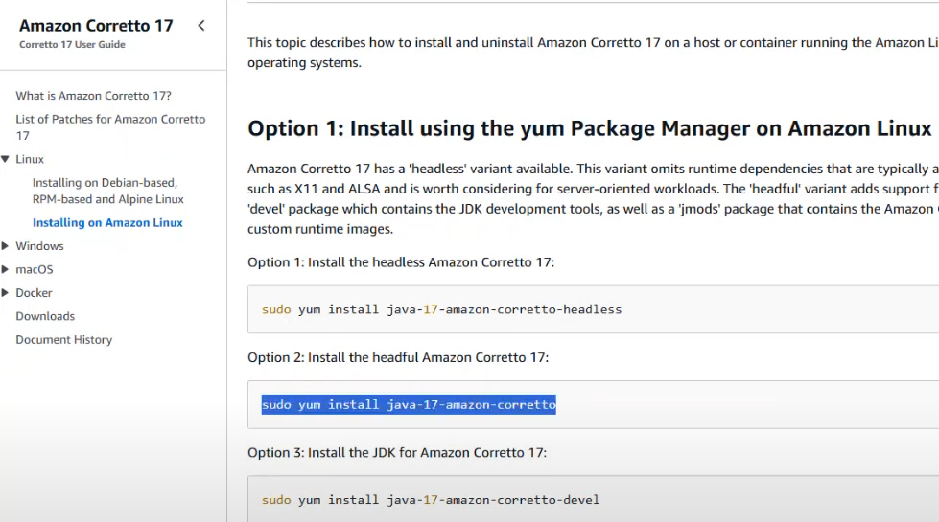
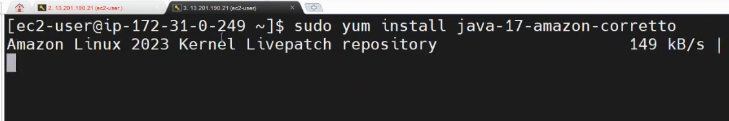
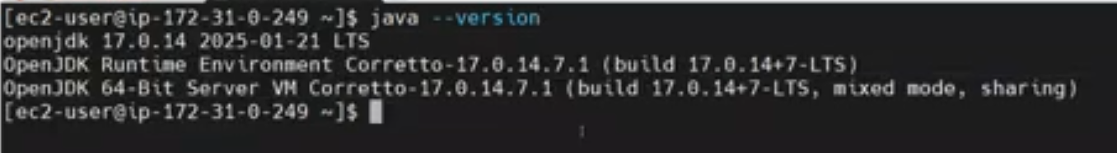
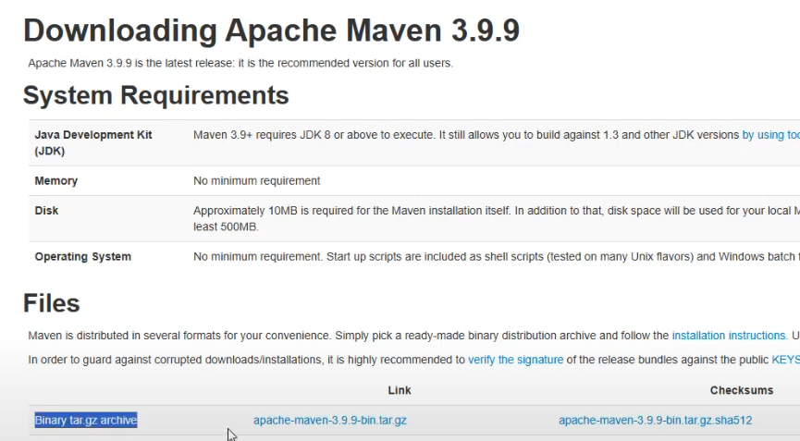

Usually user download and store the softwares in “opt” directory. Only root user has an ownership of the directory.
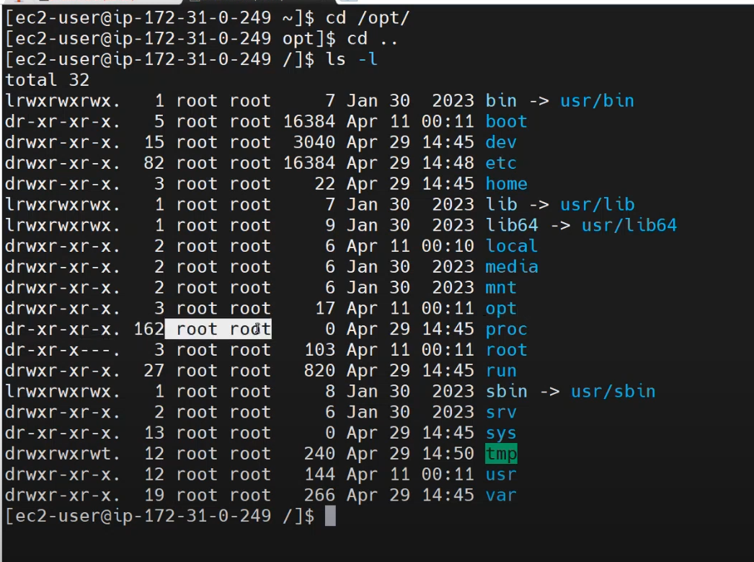
Download maven:
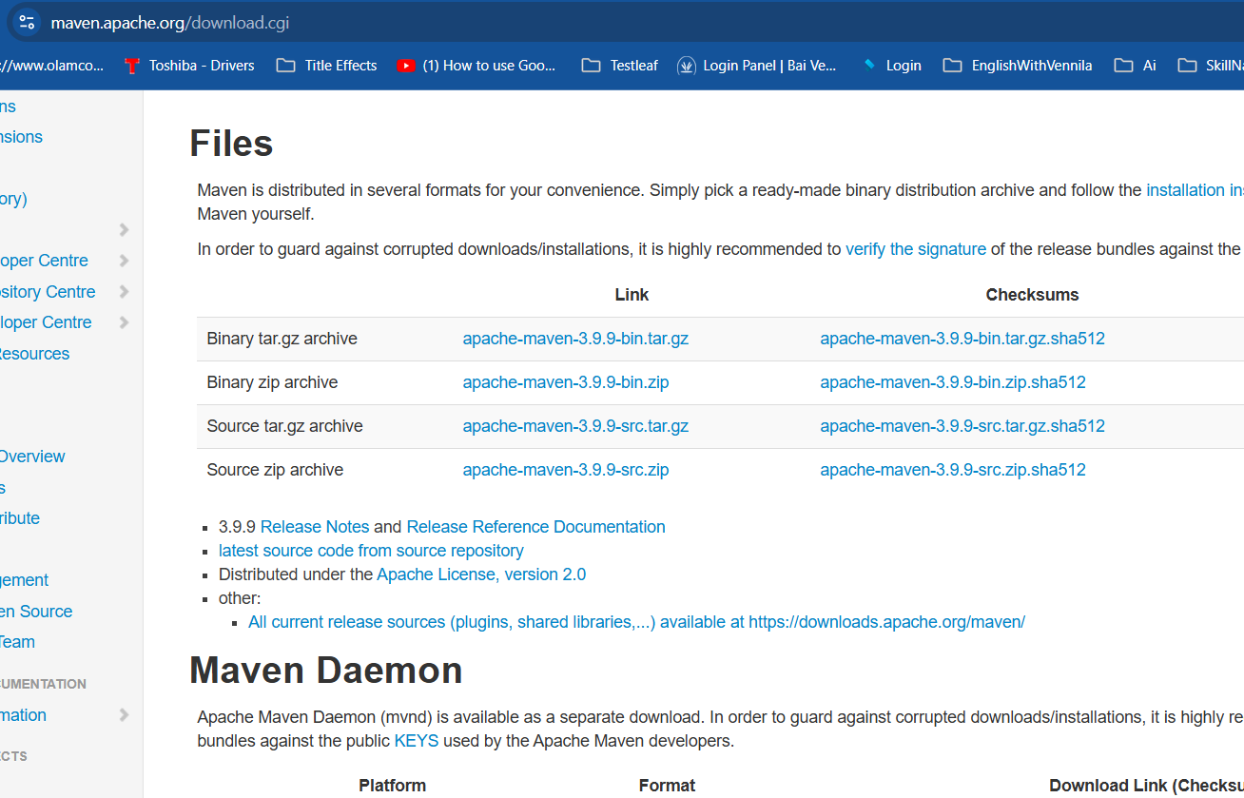
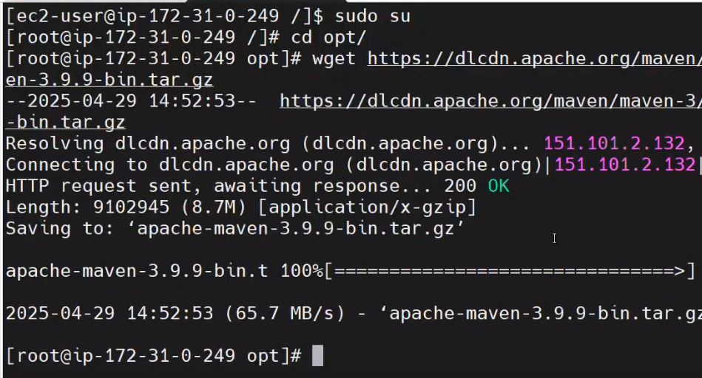

Unzip the tar file:
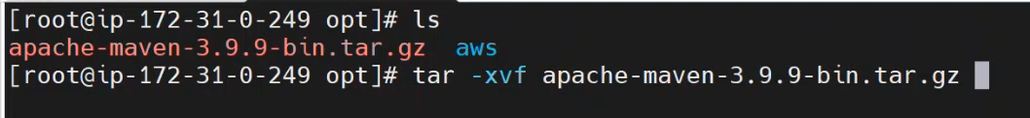
Delete the downloaded tar once we unzipped:
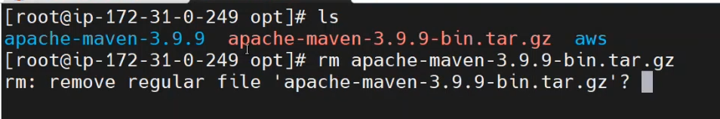
Rename the maven as we wish:
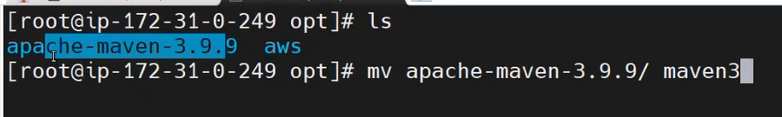
We need to set a maven path, that’s why we couldn’t get the maven version:
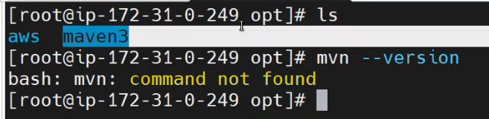
This is the maven path and maven bin path:
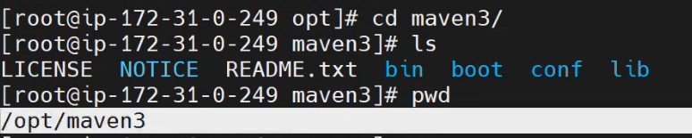
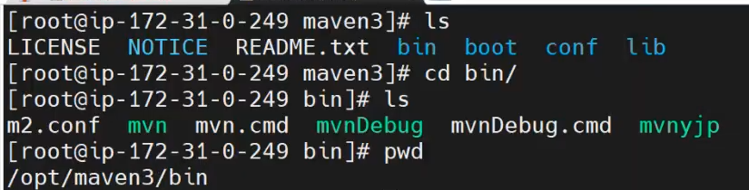
In Windows, we go to environment variables to set the mavan path. In Linux, we “bashrc”
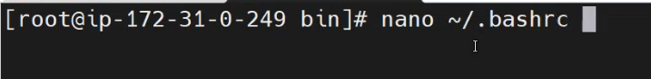
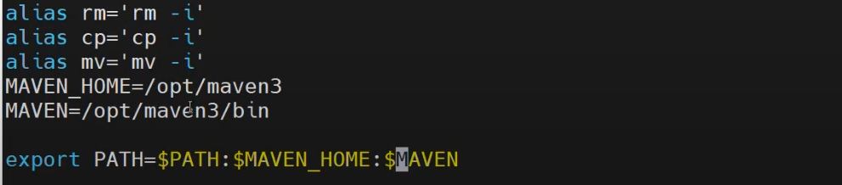
Aftering adding the path, we need to activate: >source ~/.bashrc
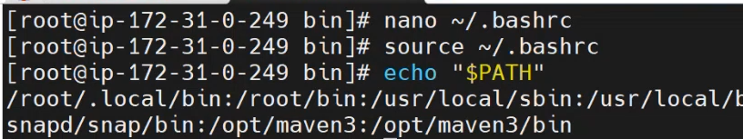
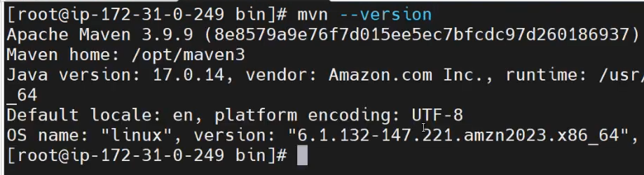

Create a maven project:
https://maven.apache.org/guides/getting-started/maven-in-five-minutes.html
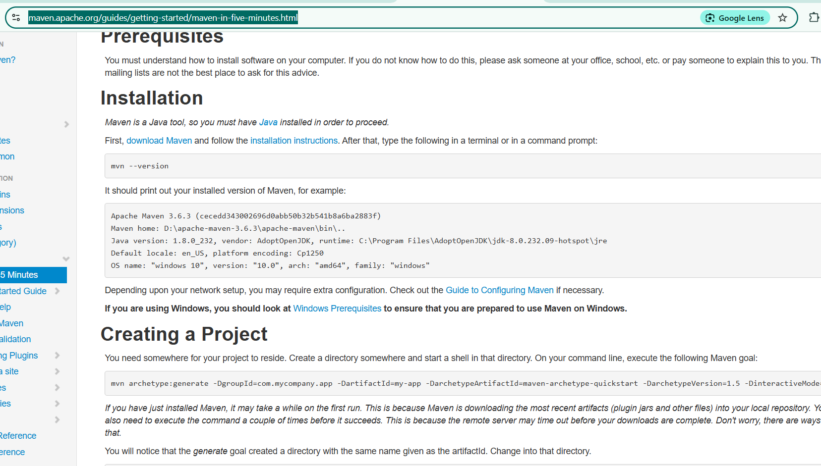

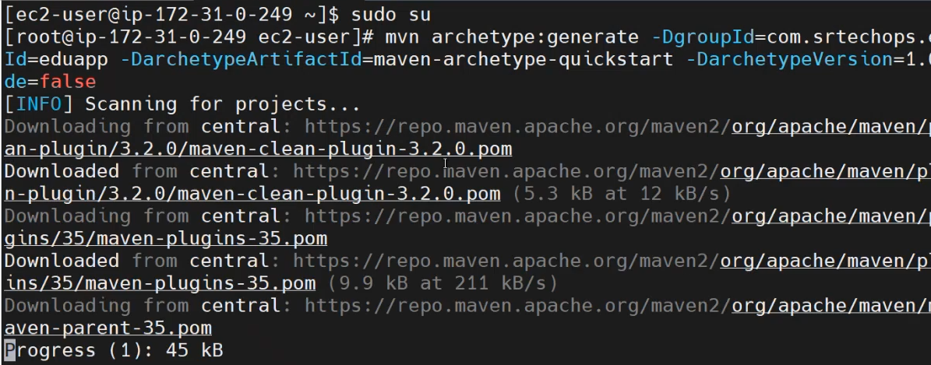

Go to the project directory and build the package using > mvn package
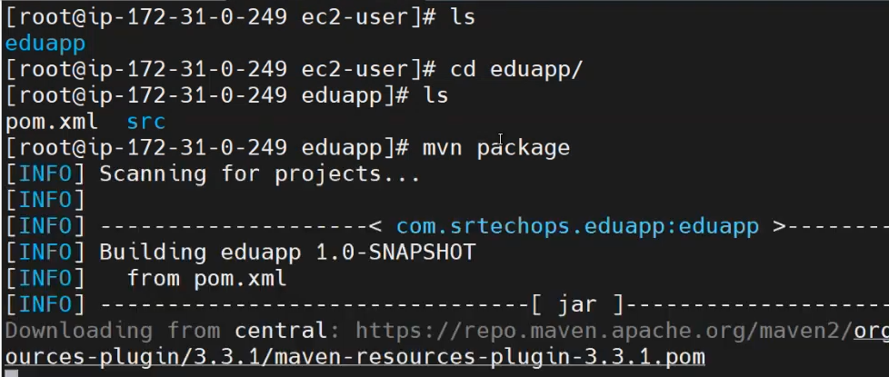
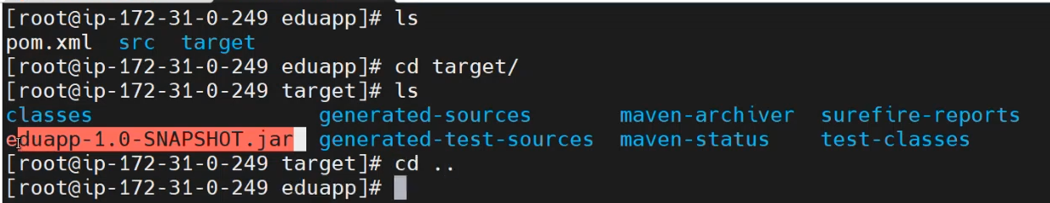
If you want to change the ownership of the “opt” directory to ec2-user. But no need to change the ownership.
We have separate “bashrc” file for Root and ec2-user.
>chown -R ec2-user:ec2-user opt/
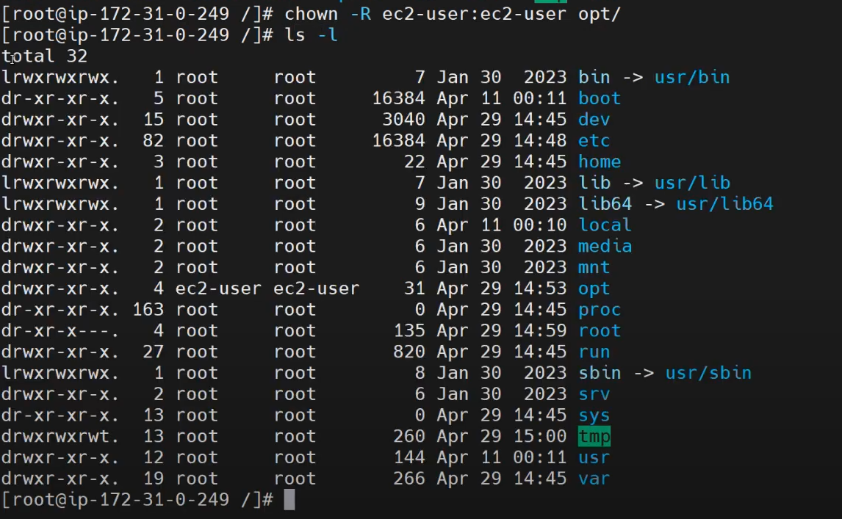
If you want to set the maven path for the ec2-user, there is separate file “bashrc” for ec2-user. Before we set it path root user > bashrc. Now, we are going to set mavan path in “bashrc” file as a ec2-user:
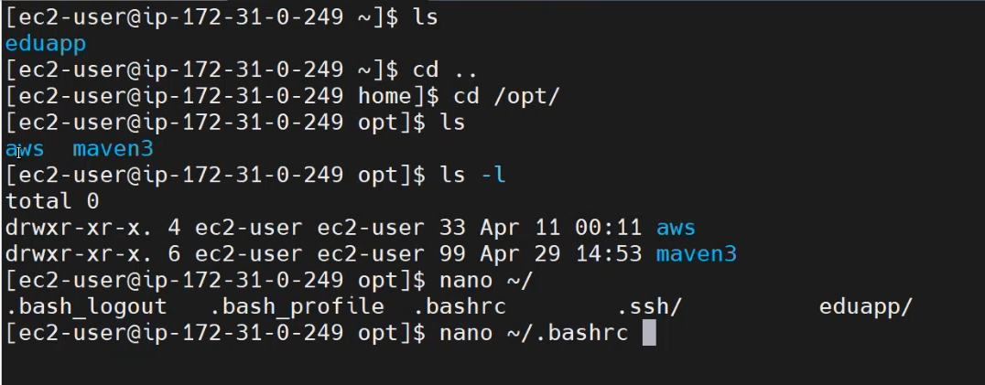

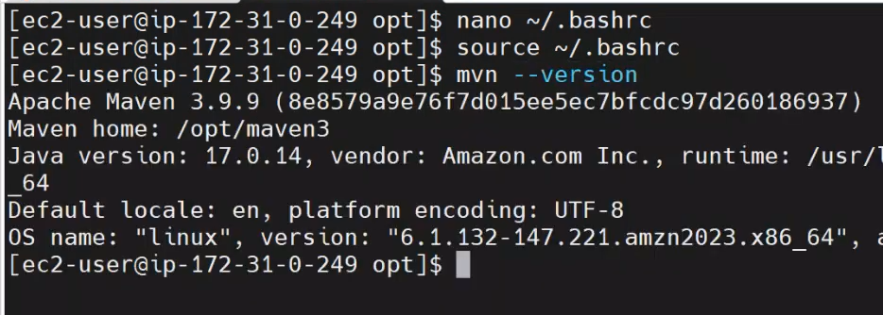
Create a maven project:
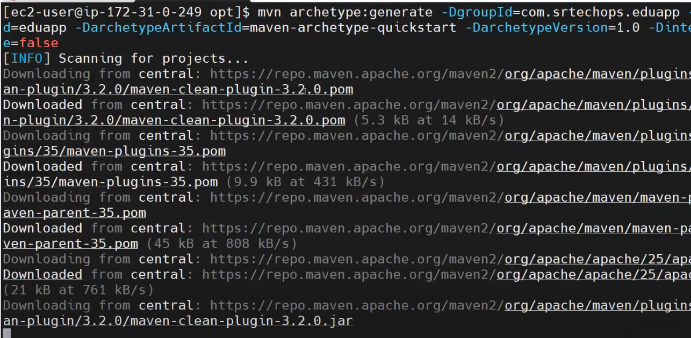
STEPS:
    - Install Java from Amazon
    - Install Maven using tar file
    - Set maven path in bashrc file and activate
    - Build the maven project

How to host this static website on the github repo to nginx? https://github.com/technext/rage.git
🗒️ Answer
Here's how to host the static website from GitHub using Nginx on your EC2 instance:
- Connect to your EC2 instance via SSH [3]
- Update your system:
sudo yum update -y
or
sudo apt update
depending on your OS [3]
- Install Git if not already installed:
sudo yum install git -y
or
sudo apt install git -y
- Navigate to the appropriate web root directory:
  - For Amazon Linux/CentOS: /usr/share/nginx/html [1]
  - For Ubuntu: /var/www/html [6]
- Clone the repository:
sudo git clone https://github.com/technext/rage.git
[5]
- Move files to Nginx web root:
- sudo cp -r rage/* .
sudo rm -rf rage/
- Set proper permissions:
sudo chmod -R 755 .
- Restart Nginx:
sudo systemctl restart nginx
- Access your website using your EC2 public IP address or domain name [4]
🌐 Sources
- stackoverflow.com - No nginx folders after installing on Amazon Linux 2 EC2 ...
- blog.devops.dev - Host a static website on AWS EC2 using NGINX - DevOps.dev
- yourtechie.hashnode.dev - Deploying a static Website to AWS EC2 with NGINX
- medium.com - Deploy a Static Website on EC2 with Nginx | by Siddhi Patel
- github.com - EC2 Web Server Setup with Git
- stackoverflow.com - NGinx Default public www location?

To host a static website on your Amazon Linux EC2 instance using Nginx, follow these steps:

🛠️ Step 1: Install Nginx
For Amazon Linux 2:Stack Overflow+2developerdiary.in+2awswithatiq.com+2
- Update your system packages:
sudo yum update -y
- Install Nginx using Amazon Linux Extras:
sudo amazon-linux-extras install nginx1 -y
This command enables the Nginx repository and installs Nginx.
- Start and enable Nginx:
sudo systemctl start nginx
sudo systemctl enable nginx
These commands start Nginx and configure it to start automatically on system boot.

📁 Step 2: Deploy Your Static Website
- Navigate to the Nginx web root directory:
cd /usr/share/nginx/html
- Replace the default index.html with your website's homepage:
sudo rm index.html
sudo nano index.html
Paste your HTML content into the editor, save, and exit.
- (Optional) Add additional files:
If your website includes CSS, JavaScript, or image files, upload them to the /usr/share/nginx/html directory.

🔓 Step 3: Configure Security Group
Ensure that your EC2 instance's security group allows HTTP traffic:
- Open the AWS EC2 Console.
- Select your EC2 instance and navigate to the "Security" tab.
- Click on the security group associated with your instance.
- Edit the inbound rules to add HTTP access:
  - Type: HTTP
  - Protocol: TCP
  - Port Range: 80
  - Source: Anywhere (0.0.0.0/0)
This configuration allows web traffic to reach your Nginx server.

🌐 Step 4: Access Your Website
Open a web browser and navigate to your EC2 instance's public IP address (e.g., http://your-ec2-public-ip).Medium
You should see your static website displayed.

✅ Additional Tips
- Verify Nginx Status:
bash
CopyEdit
sudo systemctl status nginx
This command checks if Nginx is running properly.GeeksforGeeks
- Configure Nginx (Optional):
For advanced configurations, edit the Nginx configuration file:
sudo nano /etc/nginx/nginx.conf
After making changes, reload Nginx:
sudo systemctl reload nginx
By following these steps, you can successfully host a static website on your Amazon Linux EC2 instance using Nginx.

