Tomcat
Day 1: Apache Tomcat Tutorial for Beginners | Introduction, Features & Installation Guide
https://www.youtube.com/watch?v=xKSma8R4uao&list=PL7iDpp0KYTgGlCugaPgNQbaa06JuMN1R2&index=1
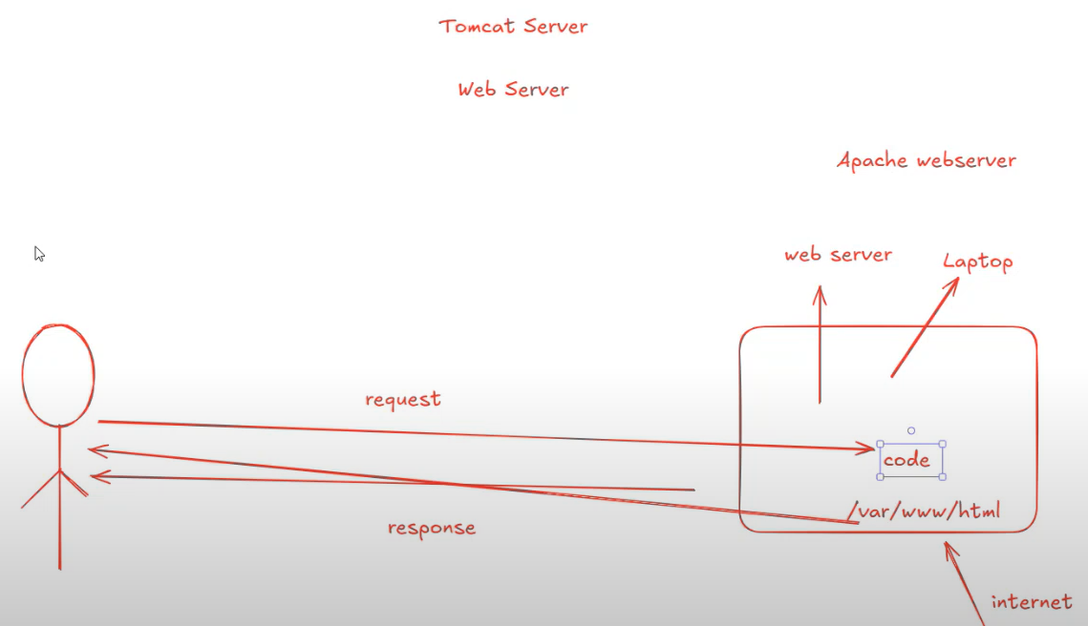
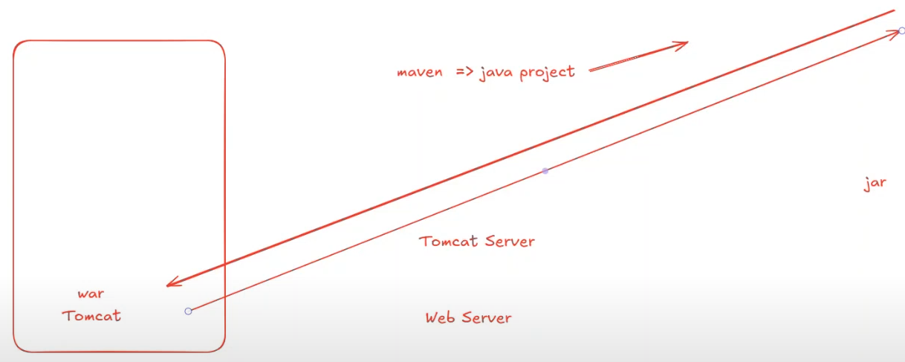
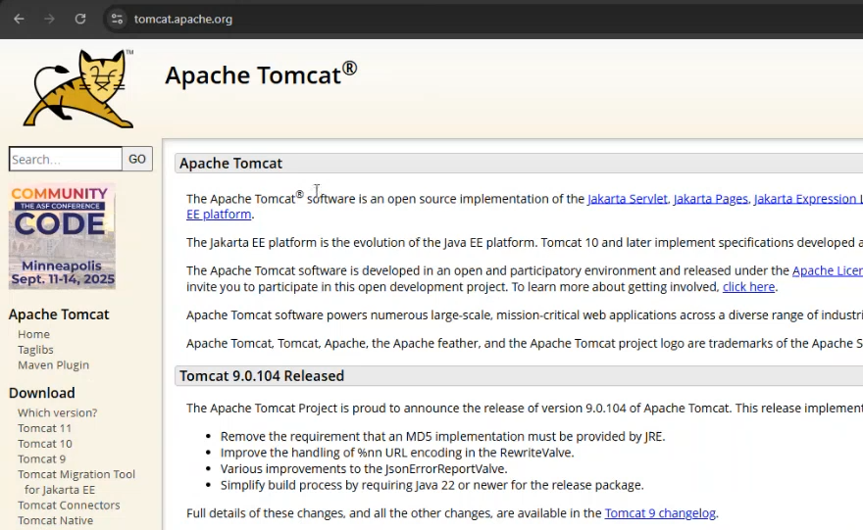
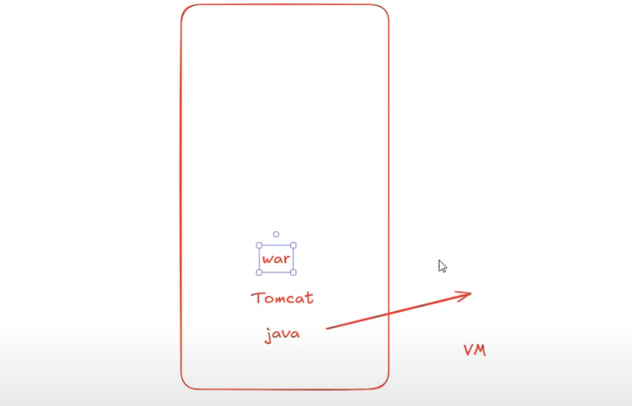
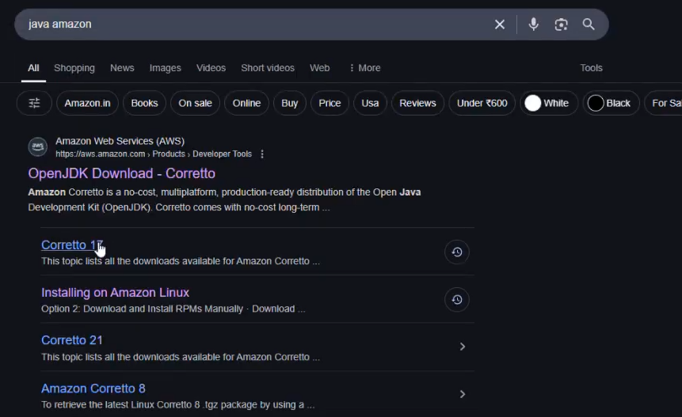
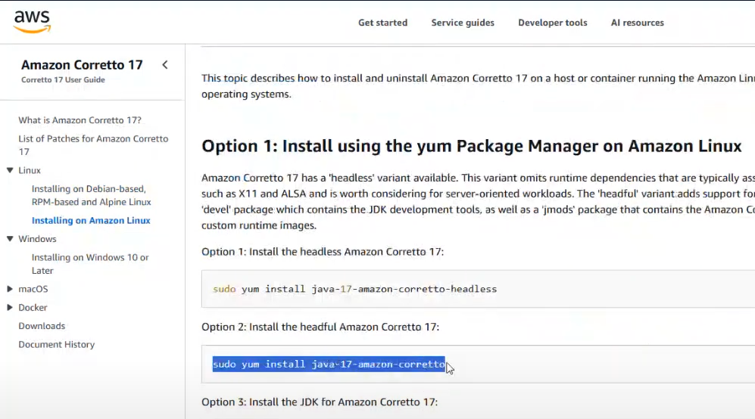
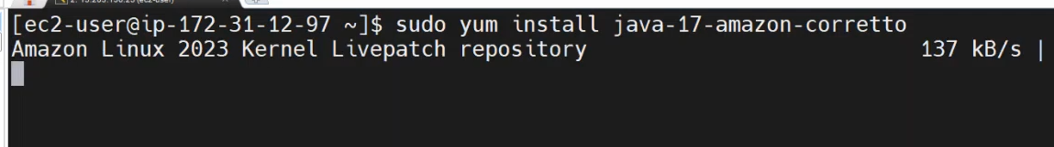
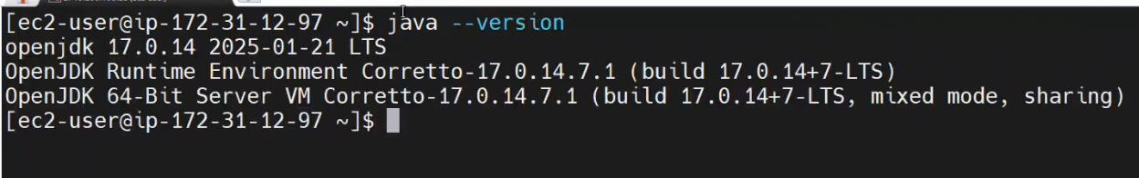
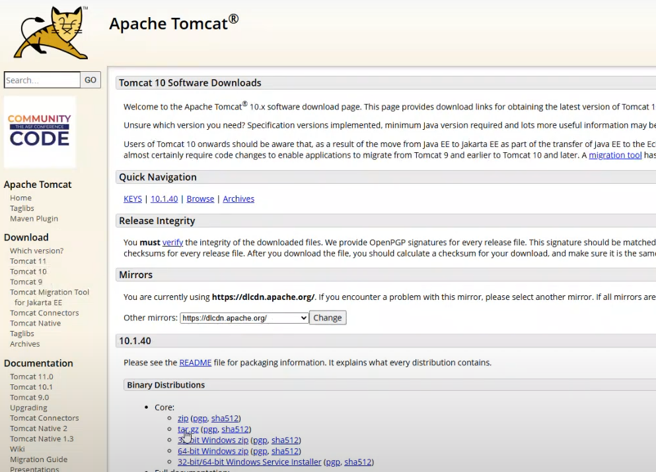
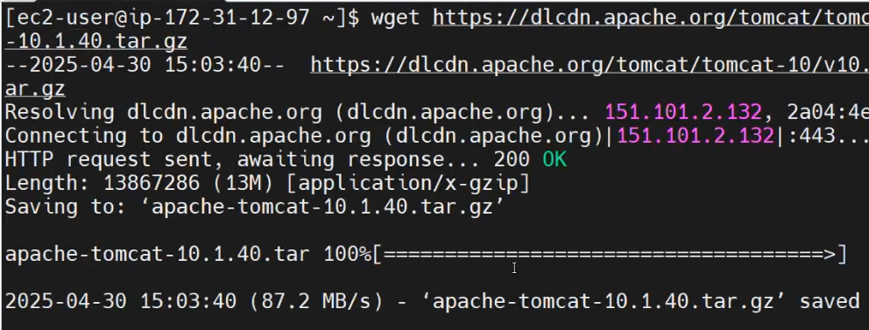
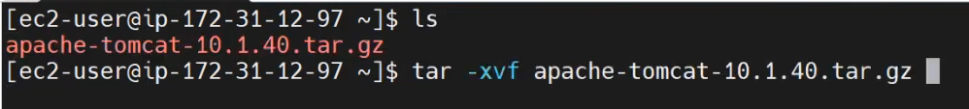
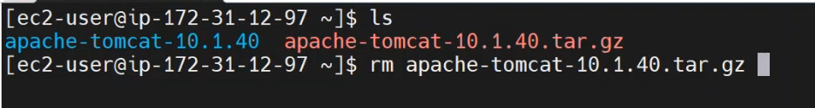
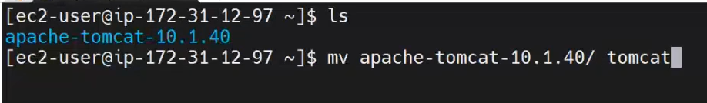
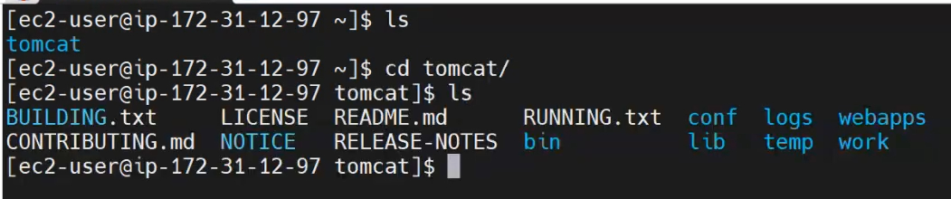
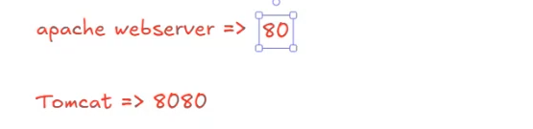
- cd bin/
- sh startup.sh
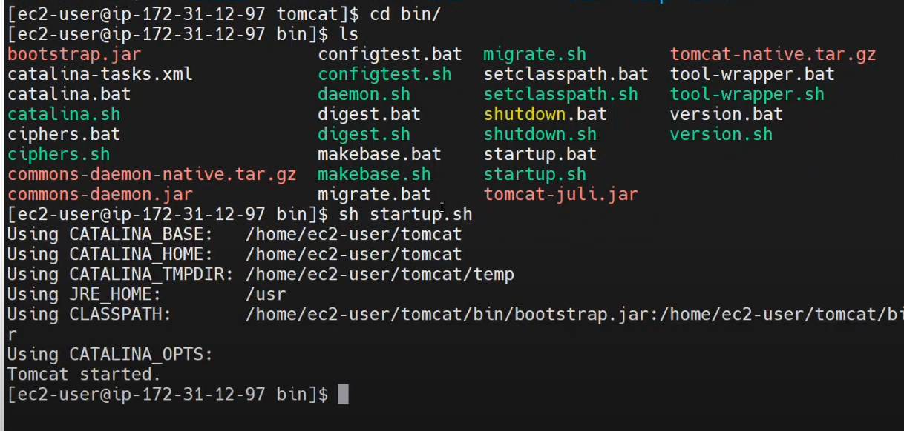

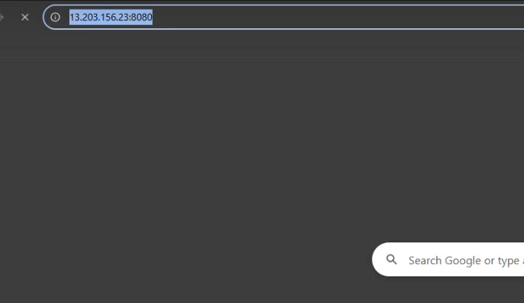
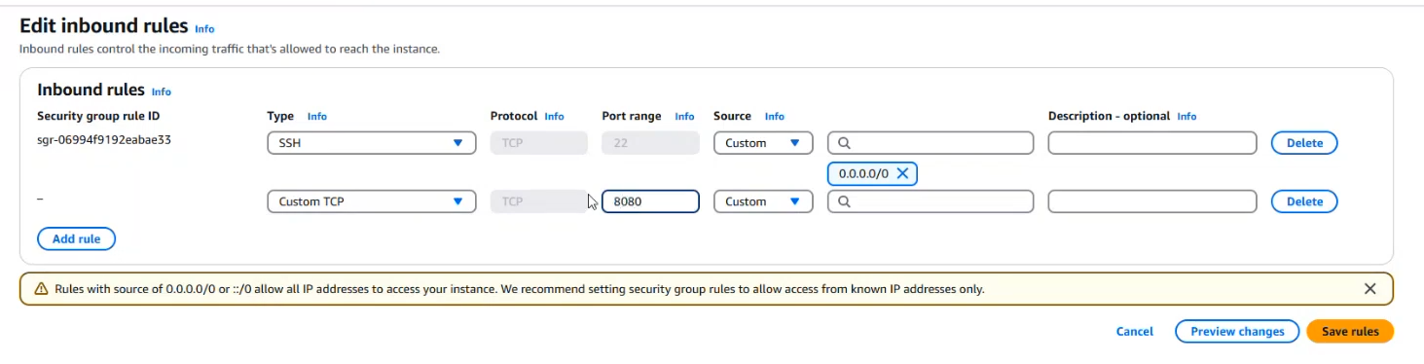
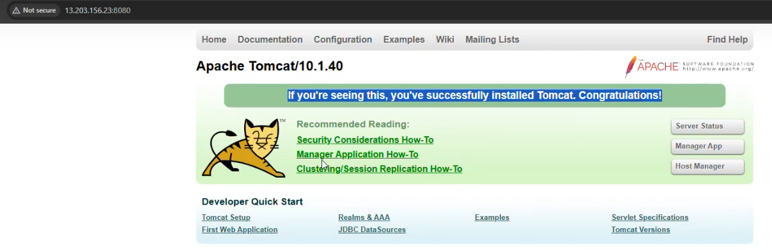

Day 2: Deploying Your First WAR File in Apache Tomcat in Minutes!
To start and stop tomcat under bin….
>sh startup.sh
>sh shutdown.sh
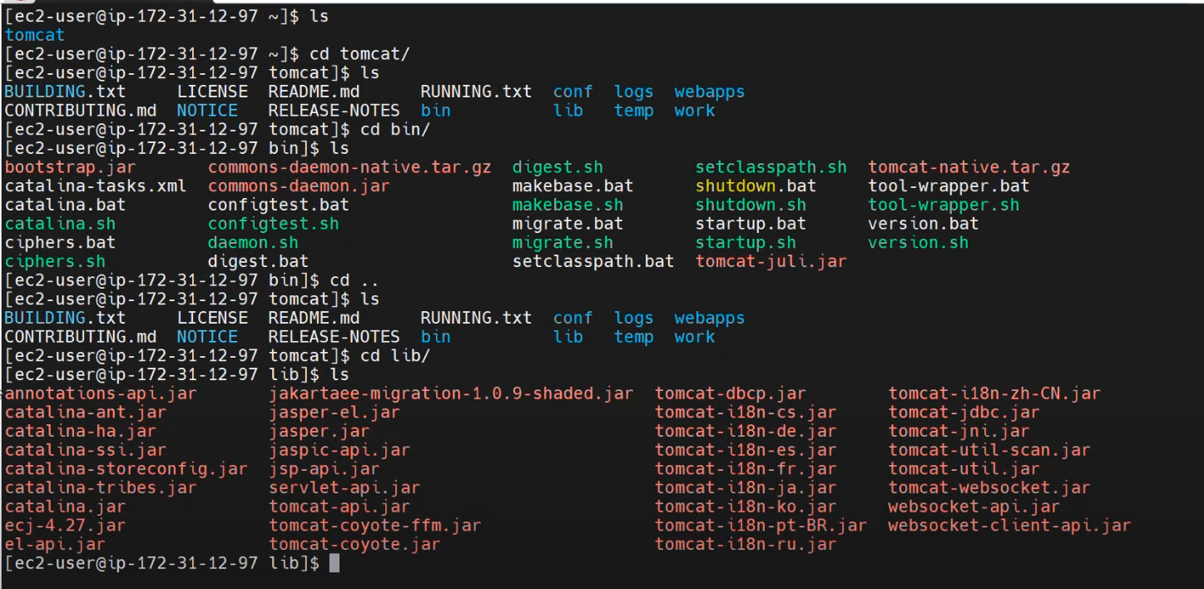
>cd logs
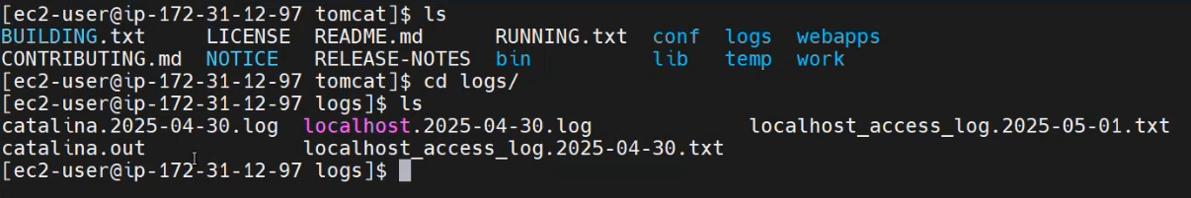
>ls conf/
Tomcat deployment directory is “webapps”
For Apache deployment directory is “/var/www/html”
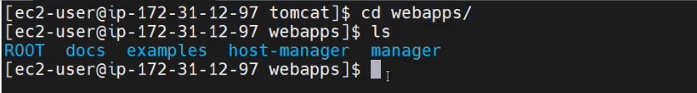

Create a maven project:
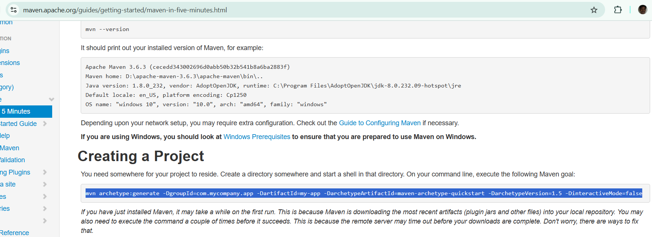
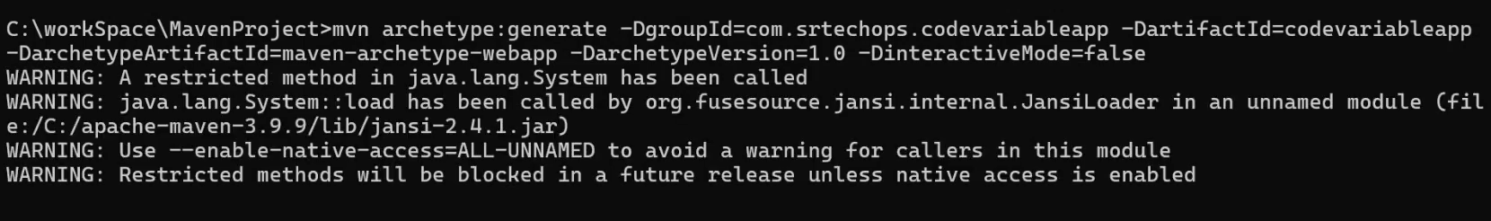
Get into the project:
>cd codevariableapp
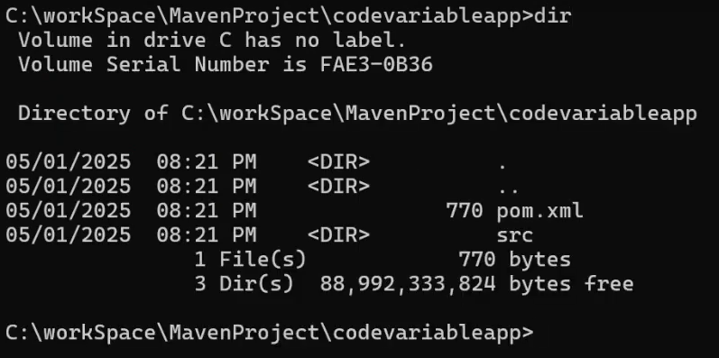
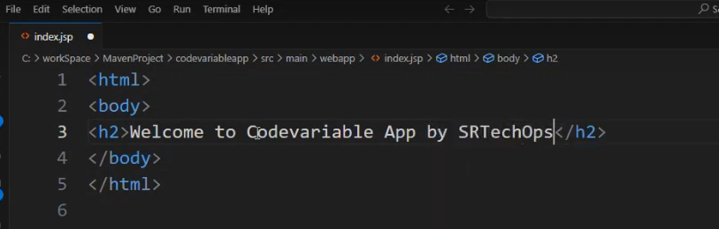
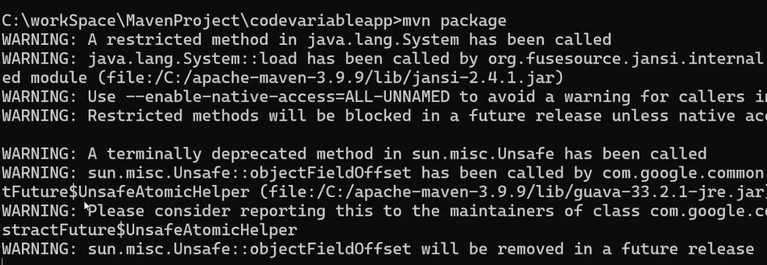
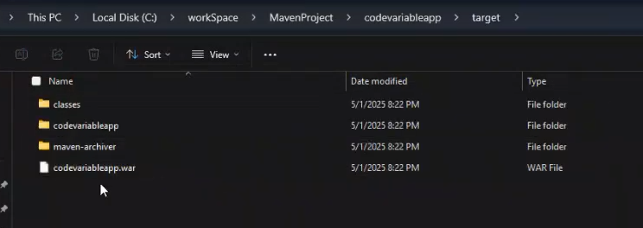
Upload war file from local (windows) to Linux > Tomcat
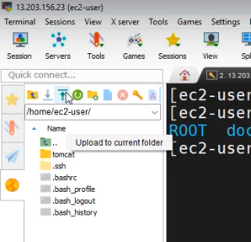
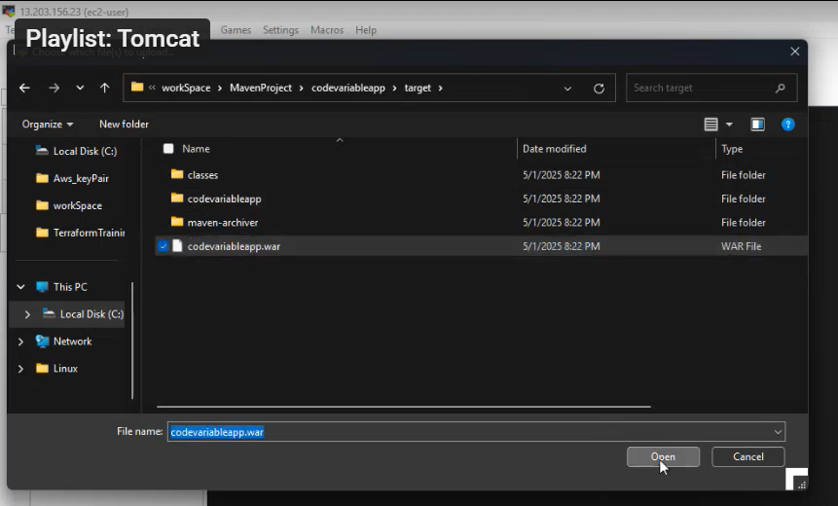
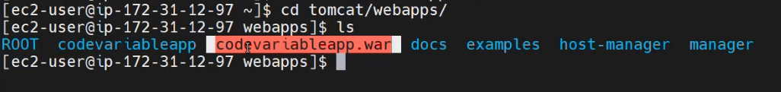
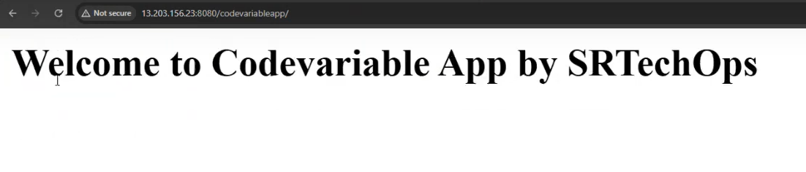
We can deploy multiple apps:
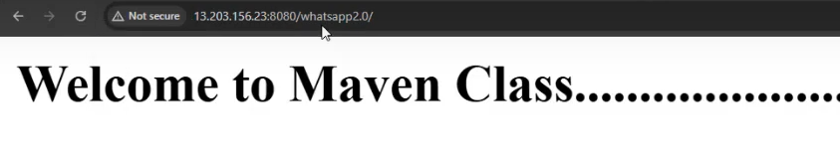
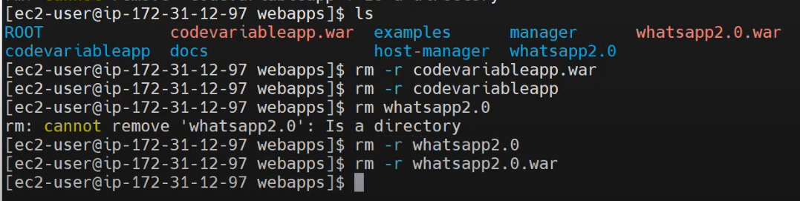
When we uplaod the war file with the name of ROOT, no need to add application name at end of the URL:
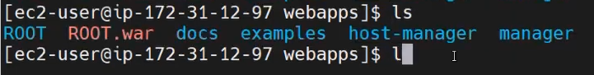
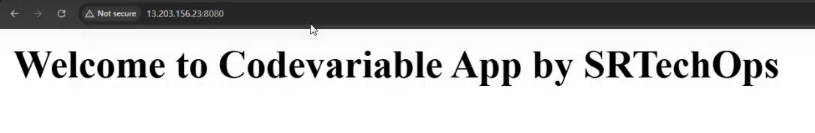

❌ A .jar file does not run directly on Apache Tomcat, because:
- Tomcat is a Servlet container meant for running Java web applications packaged as .war files (Web ARchive), not plain .jar files (Java ARchive).

✅ What Tomcat supports:
- .war files: These contain WEB-INF/, servlets, JSPs, etc., which Tomcat understands and can deploy directly.
- web.xml or annotations to define web components (like servlets, filters).

✅ What to do if you have a .jar:
If you’ve built a Spring Boot app or any Java app in .jar format and want to deploy it to Tomcat:
- If it’s a Spring Boot "fat jar", it contains an embedded Tomcat, so you run it with:
bash
CopyEdit
java -jar yourapp.jar
(No need to deploy it in Tomcat)
- If you want to deploy it on external Tomcat, package your app as a .war file instead of a .jar:
  - In pom.xml, set:
xml
CopyEdit
<packaging>war</packaging>
  - Make sure it's a web project with a proper structure.

Day 3: How to Deploy a WAR File Using GUI | Step-by-Step Guide

