Day 6: Docker Spring Boot: Jave Framework Project

We should be know
  - How to run build the code
  - How to deploy for each application
Spring Boot is a Java-based framework used for building stand-alone, production-ready applications quickly and easily. It simplifies the development process by providing sensible defaults and auto-configuration, reducing the amount of boilerplate code needed. It's particularly well-suited for developing microservices and web applications.
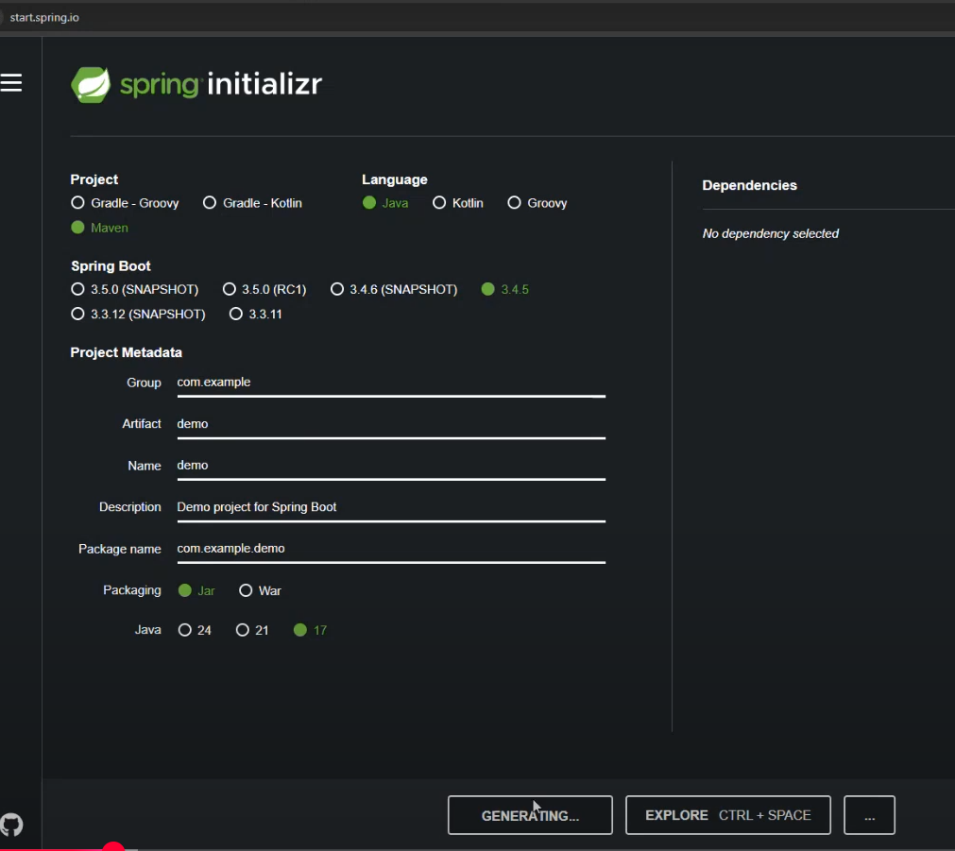

https://github.com/srtechops?tab=repositories
https://github.com/srtechops/SpringBoot_DockerProject
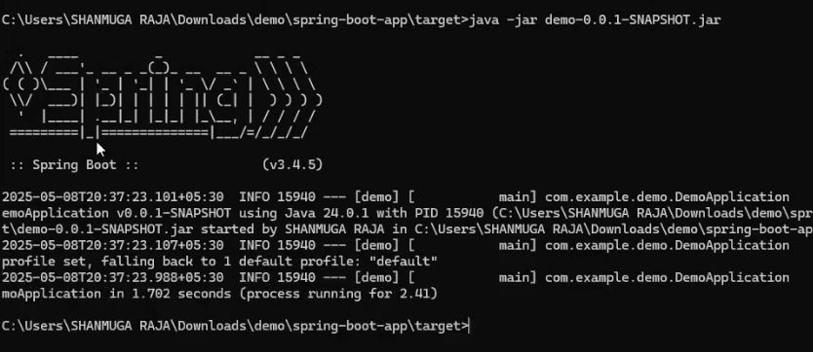
Try this:
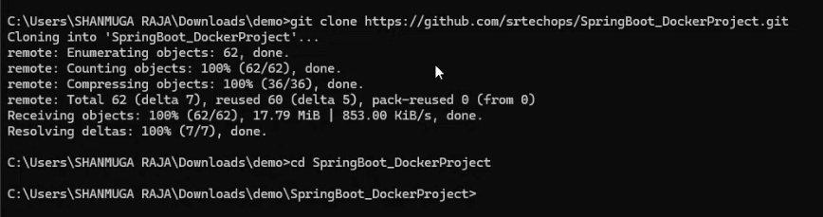
Already package is build and available on the git:
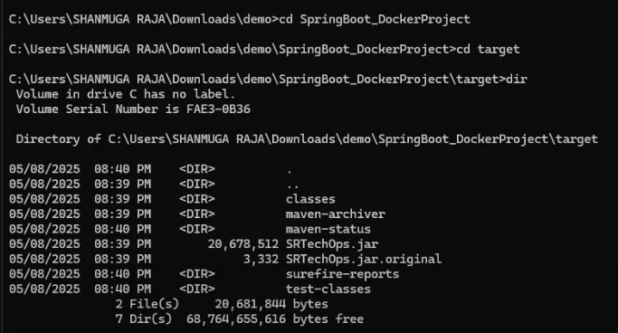
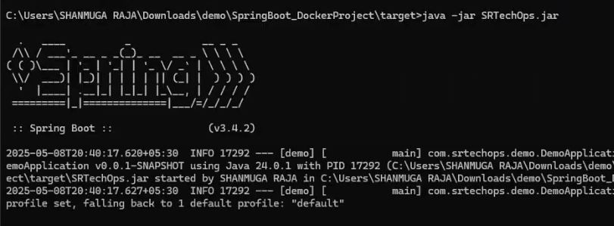
We should know the entry point:
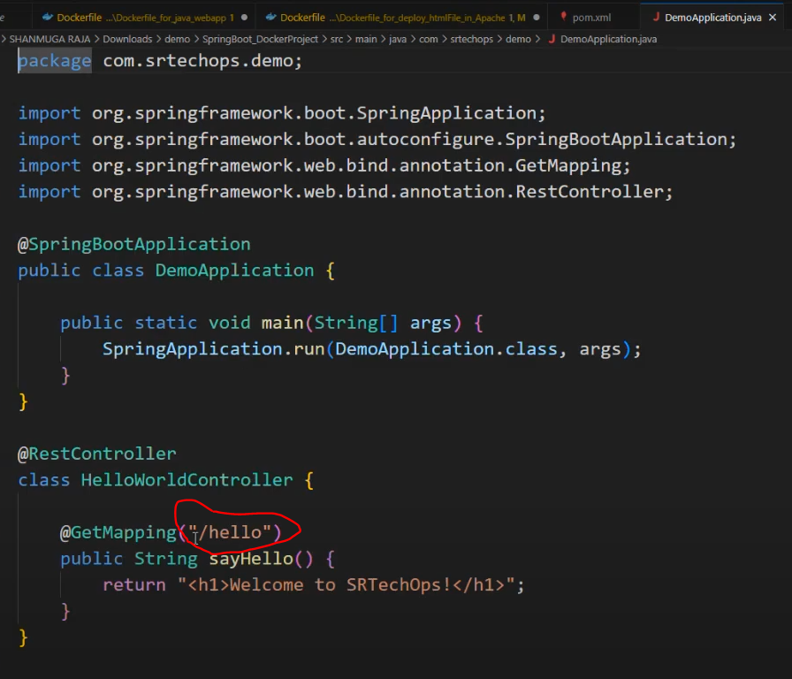

OUTPUT:

Now, We are going to write a Dockerfile and containalization of the project:
Required:
1.Java
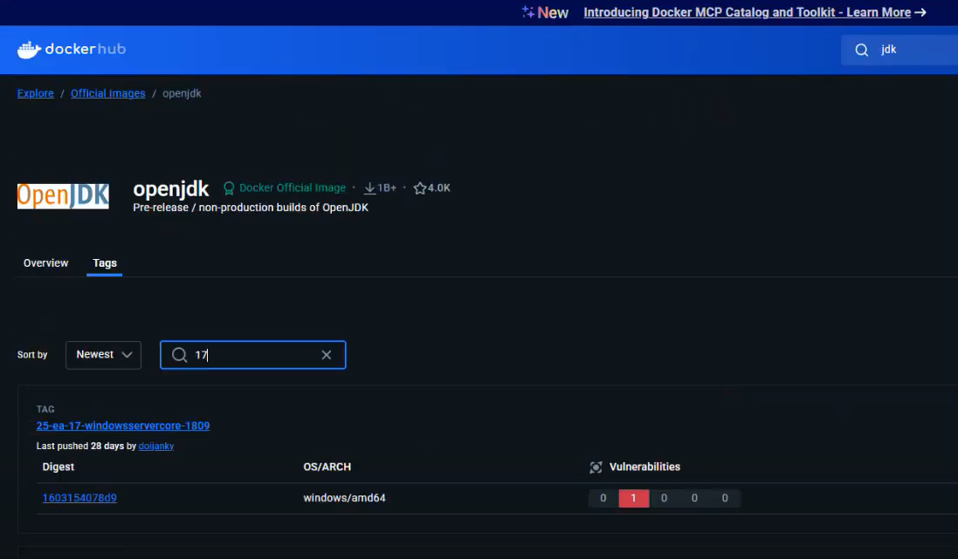
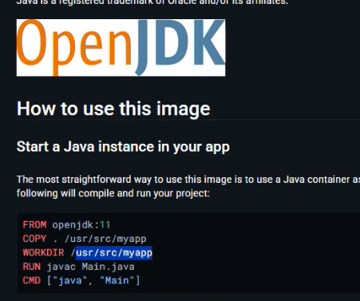
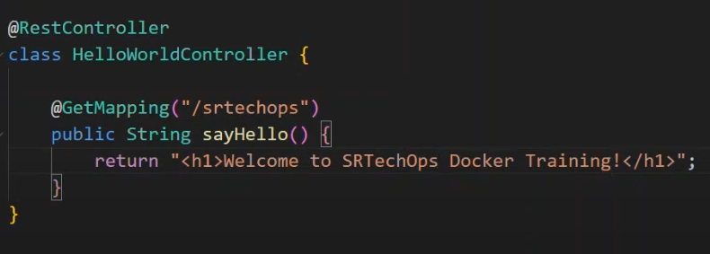
Build the project to get the latest changes:
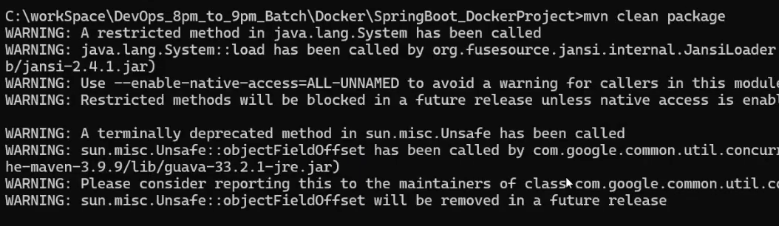
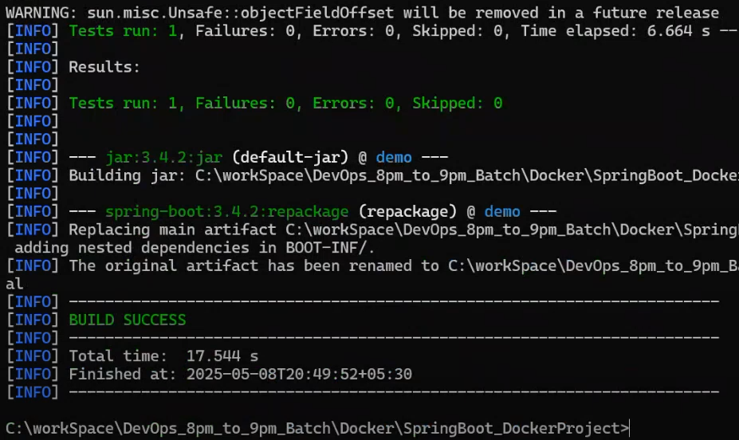

Now package is ready. We are going to run/deploy this package:
Go to target folder and the command:
>java -jar <packageName>
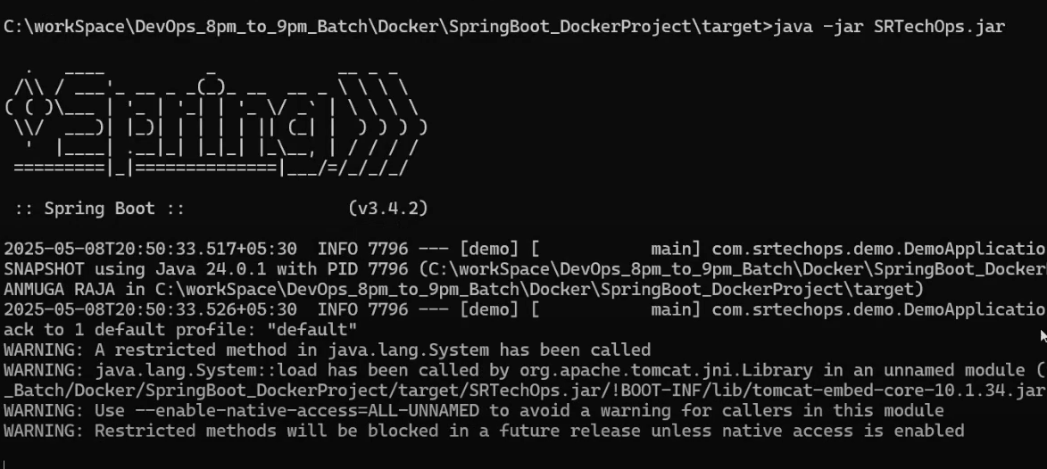
Sprint boot contains Tomcat by default. So no need to install tomcat dependency.
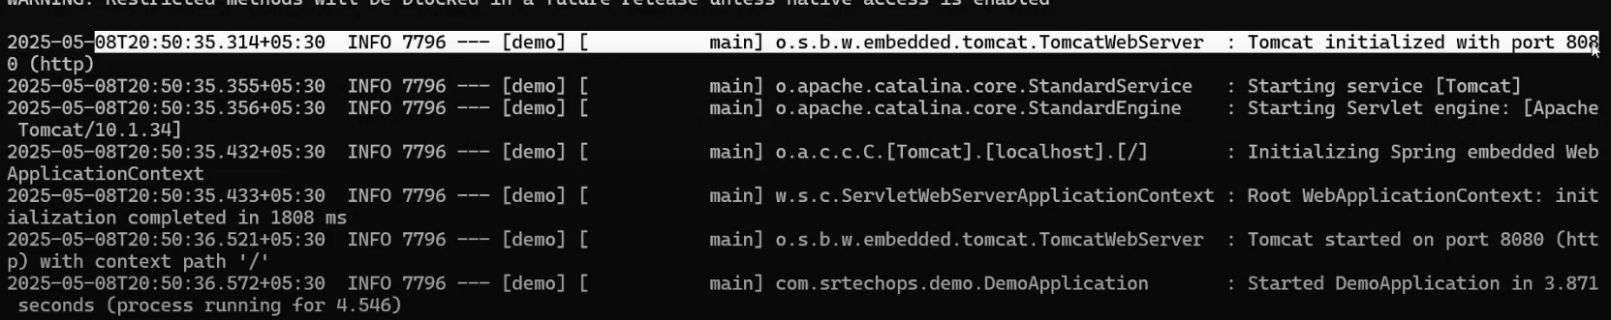
OUTPUT:
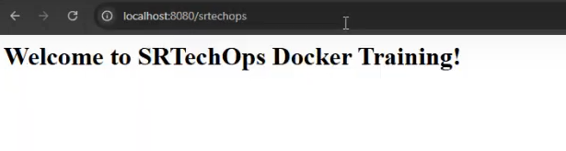
We have done the follwings in local:
  - Build the java project and get the package i.e JAR file.
  - Run/Deploy the JAR file using > java -jar <packName>
  - Using localhost:8080/endpoint, we have seen the output.

Now, We do it in Cloud OR VM:
Launch Linux machine
>Install Docker and Start
Upload <jar> package.
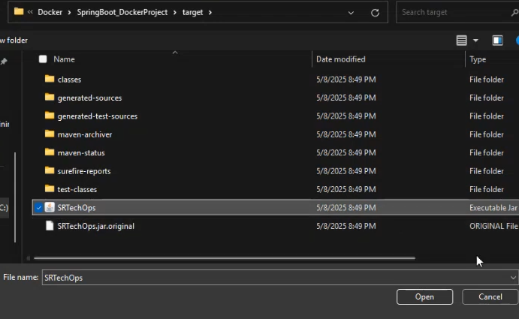
Write a Dockerfile:
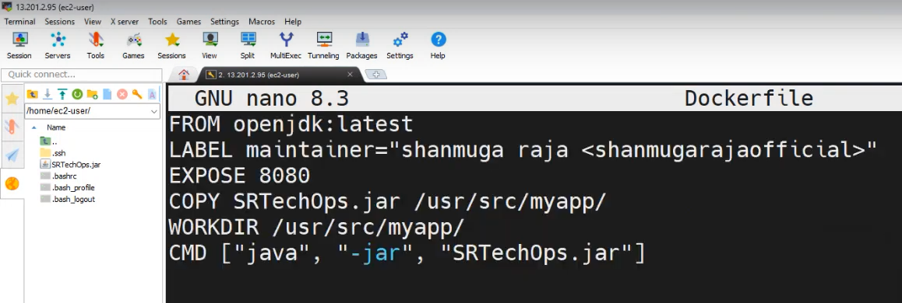
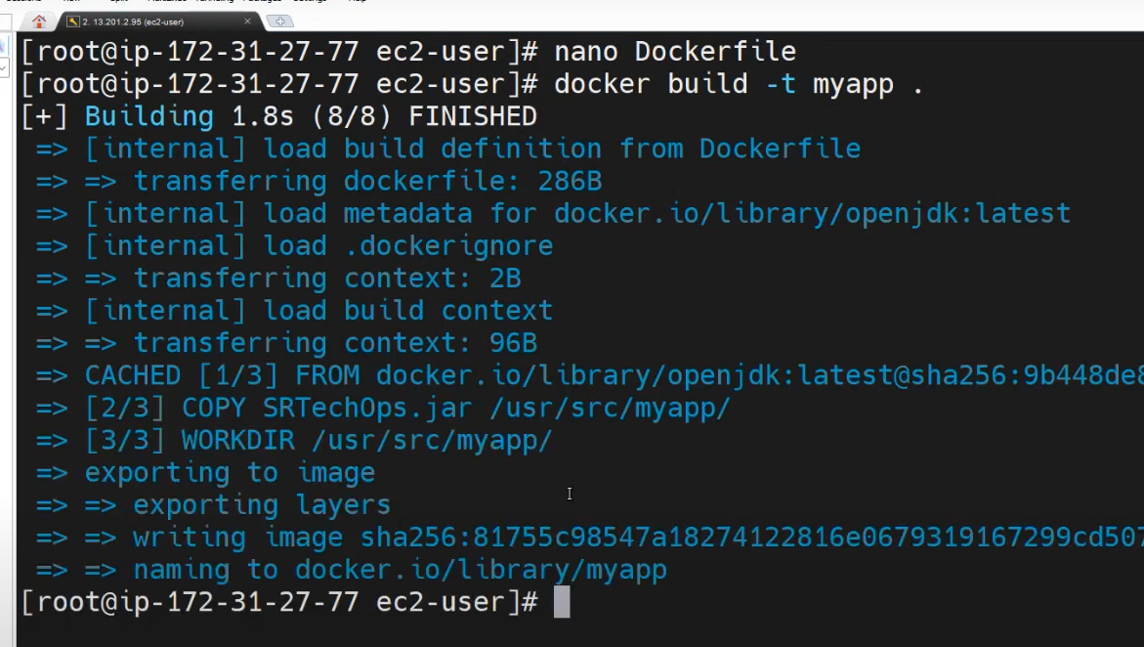
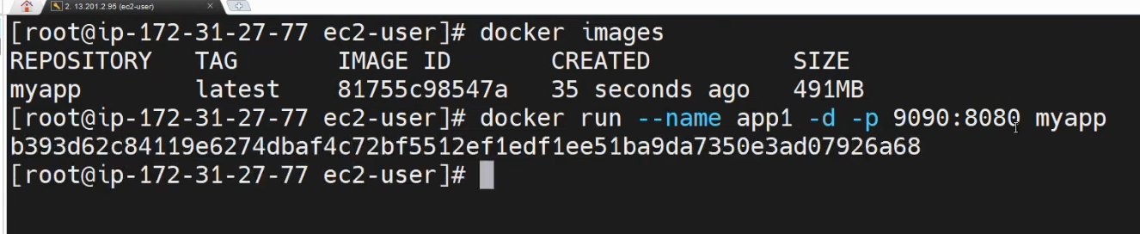
Enable host port 9090 in the VM:
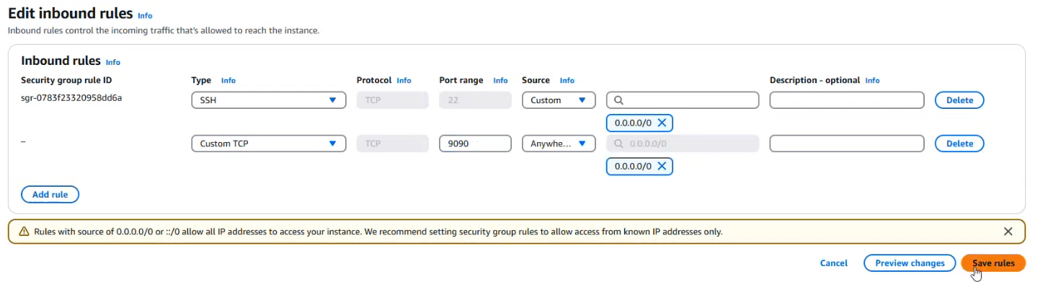
OUTPUT:
