Day 8: Running Flask Application Project
Docker file for Flask Application (Python):
Using python we write a backend logic.

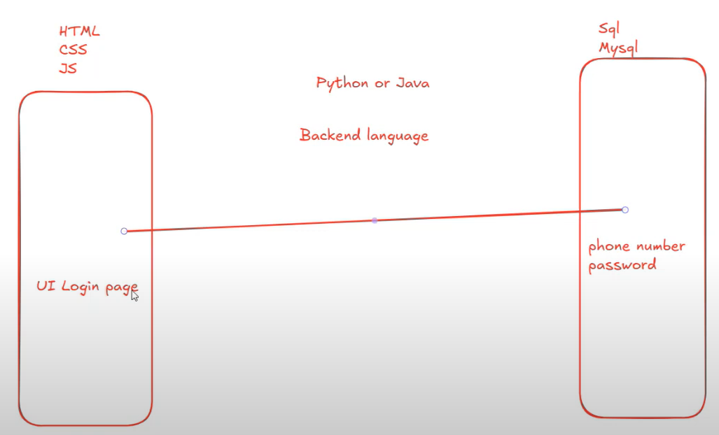
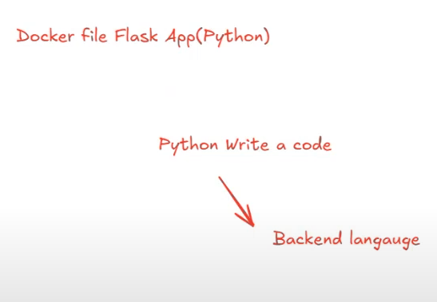
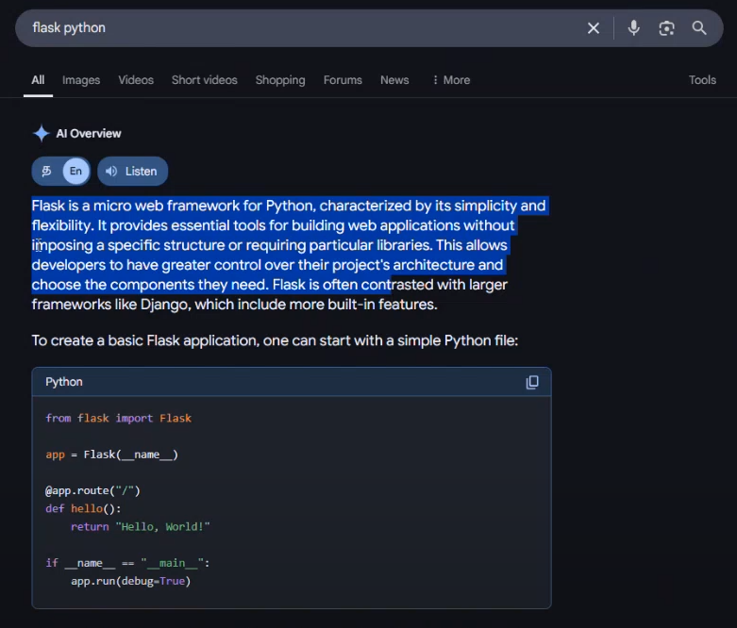
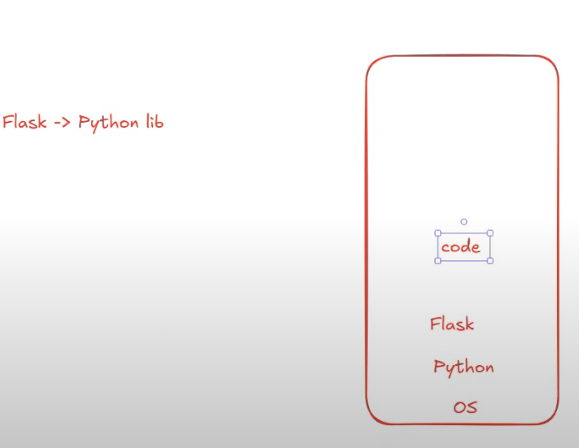
Clone the python flask application > https://github.com/srtechops/python-flask-docker-app.git
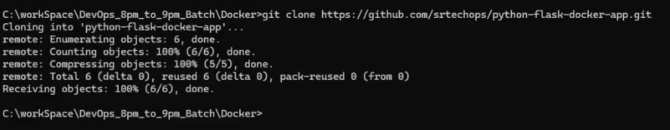
Python project structure:
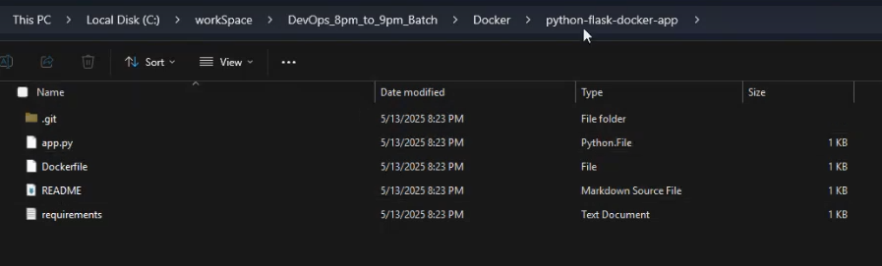

First we do it in LOCAL:
1 Python installed > python --version
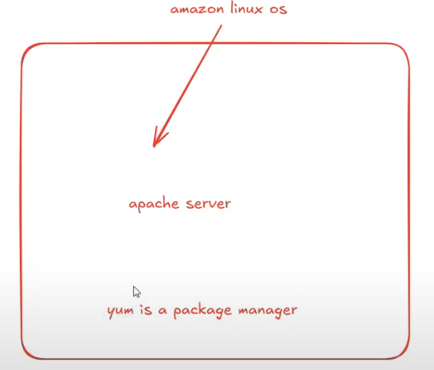
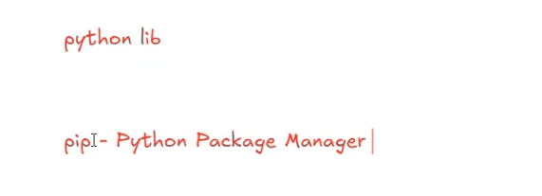
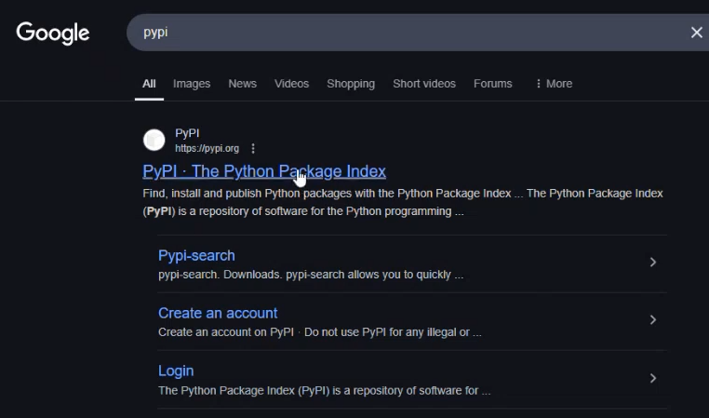
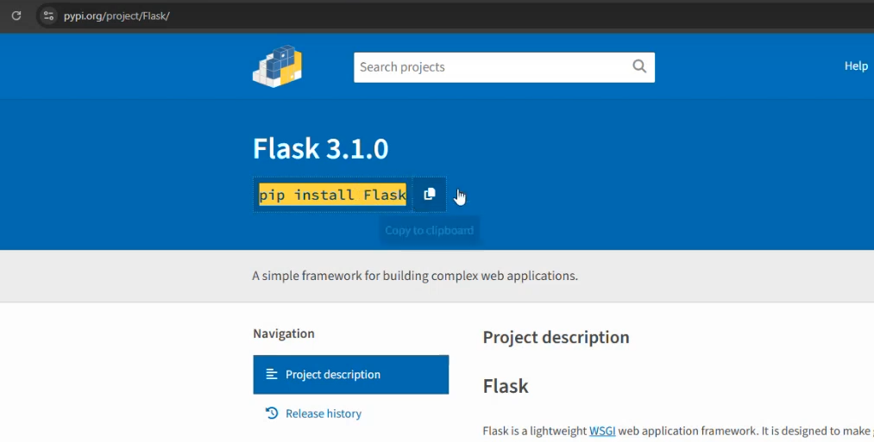

2 Flask installed > pip install flask
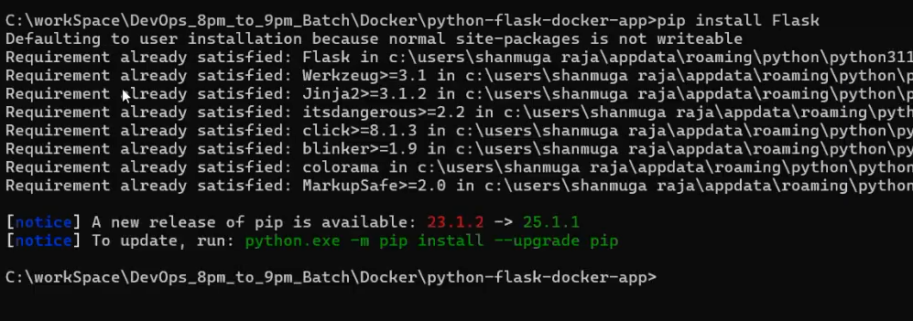
How to check whether flask is installed or not:
✅ Method 1: Use pip show
This command displays detailed information about the Flask package if it's installed:
pip show flask
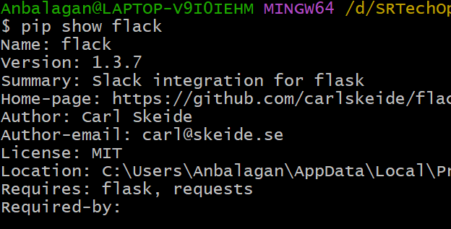
✅ Method 2: Use pip list or pip freeze
These commands list all installed packages. You can filter the output to check for Flask:
pip list | grep Flask

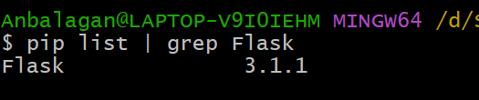
✅ Method 3: Use the flask Command-Line Tool
If Flask is installed, it provides a CLI tool. You can check its version with:
flask --version
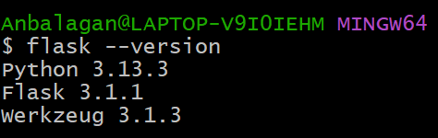
3 Run a Python applicatoin: > python app.py
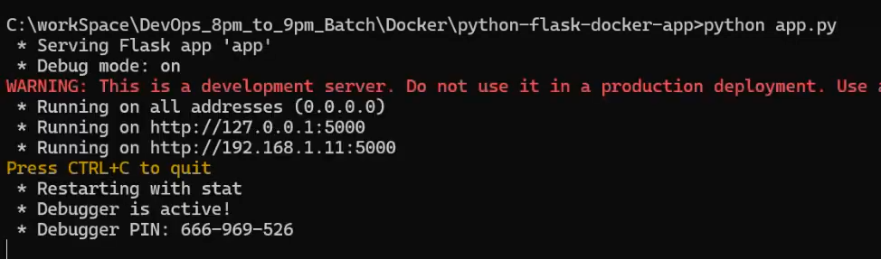
CTRL+click the URL, You will get the output:
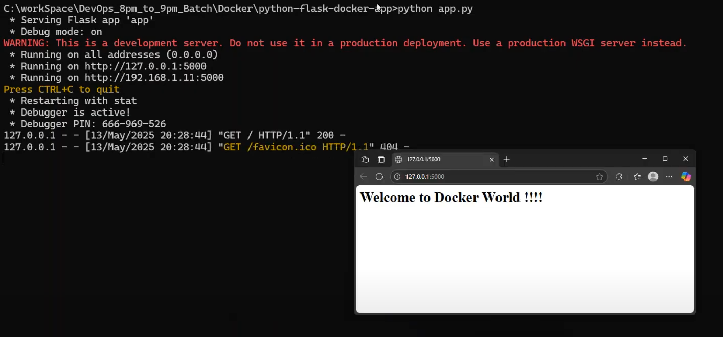
Make an amendment on the file and re-run the application:
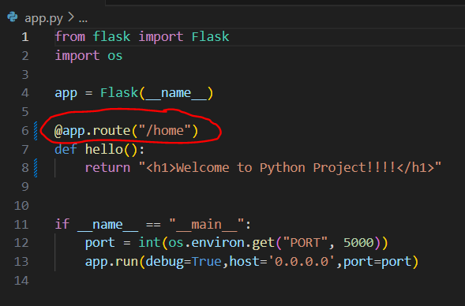
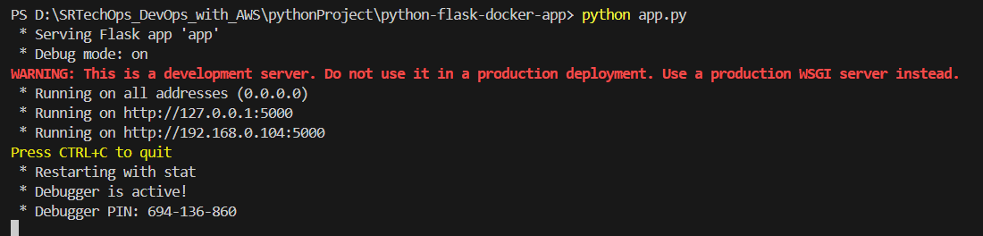

127.0.0.1 > It is LOCAL IP
5000: By default, Flask's development server runs on port 5000
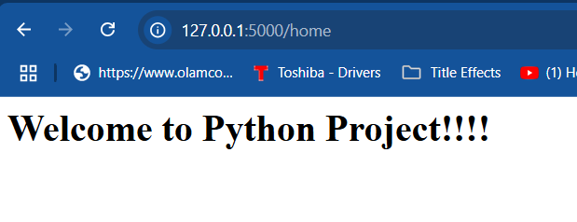
🔧 Default Ports for Python Web Frameworks
- Flask: By default, Flask's development server runs on port 5000. Microsoft Learn+4Medium+4Nylas+4
- Django: Django's development server uses port 8000 by default. LabEx+2Server Fault+2Visual Studio Code+2
- FastAPI: When using Uvicorn as the ASGI server, FastAPI applications default to port 8000.
We can change the port as our wish:
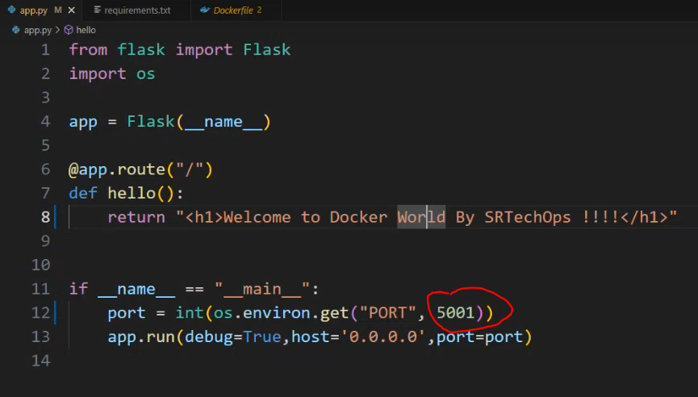
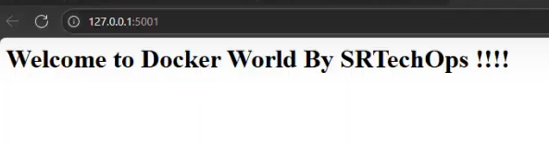
requirements.txt
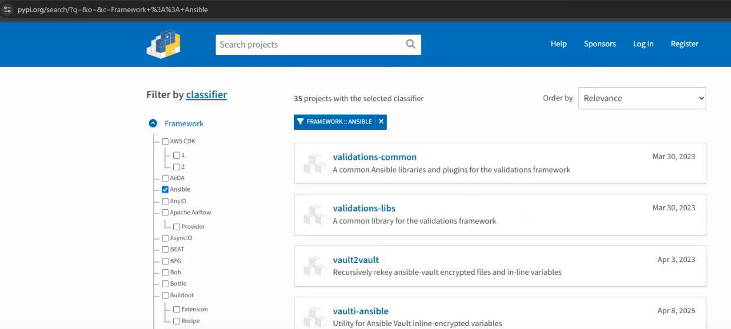
All the required python libraries/packages will be added in this file.
pip install -r requirements.txt // It will install all the required libraries/packages.
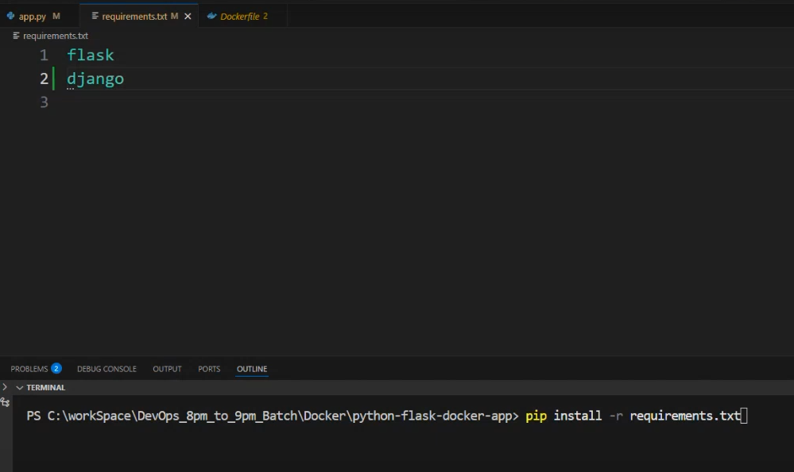
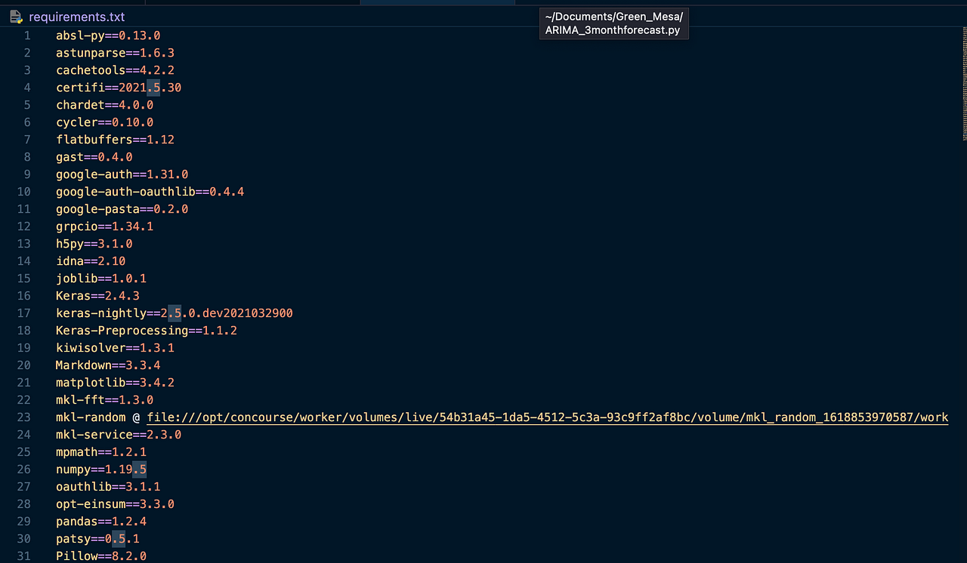
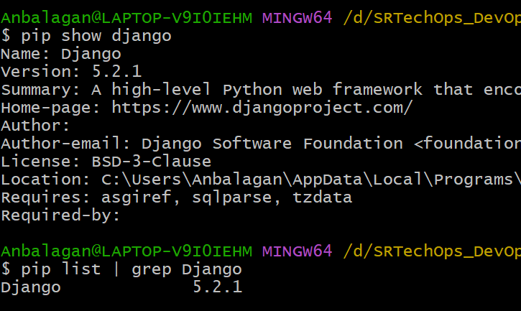
The requirements.txt file is a crucial component in Python projects, serving as a manifest of all the external packages and their specific versions that your project depends on. Here's why it's important:Medium

🔧 Purpose of requirements.txt
- Dependency Management
It lists all the packages your project requires, ensuring that anyone working on the project installs the correct dependencies.
- Reproducibility
By specifying exact package versions, it guarantees that the project behaves consistently across different environments.
- Simplified Setup
New developers or deployment environments can install all necessary packages with a single command:
pip install -r requirements.txt
- Version Control Integration
Including requirements.txt in your version control system (like Git) allows for tracking changes in dependencies over time.
- Automation in CI/CD Pipelines
It's commonly used in Continuous Integration/Continuous Deployment (CI/CD) pipelines to automate the installation of dependencies during testing and deployment phases.

🛠️ Creating a requirements.txt File
To generate a requirements.txt file that captures all the packages installed in your current environment, use:LearnPython
pip freeze > requirements.txt
This command outputs a list of installed packages and their versions, which can then be used to recreate the environment elsewhere.Wikipedia+4Medium+4Reddit+4

📝 Example of a requirements.txt File
A typical requirements.txt file might look like:
Flask==2.0.1
requests>=2.25.1
numpy~=1.21.0
Each line specifies a package and its version constraints.

In summary, requirements.txt is essential for maintaining consistent environments, facilitating collaboration, and streamlining deployment processes in Python projects.Medium+3

Basically, We create a 3 docker file for python,
    - For front-end
    - For back-end
    - For database
RUN this PROJECT in Remote Server using Docker File:
Create a VC in AWS
Connect the VC via MobaXterm
- Install and Start Docker on the VM
- sudo gpasswd -a ec2-user docker
- sudo reboot
- Clone the git OR Upload the code from your local to remote server
https://github.com/srtechops/python-flask-docker-app.git

- Create a Dockerfile
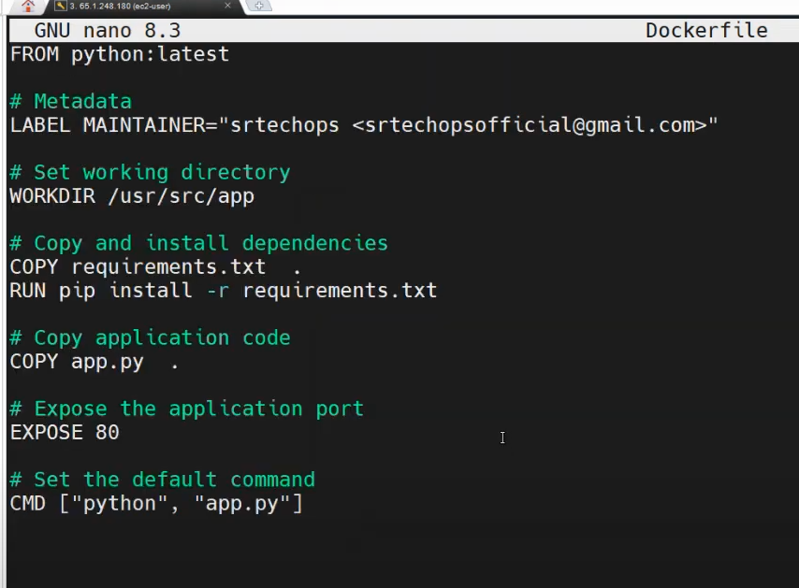

Create Docker Image:
- >docker build -t myflaskapp .
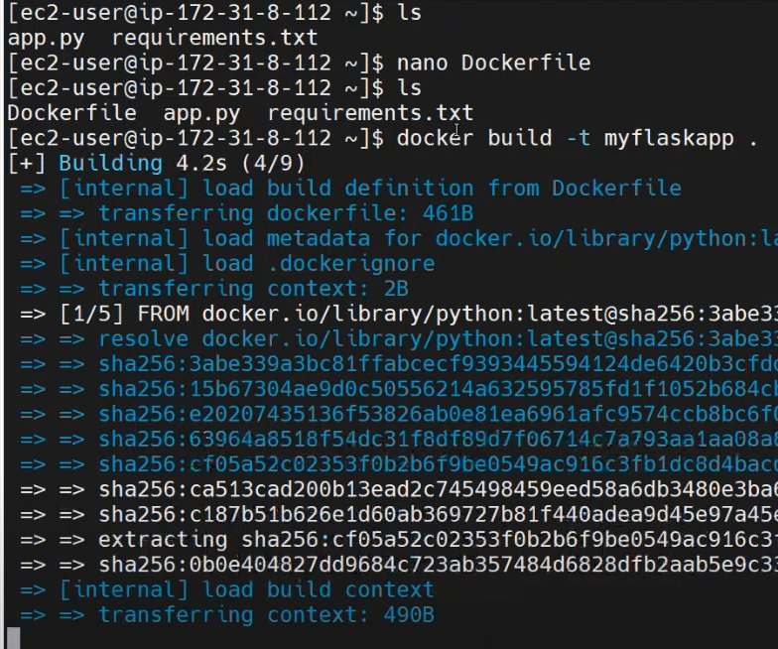

Create Docker Container using Docker Image:
Enable 80 in the Security group on the VM:
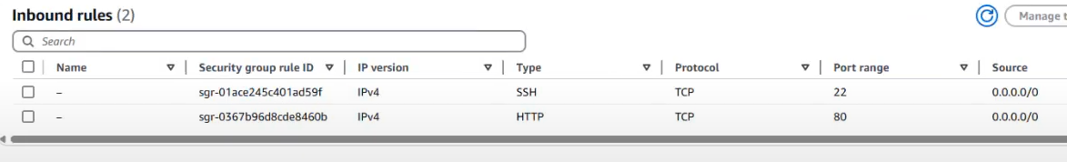
Copy and Paste the VM public IP in the Browser:
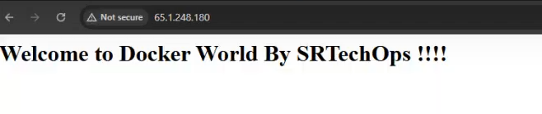
TIPS:
To delete all containers in Docker (both running and stopped), follow these steps:

🧹 Step-by-step:
1️⃣ Stop all running containers (optional but recommended):
bash
CopyEdit
docker stop $(docker ps -q)
2️⃣ Remove all containers:
bash
CopyEdit
docker rm $(docker ps -aq)

✅ One-liner (Stop and Remove all):
bash
CopyEdit
docker rm -f $(docker ps -aq)
-f forcefully stops running containers before removing them.

🔍 Bonus: Check if it's cleared
docker ps -a
→ This should now return nothing if all containers are removed.

🧠 Explanation:
✅ docker ps
- Lists running containers by default.
✅ docker ps -a
- Lists all containers, both running and stopped.
✅ docker ps -aq
- -q = quiet mode, shows only container IDs (no extra info).
- So this gives you a list of all container IDs.
✅ $(...)
- This is command substitution in bash.
- It runs the inner command (docker ps -aq) and passes the output (list of IDs) as arguments to the outer command (docker rm).
✅ docker rm <id1> <id2> ...
- Deletes the specified containers by their IDs.

📌 In short:
docker rm $(docker ps -aq)
= "Delete all containers (stopped or running)."
Note: If any container is still running, this will fail for those. To force delete running containers, use:
docker rm -f $(docker ps -aq)
Let me know if you want to do the same for images, volumes, or do a full cleanup!
why we use $ symbol?
ChatGPT said:
Great question! The $ symbol in shell scripting (like Bash) has a special meaning. It is used to access variables or evaluate commands.

🔹 Two Main Uses of $:
1️⃣ To reference a variable
Example:
name="Anbu"
echo $name
🔸 Output: Anbu

2️⃣ To run a command inside another command
This is command substitution using $(...):
echo $(date)
🔸 Output: current date and time
In your Docker example:
docker rm $(docker ps -aq)
The $() runs docker ps -aq first, gets a list of container IDs, and inserts that output into the docker rm command.

🧠 Analogy:
Think of $() like saying:
"Hey shell, run this inner command first, and use its result as if I typed it here."

