Day 9: How to Dockerize a React App | Step-by-Step Docker Tutorial for Beginners
https://www.youtube.com/watch?v=J0Yl8WBZZmU&list=PL7iDpp0KYTgEBgcnLiFNGMKNZbYReGB8p&index=8
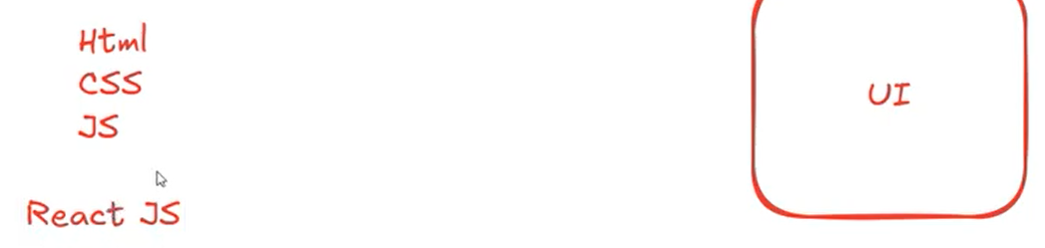

First we going to run React App MANUALLY:
  - Required: NODE js
Project clone: https://github.com/srtechops/reactProject.git
https://github.com/npm/cli
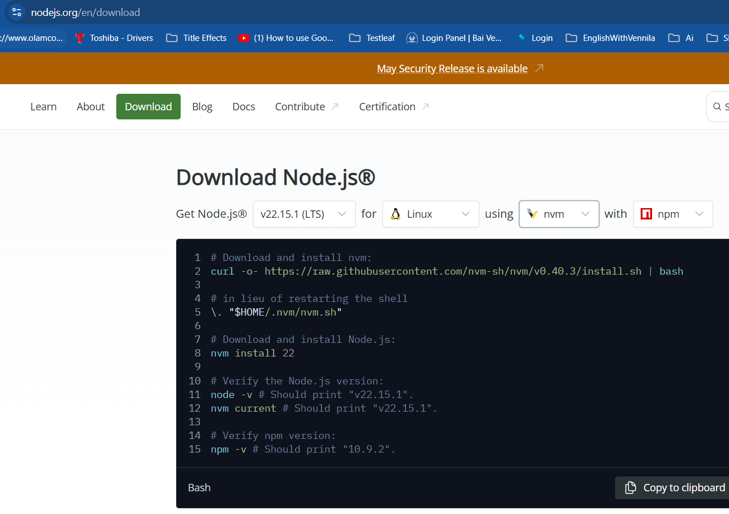
OR
Using > sudo yum install nodejs
>npm --version
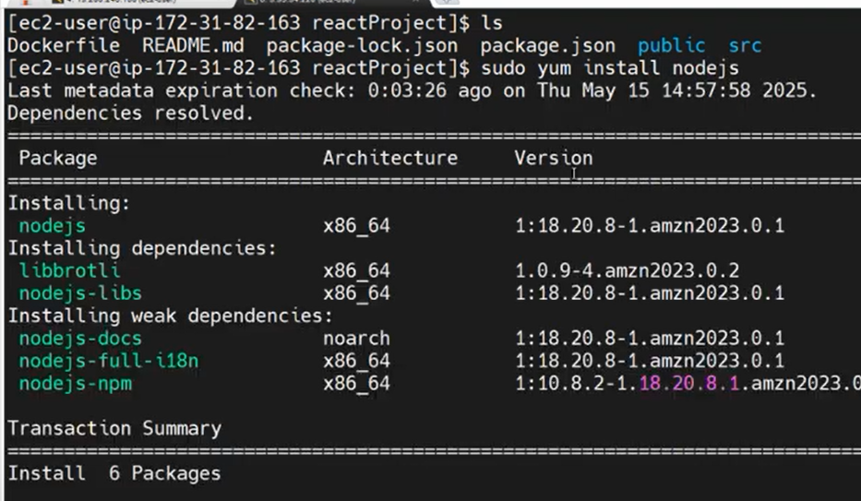

All the dependencies added on the “package.json” file.
>npm install // All the dependencies and libraries mentioned on “package.json” file will be installed
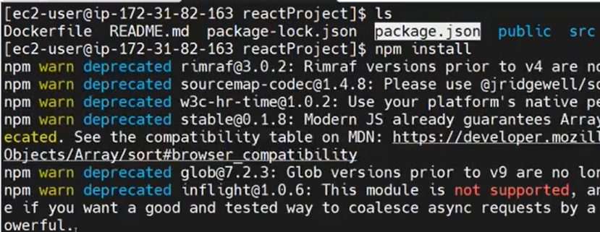
After installing, “node_modules” will be created. All the dependencies and libraries downloaded and available on the “node_modules”.
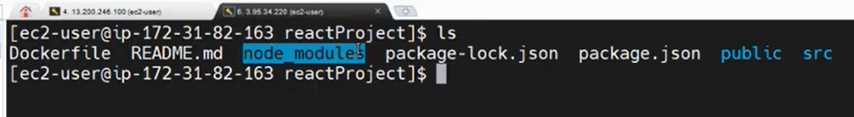
> npm start // Start the npm server/See the output.
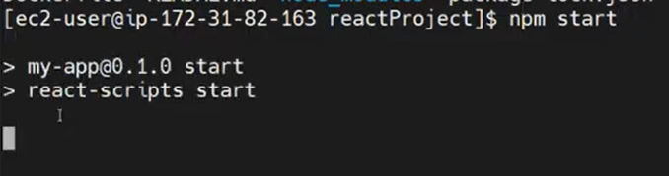
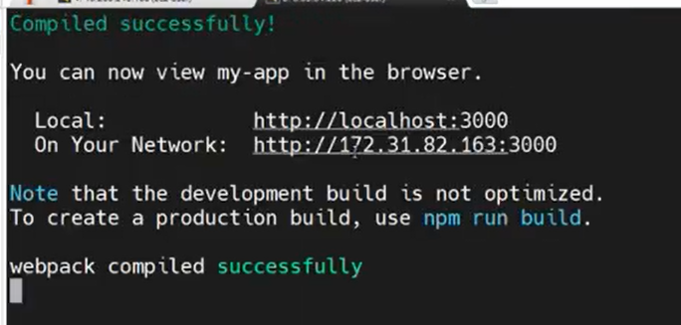
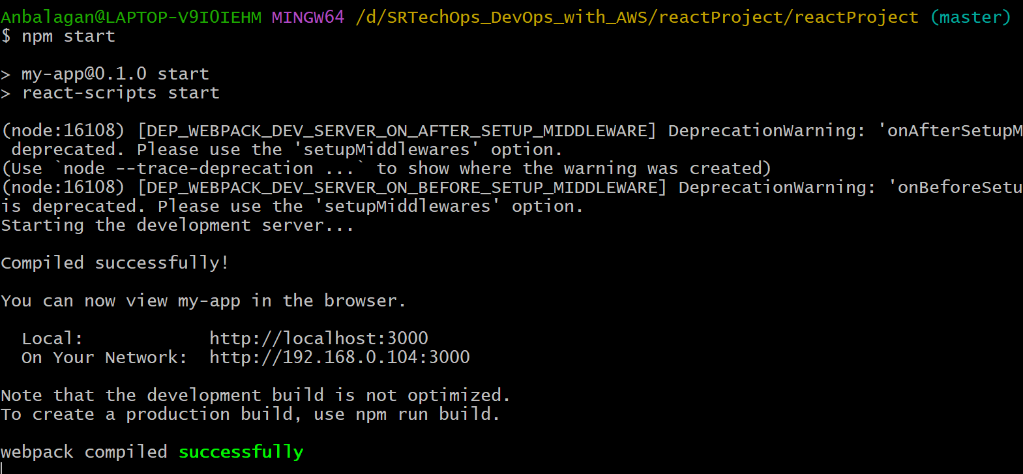

In local machine:
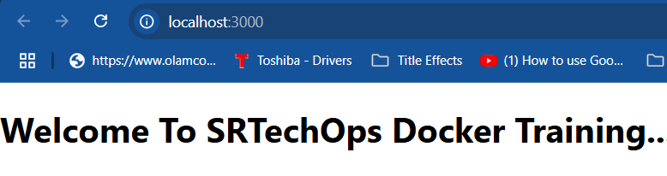
In VM:
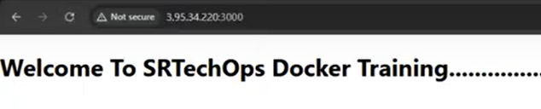

Achieve the above using Dockerfile:
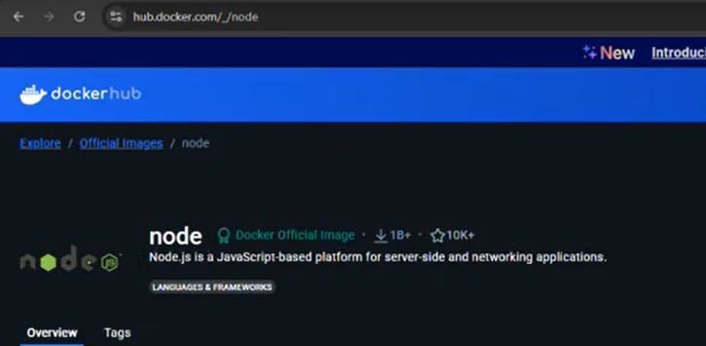
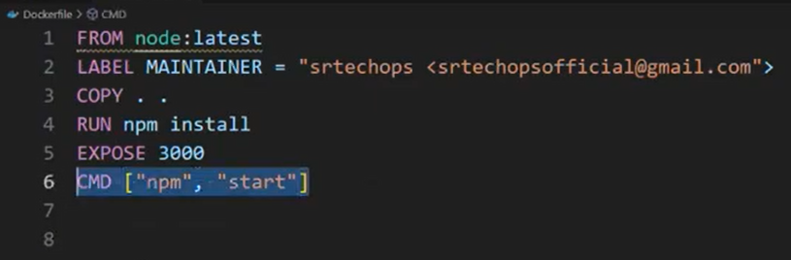
Build docker image using docker file:
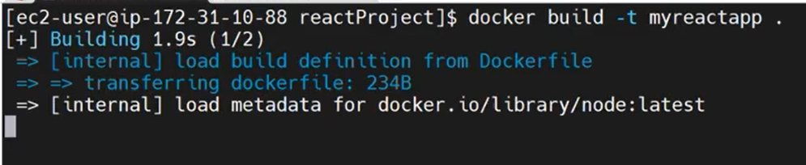
Create a docker container using docker image:
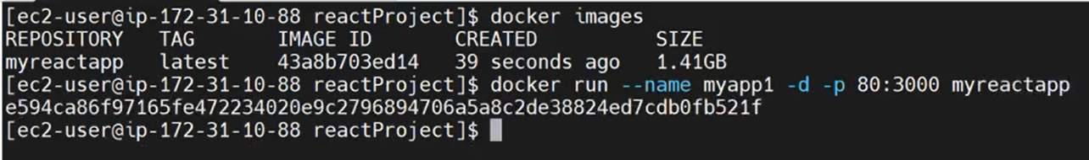
Go VM, enable port 3000 and see the result:
