1 .Docker Networking Explained | Complete Guide with Commands for Beginners
https://www.youtube.com/watch?v=VTWRocMz7D0&list=PL7iDpp0KYTgEBgcnLiFNGMKNZbYReGB8p&index=9&t=1768s
🚢 What is Docker Network?
A Docker network allows containers to communicate with each other, with the host system, and with the outside world (Internet).
Think of it as the "Wi-Fi" that connects Docker containers.

🧠 Why is it needed?
- To link multiple containers (like a web app and its database).
- To isolate containers from each other for security.
- To allow communication via container names (instead of IPs).

🛠️ Types of Docker Networks
- Bridge (default)
  - Used when you run containers without specifying a network.
  - Good for single-host setups.
  - Containers can talk using container name as hostname.
docker run -d --name webapp nginx
docker exec -it webapp ping google.com
- Host
  - Shares the host’s network stack.
  - No network isolation between container and host.
  - Used when performance is critical.
docker run --network host nginx
- None
  - The container has no networking.
  - Total isolation.
docker run --network none nginx
- Overlay
  - Connects containers across multiple Docker hosts.
  - Used in Docker Swarm mode.
- Macvlan
  - Assigns a MAC address to containers.
  - Looks like a separate physical device on the network.
  - Advanced use cases.

🧪 Example: Create a Custom Network
docker network create my_custom_net
docker run -d --name db --network my_custom_net mysql
docker run -d --name app --network my_custom_net myapp
Now app can talk to db using db as hostname.

🔍 View Networks
docker network ls # List all networks
docker network inspect <network-name> # See details

✅ Summary
Network Type | Scope | Use Case
Bridge | Local Host | Default, isolated containers
Host | Local Host | High performance, no isolation
None | Local Host | Full isolation (no network)
Overlay | Multi-host | Docker Swarm, distributed apps
Macvlan | Advanced | Appear as physical network devices

Why docker network and explain it as a 5yrs old?
🗒️ Answer
Imagine you have many toy robots, and each robot can talk to another using walkie-talkies. But they need to be on the same channel to hear each other.
Docker network is like giving each robot (or container) a walkie-talkie and putting them on the same channel so they can:
- Talk to each other easily — like sharing toys or asking for help.
- Stay safe from strangers — only robots on the same channel can talk.
- Talk to the outside world when needed — like calling mom or dad using a phone.
In big-people words: Docker network lets containers communicate securely and efficiently inside their own
Training Class:
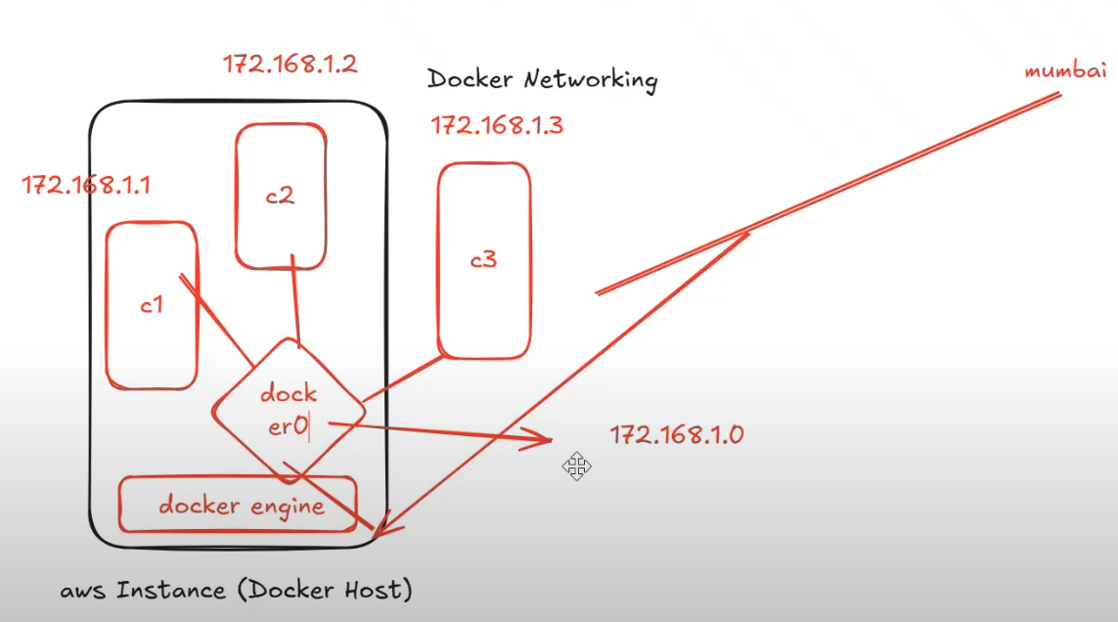
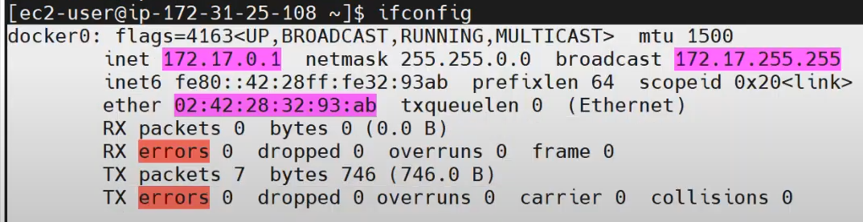
3 Types of docker network:


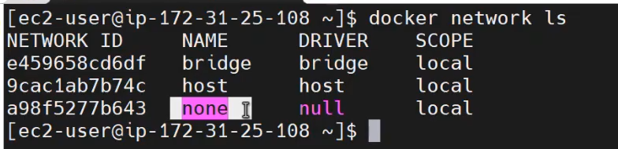
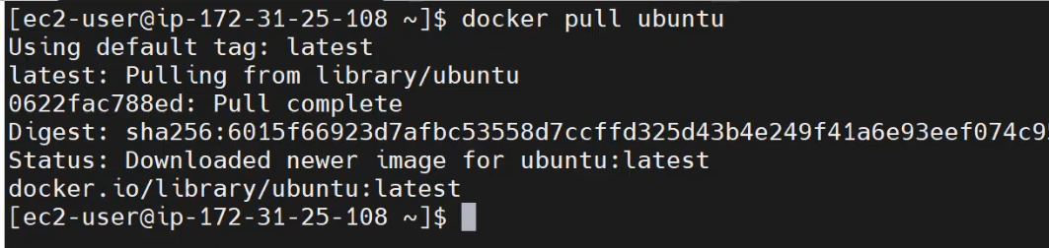
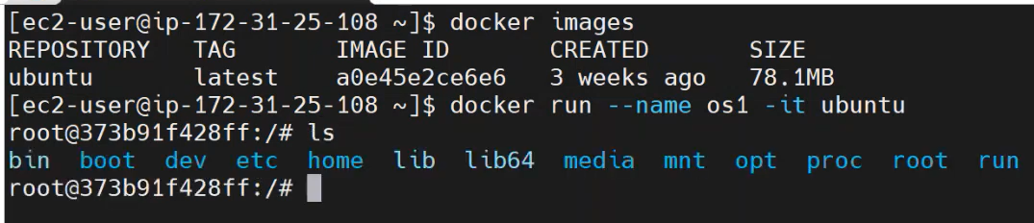
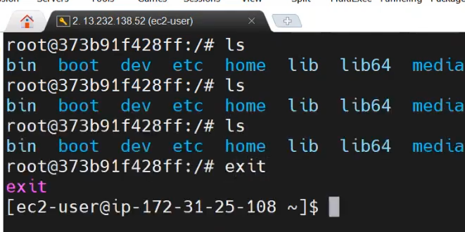
When we exit from from the container, status changed to existed. So, we need to start container > docker start <containerName>
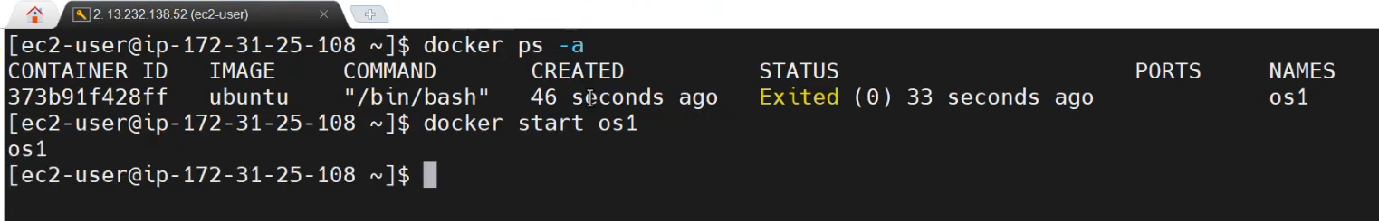
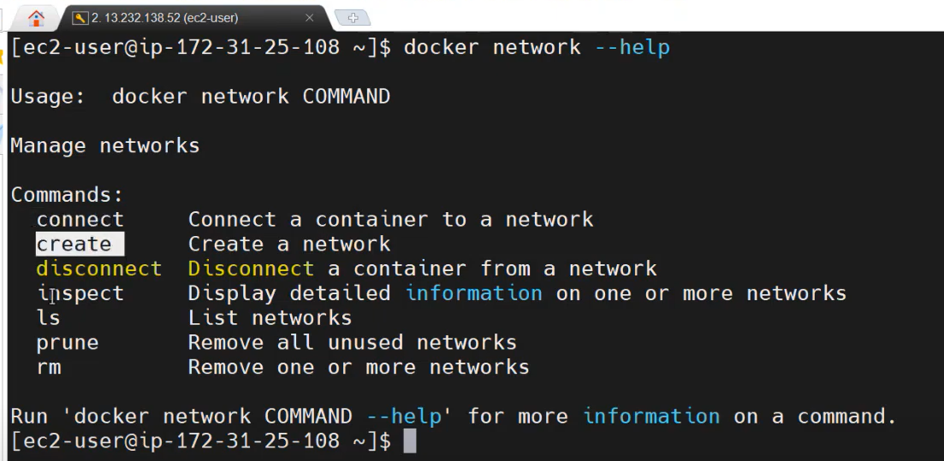
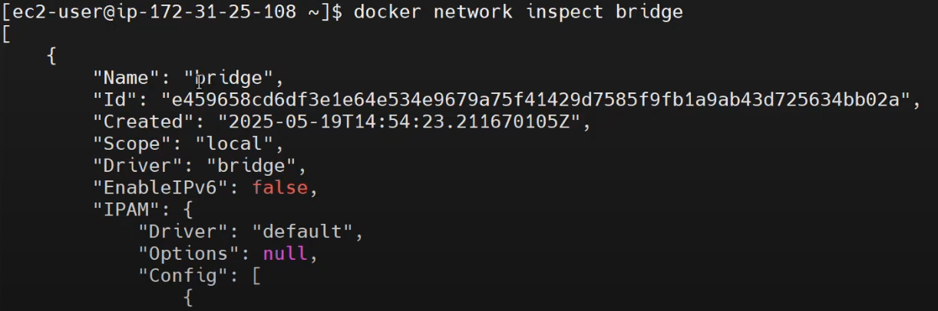
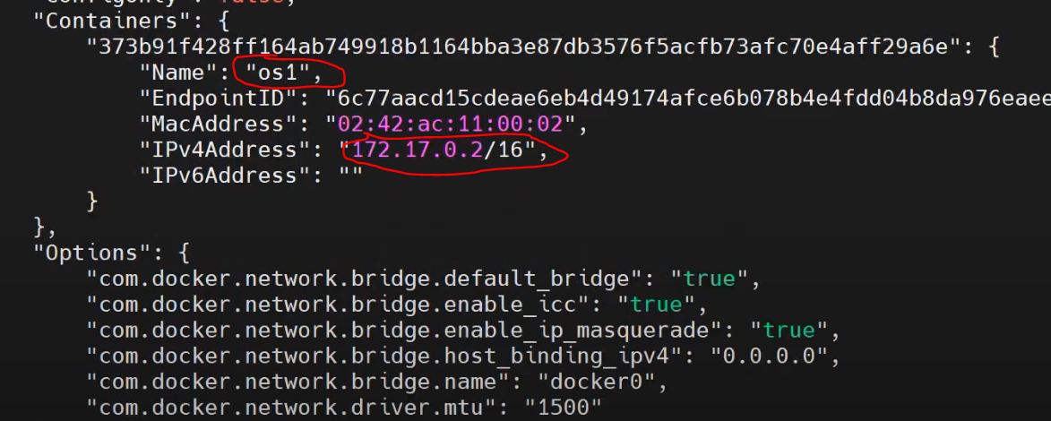
Create a another container:
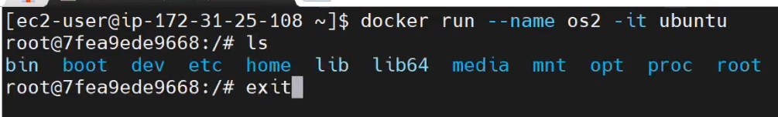
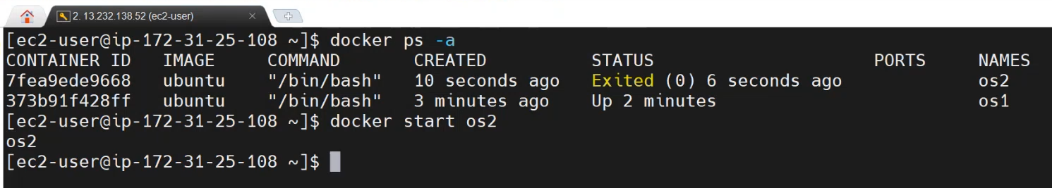
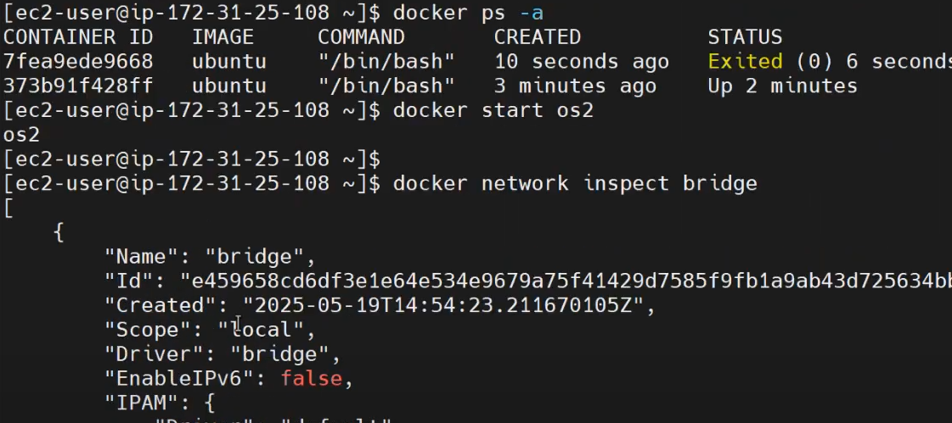
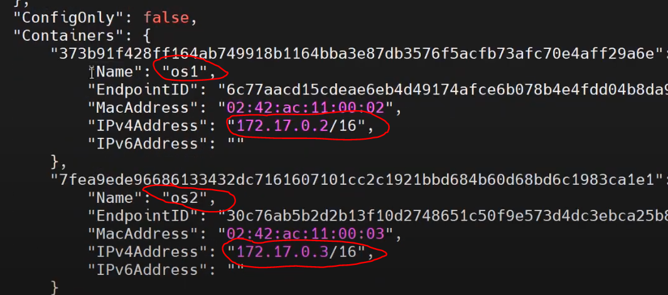
Login to OS1 container and check whether it communicate with OS2:
Open it as new tab:
>docker exec -it os1 /bin/bash
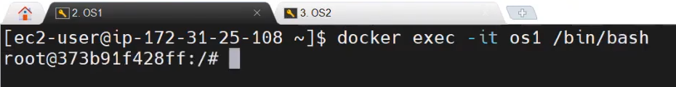

Login to OS2 container and check whether it communicate with OS1:
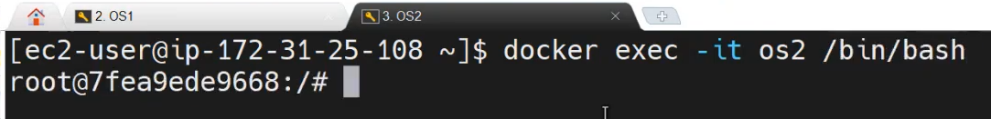
IFCONFIG and PING will not work, Need to install corresponding package, before that upate OS on both machine:
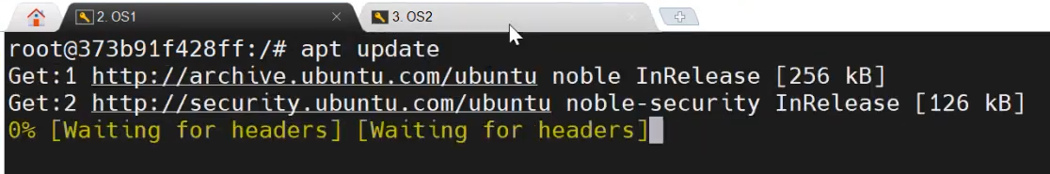
For IFCONFIG: to check container’s IP address
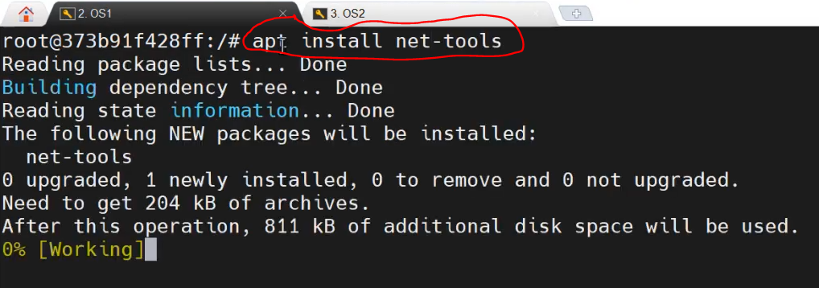
After installing >apt install net-tools, ifconfig command will work:
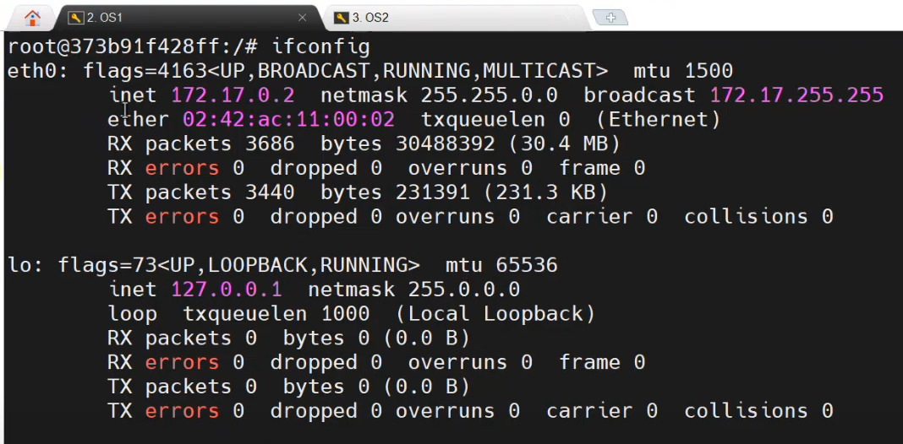
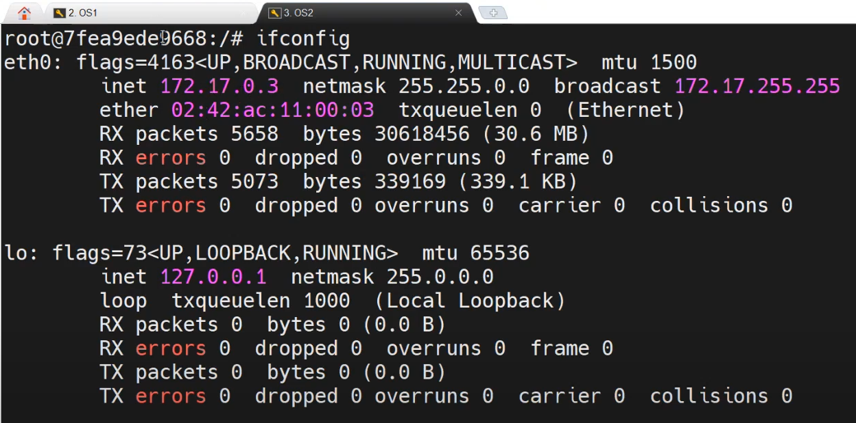
To work PING command, need to install necessary package:
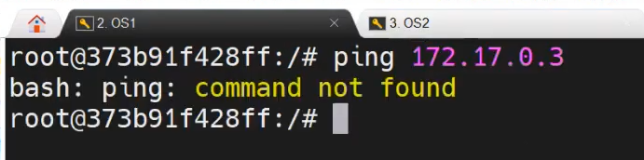

>apt install iputils-ping
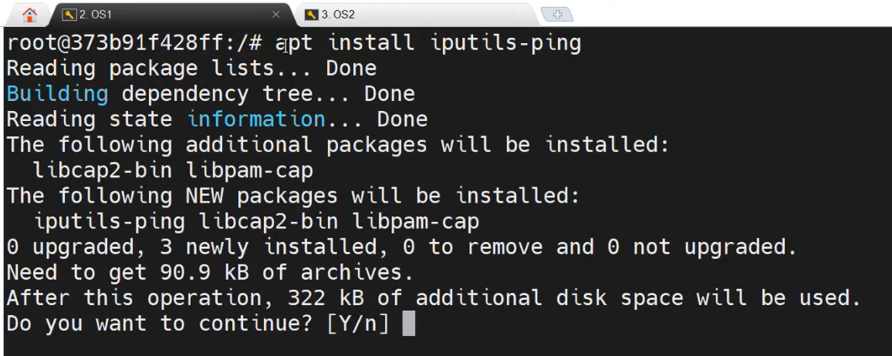
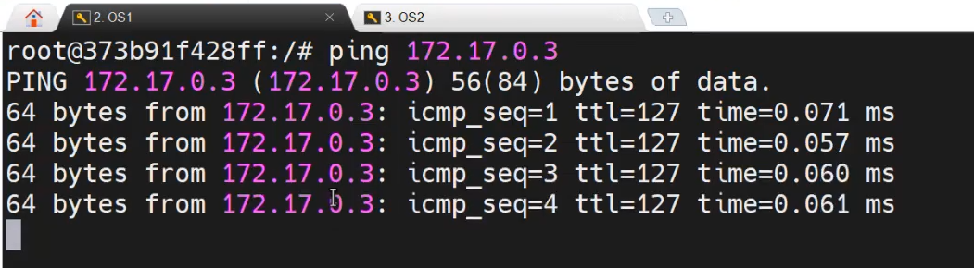
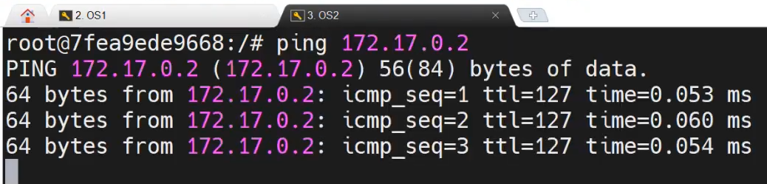
When we create a webserver and db server in the same bridge network, So they easily communicate each other.
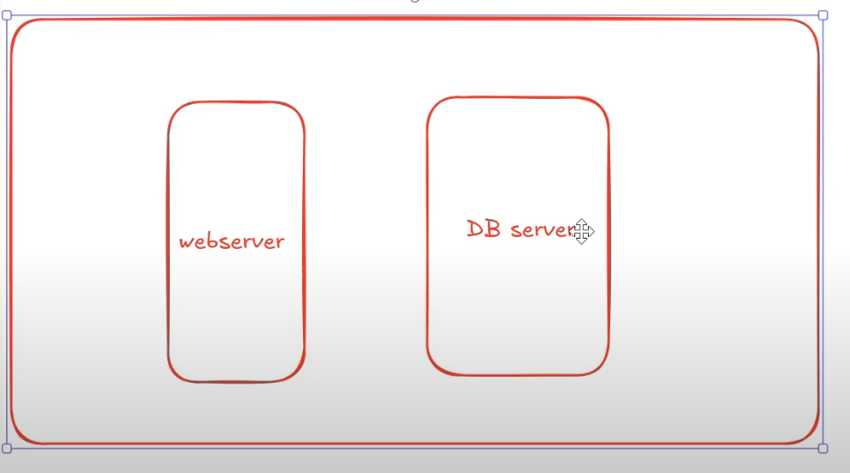
We have a FINANCE server. The webserver shouldn’t communicate the finance server. In this case, create a NEW BRIDGE network for finance server.
>docker network create -d bridge srtechops
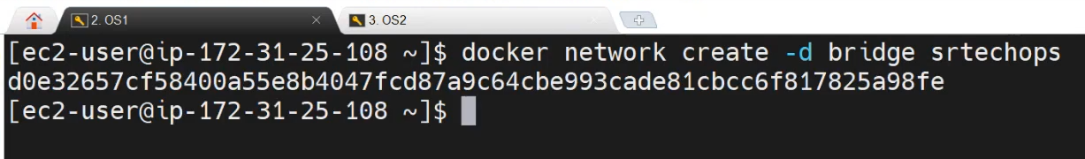
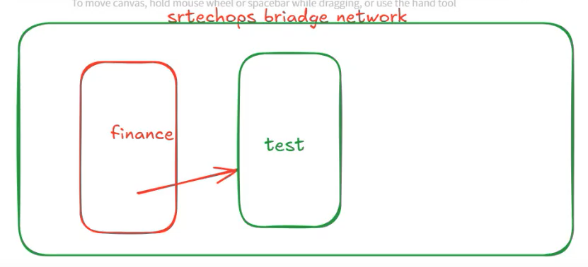
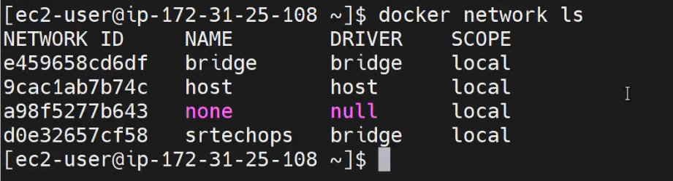
Now, create a finance container inside the newly created network:
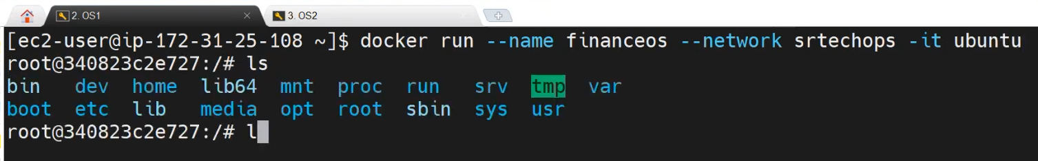

If you try to access container on the srtechops bridge network from the default bridge network. It doesn’t work. Because the both are different bridge networks.
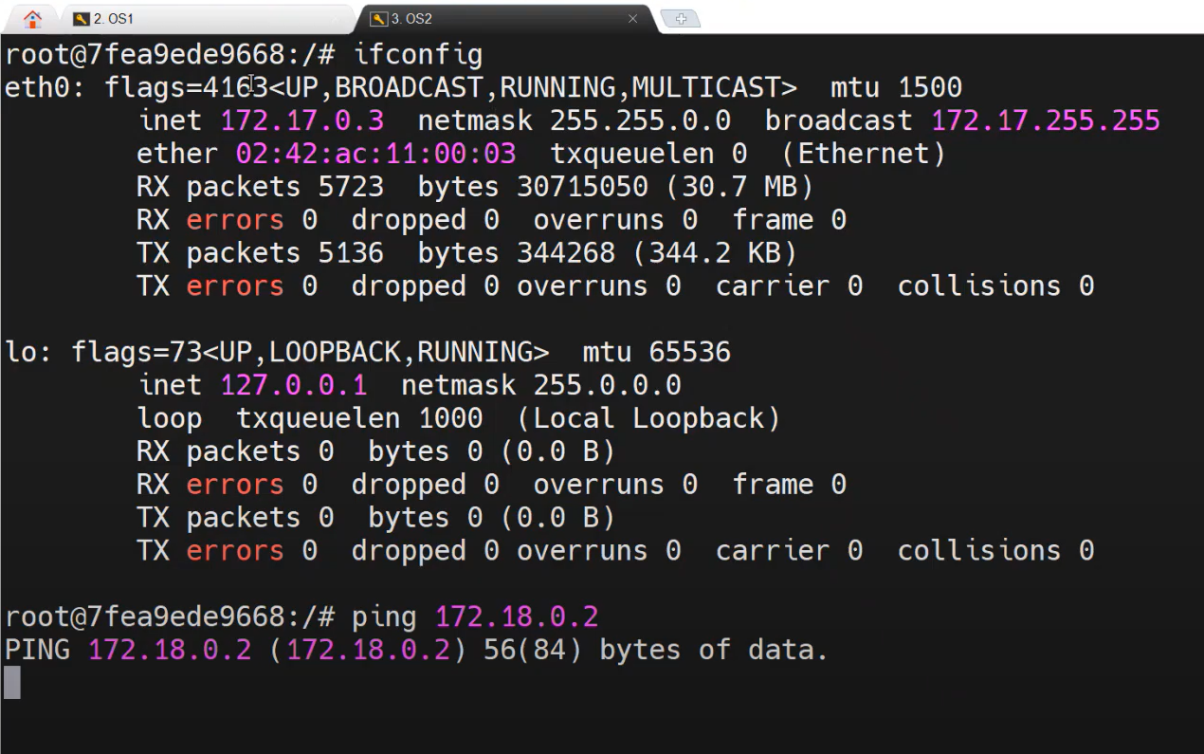

2 . Docker Networking Explained | Part 2
https://www.youtube.com/watch?v=I3OJhHbtVCI&list=PL7iDpp0KYTgEBgcnLiFNGMKNZbYReGB8p&index=10
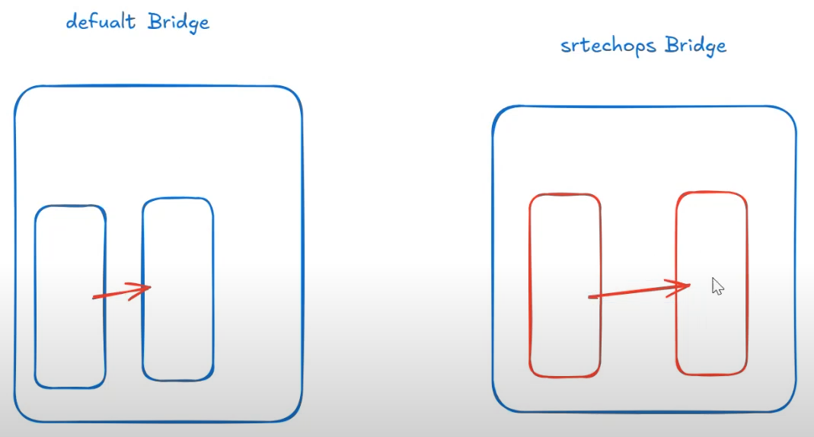
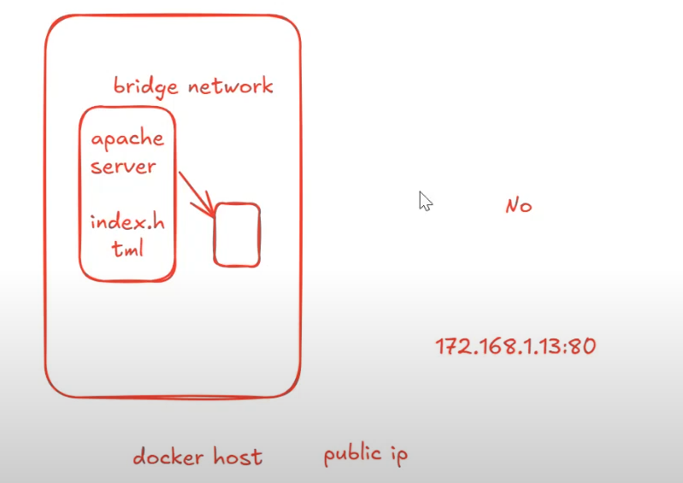
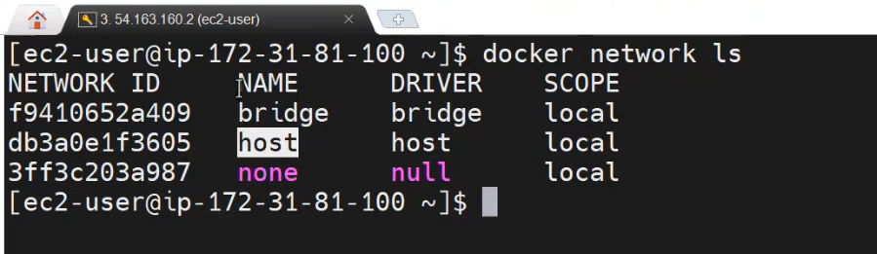
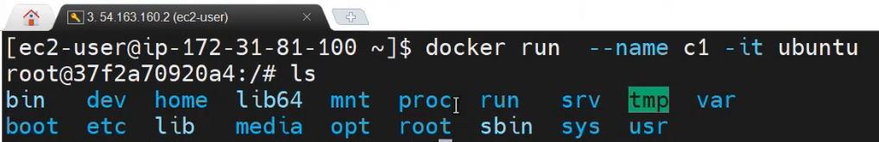
>apt update
>apt install net-tools -y
>ifconfig
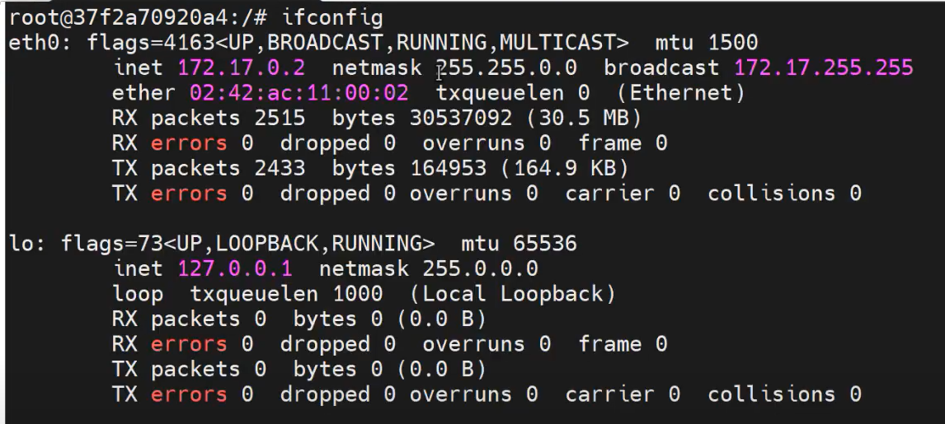
>apt install apache2
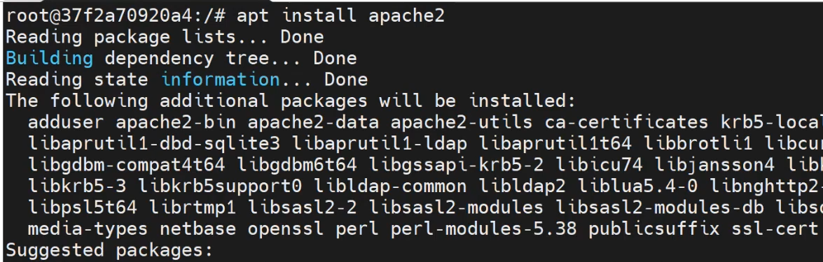
What is difference between apt install apache and apt install httpd? when we use this?
🗒️ Answer
The commands apt install apache and apt install httpd are not equivalent, and here's why:
- Package Naming Depends on OS:
  - On Ubuntu/Debian, the Apache web server package is named apache2, not apache or httpd.
  - On Red Hat-based systems (like CentOS, RHEL), the package is called httpd.
- apt install apache:
  - This will not work on Ubuntu/Debian because there is no package named apache in the APT repositories.
- apt install httpd:
  - Also typically invalid on Ubuntu/Debian.
  - On Ubuntu, you should use:
sudo apt install apache2
- When to Use:
  - Use sudo apt install apache2 on Debian/Ubuntu systems.
  - Use sudo yum install httpd or dnf install httpd on RHEL/CentOS/Fedora systems.
In short, apache2 and httpd refer to the same Apache HTTP server, but the package name differs by Linux distribution [1], [6].
🌐 Sources
- askubuntu.com - Is there any difference between apache2 and httpd?
- stackoverflow.com - Difference apache installation via apt-get ...
- httpd.apache.org - Compiling and Installing - Apache HTTP Server Version 2.4
- serverfault.com - Differences between "apache"'s installations
- geeksforgeeks.org - How to Install Apache Web Server in Linux
- superuser.com - What is the difference between Apache Web Server and ...

>service apache2 start
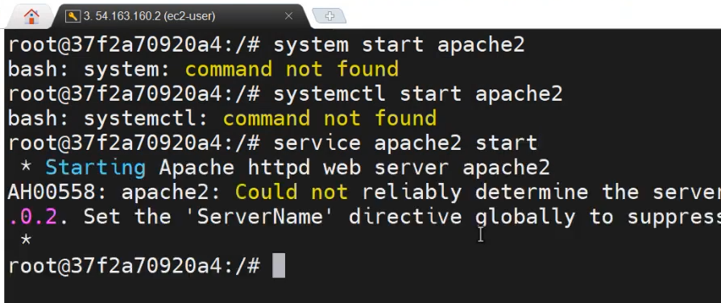

Without port forwarding, we can access apache server using host ip, because we created a apache server on the host network:
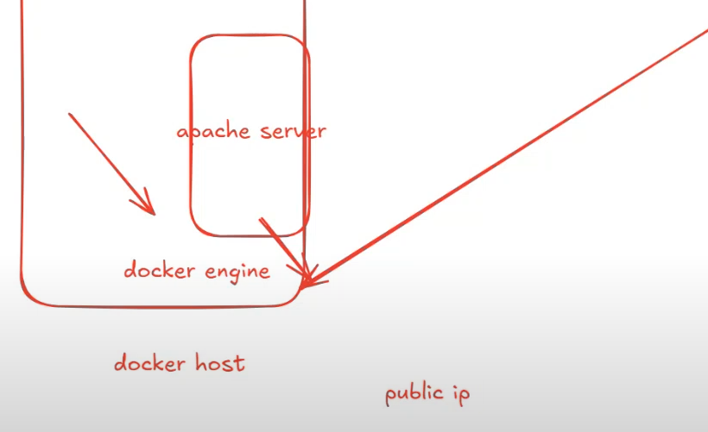
With port forwarding, we can access apache server using host ip, because the apache server on the bridge network:
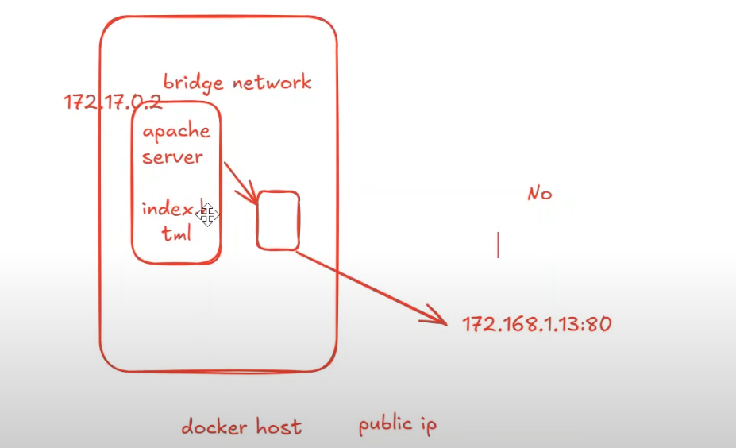
Create a new host network:
>docker run --name c2 --network host -it ubuntu
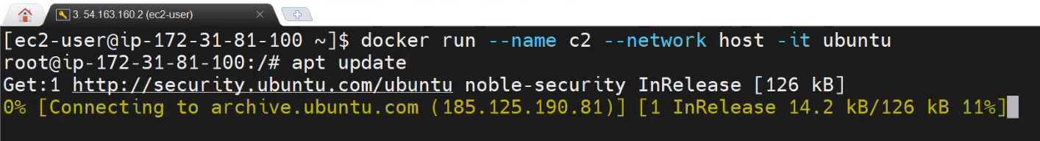
>apt update
>apt install net-tools // to check ifconfig and get ip address
> docker network inspect host
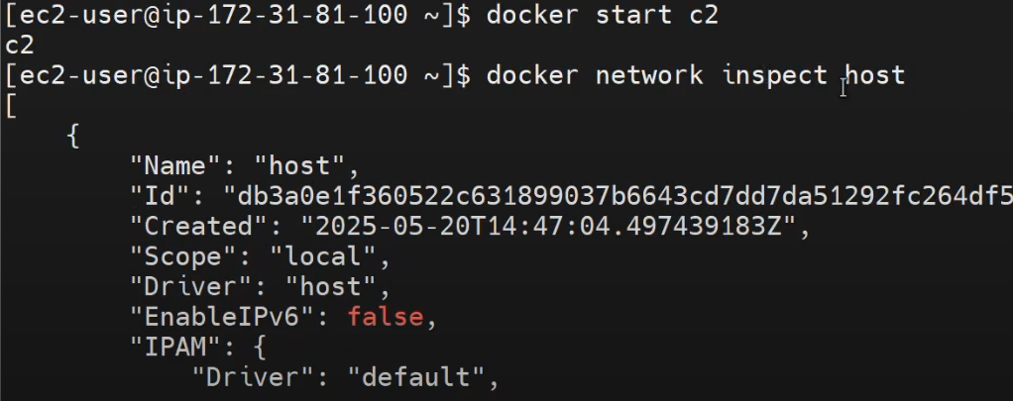
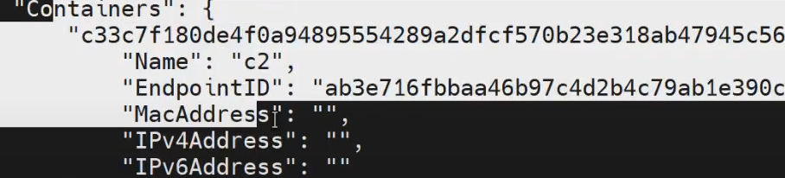
Login to the c2 container:
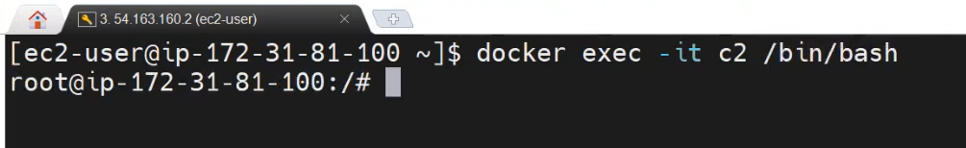
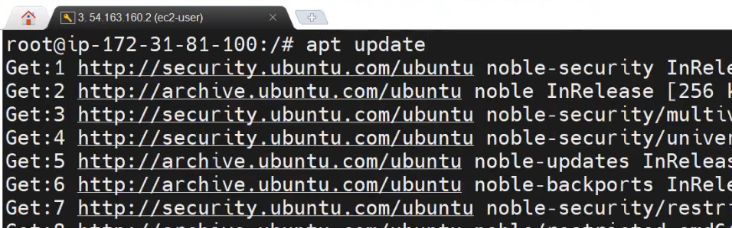
Install apache:> apt install apache2

Start the apache:> service apache2 start
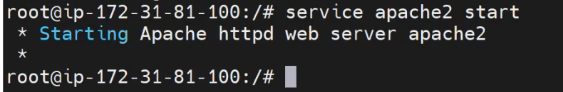
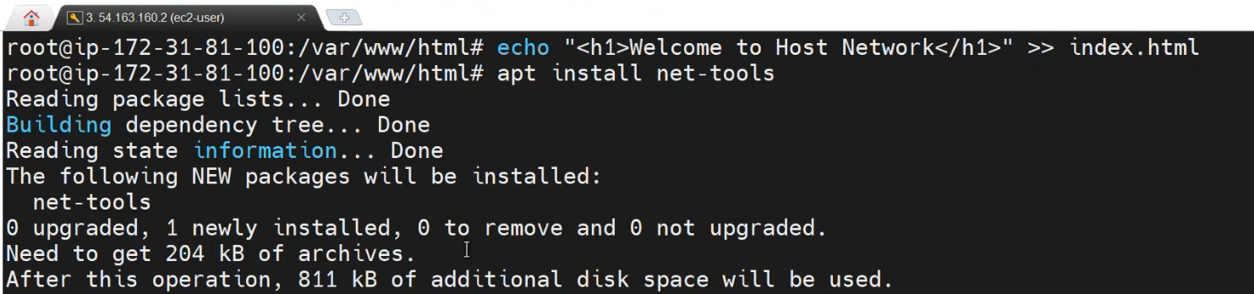
The c2 container doesn’t have IP address, because this work on host ip address:
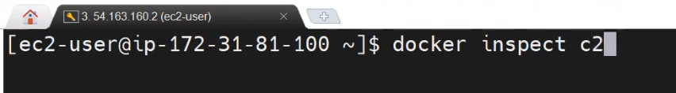
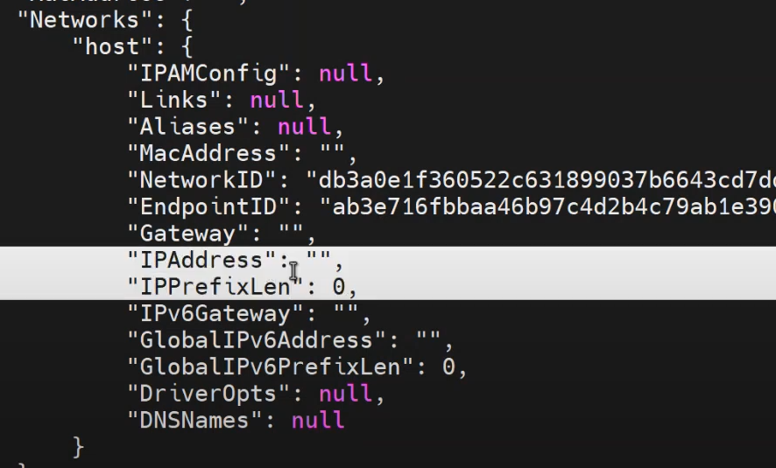

NONE Network:
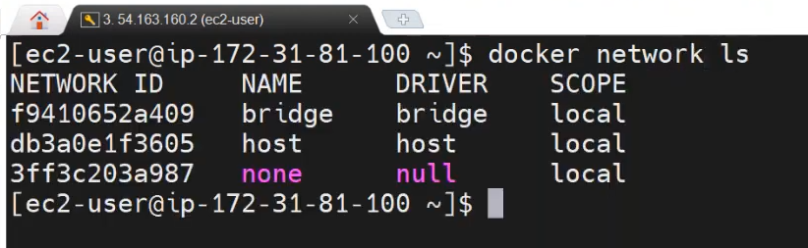
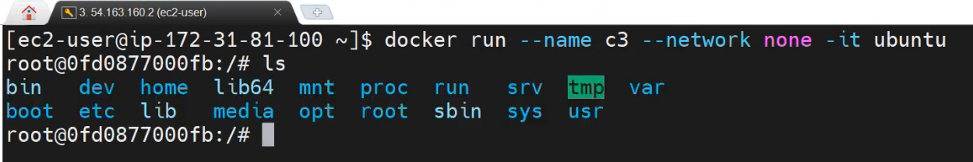
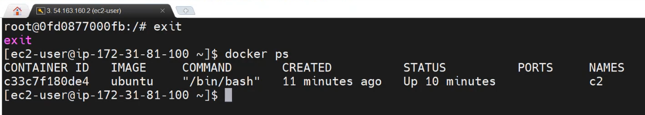
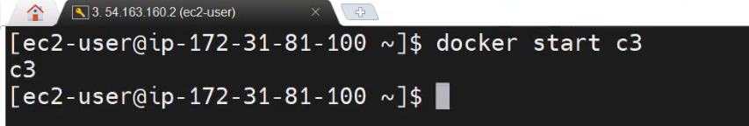
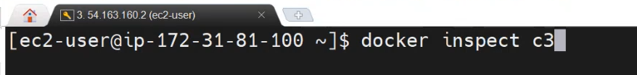
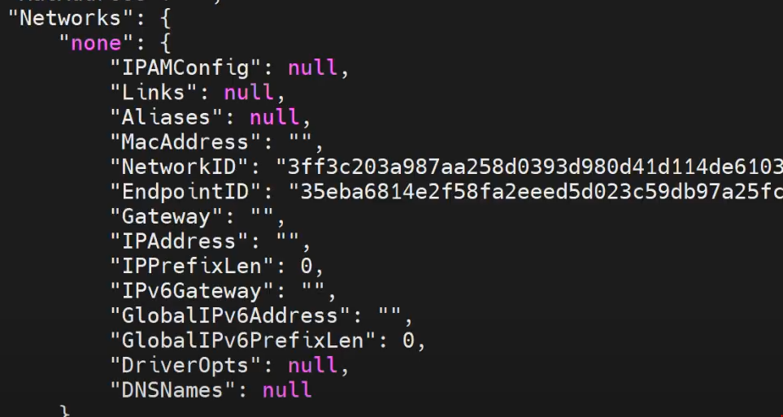

Login to c3 container:
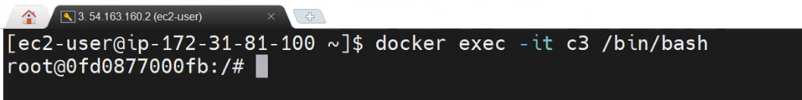
No network for NONE network, So we won’t do any update/installation on the container.
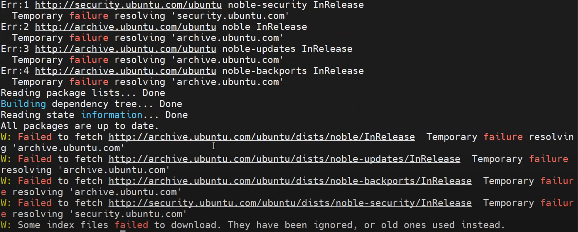

3 . Docker Networking Explained | Part 3
- docker network create
Creates a new network.
docker network create mynet
This creates a bridge network called mynet [1].
- docker network ls
Lists all Docker networks.
docker network ls
Shows default networks like bridge, host, none and custom ones.
- docker network inspect
Shows detailed information about a network.
docker network inspect mynet
Useful to view connected containers and IP settings [1].
- docker network connect
Connects a container to a specific network.
docker network connect mynet container1
Allows the container to communicate via that network [2].
- docker network disconnect
Disconnects a container from a network.
docker network disconnect mynet container1
Removes network access from the container on that network [6].

- docker network rm
Removes one or more networks.
docker network rm mynet
Network must be unused (no containers connected) [4].
- docker network prune
Removes all unused networks.
docker network prune
Cleans up networks not used by any container [5].
🌐 Sources
- docs.docker.com - docker network
- docs.docker.com - docker network connect
- meghasharmaa704.medium.com - Docker Network Commands - Meghasharmaa
- docs.docker.com - docker network rm
- learning-ocean.com - Docker Network (Remove, Prune)
- geeksforgeeks.org - Docker Networking
Difference b/w docker network prune and rm?
🗒️ Answer
The key difference between docker network prune and docker network rm lies in scope and automation:
- docker network rm <network_name>
  - Manual removal of one or more specific networks.
  - You must provide the name or ID of the network.
  - The network must not be in use by any container; otherwise, the command will fail [6].

Example:
docker network rm my_network
- docker network prune
  - Automatic cleanup of all unused networks (not connected to any container).
  - No need to specify names — Docker will identify and remove all that are safe to delete [2].
  - Prompts for confirmation unless -f (force) is used.
Example:
docker network prune
Summary:
- Use rm when you want precise control.
- Use prune for a quick cleanup of all unused networks.
🌐 Sources
- stackoverflow.com - What is the difference between "docker container prune" vs ...
- docs.docker.com - docker network prune
- datacamp.com - Docker Prune: A Complete Guide with Hands-On Examples
- docs.docker.com - Prune unused Docker objects
- geeksforgeeks.org - Docker Prune Command
- learning-ocean.com - Docker Network (Remove, Prune)

