Git & GitHub

Day 1: What is Git and GitHub? | Problems Solved by These Tools
Day 2: Git and GitHub Basic Commands(git config, git status, git add --a, git commit -m “”, git push, git log, git log --oneline)
Day 3 - Collaborators in GitHub (Private Repository)
Day 4- Github Repository (README.md, .gitignore, License, Restore, etc)
Day 5 - Git push, git pull & git conflict

Day 1: What is Git and GitHub? | Problems Solved by These Tools -9th Apr 2025
https://www.youtube.com/watch?v=9zfSRLrm-eY&list=PL7iDpp0KYTgF6MYh15THaCPCNbEArMDN4&index=1
💡 What is Git?
Git is a version control system.
🔧 Think of it like this:
- It keeps track of changes to your files.
- It lets you go back to a previous version if something breaks.
- It allows multiple people to work on the same project without messing up each other’s work.

🛠️ What can Git do?
- Track changes to your code or documents.
- Save versions (called commits) so you can rollback if needed.
- Create branches so you can try new ideas safely.
- Help with team collaboration.

🌐 What is GitHub?
GitHub is a website (a cloud platform) where you can store your Git repositories online.
🗂️ Why GitHub?
- So you don’t lose your code if your computer crashes.
- You can collaborate with teammates around the world.
- Share your projects publicly or keep them private.
- Useful for open-source projects.
- Many companies use GitHub for version control and code review.

📌 Why do we use Git + GitHub?
Feature | Git | GitHub
Tracks changes | ✅ | ❌
Saves file versions | ✅ | ❌
Stores project online | ❌ | ✅
Team collaboration | ✅ (locally) | ✅ (online)
Backup in the cloud | ❌ | ✅
Helps in code review | ❌ | ✅

🧪 Real-Life Example:
Let’s say you’re writing a school project or building a website:
- You save versions using Git:
So if a new change breaks the project, you can undo it.
- You upload it to GitHub:
So your teacher or friends can see it, review it, or help you fix issues.
Day 2: Git and GitHub Basic Commands -10th Apr 2025
https://www.youtube.com/watch?v=_3f9vc3OPBc&list=PL7iDpp0KYTgF6MYh15THaCP
CNbEArMDN4&index=2&t=53s
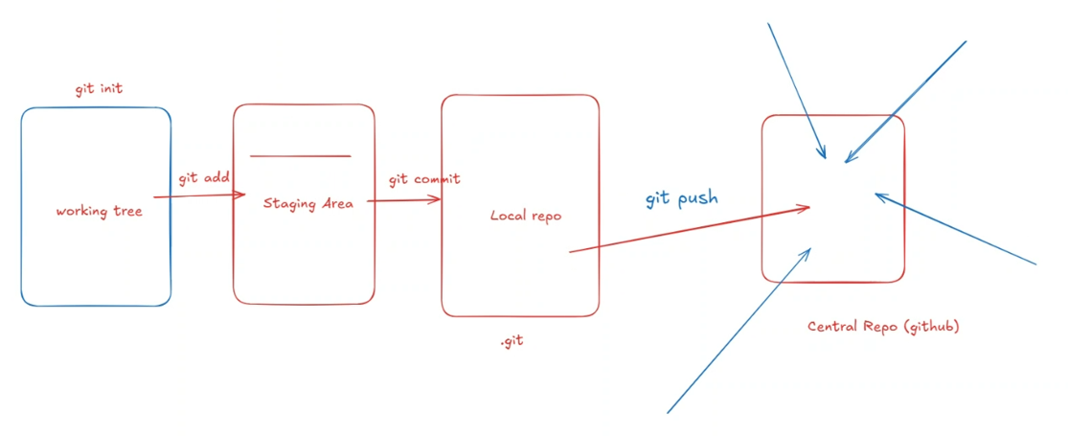
Install GIT in your laptop > Create a new folder in any of the driver (D, E, F) > Right click , select Git Bash
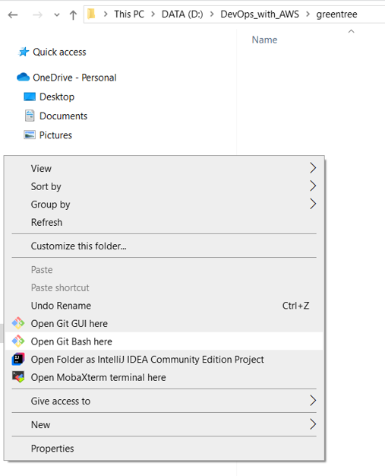
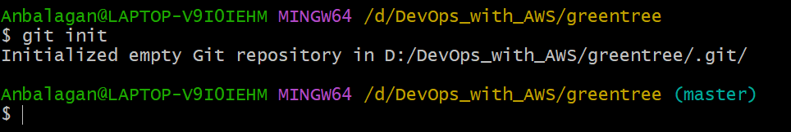
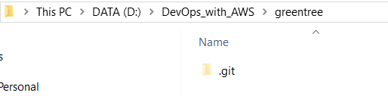

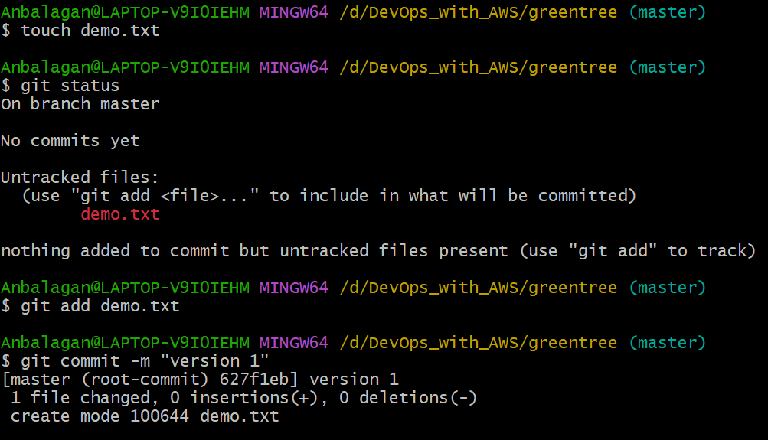
>git config user.name “Anbalagan Ramu”
>git config user.email “anburuku@gmail.com”
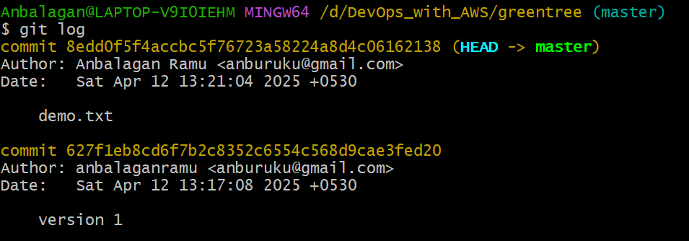
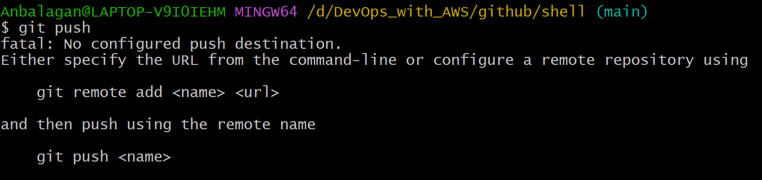
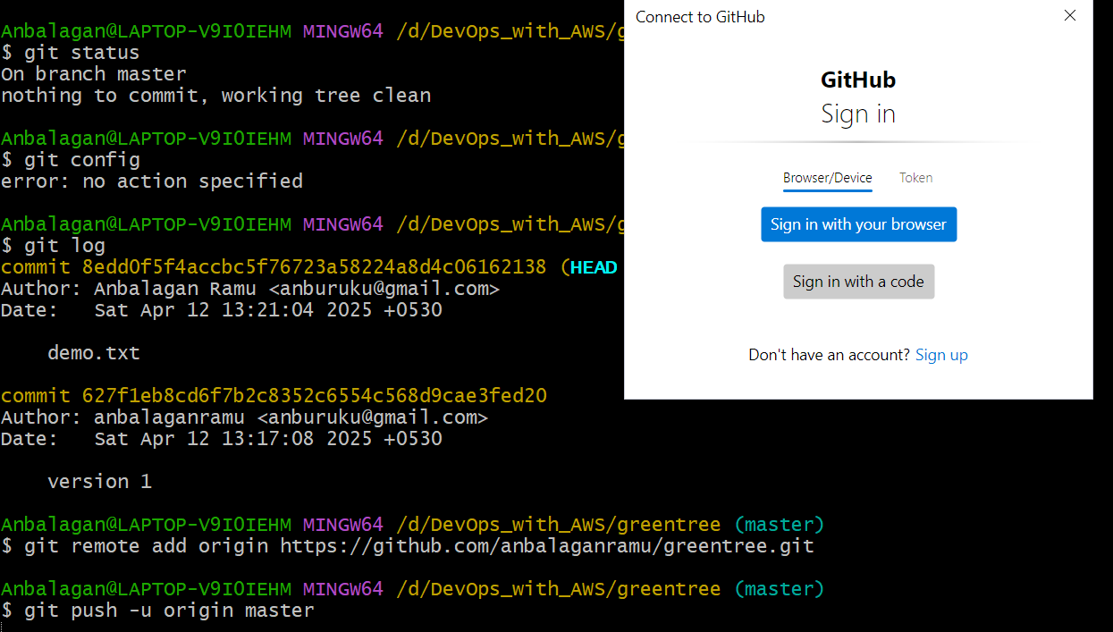
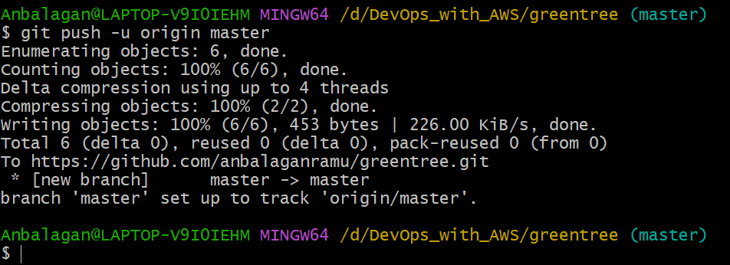
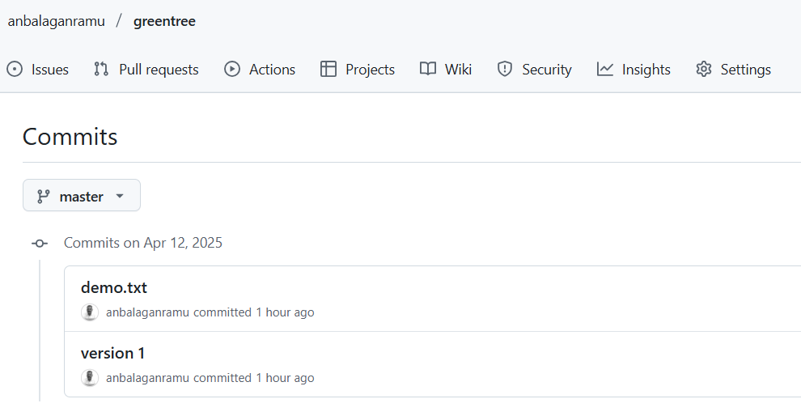
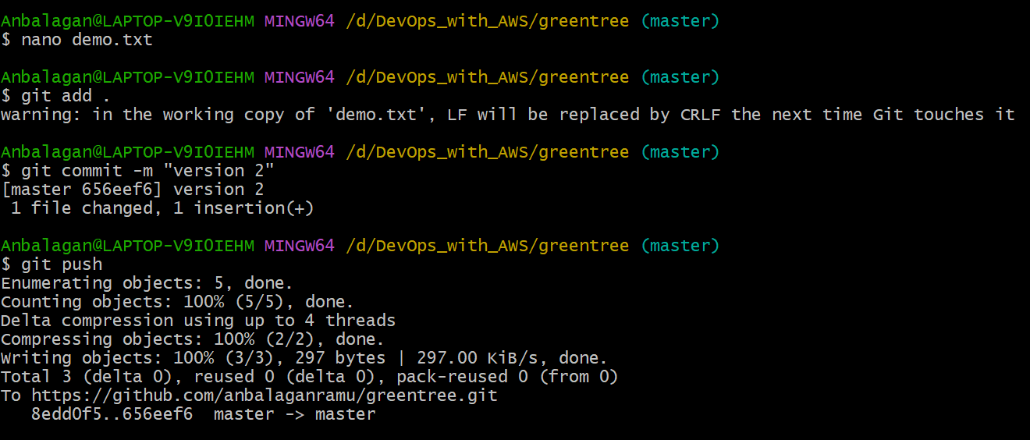
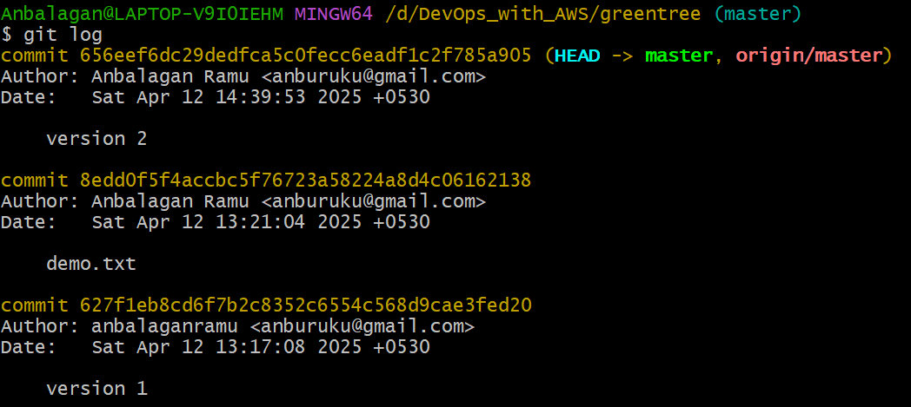

…or create a new repository on the command line
echo "# makemytrip" >> README.md
git init
git add README.md
git commit -m "first commit"
git branch -M main
git remote add origin https://github.com/anbalaganramu/makemytrip.git
git push -u origin main

…or push an existing repository from the command line
git remote add origin https://github.com/anbalaganramu/makemytrip.git
git branch -M main
git push -u origin main
🔹 Step 1: git init – Initialize a Local Repository
git init
What it does:
This command creates a new Git repository in your current folder by creating a hidden .git directory. It means Git will start tracking your files from here.
📁 After this, you’ll see .git folder in your project (if hidden files are visible).

🔹 Step 2: git remote add origin <repo-url> – Connect to Remote Repo
git remote add origin https://github.com/yourusername/your-repo.git
What it does:
This command tells Git where the remote version of your project is located.
- origin is just a name (you can use other names too, but origin is standard).
- <repo-url> is the URL of the remote repo (from GitHub, GitLab, Bitbucket, etc.).
🔗 Now your local repo knows where to send code!

🔹 Step 3: git add . – Stage Your Files
git add .
What it does:
This adds all files and folders in your project to the staging area.
The staging area is like a “draft area” where you prepare what changes you want to commit.
💡 You can also add individual files:
git add index.html

🔹 Step 4: git commit -m "message" – Save Changes
git commit -m "Initial commit"

✅ What is a Commit?
A commit is like saving a snapshot of your project at a specific point in time.
When you run:
git commit -m "Your message here"
Git takes all the changes you staged (with git add) and creates a new version of the project — like saving a checkpoint in a game.
What it does:
This takes a snapshot of your staged files and saves it as a commit in Git history.
📝 The -m flag lets you write a short message describing the changes you made (e.g., "Added homepage layout").

🔹 Step 5: git push -u origin main – Push to Remote Repo
git push -u origin main
What it does:
This uploads your local commits to the remote repository (origin) on the main branch.
- origin: the remote repo you connected to.
- main: the branch you’re pushing to (could be master in older repos).
- -u: sets this remote + branch as default, so next time you can just do git push.
- -u is short for --set-upstream.

✅ What it does:
  - It links your local branch (main, in this case) to the remote branch (origin/main), so Git knows where to push and pull from automatically in the future.
🌐 After this, your code will appear on GitHub (or whichever platform you use)!

🧠 Summary Table:
Step | Command | Purpose
1 | git init | Start tracking project with Git
2 | git remote add origin <URL> | Connect to remote repository
3 | git add . | Stage changes to be committed
4 | git commit -m "message" | Save a snapshot of changes
5 | git push -u origin main | Upload to remote repo

To create a new branch in GitHub through the command line, you use Git (which interacts with GitHub). Here’s the command:
git checkout -b branch-name
Or using the newer command:
git switch -c branch-name
Steps to follow:
- Make sure you’re in your project directory:
cd your-project-directory
- Fetch the latest changes (optional but recommended):
git pull
- Create and switch to the new branch:
git checkout -b your-branch-name
- Push the new branch to GitHub:
git push -u origin your-branch-name

Day 3 - Collaborators in GitHub (Private Repository)
https://www.youtube.com/watch?v=ekj8ZTSQ7IY&list=PL7iDpp0KYTgF6MYh15THaCPCNbEArMDN4&index=3&t=8s
Create a repository with Private:
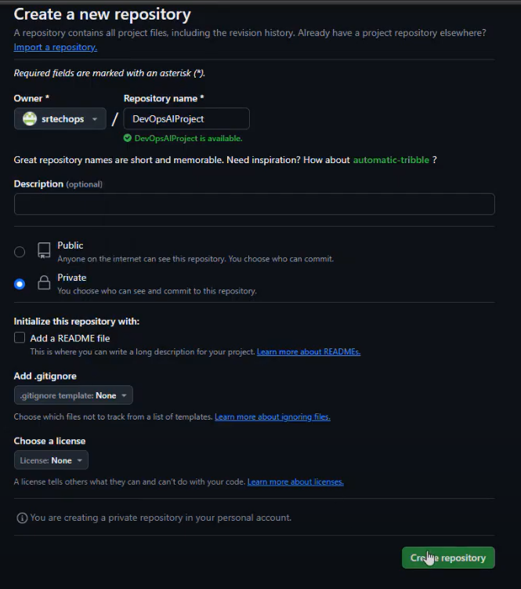

Go to Settings > Collaborators
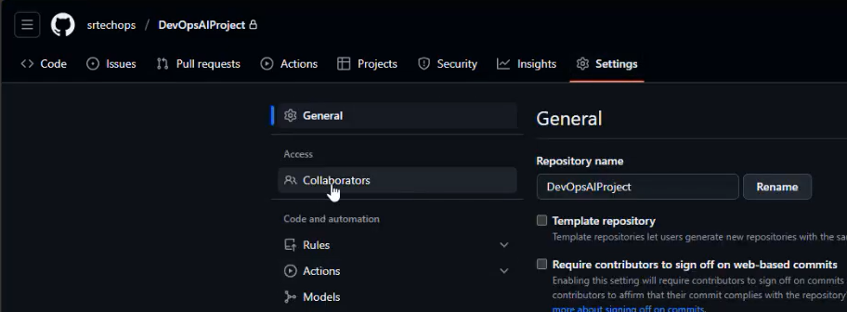
Click on Add People:
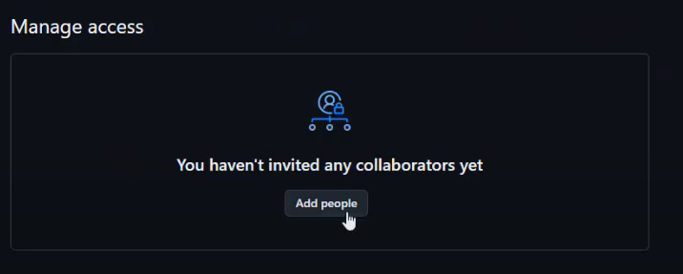
Add user’s email address:
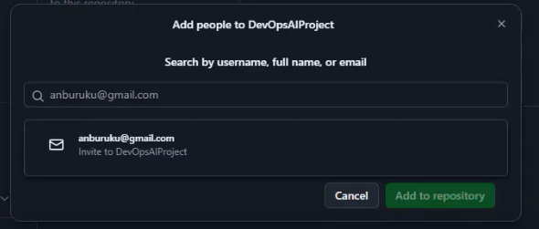
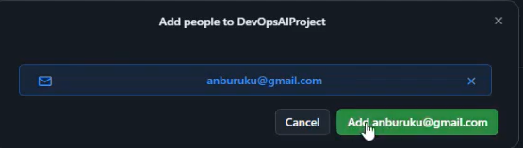
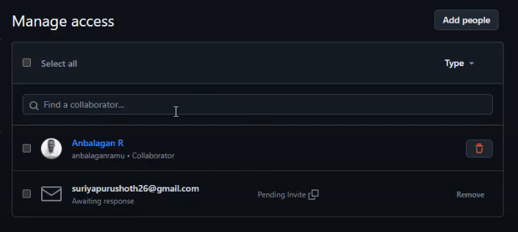

Clone the Remote Repo to Local:
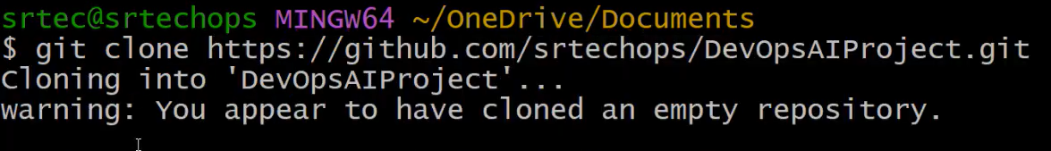
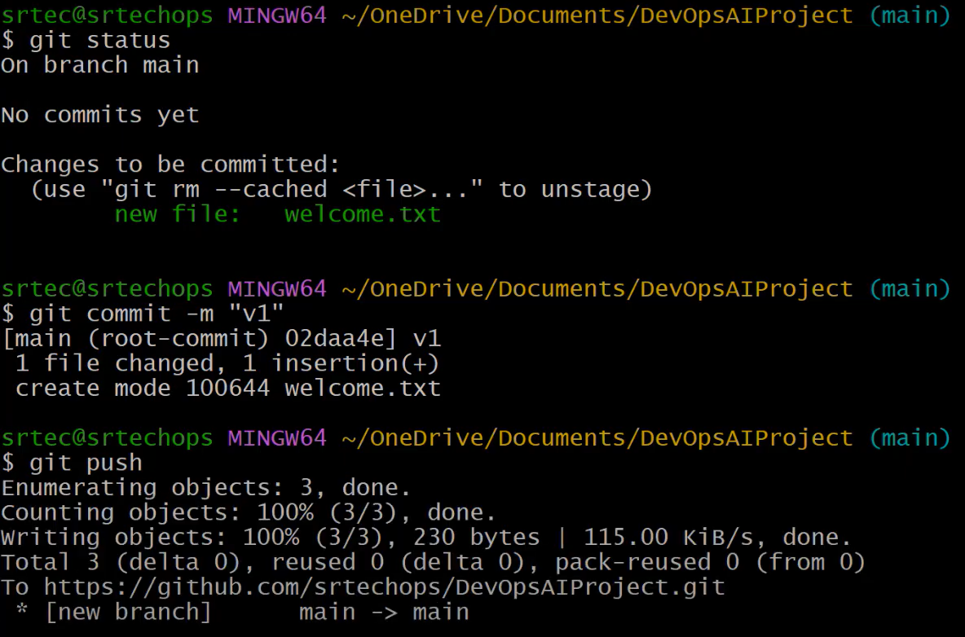
When we clone the remote repo, automatically the remote origin repo path will be added on the config file:
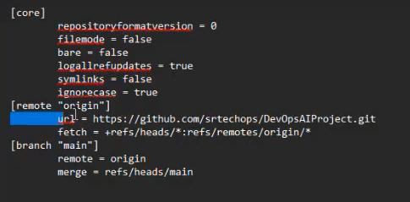
If you want to add/move multiple files to staging area:
Key Difference:
- git add . is limited to the current directory and below. It may miss deletions.
- git add -A OR git add --a stages everything, including deletions, from the root of the repo, no matter where you are.

Quick Example:
Let’s say your repo structure is:
project/
├── file1.txt
└── subdir/
└── file2.txt
- If you're in subdir/ and run git add ., it will stage changes in subdir/ only.
- If you run git add -A, it will stage all changes in the whole project/, including deletions.

Recommendation:
- Use git add -A OR git add --a if you want to be 100% sure all changes, additions, and deletions are staged.

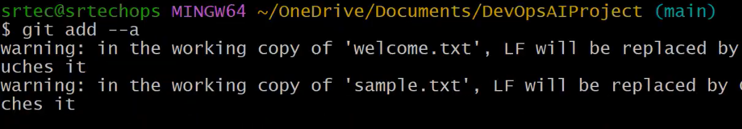
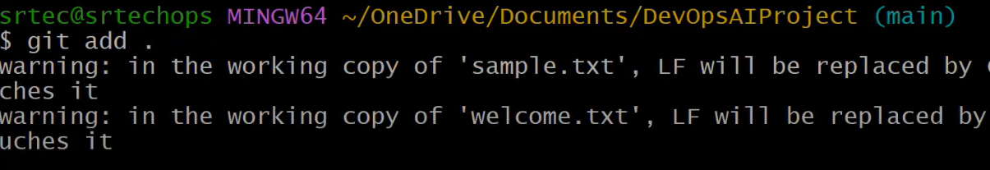

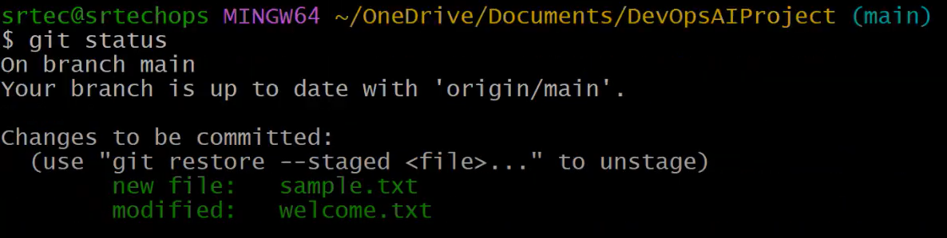
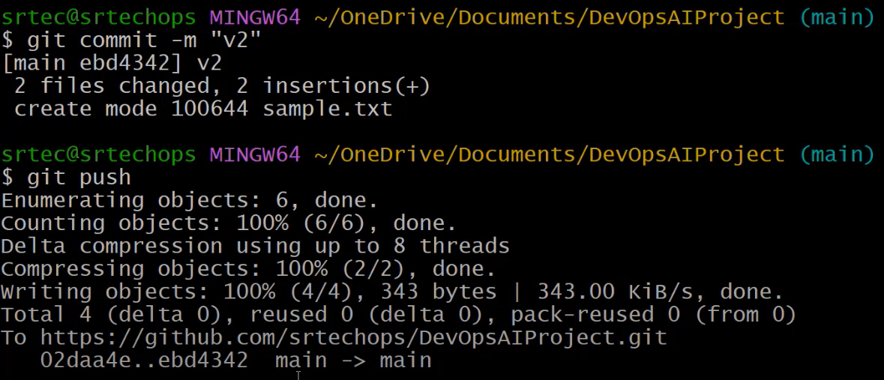
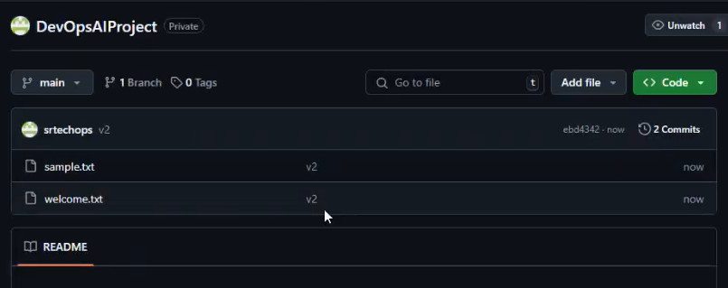
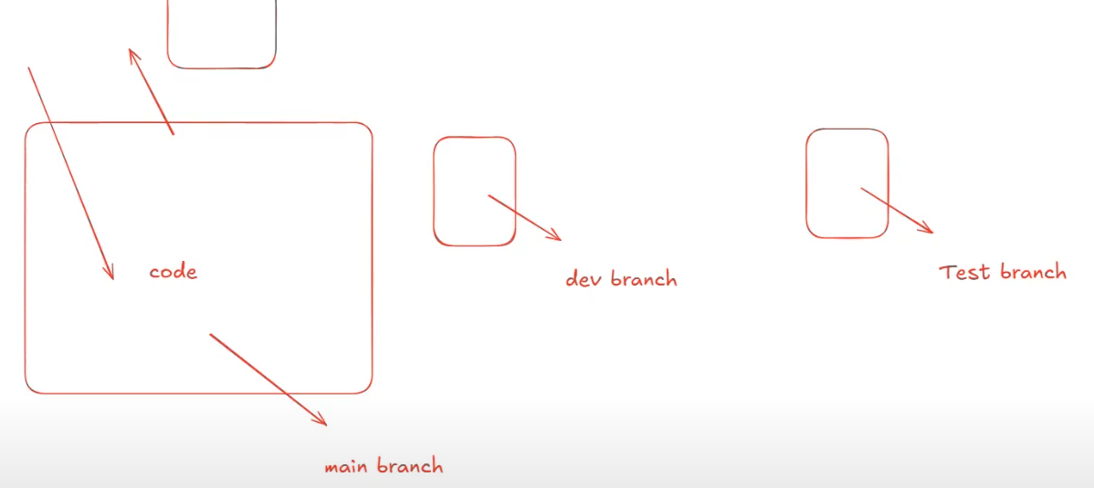

Day 4: Github Repository | -16th Apr 2025

Add a README
Help people interested in this repository understand your project by adding a README.
README file in GitHub is like the welcome mat of your project. It explains what the project is about, how to use it, and how others can contribute. It’s usually written in Markdown (.md) format and is named README.md.
https://www.markdownguide.org/getting-started/
What is Markdown?
Markdown is a lightweight markup language that you can use to add formatting elements to plaintext text documents. Created by John Gruber in 2004, Markdown is now one of the world’s most popular markup languages.
Using Markdown is different than using a WYSIWYG editor. In an application like Microsoft Word, you click buttons to format words and phrases, and the changes are visible immediately. Markdown isn’t like that. When you create a Markdown-formatted file, you add Markdown syntax to the text to indicate which words and phrases should look different.
For example, to denote a heading, you add a number sign before it (e.g., # Heading One). Or to make a phrase bold, you add two asterisks before and after it (e.g., **this text is bold**). It may take a while to get used to seeing Markdown syntax in your text, especially if you’re accustomed to WYSIWYG applications. The screenshot below shows a Markdown file displayed in the Visual Studio Code text editor.
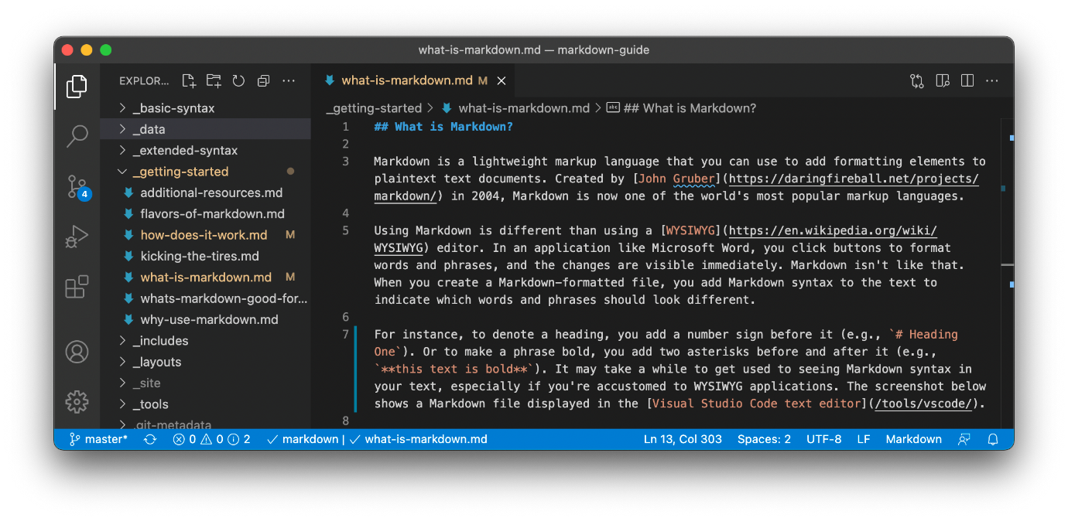
You can add Markdown formatting elements to a plaintext file using a text editor application. Or you can use one of the many Markdown applications for macOS, Windows, Linux, iOS, and Android operating systems. There are also several web-based applications specifically designed for writing in Markdown.

Here’s a simple breakdown:

📝 What is a README?
- A README is the first file people see when they visit your repository.
- It explains the purpose, setup, usage, and contribution guidelines of the project.

📂 Where is it found?
- It's typically placed in the root directory of a GitHub repo.
- GitHub automatically displays the README content at the bottom of the main page of the repo.

📃 What does it contain?
A good README.md usually has:
- Project Title
- Description – What the project does and why it exists.
- Installation Instructions – How to install and run the project.
- Usage – Examples or screenshots of how it works.
- Contributing Guidelines – How others can help improve the project.
- License – Info on how the code can be used.
- Credits – Anyone who helped or third-party tools/libraries used.

🔍 Example:
# Weather App
A simple app that shows the current weather for your location.

## Features
- Current temperature
- 5-day forecast
- Location search

## Installation
1. Clone the repo
2. Run `npm install`
3. Run `npm start`

## Contributing
Pull requests are welcome. For major changes, open an issue first.
Add a .gitignore
What is .gitignore?
- .gitignore is a special file used in Git/GitHub to tell Git which files or folders to ignore — meaning they won’t be tracked or uploaded to your GitHub repository.
- This helps keep your repo clean and avoids uploading sensitive or unnecessary files.

📂 Where is .gitignore used?
- It’s placed in the root directory of your project.
- You can also have .gitignore files in subdirectories for more fine-grained control.

❓Why use .gitignore?
Some files shouldn't be committed to GitHub, such as:
- Temporary files (*.log, *.tmp)
- Build or compiled files (*.class, *.exe)
- OS or editor files (.DS_Store, Thumbs.db, .vscode/)
- Secrets or environment files (.env, config.json)
- Dependencies (node_modules/, vendor/)

🔍 Example .gitignore file:
# Node.js
node_modules/
.env
npm-debug.log

# macOS
.DS_Store

# VSCode
.vscode/

# Python
__pycache__/
*.pyc

📌 How it works:
- When you add a file pattern in .gitignore, Git will stop tracking those files.
- If you already committed a file before adding it to .gitignore, Git will still track it unless you remove it from the repo manually using:
git rm --cached filename

🧠 Pro Tip:
When you create a new GitHub repo, GitHub lets you choose a .gitignore template based on your language (e.g., Python, Node.js, Java). It saves time!

Add a License

📄 What is a License in GitHub?
- A license in a GitHub repository tells others what they can and cannot do with your code.
- It’s a legal document that protects both the creator (you) and the users of your code.

❓ Why is a License important?
Without a license, by default:
- Others can see your code, but they can’t legally use, copy, distribute, or modify it.
- This can limit collaboration and usage.
So if you're okay with others using your code, you should add a license.

🔓 Common Open Source Licenses:
Here are a few popular ones you might see on GitHub:
License | Can Use | Can Modify | Must Credit You | Can Sell | Must Open Source Their Changes
MIT | ✅ | ✅ | ✅ | ✅ | ❌
Apache 2.0 | ✅ | ✅ | ✅ | ✅ | ❌
GPLv3 | ✅ | ✅ | ✅ | ✅ | ✅ (must also be open source)
BSD | ✅ | ✅ | ✅ | ✅ | ❌

📌 Where to add it?
- Create a file named LICENSE in the root of your repo.
- GitHub can automatically help you choose a license when creating the repository.

🧠 Example (MIT License snippet):
MIT License
Copyright (c) 2025 YourName
Permission is hereby granted, free of charge, to any person obtaining a copy
of this software and associated documentation files...

💡 Tip:
When starting a new repo on GitHub:
- Click “Add a license” → Choose one that fits your goals.
- If you're unsure, MIT License is a safe and very permissive choice.

>git restore app.txt // restore the latest changes in the working tree file
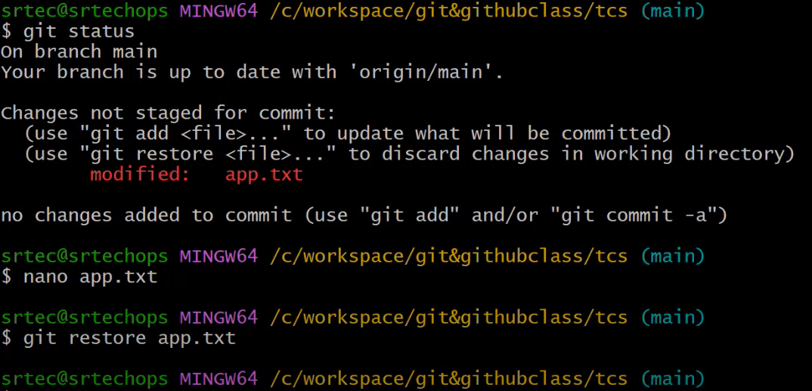
>git restore app.txt // restore the latest changes in the working tree file OR Discard changes in working directory
>git restore --staged <fileName> // restore it from the staging area OR Unstage

>git reset HEAD~1 // Uncommit and Unstage
OR
>git reset 9cb76d2
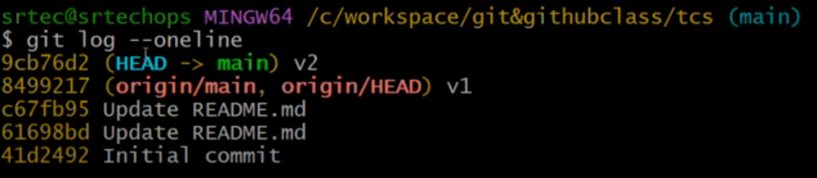
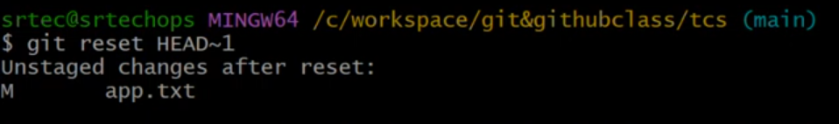
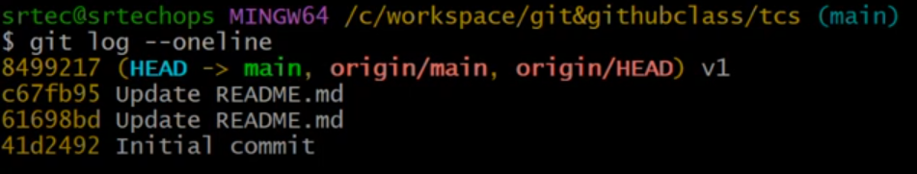
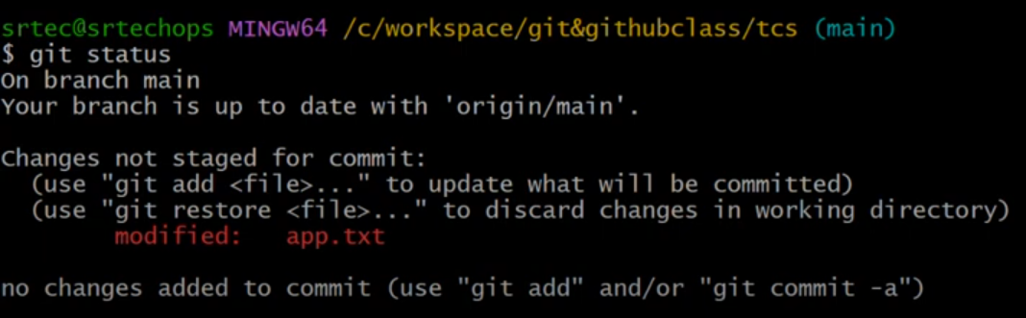

Day 5: Git push, git pull & git conflict | - 17th Apr 2025
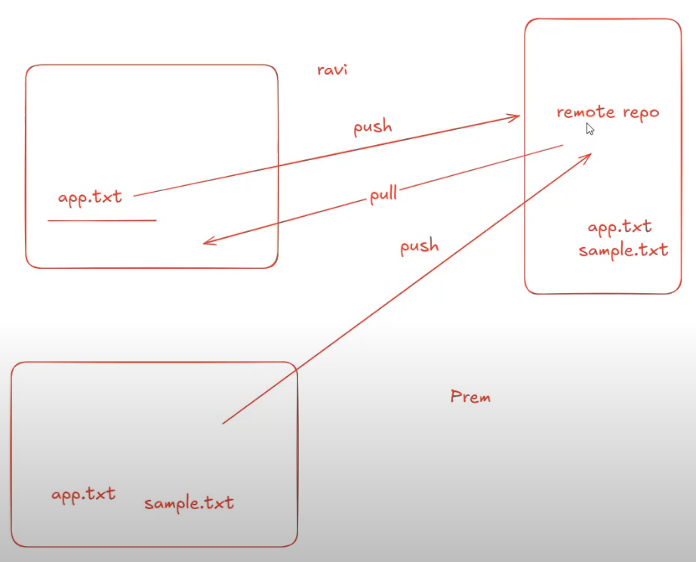
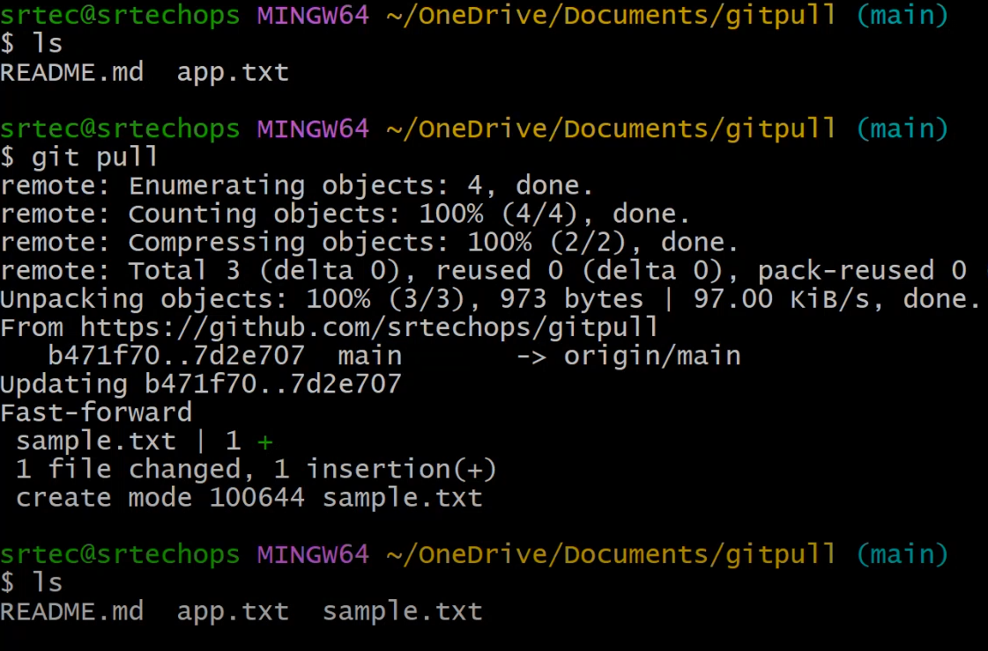
On everyday, before starting working on the project, first we need to pull latest changes/updates from remote repo to local repo using “git pull” command.
In case, If we not pull latest code or changes from remote to local repo and trying to push code from local repo to remote repo, It will throw REJECTION. Because of conflict between local repo to remote repo. So, Local and Remote Repo should be same.
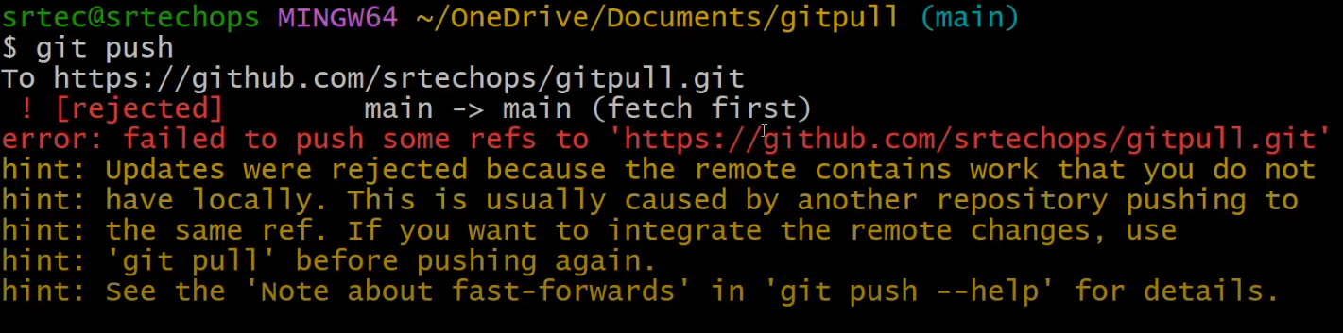
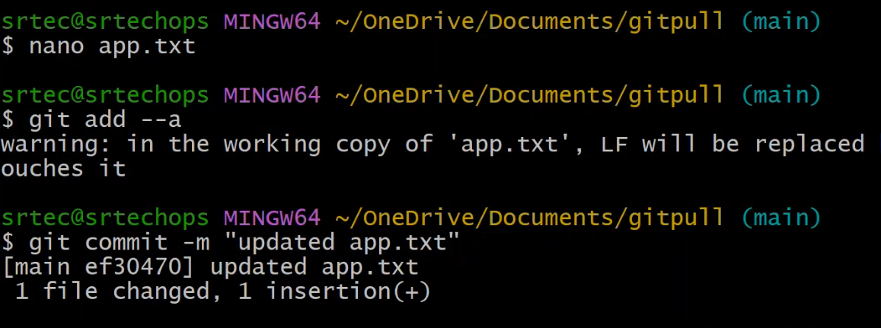
CONFLICT:
Anbu is adding new content on the app.txt in line 3:
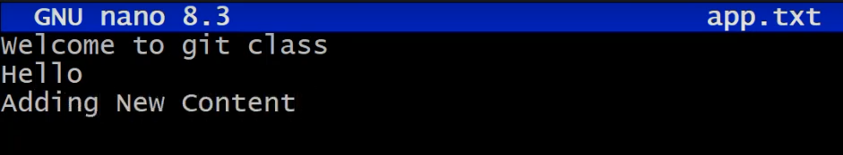
Prem is adding new content on the app.txt in line 3 and commited and available on remote repo.
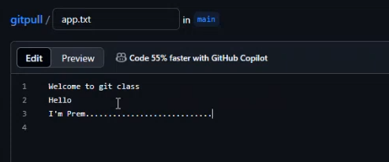
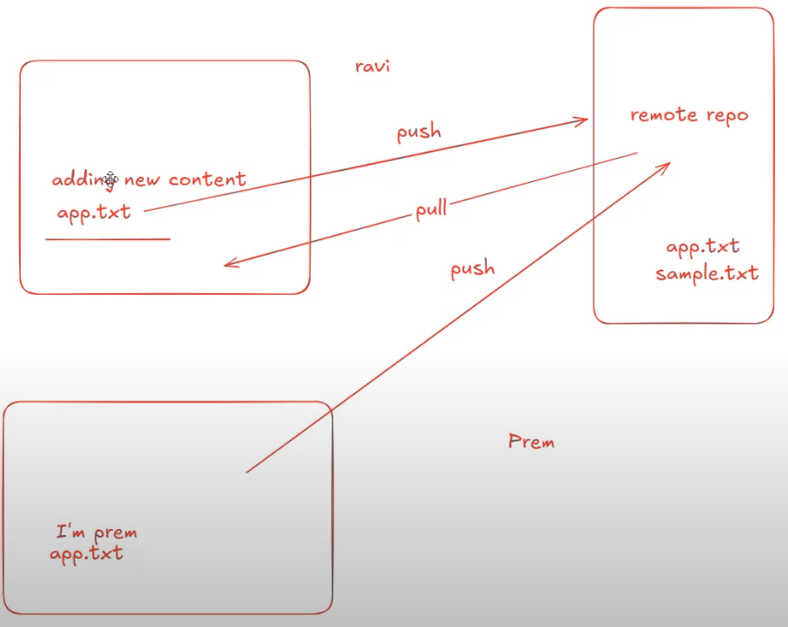
When Anbu trying to push his code to remote repo, conflict will occur:
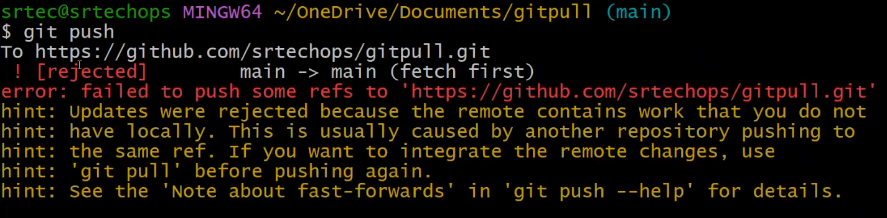

So, Anbu is pulling the code from remote repo:
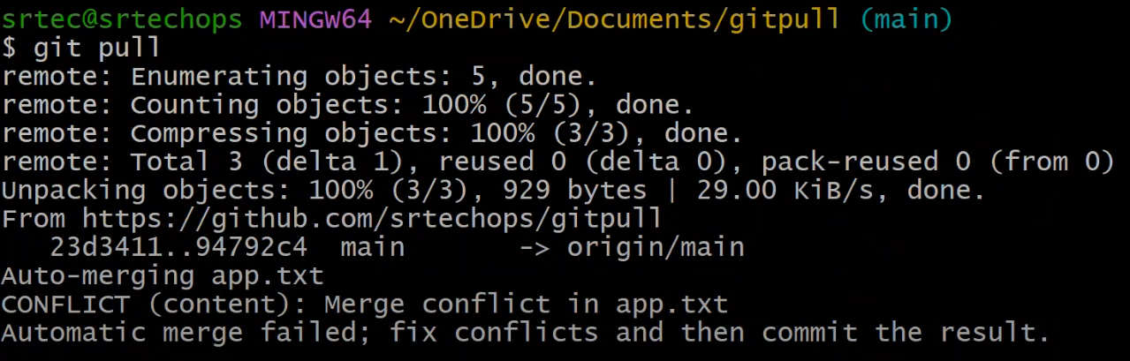
When you open the app.txt file,
Anbu’s and Prem’s changes are available on the app.txt file. Git will not decide will not decide, which one is RIGHT.
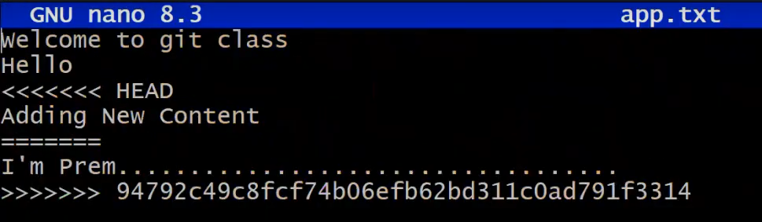
So, we need to discuss internally, keep the right one and remove the unwanted one.
