KIRO Specification – Automate MISRA Web Application Testing Using AI

Product Overview
AI SaaS platform automating MISRA compliance analysis and UI regression testing to ensure faster releases and higher quality.

Core Objectives
Automate MISRA processing, secure authentication, AI insights, regression safety, and serverless scalability.

System Actors
End User, CI/CD Pipeline, AI Engine, Cloud Backend.

Authentication Flow
User login → n8n validation → JWT token → API Gateway validation.

Business Processing Flow
File upload → S3 storage → Lambda processing → AI analysis → Dashboard display.

Regression Automation Flow
Code change → CI pipeline → Playwright tests → PASS deploy / FAIL block.

Architecture Components
Frontend (React + S3), Auth (n8n), API Gateway, Lambda services, S3, DynamoDB, AI Layer, Playwright testing.
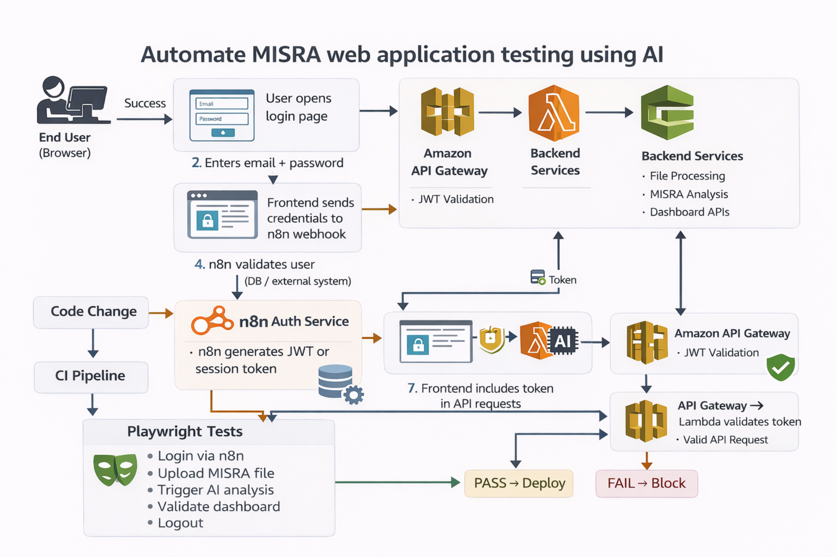

Non-Functional Requirements
Security, scalability, availability, low cost, performance, compliance.

Business Benefits
Reduced QA cost, faster releases, higher reliability, enterprise readiness.

Success Metrics
Reduced testing time, zero regressions, faster deployments.

Roadmap
Phase 1 automation, Phase 2 AI optimization, Phase 3 SaaS expansion.

Value Statement
AI-powered SaaS platform automating MISRA compliance and continuous web quality validation.

