**Weekly-test**

**Task: Setting up Jenkins for Continuous Integration/Continuous Deployment (CI/CD)**

**Description:**

**Configure Jenkins to automate the build, test, and deployment processes for your**

**application.**

**Test Case 1:** Make a commit to the version control system and verify that Jenkins automatically

triggers a build.

Expected Outcome: Jenkins should detect the new commit and start the CI pipeline

automatically, fetching the latest code changes.

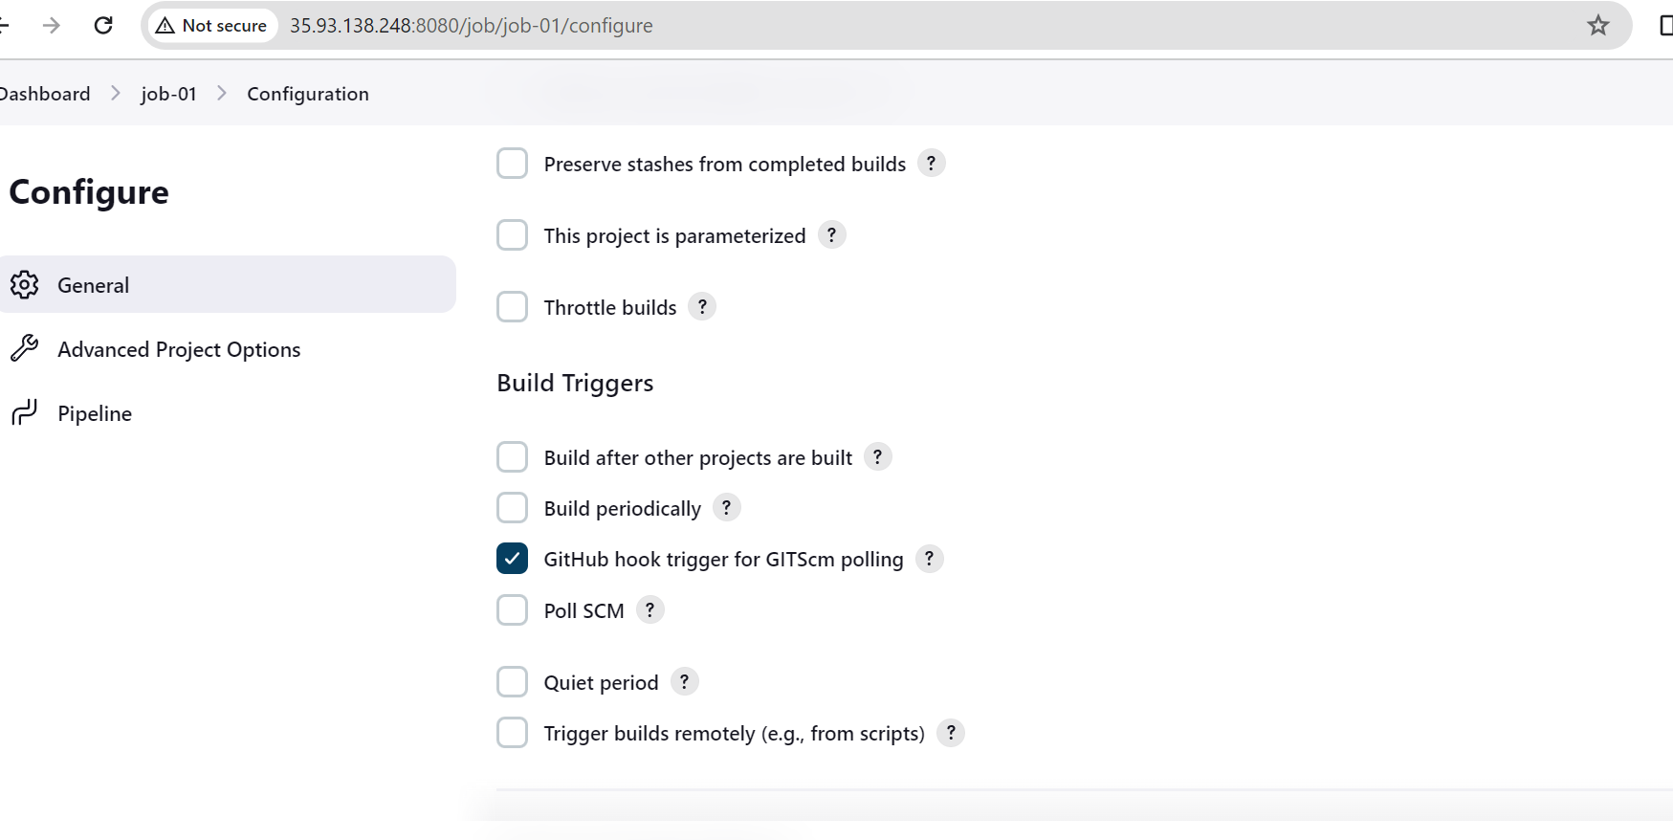

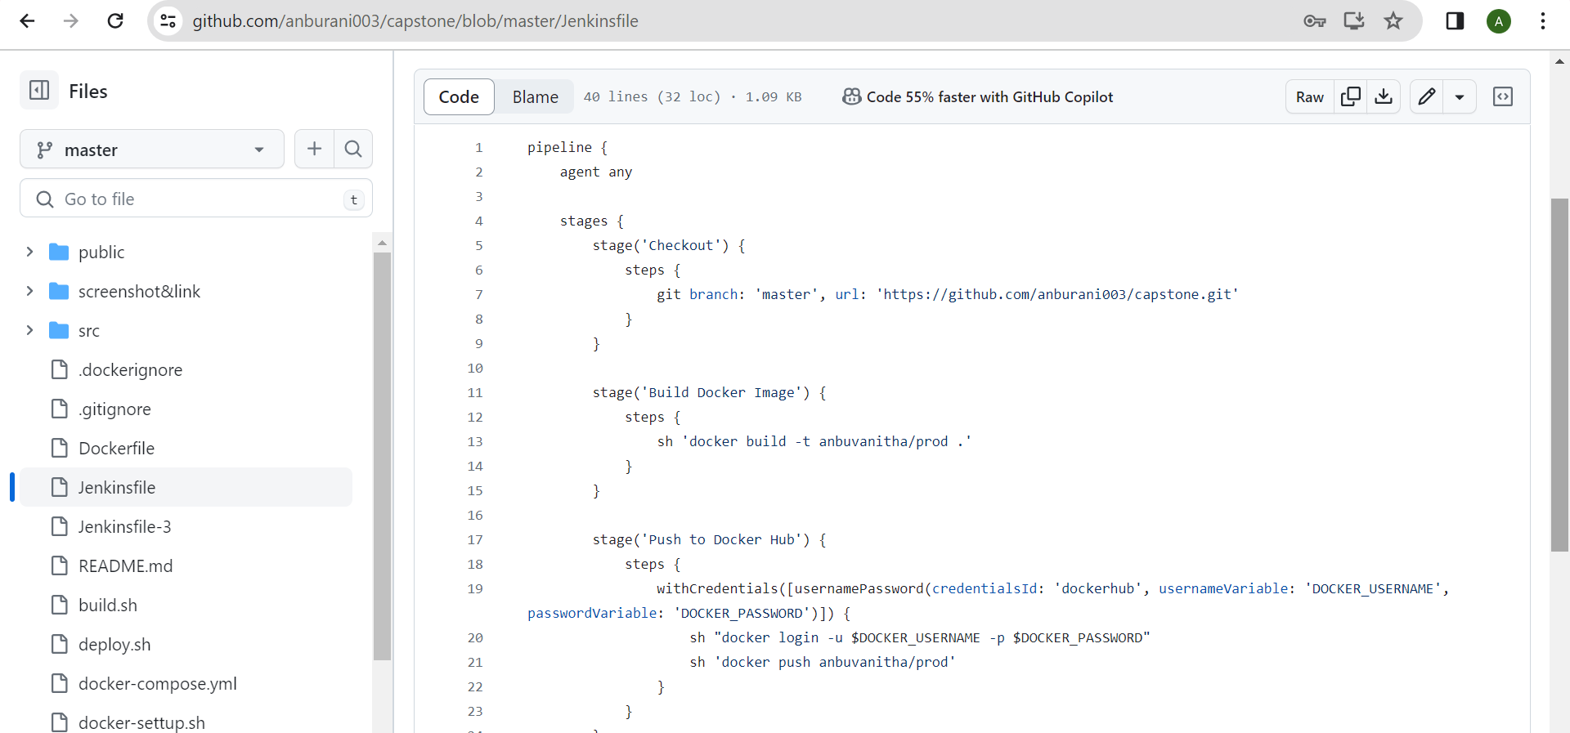

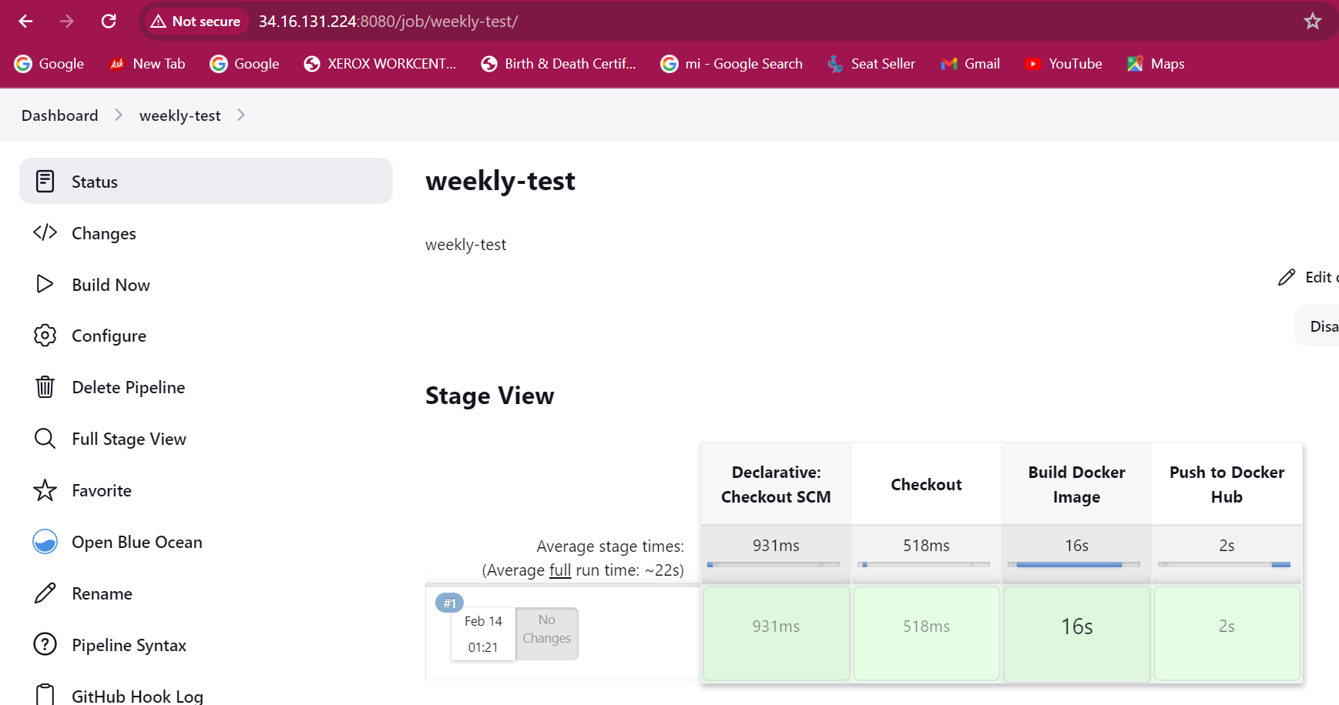

**Test Case 2:** Restrict access to certain Jenkins jobs or features based on user roles.

Expected Outcome: Users without appropriate permissions should be unable to trigger or

modify Jenkins jobs beyond their assigned privileges.

I have created a Jenkins user with the username "user-1." I have assigned the user-1 permission to read, build, and view jobs. However, I have restricted user-1 from configuring the jobs.

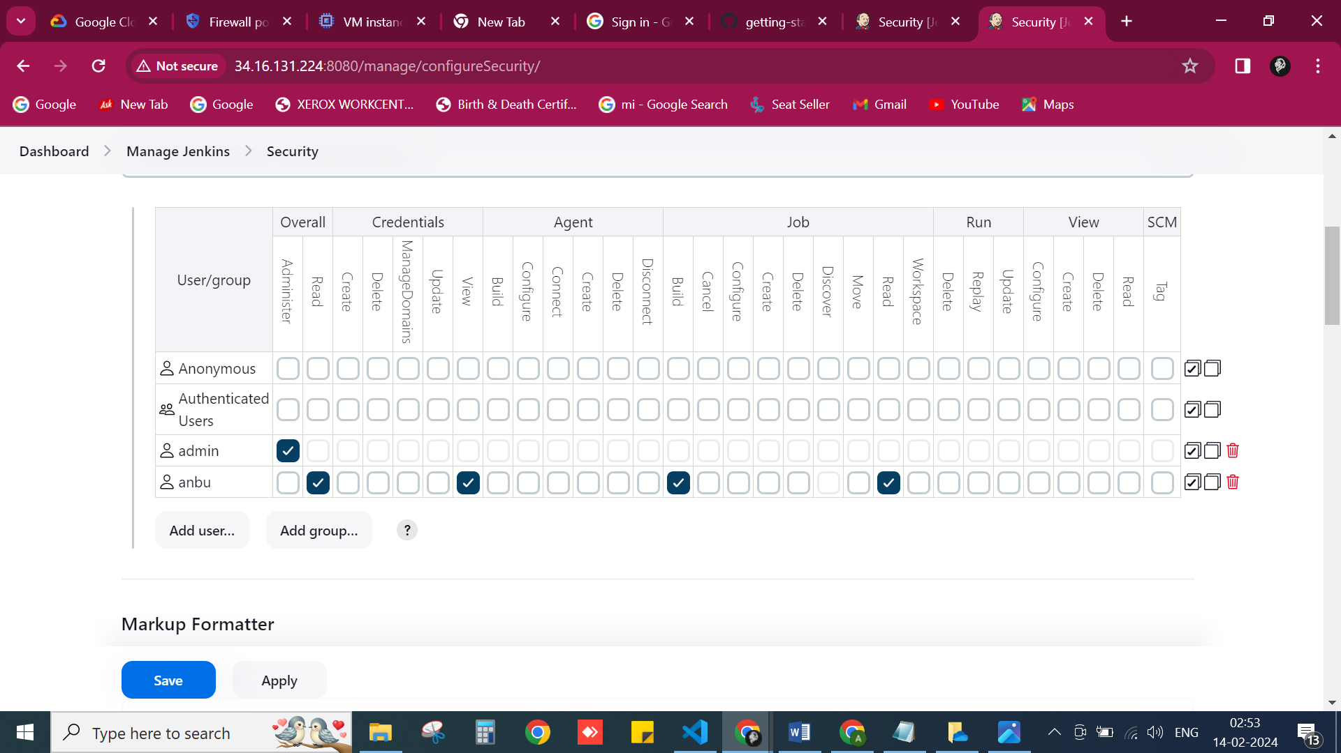

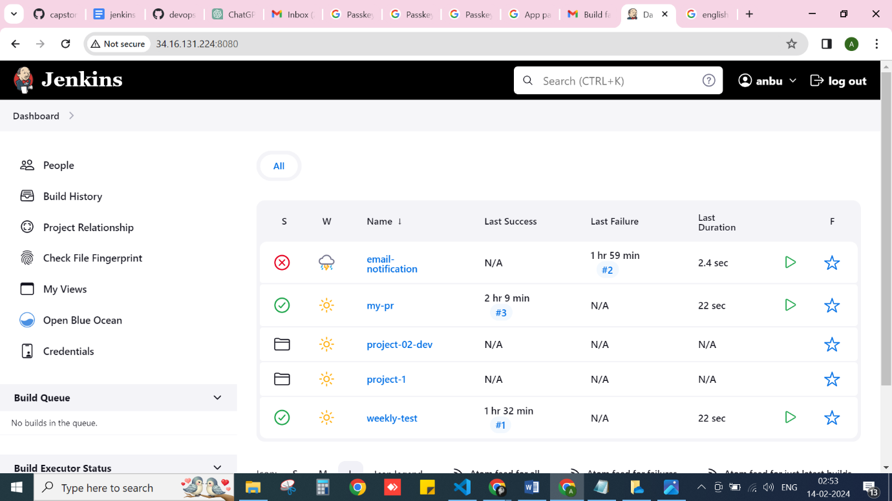

**Test Case 3:** Configure email notifications for build status changes (e.g., success, failure,

unstable).

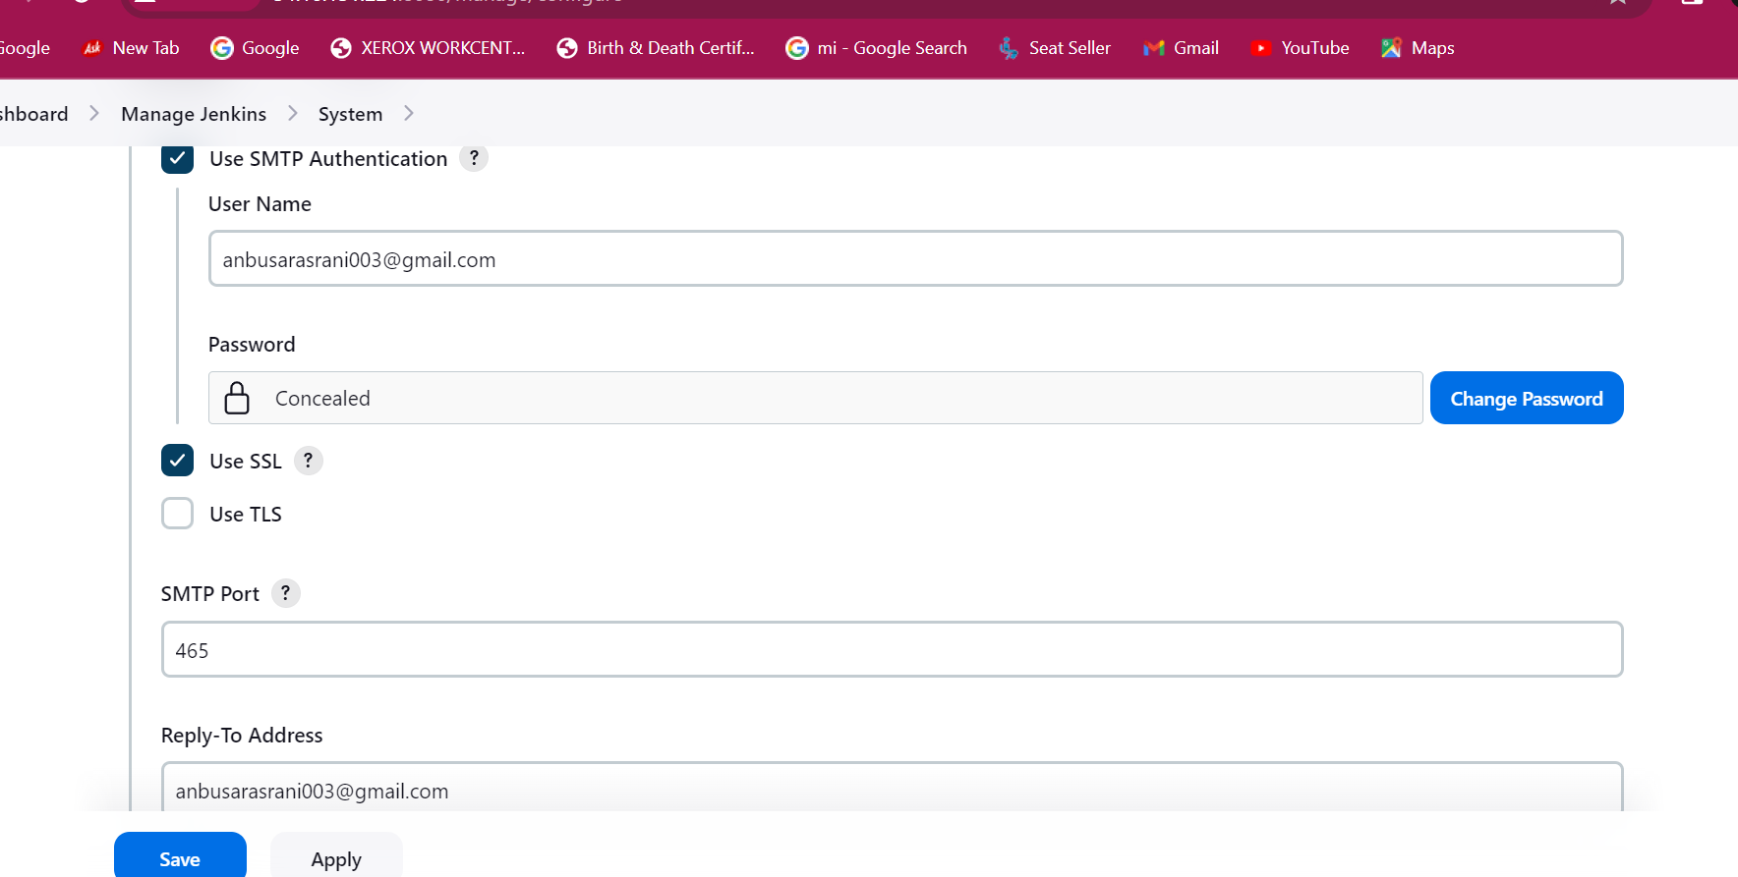

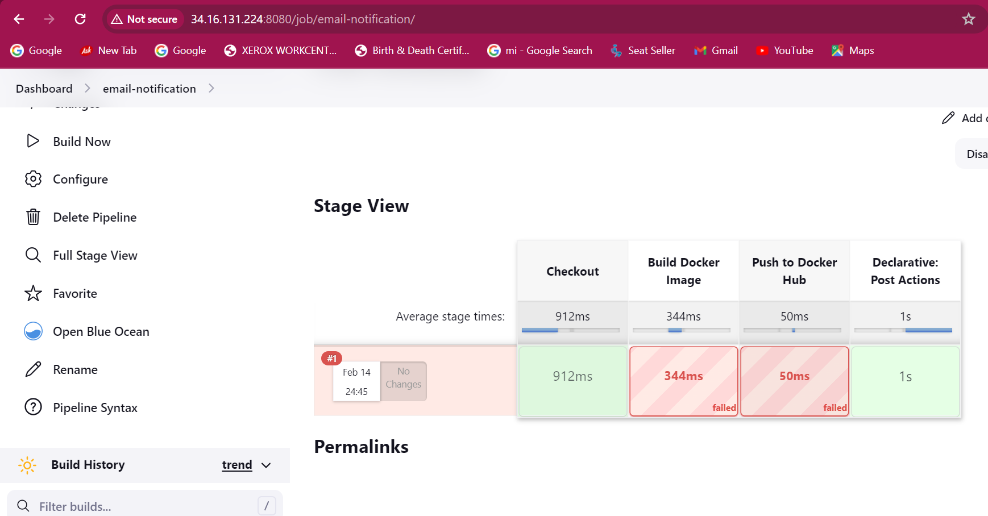

Received the notification Jenkins job build fail.

