**Web Application for "Hello GUVI GEEK" - DevOps Task**

**Introduction**

This repository contains the source code and configuration files for a small web application that displays the message "Hello GUVI GEEK". The application is designed to be built and deployed using Jenkins, Docker, and AWS EC2 instance (Ubuntu).

**Task Overview**

The task involves system provisioning, Jenkins pipeline creation, Docker image creation, and pushing the image to Docker Hub. Follow the steps below to accomplish the task.

**Tools Needed**

* GIT
* Jenkins
* Docker Hub
* AWS EC2 instance (Ubuntu)

**1. System Provisioning**

* Create a small web application displaying "Hello GUVI GEEK".
* Push the application code to a specific folder in this GitHub repository.

**2. Jenkins Pipeline**

* Create a Jenkins job to build the application.
* Utilize Jenkins Pipeline as Code for building the entire pipeline.
* On every commit, trigger the Jenkins pipeline to build the application.

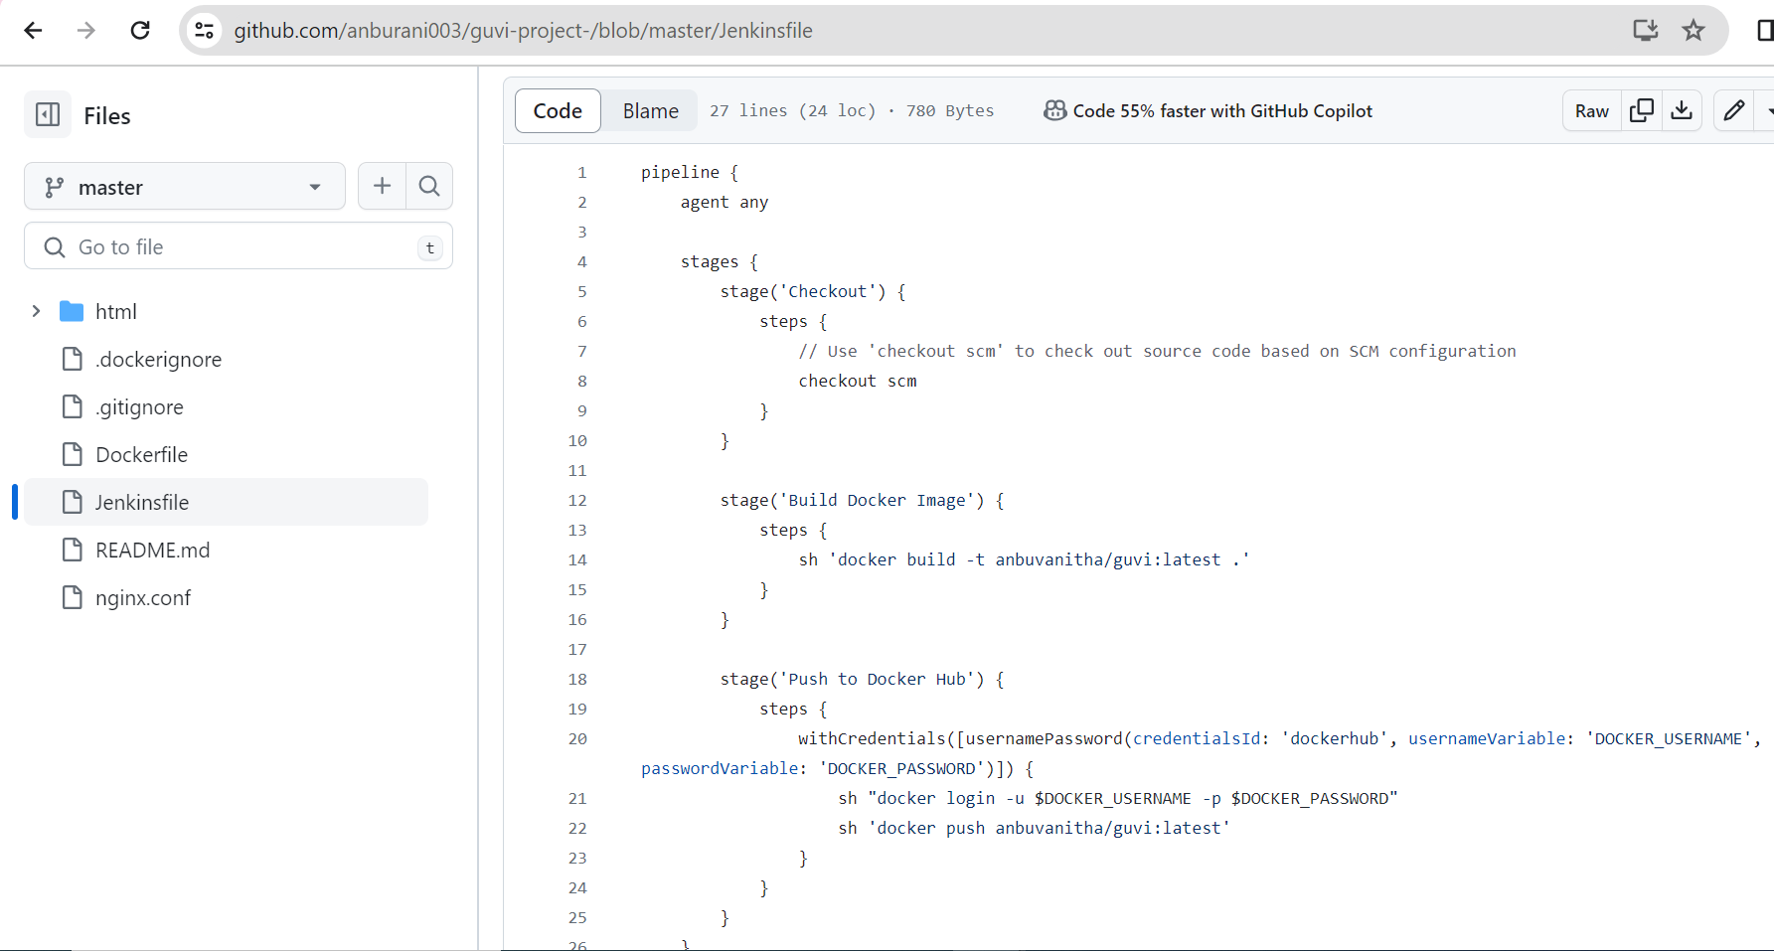

**3. Docker Image Creation & Push to Docker Hub**

* Use Jenkins and Docker Plugin to create an image of the web application.
* Push the created Docker image to Docker Hub.

(<https://hub.docker.com/repository/docker/anbuvanitha/guvi/tags?page=1&ordering=last_updated>)

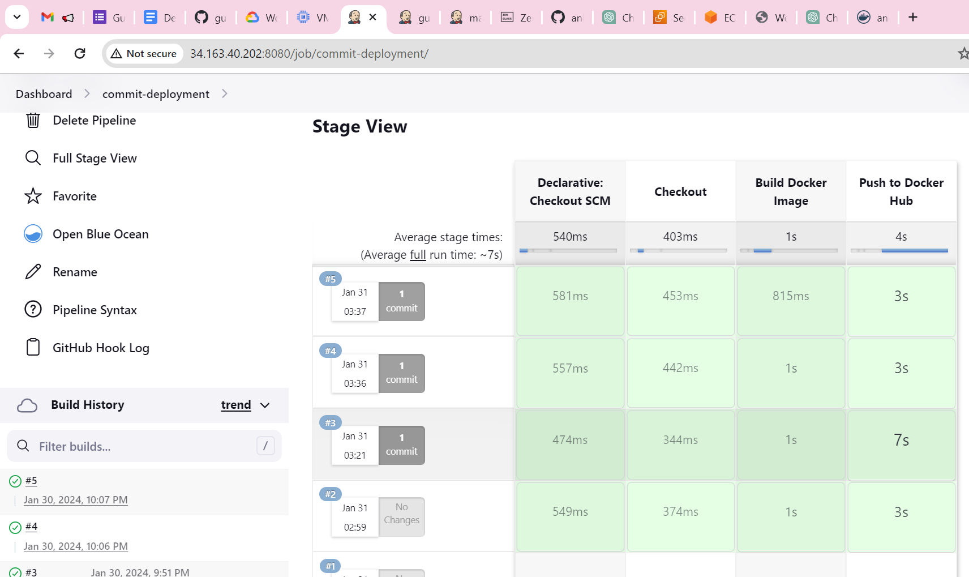

* Set the automatic tiger the Jenkins pipeline for when the commit happens in git repository.

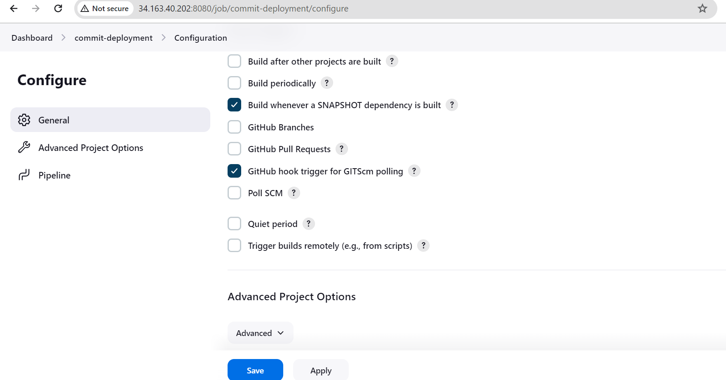

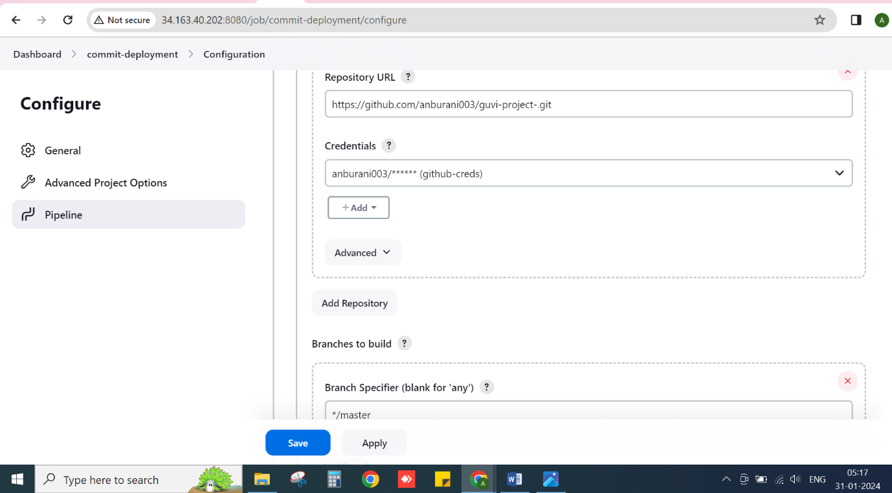

**5. AWS EC2 Instance**

* Deploy the web application on an AWS EC2 instance with Ubuntu.

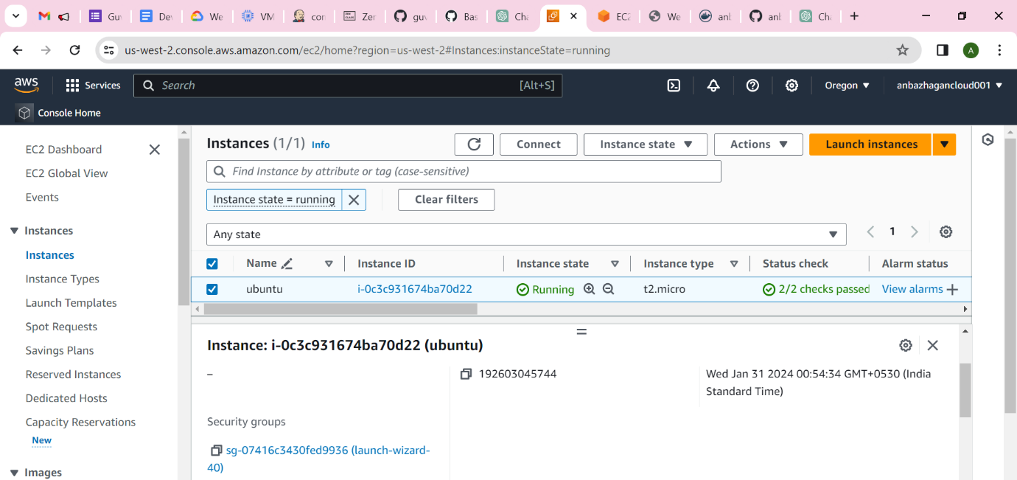

* Image pull from Docker Hub repository (build from Jenkins )

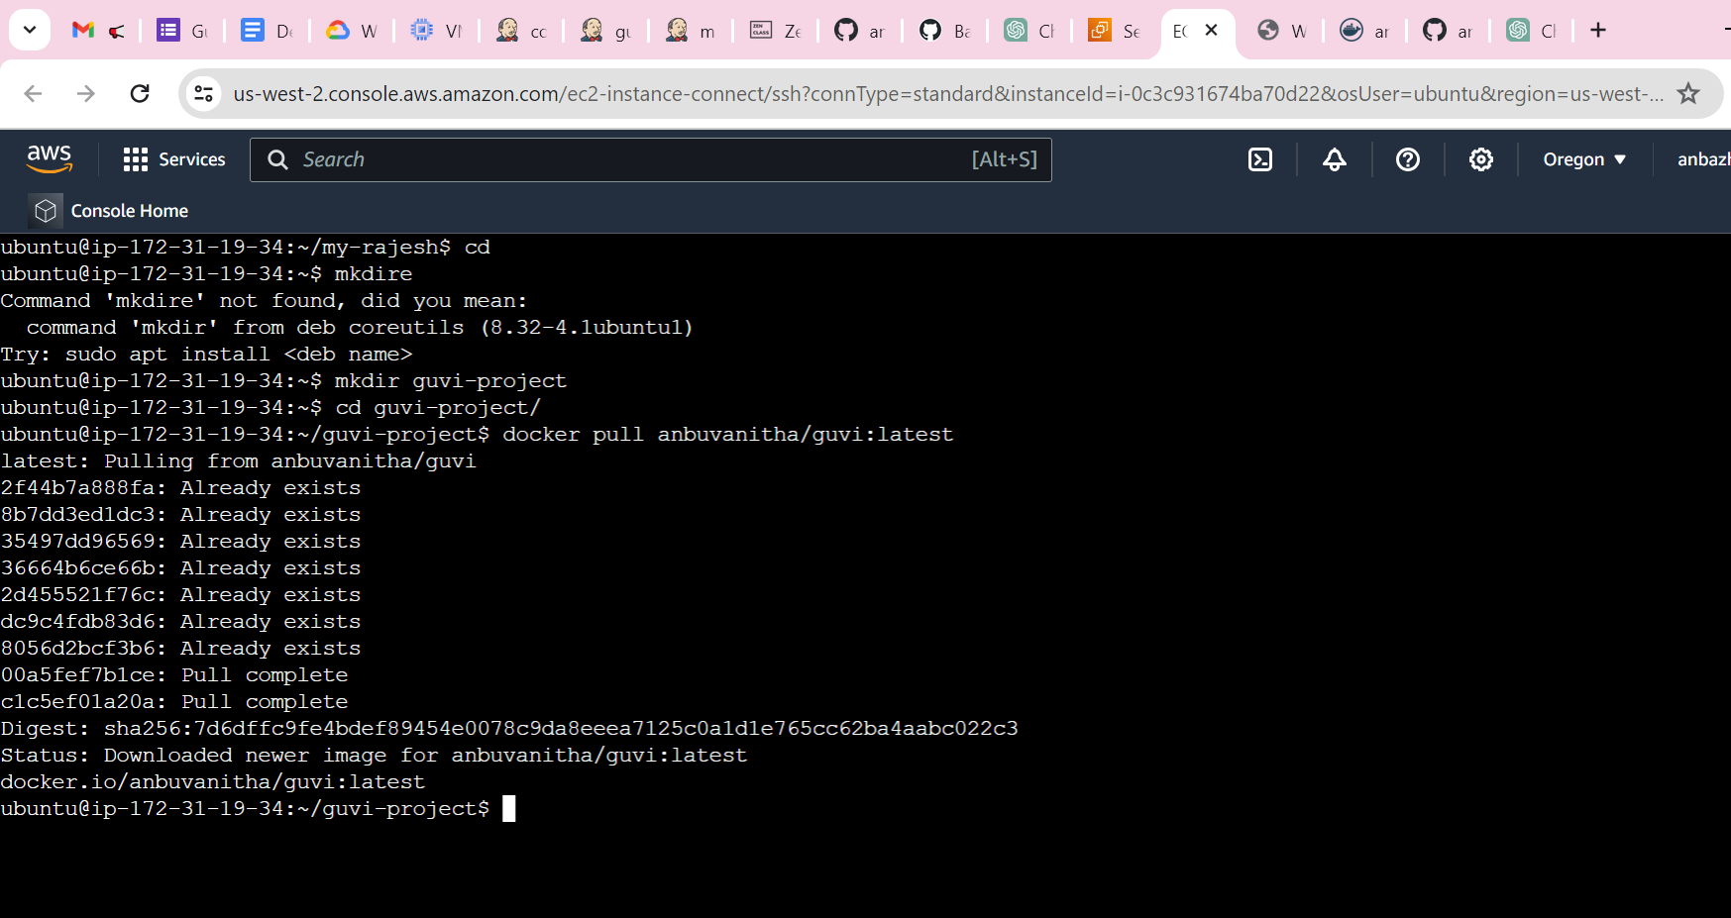

* Docker images

anbuvanitha/guvi latest d207e9c7abb8 3 hours ago 187MB

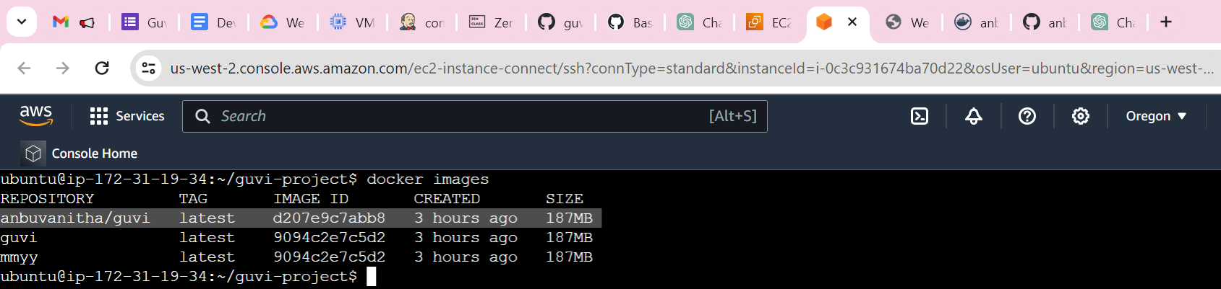

* Application deployment using Docker run command

CONTAINER ID IMAGE COMMAND CREATED STATUS PORTS NAMES

91f7934154d2 d207e9c7abb8 "/docker-entrypoint.…" 12 seconds ago Up 11 seconds 0.0.0.0:8085->80/tcp, :::8085->80/tcp guvi-project

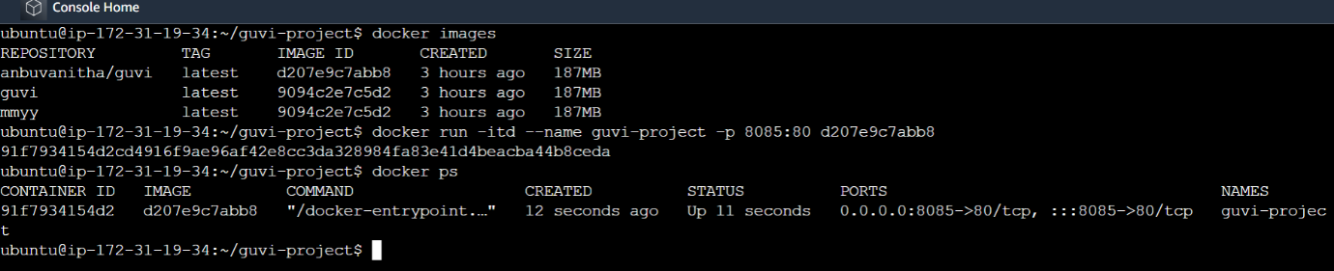

* Set the security group for deployed application access

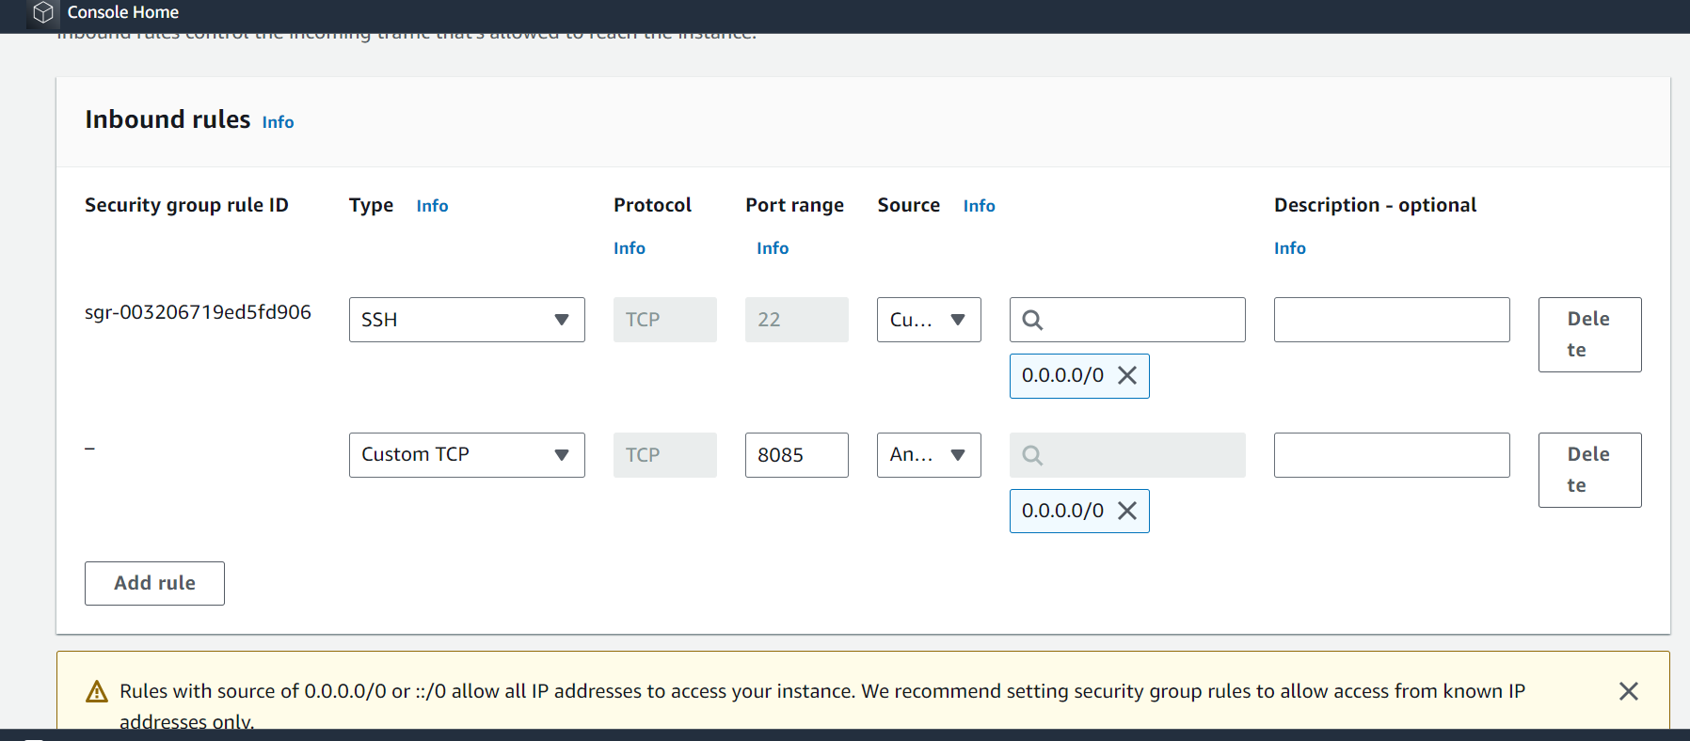

* Access with my public IP http://34.215.63.227:8085/

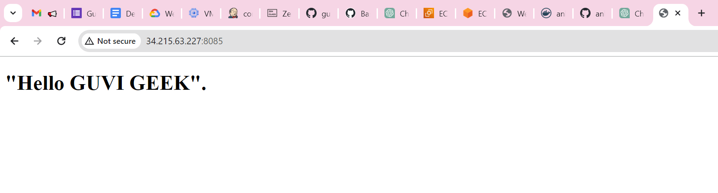

**Submission Instructions**

1. Added all work files to this GitHub repository: (<https://github.com/anburani003/guvi-project-/tree/master>)
2. Added the Docker image link: (<https://hub.docker.com/repository/docker/anbuvanitha/guvi/tags?page=1&ordering=last_updated>)