**Infrastructure Orchestration with AWS CloudFormation and Ansible**

**Infrastructure Definition (CloudFormation):**

Write CloudFormation templates to define the AWS resources EC2 (instances) needed for the application.

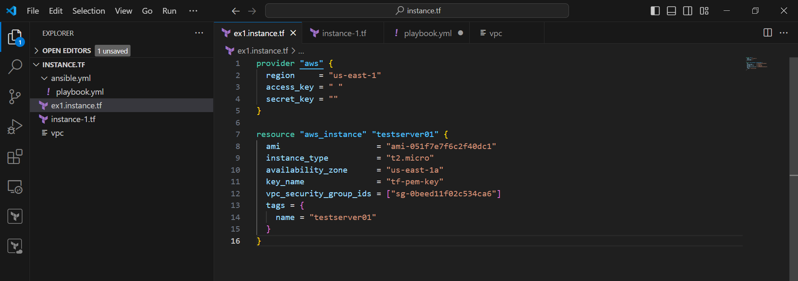

**Infrastructure Provisioning (CloudFormation):**

Use AWS CLI or AWS Management Console to deploy the CloudFormation stack, which

provisions the defined infrastructure.

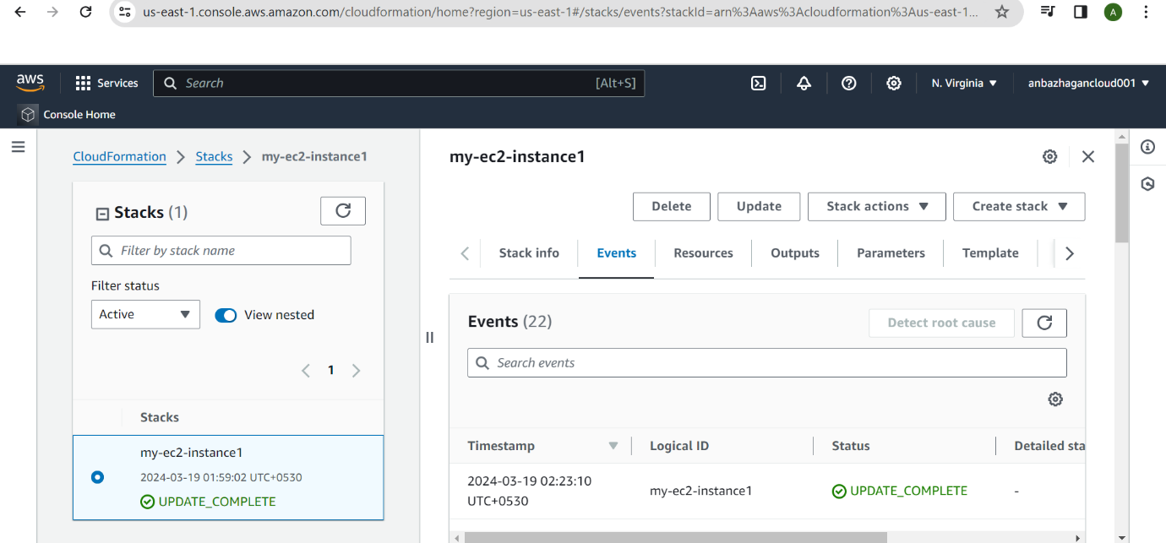

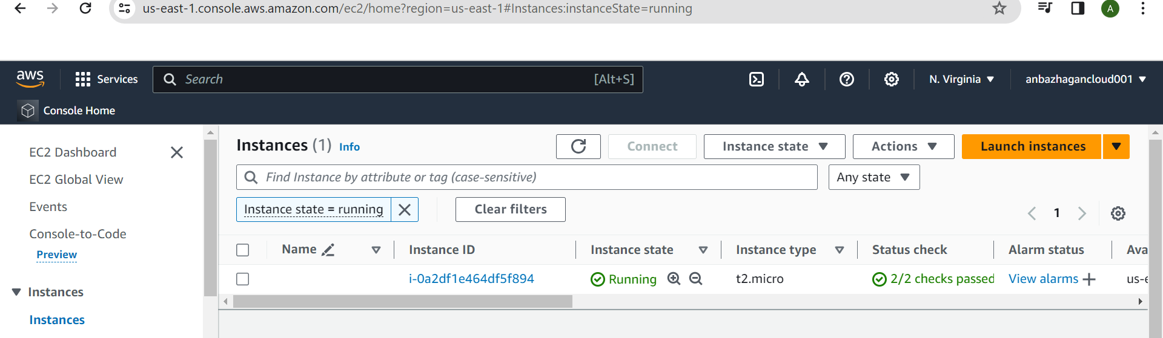

**Server Configuration (Ansible):**

Write Ansible playbooks to configure the provisioned AWS resources with **httpd server** nand

settings.

Created the 3 instance for 1-ansible master and 2 ansible slave

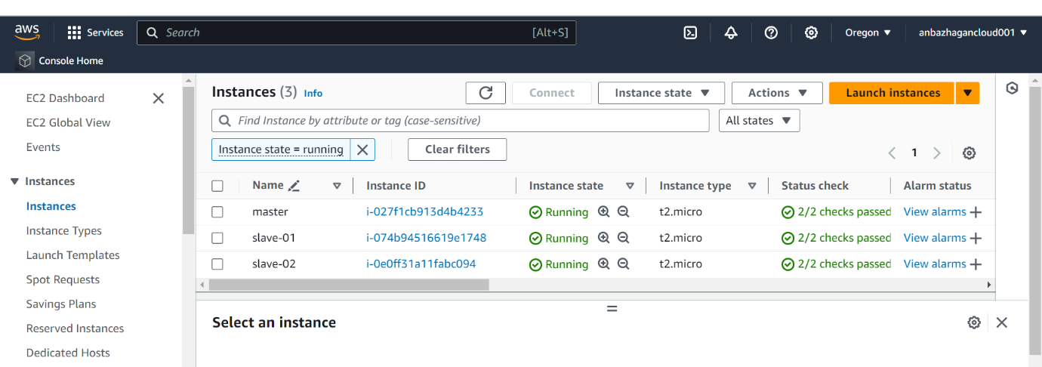

Created ansible-playbook

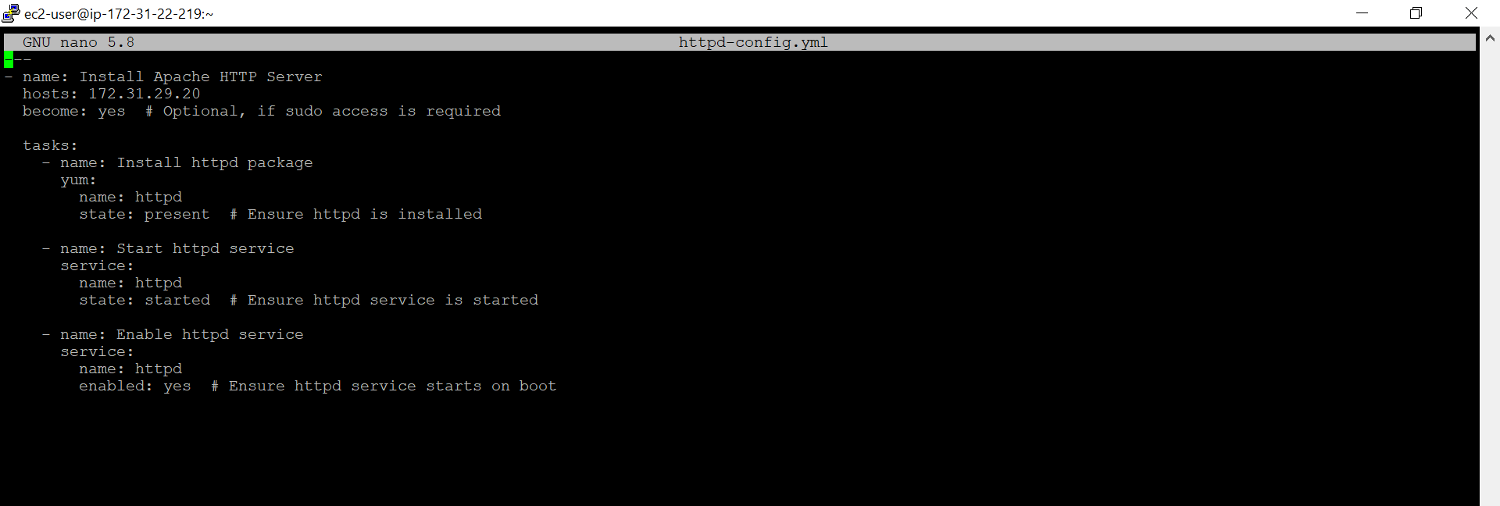

Execute the ansible-playbook using the command like

**Ansible-playbook httpd-config.yml**

**Httpd-config – this the my configuration file name**

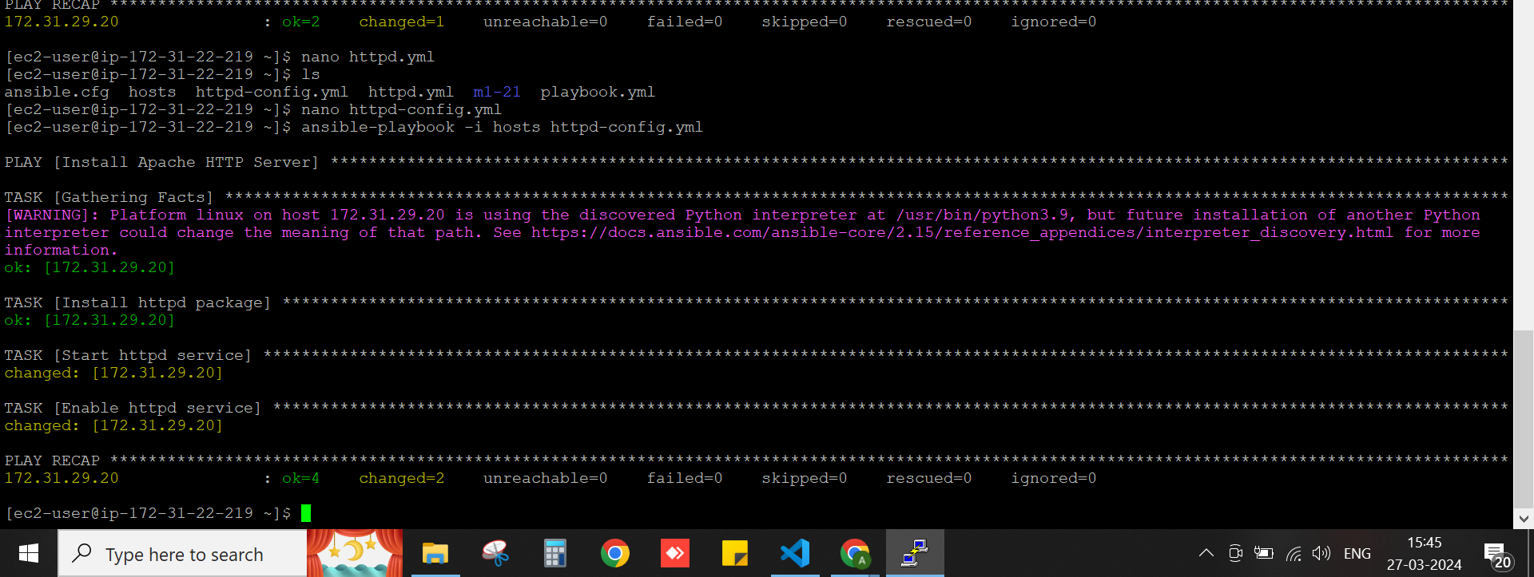

**After execute the ansible playbook httpd configuration file access with web browser using the slave public IP address .**

