**1. Router Configuration:**

**Test Case 1: Configure routing protocols (e.g., OSPF, BGP) on routers to enable dynamic**

**routing.**

**Expected Outcome: Routers should be able to exchange routing information and dynamically**

**update routing tables.**

**2. Firewall Rules Setup:**

**Test Case 2: Define and implement firewall rules to restrict incoming and outgoing traffic based**

**on security policies.**

**Expected Outcome: Traffic should be filtered according to the defined firewall rules, allowing**

**only authorized communication.**

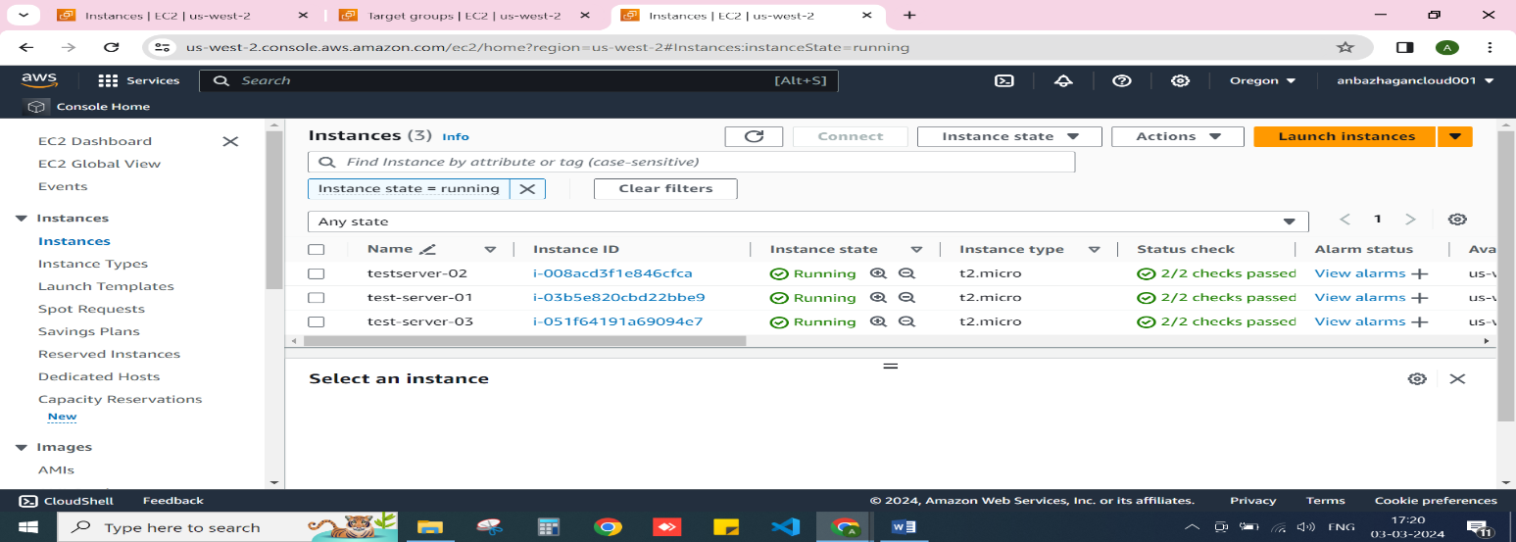

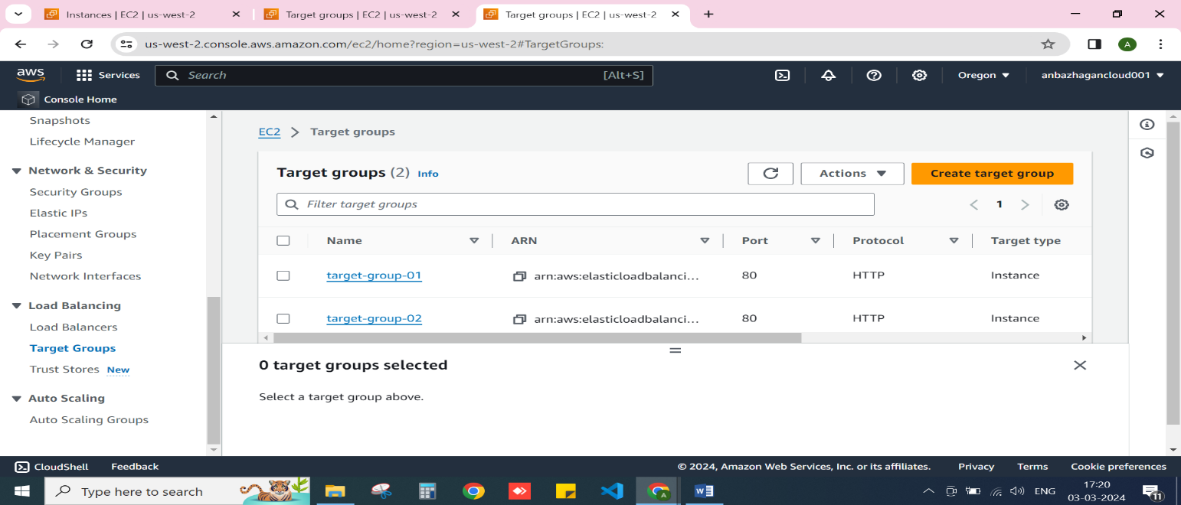

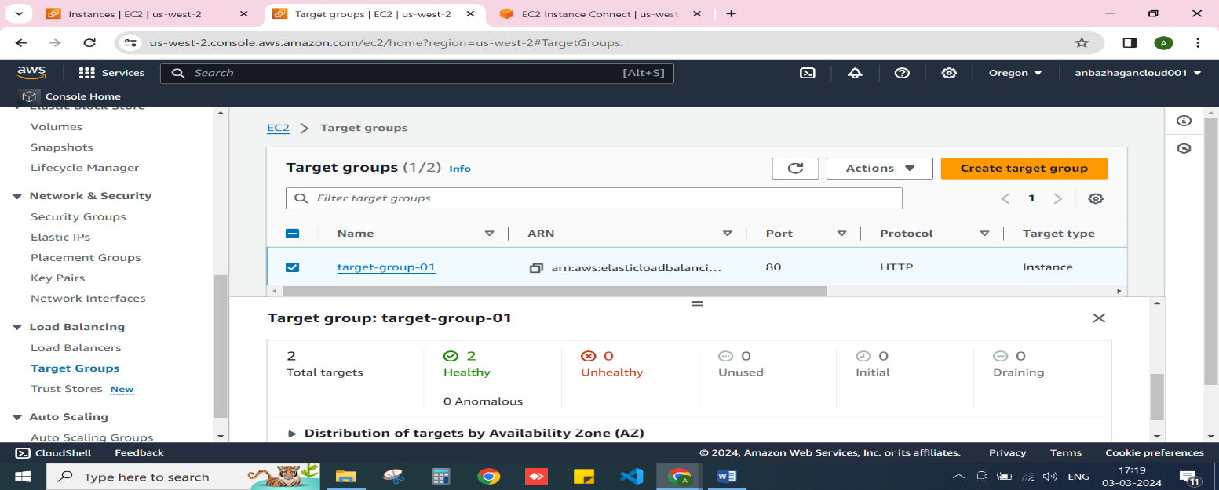

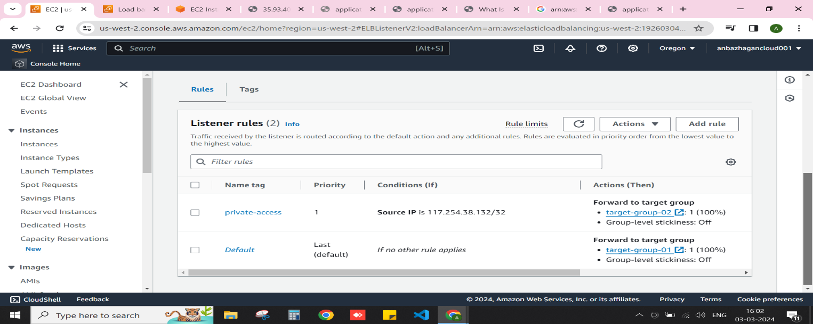

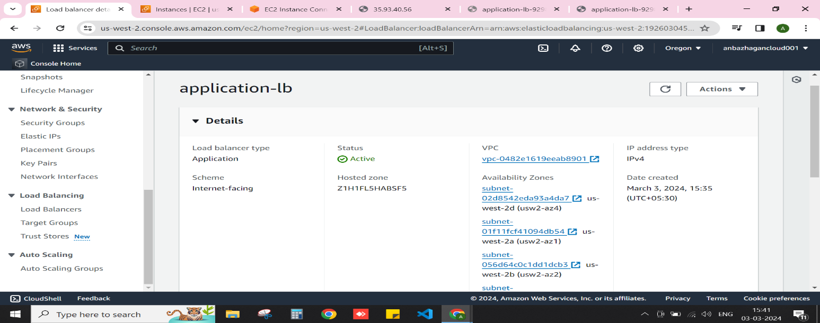

**3. Load Balancer Configuration:**

**Test Case 3: Configure a load balancer to distribute incoming traffic across multiple servers in a**

**backend pool.**

**Expected Outcome: The load balancer should evenly distribute traffic among the backend**

**servers, ensuring high availability and scalability.**

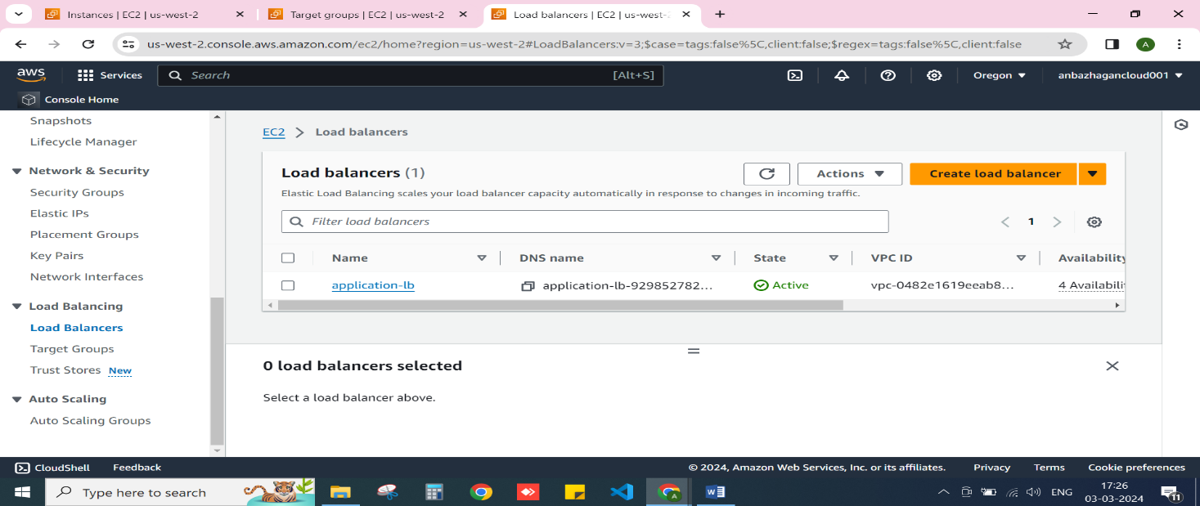

**Set the two rule for access for anyone and assigned source IP**

