**1. Automated Testing in CI:**

• Test Case 1: Integrate a sample application with automated unit tests into the CI

pipeline.

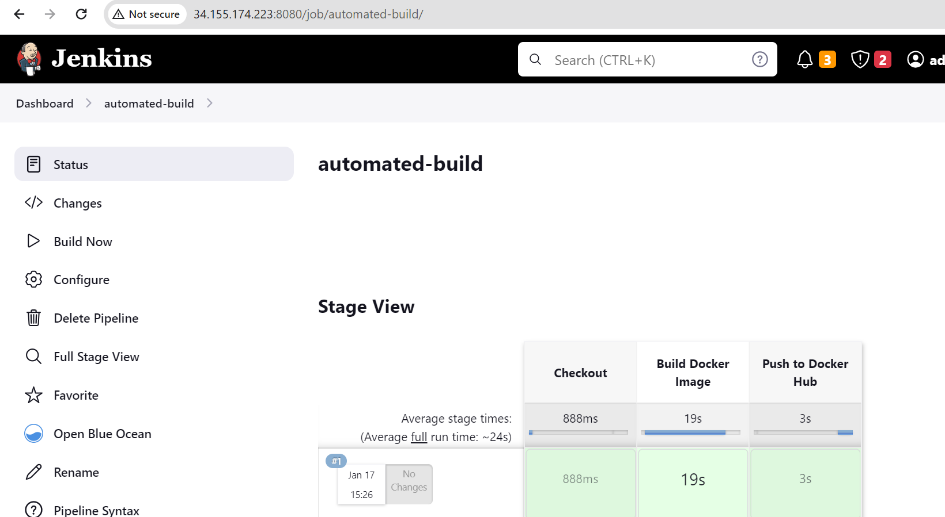

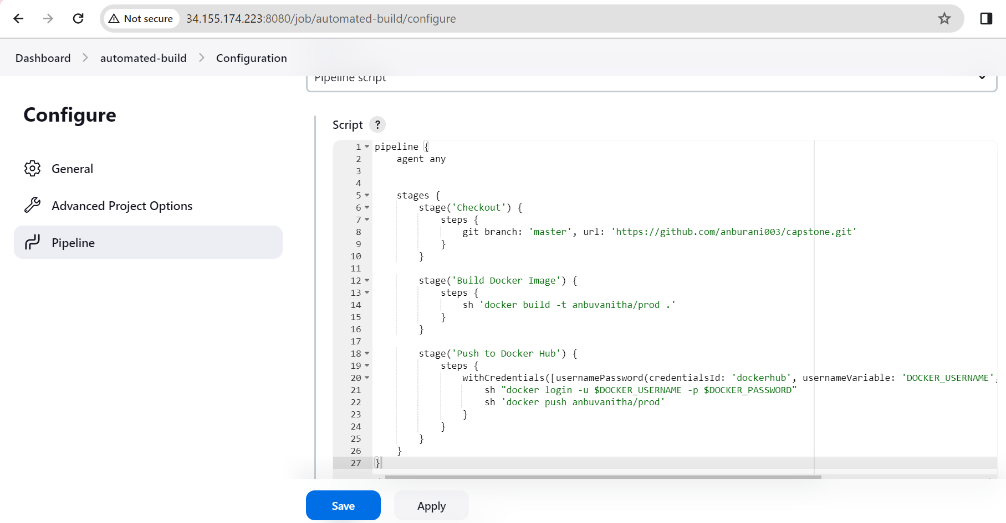

**2. Scheduled Builds:**

• Test Case 2: Schedule a periodic build (e.g., nightly build) and verify that the CI pipeline

is automatically triggered at the specified time.

