**Implement AWS Monitoring and Alerts**

**Sample Input:**

**You have multiple AWS resources, including EC2 instances, RDS databases, and Lambda**

**functions.**

**AWS CloudWatch for monitoring.**

**An email or Slack channel for receiving alerts.**

**Task:**

**Implement monitoring and set up alerts for key AWS resources to ensure proactive detection of**

**issues.**

Sample Output:

Sample Output 1: Configuration of AWS Cloud Watch alarms that monitor critical metrics (e.g.,

CPU utilization, memory usage) for each resource.

In the Cloud Watch dashboard, click on "Alarms" in the left navigation pane.

Click the "Create Alarm" button.

Choose the appropriate metric source. For example, if you want to monitor an Amazon EC2 instance's CPU utilization, select "EC2" under "Browse for metrics."

Select the specific instance and metric you want to monitor, such as "Per-Instance Metrics" and "CPU Utilization.

Define the conditions for your alarm. For example, you can set a threshold such as " am set the CPUUtilization greater than or equal to 50% (set the value of yur requirement )for 1 minute time periods."

**Attached the image for your refferance**

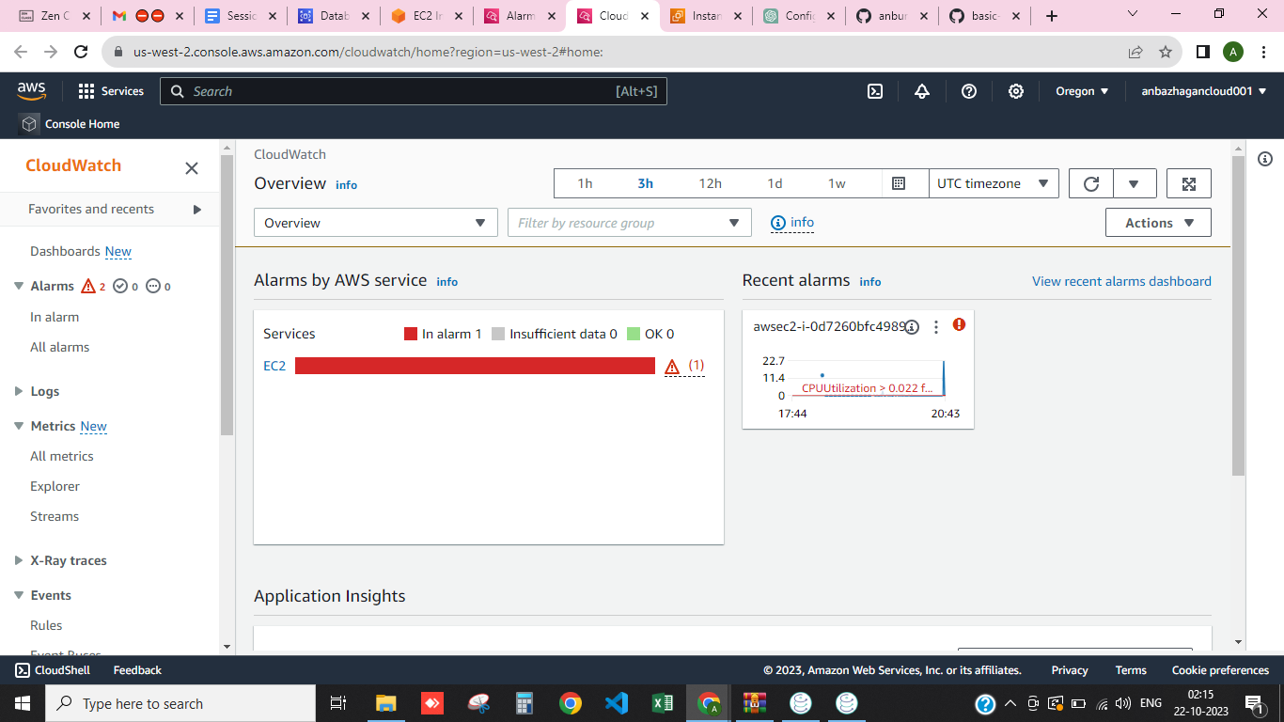

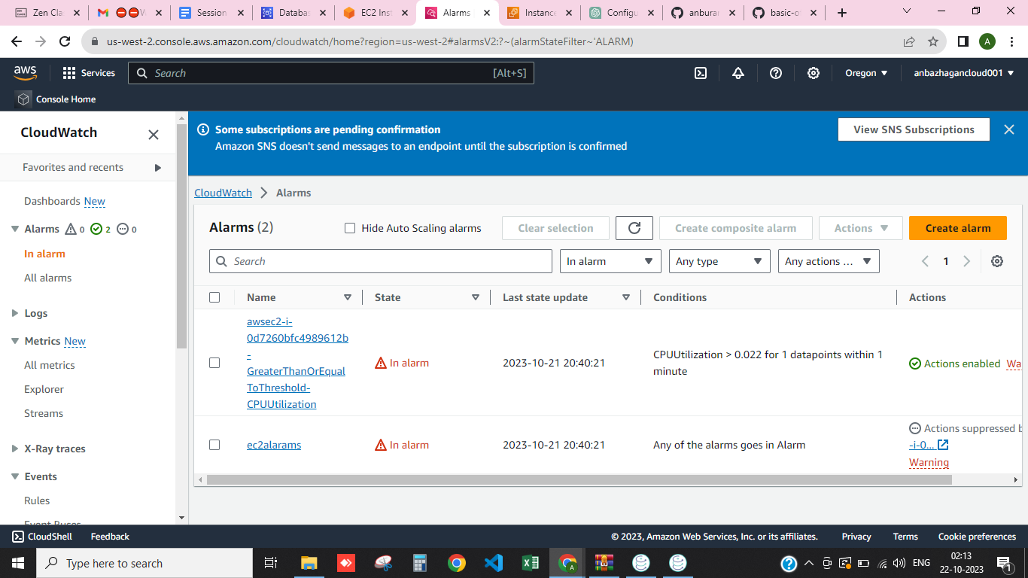

**Sample Output 2: Integration of AWS SNS (Simple Notification Service) for sending alerts to**

**specific email addresses or Slack channels when alarms are triggered.**

Navigate to the AWS SNS service in the AWS Management Console. In the SNS dashboard, click on "Topics" in the left navigation pane. Click the "Create topic" button. Enter a name for your SNS topic, e.g., "My Alerts."

Optionally, provide a display name and a description for the topic.Click "Create topic.".

**Select Protocol and Endpoint for Email :**

To send email alerts, choose "Email" as the protocol. Enter the email addresses to which you want to send notifications. You can add multiple email addresses by separating them with commas.Click "Create subscription."

**Create an SNS Alarm or Event:**

In the AWS Cloud Watch console, create a Cloud Watch alarm for the metric you want to monitor (e.g., CPU utilization or memory usage).

In the alarm configuration, specify the SNS topic you created in step 3 as the action to be taken when the alarm is triggered.

**Attached image for your reference :**

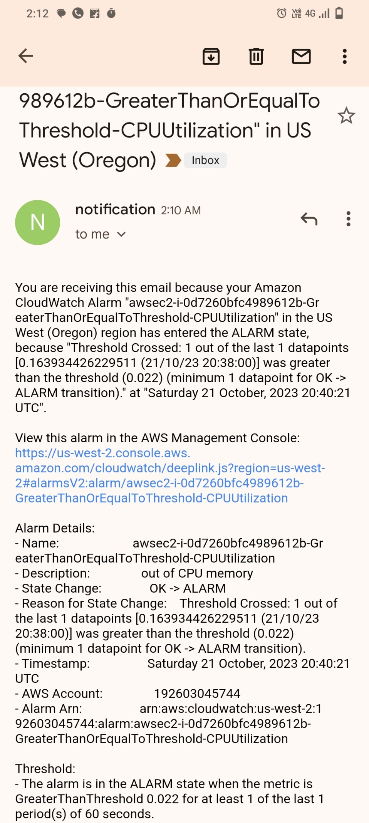

**Sample Output 3: Creation of custom Cloud Watch dashboards to visualize resource**

**performance and status, aiding in troubleshooting and analysis.**

In the Cloud Watch dashboard, click on "Dashboards" in the left navigation pane. Click the "Create dashboard" button.

Give your dashboard a descriptive name that reflects its purpose. Choose a layout template, either a blank canvas or a dashboard with default widgets to get started quickly.

On your newly created dashboard, click "Add widget" to add visualization elements. There are various widget types available, such as Line Graph, Stacked Area, Number, and Text. Select the metric or metrics you want to display on the widget. You can choose metrics from specific AWS services or custom metrics you've defined. **Am seleted Slack channels widget**

