**Task: Setting up Prometheus and Grafana for Monitoring and Visualization**

**Description:**

**Set up Prometheus for collecting metrics and Grafana for visualization to monitor the**

**performance and health of your application.**

**1. Installation and Configuration:**

**Test Case 1: Verify that Prometheus and Grafana are installed and configured on their**

**respective servers.**

**Expected Outcome: Both Prometheus and Grafana should be installed and running without**

**errors.**

**2. Metrics Collection and Visualization:**

**Test Case 2: Confirm that Prometheus collects metrics from the application and infrastructure,**

**and Grafana displays these metrics on a dashboard.**

**Expected Outcome: Metrics from the application and infrastructure should be visible on a**

**Grafana dashboard, showing real-time data.**

**3. Alerts and Notifications:**

**Test Case 3: Create an alerting rule in Prometheus to trigger an alert when a specific metric**

**threshold is breached, and verify that the alerting mechanism works.**

**Expected Outcome: An alert should be triggered when the specified metric threshold is**

**exceeded, and notifications (e.g., email or Slack) should be received.Task:**

**Implement monitoring and set up alerts for key AWS resources to ensure proactive detection of**

**issues.**

**Am using the cloud watch, because of my mentor not taken Prometheus and Grafana for Monitoring and Visualization.am already rise the query to guvi team about like this .**

Sample Output:

Sample Output 1: Configuration of AWS Cloud Watch alarms that monitor critical metrics (e.g.,

CPU utilization, memory usage) for each resource.

In the Cloud Watch dashboard, click on "Alarms" in the left navigation pane.

Click the "Create Alarm" button.

Choose the appropriate metric source. For example, if you want to monitor an Amazon EC2 instance's CPU utilization, select "EC2" under "Browse for metrics."

Select the specific instance and metric you want to monitor, such as "Per-Instance Metrics" and "CPU Utilization.

Define the conditions for your alarm. For example, you can set a threshold such as " am set the CPUUtilization greater than or equal to 50% (set the value of yur requirement )for 1 minute time periods."

**Attached the image for your refferance**

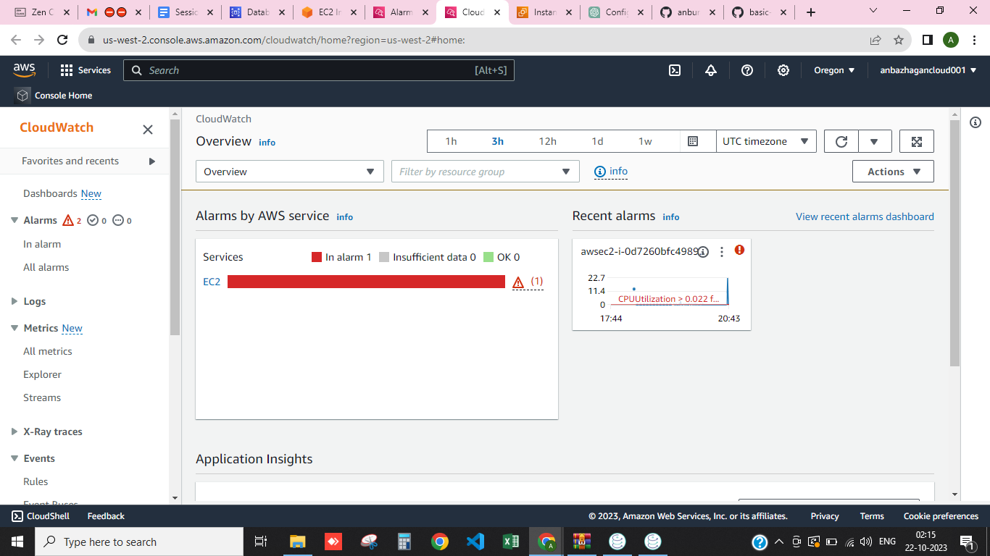

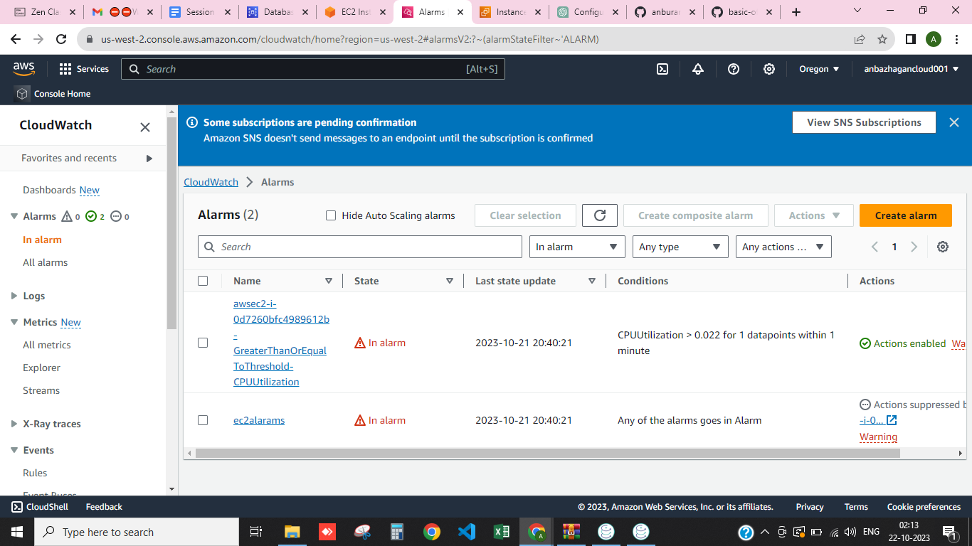

**Sample Output 2: Integration of AWS SNS (Simple Notification Service) for sending alerts to**

**specific email addresses or Slack channels when alarms are triggered.**

Navigate to the AWS SNS service in the AWS Management Console. In the SNS dashboard, click on "Topics" in the left navigation pane. Click the "Create topic" button. Enter a name for your SNS topic, e.g., "My Alerts."

Optionally, provide a display name and a description for the topic.Click "Create topic.".

**Select Protocol and Endpoint for Email :**

To send email alerts, choose "Email" as the protocol. Enter the email addresses to which you want to send notifications. You can add multiple email addresses by separating them with commas.Click "Create subscription."

**Create an SNS Alarm or Event:**

In the AWS Cloud Watch console, create a Cloud Watch alarm for the metric you want to monitor (e.g., CPU utilization or memory usage).

In the alarm configuration, specify the SNS topic you created in step 3 as the action to be taken when the alarm is triggered.

**Attached image for your reference :**

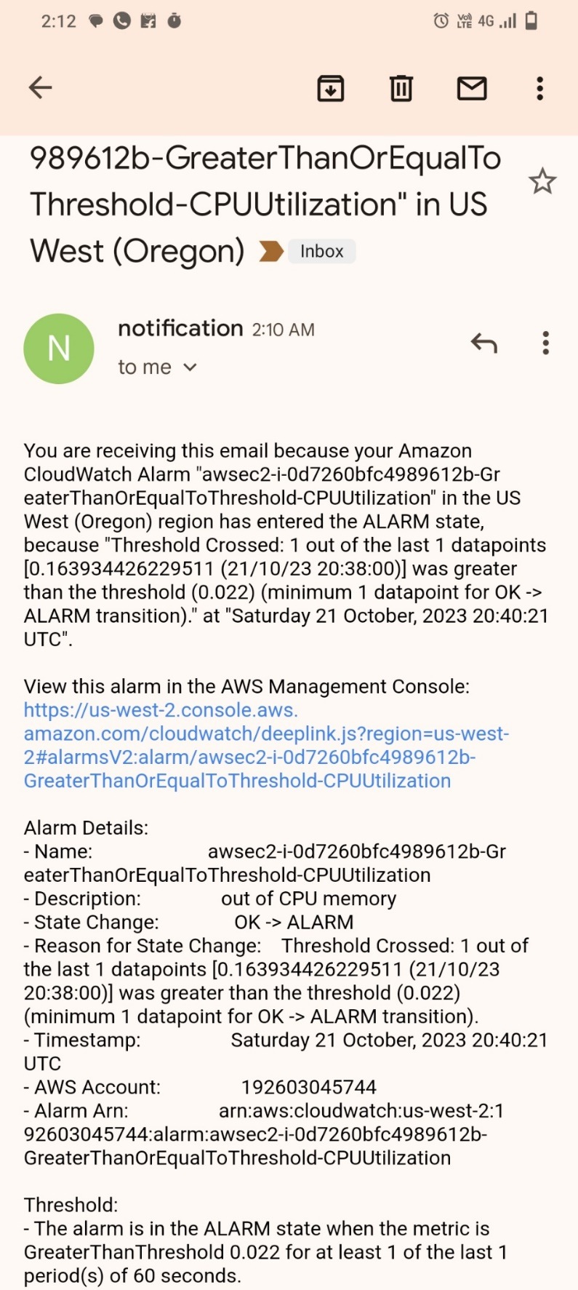

**Sample Output 3: Creation of custom Cloud Watch dashboards to visualize resource**

**performance and status, aiding in troubleshooting and analysis.**

In the Cloud Watch dashboard, click on "Dashboards" in the left navigation pane. Click the "Create dashboard" button.

Give your dashboard a descriptive name that reflects its purpose. Choose a layout template, either a blank canvas or a dashboard with default widgets to get started quickly.

On your newly created dashboard, click "Add widget" to add visualization elements. There are various widget types available, such as Line Graph, Stacked Area, Number, and Text. Select the metric or metrics you want to display on the widget. You can choose metrics from specific AWS services or custom metrics you've defined. **Am seleted Slack channels widget**

