CHAPTER IV
RESULTS AND DISCUSSION
Experiment 3: Evaluation of sensory and nutritional properties of the value added fermented food (idli) from aromatic rice cultivars
This experiment was undertaken to examine the sensory and nutritional quality of idli prepared from three aromatic rice landraces of West Bengal together with one non-aromatic check. The experiment was laid out in a two-factor completely randomised design with three replications and was repeated in two years. Factor A was variety, namely Gobindabhog (G), Radhunipagal (R), Kalojira (K) and the non-aromatic check Dudeshwar (D); Factor B was product, namely plain idli (I), idli fortified with carrot extract (CI) and idli fortified with beet extract (BI). This yielded twelve treatment combinations, designated DBI, DCI, DI, GBI, GCI, GI, KBI, KCI, KI, RBI, RCI and RI. Each parameter is treated in turn, the findings being presented first under Result and their interpretation under Discussion.

4.1 Design of the experiment and pooling of the data
The two years of data were combined only after the error variances had been tested by the Bartlett chi-square test. The test proved non-significant for most characters, demonstrating that the error variances of the two years were comparable and that the data could legitimately be pooled. It was significant only for manganese, ash, PGI and springiness; for these four characters an Aitken transformation was applied prior to the analysis of variance, and the transformed means were used for testing significance.
The coefficient of variation fell below 3 per cent for most characters. It was lowest for calcium (0.20 per cent), total phenol and total antioxidant activity (0.34 per cent each), and highest for fat (15.91 per cent), resilience (11.71 per cent), copper (9.65 per cent) and anthocyanin (9.63 per cent).
The variety and product interaction was highly significant for most of the nutritional, mineral, colour and textural characters. It proved non-significant only for taste, texture, appearance, cooking quality and overall acceptability.
In the tables that follow, the values for the two years and the pooled value of the twelve treatment combinations are given as mean plus or minus standard deviation. The annual values are means of three replications and the pooled values means of six observations. The standard error of the mean, the critical difference at the 5 per cent level and the coefficient of variation are given beneath each table. Pooled means followed by the same letter do not differ significantly at the 5 per cent level. Each table is followed by a figure presenting the pooled means, in which the vertical bars denote the standard error of the mean and the letters above the bars the groupings at the 5 per cent level.

4.2 Carbohydrate fractions

4.2.1 Amylose content (%)
Table 4.1. Amylose content (%) of idli prepared from four rice varieties fortified with carrot and beet extract
Treatment combination | Year 1 | Year 2 | Pooled mean
DBI | 9.87 ± 0.54 | 9.95 ± 0.32 | 9.91 ± 0.40f
DCI | 13.77 ± 0.23 | 12.98 ± 0.20 | 13.38 ± 0.48d
DI | 16.60 ± 0.74 | 16.90 ± 0.34 | 16.75 ± 0.54a
GBI | 9.84 ± 0.19 | 10.65 ± 0.31 | 10.24 ± 0.50f
GCI | 14.22 ± 0.34 | 14.29 ± 0.23 | 14.26 ± 0.26c
GI | 15.36 ± 0.27 | 15.78 ± 0.18 | 15.57 ± 0.31b
KBI | 10.28 ± 0.31 | 10.64 ± 0.28 | 10.46 ± 0.33f
KCI | 14.28 ± 0.19 | 14.60 ± 0.58 | 14.44 ± 0.42c
KI | 16.23 ± 0.34 | 16.26 ± 0.29 | 16.25 ± 0.28ab
RBI | 9.69 ± 0.10 | 9.87 ± 0.19 | 9.78 ± 0.17f
RCI | 11.66 ± 0.45 | 11.72 ± 0.12 | 11.69 ± 0.29e
RI | 11.65 ± 0.53 | 12.26 ± 0.36 | 11.96 ± 0.52e
SEm (+/-): Y = 0.07; V = 0.08; P = 0.07; V x P = 0.14; Y x V x P = 0.20
CD (P = 0.05): Y = NS; V = 0.24; P = 0.20; V x P = 0.40; Y x V x P = NS; CV (%) = 2.73
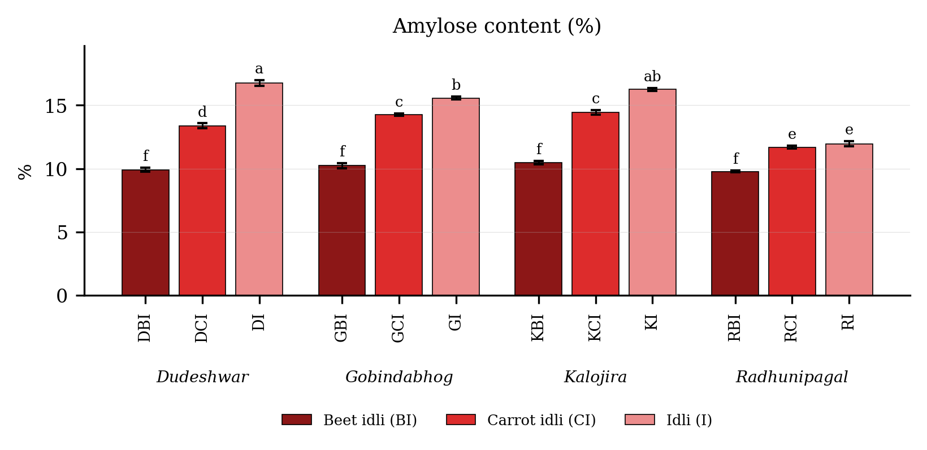
Fig. 4.1. Amylose content (%) of idli prepared from four rice varieties fortified with carrot and beet extract. Values are means of six observations and the vertical bars are the standard error of the mean. Letters above the bars denote the groupings at the 5 per cent level.
Result
Amylose content (Table 4.1 and Fig. 4.1) differed significantly among the twelve treatment combinations. It was highest in DI (16.75 per cent), followed by KI (16.25 per cent), and lowest in RBI (9.78 per cent). Among the products the mean value was 15.13 in the plain product, 13.44 in the carrot fortified product and 10.10 in the beet fortified product. Among the varieties it was highest in Kalojira (13.72) and lowest in Radhunipagal (11.14).
The variety and product interaction was significant, the critical difference at the 5 per cent level being 0.40, with a coefficient of variation of 2.73 per cent.
Discussion
The most probable basis of the decline in amylose from the plain to the beet fortified product is a combination of simple dilution and enzymatic loss. The vegetable extract replaces a proportion of the rice and black gram solids, so that the amylose concentration of the batter falls in proportion to the quantity of extract added, an effect reported wherever vegetable purees are incorporated into cereal formulations (Sharma et al., 2012; Chhikara et al., 2019). Beyond this, the amylolytic microflora developing during the overnight fermentation hydrolyses a proportion of the linear amylose chains, amylose being more readily attacked by bacterial alpha-amylase than the branched amylopectin (Steinkraus, 1997; Iyer and Ananthanarayan, 2008; Nout, 2009). The importance of this fraction resides in the fact that amylose governs the extent of retrogradation and therefore the firmness of the cooled product (Juliano, 1992; Copeland et al., 2009). All twelve combinations fall within the low-amylose class of Juliano (1971, 1992), which accounts for the characteristically soft, moist eating quality of idli prepared from these small-grained landraces (Singh et al., 2000; Bhattacharya, 2011). The unequal magnitude of the decline in the different varieties, which generated the significant interaction, is attributable to varietal differences in granule structure and in the accessibility of amylose to enzymatic attack (Singh et al., 2003; Champagne, 2004). Kaviyaselvan et al. (2026) recorded a comparable range of amylose in idli prepared from ten rice cultivars with and without pearl millet and likewise found the value to be governed jointly by cultivar and by the composition of the batter.

4.2.2 Starch content (%)
Table 4.2. Starch content (%) of idli prepared from four rice varieties fortified with carrot and beet extract
Treatment combination | Year 1 | Year 2 | Pooled mean
DBI | 26.60 ± 0.46 | 26.65 ± 0.53 | 26.63 ± 0.44i
DCI | 37.27 ± 0.39 | 37.18 ± 0.43 | 37.23 ± 0.37e
DI | 51.23 ± 0.52 | 52.08 ± 0.34 | 51.66 ± 0.61a
GBI | 24.07 ± 0.41 | 24.03 ± 0.65 | 24.05 ± 0.49j
GCI | 32.99 ± 0.21 | 32.59 ± 0.39 | 32.79 ± 0.36g
GI | 43.60 ± 0.60 | 43.76 ± 0.54 | 43.68 ± 0.52d
KBI | 27.67 ± 0.28 | 27.39 ± 0.55 | 27.53 ± 0.42h
KCI | 34.49 ± 0.39 | 34.91 ± 0.40 | 34.70 ± 0.42f
KI | 48.96 ± 0.31 | 48.56 ± 0.50 | 48.76 ± 0.43b
RBI | 26.65 ± 0.39 | 26.76 ± 0.24 | 26.71 ± 0.30hi
RCI | 34.44 ± 0.69 | 34.77 ± 0.32 | 34.61 ± 0.51f
RI | 46.67 ± 0.26 | 46.18 ± 0.12 | 46.42 ± 0.32c
SEm (+/-): Y = 0.10; V = 0.10; P = 0.09; V x P = 0.18; Y x V x P = 0.25
CD (P = 0.05): Y = NS; V = 0.28; P = 0.26; V x P = 0.50; Y x V x P = NS; CV (%) = 1.20
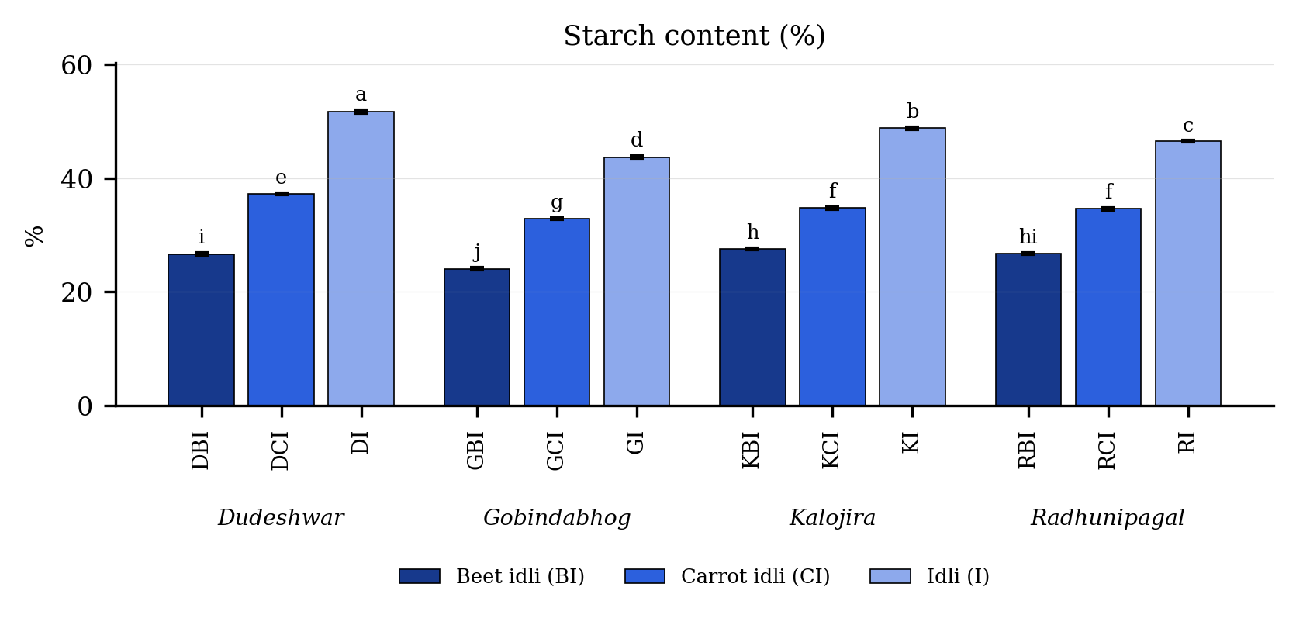
Fig. 4.2. Starch content (%) of idli prepared from four rice varieties fortified with carrot and beet extract. Values are means of six observations and the vertical bars are the standard error of the mean. Letters above the bars denote the groupings at the 5 per cent level.
Result
Starch content (Table 4.2 and Fig. 4.2) differed significantly among the twelve treatment combinations. It was highest in DI (51.66 per cent), followed by KI (48.76 per cent), and lowest in GBI (24.05 per cent). Among the products the mean value was 47.63 in the plain product, 34.83 in the carrot fortified product and 26.23 in the beet fortified product. Among the varieties it was highest in Dudeshwar (38.51) and lowest in Gobindabhog (33.51).
The variety and product interaction was significant, the critical difference at the 5 per cent level being 0.50, with a coefficient of variation of 1.20 per cent.
Discussion
The probable basis of the marked decline in starch on fortification is again the dilution of the rice and black gram base by the added extract, together with microbial utilisation of starch during fermentation. Beetroot and carrot carry very little starch of their own, so that every gram of extract added to the batter displaces an equivalent quantity of rice solids (Sharma et al., 2012; Singh and Hathan, 2014; Chhikara et al., 2019). The lactic acid bacteria and yeasts of the idli batter, chiefly Leuconostoc mesenteroides and Lactobacillus species, secrete amylases that hydrolyse starch to fermentable sugars during the overnight leavening period, which accounts for a further measurable loss (Mukherjee et al., 1965; Steinkraus et al., 1967; Soni and Sandhu, 1990; Iyer and Ananthanarayan, 2008). The higher starch content of the non-aromatic check relative to the three aromatic landraces is a varietal character and accords with Verma and Srivastav (2017), who reported a lower carbohydrate load in aromatic Indian rices than in non-aromatic rices, and with the general observation that starch content varies widely between rice genotypes (Champagne, 2004; Bhattacharya, 2011).

4.2.3 Total carbohydrate (%)
Table 4.3. Total carbohydrate (%) of idli prepared from four rice varieties fortified with carrot and beet extract
Treatment combination | Year 1 | Year 2 | Pooled mean
DBI | 45.77 ± 0.37 | 46.12 ± 0.53 | 45.94 ± 0.45g
DCI | 49.82 ± 0.62 | 50.09 ± 0.23 | 49.95 ± 0.45e
DI | 59.24 ± 0.26 | 61.19 ± 0.40 | 60.21 ± 1.11a
GBI | 41.07 ± 0.64 | 44.97 ± 0.32 | 43.02 ± 2.18h
GCI | 46.41 ± 0.44 | 48.38 ± 0.11 | 47.40 ± 1.11f
GI | 57.05 ± 0.46 | 59.35 ± 0.64 | 58.20 ± 1.35b
KBI | 40.05 ± 0.38 | 41.77 ± 0.23 | 40.91 ± 0.98i
KCI | 45.35 ± 0.53 | 48.63 ± 0.35 | 46.99 ± 1.84f
KI | 50.90 ± 0.55 | 52.39 ± 0.45 | 51.65 ± 0.93d
RBI | 41.55 ± 0.45 | 41.25 ± 0.43 | 41.40 ± 0.43i
RCI | 46.10 ± 0.29 | 49.04 ± 0.20 | 47.57 ± 1.62f
RI | 53.73 ± 0.36 | 54.30 ± 0.33 | 54.02 ± 0.44c
SEm (+/-): Y = 0.27; V = 0.10; P = 0.09; V x P = 0.17; Y x V x P = 0.24
CD (P = 0.05): Y = 0.76; V = 0.28; P = 0.24; V x P = 0.48; Y x V x P = 0.68; CV (%) = 0.86
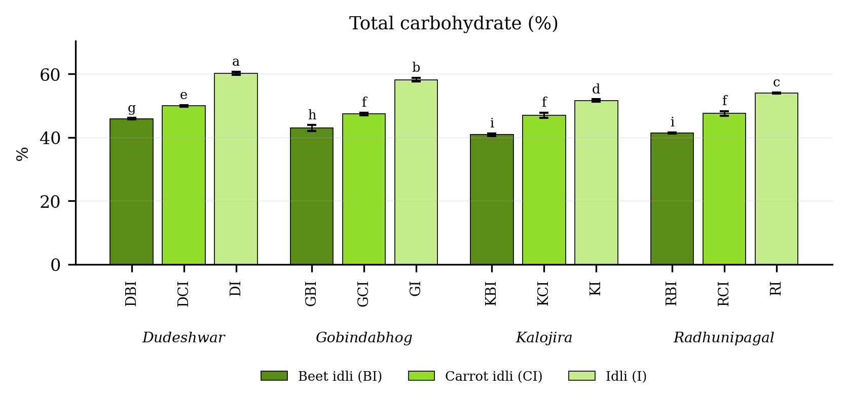
Fig. 4.3. Total carbohydrate (%) of idli prepared from four rice varieties fortified with carrot and beet extract. Values are means of six observations and the vertical bars are the standard error of the mean. Letters above the bars denote the groupings at the 5 per cent level.
Result
Total carbohydrate (Table 4.3 and Fig. 4.3) differed significantly among the twelve treatment combinations. It was highest in DI (60.21 per cent), followed by GI (58.20 per cent), and lowest in KBI (40.91 per cent). Among the products the mean value was 56.02 in the plain product, 47.98 in the carrot fortified product and 42.82 in the beet fortified product. Among the varieties it was highest in Dudeshwar (52.03) and lowest in Kalojira (46.52).
The variety and product interaction was significant, the critical difference at the 5 per cent level being 0.48, with a coefficient of variation of 0.86 per cent.
Discussion
Total carbohydrate tracked starch closely, starch constituting by far its largest fraction in a rice-based food, so that the probable basis of its decline is the same dilution and fermentative loss described for starch (Steinkraus, 1997; Iyer and Ananthanarayan, 2008; Chhikara et al., 2019). A proportion of the decline may further be attributed to the conversion of carbohydrate to carbon dioxide and organic acids during leavening of the batter, a loss unavoidable in any naturally fermented cereal product (Soni and Sandhu, 1990; Blandino et al., 2003; Poutanen et al., 2009). The consistently higher values of the non-aromatic check reflect a genuine varietal difference in grain composition and accord with the comparison of aromatic and non-aromatic Indian rices made by Verma and Srivastav (2017) and with the values compiled for Indian cereals by Gopalan et al. (2004).

4.2.4 Total soluble sugar (%)
Table 4.4. Total soluble sugar (%) of idli prepared from four rice varieties fortified with carrot and beet extract
Treatment combination | Year 1 | Year 2 | Pooled mean
DBI | 3.65 ± 0.03 | 3.70 ± 0.05 | 3.67 ± 0.05b
DCI | 2.83 ± 0.01 | 3.04 ± 0.05 | 2.94 ± 0.12d
DI | 0.58 ± 0.04 | 0.75 ± 0.05 | 0.66 ± 0.10h
GBI | 2.42 ± 0.05 | 2.56 ± 0.05 | 2.49 ± 0.09f
GCI | 2.03 ± 0.05 | 2.08 ± 0.02 | 2.06 ± 0.05g
GI | 0.55 ± 0.02 | 0.72 ± 0.01 | 0.64 ± 0.09h
KBI | 3.24 ± 0.03 | 3.57 ± 0.06 | 3.41 ± 0.19c
KCI | 2.04 ± 0.03 | 2.11 ± 0.02 | 2.08 ± 0.05g
KI | 0.36 ± 0.03 | 0.71 ± 0.05 | 0.54 ± 0.20i
RBI | 3.72 ± 0.02 | 3.93 ± 0.03 | 3.83 ± 0.12a
RCI | 2.68 ± 0.05 | 2.93 ± 0.03 | 2.80 ± 0.14e
RI | 0.46 ± 0.03 | 0.60 ± 0.01 | 0.53 ± 0.08i
SEm (+/-): Y = 0.02; V = 0.01; P = 0.01; V x P = 0.01; Y x V x P = 0.02
CD (P = 0.05): Y = 0.06; V = 0.02; P = 0.02; V x P = 0.04; Y x V x P = 0.06; CV (%) = 1.71
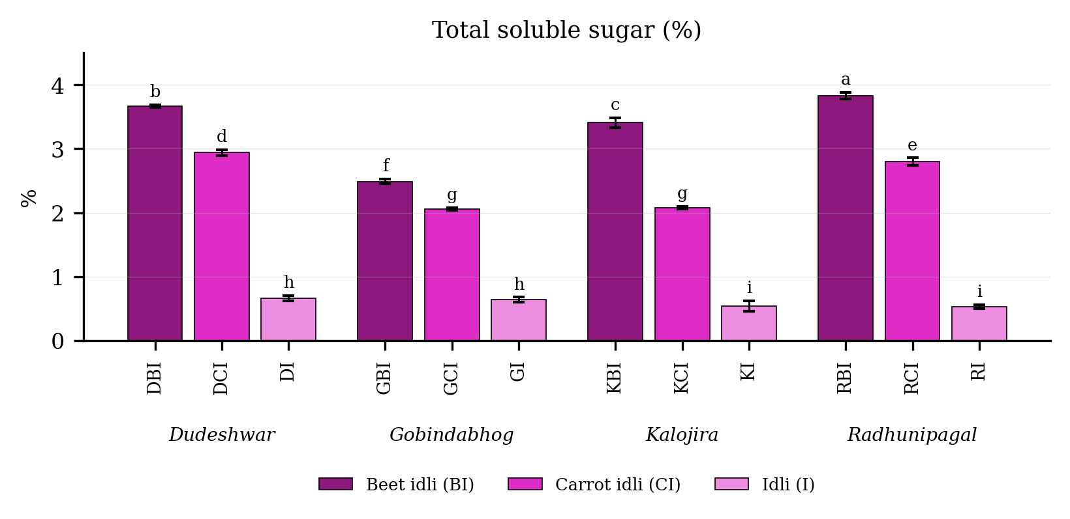
Fig. 4.4. Total soluble sugar (%) of idli prepared from four rice varieties fortified with carrot and beet extract. Values are means of six observations and the vertical bars are the standard error of the mean. Letters above the bars denote the groupings at the 5 per cent level.
Result
Total soluble sugar (Table 4.4 and Fig. 4.4) differed significantly among the twelve treatment combinations. It was highest in RBI (3.83 per cent), followed by DBI (3.67 per cent), and lowest in RI (0.53 per cent). Among the products the mean value was 3.35 in the beet fortified product, 2.47 in the carrot fortified product and 0.59 in the plain product. Among the varieties it was highest in Dudeshwar (2.42) and lowest in Gobindabhog (1.73).
The variety and product interaction was significant, the critical difference at the 5 per cent level being 0.04, with a coefficient of variation of 1.71 per cent.
Discussion
Total soluble sugar behaved in precisely the converse manner to starch, and two mechanisms acting in the same direction account for this. First, beetroot is exceptionally rich in free sucrose, glucose and fructose, so that the addition of its extract introduces a large quantity of soluble sugar directly (Singh and Hathan, 2014; Chhikara et al., 2019); carrot likewise carries appreciable free sugars, though less than beetroot (Sharma et al., 2012). Second, the amylases produced by the fermenting microflora hydrolyse a proportion of the rice starch into maltose and glucose, so that the sugar removed from the starch fraction reappears in the soluble sugar fraction (Mukherjee et al., 1965; Iyer and Ananthanarayan, 2008; Ganzle, 2014). A comparable rise in reducing sugars during the fermentation of cereal batters has been reported by Blandino et al. (2003) and, for idli specifically, by Ghosh and Chattopadhyay (2011). The rise in soluble sugar is nutritionally relevant, since it partly accounts for the higher predicted glycaemic index of the beet fortified treatments.

4.2.5 Resistant starch (%)
Table 4.5. Resistant starch (%) of idli prepared from four rice varieties fortified with carrot and beet extract
Treatment combination | Year 1 | Year 2 | Pooled mean
DBI | 1.66 ± 0.04 | 1.63 ± 0.05 | 1.64 ± 0.04c
DCI | 1.95 ± 0.03 | 1.98 ± 0.04 | 1.97 ± 0.04a
DI | 1.89 ± 0.05 | 1.89 ± 0.03 | 1.89 ± 0.04a
GBI | 1.22 ± 0.06 | 1.23 ± 0.04 | 1.23 ± 0.05e
GCI | 1.58 ± 0.05 | 1.58 ± 0.05 | 1.58 ± 0.04c
GI | 1.45 ± 0.06 | 1.45 ± 0.05 | 1.45 ± 0.05d
KBI | 1.03 ± 0.04 | 1.01 ± 0.02 | 1.02 ± 0.03f
KCI | 1.44 ± 0.04 | 1.39 ± 0.02 | 1.42 ± 0.04d
KI | 1.26 ± 0.04 | 1.24 ± 0.03 | 1.25 ± 0.03e
RBI | 1.48 ± 0.03 | 1.47 ± 0.06 | 1.47 ± 0.04d
RCI | 1.77 ± 0.03 | 1.83 ± 0.05 | 1.80 ± 0.05b
RI | 1.66 ± 0.01 | 1.61 ± 0.01 | 1.63 ± 0.03c
SEm (+/-): Y = 0.01; V = 0.01; P = 0.01; V x P = 0.02; Y x V x P = 0.02
CD (P = 0.05): Y = NS; V = 0.02; P = 0.02; V x P = 0.04; Y x V x P = NS; CV (%) = 2.68
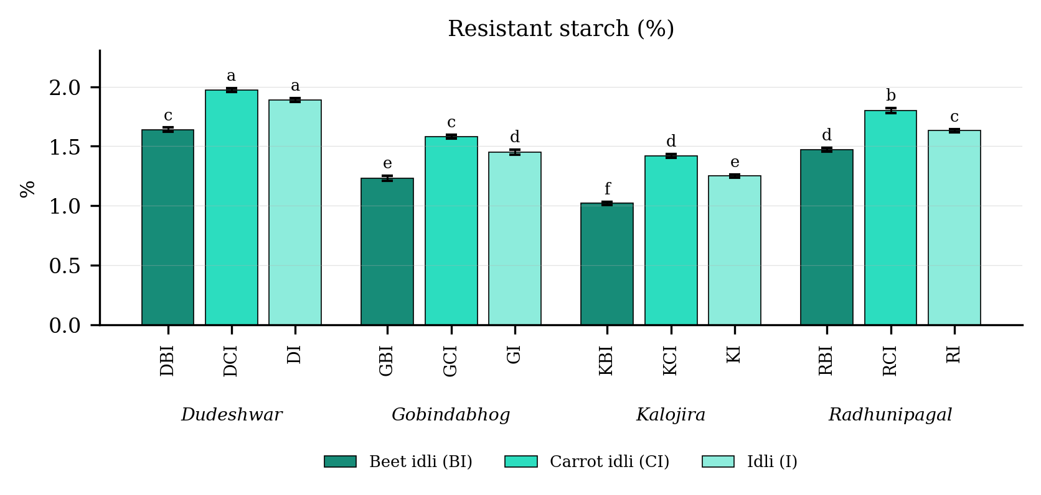
Fig. 4.5. Resistant starch (%) of idli prepared from four rice varieties fortified with carrot and beet extract. Values are means of six observations and the vertical bars are the standard error of the mean. Letters above the bars denote the groupings at the 5 per cent level.
Result
Resistant starch (Table 4.5 and Fig. 4.5) differed significantly among the twelve treatment combinations. It was highest in DCI (1.97 per cent), followed by DI (1.89 per cent), and lowest in KBI (1.02 per cent). Among the products the mean value was 1.69 in the carrot fortified product, 1.55 in the plain product and 1.34 in the beet fortified product. Among the varieties it was highest in Dudeshwar (1.83) and lowest in Kalojira (1.23).
The variety and product interaction was significant, the critical difference at the 5 per cent level being 0.04, with a coefficient of variation of 2.68 per cent.
Discussion
The most probable basis of the higher resistant starch of the carrot fortified treatments is the combined contribution of added dietary fibre and retrograded amylose. Carrot carries a substantial quantity of cellulose, hemicellulose and pectin, which are determined along with the resistant fraction and which additionally restrict enzyme access to the starch granule physically (Sharma et al., 2012; Slavin, 2013). The amylose liberated during steaming re-associates as the product cools and forms the retrograded RS3 fraction, a process well documented in cooked and cooled rice and other cereals (Englyst et al., 1992; Sajilata et al., 2006; Copeland et al., 2009). The lower values of the beet fortified treatments are accounted for by their very low amylose and high free sugar content, which leaves little material available for retrogradation (Singh and Hathan, 2014; Chhikara et al., 2019). This fraction is nutritionally important, since it escapes digestion in the small intestine and undergoes fermentation in the colon to short-chain fatty acids (Slavin, 2013).

4.2.6 Non-resistant starch (%)
Table 4.6. Non-resistant starch (%) of idli prepared from four rice varieties fortified with carrot and beet extract
Treatment combination | Year 1 | Year 2 | Pooled mean
DBI | 24.64 ± 0.45 | 26.35 ± 0.40 | 25.50 ± 1.01i
DCI | 34.72 ± 0.33 | 35.81 ± 0.08 | 35.26 ± 0.63e
DI | 49.95 ± 0.34 | 51.62 ± 0.33 | 50.78 ± 0.96a
GBI | 23.07 ± 0.49 | 24.07 ± 0.78 | 23.57 ± 0.80j
GCI | 30.68 ± 0.18 | 33.93 ± 0.46 | 32.31 ± 1.81g
GI | 42.12 ± 0.49 | 43.42 ± 0.30 | 42.77 ± 0.80d
KBI | 26.22 ± 0.63 | 27.68 ± 0.71 | 26.95 ± 1.00h
KCI | 32.89 ± 0.31 | 34.66 ± 0.35 | 33.78 ± 1.02f
KI | 47.15 ± 0.63 | 47.97 ± 0.20 | 47.56 ± 0.61b
RBI | 24.73 ± 0.46 | 27.17 ± 0.77 | 25.95 ± 1.45i
RCI | 32.48 ± 0.58 | 34.84 ± 0.32 | 33.66 ± 1.36f
RI | 44.82 ± 0.33 | 46.24 ± 0.07 | 45.53 ± 0.81c
SEm (+/-): Y = 0.14; V = 0.11; P = 0.09; V x P = 0.19; Y x V x P = 0.26
CD (P = 0.05): Y = 0.40; V = 0.30; P = 0.26; V x P = 0.52; Y x V x P = 0.74; CV (%) = 1.30
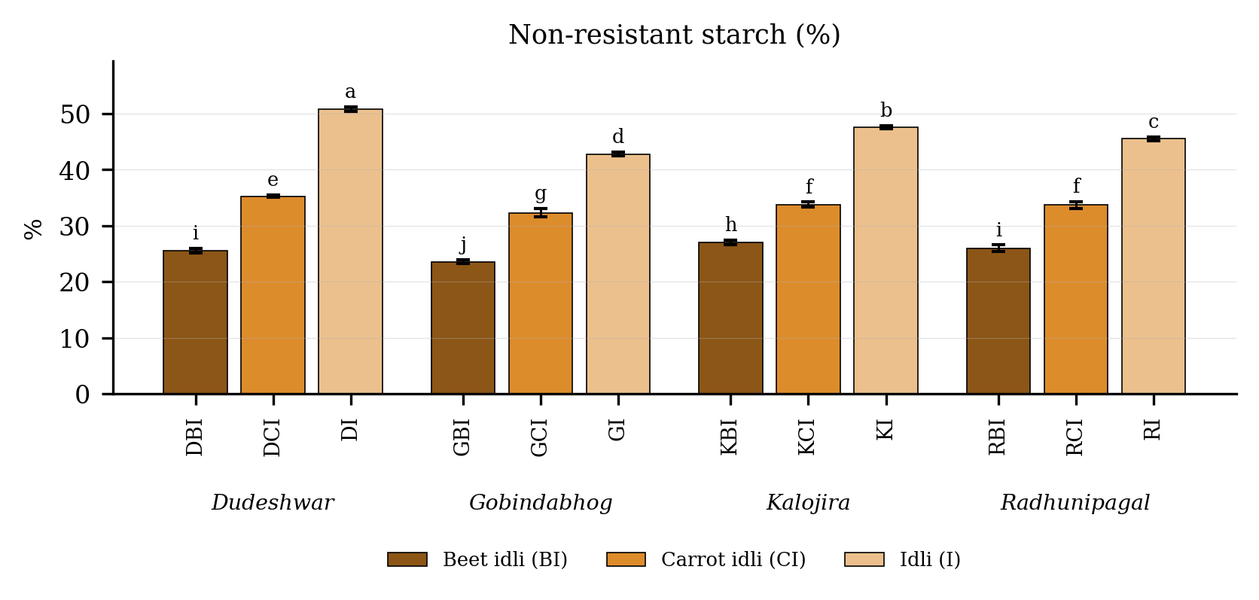
Fig. 4.6. Non-resistant starch (%) of idli prepared from four rice varieties fortified with carrot and beet extract. Values are means of six observations and the vertical bars are the standard error of the mean. Letters above the bars denote the groupings at the 5 per cent level.
Result
Non-resistant starch (Table 4.6 and Fig. 4.6) differed significantly among the twelve treatment combinations. It was highest in DI (50.78 per cent), followed by KI (47.56 per cent), and lowest in GBI (23.57 per cent). Among the products the mean value was 46.66 in the plain product, 33.75 in the carrot fortified product and 25.49 in the beet fortified product. Among the varieties it was highest in Dudeshwar (37.18) and lowest in Gobindabhog (32.88).
The variety and product interaction was significant, the critical difference at the 5 per cent level being 0.52, with a coefficient of variation of 1.30 per cent.
Discussion
Non-resistant starch is the readily digestible complement of the resistant fraction, so that the probable basis of its behaviour is simply that it tracks total starch. It was highest where the rice base was undiluted and lowest in the beet fortified treatments, which carried the least starch of all (Englyst et al., 1992; Sajilata et al., 2006). The gelatinisation occurring during steaming disrupts the granule structure and converts most of the starch into a rapidly digestible form, which is why this fraction predominates in all the treatments (Bemiller and Whistler, 2009; Copeland et al., 2009). Fermentation contributes further by partially hydrolysing the granule surface and increasing the accessible surface area (Iyer and Ananthanarayan, 2008; Ganzle, 2014). The values recorded here are comparable with those reported for other steamed and fermented cereal products (Blandino et al., 2003; Poutanen et al., 2009).

4.2.7 Predicted glycaemic index (PGI)
Table 4.7. Predicted glycaemic index (PGI) of idli prepared from four rice varieties fortified with carrot and beet extract
Treatment combination | Year 1 | Year 2 | Pooled mean
DBI | 72.50 ± 0.60 | 74.52 ± 0.57 | 73.51 ± 1.22b
DCI | 60.26 ± 0.21 | 62.90 ± 0.77 | 61.58 ± 1.53g
DI | 65.16 ± 0.60 | 65.78 ± 0.20 | 65.47 ± 0.52e
GBI | 72.72 ± 0.39 | 74.50 ± 0.33 | 73.61 ± 1.03b
GCI | 60.18 ± 0.35 | 62.61 ± 0.28 | 61.40 ± 1.36g
GI | 63.41 ± 0.12 | 66.65 ± 0.58 | 65.03 ± 1.81e
KBI | 73.43 ± 0.57 | 76.74 ± 0.55 | 75.08 ± 1.88a
KCI | 60.18 ± 0.72 | 60.89 ± 0.43 | 60.53 ± 0.66g
KI | 65.82 ± 0.55 | 68.31 ± 0.55 | 67.06 ± 1.45d
RBI | 71.81 ± 0.50 | 72.02 ± 0.11 | 71.92 ± 0.34c
RCI | 58.01 ± 0.41 | 58.91 ± 0.63 | 58.46 ± 0.68h
RI | 62.31 ± 0.16 | 64.12 ± 0.35 | 63.22 ± 1.02f
SEm (+/-): Y = 0.26; V = 0.14; P = 0.12; V x P = 0.25; Y x V x P = 0.35
CD (P = 0.05): Y = 0.74; V = 0.40; P = 0.34; V x P = 0.70; Y x V x P = 0.99; CV (%) = 0.73
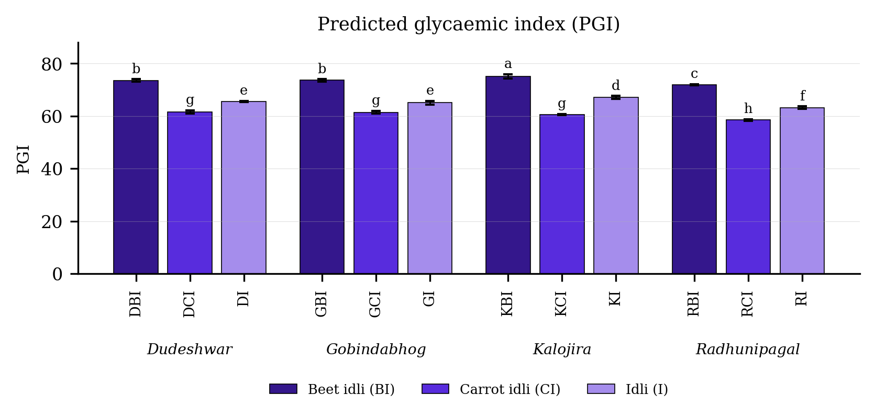
Fig. 4.7. Predicted glycaemic index (PGI) of idli prepared from four rice varieties fortified with carrot and beet extract. Values are means of six observations and the vertical bars are the standard error of the mean. Letters above the bars denote the groupings at the 5 per cent level.
Result
Predicted glycaemic index (Table 4.7 and Fig. 4.7) differed significantly among the twelve treatment combinations. It was highest in KBI (75.08 PGI), followed by GBI (73.61 PGI), and lowest in RCI (58.46 PGI). Among the products the mean value was 73.53 in the beet fortified product, 65.19 in the plain product and 60.49 in the carrot fortified product. Among the varieties it was highest in Kalojira (67.56) and lowest in Radhunipagal (64.53).
The variety and product interaction was significant, the critical difference at the 5 per cent level being 0.70, with a coefficient of variation of 0.73 per cent.
Discussion
The probable basis of the differences in predicted glycaemic index is that the rate of starch hydrolysis, rather than the total quantity of starch, determines the glycaemic response of a cereal food (Jenkins et al., 1981; Goni et al., 1997). The carrot fortified treatments returned the lowest values because the dietary fibre of carrot forms a physical barrier around the starch granule and retards the access of pancreatic amylase, and because these treatments also carried the highest resistant starch (Sajilata et al., 2006; Sharma et al., 2012; Slavin, 2013). The beet fortified treatments returned the highest values because beetroot supplies a large quantity of free sugars absorbed almost immediately (Singh and Hathan, 2014; Chhikara et al., 2019). Frei et al. (2003) and Panlasigui et al. (1991) both demonstrated for rice that varieties of comparable amylose content may differ widely in starch digestibility and glycaemic response, which accounts for the failure of the treatment ranking here to follow amylose alone. The values obtained fall within the intermediate to high range of the international tables of Foster-Powell et al. (2002).

4.3 Proximate composition

4.3.1 Total soluble protein (%)
Table 4.8. Total soluble protein (%) of idli prepared from four rice varieties fortified with carrot and beet extract
Treatment combination | Year 1 | Year 2 | Pooled mean
DBI | 1.80 ± 0.03 | 1.92 ± 0.03 | 1.86 ± 0.07fg
DCI | 2.10 ± 0.04 | 2.37 ± 0.01 | 2.23 ± 0.15c
DI | 0.94 ± 0.03 | 1.15 ± 0.06 | 1.05 ± 0.12j
GBI | 1.71 ± 0.03 | 1.94 ± 0.05 | 1.82 ± 0.13g
GCI | 2.06 ± 0.03 | 2.16 ± 0.01 | 2.11 ± 0.06d
GI | 1.23 ± 0.06 | 1.53 ± 0.03 | 1.38 ± 0.17h
KBI | 2.58 ± 0.04 | 2.85 ± 0.02 | 2.71 ± 0.15a
KCI | 1.88 ± 0.06 | 2.03 ± 0.03 | 1.95 ± 0.09e
KI | 1.13 ± 0.05 | 1.44 ± 0.02 | 1.29 ± 0.18i
RBI | 2.43 ± 0.02 | 2.66 ± 0.04 | 2.54 ± 0.13b
RCI | 1.82 ± 0.02 | 2.05 ± 0.02 | 1.93 ± 0.13ef
RI | 1.31 ± 0.04 | 1.38 ± 0.01 | 1.34 ± 0.05hi
SEm (+/-): Y = 0.02; V = 0.01; P = 0.01; V x P = 0.01; Y x V x P = 0.02
CD (P = 0.05): Y = 0.06; V = 0.02; P = 0.02; V x P = 0.04; Y x V x P = 0.06; CV (%) = 1.96
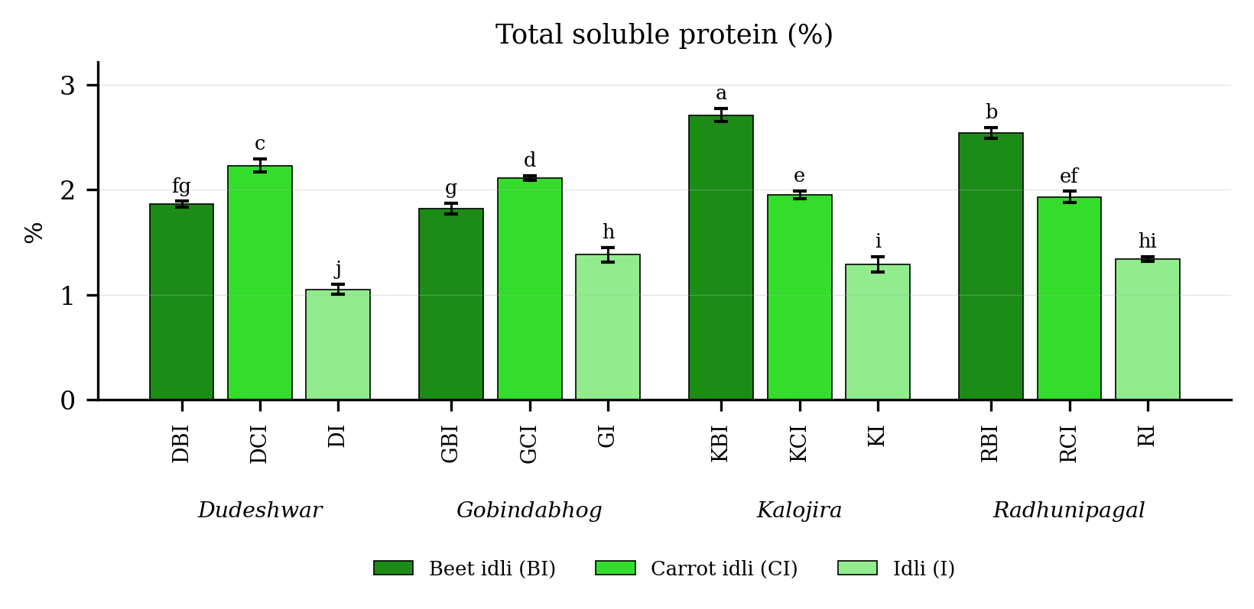
Fig. 4.8. Total soluble protein (%) of idli prepared from four rice varieties fortified with carrot and beet extract. Values are means of six observations and the vertical bars are the standard error of the mean. Letters above the bars denote the groupings at the 5 per cent level.
Result
Total soluble protein (Table 4.8 and Fig. 4.8) differed significantly among the twelve treatment combinations. It was highest in KBI (2.71 per cent), followed by RBI (2.54 per cent), and lowest in DI (1.05 per cent). Among the products the mean value was 2.23 in the beet fortified product, 2.05 in the carrot fortified product and 1.27 in the plain product. Among the varieties it was highest in Kalojira (1.98) and lowest in Dudeshwar (1.71).
The variety and product interaction was significant, the critical difference at the 5 per cent level being 0.04, with a coefficient of variation of 1.96 per cent.
Discussion
The most probable basis of the rise in total soluble protein on fortification is the proteolysis accompanying natural lactic fermentation together with the soluble protein contributed by the vegetable extract. During the overnight leavening of the batter, the proteases of Leuconostoc and Lactobacillus species hydrolyse a proportion of the rice and black gram protein into soluble peptides and free amino nitrogen, which are recovered in the Folin-Ciocalteu assay of Lowry et al. (1951) but not in the intact protein (Mukherjee et al., 1965; Chavan and Kadam, 1989; Soni and Sandhu, 1990). Ghosh and Chattopadhyay (2011) measured this increase directly in idli batter and reported a marked rise in soluble nitrogen during fermentation, and comparable increases have been recorded in other fermented cereal systems (Blandino et al., 2003; Poutanen et al., 2009). Beetroot likewise carries readily extractable protein of its own, which accounts for the beet fortified treatments ranking highest for this character (Singh and Hathan, 2014; Chhikara et al., 2019).

4.3.2 Total protein (%)
Table 4.9. Total protein (%) of idli prepared from four rice varieties fortified with carrot and beet extract
Treatment combination | Year 1 | Year 2 | Pooled mean
DBI | 11.77 ± 0.06 | 11.77 ± 0.06 | 11.77 ± 0.05f
DCI | 10.92 ± 0.02 | 10.92 ± 0.03 | 10.92 ± 0.02i
DI | 12.07 ± 0.05 | 12.04 ± 0.08 | 12.05 ± 0.06e
GBI | 12.91 ± 0.07 | 13.00 ± 0.05 | 12.95 ± 0.07c
GCI | 11.33 ± 0.02 | 11.34 ± 0.10 | 11.34 ± 0.06h
GI | 13.05 ± 0.07 | 13.11 ± 0.09 | 13.08 ± 0.08c
KBI | 13.35 ± 0.08 | 13.24 ± 0.03 | 13.29 ± 0.08b
KCI | 11.94 ± 0.10 | 11.80 ± 0.05 | 11.87 ± 0.11f
KI | 13.43 ± 0.12 | 13.46 ± 0.09 | 13.44 ± 0.10a
RBI | 12.74 ± 0.05 | 12.77 ± 0.03 | 12.76 ± 0.04d
RCI | 11.56 ± 0.06 | 11.62 ± 0.09 | 11.59 ± 0.08g
RI | 12.75 ± 0.16 | 12.74 ± 0.04 | 12.74 ± 0.11d
SEm (+/-): Y = 0.01; V = 0.02; P = 0.02; V x P = 0.03; Y x V x P = 0.04
CD (P = 0.05): Y = NS; V = 0.04; P = 0.04; V x P = 0.08; Y x V x P = NS; CV (%) = 0.61
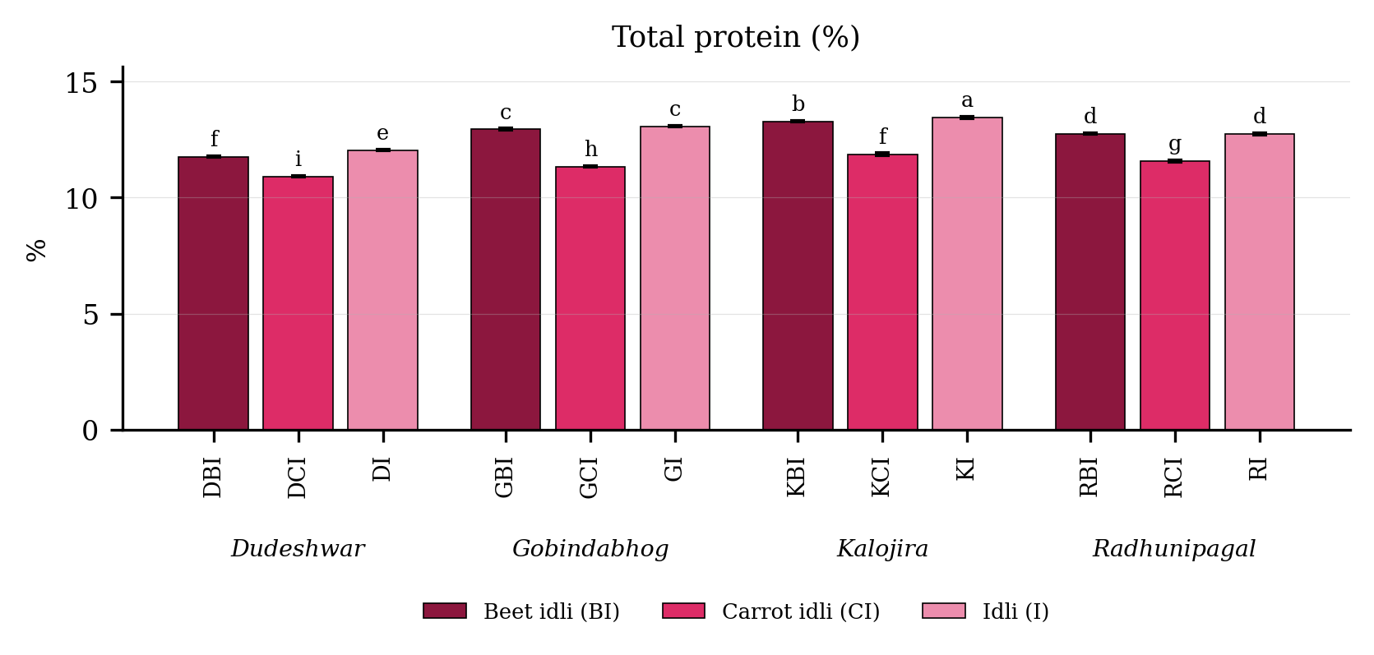
Fig. 4.9. Total protein (%) of idli prepared from four rice varieties fortified with carrot and beet extract. Values are means of six observations and the vertical bars are the standard error of the mean. Letters above the bars denote the groupings at the 5 per cent level.
Result
Total protein (Table 4.9 and Fig. 4.9) differed significantly among the twelve treatment combinations. It was highest in KI (13.44 per cent), followed by KBI (13.29 per cent), and lowest in DCI (10.92 per cent). Among the products the mean value was 12.83 in the plain product, 12.69 in the beet fortified product and 11.43 in the carrot fortified product. Among the varieties it was highest in Kalojira (12.87) and lowest in Dudeshwar (11.58).
The variety and product interaction was significant, the critical difference at the 5 per cent level being 0.08, with a coefficient of variation of 0.61 per cent.
Discussion
The idli was considerably richer in protein than milled rice, and the most probable basis is the combined contribution of black gram and of microbial biomass. The batter contains rice and black gram in a two to one ratio, and the lysine-rich protein of black gram compensates for the lysine-deficient protein of rice, yielding a product of better amino acid balance than either component alone (Reddy et al., 1981; Ufaz and Galili, 2008; Oghbaei and Prakash, 2016). Fermentation contributes further protein through the growth of the microflora and improves its digestibility by partial proteolysis (Chavan and Kadam, 1989; Nout and Sarkar, 1999; Sridevi et al., 2010). The superiority of the three aromatic landraces over the non-aromatic check, and the combination of high protein with low amylose in Radhunipagal, accord with the negative relation between grain protein and amylose reported for rice by Chattopadhyay et al. (2018), while the general level of protein recorded is comparable with the values reported for Indian rices by Rani et al. (2006) and Gopalan et al. (2004). A comparable dominance of the grain protein in the finished product was recorded by Kaviyaselvan et al. (2026), who separated the protein of idli into its four solubility fractions and found glutelin to be the largest, followed by prolamin, globulin and albumin.

4.3.3 Fat content (%)
Table 4.10. Fat content (%) of idli prepared from four rice varieties fortified with carrot and beet extract
Treatment combination | Year 1 | Year 2 | Pooled mean
DBI | 0.21 ± 0.02 | 0.22 ± 0.02 | 0.21 ± 0.02abcd
DCI | 0.26 ± 0.06 | 0.28 ± 0.05 | 0.27 ± 0.05a
DI | 0.25 ± 0.04 | 0.29 ± 0.06 | 0.27 ± 0.05a
GBI | 0.17 ± 0.01 | 0.18 ± 0.03 | 0.17 ± 0.02cd
GCI | 0.27 ± 0.03 | 0.29 ± 0.04 | 0.28 ± 0.03a
GI | 0.11 ± 0.04 | 0.25 ± 0.05 | 0.18 ± 0.09bcd
KBI | 0.22 ± 0.05 | 0.19 ± 0.01 | 0.21 ± 0.03abcd
KCI | 0.26 ± 0.02 | 0.23 ± 0.04 | 0.24 ± 0.03abc
KI | 0.30 ± 0.02 | 0.25 ± 0.05 | 0.28 ± 0.05a
RBI | 0.16 ± 0.03 | 0.18 ± 0.04 | 0.17 ± 0.03d
RCI | 0.22 ± 0.02 | 0.28 ± 0.05 | 0.25 ± 0.05ab
RI | 0.23 ± 0.01 | 0.26 ± 0.03 | 0.24 ± 0.02abc
SEm (+/-): Y = 0.01; V = 0.01; P = 0.01; V x P = 0.02; Y x V x P = 0.02
CD (P = 0.05): Y = NS; V = 0.02; P = 0.02; V x P = 0.04; Y x V x P = NS; CV (%) = 15.91
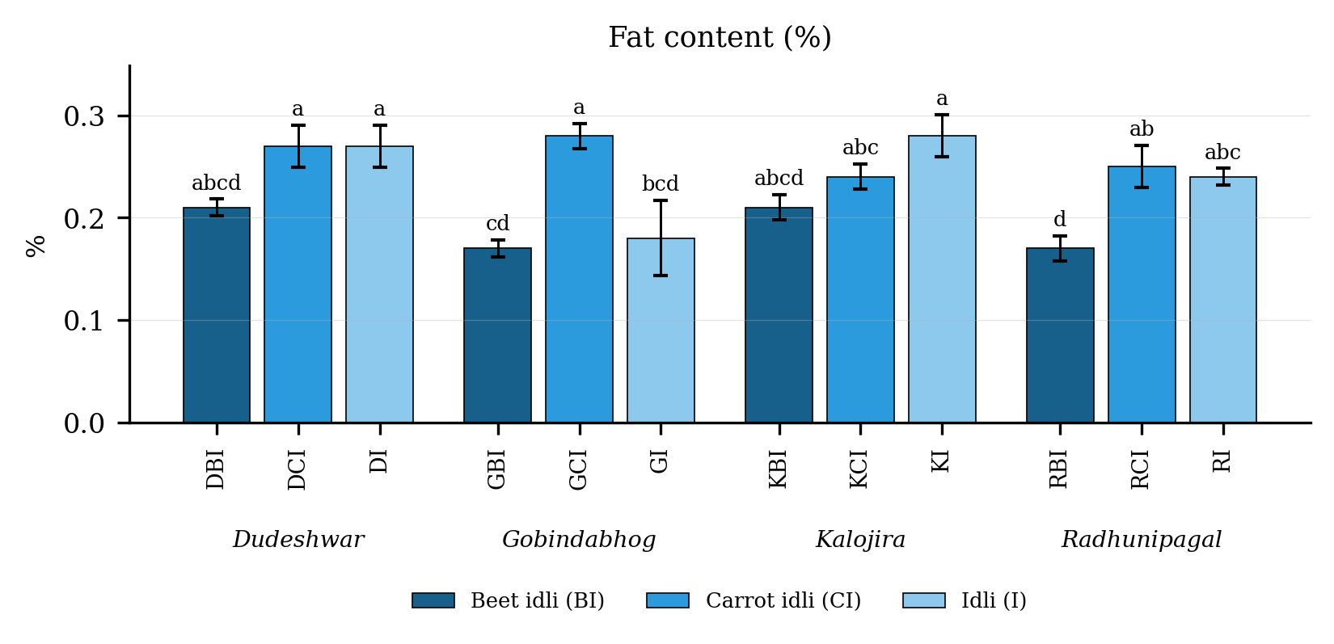
Fig. 4.10. Fat content (%) of idli prepared from four rice varieties fortified with carrot and beet extract. Values are means of six observations and the vertical bars are the standard error of the mean. Letters above the bars denote the groupings at the 5 per cent level.
Result
Fat content (Table 4.10 and Fig. 4.10) differed significantly among the twelve treatment combinations. It was highest in KI (0.28 per cent), followed by GCI (0.28 per cent), and lowest in GBI (0.17 per cent). Among the products the mean value was 0.26 in the carrot fortified product, 0.24 in the plain product and 0.19 in the beet fortified product. Among the varieties it was highest in Dudeshwar (0.25) and lowest in Gobindabhog (0.21).
The variety and product interaction was significant, the critical difference at the 5 per cent level being 0.04, with a coefficient of variation of 15.91 per cent.
Discussion
Fat was uniformly low in all the treatments, the probable basis being that idli is steamed rather than fried, so that no fat is added during preparation and the only lipid present is that of the rice and black gram themselves (Reddy et al., 1981; Gopalan et al., 2004). Rice endosperm carries very little lipid once the bran has been removed, and black gram is likewise a low-fat pulse (Champagne, 2004; Oghbaei and Prakash, 2016). The marginally higher values recorded in the carrot fortified treatments are most probably an artefact of the method rather than a genuine gain in fat, since the carotenoids of carrot are lipid-soluble and are extracted along with the fat during Soxhlet extraction, where they are weighed as part of the crude fat fraction (Britton, 1995; Rodriguez-Amaya, 2001; Sharma et al., 2012). A small loss of lipid through microbial lipase activity during fermentation may contribute further to the low values overall (Blandino et al., 2003; Nout, 2009).

4.3.4 Ash content (%)
Table 4.11. Ash content (%) of idli prepared from four rice varieties fortified with carrot and beet extract
Treatment combination | Year 1 | Year 2 | Pooled mean
DBI | 3.95 ± 0.05 | 4.04 ± 0.03 | 4.00 ± 0.06d
DCI | 3.55 ± 0.01 | 4.16 ± 0.03 | 3.86 ± 0.33f
DI | 2.52 ± 0.04 | 2.42 ± 0.04 | 2.47 ± 0.06k
GBI | 5.07 ± 0.03 | 5.35 ± 0.01 | 5.21 ± 0.15a
GCI | 4.86 ± 0.05 | 4.92 ± 0.04 | 4.89 ± 0.05b
GI | 3.58 ± 0.03 | 3.66 ± 0.02 | 3.62 ± 0.05g
KBI | 4.16 ± 0.05 | 4.18 ± 0.04 | 4.17 ± 0.04c
KCI | 3.38 ± 0.02 | 3.00 ± 0.02 | 3.19 ± 0.21h
KI | 2.62 ± 0.01 | 2.77 ± 0.05 | 2.69 ± 0.09j
RBI | 4.02 ± 0.04 | 4.04 ± 0.04 | 4.03 ± 0.04d
RCI | 3.74 ± 0.02 | 4.18 ± 0.06 | 3.96 ± 0.24e
RI | 2.84 ± 0.03 | 3.09 ± 0.05 | 2.97 ± 0.14i
SEm (+/-): Y = 0.19; V = 0.05; P = 0.04; V x P = 0.09; Y x V x P = 0.12
CD (P = 0.05): Y = 0.52; V = 0.14; P = 0.12; V x P = 0.24; Y x V x P = 0.34; CV (%) = 0.98
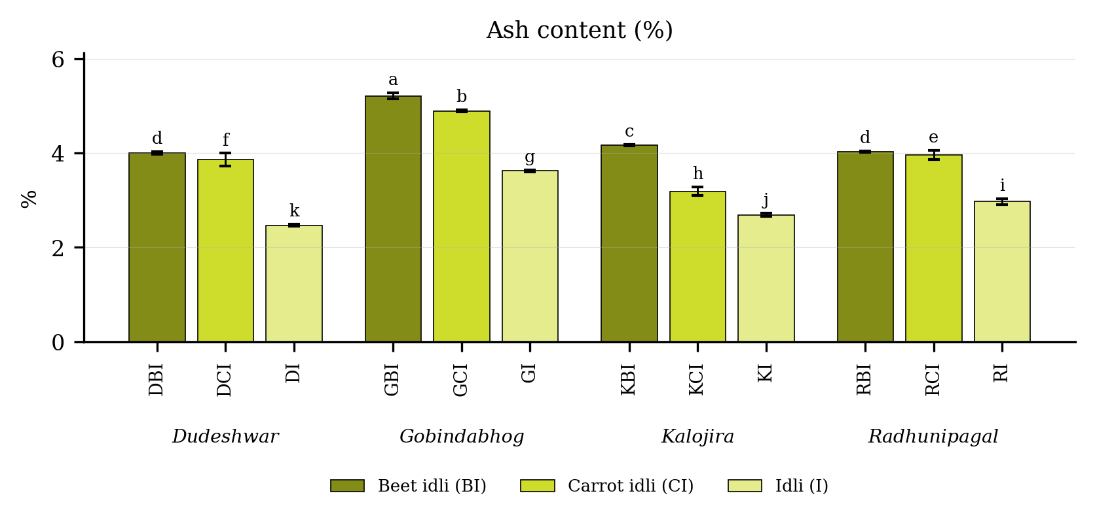
Fig. 4.11. Ash content (%) of idli prepared from four rice varieties fortified with carrot and beet extract. Values are means of six observations and the vertical bars are the standard error of the mean. Letters above the bars denote the groupings at the 5 per cent level.
Result
Ash content (Table 4.11 and Fig. 4.11) differed significantly among the twelve treatment combinations. It was highest in GBI (5.21 per cent), followed by GCI (4.89 per cent), and lowest in DI (2.47 per cent). Among the products the mean value was 4.35 in the beet fortified product, 3.97 in the carrot fortified product and 2.94 in the plain product. Among the varieties it was highest in Gobindabhog (4.57) and lowest in Kalojira (3.35).
The variety and product interaction was significant, the critical difference at the 5 per cent level being 0.24, with a coefficient of variation of 0.98 per cent.
Discussion
Ash represents the total mineral load of the product, and the most probable basis of its rise on fortification is the direct mineral contribution of the vegetable extract. Beetroot is a rich source of potassium, sodium, calcium and magnesium, and the addition of its extract raises the inorganic residue of the product substantially (Singh and Hathan, 2014; Chhikara et al., 2019), while carrot contributes a smaller but still appreciable quantity (Sharma et al., 2012). The high ash content of Gobindabhog among the varieties is consistent with its superior mineral profile discussed in the following section and reflects a genuine varietal difference in grain mineral status (Rani et al., 2006; Hemalatha et al., 2007; Gopalan et al., 2004). Values of this order have been reported for other fermented cereal and pulse products, in which the ash content is generally higher than that of the unfermented raw material on account of the loss of dry matter as carbon dioxide during leavening (Blandino et al., 2003; Oghbaei and Prakash, 2016).

4.3.5 Phytate content (mg g⁻¹)
Table 4.12. Phytate content (mg g⁻¹) of idli prepared from four rice varieties fortified with carrot and beet extract
Treatment combination | Year 1 | Year 2 | Pooled mean
DBI | 1.69 ± 0.03 | 1.78 ± 0.03 | 1.74 ± 0.05c
DCI | 0.87 ± 0.06 | 0.93 ± 0.05 | 0.90 ± 0.06g
DI | 1.14 ± 0.03 | 1.20 ± 0.03 | 1.17 ± 0.04f
GBI | 1.11 ± 0.03 | 1.13 ± 0.06 | 1.12 ± 0.04f
GCI | 1.30 ± 0.03 | 1.35 ± 0.04 | 1.32 ± 0.04e
GI | 0.78 ± 0.02 | 0.86 ± 0.04 | 0.82 ± 0.05h
KBI | 2.49 ± 0.03 | 2.55 ± 0.05 | 2.52 ± 0.05a
KCI | 1.74 ± 0.05 | 1.80 ± 0.02 | 1.77 ± 0.05c
KI | 1.44 ± 0.06 | 1.51 ± 0.03 | 1.48 ± 0.06d
RBI | 1.97 ± 0.03 | 2.09 ± 0.02 | 2.03 ± 0.07b
RCI | 1.93 ± 0.03 | 2.01 ± 0.04 | 1.97 ± 0.05b
RI | 0.88 ± 0.03 | 0.98 ± 0.01 | 0.93 ± 0.06g
SEm (+/-): Y = 0.00; V = 0.01; P = 0.01; V x P = 0.02; Y x V x P = 0.02
CD (P = 0.05): Y = 0.02; V = 0.02; P = 0.02; V x P = 0.04; Y x V x P = NS; CV (%) = 2.50
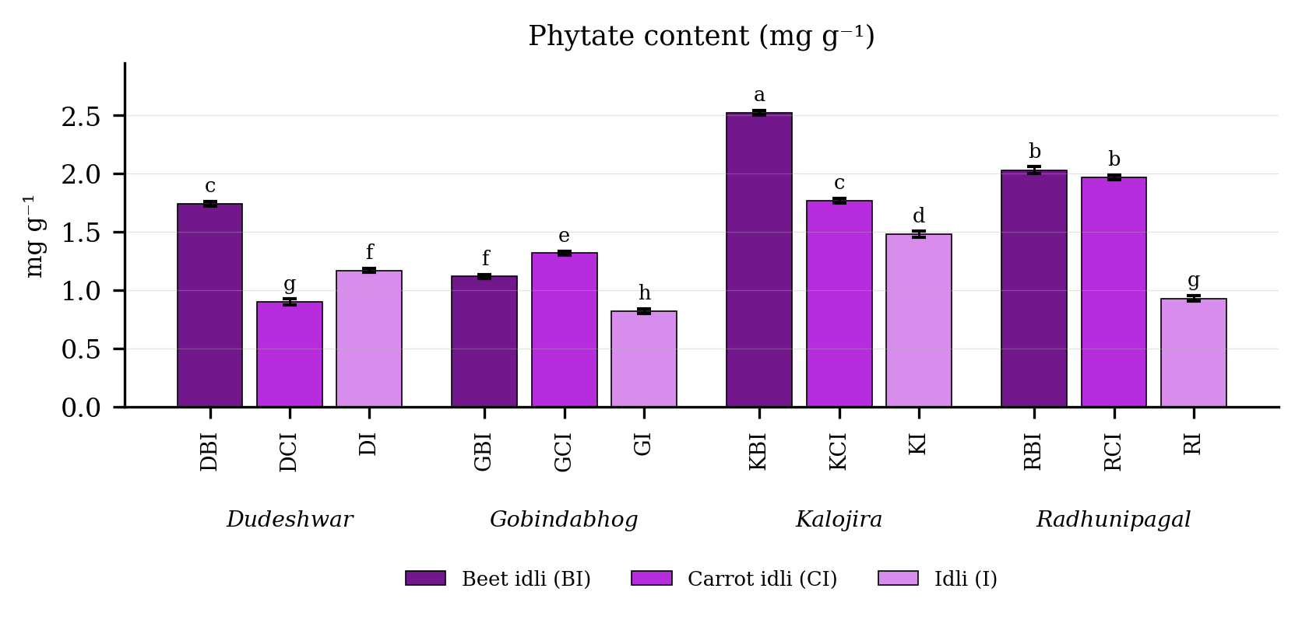
Fig. 4.12. Phytate content (mg g⁻¹) of idli prepared from four rice varieties fortified with carrot and beet extract. Values are means of six observations and the vertical bars are the standard error of the mean. Letters above the bars denote the groupings at the 5 per cent level.
Result
Phytate content (Table 4.12 and Fig. 4.12) differed significantly among the twelve treatment combinations. It was highest in KBI (2.52 mg g⁻¹), followed by RBI (2.03 mg g⁻¹), and lowest in GI (0.82 mg g⁻¹). Among the products the mean value was 1.85 in the beet fortified product, 1.49 in the carrot fortified product and 1.10 in the plain product. Among the varieties it was highest in Kalojira (1.92) and lowest in Gobindabhog (1.09).
The variety and product interaction was significant, the critical difference at the 5 per cent level being 0.04, with a coefficient of variation of 2.50 per cent.
Discussion
The most probable basis of the rise in phytate on fortification is that beetroot itself contributes phytate to the batter, phytate being the principal storage form of phosphorus in plant tissues (Reddy et al., 1982; Singh and Hathan, 2014). Phytate is of consequence because the six phosphate groups of the inositol ring chelate calcium, iron and zinc in the gastrointestinal tract and form insoluble complexes that are poorly absorbed (Haug and Lantzsch, 1983; Sandberg, 2002; Hemalatha et al., 2007). It is therefore encouraging that all the values recorded here lie well below those customarily reported for raw rice and black gram. The probable reason is that phytase derived from the grain itself and from the fermenting microflora hydrolyses a large proportion of the phytate during the soaking and overnight fermentation of the batter, a reduction demonstrated in rice, wheat, sorghum and legumes alike (Lestienne et al., 2005; Hotz and Gibson, 2007; Liang et al., 2008; Gupta et al., 2015). The mineral gain conferred by fortification is thus partly offset by the accompanying rise in phytate, and the phytate to mineral molar ratio rather than the mineral content alone should be used in judging the nutritional value of the product.

4.4 Bioactive constituents and antioxidant potential

4.4.1 Total phenol content (mg GAE 100 g⁻¹)
Table 4.13. Total phenol content (mg GAE 100 g⁻¹) of idli prepared from four rice varieties fortified with carrot and beet extract
Treatment combination | Year 1 | Year 2 | Pooled mean
DBI | 210.88 ± 0.74 | 210.97 ± 0.64 | 210.93 ± 0.62c
DCI | 131.71 ± 0.22 | 131.96 ± 0.71 | 131.84 ± 0.49g
DI | 52.38 ± 0.79 | 54.55 ± 0.37 | 53.47 ± 1.31k
GBI | 278.38 ± 0.61 | 279.96 ± 0.59 | 279.17 ± 1.02b
GCI | 163.62 ± 0.46 | 166.91 ± 0.49 | 165.27 ± 1.85e
GI | 100.76 ± 0.51 | 101.11 ± 0.47 | 100.93 ± 0.48i
KBI | 290.61 ± 0.61 | 291.33 ± 0.14 | 290.97 ± 0.56a
KCI | 175.65 ± 0.68 | 178.82 ± 0.53 | 177.24 ± 1.82d
KI | 126.08 ± 0.57 | 126.32 ± 0.15 | 126.20 ± 0.40h
RBI | 279.91 ± 0.21 | 279.74 ± 0.79 | 279.83 ± 0.52b
RCI | 133.94 ± 0.70 | 138.49 ± 0.79 | 136.22 ± 2.58f
RI | 76.17 ± 0.41 | 77.78 ± 0.76 | 76.98 ± 1.03j
SEm (+/-): Y = 0.29; V = 0.14; P = 0.12; V x P = 0.23; Y x V x P = 0.33
CD (P = 0.05): Y = 0.82; V = 0.38; P = 0.34; V x P = 0.66; Y x V x P = 0.94; CV (%) = 0.34
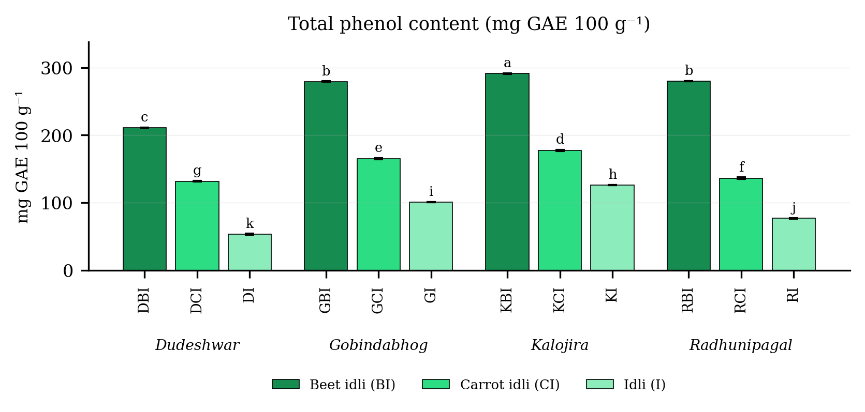
Fig. 4.13. Total phenol content (mg GAE 100 g⁻¹) of idli prepared from four rice varieties fortified with carrot and beet extract. Values are means of six observations and the vertical bars are the standard error of the mean. Letters above the bars denote the groupings at the 5 per cent level.
Result
Total phenol content (Table 4.13 and Fig. 4.13) differed significantly among the twelve treatment combinations. It was highest in KBI (290.97 mg GAE 100 g⁻¹), followed by RBI (279.83 mg GAE 100 g⁻¹), and lowest in DI (53.47 mg GAE 100 g⁻¹). Among the products the mean value was 265.23 in the beet fortified product, 152.64 in the carrot fortified product and 89.40 in the plain product. Among the varieties it was highest in Kalojira (198.14) and lowest in Dudeshwar (132.08).
The variety and product interaction was significant, the critical difference at the 5 per cent level being 0.66, with a coefficient of variation of 0.34 per cent.
Discussion
Two independent sources acting in concert constitute the most probable explanation for the very wide range recorded for total phenol. The first is the parent grain: the pigmented pericarp of the black-husked Kalojira carries a large pool of phenolic acids and proanthocyanidins, and pigmented rice grains have repeatedly been shown to contain several times more phenolics than white grains (Zhang et al., 2010; Sompong et al., 2011; Shao et al., 2014; Goufo and Trindade, 2014). The second is the fortifying material: beetroot supplies betalains together with an appreciable quantity of phenolic acids, and these compounds are reasonably stable at the mildly acidic pH generated by lactic fermentation and survive the brief moist heat of steaming (Kanner et al., 2001; Ravichandran et al., 2013; Chhikara et al., 2019). Fermentation itself may make a third and smaller contribution, since microbial esterases liberate bound phenolic acids from the cell wall matrix and render them extractable, an effect demonstrated in rice, barley and oat systems (Dordevic et al., 2010; Hole et al., 2012; Ti et al., 2014). The superiority of the aromatic landraces over the non-aromatic check likewise accords with the comparison made by Ghosh and Roychoudhury (2018). Kaviyaselvan et al. (2026) separated the phenolics of idli into soluble free, soluble bound and insoluble bound forms and found the insoluble bound fraction to be the largest and the pigmented formulations consistently richer than the non-pigmented ones, which supports the varietal effect recorded here.

4.4.2 Total flavonoid content (mg QE 100 g⁻¹)
Table 4.14. Total flavonoid content (mg QE 100 g⁻¹) of idli prepared from four rice varieties fortified with carrot and beet extract
Treatment combination | Year 1 | Year 2 | Pooled mean
DBI | 101.81 ± 0.65 | 104.09 ± 0.44 | 102.95 ± 1.34d
DCI | 73.99 ± 0.48 | 75.46 ± 0.59 | 74.72 ± 0.94i
DI | 42.34 ± 0.38 | 43.56 ± 0.37 | 42.95 ± 0.75l
GBI | 150.88 ± 0.69 | 153.40 ± 0.50 | 152.14 ± 1.48b
GCI | 96.51 ± 0.40 | 97.83 ± 0.25 | 97.17 ± 0.78f
GI | 70.49 ± 0.13 | 71.09 ± 0.77 | 70.79 ± 0.59j
KBI | 170.94 ± 0.58 | 171.75 ± 0.39 | 171.34 ± 0.63a
KCI | 98.98 ± 0.39 | 98.73 ± 0.82 | 98.86 ± 0.59e
KI | 74.96 ± 0.69 | 77.85 ± 0.20 | 76.41 ± 1.65h
RBI | 144.54 ± 0.71 | 144.61 ± 0.10 | 144.57 ± 0.46c
RCI | 85.75 ± 0.70 | 88.94 ± 0.75 | 87.34 ± 1.86g
RI | 50.49 ± 0.26 | 52.19 ± 0.39 | 51.34 ± 0.98k
SEm (+/-): Y = 0.29; V = 0.12; P = 0.11; V x P = 0.22; Y x V x P = 0.30
CD (P = 0.05): Y = 0.82; V = 0.36; P = 0.30; V x P = 0.60; Y x V x P = 0.86; CV (%) = 0.54
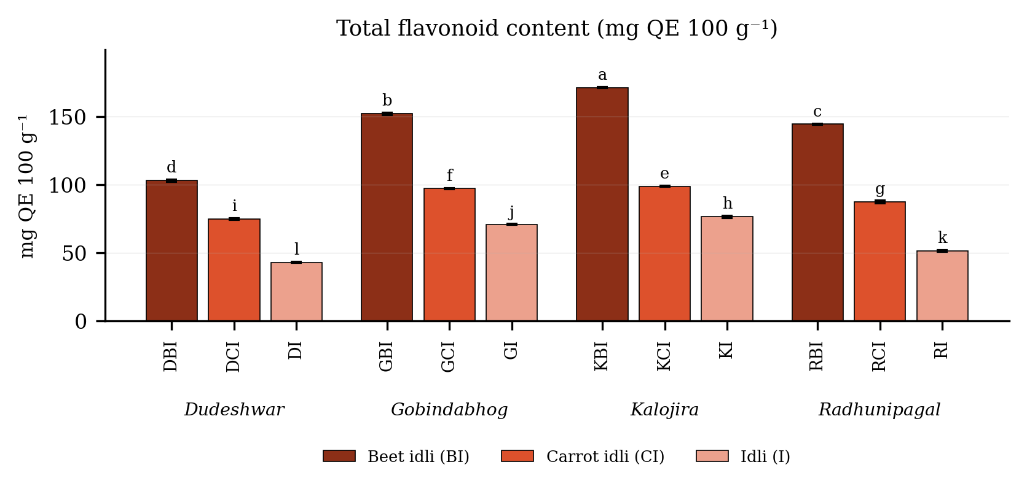
Fig. 4.14. Total flavonoid content (mg QE 100 g⁻¹) of idli prepared from four rice varieties fortified with carrot and beet extract. Values are means of six observations and the vertical bars are the standard error of the mean. Letters above the bars denote the groupings at the 5 per cent level.
Result
Total flavonoid content (Table 4.14 and Fig. 4.14) differed significantly among the twelve treatment combinations. It was highest in KBI (171.34 mg QE 100 g⁻¹), followed by GBI (152.14 mg QE 100 g⁻¹), and lowest in DI (42.95 mg QE 100 g⁻¹). Among the products the mean value was 142.75 in the beet fortified product, 89.52 in the carrot fortified product and 60.37 in the plain product. Among the varieties it was highest in Kalojira (115.54) and lowest in Dudeshwar (73.54).
The variety and product interaction was significant, the critical difference at the 5 per cent level being 0.60, with a coefficient of variation of 0.54 per cent.
Discussion
The probable basis of the flavonoid pattern is the same as that of total phenol, the two fractions sharing a common origin and comparable extraction behaviour. Flavonoids in cereal grains are concentrated in the bran, aleurone and pericarp layers, which are best developed and most heavily pigmented in the black-husked Kalojira (Adom and Liu, 2002; Liu, 2007; Sompong et al., 2011; Goufo and Trindade, 2014). Beetroot supplies a further quantity through its betalain and flavonoid fraction (Kanner et al., 2001; Chhikara et al., 2019), and carrot contributes a smaller amount (Sharma et al., 2012). The release of bound flavonoids from the cell wall matrix by microbial enzymes during fermentation constitutes a probable additional contribution, as has been demonstrated for several fermented cereals (Dordevic et al., 2010; Hole et al., 2012; Ti et al., 2014). The identical ranking of the treatments for phenol and flavonoid supports the interpretation that both were governed by the same two sources. The same order was recorded by Kaviyaselvan et al. (2026) in idli prepared from pigmented rice and pearl millet, in which the insoluble bound flavonoid fraction was the largest and the pigmented formulations again exceeded the non-pigmented ones.

4.4.3 Total antioxidant activity (mg TE 100 g⁻¹)
Table 4.15. Total antioxidant activity (mg TE 100 g⁻¹) of idli prepared from four rice varieties fortified with carrot and beet extract
Treatment combination | Year 1 | Year 2 | Pooled mean
DBI | 369.23 ± 0.17 | 367.79 ± 1.23 | 368.51 ± 1.11c
DCI | 264.09 ± 0.80 | 263.66 ± 1.22 | 263.87 ± 0.95g
DI | 166.11 ± 0.10 | 164.40 ± 0.96 | 165.26 ± 1.12k
GBI | 390.58 ± 0.96 | 388.86 ± 1.01 | 389.72 ± 1.29b
GCI | 297.95 ± 0.11 | 296.63 ± 1.29 | 297.29 ± 1.09e
GI | 189.45 ± 0.63 | 187.18 ± 1.52 | 188.31 ± 1.62i
KBI | 426.91 ± 1.16 | 426.84 ± 0.99 | 426.88 ± 0.97a
KCI | 306.42 ± 0.81 | 305.02 ± 1.50 | 305.72 ± 1.32d
KI | 211.30 ± 0.82 | 210.21 ± 1.04 | 210.76 ± 1.03h
RBI | 389.41 ± 0.40 | 387.94 ± 0.71 | 388.68 ± 0.96b
RCI | 284.57 ± 0.90 | 283.35 ± 0.76 | 283.96 ± 1.00f
RI | 176.62 ± 1.41 | 177.08 ± 0.87 | 176.85 ± 1.08j
SEm (+/-): Y = 0.18; V = 0.23; P = 0.20; V x P = 0.40; Y x V x P = 0.56
CD (P = 0.05): Y = 0.50; V = 0.64; P = 0.56; V x P = 1.13; Y x V x P = NS; CV (%) = 0.34
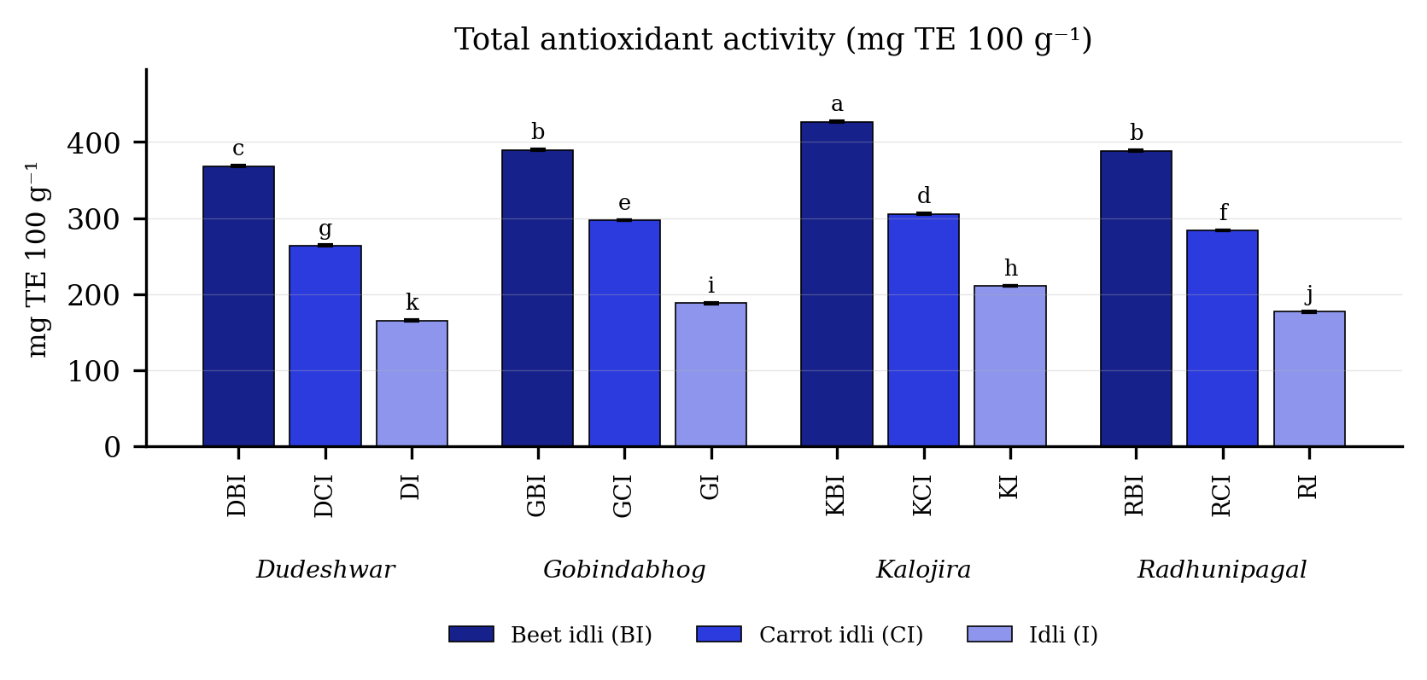
Fig. 4.15. Total antioxidant activity (mg TE 100 g⁻¹) of idli prepared from four rice varieties fortified with carrot and beet extract. Values are means of six observations and the vertical bars are the standard error of the mean. Letters above the bars denote the groupings at the 5 per cent level.
Result
Total antioxidant activity (Table 4.15 and Fig. 4.15) differed significantly among the twelve treatment combinations. It was highest in KBI (426.88 mg TE 100 g⁻¹), followed by GBI (389.72 mg TE 100 g⁻¹), and lowest in DI (165.26 mg TE 100 g⁻¹). Among the products the mean value was 393.45 in the beet fortified product, 287.71 in the carrot fortified product and 185.29 in the plain product. Among the varieties it was highest in Kalojira (314.45) and lowest in Dudeshwar (265.88).
The variety and product interaction was significant, the critical difference at the 5 per cent level being 1.13, with a coefficient of variation of 0.34 per cent.
Discussion
The most probable basis of the antioxidant activity pattern is that the antioxidant capacity of a cereal-based food is governed almost entirely by its phenolic and flavonoid pool, so that this character necessarily followed those two fractions. The relationship is well established for rice and for whole grains generally (Adom and Liu, 2002; Liu, 2007; Shao et al., 2014; Goufo and Trindade, 2014) and is confirmed in the present study by the very high correlations recorded between the three fractions. The betalains of beetroot make an additional and independent contribution, being powerful hydrogen donors with a radical-scavenging capacity comparable with that of the common flavonoids (Kanner et al., 2001; Stintzing and Carle, 2004; Ravichandran et al., 2013). Fermentation may raise the measured activity further by liberating bound phenolics into the free and more readily assayed form, an increase reported in fermented rice, barley and oat products (Dordevic et al., 2010; Hole et al., 2012; Ti et al., 2014). Kaviyaselvan et al. (2026) likewise reported that the insoluble bound fraction of idli carried the highest antioxidant activity of the three phenolic fractions, which confirms the bound phenolics of the bran layer to be the principal contributors to the antioxidant capacity of the product.

4.4.4 Beta-carotene content
Table 4.16. Beta-carotene content of idli prepared from four rice varieties fortified with carrot and beet extract
Treatment combination | Year 1 | Year 2 | Pooled mean
DBI | 3.39 ± 0.10 | 3.51 ± 0.02 | 3.45 ± 0.09e
DCI | 29.35 ± 0.09 | 29.28 ± 0.02 | 29.32 ± 0.07d
DI | 0.00 ± 0.00 | 0.00 ± 0.00 | 0.00 ± 0.00i
GBI | 1.29 ± 0.10 | 1.27 ± 0.08 | 1.28 ± 0.09h
GCI | 43.63 ± 0.06 | 43.56 ± 0.07 | 43.59 ± 0.07b
GI | 0.00 ± 0.00 | 0.00 ± 0.00 | 0.00 ± 0.00i
KBI | 2.00 ± 0.09 | 2.04 ± 0.12 | 2.02 ± 0.10g
KCI | 45.79 ± 0.04 | 45.75 ± 0.08 | 45.77 ± 0.06a
KI | 0.00 ± 0.00 | 0.00 ± 0.00 | 0.00 ± 0.00i
RBI | 3.15 ± 0.09 | 2.92 ± 0.12 | 3.03 ± 0.16f
RCI | 36.70 ± 0.06 | 36.77 ± 0.05 | 36.73 ± 0.06c
RI | 0.00 ± 0.00 | 0.00 ± 0.00 | 0.00 ± 0.00i
SEm (+/-): Y = 0.02; V = 0.02; P = 0.01; V x P = 0.03; Y x V x P = 0.04
CD (P = 0.05): Y = NS; V = 0.04; P = 0.04; V x P = 0.08; Y x V x P = 0.10; CV (%) = 0.48
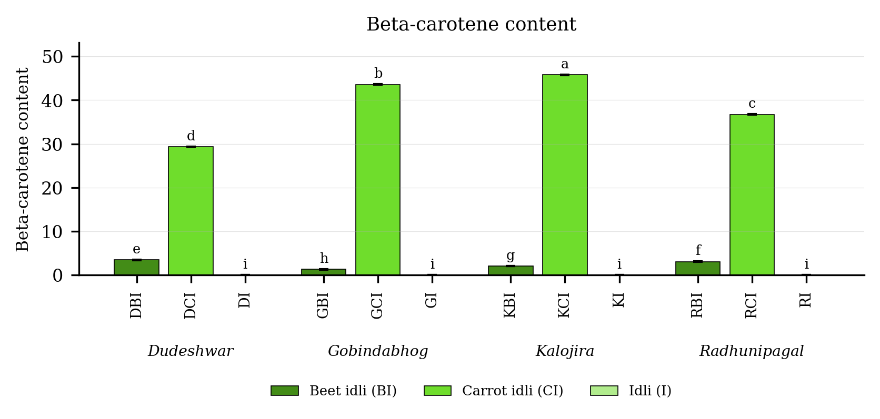
Fig. 4.16. Beta-carotene content of idli prepared from four rice varieties fortified with carrot and beet extract. Values are means of six observations and the vertical bars are the standard error of the mean. Letters above the bars denote the groupings at the 5 per cent level.
Result
Beta-carotene content (Table 4.16 and Fig. 4.16) differed significantly among the twelve treatment combinations. It was highest in KCI (45.77), followed by GCI (43.59), and lowest in DI (0.00). Among the products the mean value was 38.85 in the carrot fortified product, 2.44 in the beet fortified product and 0.00 in the plain product. Among the varieties it was highest in Kalojira (15.93) and lowest in Dudeshwar (10.92).
The variety and product interaction was significant, the critical difference at the 5 per cent level being 0.08, with a coefficient of variation of 0.48 per cent.
Discussion
Carrot constituted the only meaningful source of provitamin A in this study, which is the evident and most probable basis of the pattern recorded. Carrot ranks among the richest dietary sources of all-trans beta-carotene, and its carotenoids are located in chromoplasts readily ruptured during grinding, so that the pigment is efficiently transferred to the batter (Britton, 1995; Rodriguez-Amaya, 2001; Sharma et al., 2012). Milled rice and black gram carry essentially no carotenoid, which accounts for the nil values of the plain treatments (Champagne, 2004; Gopalan et al., 2004). The good retention of the pigment in the finished product is attributable to the mild processing conditions, all-trans beta-carotene being reasonably stable under the brief moist heat of steaming but rapidly lost under frying or prolonged dry heating (Delgado-Vargas et al., 2000; Rodriguez-Amaya, 2001). The mildly acidic pH generated by fermentation may additionally afford some protection against isomerisation and oxidation during the batter stage (Blandino et al., 2003).

4.4.5 Anthocyanin content
Table 4.17. Anthocyanin content of idli prepared from four rice varieties fortified with carrot and beet extract
Treatment combination | Year 1 | Year 2 | Pooled mean
DBI | 0.98 ± 0.06 | 0.98 ± 0.09 | 0.98 ± 0.07d
DCI | 0.00 ± 0.00 | 0.00 ± 0.00 | 0.00 ± 0.00e
DI | 0.00 ± 0.00 | 0.00 ± 0.00 | 0.00 ± 0.00e
GBI | 1.30 ± 0.10 | 1.25 ± 0.06 | 1.27 ± 0.08c
GCI | 0.00 ± 0.00 | 0.00 ± 0.00 | 0.00 ± 0.00e
GI | 0.00 ± 0.00 | 0.00 ± 0.00 | 0.00 ± 0.00e
KBI | 1.85 ± 0.04 | 1.87 ± 0.05 | 1.86 ± 0.05a
KCI | 0.00 ± 0.00 | 0.00 ± 0.00 | 0.00 ± 0.00e
KI | 0.00 ± 0.00 | 0.00 ± 0.00 | 0.00 ± 0.00e
RBI | 1.48 ± 0.09 | 1.58 ± 0.11 | 1.53 ± 0.10b
RCI | 0.00 ± 0.00 | 0.00 ± 0.00 | 0.00 ± 0.00e
RI | 0.00 ± 0.00 | 0.00 ± 0.00 | 0.00 ± 0.00e
SEm (+/-): Y = 0.01; V = 0.01; P = 0.01; V x P = 0.02; Y x V x P = 0.03
CD (P = 0.05): Y = NS; V = 0.04; P = 0.02; V x P = 0.06; Y x V x P = NS; CV (%) = 9.63
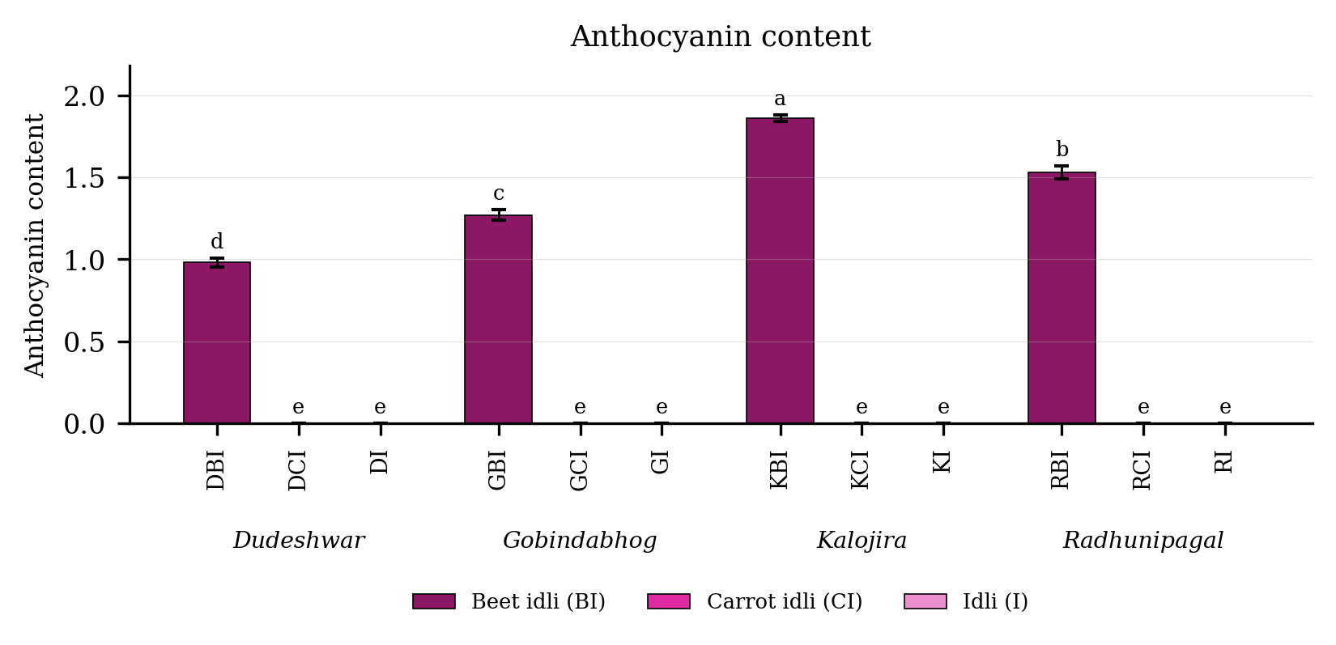
Fig. 4.17. Anthocyanin content of idli prepared from four rice varieties fortified with carrot and beet extract. Values are means of six observations and the vertical bars are the standard error of the mean. Letters above the bars denote the groupings at the 5 per cent level.
Result
Anthocyanin content (Table 4.17 and Fig. 4.17) differed significantly among the twelve treatment combinations. It was highest in KBI (1.86), followed by RBI (1.53), and lowest in DCI (0.00). Among the products the mean value was 1.41 in the beet fortified product, 0.00 in the plain product and 0.00 in the carrot fortified product. Among the varieties it was highest in Kalojira (0.62) and lowest in Dudeshwar (0.33).
The variety and product interaction was significant, the critical difference at the 5 per cent level being 0.06, with a coefficient of variation of 9.63 per cent.
Discussion
The most probable basis of the anthocyanin pattern is that the pigment derived from two sources, both present only in certain treatments. The principal source was the betacyanin fraction of beetroot, which is determined together with anthocyanin by the spectrophotometric method employed and which was introduced only into the beet fortified treatments (Stintzing and Carle, 2004; Azeredo, 2009; Chhikara et al., 2019). The second and smaller source was the pigment carried over from the black-husked kernel of Kalojira, which accounts for this variety recording the highest value within the beet fortified group (Sompong et al., 2011; Shao et al., 2014). The retention of the pigment in the finished product is attributable to the mildly acidic pH generated during lactic fermentation, betalains and anthocyanins alike being most stable in the pH range of approximately four to six and degrading rapidly under alkaline conditions or prolonged heating (Herbach et al., 2006; Azeredo, 2009; Ravichandran et al., 2013).

4.5 Mineral composition

4.5.1 Copper content (mg L⁻¹)
Table 4.18. Copper content (mg L⁻¹) of idli prepared from four rice varieties fortified with carrot and beet extract
Treatment combination | Year 1 | Year 2 | Pooled mean
DBI | 0.31 ± 0.06 | 0.32 ± 0.03 | 0.32 ± 0.04de
DCI | 0.78 ± 0.02 | 0.79 ± 0.04 | 0.78 ± 0.03b
DI | 0.19 ± 0.06 | 0.22 ± 0.06 | 0.21 ± 0.06f
GBI | 0.90 ± 0.03 | 1.04 ± 0.02 | 0.97 ± 0.08a
GCI | 0.44 ± 0.05 | 0.43 ± 0.03 | 0.44 ± 0.04c
GI | 0.27 ± 0.03 | 0.25 ± 0.03 | 0.26 ± 0.03ef
KBI | 0.32 ± 0.05 | 0.36 ± 0.03 | 0.34 ± 0.04d
KCI | 0.16 ± 0.05 | 0.26 ± 0.03 | 0.21 ± 0.06f
KI | 0.23 ± 0.07 | 0.35 ± 0.04 | 0.29 ± 0.08de
RBI | 0.29 ± 0.02 | 0.27 ± 0.04 | 0.28 ± 0.03def
RCI | 0.39 ± 0.01 | 0.45 ± 0.02 | 0.42 ± 0.04c
RI | 0.27 ± 0.02 | 0.32 ± 0.04 | 0.29 ± 0.04de
SEm (+/-): Y = 0.01; V = 0.01; P = 0.01; V x P = 0.02; Y x V x P = 0.02
CD (P = 0.05): Y = 0.04; V = 0.02; P = 0.02; V x P = 0.04; Y x V x P = 0.06; CV (%) = 9.65
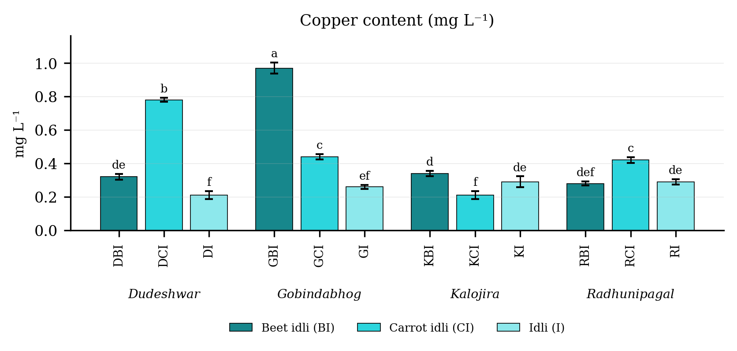
Fig. 4.18. Copper content (mg L⁻¹) of idli prepared from four rice varieties fortified with carrot and beet extract. Values are means of six observations and the vertical bars are the standard error of the mean. Letters above the bars denote the groupings at the 5 per cent level.
Result
Copper content (Table 4.18 and Fig. 4.18) differed significantly among the twelve treatment combinations. It was highest in GBI (0.97 mg L⁻¹), followed by DCI (0.78 mg L⁻¹), and lowest in DI (0.21 mg L⁻¹). Among the products the mean value was 0.48 in the beet fortified product, 0.46 in the carrot fortified product and 0.26 in the plain product. Among the varieties it was highest in Gobindabhog (0.56) and lowest in Kalojira (0.28).
The variety and product interaction was significant, the critical difference at the 5 per cent level being 0.04, with a coefficient of variation of 9.65 per cent.
Discussion
Copper is largely a varietal character determined by the mineral status of the parent grain and by the soil on which it was grown, which constitutes the most probable basis of the clear separation of the varieties recorded here (Rani et al., 2006; Hemalatha et al., 2007; Gopalan et al., 2004). Gobindabhog carried the best overall mineral profile of the four varieties, consistent with its highest ash content. The rise on fortification is attributable to the copper contributed by the vegetable extract itself, beetroot constituting a modest but useful source of trace elements (Singh and Hathan, 2014; Chhikara et al., 2019). The availability of copper, like that of the other divalent cations, is contingent upon the phytate content of the product, and the reduction of phytate during soaking and fermentation is likely to have improved its accessibility (Sandberg, 2002; Lestienne et al., 2005; Hotz and Gibson, 2007).

4.5.2 Iron content (mg L⁻¹)
Table 4.19. Iron content (mg L⁻¹) of idli prepared from four rice varieties fortified with carrot and beet extract
Treatment combination | Year 1 | Year 2 | Pooled mean
DBI | 1.45 ± 0.02 | 1.67 ± 0.05 | 1.56 ± 0.12gh
DCI | 1.39 ± 0.02 | 1.95 ± 0.02 | 1.67 ± 0.31e
DI | 1.19 ± 0.02 | 1.53 ± 0.02 | 1.36 ± 0.19j
GBI | 2.12 ± 0.03 | 2.64 ± 0.05 | 2.38 ± 0.29c
GCI | 2.02 ± 0.05 | 2.31 ± 0.06 | 2.16 ± 0.16d
GI | 2.91 ± 0.03 | 3.07 ± 0.03 | 2.99 ± 0.09b
KBI | 1.24 ± 0.03 | 1.76 ± 0.03 | 1.50 ± 0.29hi
KCI | 1.35 ± 0.05 | 1.84 ± 0.02 | 1.59 ± 0.27fg
KI | 1.28 ± 0.04 | 1.69 ± 0.04 | 1.48 ± 0.22i
RBI | 1.46 ± 0.04 | 1.85 ± 0.02 | 1.66 ± 0.21ef
RCI | 1.44 ± 0.02 | 1.55 ± 0.03 | 1.50 ± 0.06hi
RI | 3.26 ± 0.05 | 3.46 ± 0.02 | 3.36 ± 0.11a
SEm (+/-): Y = 0.03; V = 0.01; P = 0.01; V x P = 0.01; Y x V x P = 0.02
CD (P = 0.05): Y = 0.08; V = 0.02; P = 0.02; V x P = 0.04; Y x V x P = 0.06; CV (%) = 1.77
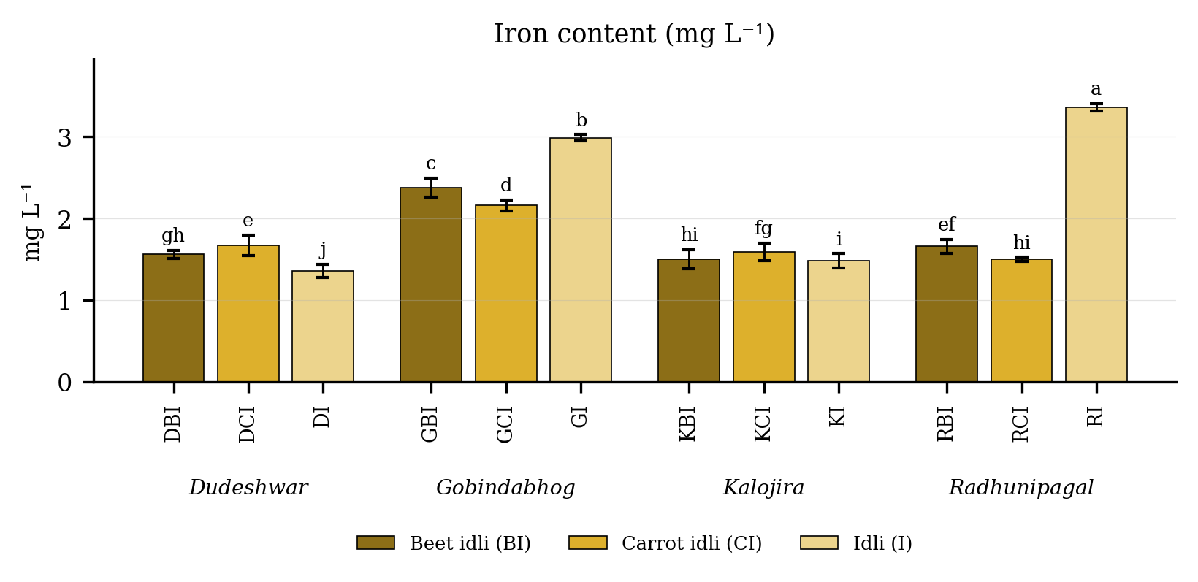
Fig. 4.19. Iron content (mg L⁻¹) of idli prepared from four rice varieties fortified with carrot and beet extract. Values are means of six observations and the vertical bars are the standard error of the mean. Letters above the bars denote the groupings at the 5 per cent level.
Result
Iron content (Table 4.19 and Fig. 4.19) differed significantly among the twelve treatment combinations. It was highest in RI (3.36 mg L⁻¹), followed by GI (2.99 mg L⁻¹), and lowest in DI (1.36 mg L⁻¹). Among the products the mean value was 2.30 in the plain product, 1.77 in the beet fortified product and 1.73 in the carrot fortified product. Among the varieties it was highest in Gobindabhog (2.51) and lowest in Kalojira (1.52).
The variety and product interaction was significant, the critical difference at the 5 per cent level being 0.04, with a coefficient of variation of 1.77 per cent.
Discussion
The most probable basis of iron being highest in the plain products of the aromatic landraces is that the grain itself constitutes the principal source of this element, so that any addition of a low-iron vegetable extract dilutes it (Rani et al., 2006; Gopalan et al., 2004; Chhikara et al., 2019). The varietal differences recorded reflect genuine differences in grain iron between the landraces, a variation well documented in rice germplasm (Champagne, 2004; Hemalatha et al., 2007). Although rice-based diets are generally poor in available iron, the soaking and fermentation steps preceding steaming improve its accessibility considerably by activating phytase and lowering the phytate to iron molar ratio, an improvement demonstrated for rice, wheat and legume systems alike (Sandberg, 2002; Lestienne et al., 2005; Hotz and Gibson, 2007; Liang et al., 2008). The practical value of the present result therefore resides as much in the processing method as in the absolute iron content.

4.5.3 Zinc content (mg L⁻¹)
Table 4.20. Zinc content (mg L⁻¹) of idli prepared from four rice varieties fortified with carrot and beet extract
Treatment combination | Year 1 | Year 2 | Pooled mean
DBI | 0.63 ± 0.02 | 0.67 ± 0.02 | 0.65 ± 0.03g
DCI | 0.65 ± 0.02 | 0.74 ± 0.03 | 0.70 ± 0.05efg
DI | 0.53 ± 0.04 | 0.75 ± 0.03 | 0.64 ± 0.12g
GBI | 0.74 ± 0.03 | 0.63 ± 0.04 | 0.69 ± 0.07efg
GCI | 0.65 ± 0.01 | 0.70 ± 0.05 | 0.67 ± 0.04g
GI | 0.73 ± 0.03 | 0.83 ± 0.04 | 0.78 ± 0.06cd
KBI | 0.74 ± 0.04 | 1.00 ± 0.04 | 0.87 ± 0.15ab
KCI | 0.72 ± 0.04 | 0.76 ± 0.05 | 0.74 ± 0.05def
KI | 0.57 ± 0.02 | 0.78 ± 0.03 | 0.68 ± 0.11fg
RBI | 0.75 ± 0.02 | 0.89 ± 0.05 | 0.82 ± 0.08bc
RCI | 0.65 ± 0.01 | 0.85 ± 0.05 | 0.75 ± 0.12cde
RI | 0.84 ± 0.06 | 0.94 ± 0.02 | 0.89 ± 0.07a
SEm (+/-): Y = 0.02; V = 0.01; P = 0.01; V x P = 0.01; Y x V x P = 0.02
CD (P = 0.05): Y = 0.06; V = 0.02; P = 0.02; V x P = 0.04; Y x V x P = 0.06; CV (%) = 4.63
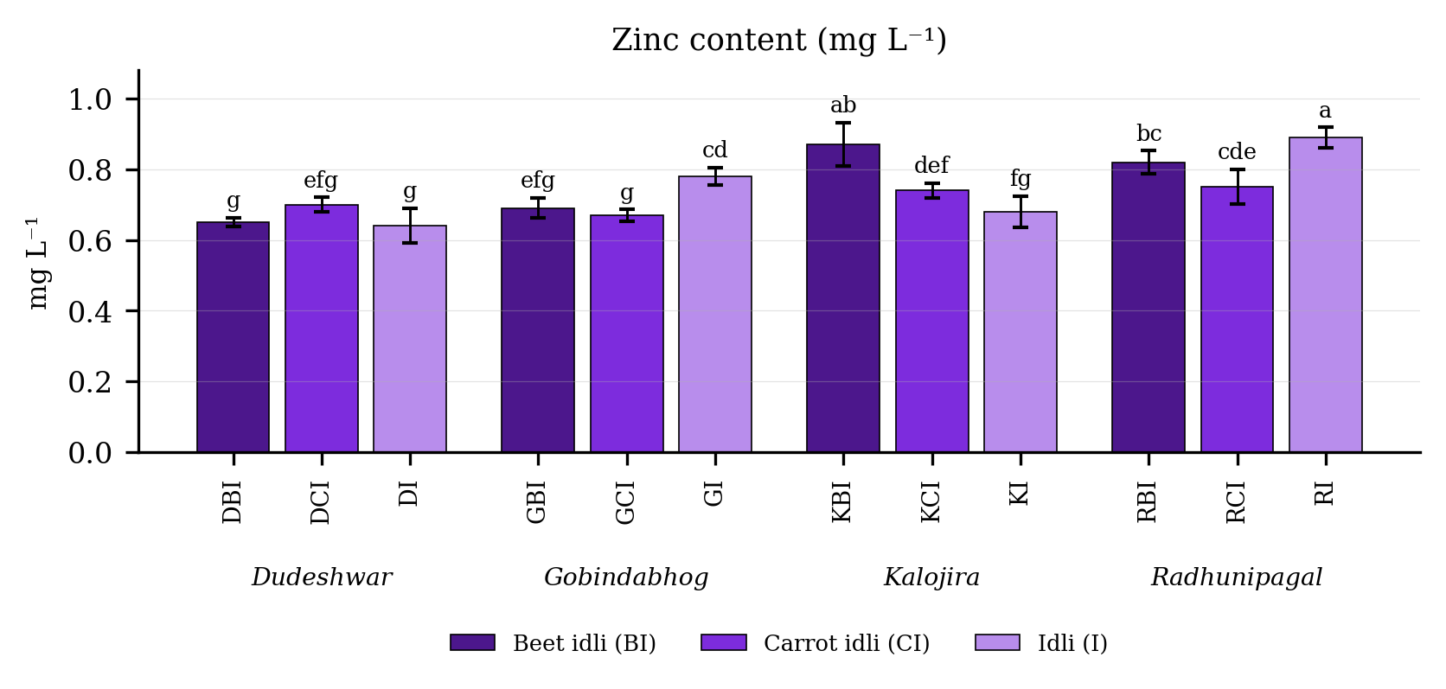
Fig. 4.20. Zinc content (mg L⁻¹) of idli prepared from four rice varieties fortified with carrot and beet extract. Values are means of six observations and the vertical bars are the standard error of the mean. Letters above the bars denote the groupings at the 5 per cent level.
Result
Zinc content (Table 4.20 and Fig. 4.20) differed significantly among the twelve treatment combinations. It was highest in RI (0.89 mg L⁻¹), followed by KBI (0.87 mg L⁻¹), and lowest in DI (0.64 mg L⁻¹). Among the products the mean value was 0.76 in the beet fortified product, 0.75 in the plain product and 0.71 in the carrot fortified product. Among the varieties it was highest in Radhunipagal (0.82) and lowest in Dudeshwar (0.66).
The variety and product interaction was significant, the critical difference at the 5 per cent level being 0.04, with a coefficient of variation of 4.63 per cent.
Discussion
Zinc altered comparatively little with fortification, the probable basis being that the grain and the black gram, rather than the vegetable extract, constitute its principal source in this product (Gopalan et al., 2004; Hemalatha et al., 2007). The differences recorded were therefore chiefly varietal and reflect the grain zinc status of the four landraces (Champagne, 2004; Rani et al., 2006). More consequential than the absolute content is the availability of the zinc present, since phytate binds zinc strongly and a phytate to zinc molar ratio exceeding fifteen is generally taken to indicate poor absorption (Sandberg, 2002; Hemalatha et al., 2007). The soaking and overnight fermentation of the batter activate endogenous and microbial phytase and lower this ratio appreciably, which has been shown to improve zinc solubility in brown rice and in other cereals (Lestienne et al., 2005; Hotz and Gibson, 2007; Liang et al., 2008; Gupta et al., 2015).

4.5.4 Manganese content (mg L⁻¹)
Table 4.21. Manganese content (mg L⁻¹) of idli prepared from four rice varieties fortified with carrot and beet extract
Treatment combination | Year 1 | Year 2 | Pooled mean
DBI | 0.40 ± 0.03 | 0.45 ± 0.06 | 0.42 ± 0.05ef
DCI | 0.38 ± 0.03 | 0.43 ± 0.04 | 0.40 ± 0.04f
DI | 0.29 ± 0.04 | 0.46 ± 0.03 | 0.37 ± 0.10f
GBI | 0.61 ± 0.06 | 0.74 ± 0.03 | 0.68 ± 0.08a
GCI | 0.59 ± 0.04 | 0.50 ± 0.04 | 0.55 ± 0.06bc
GI | 0.64 ± 0.03 | 0.73 ± 0.03 | 0.69 ± 0.05a
KBI | 0.50 ± 0.04 | 0.69 ± 0.03 | 0.60 ± 0.11b
KCI | 0.58 ± 0.02 | 0.77 ± 0.04 | 0.67 ± 0.11a
KI | 0.49 ± 0.04 | 0.62 ± 0.04 | 0.56 ± 0.08bcd
RBI | 0.42 ± 0.03 | 0.56 ± 0.06 | 0.49 ± 0.09de
RCI | 0.42 ± 0.02 | 0.60 ± 0.03 | 0.51 ± 0.10cd
RI | 0.47 ± 0.03 | 0.54 ± 0.04 | 0.51 ± 0.05cd
SEm (+/-): Y = 0.25; V = 0.15; P = 0.13; V x P = 0.25; Y x V x P = 0.36
CD (P = 0.05): Y = 0.70; V = 0.42; P = NS; V x P = 0.72; Y x V x P = 1.01; CV (%) = 6.91
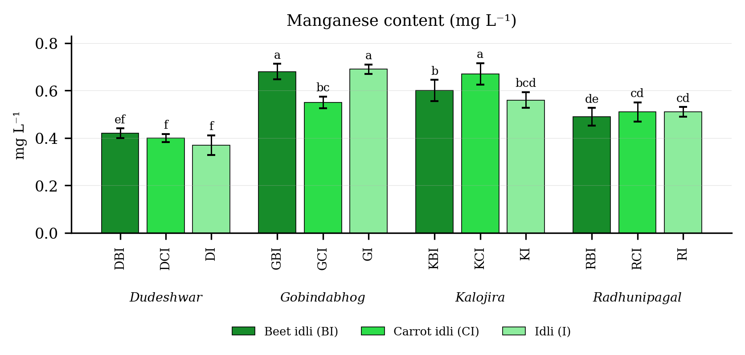
Fig. 4.21. Manganese content (mg L⁻¹) of idli prepared from four rice varieties fortified with carrot and beet extract. Values are means of six observations and the vertical bars are the standard error of the mean. Letters above the bars denote the groupings at the 5 per cent level.
Result
Manganese content (Table 4.21 and Fig. 4.21) differed significantly among the twelve treatment combinations. It was highest in GI (0.69 mg L⁻¹), followed by GBI (0.68 mg L⁻¹), and lowest in DI (0.37 mg L⁻¹). Among the products the mean value was 0.55 in the beet fortified product, 0.53 in the plain product and 0.53 in the carrot fortified product. Among the varieties it was highest in Gobindabhog (0.64) and lowest in Dudeshwar (0.40).
The variety and product interaction was significant, the critical difference at the 5 per cent level being 0.72, with a coefficient of variation of 6.91 per cent.
Discussion
Manganese was the only character in the study for which the main effect of fortification proved non-significant, the most probable basis being that neither beetroot nor carrot is a rich source of this element, so that the vegetable extract neither augmented nor appreciably diluted it (Sharma et al., 2012; Singh and Hathan, 2014; Chhikara et al., 2019). The differences recorded were therefore essentially varietal and reflect the grain manganese status of the landraces, which is known to vary with genotype and with the soil on which the crop is grown (Rani et al., 2006; Hemalatha et al., 2007; Gopalan et al., 2004). The interaction was nevertheless significant, which indicates that the small response to the extract was not identical in every variety, most probably because the base manganese content differed and because phytate, which likewise binds manganese, differed between the varieties (Sandberg, 2002; Lestienne et al., 2005).

4.5.5 Calcium content (mg L⁻¹)
Table 4.22. Calcium content (mg L⁻¹) of idli prepared from four rice varieties fortified with carrot and beet extract
Treatment combination | Year 1 | Year 2 | Pooled mean
DBI | 510.41 ± 0.79 | 510.82 ± 0.18 | 510.62 ± 0.56b
DCI | 381.93 ± 0.48 | 383.57 ± 0.55 | 382.75 ± 1.01f
DI | 96.90 ± 0.62 | 97.45 ± 0.35 | 97.18 ± 0.54j
GBI | 550.58 ± 0.78 | 551.19 ± 0.76 | 550.88 ± 0.77a
GCI | 450.87 ± 0.42 | 451.21 ± 0.10 | 451.04 ± 0.33e
GI | 112.91 ± 0.61 | 114.42 ± 0.71 | 113.67 ± 1.01g
KBI | 460.37 ± 0.44 | 460.09 ± 0.07 | 460.23 ± 0.32d
KCI | 112.24 ± 0.72 | 112.72 ± 0.73 | 112.48 ± 0.70h
KI | 61.18 ± 0.48 | 61.71 ± 0.45 | 61.44 ± 0.51l
RBI | 481.11 ± 0.26 | 482.54 ± 0.83 | 481.83 ± 0.96c
RCI | 106.39 ± 0.53 | 107.55 ± 0.71 | 106.97 ± 0.85i
RI | 66.89 ± 0.33 | 69.08 ± 0.67 | 67.99 ± 1.29k
SEm (+/-): Y = 0.11; V = 0.13; P = 0.12; V x P = 0.23; Y x V x P = 0.33
CD (P = 0.05): Y = 0.32; V = 0.38; P = 0.32; V x P = 0.66; Y x V x P = NS; CV (%) = 0.20
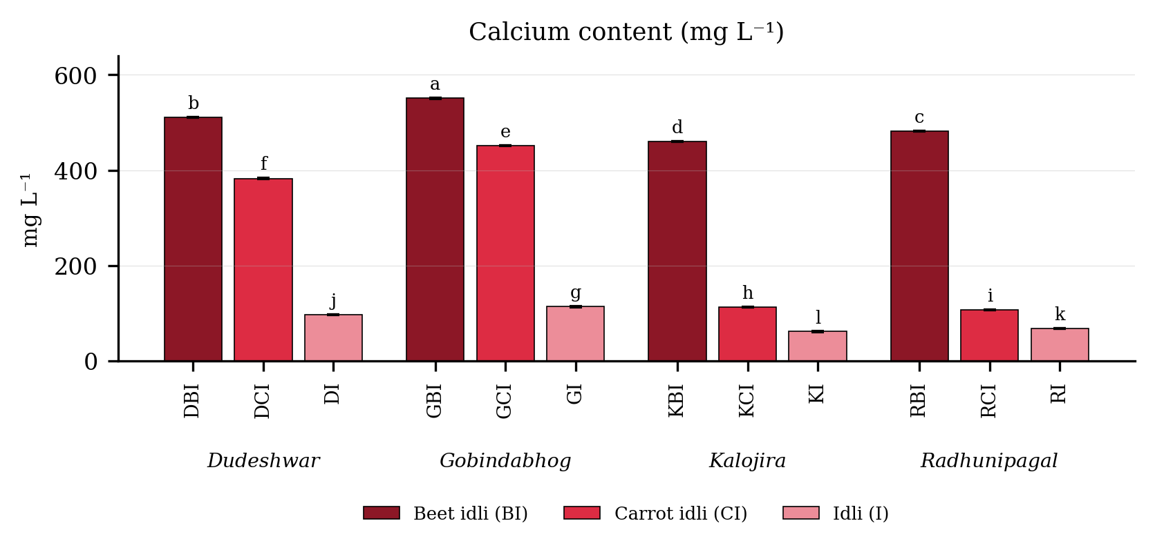
Fig. 4.22. Calcium content (mg L⁻¹) of idli prepared from four rice varieties fortified with carrot and beet extract. Values are means of six observations and the vertical bars are the standard error of the mean. Letters above the bars denote the groupings at the 5 per cent level.
Result
Calcium content (Table 4.22 and Fig. 4.22) differed significantly among the twelve treatment combinations. It was highest in GBI (550.88 mg L⁻¹), followed by DBI (510.62 mg L⁻¹), and lowest in KI (61.44 mg L⁻¹). Among the products the mean value was 500.89 in the beet fortified product, 263.31 in the carrot fortified product and 85.07 in the plain product. Among the varieties it was highest in Gobindabhog (371.86) and lowest in Kalojira (211.38).
The variety and product interaction was significant, the critical difference at the 5 per cent level being 0.66, with a coefficient of variation of 0.20 per cent.
Discussion
The very large rise in calcium on fortification has an evident and direct cause, namely that beetroot is a good source of calcium and its extract introduces a substantial quantity of the element into the batter (Singh and Hathan, 2014; Chhikara et al., 2019). Carrot contributes a smaller amount, which accounts for the intermediate position of the carrot fortified treatments (Sharma et al., 2012). Milled rice is very poor in calcium and black gram supplies only a moderate quantity, so that the plain treatments returned the lowest values (Rani et al., 2006; Gopalan et al., 2004). The gain is of practical nutritional importance, since rice-based diets are widely recognised to be deficient in calcium (Gopalan et al., 2004; Oghbaei and Prakash, 2016). It must, however, be read alongside the parallel rise in phytate recorded in the same treatments, since phytate binds calcium and reduces its absorption, so that the phytate to calcium ratio determines what proportion of the added calcium is actually available (Reddy et al., 1982; Sandberg, 2002; Hemalatha et al., 2007).

4.6 Colour attributes

4.6.1 Lightness (L*)
Table 4.23. Lightness (L*) of idli prepared from four rice varieties fortified with carrot and beet extract
Treatment combination | Year 1 | Year 2 | Pooled mean
DBI | 36.02 ± 0.72 | 36.92 ± 0.49 | 36.47 ± 0.74k
DCI | 61.25 ± 0.62 | 62.16 ± 0.56 | 61.70 ± 0.73e
DI | 72.94 ± 0.23 | 72.90 ± 0.34 | 72.92 ± 0.26a
GBI | 43.85 ± 0.94 | 45.62 ± 0.46 | 44.74 ± 1.18h
GCI | 58.16 ± 0.53 | 59.23 ± 0.48 | 58.69 ± 0.74f
GI | 66.67 ± 0.15 | 67.29 ± 0.79 | 66.98 ± 0.61c
KBI | 38.23 ± 0.71 | 39.37 ± 0.61 | 38.80 ± 0.86j
KCI | 52.96 ± 0.36 | 53.06 ± 0.21 | 53.01 ± 0.27g
KI | 68.03 ± 0.33 | 69.97 ± 0.77 | 69.00 ± 1.19b
RBI | 41.87 ± 0.25 | 43.67 ± 0.34 | 42.77 ± 1.03i
RCI | 65.31 ± 0.19 | 64.70 ± 0.36 | 65.00 ± 0.42d
RI | 60.85 ± 0.64 | 63.23 ± 0.68 | 62.04 ± 1.43e
SEm (+/-): Y = 0.20; V = 0.13; P = 0.11; V x P = 0.22; Y x V x P = 0.31
CD (P = 0.05): Y = 0.56; V = 0.36; P = 0.30; V x P = 0.62; Y x V x P = 0.88; CV (%) = 0.95
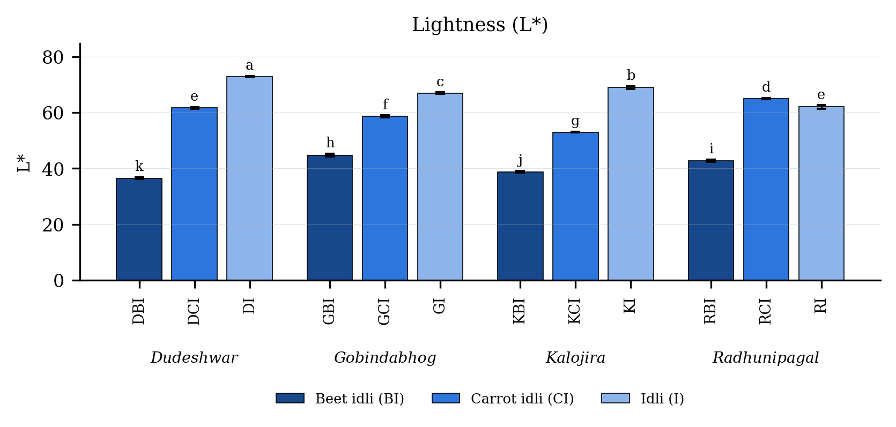
Fig. 4.23. Lightness (L*) of idli prepared from four rice varieties fortified with carrot and beet extract. Values are means of six observations and the vertical bars are the standard error of the mean. Letters above the bars denote the groupings at the 5 per cent level.
Result
Lightness (Table 4.23 and Fig. 4.23) differed significantly among the twelve treatment combinations. It was highest in DI (72.92 L*), followed by KI (69.00 L*), and lowest in DBI (36.47 L*). Among the products the mean value was 67.73 in the plain product, 59.60 in the carrot fortified product and 40.70 in the beet fortified product. Among the varieties it was highest in Dudeshwar (57.03) and lowest in Kalojira (53.60).
The variety and product interaction was significant, the critical difference at the 5 per cent level being 0.62, with a coefficient of variation of 0.95 per cent.
Discussion
The most probable basis of the decline in lightness on fortification is the direct addition of a strongly coloured pigment to an otherwise white product. Beetroot introduces betacyanin, which absorbs strongly in the green region and produces a deep red to violet colour, while the carotenoids of carrot absorb in the blue region and darken the product to a smaller extent (Delgado-Vargas et al., 2000; Stintzing and Carle, 2004; Ravichandran et al., 2013). The consistently lower lightness of all Kalojira treatments is attributable to pigment carried over from the black-husked kernel during milling and soaking (Lamberts et al., 2007; Sompong et al., 2011). Lightness constitutes an important quality index, being the colour attribute to which the human eye is most sensitive and exerting a strong influence upon the first impression of a steamed cereal product (Francis, 1995; Hutchings, 1999; Pathare et al., 2013). The values recorded demonstrate that both fortifying materials produced a change sufficiently large to be immediately apparent to the consumer. Kaviyaselvan et al. (2026) recorded the same effect in idli prepared from black and red rice cultivars, in which the pigmented formulations returned much lower lightness than the non-pigmented ones.

4.6.2 Redness (a*)
Table 4.24. Redness (a*) of idli prepared from four rice varieties fortified with carrot and beet extract
Treatment combination | Year 1 | Year 2 | Pooled mean
DBI | 4.17 ± 0.05 | 4.25 ± 0.02 | 4.21 ± 0.06h
DCI | 13.28 ± 0.03 | 13.23 ± 0.01 | 13.26 ± 0.04a
DI | -1.85 ± 0.05 | -1.77 ± 0.05 | -1.81 ± 0.06l
GBI | 10.76 ± 0.05 | 10.89 ± 0.04 | 10.82 ± 0.08d
GCI | 11.89 ± 0.03 | 11.95 ± 0.03 | 11.92 ± 0.04b
GI | -0.25 ± 0.00 | -0.28 ± 0.02 | -0.26 ± 0.02j
KBI | 10.22 ± 0.07 | 10.31 ± 0.03 | 10.26 ± 0.07e
KCI | 9.35 ± 0.04 | 9.49 ± 0.06 | 9.42 ± 0.09g
KI | 0.45 ± 0.02 | 0.37 ± 0.01 | 0.41 ± 0.04i
RBI | 9.87 ± 0.04 | 9.94 ± 0.02 | 9.91 ± 0.05f
RCI | 11.64 ± 0.02 | 11.70 ± 0.02 | 11.67 ± 0.04c
RI | -1.10 ± 0.02 | -1.03 ± 0.01 | -1.06 ± 0.04k
SEm (+/-): Y = 0.02; V = 0.01; P = 0.01; V x P = 0.01; Y x V x P = 0.02
CD (P = 0.05): Y = NS; V = 0.02; P = 0.02; V x P = 0.04; Y x V x P = 0.06; CV (%) = 0.53
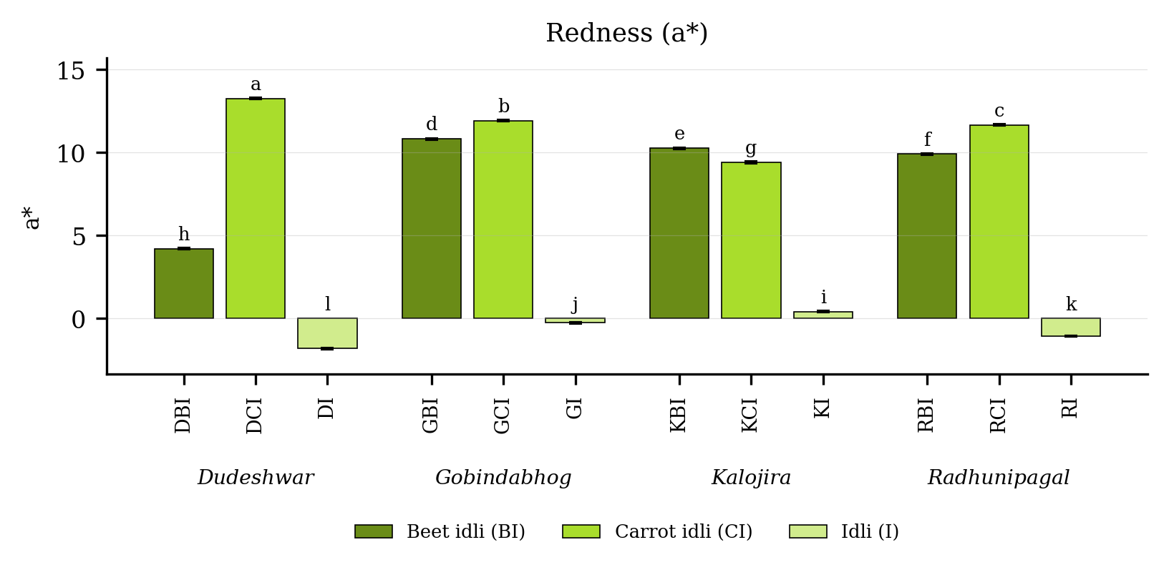
Fig. 4.24. Redness (a*) of idli prepared from four rice varieties fortified with carrot and beet extract. Values are means of six observations and the vertical bars are the standard error of the mean. Letters above the bars denote the groupings at the 5 per cent level.
Result
Redness (Table 4.24 and Fig. 4.24) differed significantly among the twelve treatment combinations. It was highest in DCI (13.26 a*), followed by GCI (11.92 a*), and lowest in DI (-1.81 a*). Among the products the mean value was 11.57 in the carrot fortified product, 8.80 in the beet fortified product and -0.68 in the plain product. Among the varieties it was highest in Gobindabhog (7.49) and lowest in Dudeshwar (5.22).
The variety and product interaction was significant, the critical difference at the 5 per cent level being 0.04, with a coefficient of variation of 0.53 per cent.
Discussion
Redness rose from a marginally negative value in the pale plain product because both fortifying materials displace the surface colour into the red region of the colour space, which constitutes the most probable and direct explanation of the result. The all-trans beta-carotene of carrot imparts an orange colour with a strongly positive a* value, and the betacyanin of beetroot a red to violet colour with an equally strong positive a* value (Britton, 1995; Rodriguez-Amaya, 2001; Stintzing and Carle, 2004). The carrot fortified treatments returned the highest values because carotenoids raise redness while depressing lightness comparatively little, whereas betalains raise redness but darken the product concurrently (Delgado-Vargas et al., 2000; Ravichandran et al., 2013; Pathare et al., 2013). Retention of both pigments through the steaming step is attributable to the brief duration and moist character of the heating and to the mildly acidic pH of the fermented batter (Herbach et al., 2006; Azeredo, 2009). Comparable a* values and the same direction of change were reported for pigmented rice idli by Kaviyaselvan et al. (2026).

4.6.3 Yellowness (b*)
Table 4.25. Yellowness (b*) of idli prepared from four rice varieties fortified with carrot and beet extract
Treatment combination | Year 1 | Year 2 | Pooled mean
DBI | 59.36 ± 0.63 | 59.54 ± 0.36 | 59.45 ± 0.47k
DCI | 98.98 ± 0.31 | 100.32 ± 0.05 | 99.65 ± 0.76d
DI | 110.10 ± 0.14 | 111.86 ± 0.22 | 110.98 ± 0.98a
GBI | 72.11 ± 0.17 | 73.05 ± 0.07 | 72.58 ± 0.52h
GCI | 93.61 ± 0.66 | 94.41 ± 0.54 | 94.01 ± 0.69f
GI | 103.88 ± 0.22 | 104.46 ± 0.46 | 104.17 ± 0.45c
KBI | 63.86 ± 0.63 | 64.90 ± 0.13 | 64.38 ± 0.70j
KCI | 85.54 ± 0.40 | 86.23 ± 0.74 | 85.88 ± 0.65g
KI | 105.38 ± 0.59 | 106.93 ± 0.56 | 106.16 ± 0.99b
RBI | 69.51 ± 0.46 | 69.93 ± 0.58 | 69.72 ± 0.52i
RCI | 104.00 ± 0.19 | 104.34 ± 0.64 | 104.17 ± 0.46c
RI | 95.60 ± 0.52 | 95.60 ± 0.46 | 95.60 ± 0.44e
SEm (+/-): Y = 0.11; V = 0.11; P = 0.09; V x P = 0.19; Y x V x P = 0.26
CD (P = 0.05): Y = 0.30; V = 0.30; P = 0.26; V x P = 0.52; Y x V x P = NS; CV (%) = 0.51
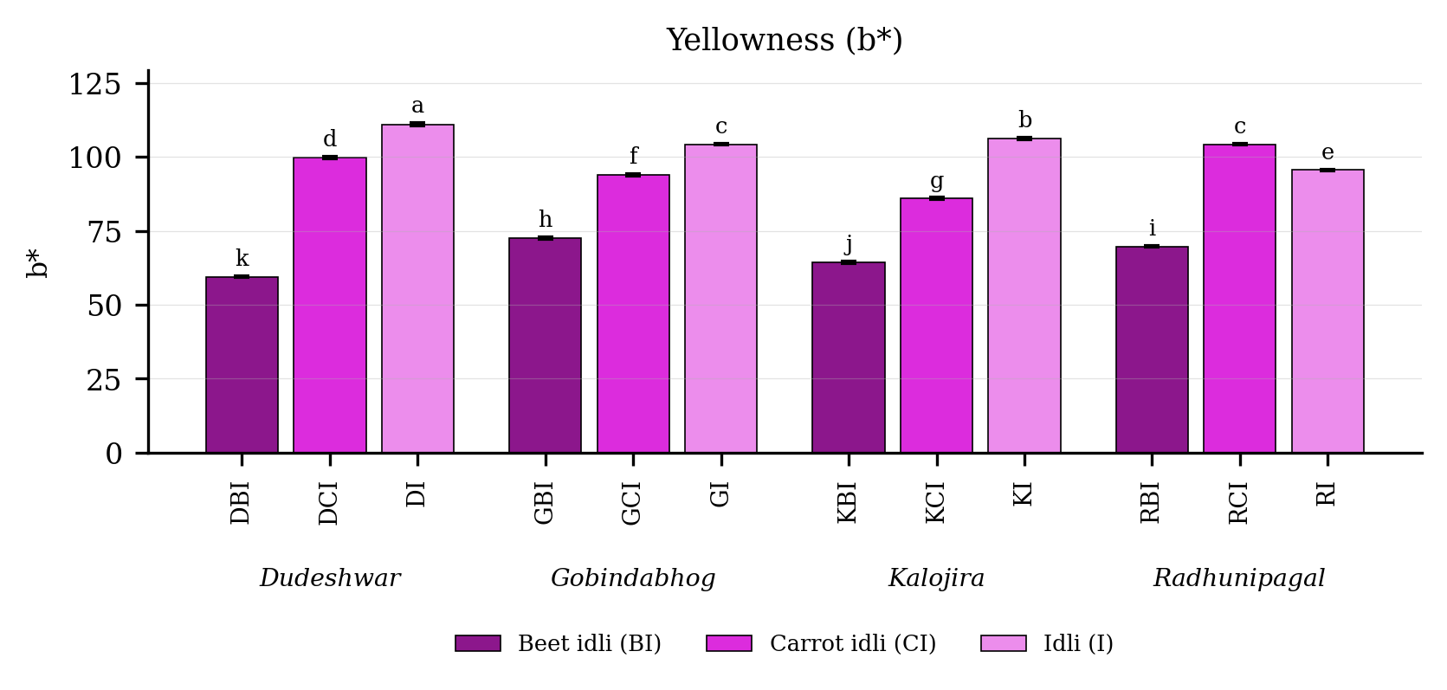
Fig. 4.25. Yellowness (b*) of idli prepared from four rice varieties fortified with carrot and beet extract. Values are means of six observations and the vertical bars are the standard error of the mean. Letters above the bars denote the groupings at the 5 per cent level.
Result
Yellowness (Table 4.25 and Fig. 4.25) differed significantly among the twelve treatment combinations. It was highest in DI (110.98 b*), followed by KI (106.16 b*), and lowest in DBI (59.45 b*). Among the products the mean value was 104.23 in the plain product, 95.93 in the carrot fortified product and 66.53 in the beet fortified product. Among the varieties it was highest in Gobindabhog (90.25) and lowest in Kalojira (85.47).
The variety and product interaction was significant, the critical difference at the 5 per cent level being 0.52, with a coefficient of variation of 0.51 per cent.
Discussion
The probable basis of the decline in yellowness is that the pale, faintly yellow starch matrix of the plain product was progressively displaced by red pigment as the extract was added, so that the b* value fell even as the total pigment load rose (Francis, 1995; Pathare et al., 2013). Betalains absorb strongly across the blue and green region and depress the yellow component, which accounts for the beet fortified treatments returning the lowest values (Stintzing and Carle, 2004; Ravichandran et al., 2013). The carrot fortified treatments retained a higher b* value because carotenoids are themselves yellow to orange pigments and augment rather than diminish this component (Britton, 1995; Rodriguez-Amaya, 2001; Sharma et al., 2012). The comparatively high yellowness of the plain product itself is attributable to the natural pigments of the grain and to the slight Maillard browning occurring at the surface during steaming (Hutchings, 1999; Lamberts et al., 2007).

4.6.4 Total colour difference (ΔE)
Table 4.26. Total colour difference (ΔE) of idli prepared from four rice varieties fortified with carrot and beet extract
Treatment combination | Year 1 | Year 2 | Pooled mean
DBI | 38.45 ± 0.20 | 38.61 ± 0.40 | 38.53 ± 0.30d
DCI | 42.41 ± 0.46 | 43.56 ± 0.35 | 42.99 ± 0.73b
DI | 41.89 ± 0.44 | 40.80 ± 0.39 | 41.35 ± 0.70c
GBI | 36.57 ± 0.24 | 35.84 ± 0.45 | 36.20 ± 0.51f
GCI | 37.81 ± 0.26 | 39.41 ± 0.59 | 38.61 ± 0.96d
GI | 35.52 ± 0.42 | 36.47 ± 0.39 | 35.99 ± 0.64f
KBI | 40.45 ± 0.09 | 40.69 ± 0.19 | 40.57 ± 0.19c
KCI | 33.33 ± 0.75 | 33.38 ± 0.53 | 33.36 ± 0.58g
KI | 37.92 ± 0.75 | 38.83 ± 0.34 | 38.37 ± 0.72d
RBI | 36.58 ± 0.80 | 38.25 ± 0.60 | 37.42 ± 1.11e
RCI | 44.49 ± 0.23 | 45.55 ± 0.72 | 45.02 ± 0.75a
RI | 28.00 ± 0.50 | 29.41 ± 0.23 | 28.70 ± 0.84h
SEm (+/-): Y = 0.19; V = 0.11; P = 0.10; V x P = 0.19; Y x V x P = 0.27
CD (P = 0.05): Y = NS; V = 0.32; P = 0.28; V x P = 0.54; Y x V x P = 0.76; CV (%) = 1.23
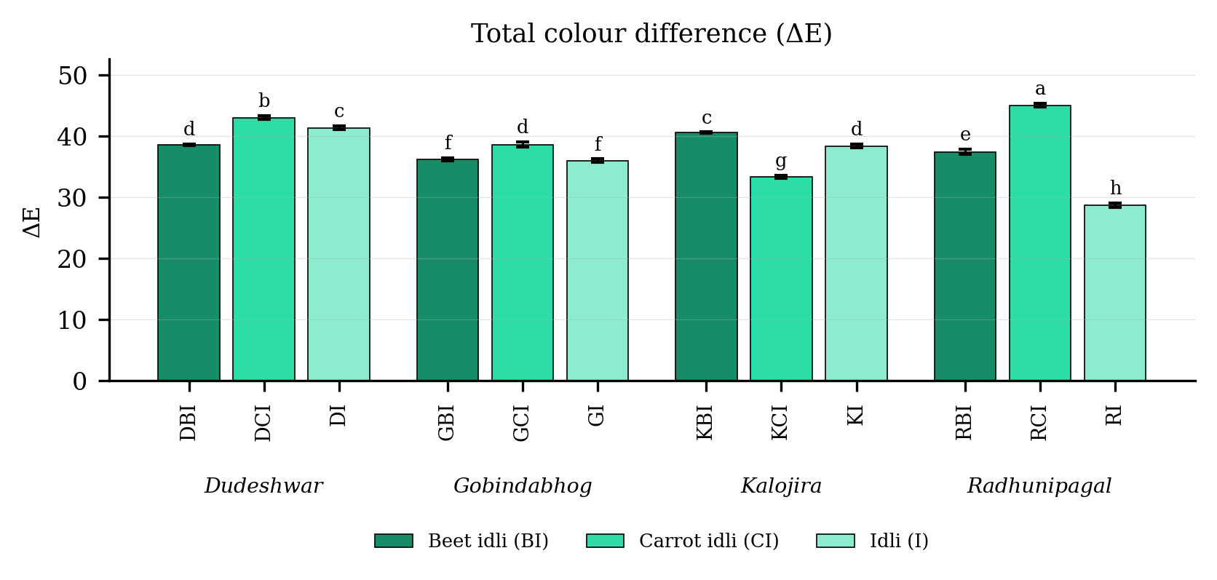
Fig. 4.26. Total colour difference (ΔE) of idli prepared from four rice varieties fortified with carrot and beet extract. Values are means of six observations and the vertical bars are the standard error of the mean. Letters above the bars denote the groupings at the 5 per cent level.
Result
Total colour difference (Table 4.26 and Fig. 4.26) differed significantly among the twelve treatment combinations. It was highest in RCI (45.02 ΔE), followed by DCI (42.99 ΔE), and lowest in RI (28.70 ΔE). Among the products the mean value was 40.00 in the carrot fortified product, 38.18 in the beet fortified product and 36.10 in the plain product. Among the varieties it was highest in Dudeshwar (40.96) and lowest in Gobindabhog (36.93).
The variety and product interaction was significant, the critical difference at the 5 per cent level being 0.54, with a coefficient of variation of 1.23 per cent.
Discussion
The total colour difference expresses the combined change in lightness, redness and yellowness relative to a reference, and the most probable basis of the high values recorded is simply that fortification altered all three coordinates simultaneously (Pathare et al., 2013). Every fortified treatment exceeded the threshold of approximately three units at which a colour change becomes apparent to an untrained observer, and most exceeded it more than tenfold (Francis, 1995; Hutchings, 1999; Pathare et al., 2013). This confirms that fortification produced a visually distinct product rather than a subtle tint, which is precisely what is required of a natural colourant intended to improve consumer appeal (Delgado-Vargas et al., 2000; Stintzing and Carle, 2004; Chhikara et al., 2019). The magnitude of the change accounts for the high appearance scores awarded to these treatments by the sensory panel. Kaviyaselvan et al. (2026) similarly reported large colour differences in pigmented rice idli and attributed them principally to the phenolic and pigment fraction of the grain rather than to the fermentation step.

4.6.5 Hue angle (°)
Table 4.27. Hue angle (°) of idli prepared from four rice varieties fortified with carrot and beet extract
Treatment combination | Year 1 | Year 2 | Pooled mean
DBI | 85.78 ± 0.56 | 86.04 ± 0.63 | 85.91 ± 0.55b
DCI | 81.68 ± 0.13 | 82.06 ± 0.52 | 81.87 ± 0.40de
DI | -89.19 ± 0.65 | -89.34 ± 0.14 | -89.27 ± 0.43g
GBI | 81.56 ± 0.62 | 81.63 ± 0.40 | 81.60 ± 0.47ef
GCI | 82.69 ± 0.69 | 82.99 ± 0.41 | 82.84 ± 0.53cd
GI | -90.20 ± 0.62 | -90.22 ± 0.50 | -90.21 ± 0.50g
KBI | 80.45 ± 0.58 | 80.92 ± 0.67 | 80.68 ± 0.62f
KCI | 83.70 ± 0.60 | 83.51 ± 0.18 | 83.61 ± 0.41c
KI | 89.51 ± 0.76 | 89.76 ± 0.28 | 89.64 ± 0.53a
RBI | 81.79 ± 0.31 | 81.61 ± 0.28 | 81.70 ± 0.28e
RCI | 83.30 ± 0.38 | 83.46 ± 0.56 | 83.38 ± 0.44c
RI | -90.00 ± 0.33 | -89.21 ± 0.60 | -89.61 ± 0.61g
SEm (+/-): Y = 0.08; V = 0.12; P = 0.10; V x P = 0.21; Y x V x P = 0.29
CD (P = 0.05): Y = NS; V = 0.34; P = 0.30; V x P = 0.58; Y x V x P = NS; CV (%) = 1.27
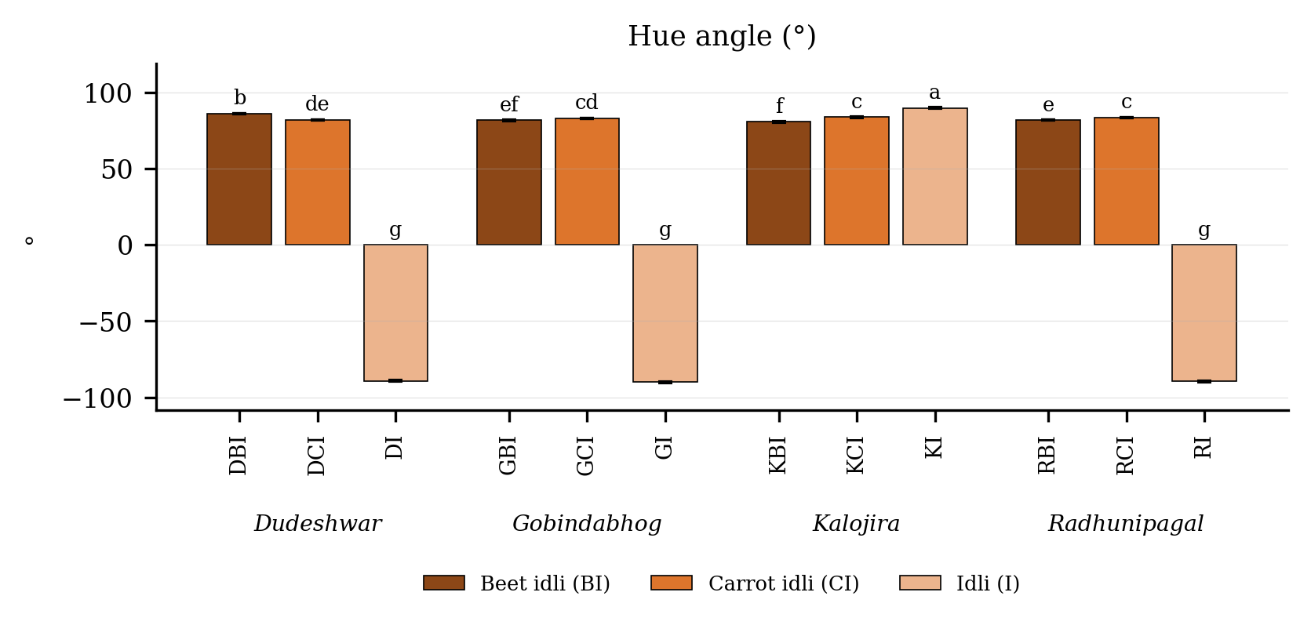
Fig. 4.27. Hue angle (°) of idli prepared from four rice varieties fortified with carrot and beet extract. Values are means of six observations and the vertical bars are the standard error of the mean. Letters above the bars denote the groupings at the 5 per cent level.
Result
Hue angle (Table 4.27 and Fig. 4.27) differed significantly among the twelve treatment combinations. It was highest in KI (89.64 °), followed by DBI (85.91 °), and lowest in GI (-90.21 °). Among the products the mean value was 82.92 in the carrot fortified product, 82.47 in the beet fortified product and -44.86 in the plain product. Among the varieties it was highest in Kalojira (84.64) and lowest in Gobindabhog (24.74).
The variety and product interaction was significant, the critical difference at the 5 per cent level being 0.58, with a coefficient of variation of 1.27 per cent.
Discussion
The hue angle describes the position of the colour on the colour wheel, and the most probable basis of the very large shift recorded is that the plain product possessed almost no chromatic character while the fortified products carried a strong and definite red to orange hue (Francis, 1995; Pathare et al., 2013). In the plain product the a* value approached zero, so that the hue angle was unstable and assumed a strongly negative value; the addition of either pigment displaced it decisively into the red region (Hutchings, 1999; Stintzing and Carle, 2004). Kalojira behaved differently from the other three varieties because pigment carried over from the black husk confers upon its plain product a chromatic character of its own even before fortification (Lamberts et al., 2007; Sompong et al., 2011). The stability of the hue in the finished product is attributable to the resistance of both betalains and carotenoids to brief moist heating at mildly acidic pH (Herbach et al., 2006; Ravichandran et al., 2013).

4.6.6 Chroma (C*)
Table 4.28. Chroma (C*) of idli prepared from four rice varieties fortified with carrot and beet extract
Treatment combination | Year 1 | Year 2 | Pooled mean
DBI | 59.33 ± 0.32 | 60.10 ± 0.55 | 59.72 ± 0.59k
DCI | 100.43 ± 0.37 | 100.49 ± 0.75 | 100.46 ± 0.53d
DI | 110.12 ± 0.19 | 111.54 ± 0.49 | 110.83 ± 0.84a
GBI | 73.17 ± 0.54 | 73.06 ± 0.15 | 73.11 ± 0.36h
GCI | 94.56 ± 0.19 | 94.38 ± 0.25 | 94.47 ± 0.22f
GI | 103.88 ± 0.22 | 104.97 ± 0.44 | 104.42 ± 0.67c
KBI | 64.36 ± 0.63 | 64.57 ± 0.06 | 64.47 ± 0.41j
KCI | 86.18 ± 0.60 | 87.20 ± 0.18 | 86.69 ± 0.69g
KI | 105.77 ± 0.55 | 106.41 ± 0.58 | 106.09 ± 0.62b
RBI | 70.04 ± 0.40 | 70.79 ± 0.66 | 70.41 ± 0.64i
RCI | 104.67 ± 0.47 | 105.17 ± 0.32 | 104.92 ± 0.45c
RI | 96.06 ± 0.16 | 96.43 ± 0.64 | 96.25 ± 0.46e
SEm (+/-): Y = 0.11; V = 0.11; P = 0.09; V x P = 0.18; Y x V x P = 0.26
CD (P = 0.05): Y = 0.30; V = 0.30; P = 0.26; V x P = 0.52; Y x V x P = NS; CV (%) = 0.50
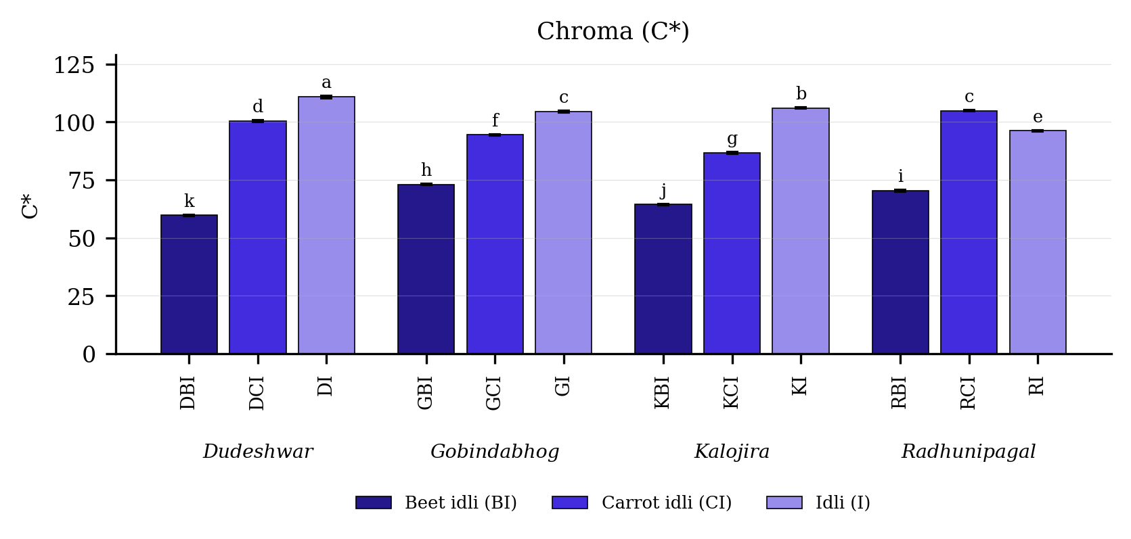
Fig. 4.28. Chroma (C*) of idli prepared from four rice varieties fortified with carrot and beet extract. Values are means of six observations and the vertical bars are the standard error of the mean. Letters above the bars denote the groupings at the 5 per cent level.
Result
Chroma (Table 4.28 and Fig. 4.28) differed significantly among the twelve treatment combinations. It was highest in DI (110.83 C*), followed by KI (106.09 C*), and lowest in DBI (59.72 C*). Among the products the mean value was 104.40 in the plain product, 96.63 in the carrot fortified product and 66.93 in the beet fortified product. Among the varieties it was highest in Gobindabhog (90.67) and lowest in Kalojira (85.75).
The variety and product interaction was significant, the critical difference at the 5 per cent level being 0.52, with a coefficient of variation of 0.50 per cent.
Discussion
Chroma expresses colour saturation and is computed from the a* and b* values jointly, so that the probable basis of its pattern is its domination by the very large b* values of the pale treatments (Francis, 1995; Pathare et al., 2013). The plain product accordingly returned the highest chroma and the beet fortified product the lowest, notwithstanding that the latter was visually far more strongly coloured. This apparent contradiction constitutes a recognised limitation of expressing the colour of dark pigmented foods in terms of chroma alone, since a dark, intensely coloured surface reflects little light and yields low tristimulus values (Hutchings, 1999; Delgado-Vargas et al., 2000; Pathare et al., 2013). The fortified products should therefore be understood as darker but not less saturated in appearance, an interpretation supported by their high sensory appearance scores and by the established behaviour of the betalain pigments concerned (Stintzing and Carle, 2004; Azeredo, 2009).

4.7 Textural attributes

4.7.1 Hardness
Table 4.29. Hardness of idli prepared from four rice varieties fortified with carrot and beet extract
Treatment combination | Year 1 | Year 2 | Pooled mean
DBI | 67.99 ± 0.53 | 67.83 ± 0.51 | 67.91 ± 0.48g
DCI | 95.73 ± 0.45 | 95.29 ± 0.45 | 95.51 ± 0.47d
DI | 45.39 ± 0.14 | 44.79 ± 0.19 | 45.09 ± 0.36k
GBI | 107.28 ± 0.36 | 107.26 ± 0.18 | 107.27 ± 0.26b
GCI | 78.28 ± 0.28 | 77.72 ± 0.50 | 78.00 ± 0.47f
GI | 105.63 ± 0.09 | 105.59 ± 0.43 | 105.61 ± 0.28c
KBI | 54.88 ± 0.36 | 55.03 ± 0.64 | 54.95 ± 0.47i
KCI | 66.85 ± 0.46 | 66.53 ± 0.57 | 66.69 ± 0.49h
KI | 147.68 ± 0.37 | 147.78 ± 0.54 | 147.73 ± 0.42a
RBI | 66.88 ± 0.65 | 66.61 ± 0.55 | 66.74 ± 0.56h
RCI | 48.99 ± 0.66 | 48.76 ± 0.51 | 48.87 ± 0.54j
RI | 88.74 ± 0.79 | 89.24 ± 0.22 | 88.99 ± 0.58e
SEm (+/-): Y = 0.06; V = 0.11; P = 0.10; V x P = 0.19; Y x V x P = 0.27
CD (P = 0.05): Y = NS; V = 0.32; P = 0.28; V x P = 0.54; Y x V x P = NS; CV (%) = 0.58
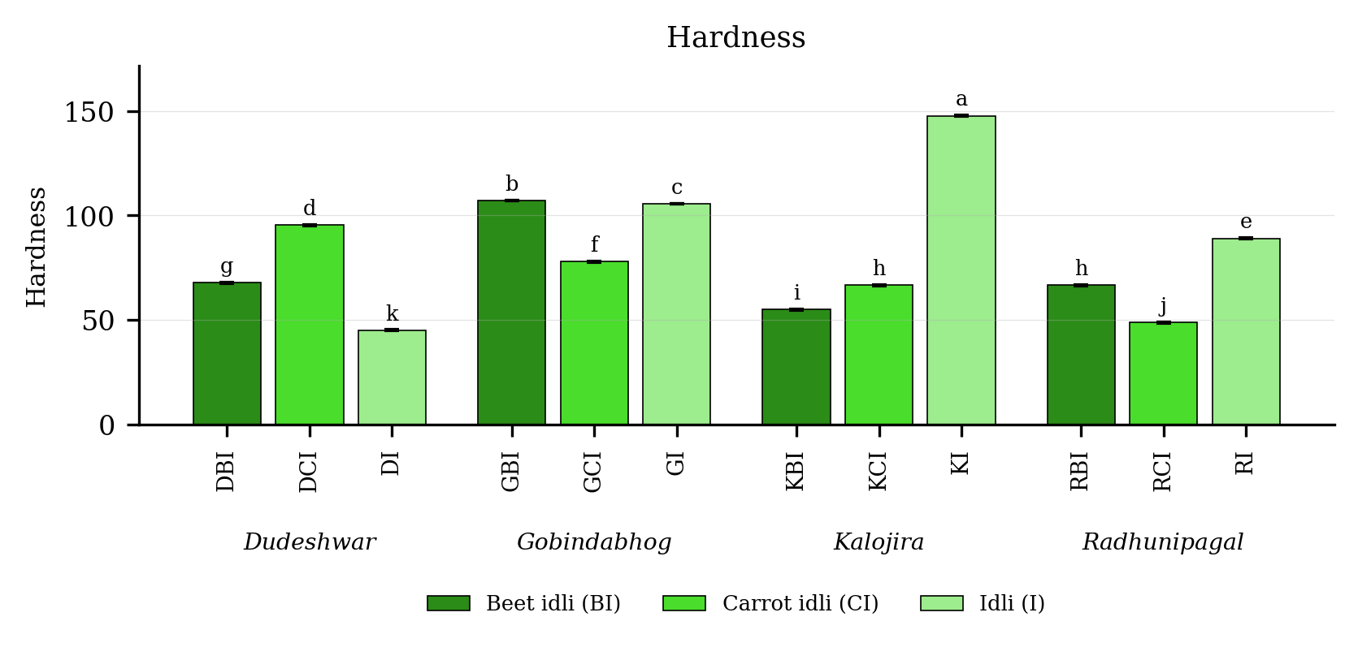
Fig. 4.29. Hardness of idli prepared from four rice varieties fortified with carrot and beet extract. Values are means of six observations and the vertical bars are the standard error of the mean. Letters above the bars denote the groupings at the 5 per cent level.
Result
Hardness (Table 4.29 and Fig. 4.29) differed significantly among the twelve treatment combinations. It was highest in KI (147.73), followed by GBI (107.27), and lowest in DI (45.09). Among the products the mean value was 96.85 in the plain product, 74.22 in the beet fortified product and 72.27 in the carrot fortified product. Among the varieties it was highest in Gobindabhog (96.96) and lowest in Radhunipagal (68.20).
The variety and product interaction was significant, the critical difference at the 5 per cent level being 0.54, with a coefficient of variation of 0.58 per cent.
Discussion
The most probable basis of the softening of the product on fortification is the dilution of the structural network conferring upon idli its characteristic texture. That network is formed by the interaction of the surface-active globulin and arabinogalactan of black gram with the gelatinised starch of rice, the protein stabilising the gas cells generated during fermentation and the starch setting around them during steaming (Reddy et al., 1981; Nisha et al., 2005; Durgadevi and Shetty, 2012). Replacing a proportion of these solids with a vegetable extract contributing neither structural protein nor starch necessarily weakens the network and yields a more tender product (Sharma et al., 2012; Chhikara et al., 2019). A second and reinforcing factor is the amylose content of the treatments, since the plain products carried the most amylose, and amylose retrogrades on cooling to form a firm gel that stiffens the crumb (Tester et al., 2004; Mohapatra and Bal, 2006; Copeland et al., 2009). The moisture contributed by the extract acts as a plasticiser and further depresses the measured hardness (Rosenthal, 1999; Bourne, 2002). Kaviyaselvan et al. (2026) recorded a comparable softening of idli where half the rice flour was replaced with pearl millet and attributed it to differences in starch granule arrangement, amylose content and the integrity of the protein and starch matrix.

4.7.2 Adhesiveness
Table 4.30. Adhesiveness of idli prepared from four rice varieties fortified with carrot and beet extract
Treatment combination | Year 1 | Year 2 | Pooled mean
DBI | -18.20 ± 0.06 | -17.55 ± 0.05 | -17.87 ± 0.36k
DCI | -1.59 ± 0.03 | -1.63 ± 0.03 | -1.61 ± 0.03d
DI | -0.27 ± 0.05 | -0.12 ± 0.04 | -0.19 ± 0.09a
GBI | -0.66 ± 0.05 | -0.54 ± 0.04 | -0.60 ± 0.08b
GCI | -2.55 ± 0.06 | -2.50 ± 0.05 | -2.53 ± 0.06h
GI | -2.37 ± 0.06 | -2.35 ± 0.03 | -2.36 ± 0.04g
KBI | -1.86 ± 0.04 | -1.68 ± 0.04 | -1.77 ± 0.10e
KCI | -1.06 ± 0.01 | -0.87 ± 0.02 | -0.96 ± 0.10c
KI | -2.36 ± 0.03 | -2.17 ± 0.02 | -2.27 ± 0.10f
RBI | -12.83 ± 0.03 | -12.29 ± 0.04 | -12.56 ± 0.30j
RCI | -5.37 ± 0.05 | -5.07 ± 0.05 | -5.22 ± 0.17i
RI | -19.77 ± 0.04 | -19.38 ± 0.03 | -19.58 ± 0.22l
SEm (+/-): Y = 0.03; V = 0.01; P = 0.01; V x P = 0.02; Y x V x P = 0.02
CD (P = 0.05): Y = 0.10; V = 0.02; P = 0.02; V x P = 0.04; Y x V x P = 0.06; CV (%) = -0.73
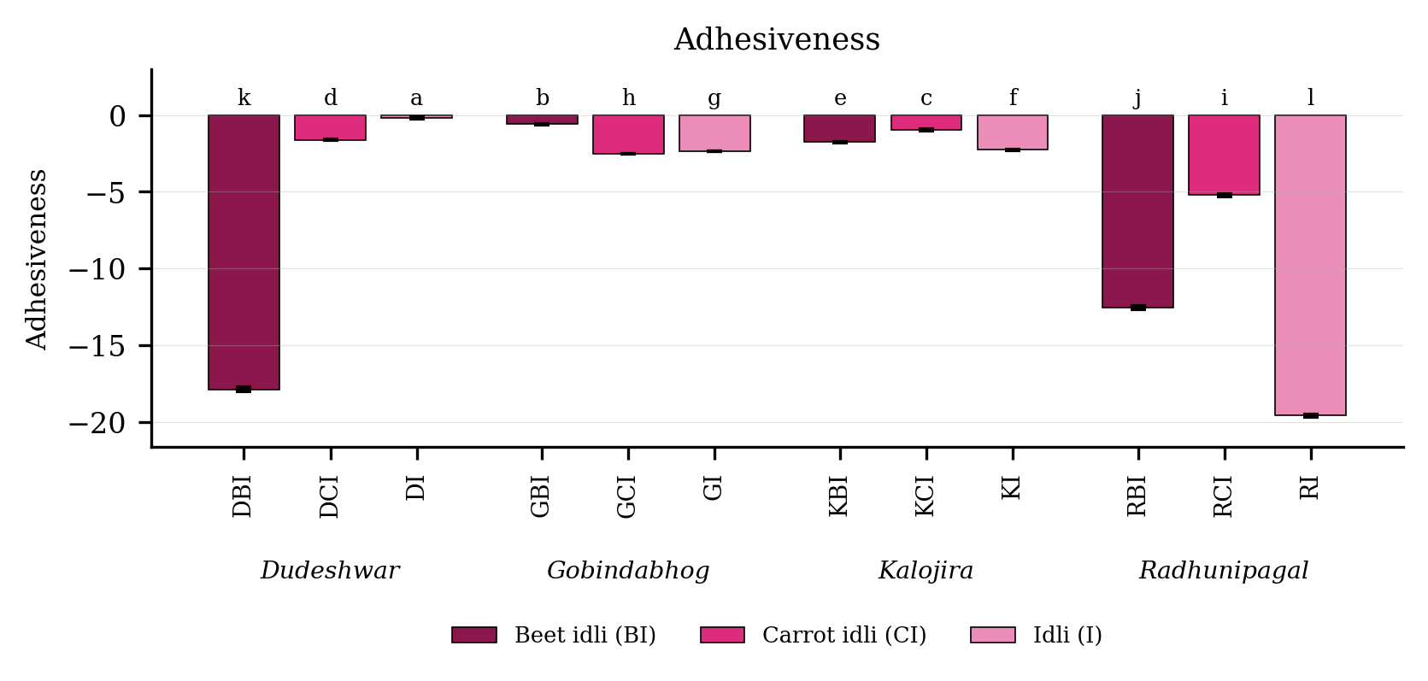
Fig. 4.30. Adhesiveness of idli prepared from four rice varieties fortified with carrot and beet extract. Values are means of six observations and the vertical bars are the standard error of the mean. Letters above the bars denote the groupings at the 5 per cent level.
Result
Adhesiveness (Table 4.30 and Fig. 4.30) differed significantly among the twelve treatment combinations. It was highest in DI (-0.19), followed by GBI (-0.60), and lowest in RI (-19.58). Among the products the mean value was -2.58 in the carrot fortified product, -6.10 in the plain product and -8.20 in the beet fortified product. Among the varieties it was highest in Kalojira (-1.67) and lowest in Radhunipagal (-12.45).
The variety and product interaction was significant, the critical difference at the 5 per cent level being 0.04, with a coefficient of variation of -0.73 per cent.
Discussion
Adhesiveness expresses the work required to separate the product from the probe and therefore reflects the surface stickiness of the steamed idli, which constitutes the most probable explanation for the differences recorded (Rosenthal, 1999; Bourne, 2002). The moisture and free sugars contributed by the vegetable extract alter the surface of the product and modify its adhesion, the free sugars of beetroot in particular being known to increase the tackiness of a steamed cereal surface (Wilkinson et al., 2000; Singh and Hathan, 2014; Chhikara et al., 2019). The varietal differences are attributable to differences in amylose content, since leached amylose accumulates at the surface during steaming and constitutes the principal source of stickiness in cooked rice (Tester et al., 2004; Mohapatra and Bal, 2006; Bhattacharya, 2011). The comparatively high variability recorded for this character is common in texture profile analysis of soft porous foods and has been noted by several workers (Szczesniak, 2002; Bourne, 2002). Kaviyaselvan et al. (2026) recorded uniformly low adhesiveness in idli and related the small differences obtained to starch fluidity and the extent of gelatinisation in the steamed product.

4.7.3 Springiness
Table 4.31. Springiness of idli prepared from four rice varieties fortified with carrot and beet extract
Treatment combination | Year 1 | Year 2 | Pooled mean
DBI | 0.46 ± 0.04 | 0.62 ± 0.03 | 0.54 ± 0.09f
DCI | 0.47 ± 0.01 | 0.89 ± 0.02 | 0.68 ± 0.23de
DI | 0.91 ± 0.05 | 1.17 ± 0.03 | 1.04 ± 0.15a
GBI | 0.61 ± 0.01 | 0.61 ± 0.03 | 0.61 ± 0.02f
GCI | 0.63 ± 0.05 | 0.88 ± 0.05 | 0.76 ± 0.14cd
GI | 0.84 ± 0.05 | 1.09 ± 0.05 | 0.97 ± 0.14b
KBI | 0.42 ± 0.03 | 0.51 ± 0.02 | 0.46 ± 0.05g
KCI | 0.61 ± 0.03 | 0.74 ± 0.03 | 0.68 ± 0.08e
KI | 0.90 ± 0.03 | 0.96 ± 0.03 | 0.93 ± 0.04b
RBI | 0.46 ± 0.05 | 0.62 ± 0.03 | 0.54 ± 0.09f
RCI | 0.78 ± 0.01 | 0.86 ± 0.02 | 0.82 ± 0.05c
RI | 0.81 ± 0.02 | 1.24 ± 0.04 | 1.02 ± 0.24a
SEm (+/-): Y = 0.37; V = 0.14; P = 0.12; V x P = 0.24; Y x V x P = 0.34
CD (P = 0.05): Y = 1.07; V = 0.40; P = 0.34; V x P = 0.68; Y x V x P = 0.97; CV (%) = 4.40
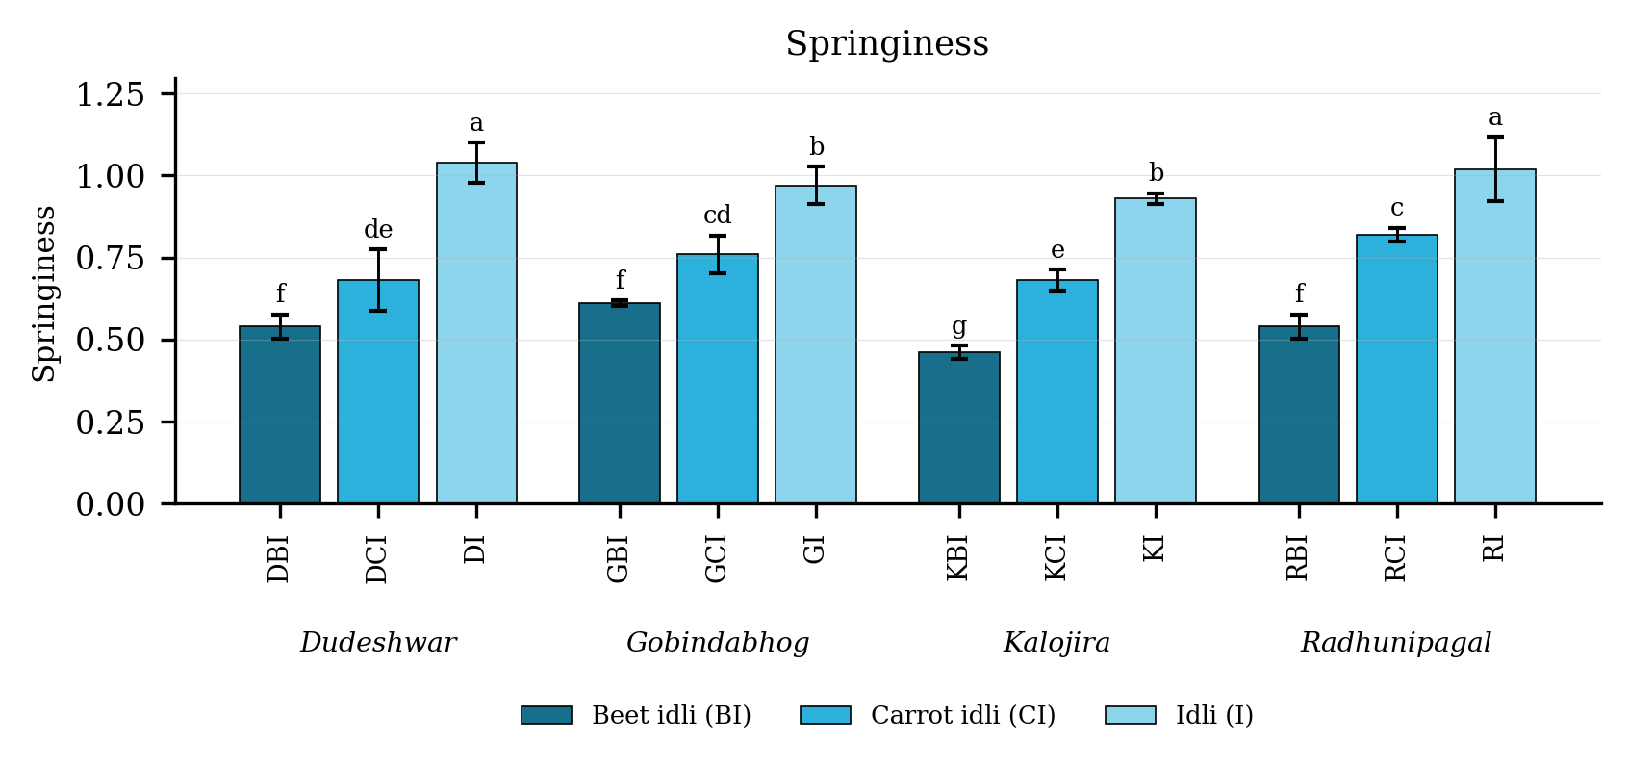
Fig. 4.31. Springiness of idli prepared from four rice varieties fortified with carrot and beet extract. Values are means of six observations and the vertical bars are the standard error of the mean. Letters above the bars denote the groupings at the 5 per cent level.
Result
Springiness (Table 4.31 and Fig. 4.31) differed significantly among the twelve treatment combinations. It was highest in DI (1.04), followed by RI (1.02), and lowest in KBI (0.46). Among the products the mean value was 0.99 in the plain product, 0.73 in the carrot fortified product and 0.54 in the beet fortified product. Among the varieties it was highest in Radhunipagal (0.79) and lowest in Kalojira (0.69).
The variety and product interaction was significant, the critical difference at the 5 per cent level being 0.68, with a coefficient of variation of 4.40 per cent.
Discussion
Springiness expresses the elastic recovery of the product following the first compression, and the most probable basis of its decline on fortification is the weakening of the amylose network providing that elasticity. The amylose liberated during steaming re-associates as the product cools and forms a continuous gel permitting the crumb to spring back, so that treatments of higher amylose content necessarily recover better (Tester et al., 2004; Mohapatra and Bal, 2006; Copeland et al., 2009). Since fortification lowered amylose, springiness declined with it, and the correlation between the two characters recorded in the present study supports this interpretation. The gas cell structure generated during fermentation likewise contributes to elastic recovery, and the dilution of the black gram protein stabilising those cells constitutes a second probable factor in the decline (Reddy et al., 1981; Nisha et al., 2005; Durgadevi and Shetty, 2012). Comparable relationships between springiness and starch structure have been reported for other steamed cereal products (Rosenthal, 1999; Bourne, 2002). A comparable decline in springiness on partial replacement of the rice component was recorded by Kaviyaselvan et al. (2026), who concluded that the cereal fraction contributes to this attribute alongside the black gram.

4.7.4 Cohesiveness
Table 4.32. Cohesiveness of idli prepared from four rice varieties fortified with carrot and beet extract
Treatment combination | Year 1 | Year 2 | Pooled mean
DBI | 0.42 ± 0.03 | 0.54 ± 0.02 | 0.48 ± 0.07f
DCI | 0.45 ± 0.02 | 0.55 ± 0.01 | 0.50 ± 0.06f
DI | 0.74 ± 0.06 | 0.70 ± 0.05 | 0.72 ± 0.05c
GBI | 0.53 ± 0.05 | 0.88 ± 0.02 | 0.70 ± 0.19cd
GCI | 0.55 ± 0.05 | 0.89 ± 0.03 | 0.72 ± 0.19c
GI | 0.73 ± 0.04 | 1.08 ± 0.02 | 0.91 ± 0.20a
KBI | 0.40 ± 0.06 | 0.39 ± 0.04 | 0.40 ± 0.05g
KCI | 0.45 ± 0.03 | 0.81 ± 0.01 | 0.63 ± 0.20de
KI | 0.79 ± 0.03 | 1.08 ± 0.03 | 0.94 ± 0.16a
RBI | 0.44 ± 0.03 | 0.75 ± 0.04 | 0.60 ± 0.17e
RCI | 0.68 ± 0.03 | 0.84 ± 0.06 | 0.76 ± 0.10bc
RI | 0.66 ± 0.05 | 0.98 ± 0.04 | 0.82 ± 0.18b
SEm (+/-): Y = 0.03; V = 0.01; P = 0.01; V x P = 0.02; Y x V x P = 0.02
CD (P = 0.05): Y = 0.08; V = 0.02; P = 0.02; V x P = 0.04; Y x V x P = 0.06; CV (%) = 5.50
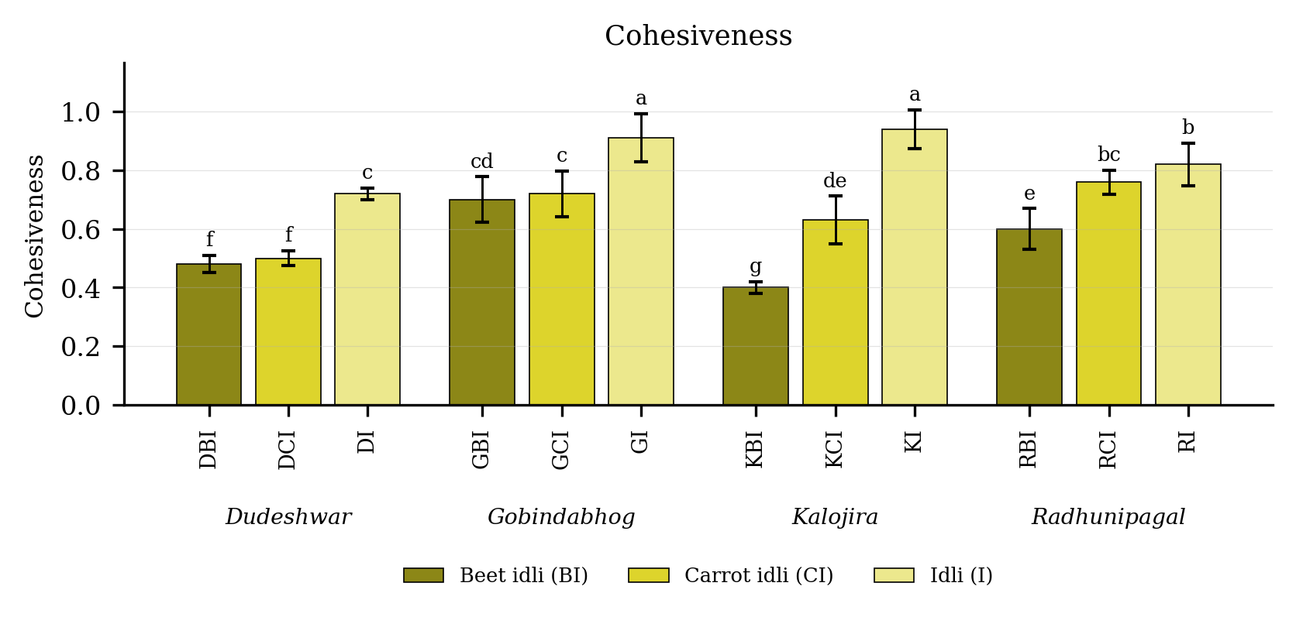
Fig. 4.32. Cohesiveness of idli prepared from four rice varieties fortified with carrot and beet extract. Values are means of six observations and the vertical bars are the standard error of the mean. Letters above the bars denote the groupings at the 5 per cent level.
Result
Cohesiveness (Table 4.32 and Fig. 4.32) differed significantly among the twelve treatment combinations. It was highest in KI (0.94), followed by GI (0.91), and lowest in KBI (0.40). Among the products the mean value was 0.85 in the plain product, 0.65 in the carrot fortified product and 0.54 in the beet fortified product. Among the varieties it was highest in Gobindabhog (0.78) and lowest in Dudeshwar (0.57).
The variety and product interaction was significant, the critical difference at the 5 per cent level being 0.04, with a coefficient of variation of 5.50 per cent.
Discussion
Cohesiveness measures the strength of the internal bonds holding the product together, so that the most probable basis of its decline on fortification is the dilution of the starch and protein matrix supplying those bonds (Rosenthal, 1999; Bourne, 2002). The addition of a vegetable extract introduces fibre and moisture but no structural protein, so that the continuity of the matrix is interrupted and the crumb is more readily broken apart (Wilkinson et al., 2000; Sharma et al., 2012; Chhikara et al., 2019). The strong contribution of black gram protein to this property is well established, the globulin and arabinogalactan of black gram forming the film that binds the gas cell walls together (Reddy et al., 1981; Nisha et al., 2005; Durgadevi and Shetty, 2012). The retrograded amylose network provides a second binding mechanism, which accounts for the treatments richest in amylose proving also the most cohesive (Tester et al., 2004; Mohapatra and Bal, 2006).

4.7.5 Gumminess
Table 4.33. Gumminess of idli prepared from four rice varieties fortified with carrot and beet extract
Treatment combination | Year 1 | Year 2 | Pooled mean
DBI | 2838.57 ± 67.15 | 2763.20 ± 103.49 | 2800.89 ± 88.27h
DCI | 4096.80 ± 123.75 | 4141.09 ± 102.92 | 4118.94 ± 104.65e
DI | 3371.49 ± 100.54 | 3469.86 ± 85.22 | 3420.68 ± 99.25f
GBI | 5759.01 ± 61.03 | 5750.58 ± 120.49 | 5754.80 ± 85.55c
GCI | 4416.26 ± 123.10 | 4431.53 ± 93.38 | 4423.90 ± 98.08d
GI | 7959.27 ± 80.66 | 8001.91 ± 44.77 | 7980.59 ± 62.85b
KBI | 2170.53 ± 51.05 | 2158.78 ± 53.42 | 2164.66 ± 47.17i
KCI | 3284.72 ± 42.99 | 3211.62 ± 44.98 | 3248.17 ± 56.14fg
KI | 11907.26 ± 80.66 | 11874.60 ± 134.46 | 11890.93 ± 100.77a
RBI | 2845.06 ± 58.03 | 2897.16 ± 107.98 | 2871.11 ± 82.62h
RCI | 3150.61 ± 140.77 | 3084.18 ± 25.53 | 3117.40 ± 97.52g
RI | 5802.58 ± 47.49 | 5795.24 ± 74.90 | 5798.91 ± 56.23c
SEm (+/-): Y = 12.22; V = 20.77; P = 17.99; V x P = 35.98; Y x V x P = 50.88
CD (P = 0.05): Y = NS; V = 59.07; P = 51.15; V x P = 102.30; Y x V x P = NS; CV (%) = 1.84
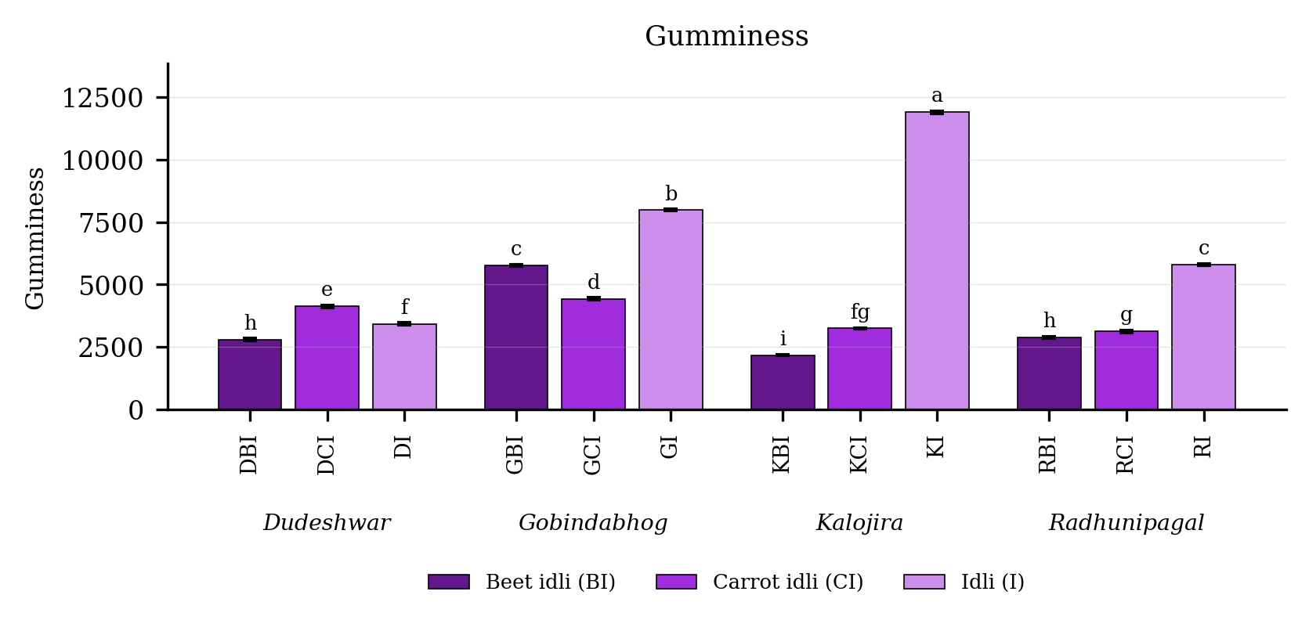
Fig. 4.33. Gumminess of idli prepared from four rice varieties fortified with carrot and beet extract. Values are means of six observations and the vertical bars are the standard error of the mean. Letters above the bars denote the groupings at the 5 per cent level.
Result
Gumminess (Table 4.33 and Fig. 4.33) differed significantly among the twelve treatment combinations. It was highest in KI (11890.93), followed by GI (7980.59), and lowest in KBI (2164.66). Among the products the mean value was 7272.78 in the plain product, 3727.10 in the carrot fortified product and 3397.86 in the beet fortified product. Among the varieties it was highest in Gobindabhog (6053.10) and lowest in Dudeshwar (3446.84).
The variety and product interaction was significant, the critical difference at the 5 per cent level being 102.30, with a coefficient of variation of 1.84 per cent.
Discussion
Gumminess is a secondary parameter computed as the product of hardness and cohesiveness, so that the most probable basis of its behaviour is simply that both of its components declined on fortification and the effect was consequently multiplied (Bourne, 2002; Szczesniak, 2002). Treatments both firm and strongly bound returned very high values, while treatments soft and weakly bound returned low ones. The underlying causes are those already discussed, namely the dilution of the black gram protein and rice starch network by the vegetable extract and the accompanying loss of amylose available for retrogradation (Reddy et al., 1981; Nisha et al., 2005; Tester et al., 2004; Durgadevi and Shetty, 2012). Since gumminess describes the energy required to disintegrate a semi-solid food to a state ready for swallowing, the lower values of the fortified treatments correspond to a product more readily eaten, consistent with their higher sensory texture scores (Rosenthal, 1999; Wilkinson et al., 2000). Kaviyaselvan et al. (2026) reported the same relationship in idli, gumminess and chewiness both declining when the rice component was partly replaced.

4.7.6 Chewiness
Table 4.34. Chewiness of idli prepared from four rice varieties fortified with carrot and beet extract
Treatment combination | Year 1 | Year 2 | Pooled mean
DBI | 1268.61 ± 32.45 | 1215.07 ± 26.51 | 1241.84 ± 39.53i
DCI | 1912.08 ± 60.13 | 1983.90 ± 150.26 | 1947.99 ± 109.66h
DI | 2905.89 ± 29.45 | 3011.91 ± 88.14 | 2958.90 ± 82.63e
GBI | 3222.37 ± 90.17 | 3168.01 ± 84.62 | 3195.19 ± 83.68d
GCI | 2733.65 ± 2.45 | 2705.69 ± 77.82 | 2719.67 ± 51.57f
GI | 6600.20 ± 113.50 | 6586.53 ± 47.00 | 6593.36 ± 78.06b
KBI | 939.01 ± 10.27 | 951.25 ± 17.17 | 945.13 ± 14.32j
KCI | 1854.07 ± 33.96 | 1916.26 ± 113.94 | 1885.16 ± 82.55h
KI | 10233.45 ± 47.20 | 10293.76 ± 88.59 | 10263.60 ± 71.56a
RBI | 1322.46 ± 59.04 | 1361.26 ± 70.02 | 1341.86 ± 61.70i
RCI | 2266.44 ± 68.39 | 2325.31 ± 69.85 | 2295.88 ± 69.73g
RI | 4760.08 ± 21.46 | 4800.11 ± 83.34 | 4780.09 ± 58.68c
SEm (+/-): Y = 7.20; V = 16.87; P = 14.61; V x P = 29.23; Y x V x P = 41.33
CD (P = 0.05): Y = 20.49; V = 47.97; P = 41.56; V x P = 83.10; Y x V x P = NS; CV (%) = 2.14
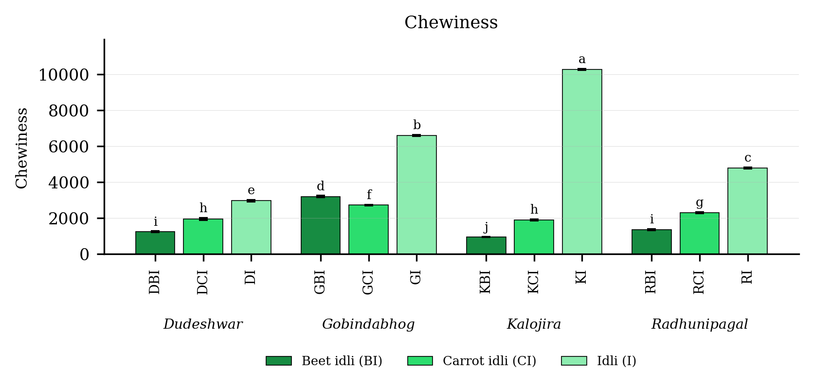
Fig. 4.34. Chewiness of idli prepared from four rice varieties fortified with carrot and beet extract. Values are means of six observations and the vertical bars are the standard error of the mean. Letters above the bars denote the groupings at the 5 per cent level.
Result
Chewiness (Table 4.34 and Fig. 4.34) differed significantly among the twelve treatment combinations. It was highest in KI (10263.60), followed by GI (6593.36), and lowest in KBI (945.13). Among the products the mean value was 6148.99 in the plain product, 2212.18 in the carrot fortified product and 1681.00 in the beet fortified product. Among the varieties it was highest in Kalojira (4364.63) and lowest in Dudeshwar (2049.58).
The variety and product interaction was significant, the critical difference at the 5 per cent level being 83.10, with a coefficient of variation of 2.14 per cent.
Discussion
Chewiness is the product of gumminess and springiness and is therefore doubly dependent upon the primary texture parameters, which constitutes the most probable basis of the very wide range recorded (Bourne, 2002; Szczesniak, 2002). Treatments simultaneously hard, cohesive and elastic required the greatest work of mastication, and these were the plain products, in which the black gram protein and rice starch network was undiluted and the amylose content highest (Reddy et al., 1981; Nisha et al., 2005; Tester et al., 2004). The fortified treatments, in which all three primary parameters were lower, yielded a product breaking down rapidly in the mouth (Wilkinson et al., 2000; Durgadevi and Shetty, 2012). The close correspondence between these instrumental values and the texture scores awarded by the panel supports the position of Szczesniak (2002) and Rosenthal (1999) that instrumental texture profile analysis of a steamed cereal food reflects perceived texture reliably.

4.7.7 Resilience
Table 4.35. Resilience of idli prepared from four rice varieties fortified with carrot and beet extract
Treatment combination | Year 1 | Year 2 | Pooled mean
DBI | 0.15 ± 0.03 | 0.27 ± 0.05 | 0.21 ± 0.08de
DCI | 0.16 ± 0.04 | 0.38 ± 0.02 | 0.27 ± 0.12cd
DI | 0.42 ± 0.03 | 0.49 ± 0.06 | 0.46 ± 0.06b
GBI | 0.24 ± 0.01 | 0.25 ± 0.04 | 0.25 ± 0.02de
GCI | 0.25 ± 0.05 | 0.30 ± 0.05 | 0.27 ± 0.05cd
GI | 0.45 ± 0.04 | 0.65 ± 0.00 | 0.55 ± 0.11a
KBI | 0.15 ± 0.03 | 0.33 ± 0.03 | 0.24 ± 0.10de
KCI | 0.22 ± 0.02 | 0.30 ± 0.01 | 0.26 ± 0.05de
KI | 0.45 ± 0.04 | 0.51 ± 0.04 | 0.48 ± 0.05ab
RBI | 0.12 ± 0.04 | 0.27 ± 0.04 | 0.19 ± 0.09e
RCI | 0.30 ± 0.04 | 0.25 ± 0.04 | 0.28 ± 0.05cd
RI | 0.32 ± 0.04 | 0.36 ± 0.04 | 0.34 ± 0.04c
SEm (+/-): Y = 0.02; V = 0.01; P = 0.01; V x P = 0.02; Y x V x P = 0.02
CD (P = 0.05): Y = 0.06; V = 0.02; P = 0.02; V x P = 0.04; Y x V x P = 0.06; CV (%) = 11.71
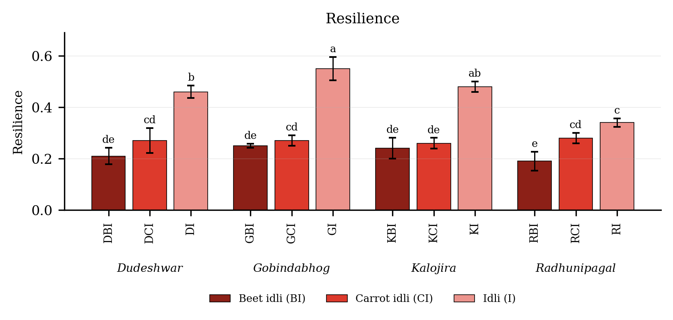
Fig. 4.35. Resilience of idli prepared from four rice varieties fortified with carrot and beet extract. Values are means of six observations and the vertical bars are the standard error of the mean. Letters above the bars denote the groupings at the 5 per cent level.
Result
Resilience (Table 4.35 and Fig. 4.35) differed significantly among the twelve treatment combinations. It was highest in GI (0.55), followed by KI (0.48), and lowest in RBI (0.19). Among the products the mean value was 0.46 in the plain product, 0.27 in the carrot fortified product and 0.22 in the beet fortified product. Among the varieties it was highest in Gobindabhog (0.36) and lowest in Radhunipagal (0.27).
The variety and product interaction was significant, the critical difference at the 5 per cent level being 0.04, with a coefficient of variation of 11.71 per cent.
Discussion
Resilience expresses the instantaneous elastic recovery of the product during the first compression and is therefore closely related to springiness, which constitutes the most probable basis of the two characters behaving alike (Rosenthal, 1999; Bourne, 2002). The recovery is contingent upon the elasticity of the retrograded amylose gel and of the protein films surrounding the gas cells, both of which were diluted by the vegetable extract (Reddy et al., 1981; Nisha et al., 2005; Tester et al., 2004). The comparatively high coefficient of variation recorded for this character is to be expected, since resilience is determined over a very short interval and is sensitive to small differences in the porosity of individual samples, a limitation noted for soft aerated foods generally (Wilkinson et al., 2000; Szczesniak, 2002; Durgadevi and Shetty, 2012). Kaviyaselvan et al. (2026) likewise found resilience to be conditioned by both cultivar and the composition of the product.

4.8 Sensory quality

4.8.1 Aroma score
Table 4.36. Aroma score of idli prepared from four rice varieties fortified with carrot and beet extract
Treatment combination | Year 1 | Year 2 | Pooled mean
DBI | 5.30 ± 0.26 | 6.73 ± 0.25 | 6.02 ± 0.82de
DCI | 5.67 ± 0.32 | 5.83 ± 0.15 | 5.75 ± 0.24e
DI | 5.00 ± 0.20 | 6.43 ± 0.35 | 5.72 ± 0.83e
GBI | 7.23 ± 0.25 | 7.07 ± 0.90 | 7.15 ± 0.60abc
GCI | 6.80 ± 0.36 | 7.70 ± 0.26 | 7.25 ± 0.57ab
GI | 7.77 ± 0.25 | 7.63 ± 0.25 | 7.70 ± 0.24a
KBI | 6.23 ± 0.15 | 6.67 ± 0.55 | 6.45 ± 0.43bcde
KCI | 5.47 ± 0.40 | 5.83 ± 0.21 | 5.65 ± 0.35e
KI | 6.63 ± 0.15 | 6.80 ± 1.31 | 6.72 ± 0.84bcd
RBI | 5.93 ± 0.15 | 6.00 ± 0.10 | 5.97 ± 0.12de
RCI | 6.37 ± 0.21 | 6.23 ± 0.64 | 6.30 ± 0.43cde
RI | 7.33 ± 0.21 | 6.97 ± 0.85 | 7.15 ± 0.59abc
SEm (+/-): Y = 0.11; V = 0.11; P = 0.09; V x P = 0.19; Y x V x P = 0.27
CD (P = 0.05): Y = NS; V = 0.30; P = 0.26; V x P = 0.54; Y x V x P = NS; CV (%) = 7.14
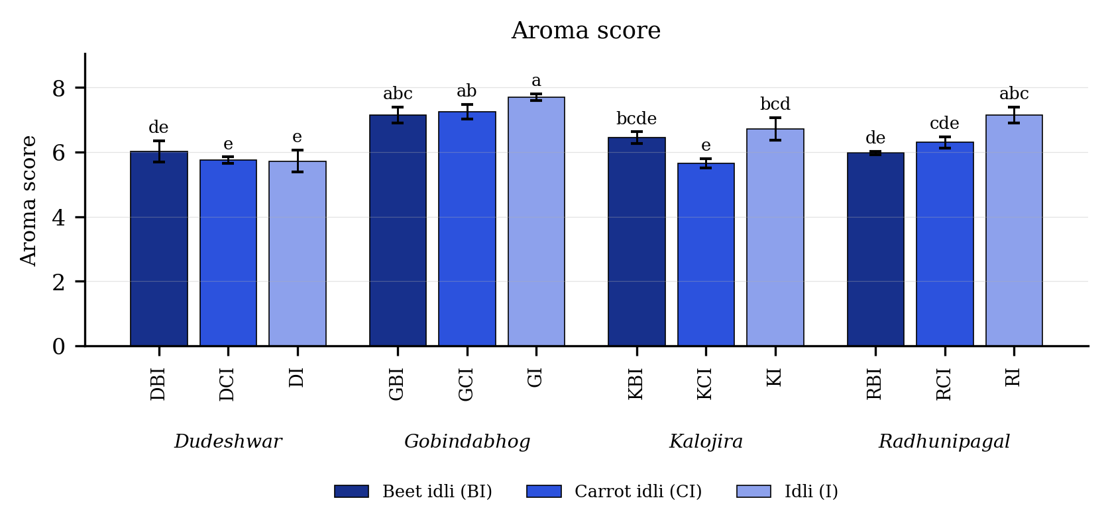
Fig. 4.36. Aroma score of idli prepared from four rice varieties fortified with carrot and beet extract. Values are means of six observations and the vertical bars are the standard error of the mean. Letters above the bars denote the groupings at the 5 per cent level.
Result
Aroma score (Table 4.36 and Fig. 4.36) differed significantly among the twelve treatment combinations. It was highest in GI (7.70), followed by GCI (7.25), and lowest in KCI (5.65). Among the products the mean value was 6.82 in the plain product, 6.40 in the beet fortified product and 6.24 in the carrot fortified product. Among the varieties it was highest in Gobindabhog (7.37) and lowest in Dudeshwar (5.83).
The variety and product interaction was significant, the critical difference at the 5 per cent level being 0.54, with a coefficient of variation of 7.14 per cent.
Discussion
The most probable basis of the high aroma scores of the plain products of the aromatic landraces is that 2-acetyl-1-pyrroline, the principal volatile responsible for the characteristic aroma of scented rice, survives the entire preparation sequence of soaking, grinding, fermentation and steaming (Buttery et al., 1983; Bhattacharjee et al., 2002; Yoshihashi et al., 2002). Its retention under moist heat has been demonstrated repeatedly, so that the aroma of a scented landrace is expressed in cooked and processed products as well as in the grain itself (Wongpornchai et al., 2004; Champagne, 2008; Sakthivel et al., 2009). The lower scores of the fortified treatments within each aromatic variety are most probably attributable to sensory masking, the earthy geosmin of beetroot and the terpenes of carrot competing with the rice volatile for the attention of the panel rather than destroying it chemically (Sharma et al., 2012; Ghosh and Roychoudhury, 2018; Chhikara et al., 2019). A small loss through volatilisation during the protracted fermentation of the batter may contribute further (Blandino et al., 2003).

4.8.2 Taste score
Table 4.37. Taste score of idli prepared from four rice varieties fortified with carrot and beet extract
Treatment combination | Year 1 | Year 2 | Pooled mean
DBI | 6.70 ± 0.20 | 6.55 ± 0.20 | 6.62 ± 0.20
DCI | 6.03 ± 0.25 | 5.88 ± 0.25 | 5.96 ± 0.24
DI | 5.23 ± 0.25 | 5.08 ± 0.25 | 5.16 ± 0.24
GBI | 6.90 ± 0.40 | 6.75 ± 0.40 | 6.82 ± 0.37
GCI | 6.80 ± 0.20 | 6.65 ± 0.20 | 6.72 ± 0.20
GI | 6.17 ± 0.47 | 6.02 ± 0.47 | 6.09 ± 0.43
KBI | 7.77 ± 0.25 | 7.62 ± 0.25 | 7.69 ± 0.24
KCI | 7.37 ± 0.21 | 7.22 ± 0.21 | 7.29 ± 0.20
KI | 6.80 ± 0.26 | 6.65 ± 0.26 | 6.72 ± 0.25
RBI | 7.37 ± 0.15 | 7.22 ± 0.15 | 7.29 ± 0.16
RCI | 7.13 ± 0.40 | 6.98 ± 0.40 | 7.06 ± 0.37
RI | 6.37 ± 0.40 | 6.22 ± 0.40 | 6.29 ± 0.37
SEm (+/-): Y = 0.00; V = 0.07; P = 0.06; V x P = 0.12; Y x V x P = 0.18
CD (P = 0.05): Y = <0.01; V = 0.20; P = 0.18; V x P = NS; Y x V x P = NS; CV (%) = 4.59
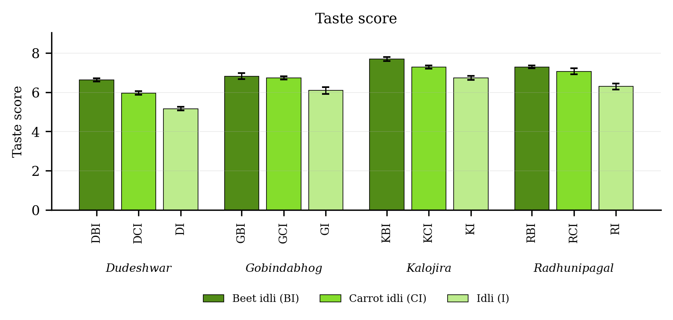
Fig. 4.37. Taste score of idli prepared from four rice varieties fortified with carrot and beet extract. Values are means of six observations and the vertical bars are the standard error of the mean. Letters above the bars denote the groupings at the 5 per cent level.
Result
Taste score (Table 4.37 and Fig. 4.37) differed significantly among the twelve treatment combinations. It was highest in KBI (7.69), followed by RBI (7.29), and lowest in DI (5.16). Among the products the mean value was 7.11 in the beet fortified product, 6.76 in the carrot fortified product and 6.06 in the plain product. Among the varieties it was highest in Kalojira (7.23) and lowest in Dudeshwar (5.91).
The variety and product interaction was non-significant for this character.
Discussion
The most probable basis of the improvement in taste on fortification is the free sugar contributed by the vegetable extract, beetroot and carrot both carrying appreciable quantities of sucrose and reducing sugars that sweeten the product perceptibly (Sharma et al., 2012; Singh and Hathan, 2014; Chhikara et al., 2019). The organic acids produced during lactic fermentation confer upon idli its characteristic mild sourness, and the added sweetness balances this acidity and improves the overall taste impression (Soni and Sandhu, 1990; Nout and Sarkar, 1999; Blandino et al., 2003). A second and less direct factor is that the visual appeal of a coloured product elevates the scores awarded for taste, a cross-modal interaction well documented in sensory evaluation (Amerine et al., 1965; Francis, 1995; Meilgaard et al., 2007). The non-significant interaction indicates that this gain was of equal magnitude in all four varieties, so that the effect is a property of the fortifying material rather than of any particular landrace (Pal et al., 2019).

4.8.3 Flavour score
Table 4.38. Flavour score of idli prepared from four rice varieties fortified with carrot and beet extract
Treatment combination | Year 1 | Year 2 | Pooled mean
DBI | 6.97 ± 0.06 | 6.82 ± 0.06 | 6.89 ± 0.10cde
DCI | 6.73 ± 0.06 | 6.58 ± 0.06 | 6.66 ± 0.10def
DI | 5.53 ± 0.06 | 5.38 ± 0.06 | 5.46 ± 0.10g
GBI | 7.17 ± 0.15 | 7.02 ± 0.15 | 7.09 ± 0.16bcd
GCI | 7.07 ± 0.06 | 6.92 ± 0.06 | 6.99 ± 0.10cde
GI | 6.30 ± 0.00 | 6.15 ± 0.00 | 6.22 ± 0.08f
KBI | 8.03 ± 0.06 | 7.88 ± 0.06 | 7.96 ± 0.10a
KCI | 7.63 ± 0.31 | 7.48 ± 0.31 | 7.56 ± 0.29ab
KI | 7.07 ± 0.49 | 6.92 ± 0.49 | 6.99 ± 0.45cde
RBI | 7.63 ± 0.21 | 7.48 ± 0.21 | 7.56 ± 0.20ab
RCI | 7.40 ± 0.35 | 7.25 ± 0.35 | 7.32 ± 0.32bc
RI | 6.63 ± 0.42 | 6.48 ± 0.42 | 6.56 ± 0.38ef
SEm (+/-): Y = 0.00; V = 0.06; P = 0.05; V x P = 0.10; Y x V x P = 0.14
CD (P = 0.05): Y = <0.01; V = 0.16; P = 0.14; V x P = 0.28; Y x V x P = NS; CV (%) = 3.51
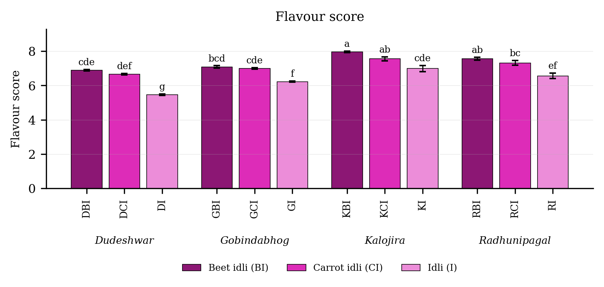
Fig. 4.38. Flavour score of idli prepared from four rice varieties fortified with carrot and beet extract. Values are means of six observations and the vertical bars are the standard error of the mean. Letters above the bars denote the groupings at the 5 per cent level.
Result
Flavour score (Table 4.38 and Fig. 4.38) differed significantly among the twelve treatment combinations. It was highest in KBI (7.96), followed by RBI (7.56), and lowest in DI (5.46). Among the products the mean value was 7.38 in the beet fortified product, 7.13 in the carrot fortified product and 6.31 in the plain product. Among the varieties it was highest in Kalojira (7.50) and lowest in Dudeshwar (6.34).
The variety and product interaction was significant, the critical difference at the 5 per cent level being 0.28, with a coefficient of variation of 3.51 per cent.
Discussion
Flavour integrates the perception of aroma and taste, and the most probable basis of the highest scores being obtained by the fortified treatments is that the gain in taste conferred by the added sugars outweighed the small loss of rice aroma occasioned by masking (Amerine et al., 1965; Meilgaard et al., 2007). The organic acids and volatile esters formed during lactic fermentation likewise contribute positively to the flavour of the product, and their concentration is conditioned by the fermentable substrate available in the batter, which the vegetable extract augments (Soni and Sandhu, 1990; Nout and Sarkar, 1999; Blandino et al., 2003; Ganzle, 2014). Kalojira scored highest, most probably because its own pigment and phenolic fraction confer a mild astringency perceived by the panel as depth of flavour, an effect reported for pigmented rice products by Sompong et al. (2011) and Pal et al. (2019).

4.8.4 Texture score
Table 4.39. Texture score of idli prepared from four rice varieties fortified with carrot and beet extract
Treatment combination | Year 1 | Year 2 | Pooled mean
DBI | 7.15 ± 0.38 | 7.00 ± 0.38 | 7.08 ± 0.35
DCI | 6.92 ± 0.28 | 6.77 ± 0.28 | 6.84 ± 0.26
DI | 5.72 ± 0.38 | 5.57 ± 0.38 | 5.64 ± 0.35
GBI | 7.35 ± 0.18 | 7.20 ± 0.18 | 7.28 ± 0.18
GCI | 7.25 ± 0.38 | 7.10 ± 0.38 | 7.18 ± 0.35
GI | 6.48 ± 0.33 | 6.33 ± 0.33 | 6.41 ± 0.30
KBI | 8.22 ± 0.33 | 8.07 ± 0.33 | 8.14 ± 0.31
KCI | 7.82 ± 0.58 | 7.67 ± 0.58 | 7.74 ± 0.52
KI | 7.25 ± 0.80 | 7.10 ± 0.80 | 7.18 ± 0.72
RBI | 7.82 ± 0.50 | 7.67 ± 0.50 | 7.74 ± 0.46
RCI | 7.58 ± 0.49 | 7.43 ± 0.49 | 7.51 ± 0.44
RI | 6.82 ± 0.60 | 6.67 ± 0.60 | 6.74 ± 0.54
SEm (+/-): Y = 0.00; V = 0.11; P = 0.09; V x P = 0.19; Y x V x P = 0.27
CD (P = 0.05): Y = <0.01; V = 0.30; P = 0.26; V x P = NS; Y x V x P = NS; CV (%) = 6.51
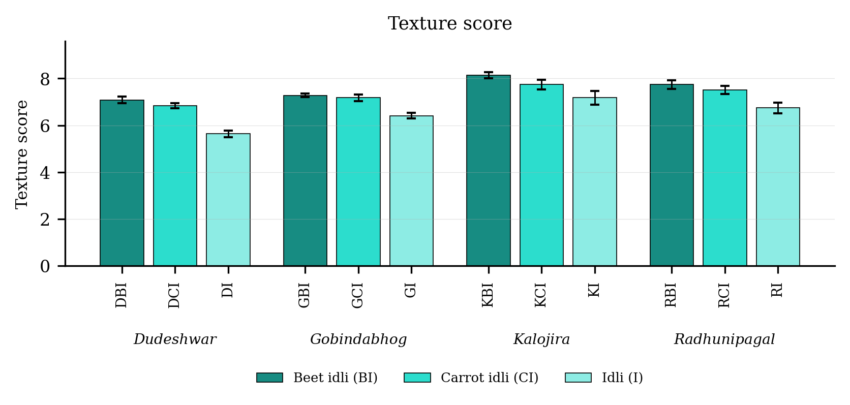
Fig. 4.39. Texture score of idli prepared from four rice varieties fortified with carrot and beet extract. Values are means of six observations and the vertical bars are the standard error of the mean. Letters above the bars denote the groupings at the 5 per cent level.
Result
Texture score (Table 4.39 and Fig. 4.39) differed significantly among the twelve treatment combinations. It was highest in KBI (8.14), followed by RBI (7.74), and lowest in DI (5.64). Among the products the mean value was 7.56 in the beet fortified product, 7.32 in the carrot fortified product and 6.49 in the plain product. Among the varieties it was highest in Kalojira (7.69) and lowest in Dudeshwar (6.52).
The variety and product interaction was non-significant for this character.
Discussion
The most probable basis of the higher texture scores of the fortified treatments is that the panel preferred a softer, less chewy and more readily broken product, and the instrumental determinations confirm that fortification produced precisely that character (Bourne, 2002; Szczesniak, 2002). Consumers of idli expect a soft, spongy crumb, and the dilution of the starch and protein network by the vegetable extract, together with the moisture it contributes, conferred exactly that quality (Reddy et al., 1981; Nisha et al., 2005; Durgadevi and Shetty, 2012). The close agreement between the instrumental values and the panel scores supports the position of Rosenthal (1999), Wilkinson et al. (2000) and Szczesniak (2002) that texture profile analysis of a steamed cereal product predicts perceived texture reliably, and it entails that the instrumental determination may be employed to screen new formulations in advance of sensory evaluation.

4.8.5 Appearance score
Table 4.40. Appearance score of idli prepared from four rice varieties fortified with carrot and beet extract
Treatment combination | Year 1 | Year 2 | Pooled mean
DBI | 7.90 ± 0.20 | 7.75 ± 0.20 | 7.82 ± 0.20
DCI | 7.67 ± 0.31 | 7.52 ± 0.31 | 7.59 ± 0.29
DI | 6.47 ± 0.21 | 6.32 ± 0.21 | 6.39 ± 0.20
GBI | 8.10 ± 0.40 | 7.95 ± 0.40 | 8.03 ± 0.37
GCI | 8.00 ± 0.20 | 7.85 ± 0.20 | 7.92 ± 0.20
GI | 7.23 ± 0.25 | 7.08 ± 0.25 | 7.16 ± 0.24
KBI | 8.97 ± 0.25 | 8.82 ± 0.25 | 8.89 ± 0.24
KCI | 8.57 ± 0.21 | 8.42 ± 0.21 | 8.49 ± 0.20
KI | 8.00 ± 0.26 | 7.85 ± 0.26 | 7.92 ± 0.25
RBI | 8.57 ± 0.15 | 8.42 ± 0.15 | 8.49 ± 0.16
RCI | 8.33 ± 0.40 | 8.18 ± 0.40 | 8.26 ± 0.37
RI | 7.57 ± 0.40 | 7.42 ± 0.40 | 7.49 ± 0.37
SEm (+/-): Y = 0.00; V = 0.07; P = 0.06; V x P = 0.12; Y x V x P = 0.16
CD (P = 0.05): Y = <0.01; V = 0.18; P = 0.16; V x P = NS; Y x V x P = NS; CV (%) = 3.61
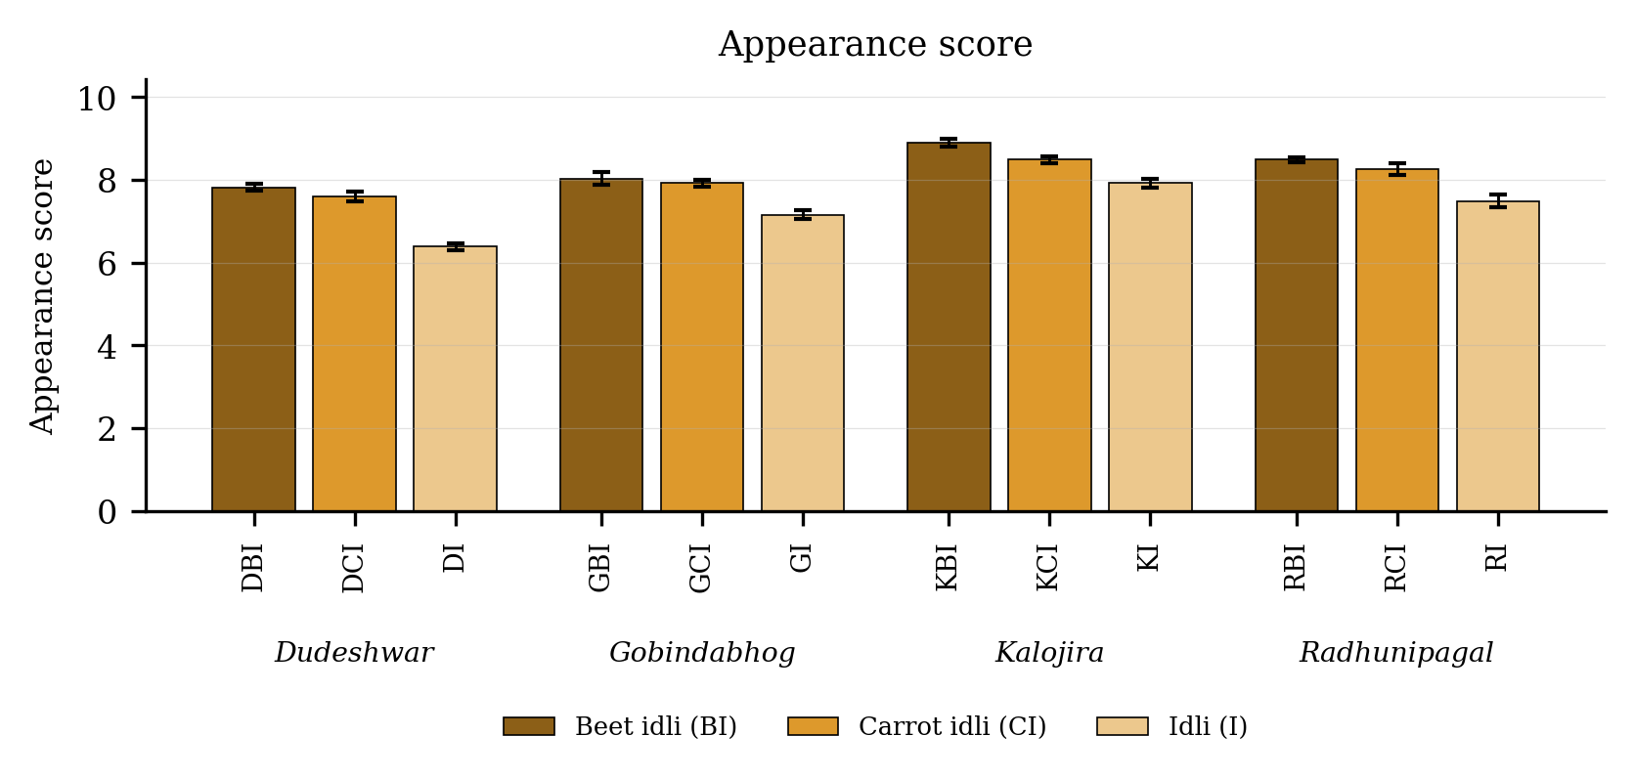
Fig. 4.40. Appearance score of idli prepared from four rice varieties fortified with carrot and beet extract. Values are means of six observations and the vertical bars are the standard error of the mean. Letters above the bars denote the groupings at the 5 per cent level.
Result
Appearance score (Table 4.40 and Fig. 4.40) differed significantly among the twelve treatment combinations. It was highest in KBI (8.89), followed by RBI (8.49), and lowest in DI (6.39). Among the products the mean value was 8.31 in the beet fortified product, 8.06 in the carrot fortified product and 7.24 in the plain product. Among the varieties it was highest in Kalojira (8.43) and lowest in Dudeshwar (7.27).
The variety and product interaction was non-significant for this character.
Discussion
The most probable basis of the very high appearance scores of the fortified treatments is the introduction of an attractive natural colour into what is otherwise a plain white product. The colour difference recorded for every fortified treatment lay many times above the threshold at which a change becomes visible, so that the difference in appearance was immediately apparent to the panel (Francis, 1995; Hutchings, 1999; Pathare et al., 2013). Consumers respond positively to natural pigments in traditional foods, particularly where the colour is recognisably derived from a familiar vegetable rather than from a synthetic additive (Delgado-Vargas et al., 2000; Stintzing and Carle, 2004; Chhikara et al., 2019). Comparable improvements in the appearance rating of traditional Indian foods following the addition of pigment-rich fractions have been reported by Pal et al. (2019) and Bagchi et al. (2020).

4.8.6 Cooking quality score
Table 4.41. Cooking quality score of idli prepared from four rice varieties fortified with carrot and beet extract
Treatment combination | Year 1 | Year 2 | Pooled mean
DBI | 7.45 ± 0.20 | 7.30 ± 0.20 | 7.38 ± 0.20
DCI | 7.22 ± 0.31 | 7.07 ± 0.31 | 7.14 ± 0.29
DI | 6.02 ± 0.21 | 5.87 ± 0.21 | 5.94 ± 0.20
GBI | 7.65 ± 0.40 | 7.50 ± 0.40 | 7.58 ± 0.37
GCI | 7.55 ± 0.20 | 7.40 ± 0.20 | 7.47 ± 0.20
GI | 6.78 ± 0.25 | 6.63 ± 0.25 | 6.71 ± 0.24
KBI | 8.52 ± 0.25 | 8.37 ± 0.25 | 8.44 ± 0.24
KCI | 8.12 ± 0.21 | 7.97 ± 0.21 | 8.04 ± 0.20
KI | 7.55 ± 0.26 | 7.40 ± 0.26 | 7.47 ± 0.25
RBI | 8.12 ± 0.15 | 7.97 ± 0.15 | 8.04 ± 0.16
RCI | 7.88 ± 0.40 | 7.73 ± 0.40 | 7.81 ± 0.37
RI | 7.12 ± 0.40 | 6.97 ± 0.40 | 7.04 ± 0.37
SEm (+/-): Y = 0.00; V = 0.07; P = 0.06; V x P = 0.12; Y x V x P = 0.16
CD (P = 0.05): Y = <0.01; V = 0.18; P = 0.16; V x P = NS; Y x V x P = NS; CV (%) = 3.82
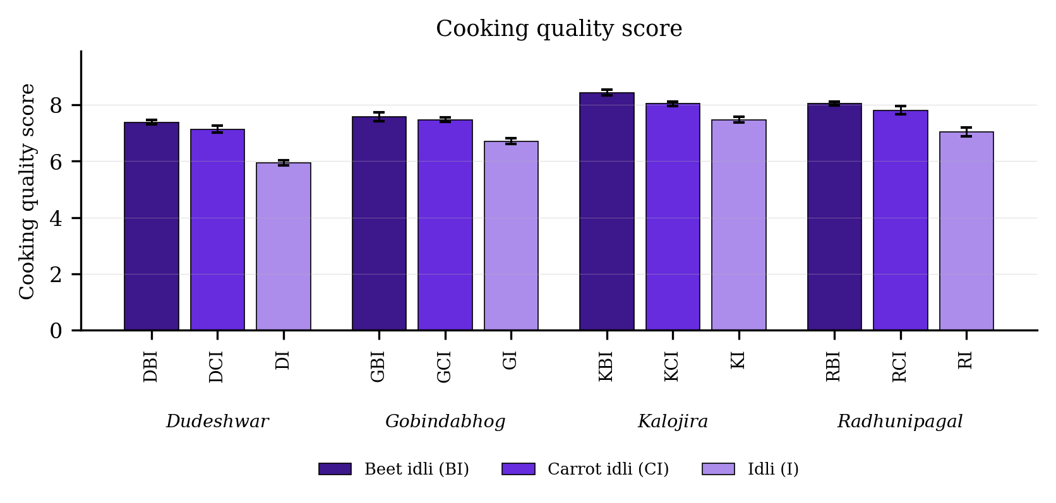
Fig. 4.41. Cooking quality score of idli prepared from four rice varieties fortified with carrot and beet extract. Values are means of six observations and the vertical bars are the standard error of the mean. Letters above the bars denote the groupings at the 5 per cent level.
Result
Cooking quality score (Table 4.41 and Fig. 4.41) differed significantly among the twelve treatment combinations. It was highest in KBI (8.44), followed by RBI (8.04), and lowest in DI (5.94). Among the products the mean value was 7.86 in the beet fortified product, 7.61 in the carrot fortified product and 6.79 in the plain product. Among the varieties it was highest in Kalojira (7.98) and lowest in Dudeshwar (6.82).
The variety and product interaction was non-significant for this character.
Discussion
Cooking quality as judged by the panel encompasses the shape, surface finish and uniformity of the steamed product, and the most probable basis of the higher scores of the fortified treatments is that the added moisture and fibre improved the flow of the batter and permitted it to spread evenly within the mould (Reddy et al., 1981; Nisha et al., 2005; Durgadevi and Shetty, 2012). A batter of suitable consistency retains the gas generated during fermentation more evenly and yields a product of regular shape and smooth surface (Mukherjee et al., 1965; Soni and Sandhu, 1990; Sridevi et al., 2010). The uniform colour of the fortified products may have contributed indirectly, since surface irregularities are less conspicuous against a coloured background than against a white one (Hutchings, 1999; Pathare et al., 2013).

4.8.7 Overall acceptability score
Table 4.42. Overall acceptability score of idli prepared from four rice varieties fortified with carrot and beet extract
Treatment combination | Year 1 | Year 2 | Pooled mean
DBI | 7.65 ± 0.20 | 7.50 ± 0.20 | 7.58 ± 0.20
DCI | 7.42 ± 0.31 | 7.27 ± 0.31 | 7.34 ± 0.29
DI | 6.22 ± 0.21 | 6.07 ± 0.21 | 6.14 ± 0.20
GBI | 7.85 ± 0.40 | 7.70 ± 0.40 | 7.78 ± 0.37
GCI | 7.75 ± 0.20 | 7.60 ± 0.20 | 7.68 ± 0.20
GI | 6.98 ± 0.25 | 6.83 ± 0.25 | 6.91 ± 0.24
KBI | 8.72 ± 0.25 | 8.57 ± 0.25 | 8.64 ± 0.24
KCI | 8.32 ± 0.21 | 8.17 ± 0.21 | 8.24 ± 0.20
KI | 7.75 ± 0.26 | 7.60 ± 0.26 | 7.68 ± 0.25
RBI | 8.32 ± 0.15 | 8.17 ± 0.15 | 8.24 ± 0.16
RCI | 8.08 ± 0.40 | 7.93 ± 0.40 | 8.01 ± 0.37
RI | 7.32 ± 0.40 | 7.17 ± 0.40 | 7.24 ± 0.37
SEm (+/-): Y = 0.00; V = 0.07; P = 0.06; V x P = 0.12; Y x V x P = 0.16
CD (P = 0.05): Y = <0.01; V = 0.18; P = 0.16; V x P = NS; Y x V x P = NS; CV (%) = 3.72
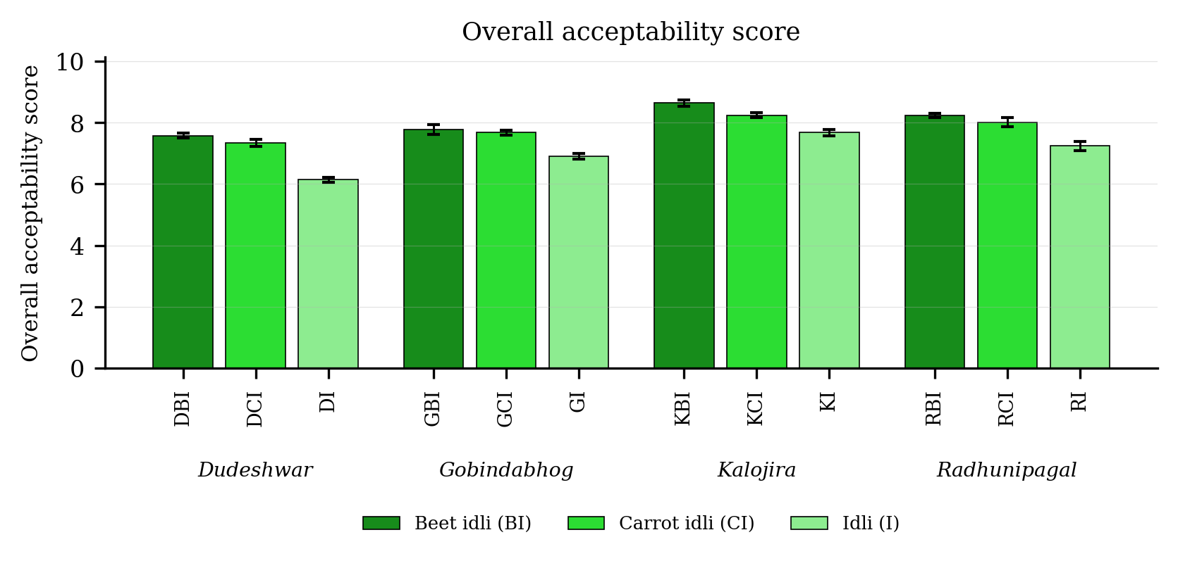
Fig. 4.42. Overall acceptability score of idli prepared from four rice varieties fortified with carrot and beet extract. Values are means of six observations and the vertical bars are the standard error of the mean. Letters above the bars denote the groupings at the 5 per cent level.
Result
Overall acceptability score (Table 4.42 and Fig. 4.42) differed significantly among the twelve treatment combinations. It was highest in KBI (8.64), followed by RBI (8.24), and lowest in DI (6.14). Among the products the mean value was 8.06 in the beet fortified product, 7.82 in the carrot fortified product and 6.99 in the plain product. Among the varieties it was highest in Kalojira (8.19) and lowest in Dudeshwar (7.02).
The variety and product interaction was non-significant for this character.
Discussion
Overall acceptability constitutes a composite judgement, and the most probable basis of the ranking obtained is that the fortified treatments were superior for the three attributes weighing most heavily within it, namely appearance, texture and taste (Amerine et al., 1965; Meilgaard et al., 2007). The natural pigment rendered the product visually attractive, the dilution of the starch and protein network rendered it softer and more readily eaten, and the free sugars of the extract improved its taste (Reddy et al., 1981; Sharma et al., 2012; Pathare et al., 2013; Chhikara et al., 2019). The small loss of rice aroma did not offset these gains, which is consistent with the finding that aroma alone was uncorrelated with acceptability in the present data. The non-significant interaction constitutes an important practical result, since it demonstrates that the advantage conferred by fortification was of equal magnitude in every variety and is therefore a general property of the treatment rather than of any one landrace, a conclusion consonant with the reports of Pal et al. (2019) and Bagchi et al. (2020) on pigment-enriched traditional Indian foods.

4.9 Correlation among the quality parameters
The relations among the forty two quality parameters were examined by computing the Pearson correlation coefficient over twenty four treatment means, namely the twelve treatment combinations in each of the two years. The full matrix is presented as a heat map in Fig. 4.43 and the correlation of overall acceptability with every other parameter in Table 4.43. At twenty two degrees of freedom the coefficient must exceed 0.404 to attain significance at the 5 per cent level and 0.515 at the 1 per cent level (Snedecor and Cochran, 1994). It should be borne in mind throughout that a correlation establishes only that two characters covaried within this data set; it does not of itself demonstrate that one caused the other.
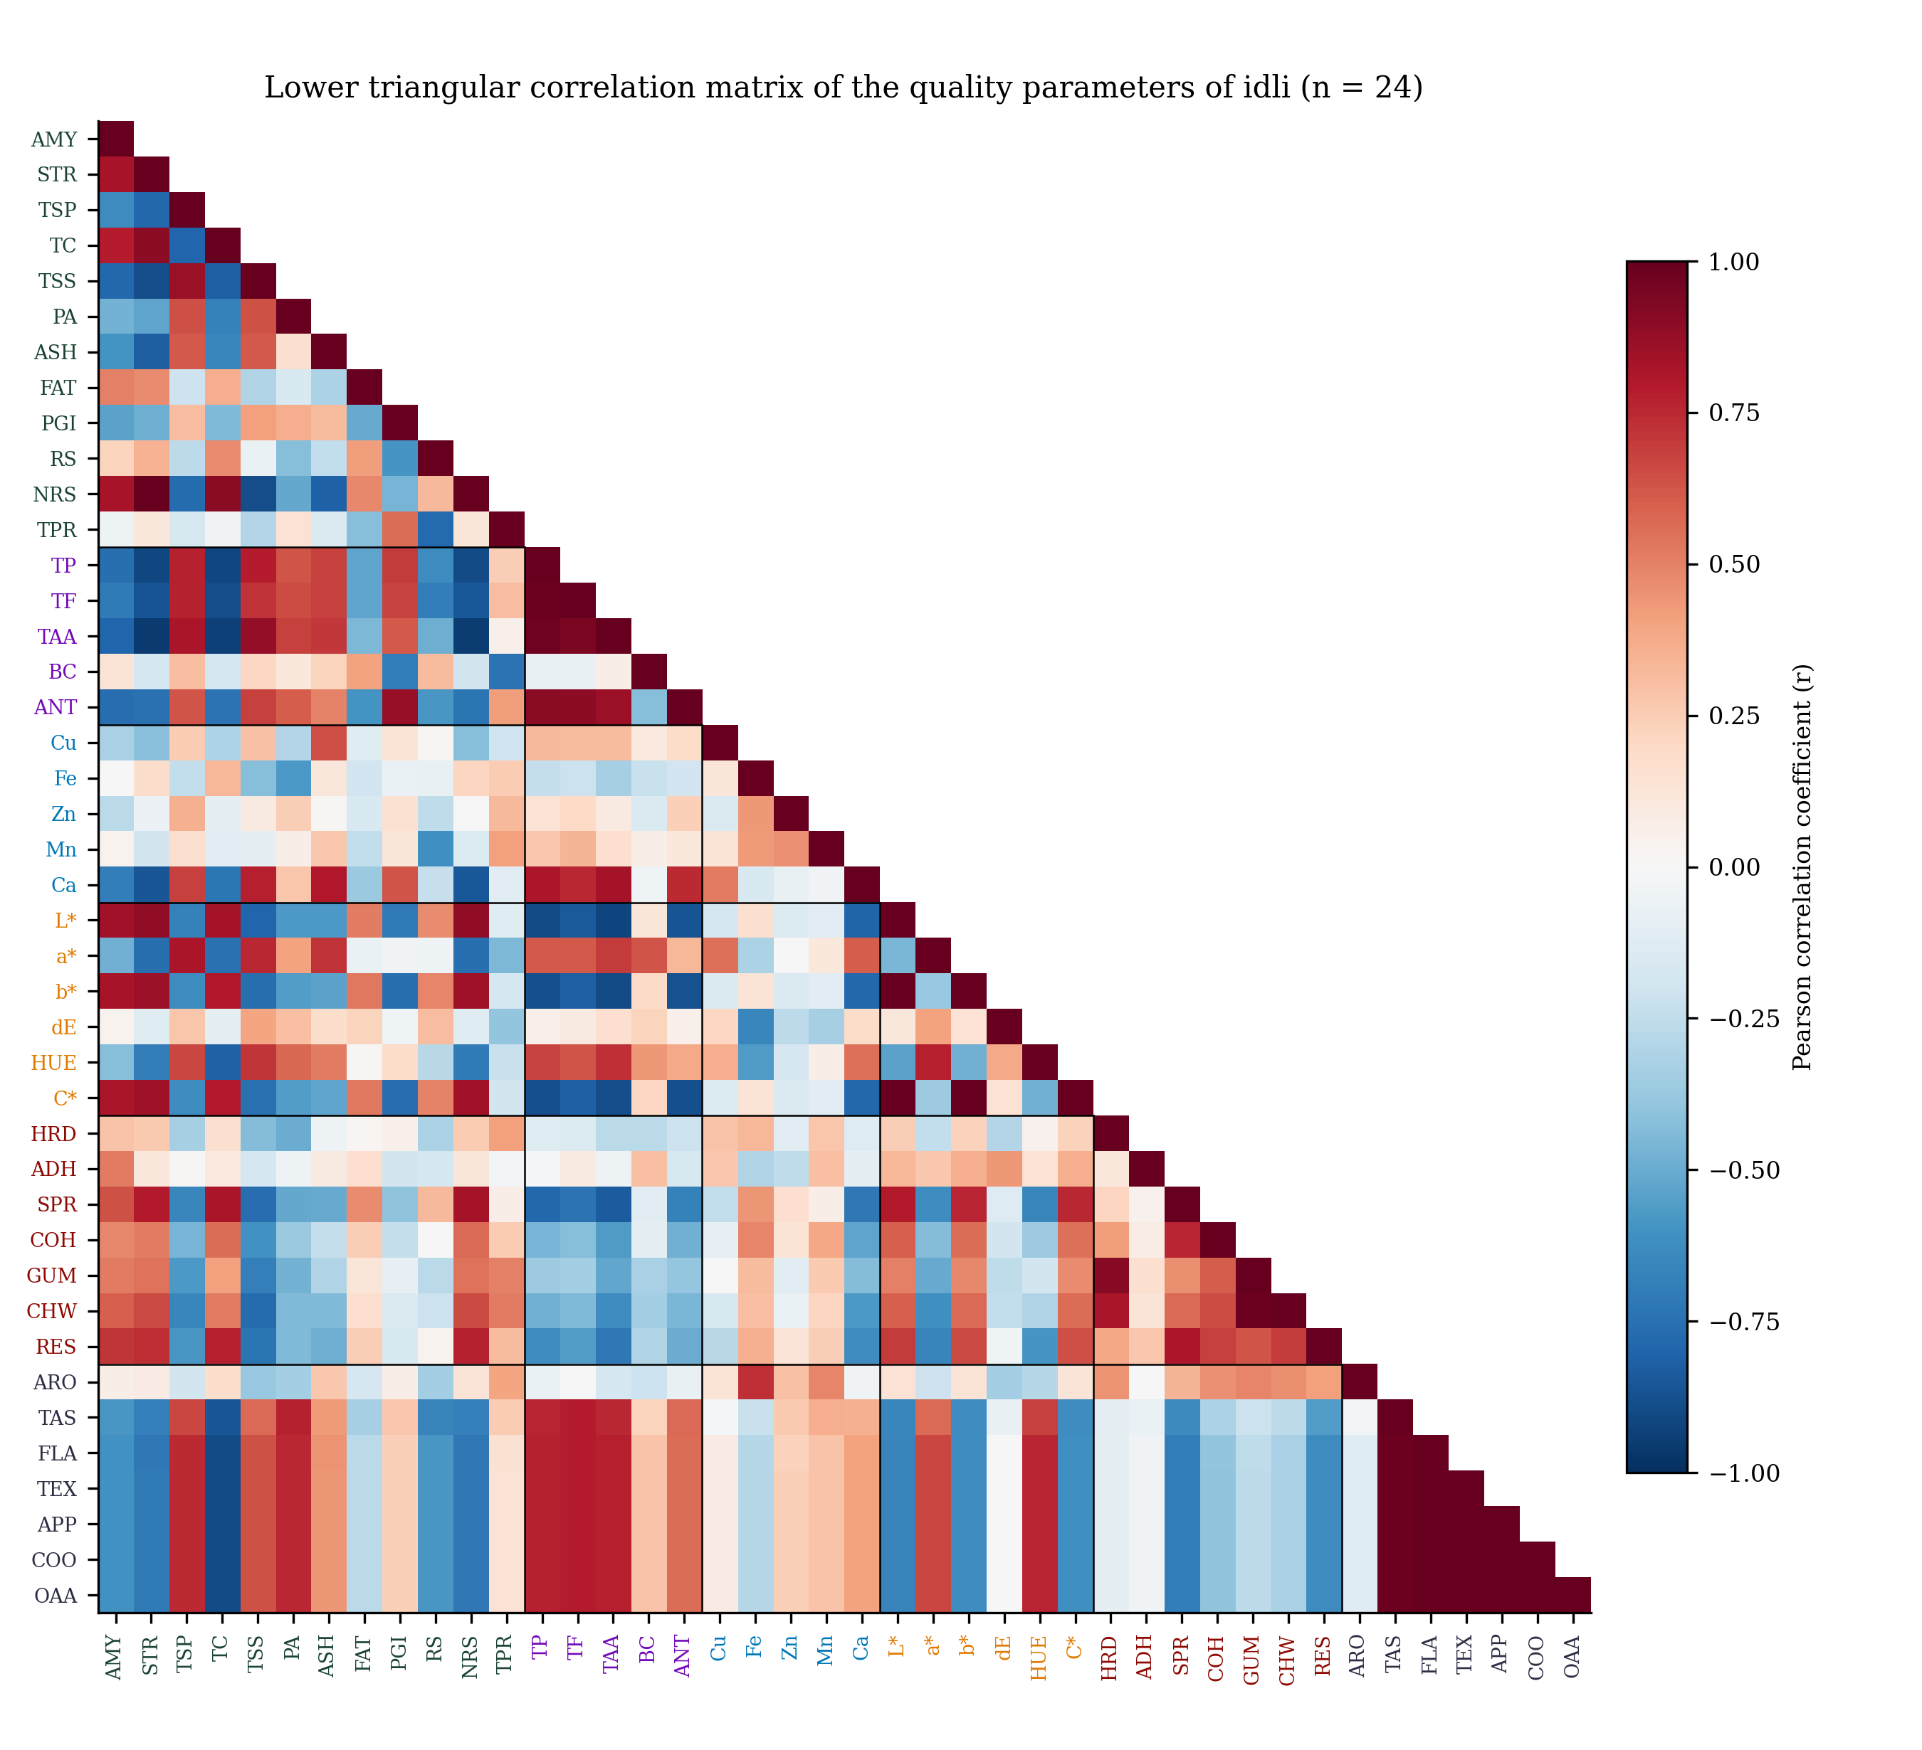
Fig. 4.43. Lower triangular heat map of the correlation matrix of the forty two quality parameters of idli. Parameter labels are coloured by the group to which the parameter belongs.
Table 4.43. Correlation coefficients of overall acceptability with the quality parameters of idli (n = 24)
Parameter | r | Parameter | r
Amylose | -0.603** | Chroma | -0.613**
Starch | -0.710** | PGI | 0.235NS
Total soluble protein | 0.746** | Resistant starch | -0.584**
Total phenol | 0.773** | Non-resistant starch | -0.716**
Total flavonoid | 0.782** | Hardness | -0.093NS
Total antioxidant activity | 0.780** | Adhesiveness | -0.038NS
Total carbohydrate | -0.895** | Springiness | -0.691**
Total soluble sugar | 0.640** | Cohesiveness | -0.399NS
Copper | 0.080NS | Gumminess | -0.260NS
Iron | -0.287NS | Chewiness | -0.326NS
Zinc | 0.235NS | Resilience | -0.629**
Manganese | 0.284NS | Aroma | -0.123NS
Calcium | 0.405* | Taste | 0.981**
Phytate | 0.753** | Flavour | 1.000**
Ash | 0.443* | Texture | 1.000**
Fat | -0.269NS | Appearance | 1.000**
Lightness (L*) | -0.662** | Cooking quality | 1.000**
Redness (a*) | 0.667** | Total protein | 0.148NS
Yellowness (b*) | -0.619** | Beta-carotene | 0.289NS
Colour difference | 0.005NS | Anthocyanin | 0.560**
Hue angle | 0.762**
* significant at P = 0.05; ** significant at P = 0.01; NS not significant. Critical values of r at 22 degrees of freedom are 0.404 at P = 0.05 and 0.515 at P = 0.01.
The three bioactive fractions were very closely associated. Total phenol correlated with total flavonoid (r = 0.983) and with total antioxidant activity (r = 0.971), and total flavonoid with total antioxidant activity (r = 0.945), all three coefficients being significant at the 1 per cent level. Coefficients of this magnitude are unsurprising, since the three assays determine the same group of compounds: the DPPH assay records the hydrogen-donating power of the phenolic and flavonoid pool, so that its value must follow that pool, as has likewise been reported for rice by Goufo and Trindade (2014) and for idli by Kaviyaselvan et al. (2026). Total soluble protein correlated with total phenol (r = 0.767) and phytate with total phenol (r = 0.632). These two associations have a different basis, namely that protein, phytate and bound phenolic acids co-occur in the aleurone and sub-aleurone layers of the grain, so that a treatment raising one tends to raise the others.
The carbohydrate fractions were negatively associated with the bioactive fractions throughout. Total carbohydrate was negatively correlated with total phenol (r = -0.913) and starch with total antioxidant activity (r = -0.955). Total carbohydrate was itself correlated with starch (r = 0.895) and amylose (r = 0.824), and lightness with yellowness (r = 0.995) and with total carbohydrate (r = 0.832). This entire block of coefficients expresses a single gradient rather than several separate effects: each gram of vegetable extract added to the batter displaces a gram of rice and black gram, so that starch is removed and pigment added in the same operation (Chhikara et al., 2019). The fortified products were therefore darker, lower in starch and richer in antioxidants concurrently, and lightness moved with total carbohydrate because the pale colour of the plain product derives from its undiluted starch matrix (Pathare et al., 2013).
Several of the textural coefficients are mechanical rather than biological in origin. Hardness correlated with gumminess (r = 0.913) and chewiness (r = 0.816), which follows from both being computed from hardness and cohesiveness rather than determined directly (Bourne, 2002). Springiness correlated with amylose (r = 0.640) and cohesiveness with amylose (r = 0.484), amylose forming the gel that permits the crumb to recover after compression, so that a product of higher amylose content is firmer and more elastic (Tester et al., 2004). Resistant starch was negatively correlated with the predicted glycaemic index (r = -0.587), as is to be expected since resistant starch is the fraction escaping digestion. Ash correlated with calcium (r = 0.804), which demonstrates that the mineral load of the product was governed largely by the calcium supplied by beetroot.
The coefficients obtained for overall acceptability indicate what the panel in fact responded to. It was negatively correlated with total carbohydrate (r = -0.895), non-resistant starch (r = -0.716), starch (r = -0.710), springiness (r = -0.691) and lightness (r = -0.662), and positively correlated with total flavonoid (r = 0.782), total antioxidant activity (r = 0.780), total phenol (r = 0.773), hue angle (r = 0.762), phytate (r = 0.753) and total soluble protein (r = 0.746). The panel accordingly awarded low scores to products that were starchy, springy and pale, and high scores to products that were coloured and pigment-rich, which is the profile of the fortified treatments. The probable reason is that colour and tenderness determine the acceptability of a steamed cereal food to a greater extent than any single chemical constituent (Pathare et al., 2013; Kaviyaselvan et al., 2026). The positive coefficients for phytate and total soluble protein should not be construed as causal, since these constituents simply rose in the same treatments that were fortified and therefore covaried with acceptability without influencing it. Aroma was the sole sensory attribute uncorrelated with acceptability (r = -0.123), most probably because aroma derives from the 2-acetyl-1-pyrroline of the rice whereas acceptability was determined by colour and texture.
One feature of the matrix requires comment. Taste, flavour, texture, appearance, cooking quality and overall acceptability were correlated with one another at exactly unity, the six scores differing only by a constant. This is a property of the manner in which the scores were recorded and not a biological finding. Their relations with the physico-chemical parameters are therefore identical, and only overall acceptability has been carried forward into the multivariate analyses that follow.

4.10 Principal component analysis
Principal component analysis was performed on the standardised values of the forty two parameters over the twenty four treatment means. The method takes a large number of related parameters and derives a few new axes carrying most of the variation, each axis constituting a weighted combination of the original parameters. The weights are termed loadings, a high loading denoting that the parameter contributes strongly to that axis (Jolliffe, 2002). Only components with an eigenvalue above unity were retained, which is the customary practice for food quality data in which many related characters are determined on the same samples (Granato et al., 2018). The eigenvalues are given in Table 4.44, the scree plot in Fig. 4.44, the loadings in Table 4.45 and the biplot of the first two components in Fig. 4.45.
Table 4.44. Eigenvalues and variance explained by the first eight principal components
Principal component | Eigenvalue | Variance explained (%) | Cumulative variance (%)
PC1 | 21.97 | 50.12 | 50.12
PC2 | 6.19 | 14.12 | 64.24
PC3 | 4.21 | 9.60 | 73.84
PC4 | 3.16 | 7.20 | 81.04
PC5 | 2.46 | 5.62 | 86.66
PC6 | 1.77 | 4.04 | 90.70
PC7 | 1.09 | 2.48 | 93.18
PC8 | 0.75 | 1.71 | 94.89
Components with an eigenvalue above unity were retained following the Kaiser criterion.
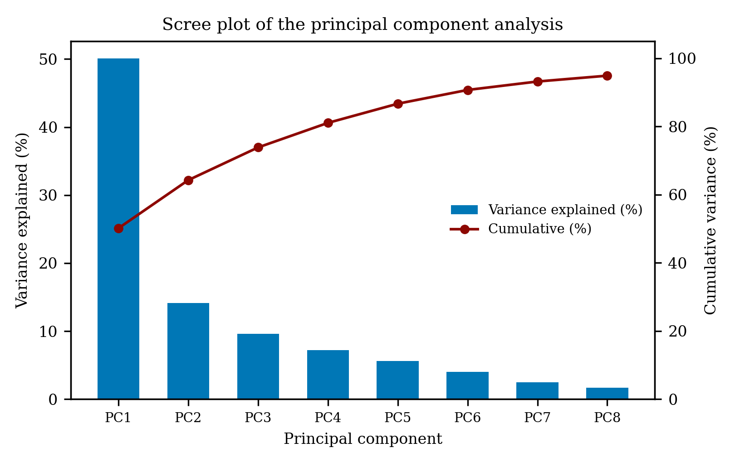
Fig. 4.44. Scree plot showing the variance explained and the cumulative variance explained by the first eight principal components.
Table 4.45. Loadings of the quality parameters on the first three principal components
Parameter | PC1 | PC2 | PC3
Amylose | -0.836 | -0.073 | 0.353
Starch | -0.963 | 0.037 | 0.107
Total soluble protein | 0.867 | -0.156 | 0.134
Total phenol | 0.968 | 0.227 | -0.056
Total flavonoid | 0.942 | 0.271 | 0.013
Total antioxidant activity | 1.005 | 0.027 | -0.071
Total carbohydrate | -0.988 | -0.015 | -0.129
Total soluble sugar | 0.905 | -0.324 | -0.147
Copper | 0.279 | -0.061 | -0.032
Iron | -0.330 | 0.561 | -0.178
Zinc | 0.143 | 0.408 | 0.037
Manganese | 0.143 | 0.617 | 0.403
Calcium | 0.793 | -0.052 | -0.372
Phytate | 0.728 | -0.051 | 0.211
Ash | 0.684 | 0.015 | -0.033
Fat | -0.447 | -0.444 | 0.371
Lightness (L*) | -0.927 | -0.145 | 0.322
Redness (a*) | 0.747 | -0.416 | 0.347
Yellowness (b*) | -0.893 | -0.195 | 0.373
Colour difference | 0.126 | -0.590 | 0.125
Hue angle | 0.759 | -0.212 | 0.439
Chroma | -0.888 | -0.203 | 0.379
PGI | 0.534 | 0.510 | -0.525
Resistant starch | -0.475 | -0.783 | -0.250
Non-resistant starch | -0.965 | 0.069 | 0.109
Hardness | -0.291 | 0.592 | 0.289
Adhesiveness | -0.112 | -0.123 | 0.500
Springiness | -0.875 | 0.138 | 0.081
Cohesiveness | -0.615 | 0.396 | 0.269
Gumminess | -0.547 | 0.608 | 0.347
Chewiness | -0.647 | 0.583 | 0.341
Resilience | -0.794 | 0.364 | 0.101
Aroma | -0.206 | 0.658 | 0.069
Taste | 0.840 | 0.239 | 0.439
Flavour | 0.874 | 0.127 | 0.456
Texture | 0.874 | 0.125 | 0.455
Appearance | 0.874 | 0.125 | 0.455
Cooking quality | 0.874 | 0.125 | 0.455
Overall acceptability | 0.874 | 0.125 | 0.455
Total protein | 0.025 | 0.922 | -0.025
Beta-carotene | 0.133 | -0.644 | 0.623
Anthocyanin | 0.834 | 0.313 | -0.376
Loadings above 0.70 in absolute value were treated as important contributors to that component.
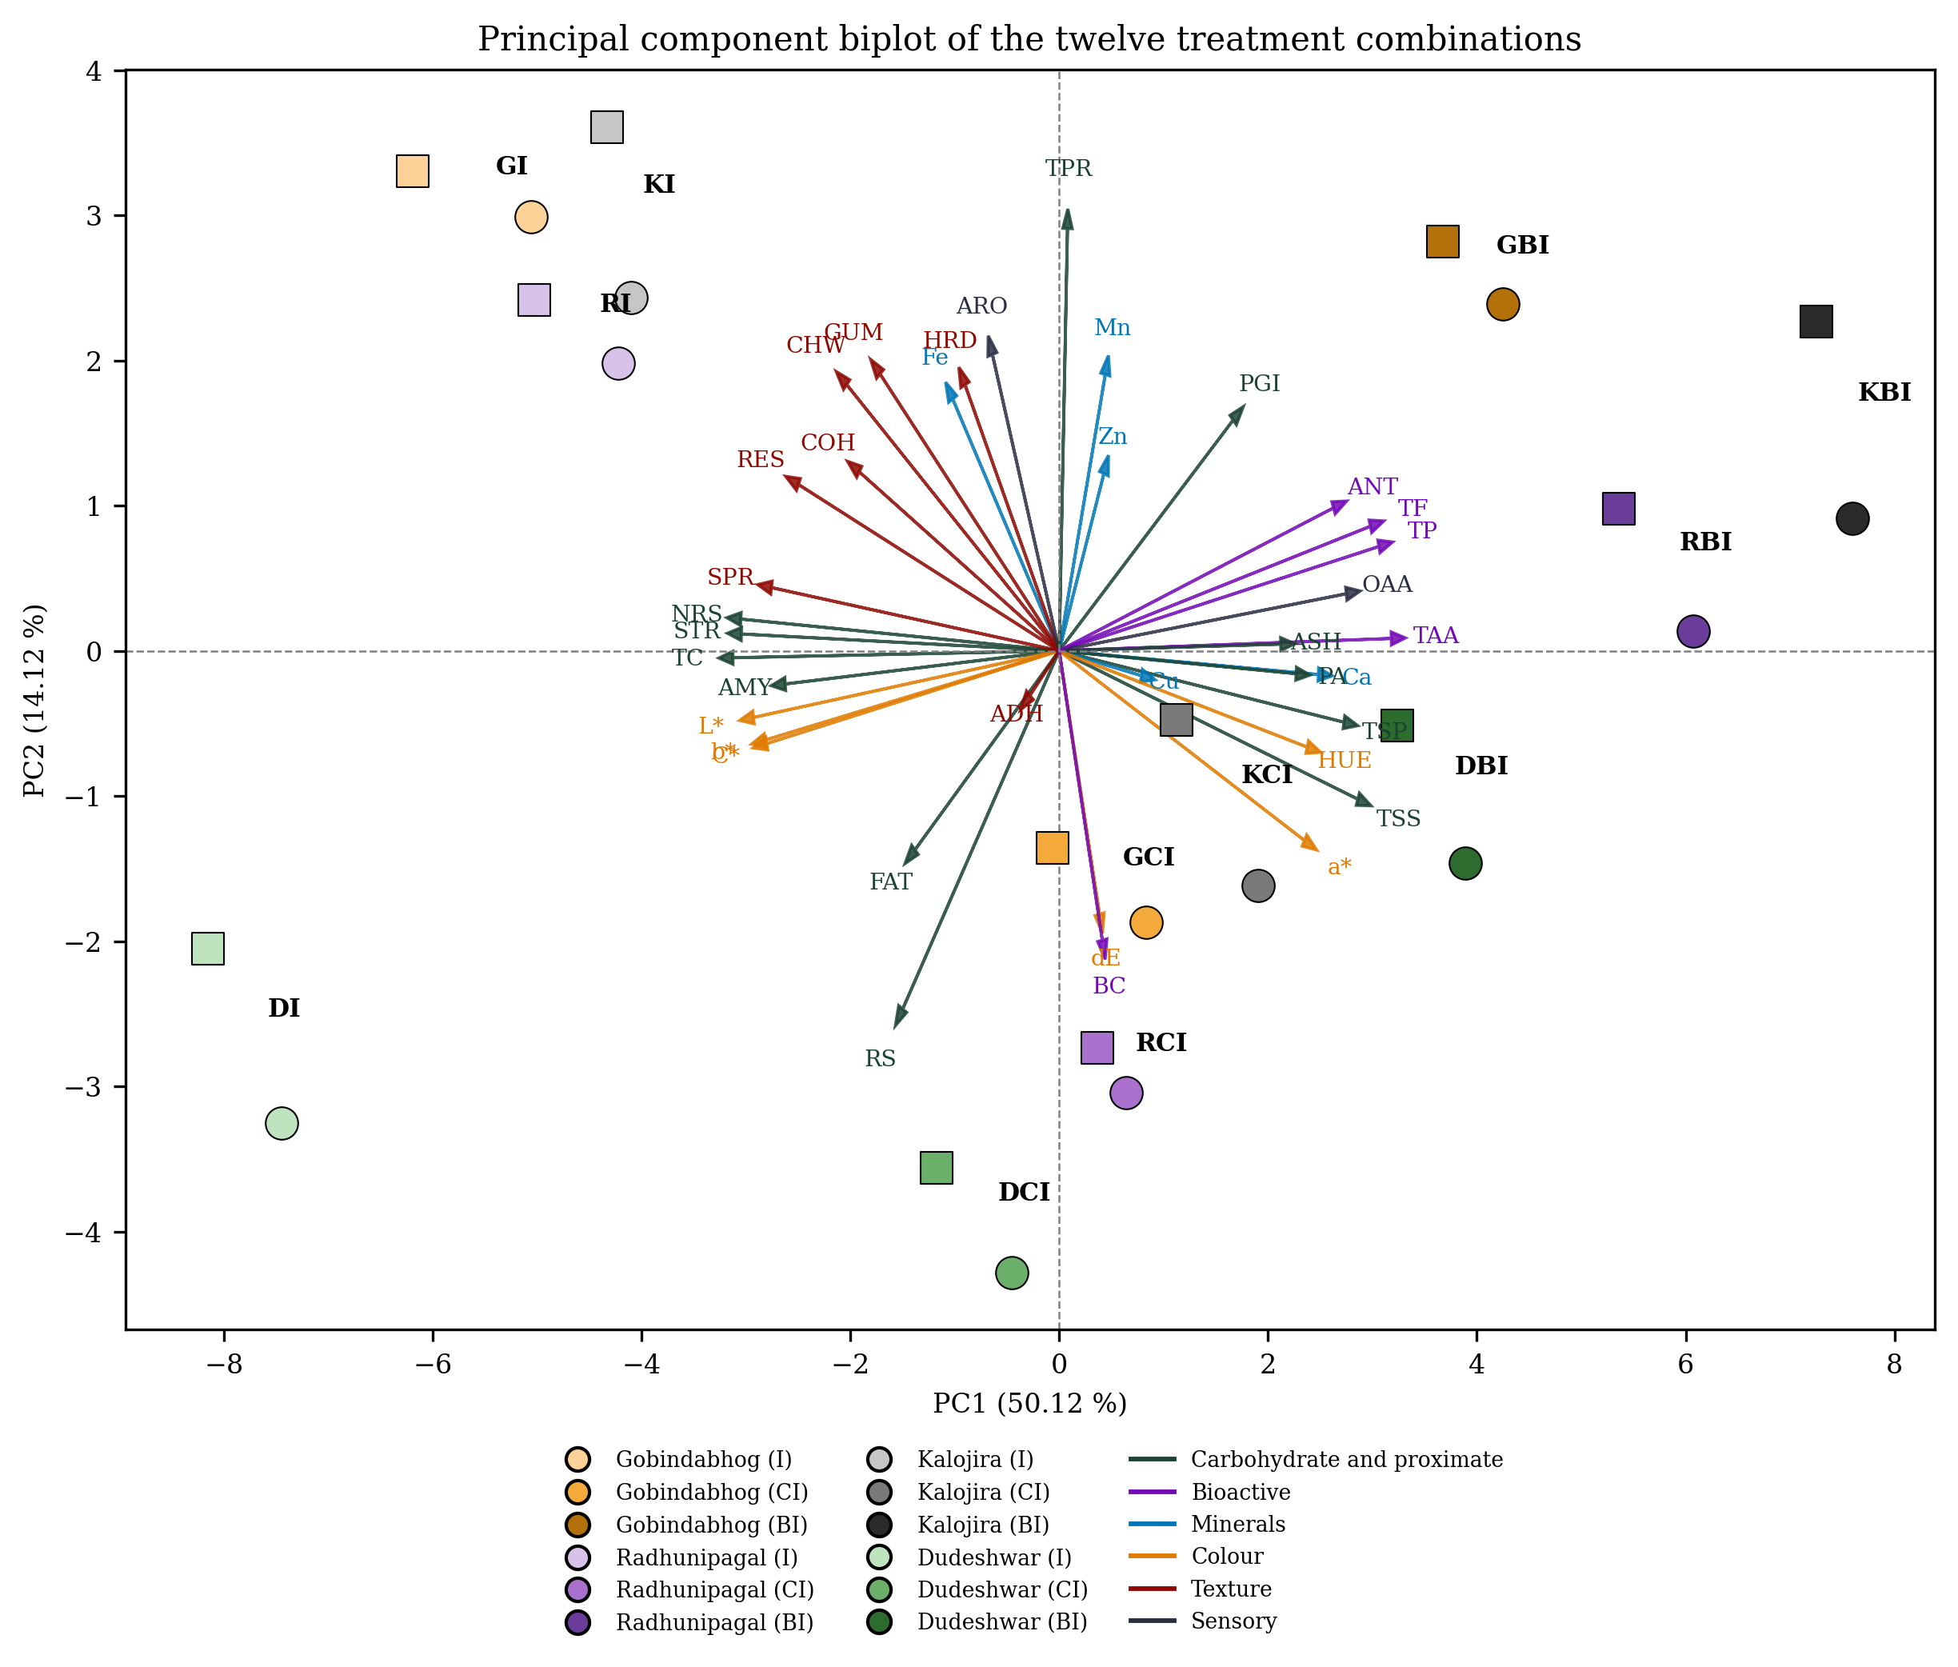
Fig. 4.45. Principal component biplot of the twelve treatment combinations. Each variety is shown in a separate colour and the three products within a variety in three shades of that colour, the lightest being the plain product and the darkest the beet fortified product. Circles denote the first year and squares the second year.
Seven components returned eigenvalues above unity. The first component explained 50.12 per cent of the total variation and the second 14.12 per cent, the two together accounting for 64.24 per cent and the first five components for 86.66 per cent. A first component of this magnitude demonstrates that one principal effect runs through the entire data set rather than several independent effects.
The loadings identify that effect. The positive pole of the first component was defined by total antioxidant activity (1.005), total phenol (0.968), total flavonoid (0.942), total soluble sugar (0.905) and overall acceptability (0.874), and the negative pole by total carbohydrate (-0.988), non-resistant starch (-0.965), starch (-0.963), lightness (-0.927), yellowness (-0.893), chroma (-0.888), springiness (-0.875) and amylose (-0.836). This is the same dilution gradient evident in the correlation matrix, since the addition of a vegetable extract removes starch and adds pigment in a single operation, so that all these parameters must move together in a fixed pattern (Chhikara et al., 2019). The first component may therefore be designated a fortification axis. A single dominant component of this kind is common in fortified and fermented cereal products, in which one processing step alters many characters simultaneously (Granato et al., 2018).
The second component carried a considerably smaller share of the variation. Its positive pole was defined by total protein (0.922), aroma (0.658), manganese (0.617), gumminess (0.608) and hardness (0.592), and its negative pole by resistant starch (-0.783), beta-carotene (-0.644) and total colour difference (-0.590). This axis separates the carrot fortified treatments from the remainder. The probable reason is that the two fortifying materials behave differently: carrot supplies carotenoid and dietary fibre but very little free sugar, so that it raises beta-carotene and resistant starch and leaves the product firmer, whereas beetroot supplies free sugar and betalain instead (Sharma et al., 2012). The second component therefore describes the difference between the two vegetables rather than any difference between the varieties.
The biplot presents the same result in graphical form. Treatments lying close together possess a similar quality profile, and a treatment lying near a vector is high in that parameter (Jolliffe, 2002). The twelve treatments separated into three distinct groups along the first component in the order plain, carrot fortified and beet fortified, while the four varieties fell in the same order within every group, namely Dudeshwar, Gobindabhog, Radhunipagal and Kalojira. Fortification therefore determined the broad position of a treatment and variety its position within the group, so that fortification constituted the stronger factor and variety the weaker. KBI occupied the extreme positive position, proximate to the phenol, flavonoid, antioxidant and anthocyanin vectors, and DI the extreme negative position, proximate to the starch, carbohydrate and lightness vectors. The two years of each treatment invariably fell close together, most probably because the treatment effects were reproducible across the two seasons, which affords independent support for pooling the data. A comparable application of the method was made by Kaviyaselvan et al. (2026), who subjected twenty seven colour, textural and nutritional attributes of idli to principal component analysis and used the position of the products on the biplot to identify the most promising formulations.

4.11 Cluster analysis
Cluster analysis was performed on the standardised values of the forty two parameters of the twelve treatment combinations in order to group the treatments according to their overall quality. The squared Euclidean distance served as the measure of dissimilarity, and the groups were formed by the minimum variance method of Ward (1963), which is widely employed for food quality data on account of the compact, nearly equal groups it yields (Everitt et al., 2011). The dendrogram is given in Fig. 4.46, the composition of the clusters in Table 4.46 and the cluster means in Table 4.47. The cophenetic correlation coefficient was 0.793, which demonstrates that the dendrogram represents the original distance matrix reasonably faithfully (Murtagh and Legendre, 2014).
Table 4.46. Grouping of the twelve treatment combinations by Ward cluster analysis
Cluster | Number of members | Treatment combinations
Cluster I | 3 | GI, KI, RI
Cluster II | 1 | DI
Cluster III | 4 | DCI, GCI, KCI, RCI
Cluster IV | 4 | DBI, GBI, KBI, RBI
Clustering was based on the squared Euclidean distance of the standardised values of the forty two parameters. The cophenetic correlation coefficient was 0.793.
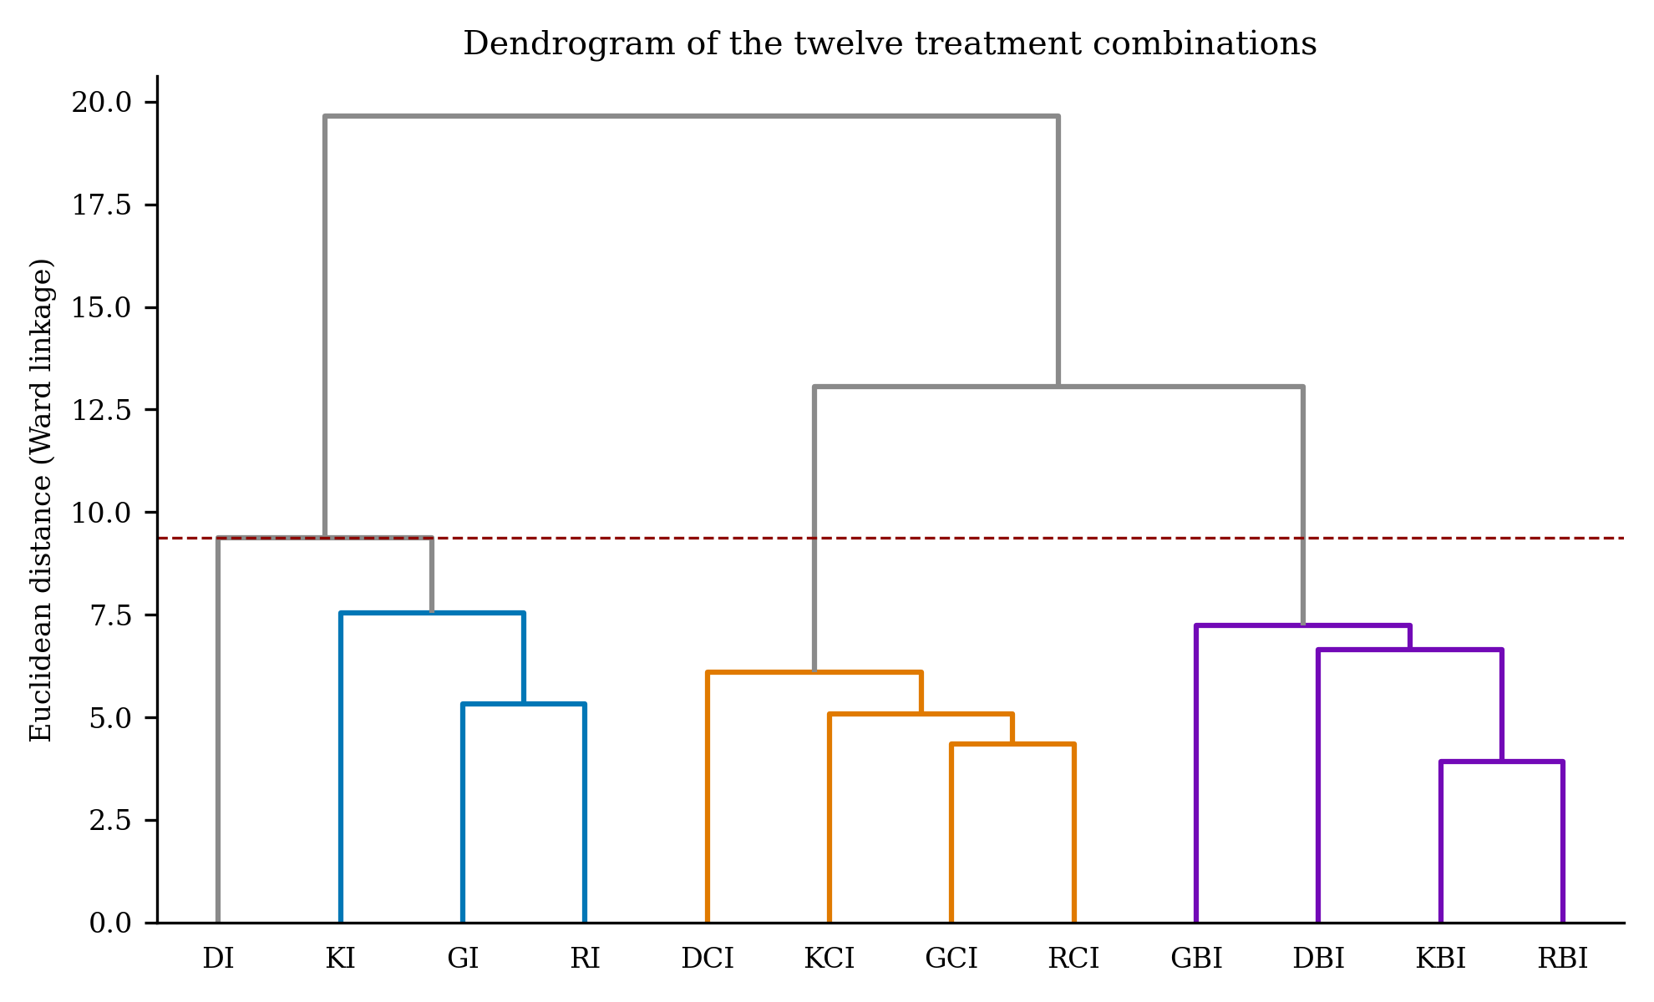
Fig. 4.46. Dendrogram of the twelve treatment combinations obtained by Ward cluster analysis of the standardised values of the forty two quality parameters. The broken line marks the level at which four clusters were formed.
Table 4.47. Mean values of the important quality parameters in the four clusters
Parameter | Cluster I (n = 3) | Cluster II (n = 1) | Cluster III (n = 4) | Cluster IV (n = 4)
Amylose (%) | 14.59 | 16.75 | 13.44 | 10.10
Starch (%) | 46.29 | 51.66 | 34.83 | 26.23
Total carbohydrate (%) | 54.62 | 60.22 | 47.98 | 42.82
Resistant starch (%) | 1.45 | 1.89 | 1.69 | 1.34
PGI | 65.10 | 65.47 | 60.49 | 73.53
Total soluble protein (%) | 1.34 | 1.04 | 2.06 | 2.24
Total protein (%) | 13.09 | 12.05 | 11.43 | 12.69
Phytate (mg g⁻¹) | 1.07 | 1.17 | 1.49 | 1.85
Total phenol (mg GAE 100 g⁻¹) | 101.37 | 53.47 | 152.64 | 265.22
Total flavonoid (mg QE 100 g⁻¹) | 66.18 | 42.95 | 89.52 | 142.75
Total antioxidant activity (mg TE 100 g⁻¹) | 191.97 | 165.25 | 287.71 | 393.44
Beta-carotene | 0.00 | 0.00 | 38.85 | 2.45
Anthocyanin | 0.00 | 0.00 | 0.00 | 1.41
Calcium (mg L⁻¹) | 81.03 | 97.18 | 263.31 | 500.89
Lightness (L*) | 66.01 | 72.92 | 59.60 | 40.69
Redness (a*) | -0.31 | -1.81 | 11.57 | 8.80
Hardness | 114.11 | 45.09 | 72.27 | 74.22
Springiness | 0.97 | 1.04 | 0.73 | 0.54
Overall acceptability | 7.27 | 6.14 | 7.82 | 8.06
Cluster means were worked out from the pooled treatment means of the two years.
The twelve treatments resolved into four clusters at a linkage distance of approximately 9.4. Cluster I comprised the three plain products of the aromatic landraces, namely GI, KI and RI; Cluster II comprised DI alone; Cluster III comprised all four carrot fortified products and Cluster IV all four beet fortified products. The salient point is that the first division was determined by fortification and not by variety, all four beet fortified treatments grouping together irrespective of parent variety, and the same obtaining for the carrot fortified treatments. This confirms the result of the principal component analysis, namely that the type of fortification constitutes the principal source of variation in product quality. Variety was operative only at the second level, where the plain product of the non-aromatic check separated from the plain products of the three aromatic landraces and formed a cluster of its own. This separation is itself informative, since it demonstrates that the quality of the non-aromatic check departs from that of the aromatic landraces to a greater extent than any two aromatic landraces depart from each other.
The cluster means characterise the four groups distinctly. Cluster IV, the beet fortified group, returned the highest total phenol (265.22 mg GAE 100 g⁻¹), total flavonoid (142.75 mg QE 100 g⁻¹), total antioxidant activity (393.44 mg TE 100 g⁻¹), total soluble protein (2.24 per cent), calcium (500.89 mg L⁻¹), anthocyanin (1.41) and overall acceptability (8.06), together with the lowest amylose, starch, total carbohydrate and lightness. Cluster III, the carrot fortified group, was intermediate for the bioactive fractions but returned by far the highest beta-carotene (38.85), the highest resistant starch among the fortified groups (1.69 per cent), the lowest predicted glycaemic index (60.49) and the highest redness (11.57). Cluster I, the plain aromatic group, exhibited high starch, the highest total protein (13.09 per cent), the greatest hardness (114.11) and a moderate acceptability of 7.28. Cluster II, comprising DI alone, returned the highest amylose, starch and total carbohydrate and the lowest total phenol, flavonoid, antioxidant activity and overall acceptability (6.14). On this basis Cluster IV is the group of choice where a functional product of high antioxidant value and high acceptability is required, and Cluster III where a provitamin A-rich product of low glycaemic response is required.

4.12 Summary and conclusion

4.12.1 Summary
The present experiment was undertaken to evaluate the sensory and nutritional quality of idli prepared from three traditional aromatic rice landraces of West Bengal, namely Gobindabhog, Radhunipagal and Kalojira, together with the non-aromatic check Dudeshwar, each employed plain and fortified with carrot or beet extract. The experiment was laid out in a two-factor completely randomised design with three replications and was repeated in two consecutive years, yielding twelve treatment combinations and forty two quality parameters. The salient findings are summarised below.
Pooling of the data was justified by the Bartlett chi-square test, which proved non-significant for all but four characters; for manganese, ash, PGI and springiness an Aitken transformation was applied prior to analysis. The experiment was precise, the coefficient of variation remaining below 3 per cent for most characters, with the lowest values for calcium (0.20 per cent) and for total phenol and antioxidant activity (0.34 per cent each). The variety and product interaction was highly significant for the great majority of the nutritional, mineral, colour and textural characters, demonstrating that the four varieties did not respond identically to fortification. It proved non-significant only for taste, texture, appearance, cooking quality and overall acceptability.
Among the carbohydrate fractions, amylose ranged from 16.75 per cent in DI to 9.78 per cent in RBI, placing every combination within the low-amylose class. Starch declined from 51.66 per cent in DI to 24.05 per cent in GBI and total carbohydrate from 60.21 to 40.91 per cent, while total soluble sugar rose in the converse direction from 0.53 per cent in RI to 3.83 per cent in RBI. Resistant starch was highest in DCI (1.97 per cent), and the predicted glycaemic index lowest in RCI (58.46) and highest in KBI (75.08), the carrot fortified treatments consistently returning the most favourable glycaemic profile.
Among the proximate constituents, total soluble protein ranged from 2.71 per cent in KBI to 1.05 per cent in DI and total protein from 13.44 per cent in KI to 10.92 per cent in DCI, the three aromatic landraces exceeding the non-aromatic check throughout. Fat was uniformly low at 0.17 to 0.28 per cent, as is to be expected of a steamed product. Ash ranged from 5.21 per cent in GBI to 2.47 per cent in DI and phytate from 2.52 mg g⁻¹ in KBI to 0.82 mg g⁻¹ in GI, both being highest in the beet fortified treatments.
The bioactive fractions exhibited the widest variation of any group of characters. Total phenol ranged from 290.97 mg GAE 100 g⁻¹ in KBI to 53.47 mg GAE 100 g⁻¹ in DI, a differential exceeding fivefold, and total flavonoid and total antioxidant activity followed the same order, from 171.34 to 42.95 mg QE 100 g⁻¹ and from 426.88 to 165.26 mg TE 100 g⁻¹ respectively. Beta-carotene was contributed almost entirely by carrot, attaining 45.77 in KCI against nil in every plain treatment, while anthocyanin was recorded only in the beet fortified treatments, attaining 1.86 in KBI.
Among the minerals, calcium exhibited the greatest response to fortification, rising from 61.44 mg L⁻¹ in KI to 550.88 mg L⁻¹ in GBI. Copper was highest in GBI (0.97 mg L⁻¹), iron and zinc in RI (3.36 and 0.89 mg L⁻¹) and manganese in GI (0.69 mg L⁻¹). Manganese was the only character for which the main effect of fortification proved non-significant.
Fortification altered the colour of the product markedly. Lightness declined from 72.92 in DI to 36.47 in DBI, redness rose from -1.81 in DI to 13.26 in DCI, and yellowness declined from 110.98 to 59.45. The total colour difference ranged from 28.70 to 45.02, in every case far above the threshold at which a change becomes visible to an untrained eye. The texture was correspondingly softened, hardness declining from 147.73 in KI to 45.09 in DI, springiness from 1.04 to 0.46, and gumminess and chewiness from 11890.93 and 10263.60 in KI to their lowest values in KBI.
On the sensory panel, aroma was scored highest in GI (7.70) and lowest in KCI (5.65), demonstrating that the vegetable extract partly masks the native aroma of the rice. For every other attribute the fortified treatments were superior, overall acceptability ranging from 8.64 in KBI to 6.14 in DI. The non-significant interaction for the principal sensory attributes established that the benefit conferred by fortification was of equal magnitude in all four varieties.
The multivariate analyses reinforced these findings. Correlation demonstrated that overall acceptability was governed chiefly by colour and texture, being negatively related to total carbohydrate (r = -0.895) and positively to total flavonoid (r = 0.782). Principal component analysis extracted a first component explaining 50.12 per cent of the variation, which separated the plain, carrot fortified and beet fortified products along a single fortification gradient. Cluster analysis resolved the twelve treatments into four clusters in which the first division was again determined by fortification and not by variety, the plain product of the non-aromatic check standing apart as a cluster of its own.

4.12.2 Conclusion
It may be concluded from the present experiment that variety, type of fortification and their interaction all exert a significant influence upon the nutritional, mineral, colour, textural and sensory quality of idli prepared from aromatic rice, and that fortification is the stronger of the two factors. Both the principal component analysis and the cluster analysis identified fortification, rather than variety, as the principal source of variation in product quality, variety operating at a second level within each product group.
The three aromatic landraces were superior to the non-aromatic check Dudeshwar for protein, phenol, flavonoid, antioxidant potential and every sensory attribute examined. This affords a sound nutritional justification, in addition to the cultural and aromatic value already recognised, for the continued cultivation and conservation of these landraces. Among them, Kalojira was the richest in the bioactive fractions, Gobindabhog carried the best mineral profile with the lowest phytate load, and Radhunipagal yielded the softest product with the highest iron and zinc.
Fortification with beet extract raised total phenol approximately threefold, antioxidant activity approximately twofold and calcium approximately sixfold, and constituted the sole source of anthocyanin, while fortification with carrot extract constituted the sole source of beta-carotene and yielded the highest resistant starch with the lowest predicted glycaemic index. Both treatments softened the product, improved its colour and raised its acceptability, and did so to an equal extent in every variety. The gain in minerals is, however, partly offset by an accompanying rise in phytate, so that the phytate to mineral ratio rather than the mineral content alone should be used in judging the nutritional value of the fortified product.
On the basis of overall performance, KBI, namely idli prepared from Kalojira and fortified with beet extract, is recommended as the superior combination, having returned the highest total phenol, flavonoid, antioxidant activity, soluble protein, anthocyanin and overall acceptability. KCI is recommended where a provitamin A-rich product of low glycaemic response is required, and GBI where a mineral-enriched product is required. The plain product of the non-aromatic check was the poorest treatment for almost every character examined and is unsuited to this purpose.
The wider significance of these findings is that a traditional fermented food may be enriched in phenolics, antioxidants, provitamin A and minerals using nothing more than two commonly available vegetables, without recourse to any synthetic colourant, additive or fortificant, and without any loss of consumer acceptance. This affords a practical route for adding value to the aromatic rice landraces of West Bengal and for improving the nutritional quality of a food consumed daily by a large population.
Certain limitations should be recognised. The study was confined to four varieties and to a single level of fortification, and the sensory evaluation was conducted by a semi-trained panel rather than a consumer panel. The bioaccessibility of the added minerals and pigments was not determined directly, and the shelf life and microbiological stability of the fortified batter were not examined. Further work may therefore be directed towards optimising the level of vegetable extract, determining the in vitro bioaccessibility of the added iron, zinc and calcium in the presence of the observed phytate, characterising the individual phenolic acids and betalains by chromatographic methods, and evaluating the storage behaviour and consumer acceptance of the fortified product on a larger scale.

REFERENCES
Adom, K. K. and Liu, R. H. (2002). Antioxidant activity of grains. Journal of Agricultural and Food Chemistry, 50(21): 6182-6187.
Amerine, M. A., Pangborn, R. M. and Roessler, E. B. (1965). Principles of Sensory Evaluation of Food. Academic Press, New York, 602p.
Azeredo, H. M. C. (2009). Betalains: properties, sources, applications and stability - a review. International Journal of Food Science and Technology, 44(12): 2365-2376.
Bagchi, T. B., Chattopadhyay, K., Sarkar, S., Sanghamitra, P., Kumar, A., Basak, N., Sivashankari, M. and Priyadarsini, S. (2020). Rice Products and Their Nutritional Status. NRRI Research Bulletin No. 23, ICAR-National Rice Research Institute, Cuttack, Odisha.
Bemiller, J. and Whistler, R. (2009). Starch: Chemistry and Technology. 3rd Edn. Academic Press, New York, 879p.
Bhattacharjee, P., Singhal, R. S. and Kulkarni, P. R. (2002). Basmati rice: A review. International Journal of Food Science and Technology, 37: 1-12.
Bhattacharya, K. R. (2011). Rice Quality: A Guide to Rice Properties and Analysis. Woodhead Publishing, Cambridge, 566p.
Blandino, A., Al-Aseeri, M. E., Pandiella, S. S., Cantero, D. and Webb, C. (2003). Cereal-based fermented foods and beverages. Food Research International, 36(6): 527-543.
Bourne, M. C. (2002). Food Texture and Viscosity: Concept and Measurement. 2nd Edn. Academic Press, London, 427p.
Britton, G. (1995). Structure and properties of carotenoids in relation to function. The FASEB Journal, 9(15): 1551-1558.
Buttery, R. G., Ling, L. C., Juliano, B. O. and Turnbaugh, J. G. (1983). Cooked rice aroma and 2-acetyl-1-pyrroline. Journal of Agricultural and Food Chemistry, 31(4): 823-826.
Champagne, E. T. (2004). Rice: Chemistry and Technology. 3rd Edn. American Association of Cereal Chemists, St. Paul, Minnesota, 640p.
Champagne, E. T. (2008). Rice aroma and flavor: a literature review. Cereal Chemistry, 85(4): 445-454.
Chang, C., Yang, M., Wen, H. and Chern, J. (2002). Estimation of total flavonoid content in propolis by two complementary colourimetric methods. Journal of Food and Drug Analysis, 10(3): 178-182.
Chattopadhyay, K., Sharma, S. G., Bagchi, T. B., Molla, K. A., Sarkar, S., Marndi, B. C., Sarkar, A., Dash, S. K. and Singh, O. N. (2018). Development of recombinant high-yielding lines with improved protein content in rice (Oryza sativa L.). The Journal of Agricultural Science, 156(2): 1-17.
Chavan, J. K. and Kadam, S. S. (1989). Nutritional improvement of cereals by fermentation. Critical Reviews in Food Science and Nutrition, 28(5): 349-400.
Chhikara, N., Kushwaha, K., Sharma, P., Gat, Y. and Panghal, A. (2019). Bioactive compounds of beetroot and utilization in food processing industry: A critical review. Food Chemistry, 272: 192-200.
Copeland, L., Blazek, J., Salman, H. and Tang, M. C. (2009). Form and functionality of starch. Food Hydrocolloids, 23(6): 1527-1534.
Das, M. N. and Giri, N. C. (1986). Design and Analysis of Experiments. New Age International, New Delhi, 488p.
Delgado-Vargas, F., Jimenez, A. R. and Paredes-Lopez, O. (2000). Natural pigments: carotenoids, anthocyanins and betalains - characteristics, biosynthesis, processing and stability. Critical Reviews in Food Science and Nutrition, 40(3): 173-289.
Dordevic, T. M., Siler-Marinkovic, S. S. and Dimitrijevic-Brankovic, S. I. (2010). Effect of fermentation on antioxidant properties of some cereals and pseudo cereals. Food Chemistry, 119(3): 957-963.
Durgadevi, M. and Shetty, P. H. (2012). Effect of ingredients on texture profile of fermented food, idli. APCBEE Procedia, 2: 190-198.
Englyst, H. N., Kingman, S. M. and Cummings, J. H. (1992). Classification and measurement of nutritionally important starch fractions. European Journal of Clinical Nutrition, 46(Suppl. 2): S33-S50.
Everitt, B. S., Landau, S., Leese, M. and Stahl, D. (2011). Cluster Analysis. 5th Edn. John Wiley and Sons, Chichester, 330p.
Foster-Powell, K., Holt, S. H. A. and Brand-Miller, J. C. (2002). International table of glycemic index and glycemic load values. American Journal of Clinical Nutrition, 76(1): 5-56.
Francis, F. J. (1995). Quality as influenced by color. Food Quality and Preference, 6(3): 149-155.
Frei, M., Siddhuraju, P. and Becker, K. (2003). Studies on the in vitro starch digestibility and the glycemic index of six different indigenous rice cultivars from the Philippines. Food Chemistry, 83(3): 395-402.
Ganzle, M. G. (2014). Enzymatic and bacterial conversions during sourdough fermentation. Food Microbiology, 37: 2-10.
Ghosh, D. and Chattopadhyay, P. (2011). Preparation of idli batter, its properties and nutritional improvement during fermentation. Journal of Food Science and Technology, 48(5): 610-615.
Ghosh, P. and Roychoudhury, A. (2018). Differential levels of metabolites and enzymes related to aroma formation in aromatic Indian rice varieties: comparison with non-aromatic varieties. 3 Biotech, 8(25): 1-13.
Gomez, K. A. and Gomez, A. A. (1984). Statistical Procedures for Agricultural Research. 2nd Edn. John Wiley and Sons, New York, 680p.
Goni, I., Garcia-Alonso, A. and Saura-Calixto, F. (1997). A starch hydrolysis procedure to estimate glycemic index. Nutrition Research, 17(3): 427-437.
Gopalan, C., Rama Sastri, B. V. and Balasubramanian, S. C. (2004). Nutritive Value of Indian Foods. National Institute of Nutrition, Indian Council of Medical Research, Hyderabad, 161p.
Goufo, P. and Trindade, H. (2014). Rice antioxidants: phenolic acids, flavonoids, anthocyanins, proanthocyanidins, tocopherols, tocotrienols, gamma-oryzanol and phytic acid. Food Science and Nutrition, 2(2): 75-104.
Granato, D., Santos, J. S., Escher, G. B., Ferreira, B. L. and Maggio, R. M. (2018). Use of principal component analysis (PCA) and hierarchical cluster analysis (HCA) for multivariate association between bioactive compounds and functional properties in foods: A critical perspective. Trends in Food Science and Technology, 72: 83-90.
Gupta, R. K., Gangoliya, S. S. and Singh, N. K. (2015). Reduction of phytic acid and enhancement of bioavailable micronutrients in food grains. Journal of Food Science and Technology, 52(2): 676-684.
Haug, W. and Lantzsch, H. J. (1983). Sensitive method for the rapid determination of phytate in cereals and cereal products. Journal of the Science of Food and Agriculture, 34: 1423-1426.
Hemalatha, S., Platel, K. and Srinivasan, K. (2007). Zinc and iron contents and their bioaccessibility in cereals and pulses consumed in India. Food Chemistry, 102(4): 1328-1336.
Herbach, K. M., Stintzing, F. C. and Carle, R. (2006). Betalain stability and degradation - structural and chromatic aspects. Journal of Food Science, 71(4): R41-R50.
Hole, A. S., Rud, I., Grimmer, S., Sigl, S., Narvhus, J. and Sahlstrom, S. (2012). Improved bioavailability of dietary phenolic acids in whole grain barley and oat groat following fermentation with probiotic Lactobacillus acidophilus, Lactobacillus johnsonii and Lactobacillus reuteri. Journal of Agricultural and Food Chemistry, 60(25): 6369-6375.
Hotz, C. and Gibson, R. S. (2007). Traditional food-processing and preparation practices to enhance the bioavailability of micronutrients in plant-based diets. Journal of Nutrition, 137(4): 1097-1100.
Hutchings, J. B. (1999). Food Colour and Appearance. 2nd Edn. Aspen Publishers, Gaithersburg, Maryland, 610p.
Iyer, B. K. and Ananthanarayan, L. (2008). Effect of alpha-amylase addition on fermentation of idli, a popular South Indian cereal-legume-based snack food. LWT - Food Science and Technology, 41(6): 1053-1059.
Jenkins, D. J. A., Wolever, T. M. S., Taylor, R. H., Barker, H., Fielden, H., Baldwin, J. M., Bowling, A. C., Newman, H. C., Jenkins, A. L. and Goff, D. V. (1981). Glycemic index of foods: a physiological basis for carbohydrate exchange. American Journal of Clinical Nutrition, 34(3): 362-366.
Jolliffe, I. T. (2002). Principal Component Analysis. 2nd Edn. Springer-Verlag, New York, 487p.
Juliano, B. O. (1971). A simplified assay for milled rice amylose. Cereal Science Today, 16: 334-338.
Juliano, B. O. (1992). Structure, chemistry and function of the rice grain and its fractions. Cereal Foods World, 37(10): 772-779.
Kaiser, H. F. (1960). The application of electronic computers to factor analysis. Educational and Psychological Measurement, 20(1): 141-151.
Kanner, J., Harel, S. and Granit, R. (2001). Betalains - a new class of dietary cationized antioxidants. Journal of Agricultural and Food Chemistry, 49(11): 5178-5185.
Kaur, C. and Kapoor, H. C. (2002). Anti-oxidant activity and total phenolic content of some Asian vegetables. International Journal of Food Science and Technology, 37: 153-161.
Kaviyaselvan, V., Pal, S. and Bagchi, T. B. (2026). Potential of pigmented rice cultivars and pearl millet flour for improving traditional idli quality. Oryza, 63(2): 192-205.
Lamberts, L., De Bie, E., Vandeputte, G. E., Veraverbeke, W. S., Derycke, V., De Man, W. and Delcour, J. A. (2007). Effect of milling on colour and nutritional properties of rice. Food Chemistry, 100(4): 1496-1503.
Lestienne, I., Icard-Verniere, C., Mouquet, C., Picq, C. and Treche, S. (2005). Effects of soaking whole cereal and legume seeds on iron, zinc and phytate contents. Food Chemistry, 89(3): 421-425.
Liang, J., Han, B. Z., Nout, M. J. R. and Hamer, R. J. (2008). Effects of soaking, germination and fermentation on phytic acid, total and in vitro soluble zinc in brown rice. Food Chemistry, 110(4): 821-828.
Liu, R. H. (2007). Whole grain phytochemicals and health. Journal of Cereal Science, 46(3): 207-219.
Lowry, O. H., Rosebrough, N. J., Farr, A. L. and Randall, R. J. (1951). Protein measurement with the Folin phenol reagent. Journal of Biological Chemistry, 193: 265-275.
Meilgaard, M. C., Civille, G. V. and Carr, B. T. (2007). Sensory Evaluation Techniques. 4th Edn. CRC Press, Boca Raton, 464p.
Mohapatra, D. and Bal, S. (2006). Cooking quality and instrumental textural attributes of cooked rice for different milling fractions. Journal of Food Engineering, 73(3): 253-259.
Mukherjee, S. K., Albury, M. N., Pederson, C. S., Van Veen, A. G. and Steinkraus, K. H. (1965). Role of Leuconostoc mesenteroides in leavening the batter of idli, a fermented food of India. Applied Microbiology, 13(2): 227-231.
Murtagh, F. and Legendre, P. (2014). Ward's hierarchical agglomerative clustering method: which algorithms implement Ward's criterion? Journal of Classification, 31(3): 274-295.
Nisha, P., Ananthanarayan, L. and Singhal, R. S. (2005). Effect of stabilizers on stabilization of idli (traditional South Indian food) batter during storage. Food Hydrocolloids, 19(2): 179-186.
Nout, M. J. R. (2009). Rich nutrition from the poorest: Cereal fermentations in Africa and Asia. Food Microbiology, 26(7): 685-692.
Nout, M. J. R. and Sarkar, P. K. (1999). Lactic acid food fermentation in tropical climates. Antonie van Leeuwenhoek, 76(1-4): 395-401.
Oghbaei, M. and Prakash, J. (2016). Effect of primary processing of cereals and legumes on its nutritional quality: A comprehensive review. Cogent Food and Agriculture, 2(1): 1136015.
Pal, S., Bagchi, T. B., Dhali, K., Kar, A., Sanghamitra, P., Sarkar, S., Samaddar, M. and Majumder, J. (2019). Evaluation of sensory, physicochemical properties and consumer preference of black rice and their products. Journal of Food Science and Technology, 56: 1484-1494.
Panlasigui, L. N., Thompson, L. U., Juliano, B. O., Perez, C. M., Yiu, S. H. and Greenberg, G. R. (1991). Rice varieties with similar amylose content differ in starch digestibility and glycemic response in humans. American Journal of Clinical Nutrition, 54(5): 871-877.
Panse, V. G. and Sukhatme, P. V. (1985). Statistical Methods for Agricultural Workers. 4th Edn. Indian Council of Agricultural Research, New Delhi, 359p.
Pathare, P. B., Opara, U. L. and Al-Said, F. A. (2013). Colour measurement and analysis in fresh and processed foods: A review. Food and Bioprocess Technology, 6(1): 36-60.
Poutanen, K., Flander, L. and Katina, K. (2009). Sourdough and cereal fermentation in a nutritional perspective. Food Microbiology, 26(7): 693-699.
Rani, N., Pandey, M. and Prasad, G. S. V. (2006). Historical significance, grain quality features and precision breeding for improvement of export quality basmati varieties in India. Indian Journal of Crop Science, 1: 29-41.
Ravichandran, K., Saw, N. M. M. T., Mohdaly, A. A. A., Gabr, A. M. M., Kastell, A., Riedel, H., Cai, Z., Knorr, D. and Smetanska, I. (2013). Impact of processing of red beet on betalain content and antioxidant activity. Food Research International, 50(2): 670-675.
Reddy, N. R., Sathe, S. K. and Salunkhe, D. K. (1982). Phytates in legumes and cereals. Advances in Food Research, 28: 1-92.
Reddy, N. R., Sathe, S. K., Pierson, M. D. and Salunkhe, D. K. (1981). Idli, an Indian fermented food: A review. Journal of Food Quality, 5: 89-101.
Rodriguez-Amaya, D. B. (2001). A Guide to Carotenoid Analysis in Foods. ILSI Press, Washington DC, 64p.
Rosenthal, A. J. (1999). Food Texture: Measurement and Perception. Aspen Publishers, Gaithersburg, Maryland, 311p.
Sajilata, M. G., Singhal, R. S. and Kulkarni, P. R. (2006). Resistant starch: A review. Comprehensive Reviews in Food Science and Food Safety, 5(1): 1-17.
Sakthivel, K., Sundaram, R. M., Shobha Rani, N., Balachandran, S. M. and Neeraja, C. N. (2009). Genetic and molecular basis of fragrance in rice. Biotechnology Advances, 27(4): 468-473.
Sandberg, A. S. (2002). Bioavailability of minerals in legumes. British Journal of Nutrition, 88(S3): S281-S285.
Shao, Y., Xu, F., Sun, X., Bao, J. and Beta, T. (2014). Identification and quantification of phenolic acids and anthocyanins as antioxidants in bran, embryo and endosperm of white, red and black rice kernels (Oryza sativa L.). Journal of Cereal Science, 59(2): 211-218.
Sharma, K. D., Karki, S., Thakur, N. S. and Attri, S. (2012). Chemical composition, functional properties and processing of carrot: A review. Journal of Food Science and Technology, 49(1): 22-32.
Singh, B. and Hathan, B. S. (2014). Chemical composition, functional properties and processing of beetroot: A review. International Journal of Scientific and Engineering Research, 5(1): 679-684.
Singh, N., Singh, J., Kaur, L., Sodhi, N. S. and Gill, B. S. (2003). Morphological, thermal and rheological properties of starches from different botanical sources. Food Chemistry, 81(2): 219-231.
Singh, R. K., Singh, U. S., Khush, G. S., Rohilla, R., Singh, J. P., Singh, G. and Shekhar, K. S. (2000). Small and medium grained aromatic rices of India. In: Aromatic Rices (Eds. Singh, R. K., Singh, U. S. and Khush, G. S.). Oxford and IBH Publishing, New Delhi. pp. 155-177.
Slavin, J. (2013). Fiber and prebiotics: mechanisms and health benefits. Nutrients, 5(4): 1417-1435.
Snedecor, G. W. and Cochran, W. G. (1994). Statistical Methods. 8th Edn. Iowa State University Press, Ames, 503p.
Sompong, R., Siebenhandl-Ehn, S., Linsberger-Martin, G. and Berghofer, E. (2011). Physicochemical and antioxidative properties of red and black rice varieties from Thailand, China and Sri Lanka. Food Chemistry, 124(1): 132-140.
Soni, S. K. and Sandhu, D. K. (1990). Indian fermented foods: microbiological and biochemical aspects. Indian Journal of Microbiology, 30(2): 135-157.
Sridevi, J., Halami, P. M. and Vijayendra, S. V. N. (2010). Selection of starter cultures for idli batter fermentation and their effect on quality of idlis. Journal of Food Science and Technology, 47(5): 557-563.
Steinkraus, K. H. (1996). Handbook of Indigenous Fermented Foods. 2nd Edn. Marcel Dekker, New York, 776p.
Steinkraus, K. H. (1997). Classification of fermented foods: worldwide review of household fermentation techniques. Food Control, 8(5-6): 311-317.
Steinkraus, K. H., Van Veen, A. G. and Thiebeau, D. B. (1967). Studies on idli - an Indian fermented black gram-rice food. Food Technology, 21(6): 110-113.
Stintzing, F. C. and Carle, R. (2004). Functional properties of anthocyanins and betalains in plants, food and in human nutrition. Trends in Food Science and Technology, 15(1): 19-38.
Szczesniak, A. S. (2002). Texture is a sensory property. Food Quality and Preference, 13(4): 215-225.
Tester, R. F., Karkalas, J. and Qi, X. (2004). Starch composition, fine structure and architecture. Journal of Cereal Science, 39(2): 151-165.
Ti, H., Zhang, R., Zhang, M., Li, Q., Wei, Z., Zhang, Y., Tang, X., Deng, Y., Liu, L. and Ma, Y. (2014). Dynamic changes in the free and bound phenolic compounds and antioxidant activity of brown rice at different germination stages. Food Chemistry, 161: 337-344.
Ufaz, S. and Galili, G. (2008). Improving the content of essential amino acids in crop plants: goals and opportunities. Plant Physiology, 147: 954-961.
Verma, D. and Srivastav, P. P. (2017). Proximate composition, mineral content and fatty acids analyses of aromatic and non-aromatic Indian rice. Rice Science, 24(1): 21-31.
Ward, J. H. (1963). Hierarchical grouping to optimize an objective function. Journal of the American Statistical Association, 58(301): 236-244.
Wilkinson, C., Dijksterhuis, G. B. and Minekus, M. (2000). From food structure to texture. Trends in Food Science and Technology, 11(12): 442-450.
Wongpornchai, S., Dumri, K., Jongkaewwattana, S. and Siri, B. (2004). Effects of drying methods and storage time on the aroma and milling quality of rice (Oryza sativa L.) cv. Khao Dawk Mali 105. Food Chemistry, 87(3): 407-414.
Yoshihashi, T., Huong, N. T. T. and Inatomi, H. (2002). Precursors of 2-acetyl-1-pyrroline, a potent flavor compound of an aromatic rice variety. Journal of Agricultural and Food Chemistry, 50(7): 2001-2004.
Zhang, M. W., Zhang, R. F., Zhang, F. X. and Liu, R. H. (2010). Phenolic profiles and antioxidant activity of black rice bran of different commercially available varieties. Journal of Agricultural and Food Chemistry, 58(13): 7580-7587.

