**🛠️ 1: What Is DevOps?:**

🔍 Definition

DevOps is a modern software development methodology that merges **development (Dev)** and **operations (Ops)** teams into a unified workflow. Instead of working in silos, these teams collaborate throughout the entire software lifecycle—from planning and coding to testing, deployment, and monitoring.

🧬 Core Principles

* **Collaboration**: Developers and operations work together, share responsibilities, and align goals.
* **Automation**: Tasks like testing, deployment, and monitoring are automated to reduce manual errors.
* **Continuous Integration (CI)**: Code changes are frequently merged and tested.
* **Continuous Delivery (CD)**: Software is automatically prepared for release after passing tests.
* **Infrastructure as Code (IaC)**: Infrastructure is managed using code for consistency and repeatability.

🔄 DevOps Lifecycle

The DevOps lifecycle typically includes:

1. **Plan** – Define requirements and goals.
2. **Develop** – Write and build code collaboratively.
3. **Integrate** – Merge code changes continuously.
4. **Test** – Run automated tests to catch bugs early.
5. **Release** – Prepare and approve software for deployment.
6. **Deploy** – Automatically push updates to production.
7. **Operate** – Monitor system performance and reliability.
8. **Monitor** – Gather feedback and metrics for improvement.

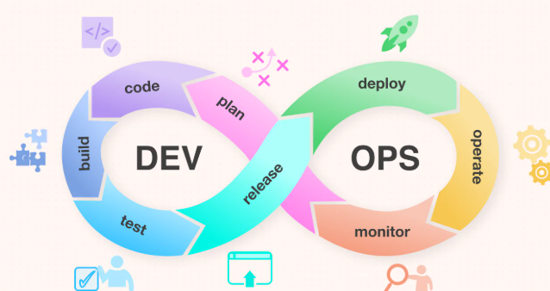

**🚀 2: Advantages of DevOps**

⚡ 1. Faster Software Delivery

DevOps speeds up the release cycle by automating testing and deployment. Updates, bug fixes, and new features can reach users quickly—sometimes multiple times a day.

🤝 2. Improved Collaboration

By breaking down barriers between Dev and Ops, teams communicate better, share knowledge, and solve problems faster. This reduces delays and miscommunication.

🧪 3. Higher Software Quality

Automated testing and continuous monitoring catch bugs early, resulting in more stable and secure software. Frequent updates also mean quicker fixes and improvements.

🔄 4. Enhanced Flexibility

DevOps enables rapid adaptation to market changes and customer feedback. Businesses can pivot quickly and stay competitive.

⏱️ 5. Time and Cost Efficiency

Automation reduces manual work, saving time and minimizing human errors. This leads to smoother workflows and lower operational costs

😊 6. Better Customer Experience

Stable systems, frequent updates, and fast bug resolution lead to happier users and increased customer satisfaction.

**🧩 3: Use Cases and Applications**

🏢 1. Enterprise Software Development

Large organizations use DevOps to streamline development across multiple teams, ensuring consistent delivery and faster time-to-market.

📱 2. Mobile App Deployment

DevOps helps mobile teams release frequent updates, fix bugs quickly, and respond to user feedback with agility.

☁️ 3. Cloud Infrastructure Management

With Infrastructure as Code (IaC), DevOps automates cloud provisioning and scaling, making cloud operations more reliable and cost-effective.

🎮 4. Game Development

Game studios use DevOps to push updates, patches, and new content rapidly while maintaining performance and uptime.

🧠 5. AI/ML Model Deployment

DevOps practices are increasingly used to automate the deployment and monitoring of machine learning models in production environments.

🧪 6. DevSecOps (Security Integration)

Security is integrated into the DevOps pipeline, ensuring vulnerabilities are caught early and compliance is maintained throughout development.