DAY -1

SQL AND ADVANCE SQL

1.Domain driven design: basically tables,classes and contents based on the domain we gonna built the application eg student information system,crim reporting system

Domain Driven Design:

Examples:

Educational Application

           Student, Teacher, Course, Department, Subject

Banking Application

           Account, Customer, Fund Transfer …

Retail Application

           Product, Order, Cart, Payment

 Excercises in sql refreshment:

--creating table

create table students(

student_id int primary key ,

name varchar(200),

course varchar(200),

join_date date

);

insert into students values

(1,"Anbu","data engineering","2025-01-01"),

(2,"Dhanu","QA","2025-02-02"),

(3,"Abu","data analytics","2025-03-03");

select*from students

select name,course from students

select * from students where join_date > "2025-01-01";

select * from students where course="data engineering" and join_date>"2025-01-01"

select * from students where join_date between "2025-01-01" and "2025-03-03"

select *from students where course in("data engineering","QA")

-----------------------------------------------------------------

--another variation of like

select*from students where name like 'A%'

select*from students where name like '%u'

select course from students where course like "%engineering%"

-------------------------------------------------------------------------

--updating

update students set course="Advanced data engineering" where student_id=1;

update students

set join_date="2025-11-11"

where name ="Dhanu"

select*from students

--deleting

delete from students

where join_date = "2025-03-03"

delete from students where student_id=1

select*from students

create,read,update,delete these are the foundation and mandatory functions where all websites applications uses that we do

--deleting

delete from students

where join_date = "2025-03-03"

delete from students where student_id=1

select*from students

explain query for sales analytics database

---variration1:

select employee_name,sum(sale_amount) from sales_Data

group by employee_name

having sum(sale_amount)>(select avg(sale_amount) from sales_data)

--interpretation : the employees whose total sales amount greater than avg sales amount of total employees

-- employees who earn more than average salary

select*from employees

where salary>(select avg(Salary)from employees)

Inline query:

The query statement inside from is called inline query

Subquery: the query in where clause statement is called subquery.

Example of Inline query:

select dept_avg.department,dept_avg.avg_salary from(

select department,avg(salary) as avg_salary

from employees

group by department)

as dept_avg

RANKING:

select emp_name,department,salary,

rank() over (order by salary desc )as salary_rank

from employees

--we have ranks the top employees based on salary

JOINS

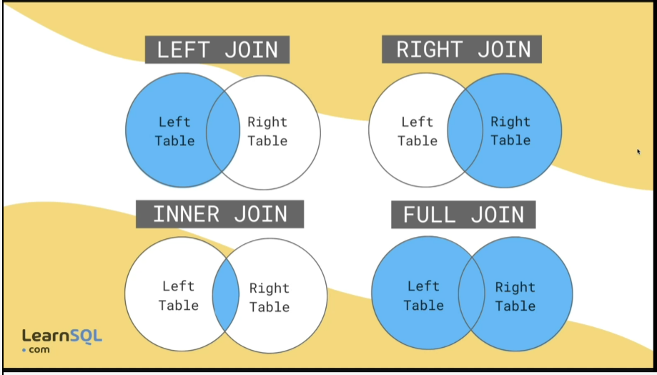

THESE ARE THE TYPES OF JOINS IN SQL

Examples of inner join:

select customers.customer_name,o.product_name,o.order_amount from orders as o inner join customers using(customer_id)

we can use all joins by join names except full outer join

for full outer join we need to use two joined tables and union keyword