Contents

1. Introduction

1.1. Context
1.2. Motivation
1.3. Objectives

2. Theoretical background

2.1. Social websites
2.1.1. Social media impact
2.1.2. Blogging
2.2. Interactive maps
2.3. GIS applications
2.4. Client-Server Model
2.5. Back-end technologies
2.6. Front-end technologies

3. Application

3.1. Description of the app
3.2. Technologies used for the application
3.2.1. MongoDB
3.2.2. Spring Boot
3.2.3. Gradle Build Tool
3.2.4. Angular
3.2.5. Bootstraps
3.3. Technologies for making interactive maps
3.3.1. OpenStreetMap and Mapbox
3.3.2. QGIS
3.3.3. Leaflet
3.4. Maps Data
3.4.1. Data formats
3.4.2. Data processing
3.5. Architecture

4. Conclusion

4.1. Conclusions
4.2. Contributions
4.3. Further research

5. Bibliography

Introduction

1.1. Context

Cartography is defined as the art and science of mapmaking and map use. Cartography became a legitimate scientific discipline after the Second World War as the result of the growing interest in map design research and the evolution of geography, in general. The philosophy during what Arthur H. Robinson called the “Golden Era of Cartography” was functional design, which means considering the function of a map as being part of the design process. This approach to cartographic research gave rise to the communication model, which describes the map as a method which enables a message to be passed from the mapmaker to the map user. Then, cartography evolved with research on visual communication from advertising, art, education, and psychology. Although the communication model largely has stopped being used due to concerns from practical/applied and critical/social theory perspectives, the design and use guidelines generated during this era remain the structure of the modern cartographic curriculum. Today, many scholars make their research on the subject of cartographic representation, continuing the Robinson-era investigation into how maps work, are seen and understood, while also giving meaning to the maps.

The history of mountain-climbing goes way back, as in the 14th century the first ascent to a summit was registered, but the humanity could have reached mountains peaks millions of years ago. Regardless of the reasons of these climbing trips, history and evolution improved the process of mountain-climbing. Not only is there better equipment available nowadays, more technological devices, already marked trails, but maybe the most valuable advantage of all is the ability to learn from other people’s experiences. The importance of receiving advice, as well as passing the knowledge to the other party, resulted in the appearance of mountain lover’s communities, forums and personal blogs regarding this expanding field. It is said that the deepest way of learning is through one’s own experience, but it helps for sure collecting stories from individuals who went through the same thing. There are also the basic need of communication, interaction and the feeling of belongingness that make a person want to join a community and become an active member of it.

1.2. Motivation

Designers and developers working with cartography and geovisualization spend a majority of their time engaging with the technological component of cartographic interaction, with less time available for understanding user characteristics and needs, so one reason of writing this paper is to focus on the users’ needs, while choosing the most optimal technologies for creating interactive maps. The idea of the application came as a result of this lack of many user-centered platforms, as there are many websites that present news about climbers, mountain regions or equipment, websites that provide generic information about trails and paths, but there are just a few that put the experience and the stories of its users first. There are fewer that use interactive maps in order to attract its users. As mountaineers are not mundane at all and are always on the look for something more exciting and better than it was before, I realized that what the mountain lovers are missing is a challenging platform where they can share their stories, read others’, interact with the other member of this community, as well as using maps in the most interactive ways, such as playing with their designs. Therefore, it is the lack of investment in map-based applications showed worldwide resulted in the idea of giving research in this domain and developing a website that would suit the needs of many mountaineers out there. To put it all in a nutshell, the motivation behind this paper is studying about the creation and behavior of interactive maps having the users in mind and insist on having an efficient and strong application too as a result of the combination of various technologies.

1.3. Objectives

The paper aims to find the most efficient and the most accurate way of creating interactive maps based on the users’ needs, working with layers and geographic data formats while having a consistent, scalable and responsive application. First, the concept of social websites will be presented, then the next step is about the system which allows working with geographic data: GIS. Furthermore, the client-server model, as well as back-end and front-end technologies are being described as being main concepts of the structure of the application. Subsequently, it will be presented a client-server web application that uses interactive maps, insisting on the combination of technologies chosen and several experiments to decide on the best data format to be used for creating layers and interactive maps.

Theoretical background

2.1. Social websites

Combining social media and blogging brings a user the ability to evolve with oneself, as well as nourish relationships with other users, and therefore it feeds the needs that a user has. Subsequently, there are presented reasons users user social media websites, as well as blogs.

2.1.1. Social media impact

Information and communication technology have and are continuously changing and the one to thank to (or to blame) is the emergence of social media. The pace of change is accelerating and with it, the reason people use social media id changing constantly. A study by New York Times Consumer Insight Group revealed the motivations that participants cited for sharing information on social media. The greatest percentages are taken from the people who want to pass valuable information or to support a cause/issue they feel strongly about. Besides that, a percentage of 68% of people admitted they share information on social media in order to build an image for themselves and demonstrate who they are. 78% of people said that sharing information for them means interacting, growing, nurturing relationships and staying in touch with others, while 69% want to participate and feel involved in things happening in the world.

2.1.2. Blogging

Having a blog is a great and personal platform for people to voice their ideas, thoughts, experiences and feelings. Blogging gives one the opportunity to connect and network with likeminded individuals who share the same passions. What is more, when starting a blog, a person with experience in a field has the opportunity to educate others interested in that particular field of expertise. That is also a way of promoting oneself if that person is a professional who seeks for making a living out of that passion.

2.2. Interactive maps

In a world where social media is a descending and fast changing environment, a fearful factor is the fierce competition. That being said, there are many elements that have to be used in order to have a successful social media website and keep the users excited and loyal to a site. It is therefore essential to attract the users by making them feel that they have a role in the making of their own webpage, such as customizing designs, interacting with various elements. That is only a proof of the importance of interactive maps.

The digital evolution and subsequent information age together have induced changes that are as numerous as they are fundamental to the ways in which maps are produced and consumed, with interactivity being among the most significant of these new possibilities. While static maps are simply maps that are viewed as a fixed image, interactive maps allow users to select from a range of data layers and map features to create and view their own customized maps. Functions such as zoom, hover-over pop-ups and click actions create a dynamic experience that enables users to engage with the data and explore the map’s underlying patterns in greater depth.

There are several distinct benefits to using interactive maps over more traditional types. The interactive design makes it exceptionally easy to pinpoint a given location. A particular position or landmark can be identified by simply entering its address or, with certain models of interactive maps, its name or latitudinal and longitudinal coordinates. As technical problems are overcome, it is becoming easier to create interactive mapping sites.

MacEachren and Ganter provide a well documented research about the relationship between user and his ability and cartographic representation, perception, cognition, and motor skills. The authors propose a pattern-matching model of visual thinking, later clarified by MacEachren under the title of ‘feature identification’. The model includes two main stages: a perceptual-cognitive stage of recognizing previously known patterns and noticing unexpected ones, and a cognitive stage of evaluating the viewed patterns and integrating them into existing knowledge schema. Importantly, MacEachren and Ganter’s pattern-seeking model can be combined with
Donald Norman’s ‘seven stages of action’, term invented by him when trying to explain the psychology behind the execution of a task performed by a person, in order to determine which stages are driven by cognition, perception or motor skills.
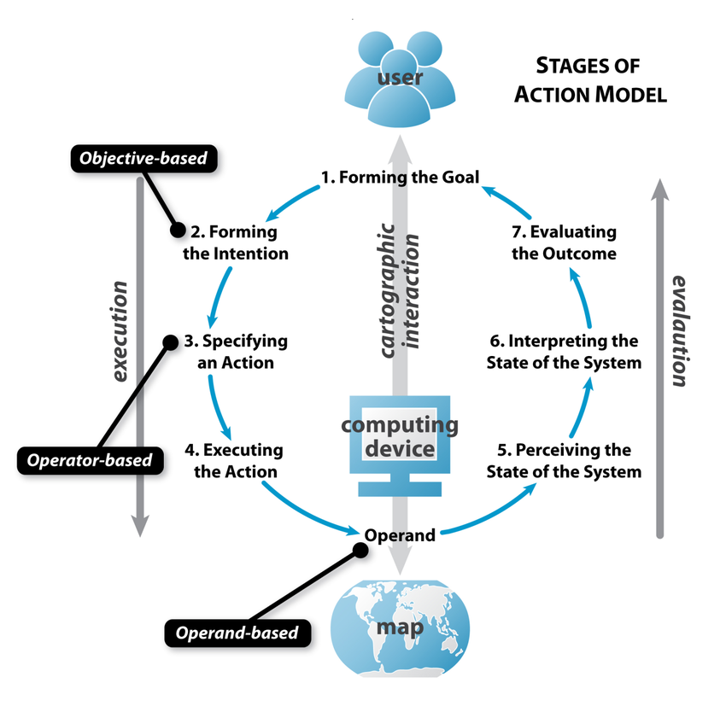
Schema representing Donald Norman’s seven stages of action and
MacEachren and Ganter’s pattern-seeking model

There are three main categories of technological considerations when it comes to cartographic interaction: input capabilities, bandwidth size and processing power (together impacting system response time), and display capabilities. Input devices are the computing technology that allows the user to “speak” to the map. Most personal computers support two kinds of input devices: keying and pointing. Most of the interaction research regarding information visualization and visual analytics emphasizes the pointing devices for manipulation of graphical user interface widgets or the visual representation itself. Traditional point devices include directional pads, joysticks, mice, touchpads, touch points, and trackballs, among others. The mouse generally outperforms other pointing devices for two-dimensional representations. Bandwidth and processing are considered together because they determine the speed at which interaction occurs . The delays in cartographic interaction can be caused by lags in processing the geographic information calculations and serving the updated cartographic representations. The efficient processing, web delivery, and representation of voluminous and crowdsourced geographic information through cartographic interfaces remains a key research topic spanning all areas of cartography. The final technological concern for cartographic interaction is the display capability, the computing technology that allows the map to “speak” to the user. The visual display enables cartographic interaction by providing affordances and feedback. Visual affordances are graphic signals to the user about how to interact with the interface, and are essential for specifying and executing an action. Visual feedback describes graphic signals (including updates to the map itself) to the user about what happened as a result of the interaction, and is essential for perceiving and interpreting the state of the system. Harrower identified in his research three display characteristics that vary from screen to screen and that therefore affect cartographic representations and interactions: screen resolution, screen size, and color depth. Characteristics that can be added to this listing include: luminance capability, refresh rate, expected viewing distance, display continuity (in the case of multiple screens linked together), lighting conditions, and portability. All of these characteristics influence the amount and type of affordances and feedback provided to support cartographic interaction.

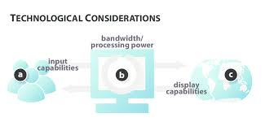

The three main technological considerations regarding

cartographic interaction, according to Robert Roth

2.3. Gis Applications

GIS actually means geographic information system which is designed to store, manipulate, transform and manage geographical data, which is in some way georeferenced to locations on the earth (latitude and longitude, for example). GIS maps can be zoomed, their layers can be switched on and off, markers and other symbols can be applied.

GIS works following these steps: getting relating information from a different source (from paper maps, for instance), capturing data using GPS, scanning, digitizing or coordinate Geometry Software, data analysis which means finding spatial relationships between objects and linking their information, information retrieval, such as finding more information about the location of land detail that exists in the real world, for example the depth of a lake or the soil type of the property, topological modelling (to answer questions about the relationships between features on the earth), networks, which are series of connected lines that is used to represent system, most commonly used with stream and roads. By assigning values, such as direction or speed to the linear system, the user can “move” contaminants through the streams and determine what areas will be most affected based on flow. Then, there is the overlay used to show the relationships between several different feature in the real world. An example would be to show what areas of a property fall inside of an environmentally protected area or where the newly planned soccer fields are in relationship to schools. The last step, but not the least, is the data output which is the result of applying the above methods. At this level, a produced map on screen or paper that graphically conveys the result or answers to several questions will be produced. Wall maps and other graphics can be generated, allowing the viewer to visualize and thereby understand potential events.

The components of a GIS are the hardware, the software, the data, the methods or logic and finally a thinking operator. The hardware can be anything as small as a GPS receiver to a laptop or personal computer all the way up to a multi-platform server or a network. The software is a specialized software package and there is a generous list, among which are ESRI which includes ArcMap, ArcGIS, ArcSDE, ArcIMS, ArcWeb services and ArcGIS Server, as well as open-source softwares like QGis, Grass Gis and MapWindow GIS. The data used can be in many formats from maps to computer files to spreadsheet, the methods are the steps that are gone through to get the answer from the data and the thinking operator is the GIS professional who uses the first four components to input all the data, execute the methods, analyze the results and finally make a map to convey the information to others.

The data used in GIS can be collected from GPS, paper maps, spreadsheets or computer generated files. A GPS receiver can easily create point data through entering coordinates in the field. Paper maps can be digitalized or scanned into the computers database while the software breaks down the lines into a series of related XY coordinates to regenerate the line inside the computer software. Spreadsheets like Microsoft Excel allows the user to take data and associate it with a feature through a common attribute or common piece of data. Now, the easiest wat of collecting data is via computer generated files as AutoCAD or digital drawings, as they can be directly imported into GIS software.

An important term related to GIS is geoprocessing, as it is a set of tools which fundamental purposes are to allow you to automate GIS tasks and perform spatial analysis and modeling. Procedures that can be automated using geoprocessing are necessary to ensure data quality. Automating such tasks using geoprocessing helps sharing and communicating the series of procedures and perform batch processing flows.

When it comes to geographic representations, as part of a GIS database design, users specify certain features that will be represented. For example, parcels will be represented as polygons, streets will be centerlines and the door in front of a house as a point.

In case there is more data that needs to be added besides the spatial one, this software has incorporated a table that stores attribute data. Here the user can store additional information about each of the spatial features. For a developer, this might look like a database and that is because GIS database exists. An example for storing additional information would be an application for administrating the surrounding schools. The actual location of the schools is the spatial data. Additional data such as the school name, area, student capacity would make up the attribute data. It is the partnership of these two data types that enables GIS to be such an effective problem solving tool through spatial analysis.

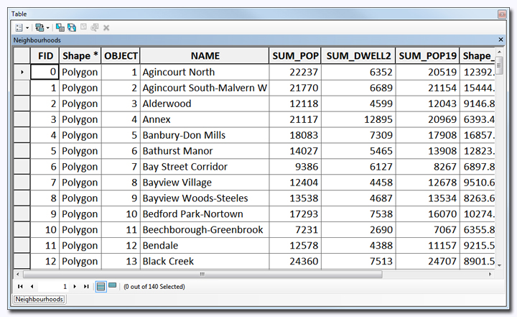

Attribute table from a GIS map

GIS, like other information technologies, must be implemented in a way that allows each applications to support the wanted work flows and requirements. This is accomplished by providing a software platform that supports a variety of geographic dataset types and a lot of tools for managing, editing, analyzing and displaying data.
The most common used and the most professional platform used for developing GIS applications is ArcGIS. That is “a platform for organizations to create, manage, share, and analyze spatial data. It consists of server components, mobile and desktop applications, and developer tools”, according to the ArcGIS developer’s website. However, as this is a platform you have to pay for, there are free and open-source platforms that support viewing, editing, and analysis of geospatial data, such as QGIS.

Furthermore, a map has to be able to be seen by users. There is a plugin for transforming a GIS map into a web map and is called Gis2web. It generates a web map from a QGIS project, either as OpenLayers or Leaflet. It replicates as many aspects of the project as it can, including layers and styles. For this, no server-side software is required. However, using a programming language is a more versatile method of creating maps which are more interactive and intuitive. In this case, a user can have much more direct control of the map, as for the programmer, it is easier to place the map into a piece of code.

2.4. Client-server model

Web development is about the communication between two parts, the server and the clients, over the HTTP (Hypertext Transfer Protocol). The server is the one storing all the data and managing most of the processes and is responsible for responding to a client’s request by giving pages or services, displaying them to the users. The client requests processes or specified data. To put it more simple, client-side is an application that runs on the users' computer, while server-side is running somewhere else (on another server most likely). In the client–server model, the client is usually considered the front end and the server is usually considered the back end, even when some presentation work is actually done on the server.

2.5. Back-end technologies

By being able to communicate with database, a back-end application provides services and handles requests of the front-end. In order to make sure that the data or services requested by the front-end system are properly delivered by the back-end, there are a few important back-end technologies that must be used. These are web frameworks, database applications and web server software.

A web application framework is a code library that is designed to help web developers build reliable, scalable and maintainable dynamic web applications and web services. By providing the necessary functionalities and features, a web framework helps developers to stay focused on the logic of the application and to write clean, maintainable code without having to “reinvent the wheel”. Even though the majority of web frameworks are exclusively server-side technologies, some web frameworks have started focusing on client-side programming as well as providing full support to web developers, especially full-stack developers.

Database applications are software programs that are created to manage and retrieve information efficiently. All data that is shared between components of a web application or needs to be persisted between requests have to be stored somewhere. That is why databases are being used.

There are two types of databases that are used by web developers, and they are relational databases and nonrelational databases. Relational databases represent data in tables and rows, and the tables in a database are related to each other in some way. The most popular are Microsoft SQL Server, Oracle Database and MySQL. Relational databases can sometimes also be called relational database management systems (RDBMS) or SQL databases. Non-relational databases, also known as NoSQL databases, amongst which is MongoDB, represent data in different ways from the relations stored in tables used in the relational databases. NoSQL databases are widely used for their simplicity, design, flexibility and scalability.

The web server software uses HTTP to serve content to users, in response to the requests that are made by the clients. Selecting which web server software to use depends on different aspects such as: compatibility with the operating system, security and its performance capability.

2.6. Front-end technologies

In contrast to the back-end, front-end application is the one that users interact with directly. To create the front-end for a website, the next three languages are mandatory: HTML, CSS and JavaScript. These are the three core components that control a web page’s content, appearance and interactive functionality. HTML is a HyperText Markup Language file format that is used for structuring the content of a web page, and Cascading Style Sheets (CSS) is a style sheet language used for applying all the visual styles to the web page. Along with HTML and CSS, JavaScript is a programming language that defines almost all the interactive functionalities on the web page.

In addition to these three main components, there are frontend frameworks that have the benefit of offering responsive web design, which is an optimal solution to displaying the web pages properly across multiple devices with different screen sizes and resolutions (desktops, laptops, tables, phones). The leader of these frameworks in undoubtedly Bootstrap.

Application

3.1. Description of the app

The application that is going to be presented combines social media, blogging, interactive customized maps and contest-game structure in order to create a community for mountaineers, a place where they can share their experiences within several mountain areas in a blog format. The app enables users to make an account, write a story, see the stories of other users, gain points and have ranks based on which other users can see your experience.

The main page is a signing up/ login page. After signing in or signing up, the user is automatically directed to the main page, where a general map is shown. When clicking on a region, the user can see all the stories that were posted regarding that region, as well as comments and likes of that story. Also, the user has the option to see the most recent stories that were posted in a feed.

Each user has his own standard page where it is shown some data about the user, his customized map and also, the most recent stories. A user can edit his profile by updating data that was written when singing up, complete additional data and upload a profile picture. The individual map can be customized by selecting one of the design from a given list, as well as choosing a color for the area they wrote a story about. A story consists of a text and/or uploaded pictures that can be posted when clicking on a section of the map.

Each story added means some points awarded to the owner of the story. The points are to be exchanged into a status: mountain beginner, expert of the heights, rocks’ master etc., that are shown on the user’s page. This creates a challenging environment for users and gives them the push of posting a story. What is more, it creates many opportunities to keep the users interested and active, such as gaining points by receiving a high number of likes at their posted story, having signed up for a long time etc.

3.2. Technologies used for the application

There are so many versatile programming languages, databases and frameworks to use in web development nowadays, that a developer has to think through better than ever what are the advantages and disadvantages of each one and what is the best combination suited for the application going to be developed. Based on many factors such as efficiency, compatibility with one another and with the application idea, popularity and innovation factors , I considered that the combination of MongoDB, Spring Boot, Gradle, Angular 4 with Angular CLI and a touch of Bootstrap are the most suited to create the application.

3.2.1. MongoDB

The choice of using MongoDB instead of the classic studied relational databases such as MySQL, SQL Server or PostgreSQL came after analyzing the differences between SQL and NoSQL and comparing their advantages and disadvantages.

3.2.2. Spring Boot

3.2.3. Gradle Build Tool

3.2.4. Angular

3.2.5. Bootstrap

3.3. Technologies for making interactive maps

Studying maps and software used for processing maps, learning about raster and vector layers, discovering the meaning of new words such as georeferencing and geoprocessing brought me the true challenge. I had to combine design, geometry and geography in order to obtain the data I needed via QGIS. The design of the maps was taken from OpenStreetMap and MapBox. After obtaining the maps, I had to make them interactive, so I used a JavaScript library for interactive maps: Leaflet-Omnivore. Subsequently, they will be presented and given examples of how I used them during the learning period of how to make my own maps.

3.3.2. OpenStreetMap and Mapbox

Mapbox is an open source mapping platform for custom designed maps, a place where users can design their own maps (colors, what information is shown, the font used for names etc.). Besides the maps shared by users, there is a variety of free maps whose APIs can be used for developing further using that map.

OpenStreetMap is a collaborative project to create a free editable map of the world and even though Google Maps is a more popular option for mapping applications, Mapbox uses maps from OpenStreetMap, so I chose the exquisite and creative designing that are brought forward by the Mapbox-OpenStreetMap partnership over the popularity of Google Maps.

3.3.2. QGIS

QGIS is a free and open-source Geographic Information System (GIS) application that enables creating, editing, visualizing, analyzing and publishing geospatial information. QGIS provides a continously growing number of capabilities provided by core functions and plugins. A user can visualize, manage, edit, analyse data, and compose printable maps.
QGIS supports both raster and vector layers. Vector data is stored as either point, line, or polygon features. Multiple formats of raster images are supported, and the software can georeferenced images.

QGIS supports shapefiles, coverages, personal geodatabases, dxf, MapInfo, PostGIS, and other formats. Web services, including Web Map Service and Web Feature Service, are also supported to allow use of data from external sources.

3.3.3. Leaflet

Leaflet is an open-source JavaScript library for interactive maps. It is designed with simplicity, performance and usability in mind. It works efficiently across all major desktop and mobile platforms, can be extended with lots of plugins, has a fine documentation and a simple, readable source code.

While Leaflet is meant to be as lightweight as possible, and focuses on a core set of features, an easy way to extend its functionality is to use third-party plugins that cover the following areas: tile & image layers, overlay display, map interaction, miscellaneous, overlay data, overlay interaction and integration.

Leaflet was used to add the geodata from the JSON file as a layer to the map provided by Mapbox. Because of choosing the data format GeoJSON, no plugin for overlaying needed to be used, because Leaflet supports this format by default.

3.4. Maps Data

As there is few or no geographical data representing mountain areas in Romania, I had to experiment a lot with several data types and search for as correct data as I could before I found the most efficient one. Next I will present the datatypes I had to use in order to get the most efficient and correct results.
3.4.1. Data formats

There are some websites that use sections of maps in order to highlight areas in the world, such as mountains, countries or regions, but they are static maps. In that case, it is easy to use SVGs (Scalable Vector Graphics) which define vector-based graphics in XML format. Such data format is easy to place over a HTML page, use its clickable properties and change its color, but the real problem is that even if I obtained the SVG of the mountain areas in Romania, I would still had to georeference a shape like a polygon. One method would be to take one extreme point (for example, the leftmost point) and get through the internet the longitude and latitude of that point on a map. To be more precise, as many points that are found on a map, the better the approximation of all the other points, but when this mechanism was tried, the polygon was easily distorted and the points of the polygon were really approximate. Even if the approximation was exact, SVGs regarding mountain regions are still not easy to find.

When I discovered that the data is nowhere to be found, I invested time in manually making my own data, with a much less approximation error than in the SVG case. It took weeks to analyze the existing maps of each mountain region, read about their boundaries and represent point by point the according polygon.

The process of creating georeferenced polygons in QGIS is very simple, as you just open a map from one of the ones available in QGIS (from OpenStreetMap, Google Maps, Bing Maps, Apple Maps and many more), you add a vector layer on which you are free to draw points by clicking on the layer. QGIS provides automatically the longitude and latitude of the points. A vector layer can be used to draw three types of geometric features: point, line and polygon. For the drawing of the mountain sections, polygons were used, as the application is also interested in the area of the figure, not only its contour.

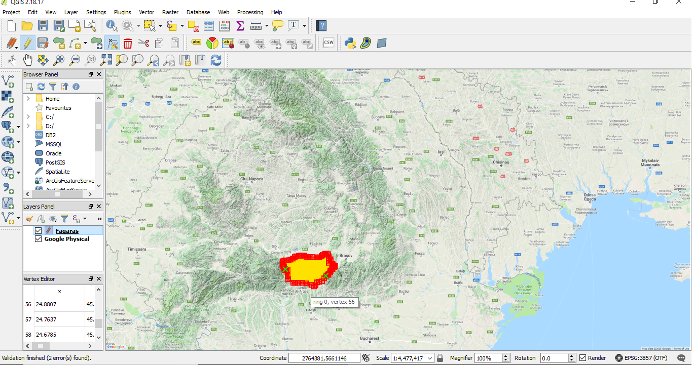
Manually drawing shapes in QGIS (a red dot represents a point and a green X on a point means
the point overrides another point or does not respect the geometrical shape of a polygon)
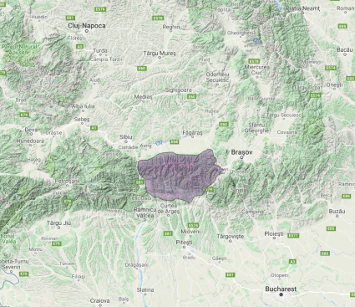
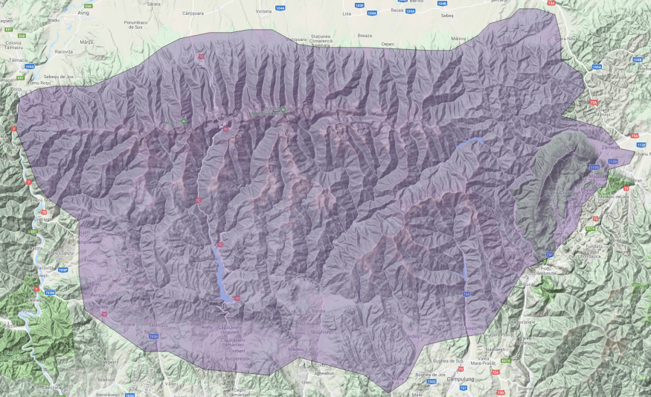

Mountain section zoomed at scale 1:4,477,417 Mountain section zoomed at scale 1:1,119,354

From the two images, it is noticeable that as the map is zoomed, the points from the polygon used for drawing the mountain section are approximate (the contour has to go along the roads but it overrides it or is too far from it). In order to have more correct data, the points would have to be drawn when the map is zoomed at a very high or at its maximum capacity.
A vector layer is saved as a Shapefile and that is a whole new type of data format from what I have been used to. To begin with, Shapefile is provided by ESRI (Environmental Systems Research Institute). It is a digital map format that stores non-topological geometry and attributes information for the spatial features in a data set which supports point, line and polygon elements. Shapefile is an open format and it is easy for analysis and development, which is suitable for small and medium-sized map application.

One of the most intriguing characteristics about this type of data format is that it consists of three main parts of data: shape format where the feature geometry is stored itself (.shp), a positional index of the feature geometry which allows seeking forward and backward quickly (.shx) and a dBASE table which contains the attribute table (.dbf). There are other files that can be added along with these three, such as a file specifying the coordinate system and projection information (.prj), spatial index of the features (.sbn or .sbx), a file used to specify the code page for identifying the character encoding to be used (.cpg) and many more.

However, Shapefile format cannot be overlayed on a map and therefore, a conversion to another accepted data format must be done, which is easily achieved in QGIS by saving the shapefile as the wanted type of file. The most popular and used data formats for geographic data were GeoJSON, GPX and KML, so a comparison between them had to be done.

GPX (GPS Exchange Format) and KML (Keyhole Markup Language) are both XML schema designed formats that are used to specify and describe geographical data. Each one of them has its ups and downs. GPX has the advantage that is was designed for lossless storage and transfer of data of GPS devices. As such, it can contain a vast array of very detailed data such as GPX signal strength, number of visible satellites etc. However, it does not recognize polygon geometries as a shape and throws an error when trying to convert from shapefile to GPX. This way, this format is mostly used for tracks, waypoints and routes.

Analyzing the previous two geodata formats, it made me realize that XML is a rather weaker format than JSON which seems “the cool kid on the block”, would also be logic options to use it if I am handling the maps with JavaScript and has a lot of advantages. To begin with, JSON requires only one tag, whereas in XML is a constant struggle of opening and closing the tags. Because JSON is transportation-independent, it is just a matter of bypassing the XMLHttpRequest object for getting the wanted data. What is more, it is better at helping procedural decisions in JavaScript based on objects and their values or methods, it is easier to read than XML (however that is subjective) and JSON format even accepts methods.

GeoJSON is an open standard format designed for representing geographical features like Point, LineString, Polygon, MultiPoint, MultiLineString, and MultiPolygon in a JSON manner. Geometric objects with additional properties are Feature objects and sets of such features are contained by FeatureCollection objects.

Here is an example of a point represented in a GeoJSON file:

{
"type": "Feature",
"geometry": {
"type": "Point",
"coordinates": [125.6, 10.1]
},
"properties": {
"name": "Dinagat Islands"
}
}

A short while after I finished drawing the polygons, I had the opportunity of receiving the data that I had been looking for, but it was nowhere to be found on the internet, from The Faculty Of Geography, Babes-Bolyai University. It contained all the types of landform in Romania, so I only had to select the mountains from the attribute table of the shapefiles, which was really generous containing all of their names, perimeter, regions, area, acres and hectares.

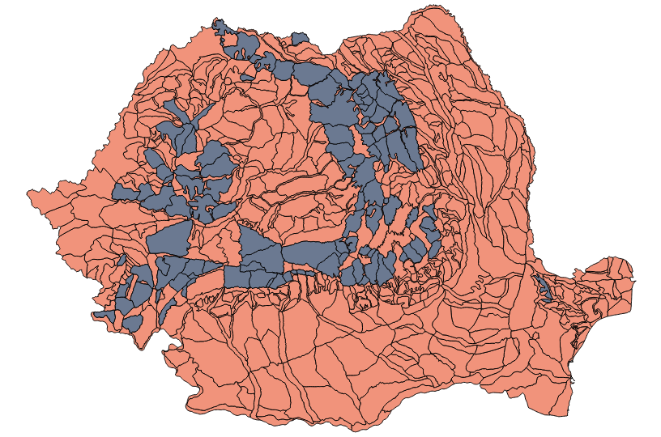

Image of the shapefiles received from The Faculty of Geography (the black sections represent the mountains selection I made)

3.4.2. Data processing

Initially, after all polygons were converted to GeoJSON files, all of them were overlayed on a map and the results were terrifying. At the end of drawing the mountains sections, I had 67 files, and placing each one of them over the map was so time consuming, that the application either crashed or it took 10 minutes for the regions to be all shown on the map. Then I thought about bringing them together into one layer, so I opened each Shapefile representing the mountains sections into QGIS and merge them into one Shapefile which was then converted into a GeoJSON file. This method worked, as the file containing the 67 files loaded almost instantly.

After receiving the latest data and processing it in QGIS, I obtained 118 polygons that were merged into the same GeoJSON. This file was also easily handled by Leaflet and no delay in the appearance of the layer was shown.

The question is: how many polygons into one file or how many GeoJSONs until the application would start to crash again or take an infinite amount of time to load? For the data used in my application for now it works, but for a future application that would use mountain regions from all over the world, some strategies would have to be applied. To begin with, the creation and starting of the layers should be taken care as soon as the application starts, so it has time to load until the map is opened. Moreover, the polygons representing the mountains should be separated and merged into files as convenient as possible and load to the layer only the necessary files ( for instance, the map would show only the mountains from each user’s location).

6. Bibliography

- What are interactive maps?
http://www.wisegeek.com/what-are-interactive-maps.htm
- Musser, Karl. "Interactive mapping on the world wide web." (1997).
- Roth, Robert E. "Interactive maps: What we know and what we need to know." Journal of Spatial Information Science 2013.6 (2013): 59-115.

- MacEachren, Alan M., and John H. Ganter. "A pattern identification approach to cartographic visualization." Cartographica: The International Journal for Geographic Information and Geovisualization 27.2 (1990): 64-81.

- Caitlin Dempsey, What is GIS?, January 11, 2018
https://www.gislounge.com/what-is-gis/
- ESRI, What is ArcGis?, 2011-2014
http://downloads.esri.com/support/documentation/ao_/698What_is_ArcGis.pdf

- William, Prince. "What is GIS?." (2016).

- Pham, Phu. "Hybrid mobile application with Ionic and MEAN stack." (2016).
- Maryanne Gaitho, What is the real impact of social media?, December 13, 2017
https://www.simplilearn.com/real-impact-social-media-article

- Gary Dekmezian, Who do people blog? The benefits of blogging, September 23, 2016
https://www.huffingtonpost.com/gary-dekmezian/why-do-people-blog-the-be_b_8178624.html?guccounter=1

- Parker, Zachary, Scott Poe, and Susan V. Vrbsky. "Comparing nosql mongodb to an sql db." Proceedings of the 51st ACM Southeast Conference. ACM, 2013.

- Walls, Craig. Spring Boot in action. Manning Publications Co., 2016.

- Muschko, Benjamin. Gradle in action. Manning, 2014.

- What is Angular?

https://angular.io/docs

- Xia, Kai, and Chao Wei. "Study on real-time navigation data model based on ESRI shapefile." Embedded Software and Systems Symposia, 2008. ICESS Symposia'08. International Conference on. IEEE, 2008.

- Sam Deering. “Why use JSON over XML?”. March 02, 2011
https://www.sitepoint.com/json-vs-xml/

- Leaflet Plugins
https://leafletjs.com/plugins.html

