Data Technician
Workbook
Week 6 Pandas

Name:
Course Date:
Table of contents
Day 1: Task 1 4
Day 2: Task 1 4
Day 2: Task 2 5
Day 4: Task 1 6
Day 4: Task 2 6
Day 4: Task 3 7
Course Notes 7
Python Additonal Resources 8
Exercise 1: You can complete training on this website. 8
Exercise 2: Complete exercise on Google Colab and share your notebook with the trainer. 8
Exercise 3: Complete exercise on Google Colab and share your notebook with the trainer. 9
Exercise 4: Challenge yourself on hackerrank. Solve Python | HackerRank 9
Exercise 5: Practice on CodingChef. Print Coding Chef Question in Python 9
Exercise 6: Kaggle Data Visualization: Learn Data Visualization | Kaggle 9
Exercise 7: Kaggle Pandas Tutorial: Learn Pandas | Kaggle 10
Exercise 8: Video: Learn Pandas in Under 3 Hours | Filtering, Joins, Indexing, Data Cleaning, Visualizations - YouTube 10


How to get a link to your notebook
- Select share
- Select Restricted under General access
- Change it to Anyone with the link
- Select Copy link and paste under each task
- Enter trainers email address Yusuf.Satilmis@leepgroup.com and press end.


Day 4: Task 1

- Follow below link. https://colab.research.google.com/drive/1ZLG3LgzHUgYfVlLzs8W2OpBugHWRBTKP?usp=sharing
- Save a copy of this notebook in your Drive and rename by adding your name at the beginning.

- Go through the notebook and complete the exercises at the end.
- Paste the link to your notebook below.
Paste the link to your notebook | https://colab.research.google.com/drive/1OgFvCfc_aCLnMhzdsHU9A08nrC0XZxo4  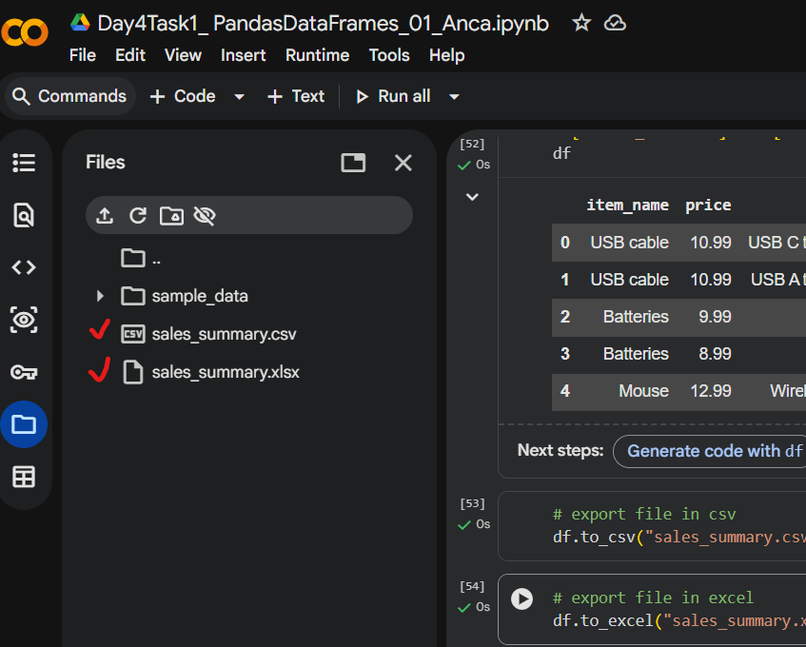  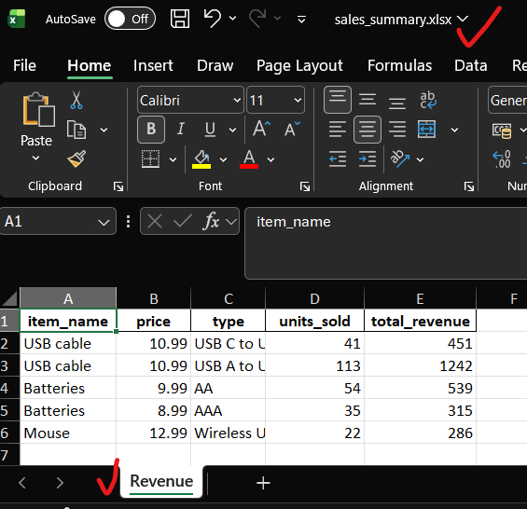

- Share your notebook with your trainer.

Day 4: Task 2
- Follow below link. https://colab.research.google.com/drive/1OIlNFt7vYRuikgRUw8HemN543jdeM8lM?usp=sharing
- Save a copy of this notebook in your Drive and rename by adding your name at the beginning.
- Download the dataset here. https://drive.google.com/file/d/14Yz-06ykP-KL-lKFFckqfJk2jVm59zY4/view?usp=sharing
- Go through the notebook and complete the exercises at the end.
- Paste the link to your notebook below.
Paste the link to your notebook | https://colab.research.google.com/drive/1g5E3VZ03s6cT7UCsquV7cLO4kkzQzJm1

- Share your notebook with your trainer.

https://colab.research.google.com/drive/1g5E3VZ03s6cT7UCsquV7cLO4kkzQzJm1

Day 4: Task 3
- Follow below link. https://colab.research.google.com/drive/1SzWwpS86Eju3tp_EDpBKFmYqFseWVam_?usp=sharing
- Save a copy of this notebook in your Drive and rename by adding your name at the beginning.
- Download the dataset here. https://drive.google.com/file/d/1FSo51F-FDXoj7mQQoKY8tk6iFg2l6YiJ/view?usp=sharing
- Go through the notebook and complete the exercises at the end.
- Paste the link to your notebook below.
Paste the link to your notebook | https://colab.research.google.com/drive/185YWJXAo2-98gS1N7ga29LdIPzIAyXzX?usp=sharing

- Share your notebook with your trainer.
https://colab.research.google.com/drive/185YWJXAo2-98gS1N7ga29LdIPzIAyXzX?usp=sharing

Day 4: Task 4 (Optional)
- Follow below link.
https://colab.research.google.com/drive/1eEk_lUtJ7d6Nb5rtT1UZcpgdCoXGneGr?usp=sharing

- Save a copy of this notebook in your Drive and rename by adding your name at the beginning.
- Download the dataset here. GDP (nominal) per Capita.csv
- Go through the notebook and complete the exercises at the end.
- Paste the link to your notebook below.
Paste the link to your notebook

- Share your notebook with your trainer.

Course Notes

It is recommended to take notes from the course; use the space below to do so, or use the revision guide shared with the class:

Python Additonal Resources
Recommended DataCamp Courses
- Introduction to Python - DataCamp Learn
- Intermediate Python - DataCamp Learn
- Data Manipulation with pandas - DataCamp Learn
- Introduction to Data Visualization with Seaborn - DataCamp Learn
- Introduction to Data Visualization with Matplotlib - DataCamp Learn

Exercise 1: You can complete training on this website.
Free Python Course by Cisco: No Prior Experience Necessary! (highly recommended, free course. Certification upon completion.)
Or complete other exercises.

Exercise 2: Complete exercise on Google Colab and share your notebook with the trainer.
- Write a Python program to print "Hello, World!"
- Write a Python program to calculate the sum of two numbers entered by the user.
- Write a Python program to convert temperature entered by user from Celsius to Fahrenheit.
- Write a Python program to calculate the area of a rectangle given its length and width
- Create a program that takes a user's name and age as input and prints a greeting message
- Write a program to check if a number is even or odd
- Given a list of numbers, find the maximum and minimum values
- Create a Python function to check if a given string is a palindrome
- Calculate the compound interest for a given principal amount, interest rate, and time period
- Write a program that converts a given number of days into years, weeks, and days
- Given a list of integers, find the sum of all positive numbers
- Create a program that takes a sentence as input and counts the number of words in it
- Write a program to check if a number is prime.
- Write a program that checks if a given number is positive, negative, or zero.
- Create a loop that prints the first 10 even numbers.
- Implement a program that finds the largest number in a list.
- Create a program that takes a year as input and checks if it is a leap year or not
- Calculate the sum of digits of a given number.
- Create a program that checks if a given string is a palindrome.

Exercise 3: Complete exercise on Google Colab and share your notebook with the trainer.
You are going to use the different Python concepts seen to build a program that will simulate the behaviour of an ATM. Follow the instructions below:
Print a main menu to ask the user different options for displaying the bank account balance, for depositing money, to withdraw money, and to exit from the ATM. Ideally create a function for each menu option to be executed. Use conditional statements for asking the user the different menu options.
Additional (optional): Ask the user a PIN to access to the ATM menu once the PIN is correct otherwise ask the user to try again.
Prompt the user to enter an option:
  - If ‘1’ is entered, display the current balance and return to main menu.
  - If ‘2’ is entered, print a sub-menu with different withdrawal amounts (give also a choice for “other amount’ to let the user enter an amount) :
  - Check that the requested withdrawal is allowed, print a message to show that the money has been withdrawn, calculate the new balance and return to main menu.
  - If ‘other_amount’ is selected, then prompt the user for an integer value. Check this number is a multiple of 10 and that the withdrawal is permitted, print a message to show that the money has been withdrawn, calculate the new balance and return to main menu.
- If ‘exit’ is selected print a goodbye message and exit (break).
- If another value is entered, print an error message and print the menu again.

-Re-use the ATM menu options across the program to ask the user if he/she would like to perform another operation on the bank account.

Exercise 4: Challenge yourself on hackerrank. Solve Python | HackerRank

Exercise 5: Practice on CodingChef. Print Coding Chef Question in Python

Exercise 6: Kaggle Data Visualization: Learn Data Visualization | Kaggle

Exercise 7: Kaggle Pandas Tutorial: Learn Pandas | Kaggle

Exercise 8: Video: Learn Pandas in Under 3 Hours | Filtering, Joins, Indexing, Data Cleaning, Visualizations - YouTube

END OF WORKBOOK

Please check through your work thoroughly before submitting and update the table of contents if required.

Please send your completed work booklet to your trainer via MS Teams Assignments Page.

